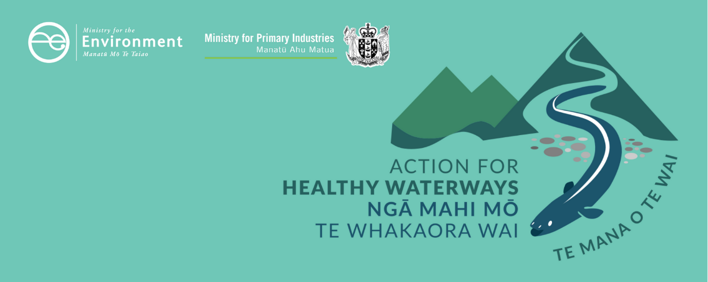

Information on attributes for managing the ecosystem health and human contact values in the National Policy Statement for Freshwater (2020)
This information sheet is one of a series outlining requirements as part of a new approach to managing the health of freshwater in New Zealand. These actions will see us start making immediate improvements where needed and set us on a path to healthier freshwater within a generation.
These requirements have been developed following consultation with New Zealanders. In 2019, the Government consulted on new regulations and a new risk-based approach for improving farm environmental practices through mandatory farm plans in the document Action for healthy waterways. The Government asked for feedback on proposed regulations – a new National Policy Statement for Freshwater Management, new National Environmental Standards for Freshwater and regulations under section 360 of the Resource Management Act 1991. As a result of more than 17,500 submissions, and reflecting the new environment created by COVID-19, the Government has made several changes to what was proposed.
This information sheet describes how attributes in the new NPS-FM, many of which have a minimum standard, or national bottom line, contribute to understanding how freshwater provides for ecosystem health and human contact.
You can find more information sheets on the Ministry for the Environment’s website at www.mfe.govt.nz/action-for-healthy-waterways.

Overview
Under the Resource Management Act 1991, the National Policy Statement for Freshwater Management (NPS-FM) provides national direction which regional councils then translate into action on the ground through their regional plans. The current NPS-FM was amended in 2017 and is now being replaced.
The NPS-FM requires every regional council, in consultation with its community, to develop a plan for maintaining or improving the state of freshwater in the region. There are a number of compulsory values and attributes (measures of the state of a river or lake) that must be met, and communities can choose to go above and beyond these.

Attributes
An attribute is something we can measure and monitor that tells us about the state of a river or lake.
There are 22 compulsory attributes in the new NPS-FM, many of which have a minimum standard, or national bottom line – these contribute to understanding how freshwater provides for ecosystem health and human contact.
The council and community must set target attribute states at or above the bottom line and plan what actions they will take to meet these targets. They are required to improve or at the very least maintain the current state of waterways. Regions can choose to add additional attributes, or higher targets.

Actions
The regional council must then work out what needs to be managed to achieve the target attribute states (for example, contaminants, habitat or land use), set limits on these and develop rules about resource use to achieve the objectives they have set.
Councils must also monitor and report on the extent to which the target attribute states are being achieved.
Note that there are other actions that may also be required to achieve ecosystem health. For example, there is no attribute relating to the volume of water flowing through a waterway, but managing this will contribute to desired outcomes.
This document focusses on attributes and how they work.
Figure 1: Overview of the freshwater planning system
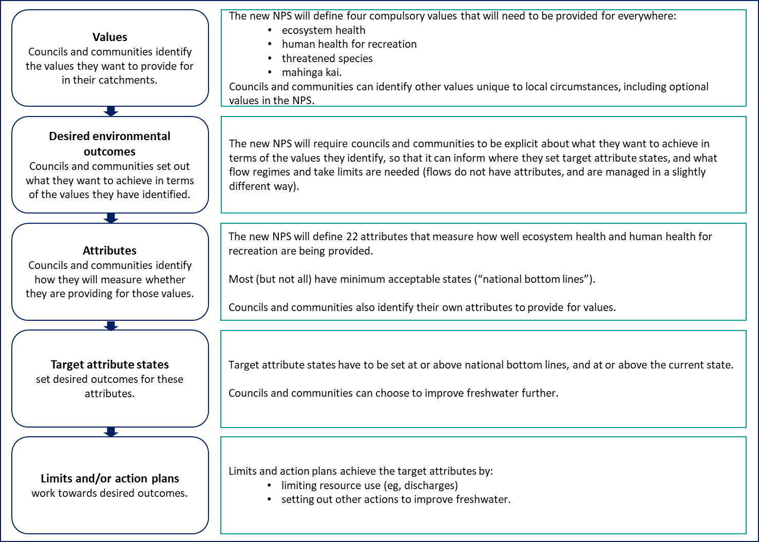

What is the difference between an NPS-FM and an NES?
The NPS-FM sets out what regional councils must do to manage freshwater when they prepare regional water plans under the RMA. Regional councils must complete their plans by the end of 2026 (or 2027 if they are granted an extension). The timeframe for action to achieve attribute targets is set by councils in consultation with their communities. This will be a long term process, and may take decades.
National Environmental Standards set nationally consistent rules for the ways particular activities or resource uses are to be carried out. New National Environmental Standards for Freshwater will also come into effect in mid-2020 and will deliver on shorter-term freshwater objectives.

How will regional councils need to manage attributes?
Regional councils will need to set target states for attributes, above any minimum standard set in the NPS-FM (national bottom line) if applicable, and either improving or at least maintaining the current state. They will need to monitor all attributes over time, and take action if conditions decline.
Councils will work towards target attribute states in different ways, as shown in figure 2.
Figure 2: Different ways of setting and working toward target attribute states

What types of attributes are included?
We can think of the attributes in three main ways.
- Water quality and physical habitat attributes
These measure the ability of the physical environment to support healthy ecosystems. They tell us about the amount of:
- nutrients (nitrogen and phosphorus) in the water
- sediment in the water and on river and streambeds
- dissolved oxygen.

Aquatic life and ecosystem processes attributes
These tell us about:
- animal life (macroinvertebrates and fish)
- plants and algae (periphyton, phytoplankton and submerged plants)
- ecosystem functioning – how much the ecosystem as a whole is producing and breaking down organic matter.

Human health attributes
These tell us about health risks for people by measuring:
- potentially toxic algae (cyanobacteria) and the presence of faecal bacteria (E. coli., which is a proxy for risk of infection).
Table 1: Attributes for a new National Policy Statement for Freshwater Management
Attributes for which regional councils will have to set limits on resource use are shown in bold. Other attributes will have to be measured and monitored, and an action plan implemented if they decline or are below a national bottom line.
Attribute | Where | Includes a national bottom line | New or changed
Water quality and physical habitat
Nitrogen – see attribute guide 1
Total Nitrogen (trophic state) | Lakes
Ammonia (toxicity) | Rivers and lakes
Nitrate (toxicity) | Rivers and lakes
Phosphorus – see attribute guide 2
Total Phosphorus (trophic state) | Lakes
Dissolved reactive phosphorus | Rivers
Sediment – see attribute guide 3
Suspended fine sediment | Rivers
Deposited fine sediment | Wadeable streams and rivers (except naturally soft-bottomed streams)
Dissolved oxygen – see attribute guide 4
Dissolved oxygen | Rivers (below point sources only)
Dissolved oxygen | Rivers
Lake-bottom dissolved oxygen | Lakes
Mid-hypolimnetic dissolved oxygen | Seasonally stratifying lakes
Aquatic life and ecosystem processes
Animal life – see attribute guide 5
Macroinvertebrates (1 of 2: MCI, QMCI) | Wadeable streams and rivers
Macroinvertebrates (2 of 2: ASPM) | Wadeable streams and rivers
Fish (rivers) | Wadeable streams and rivers
Plants and algae – see attribute guide 6
Phytoplankton (trophic state) | Lakes
Periphyton (trophic state) | Rivers
Submerged plants (natives) | Lakes
Submerged plants (invasive species) | Lakes
Ecosystem functioning – see attribute guide 7
Ecosystem metabolism | Rivers
Human health
Health risk – see attribute guide 8
Cyanobacteria (planktonic) | Lakes and lake-fed rivers
Escherichia coli (E. coli) | Lakes and rivers
Escherichia coli (E. coli) (primary contact sites – eg, where people want to swim) | Lakes and rivers (primary contact sites)

Attribute guide 1: Nitrogen

Which attributes does this relate to?
There are existing limit-setting attributes for total nitrogen in lakes, ammonia (toxicity) and nitrate (toxicity). The national bottom lines for nitrate and ammonia toxicity will be strengthened in the new NPS-FM.

Why manage nitrogen?
Nitrogen contributes to the growth of plants and algae, which can become a nuisance if excessive.
In rivers | aquatic plants and periphyton (slime)
In lakes | plants and phytoplankton (microscopic algae)
In estuaries | microscopic algae, seaweed and plants

Some forms of nitrogen (eg, nitrate, ammonia) can be toxic to aquatic animals.
Reducing nitrogen will help to support healthy communities of microbes, invertebrates and fish. The ecosystems would be healthier and more resilient to other disturbances.

Where does nitrogen in freshwater come from?
The main sources of nitrogen in our rivers, lakes and wetlands are:
- wastewater (eg, treatment plants and septic systems)
- run-off from pasture, croplands and lawns (eg, animal manure and urine, fertiliser)
- industrial discharges.

Are there any restrictions on the amount of nitrogen in rivers already?
The existing NPS-FM does not include specific standards for concentrations of nitrogen as a nutrient in rivers.
However, it does direct councils to set limits on nutrient discharges to:
- manage the growth of periphyton in rivers where periphyton can grow (ie, in hard-bottomed, stony rivers)
- manage nutrient levels in any sensitive receiving environments (ie, if there are lakes or estuaries downstream)
- in all rivers and lakes, manage toxic effects of nitrogen. Toxic effects occur at higher concentrations than nutrient effects.

What will change?
The national bottom lines for nitrate and ammonia toxicity will be strengthened to protect 95 per cent of species from toxic effects (up from 80 per cent currently). This will be more stringent than the existing requirements in some soft-bottomed rivers that do not grow periphyton or have an estuary or lake downstream.
Councils will also need to manage nitrogen to provide for other ecosystem health attributes, such as macroinvertebrates. Policy work continues to consider whether there should be a dissolved inorganic nitrogen (DIN) bottom line.

Will other measures have an effect on nitrogen?
Improvements in stock management and the use of nitrogen fertiliser can help to reduce the amount of nitrogen that enters waterways. Complementary policies in the Action for healthy waterways package include managing excessive nitrogen discharges with a cap on fertiliser application.

Attribute guide 2: Phosphorus

Which attributes does this relate to?
There is an existing limit-setting attribute for total phosphorus in lakes. The new NPS-FM will also have an action-planning attribute for dissolved reactive phosphorus (DRP) in rivers.

Why manage phosphorus?
Like nitrogen, phosphorus contributes to the growth of plants and algae, which can become a nuisance if excessive.
In rivers | aquatic plants and periphyton (slime)
In lakes | plants and phytoplankton (microscopic algae)
In estuaries | microscopic algae, seaweed and plants
Reducing phosphorus would help to support healthy communities of microbes, invertebrates and fish. The ecosystems would be healthier and more resilient to other disturbances.

Where does phosphorus in freshwater come from?
The main sources of phosphorus in our rivers, lakes and wetlands are wastewater treatment plants, fertiliser use, sediment derived from erosion of soil and industrial discharges.
Some places (eg, steep areas) are naturally prone to erosion, and high concentrations of phosphorus occur even in some places under native land cover, because of naturally high levels in the soil.

Are there any restrictions on the amount of phosphorus in rivers already?
The existing NPS-FM doesn’t include specific standards for concentrations of phosphorus in rivers.
However, it does direct councils to set limits on nutrient discharges to:
- manage the growth of periphyton in rivers where periphyton can grow (ie, in hard-bottomed, stony rivers)
- manage nutrient levels in any sensitive receiving environments (ie, if there are lakes and estuaries downstream).

What will change?
There will be a new action-planning attribute for DRP. There won’t be a national bottom line for this attribute. This means that councils will need to monitor and manage to make sure levels of DRP don’t increase. Councils will also need to manage phosphorus to provide for other ecosystem health attributes, such as macroinvertebrates.

Will other measures have an effect on phosphorus?
Because soil contains phosphorus, any measures that help to reduce erosion and sediment will also help to reduce the amount of phosphorus that gets into the water.
Complementary policies in the Action for healthy waterways package include those for managing sediment, keeping livestock clear of waterways on farms, and making sure winter grazing practices don’t result in excessive runoff into waterways.

Why not have a national bottom line for DRP?
Because DRP (like sediment) shows significant natural variation in different river types, one bottom line that applies nationally risks being ineffective and inequitable.
The NPS-FM has an exemption for naturally occurring processes. If we had one national bottom line for DRP, many rivers would be exempt, because they have naturally high levels of DRP. There will be further research on natural variability among river classes to support DRP attributes.

Attribute guide 3: Sediment

Which attributes does this relate to?
The new NPS-FM will have a limit-setting attribute for fine suspended sediment and an action-plan attribute for fine deposited sediment in rivers.

Why manage sediment?
Sediment is a major driver of freshwater and marine biodiversity loss. Current levels are high enough to cause habitat degradation and loss of fish and macroinvertebrate species in some river reaches in every region in New Zealand.
Suspended sediment reduces the clarity of water. When it settles, it forms a muddy layer on the bottom of a waterbody.
Both suspended and deposited sediment can impact fish and macroinvertebrates and their habitat, so we need to assess and manage both. Sediment carried in rivers can also be deposited in estuaries, impacting the health of those ecosystems.

Where does sediment come from?
Soil washes naturally into rivers and streams.
Human activities such as deforestation and earthworks can significantly increase soil erosion, which increases sediment in waterways. In particular, some hill country areas have very high erosion rates, due in part to the grazing of marginal land.

Are there any restrictions on the amount of sediment in rivers already?
Although councils do have to take sediment into account, the existing NPS-FM doesn’t include standards for sediment.

What will change?
There will be new attributes for fine suspended sediment and fine deposited sediment. Both attributes will have different bottom lines for different classes of rivers. Councils will need to set target states that are at or better than the current state, and at or better than the relevant bottom line.
Suspended sediment will be a limit-setting attribute, and councils will need to set limits on resource use to achieve the target state. Deposited sediment will be an action-planning attribute.

Will other measures have an effect on sediment?
Other regulations as part of the Action for healthy waterways package include those for keeping livestock clear of waterways on farms and making sure winter grazing practices don’t result in excessive runoff into waterways.

Why does the attribute for suspended and deposited sediment have several bottom lines?
New Zealand’s terrain and natural sediment levels vary from place to place. The bottom lines are based on a spatial classification system called the River Environment Classification (REC). The REC system sorts river segments into groups based on their climate, topography and geology.
Using a spatial classification system means that:
- streams with naturally high suspended and deposited sediment levels can have different bottom lines from those with naturally lower levels
- areas with specific characteristics, such as glacial headwaters, can be exempted from some requirements.

Attribute guide 4: Dissolved oxygen

Which attributes does this relate to?
There is an existing limit-setting attribute for dissolved oxygen below point sources. The new NPS-FM will also include action-planning attributes for dissolved oxygen in rivers and lakes.

Why manage dissolved oxygen?
Dissolved oxygen is required by all aquatic life for respiration. The availability of dissolved oxygen is one of the main things that determines which animals can survive in a freshwater ecosystem.
Dissolved oxygen is also needed to maintain some ways that ecosystems function and recycle nutrients (eg, the way nutrients bind to sediment at the bottom of lakes).

What factors affect dissolved oxygen?
Dissolved oxygen can be depleted when organic matter decomposes.
Point source discharges of organic matter (eg, a waste stream from pulp and paper processing) can result in lowered levels of dissolved oxygen downstream from the discharge as the organic matter breaks down.
Diffuse discharges of nutrients (eg, run-off from farms) can also affect the availability of dissolved oxygen in a waterbody. They cause excessive growth of plants or algae, which then use up oxygen at night and when they are decomposed.
The rate of flow and mixing also affects how quickly oxygen is incorporated and used up. In lakes that form layers (“stratify”), oxygen can become depleted in the cold bottom layer because it is isolated from mixing at the surface. Rivers that have a lot of mixing (such as fast flows, rapids or waterfalls) are often well-oxygenated.

Are there any restrictions on dissolved oxygen already?
The existing NPS-FM requires councils to set limits to manage dissolved oxygen below point sources.

What will change?
There will be new action-planning attributes that will expand the range of monitoring to include dissolved oxygen in:
- rivers and seasonally stratifying lakes, to protect habitat for aquatic animals
- the bottom of lakes, to protect against nutrient release from the bottom sediments.
There will be national bottom lines for these attributes. Councils will need to measure and monitor the attributes, and take action if they decline or are below a bottom line.

Would other measures have an effect on dissolved oxygen?
Changes that reduce the growth of nuisance plants and algae, including by reducing the amount of nutrients in the water, will help to improve dissolved oxygen.
There are already attributes for nutrients and algae in lakes, and periphyton in rivers. Complementary proposals in the Action for healthy waterways package include a strengthened bottom line for nitrate and a new action-planning attribute for dissolved reactive phosphorus

Attribute guide 5: Animal life

Which proposal does this relate to?
There are existing requirements for macroinvertebrates. The new NPS-FM will include new and changed action-plan attributes for macroinvertebrates and fish.

Why monitor macroinvertebrates and fish?
Macroinvertebrates (eg, insects, freshwater crayfish, snails, and worms) play an important role in maintaining a healthy ecosystem including as a key component of freshwater ecosystem food chains.
The make-up of a macroinvertebrate community changes over time depending on the water quality and habitat, so it can give us a longer-term picture of what is going on in the water than if we just measured physical attributes.
We want to make sure our freshwater provides a good habitat for fish. Three-quarters of New Zealand’s freshwater fish species are threatened or declining.

What impacts macroinvertebrates and fish?
Changes in water quality, quantity and physical habitat, as well as plants and algae, can all impact animal life.
Loss of wetlands and streams (eg, when land is developed) reduces the amount of habitat available.

Are these attributes managed already?
The existing NPS-FM requires councils to monitor one measure of macroinvertebrates in streams and rivers (the Macroinvertebrate Community Index, MCI), and to seek to improve it if it declines or is below a minimum standard.

What will change?
In the new NPS-FM:
- the minimum standard (bottom line) for MCI will be raised from 80 to 90
- new macroinvertebrate attributes will require additional ways of measuring macroinvertebrate communities, to give a better picture of the health of those communities
- there will be a new attribute for fish species in rivers.
All of these will be action-planning attributes. The macroinvertebrate attributes will have national bottom lines: councils will need to measure and monitor macroinvertebrates, and take action if they decline or are below a national bottom line. The fish species attribute will not have a bottom line: councils will need to monitor fish species, and take action if they decline.

Will other measures have an effect on animal life?
All measures to improve water quality and physical habitat should have a positive effect on animal life. Other specific measures in the Action for healthy waterways package to provide for animal life include:
- improving protection for threatened indigenous species
- providing for fish passage
- stopping further loss of natural wetlands and streams.

Attribute guide 6: Plants and algae

Which attributes does this relate to?
There are existing limit-setting attributes for phytoplankton and periphyton. The new NPS-FM will also include action-planning attributes for lake submerged plants (natives) and lake submerged plants (invasive species).

Why monitor plants and algae?
Existing attributes require councils to set limits to manage the growth of plants and algae:
In rivers | phytoplankton (floating algae)
In lakes | periphyton (slime on rocks)

It is normal for healthy ecosystems to have some phytoplankton or periphyton, but excessive growth can:
- smother habitat
- reduce oxygen in the water (oxygen is needed for other aquatic life and for important chemical processes)
- change the appearance of the water and people’s ability to fish, swim or carry out other activities.
Communities of larger plants also play an important role in lake ecosystems. They affect the way that nutrients, sediment and oxygen are processed and provide habitat for aquatic plants and animals. Invasive plants can impact native species in these communities, and change the way the ecosystem functions.

What influences the growth of plants and algae?
Phytoplankton and periphyton are affected by the type of water body, flow and how much light is available. Excessive nutrients (nitrogen and phosphorus) contribute to increased growth of phytoplankton and periphyton.
Some aquatic weeds have invaded New Zealand’s rivers and lakes from other countries. They can take over habitats, replacing our native plants. They can cause the loss of important plant and animal species, and affect people’s use and enjoyment of waterways.

Are these attributes managed already?
Existing attributes require councils to set limits to manage the growth of phytoplankton and periphyton.

What will change?
There will be new action-planning attributes for submerged plants in lakes – the proportion of native species and the proportion of invasive species. These attributes will have national bottom lines. Councils will need to measure and monitor submerged plants in lakes, and take action if the measures decline or are worse than national bottom lines.

Will other measures have an effect on plants and algae?
Measures that reduce nutrients (nitrogen and phosphorus) help to reduce the growth of phytoplankton and periphyton.

Attribute guide 7: Ecosystem functioning

Which attribute does this relate to?
The new NPS-FM will include an action-plan attribute for ecosystem metabolism (gross primary productivity and ecosystem respiration) in rivers.

What is ecosystem metabolism?
Ecosystem metabolism is a measure of the way carbon is cycling through a freshwater ecosystem.
All forms of aquatic life produce and consume organic carbon. Ecosystem metabolism is a measure of the base of the food chain. It tells us about how organic matter is being recycled by microbes.
We can estimate ecosystem metabolism by measuring dissolved oxygen in the water.

What affects ecosystem metabolism?
Human activities can affect ecosystem metabolism in different ways, for example:
- increased shading over a river can slow down ecosystem metabolism
- increased nutrients can speed it up.

Is this attribute managed already?
There are not currently any specific requirements for ecosystem metabolism in the NPS-FM.

What will change?
There will be a new action-planning attribute for ecosystem metabolism in rivers. This attribute won’t have a national bottom line. Councils will need to measure and monitor ecosystem metabolism and take action if it declines.

Will other measures have an effect on ecosystem metabolism?
Changes that improve river habitat or water quality, such as increasing shading or decreasing sources of nutrients or toxicants, will help to improve ecosystem metabolism.

What does good ecosystem metabolism look like?
Right now, we don’t know enough about ecosystem metabolism in New Zealand’s lakes and rivers to define a bottom line or bands for this attribute.
More measuring and monitoring will help us understand it better.

Attribute guide 8: Human health risk

Which attributes does this relate to?
There are existing limit-setting attributes for Escherichia coli (E. coli) in lakes and rivers generally, and for cyanobacteria in lakes and lake-fed rivers. In the new NPS-FM, there will be an additional action-planning attribute for Escherichia coli (E. coli) at places where people want to swim (“primary contact sites”).

Why manage E. coli?
E. coli in water is an indicator of faecal contamination. It tells us there might be organisms in the water that could cause diseases like campylobacteriosis, salmonellosis, giardiasis or cryptosporidiosis.
This is particularly important at primary contact sites where people might swallow or inhale water or water vapour.
Some types of cyanobacteria (blue-green algae) are potentially toxic to humans.

Where do these organisms come from?
The main sources of E. coli and related disease-causing organisms are wastewater and stock that graze near waterways.
An increase in nutrients can contribute to “blooms” (rapid excessive growth) of cyanobacteria.

Are there any restrictions to provide for human health already?
The current NPS-FM includes a limit-setting attribute for E. coli in rivers and lakes, with a national bottom line.
The existing NPS-FM requires councils to set limits to maintain or improve cyanobacteria concentrations at a standard above a national bottom line.

What will change?
To reduce the particular risk of infection or illness from primary contact, there will also be a new action-planning attribute that applies a more stringent bottom line to primary contact sites during the summer.

Will other measures have an effect on E. coli?
Changes that improve the management of wastewater and stock will reduce the amount of E. coli and disease-causing organisms in freshwater.
Complementary measures in the Action for healthy waterways package include those for keeping livestock clear of waterways on farms and making sure winter grazing practices don’t result in excessive runoff into waterways.

Disclaimer
The information in this publication is, according to the Ministry for the Environment’s best efforts, accurate at the time of publication. The information provided does not alter the laws of New Zealand and other official guidelines or requirements. Users should take specific advice from qualified professional people before undertaking any action as a result of information obtained from this publication.
The Ministry for the Environment does not accept any responsibility or liability whether in contract, tort, equity or otherwise for any action taken as a result of reading, or reliance placed on the Ministry for the Environment because of having read any part, or all, of the information in this publication or for any error, or inadequacy, deficiency, flaw in or omission from the information provided in this publication.



Published in May 2020 by the
Ministry for the Environment and Ministry for Primary Industries
Publication number: INFO 942

Our Freshwater 2020: https://www.mfe.govt.nz/publications/environmental-reporting/our-freshwater-2020
Environment Aotearoa 2019: https://www.mfe.govt.nz/environment-aotearoa-2019-summary

