**Acknowledgements**

The Ministry acknowledges Ton Snelder of Land, Water and People who provided material used in this guidance.

This document may be cited as: Ministry for the Environment. 2020. *Action for healthy waterways: Guidance on look-up tables for setting nutrient targets for periphyton*. Wellington: Ministry for the Environment.

Published in August 2020 by the  
Ministry for the Environment   
Manatū Mō Te Taiao  
PO Box 10362, Wellington 6143, New Zealand

ISBN: 978-1-99-003305-6 (online)

Publication number: ME 1517

© Crown copyright New Zealand 2020

This document is available on the Ministry for the Environment website: [www.mfe.govt.nz](http://www.mfe.govt.nz).



# Contents

1. Introduction 5

Periphyton 5

Purpose of this document 5

2. A risk-based approach to managing periphyton 6

The meaning of the spatial exceedance criteria 6

Recalibrated concentration targets 11

Limitations and things to be aware of 12

3. Further information 14

References 15

Appendix 1: How do I work out the River Environment Classification class of a particular site? 16

# Figures

Figure 1: Made up example of stressor-response relationship and associated regression model 7

Figure 2: Estimate of the level of the stressor associated with a response threshold of 600 (in this case a stressor value of 25) 8

Figure 3: Estimate of the level of the stressor associated with a response threshold of 600 from a stressor-response relationship that is more uncertain than the example shown in Figure 2 9

Figure 4: Estimate of the level of the stressor associated with a response threshold of 600 when a spatial exceedance criterion is applied to the stressor-response relationship 10

# Tables

Table 1: Recalibrated TN concentration targets (mg m-3) to achieve the chlorophyll thresholds of 50, 120 and 200 mg m-2 for spatial exceedance criteria of 10%, 20% and 30% 11

Table 2: Recalibrated DRP concentration targets (mg m-3) to achieve the chlorophyll thresholds of 50, 120 and 200 mg m-2 for spatial exceedance criteria of 10%, 20% and 30% 12

# **1. Introduction**

## Periphyton

It is normal for healthy ecosystems to have some periphyton, but excessive growth can:

* smother habitat
* reduce oxygen in the water (oxygen is needed for other aquatic life and for important chemical processes)
* change the appearance of the water and people’s ability to fish, swim or carry out other activities.

The National Policy Statement for Freshwater Management (NPS-FM) requires regional councils and unitary authorities (referred to as ‘councils’) to manage periphyton in rivers as a compulsory attribute to achieve the value ecosystem health (refer to clause 3.13: *Special provision for attributes affected by nutrients*). This means councils must set an environmental objective for periphyton in rivers for all freshwater management units (FMUs).

The periphyton attribute was intended to give councils flexibility in managing the negative effects of nutrients, because the impact of the same nutrient concentration on periphyton will vary due to other factors present (eg, flow, stream shading, temperature bed type) at different locations.

Councils also need to work out target attribute states for each part of the catchment and manage the catchment to protect the most sensitive areas. That will mean the levels of nitrogen and phosphorus in rivers need to provide for the desired outcomes in nutrient-sensitive downstream environments (such as rivers, wetlands, lakes or estuaries). In rivers that neither grow periphyton nor have a sensitive receiving environment downstream, the nitrate and ammonia toxicity attributes provide the minimum requirement for setting a target attribute state under the NPS-FM.

## Purpose of this document

This guidance is intended to provide a starting point for defining nutrient concentrations for managing to the periphyton attribute states, as required by the NPS-FM, clause 3.13: *Special provision for attributes affected by nutrients*. It should be read together with the NPS-FM and other guidance (see the Further Information section).

# 2. A risk-based approach to managing periphyton

Periphyton in rivers can be managed by restricting the amount of nutrient in the water. Deriving nutrient targets to achieve a periphyton biomass/abundance objective cannot be 100% certain. This is because of natural variability, complex interactions in the environment, and the complexity of the relationship between nutrients and periphyton abundance. Periphyton responds to a wide range of environmental drivers, such as: nutrients, flows, temperature, light, and grazing by invertebrates. Periphyton is more likely to grow in stony or gravelly rivers and is less likely to grow in muddy or sandy rivers (although it can grow on other surfaces such as macrophytes in these situations).

For a given amount of nutrients in a river, there will always be a risk that the predicted amount of periphyton will be exceeded. Therefore, the risks of not achieving the periphyton biomass bottom-line were built into the nutrient targets for managing periphyton. The spatial exceedance criteria quantify the probability of a randomly chosen site having periphyton abundance greater than the biomass bottom-line when the concentration is within the target concentration. A risk-based approach is a way to account for variation between locations in flow regimes, temperature and stream shading (amongst other factors).

Periphyton spatial exceedance is an indicator of the level of risk accepted by regional councils to waterways having excessive levels of periphyton. For example, a 10% spatial exceedance means there is a 10% chance that, at a given site and at the target nutrient concentration, the periphyton bottom-line will not be met.

This guidance provides look-up tables for different periphyton spatial exceedance criteria of 10%, 20% and 30%, and for different river types as described by the River Environment Classification[1] (REC). The spatial exceedance criteria essentially describe the probability of a randomly chosen river reach in the REC failing to meet the bottom-line.

## The meaning of the spatial exceedance criteria

Most targets for water quality are based on a relationship between a stressor and a response. In the case of periphyton, the stressor is nitrogen or phosphorus (N and P) and the response is biomass. Concentration targets for N and P are generally defined by deciding on a response threshold that is acceptable – for example a periphyton biomass of 200mg m-2 of chlorophyll a.

The acceptable level of response is a subjective (socio-political) decision. The level of the stressor that will allow this threshold (or objective) to be achieved is the “target” and is derived from a relationship biomass – response. The derivation of the concentration target is essentially a scientific/technical process – but it is not entirely objective, and it has uncertainties.

A stressor-response relationship is generally derived by observing sites (or lab test cases) with differing levels of stressor and response. The relationship is usually defined by fitting a line to the observations (a regression). There is always uncertainty involved due to sampling error and uncontrolled sources of variation, so the regression model approximates the relationship. A purely made up stressor-response relationship and associated regression model is shown in figure 1. The grey ribbon in this plot represents the uncertainty of the regression model of the stressor-response relationship.

Figure 1: Made up example of stressor-response relationship and associated regression model

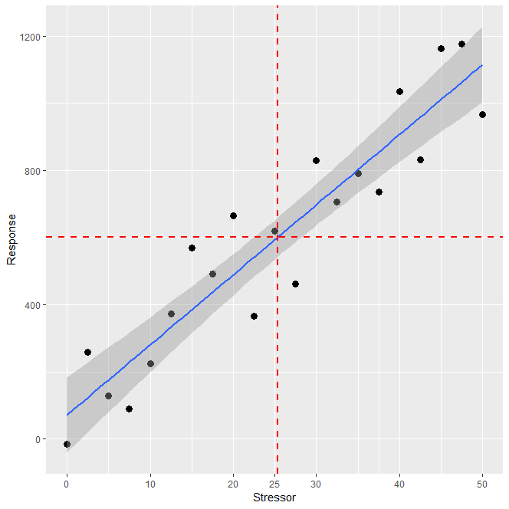

**Note:** The blue line is a regression fitted to the observations (black points). The red dashed lines indicates the stressor target value to achieve a nominated response threshold.

The uncertainty associated with the stressor-response relationship means that when reading off the target to fit a nominated response threshold there will be uncertainty. For example, in figure 2 the (purely nominal) response threshold is 600 and the stressor target is estimated to be 25. However, because the stressor-response relationship is based on a line of best fit, the stressor target indicates the mean response to that level of the stressor. Therefore, our expectation should be that if many locations have a stressor level of 25, only 50% will have a response below 600. In addition, at a stressor level of 25, 50% of locations can be expected to exceed the response threshold.

Figure 2: Estimate of the level of the stressor associated with a response threshold of 600  
(in this case a stressor value of 25)

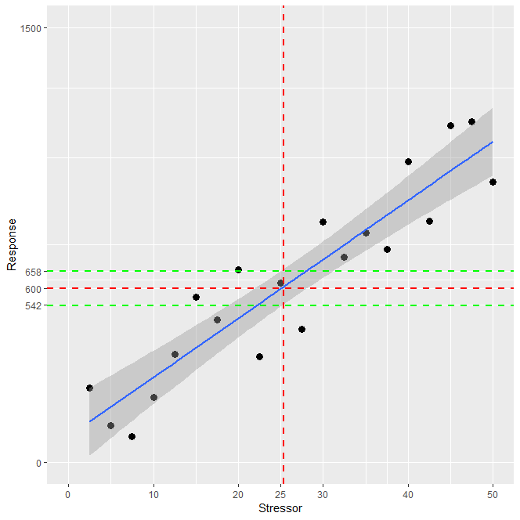

**Note:** The green lines indicate the 95% confidence interval for the mean value of the response associated with a stressor of 25.

When concentration targets are defined, the details of these uncertainties are often not made clear. A subjective decision is made by the developer of the target that the uncertainty is acceptable because the amount by which the 50% of locations that exceed the acceptable response is “small”. However, some stressor – response relationships are less certain than others due to unexplained variation. To illustrate this, another made up example of a more uncertain stressor – response relationship is shown in figure 3. In this case, the response threshold is the same as before (600) and the estimated target is the same as before (25). Half of the cases with a stressor level equal to 25 will have a response greater than the response threshold (as before) but those responses can be expected to deviate to a greater extent from the threshold of 600 (as shown by the green lines in figure 3).

Figure 3: Estimate of the level of the stressor associated with a response threshold of 600 from a stressor-response relationship that is more uncertain than the example shown in figure 2

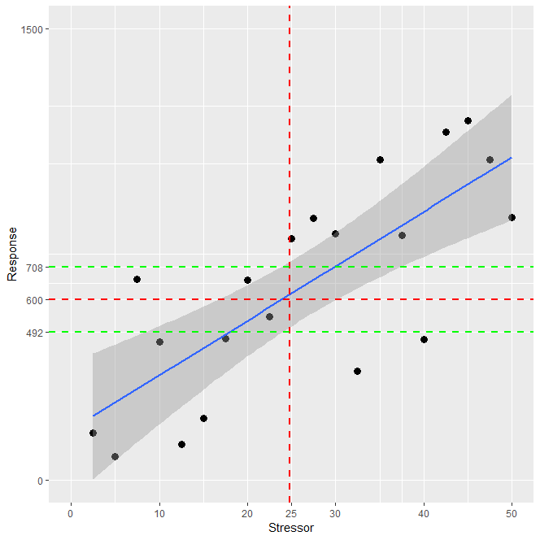

**Note:** The green lines indicate the 95% confidence interval for the mean value of the response associated with a stressor of 25.

Stressor response relationships are generally very uncertain for periphyton (and other biological responses) because the responses are complex and important controlling variables are often unknown and unmeasured. When Snelder *et al.* (2019) derived TN and DRP targets for periphyton, they developed the idea of spatial exceedance criteria as a way of being transparent about, and allowing the user to make choices about, the uncertainty of the concentration targets.

The different spatial exceedance criteria can be thought of as translations of the regression line upwards so that the proportion of sites that exceed the biomass threshold is decreased (figure 4). In the made up example shown in figure 4 the solid red line is the translation of the original regression line upwards so that a smaller proportion of the sites are above the line (eg, 10% or 20% instead of 50%). The new criterion corresponding to a response threshold of 600 and a smaller spatial exceedance criterion is read off from the translated line. This stressor target (15) is obviously more conservative than when the spatial exceedance criteria are not applied. Note that using the original regression line to define the target is effectively employing a 50% spatial exceedance criterion.

Figure 4: Estimate of the level of the stressor associated with a response threshold of 600 when a spatial exceedance criterion is applied to the stressor-response relationship

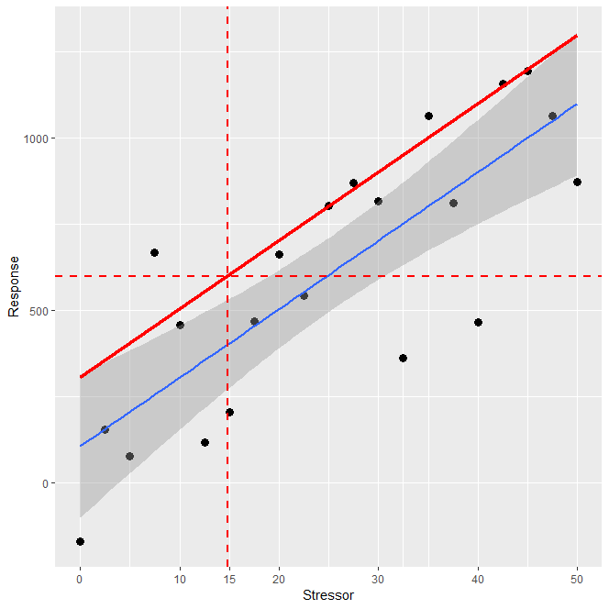

Snelder *et al.* (2019) proposed spatial exceedance criteria as a way of transparently managing the risk of not keeping the response to at or below the threshold when the underlying stressor-response relationship was uncertain. It is noted that even with a spatial exceedance of 10% there is some risk (ie, 10%) that the response at some sites will exceed the threshold. Reducing this risk further would mean increasing the stringency of the target – which obviously has costs that ideally would be weighed against the consequences of some localised exceedances.

A key point is that acceptance of the risk that a target will not always achieve the acceptable level of response (the threshold) is common to most environmental targets but it is often unstated. For example, the toxicity based attribute states in the NPS-FM are based on similar types of statistical analysis. For toxicity, the attribute state is set to protect a proportion of the test species (ie, the threshold), but there is (unstated) uncertainty in the target and the actual proportion of species being protected may be less than the nominated threshold. Another example of risks of non-achievement of attribute states is the TN and TP for lakes. TN and TP are stressors and targets for these are intended to achieve associated in-lake chlorophyll biomass (the response). However, the TN and TP concentration targets are uncertain and, for at least some lakes, the in-lake chlorophyll biomass threshold will exceed the designated attribute states when either TN and TP do not exceed the associated target.

In conclusion, the Snelder *et al.* (2019) nutrient targets are intended to be guidance/starting points for defining nutrient concentrations for managing to the periphyton attribute states. They are not inconsistent with other water quality targets because all targets should be regarded as uncertain. However, the Snelder *et al.* (2019) targets were not intended to be used as attributes for setting objectives; they are targets for biological stressors intended for use in setting risk-based limits to resource use, and are uncertain. If an individual site exceeds the Snelder *et al.* (2019) targets, the correct interpretation is that it has an “unacceptably high risk” of failing to achieve the nominated biological threshold (or objective). Exceeding the target, however, does not mean that the site is exceeding the biological threshold, because the nutrient targets are uncertain and only monitoring of periphyton can confirm the actual biomass. However, in the absence of biological information, the manager would interpret failing the target as evidence that there is an issue and may decide to act accordingly.

## Recalibrated concentration targets

An initial analysis in Snelder *et al.* (2019) suggested that testing data could be used to re‑calibrate the original TN and DRP concentration targets given the test indicated that they were too conservative and too permissive across all REC classes, respectively. Re-calibration involves adjusting the concentration targets so that the proportion of test sites exceeding the biomass threshold matched the spatial exceedance criteria.

To recalibrate the concentration targets, the original concentration targets for each REC Source of Flow class are interpolated from the observed to obtain the TN and DRP concentrations at which the proportion of sites exceeding the biomass threshold is consistent with the designated spatial exceedance (ie, 10, 20, 30 and 50). The results of the re‑calibrations are show in tables 1 and 2.

Note that re‑calibrated TN concentration targets were used in the analysis of the impact of existing NPS-FM periphyton attribute bottom-lines and dissolved inorganic nitrogen bottom‑lines proposed as part of the Essential Freshwater policy package (Ministry for the Environment, 2019). For more information on how the concentration targets were derived, see the Further Information section.

Table 1: Recalibrated TN concentration targets (mg m-3) to achieve the chlorophyll thresholds of 50, 120 and 200 mg m-2 for spatial exceedance criteria of 10%, 20% and 30%

|  | | 10% Spatial exceedance | | | 20% Spatial exceedance | | | | 30% Spatial exceedance | | |
| --- | --- | --- | --- | --- | --- | --- | --- | --- | --- | --- | --- |
| REC class | T50 | | T120 | T200 | | T50 | T120 | T200 | T50 | T120 | T200 |
| **CXGM** | 74 | | 369 | 899 | | 183 | 883 | 2059 | 555 | 2519 | 5233 |
| **CXM** | 130 | | 651 | 1566 | | 328 | 1554 | 3434 | 1019 | 4252 | 5188 |
| **CXH** | 134 | | 682 | 1625 | | 336 | 1609 | 3532 | 1044 | 4324 | 5346 |
| **CXL** | 96 | | 482 | 1174 | | 233 | 1134 | 2607 | 710 | 3144 | 6040 |
| **CXLk** | 30 | | 146 | 351 | | 68 | 330 | 792 | 195 | 918 | 2171 |
| **CWGM** | 34 | | 169 | 407 | | 77 | 374 | 892 | 214 | 992 | 2337 |
| **CWM** | 38 | | 193 | 455 | | 90 | 437 | 1039 | 262 | 1242 | 2833 |
| **CWH** | 41 | | 208 | 499 | | 101 | 488 | 1154 | 311 | 1428 | 3243 |
| **CWL** | 32 | | 159 | 385 | | 76 | 370 | 874 | 223 | 1045 | 2426 |
| **CWLk** | 20 | | 100 | 243 | | 47 | 227 | 544 | 131 | 617 | 1450 |
| **CDM** | 22 | | 109 | 263 | | 50 | 241 | 578 | 139 | 648 | 1551 |
| **CDH** | 19 | | 97 | 234 | | 44 | 217 | 516 | 124 | 589 | 1394 |
| **CDL** | 20 | | 101 | 244 | | 47 | 229 | 542 | 132 | 633 | 1474 |
| **CDLk** | 17 | | 88 | 209 | | 40 | 192 | 463 | 111 | 521 | 1257 |
| **WXL** | 36 | | 179 | 427 | | 87 | 414 | 1008 | 259 | 1211 | 2792 |
| **WXH** | 39 | | 198 | 475 | | 95 | 462 | 1096 | 287 | 1371 | 3082 |
| **WWH** | 57 | | 288 | 701 | | 144 | 690 | 1645 | 444 | 2064 | 4401 |
| **WWL** | 21 | | 104 | 252 | | 50 | 238 | 576 | 143 | 689 | 1636 |
| **WWLk** | 20 | | 102 | 247 | | 47 | 230 | 551 | 135 | 644 | 1525 |
| **WDL** | 11 | | 53 | 125 | | 24 | 117 | 279 | 68 | 317 | 751 |
| **WDLk** | 24 | | 119 | 283 | | 55 | 272 | 648 | 161 | 761 | 1822 |

Table 2: Recalibrated DRP concentration targets (mg m-3) to achieve the chlorophyll thresholds of 50, 120 and 200 mg m-2 for spatial exceedance criteria of 10%, 20% and 30%

|  |  |  |  |  |  |  |  |  |  |
| --- | --- | --- | --- | --- | --- | --- | --- | --- | --- |
| REC class | 10% Spatial exceedance | | | 20% Spatial exceedance | | | 30% Spatial exceedance | | |
| T50 | T120 | T200 | T50 | T120 | T200 | T50 | T120 | T200 |
| **CXGM** | 0.4 | 13.4 | 54.0 | 1.5 | 55.9 | 160.3 | 104.5 | 300.7 | 366.7 |
| **CXM** | 1.6 | 34.5 | 109.1 | 8.0 | 114.2 | 288.1 | 206.5 | 336.4 | 373.0 |
| **CXH** | 1.4 | 30.6 | 103.9 | 6.8 | 105.0 | 272.3 | 194.8 | 359.3 | 356.1 |
| **CXL** | 0.6 | 16.8 | 65.5 | 2.5 | 68.1 | 185.2 | 117.7 | 311.8 | 374.6 |
| **CXLk** | 0.1 | 1.2 | 9.4 | 0.2 | 5.5 | 41.1 | 21.1 | 169.9 | 298.6 |
| **CWGM** | 0.1 | 2.9 | 17.8 | 0.3 | 14.4 | 68.7 | 30.2 | 227.4 | 315.1 |
| **CWM** | 0.2 | 3.1 | 17.6 | 0.3 | 15.0 | 71.0 | 36.6 | 245.3 | 317.5 |
| **CWH** | 0.2 | 3.1 | 18.0 | 0.3 | 15.2 | 68.6 | 41.0 | 252.0 | 321.8 |
| **CWL** | 0.1 | 1.2 | 8.4 | 0.2 | 5.6 | 38.1 | 20.1 | 159.5 | 272.9 |
| **CWLk** | 0.1 | 0.5 | 4.3 | 0.2 | 1.9 | 21.3 | 9.3 | 104.5 | 265.6 |
| **CDM** | 0.2 | 0.5 | 4.9 | 0.2 | 2.3 | 23.6 | 10.1 | 108.2 | 272.5 |
| **CDH** | 0.1 | 0.4 | 2.6 | 0.2 | 1.2 | 12.7 | 5.5 | 76.0 | 221.3 |
| **CDL** | 0.2 | 0.3 | 2.4 | 0.2 | 1.1 | 11.7 | 6.0 | 76.7 | 220.9 |
| **CDLk** | 0.2 | 0.3 | 2.6 | 0.2 | 1.0 | 12.4 | 5.6 | 72.4 | 212.2 |
| **WXL** | 0.2 | 1.6 | 11.5 | 0.2 | 8.0 | 50.2 | 26.9 | 201.3 | 293.9 |
| **WXH** | 0.2 | 2.8 | 15.8 | 0.3 | 13.9 | 62.1 | 36.6 | 241.9 | 305.8 |
| **WWH** | 0.3 | 5.6 | 27.2 | 0.6 | 26.5 | 96.9 | 60.3 | 287.5 | 343.3 |
| **WWL** | 0.2 | 0.5 | 3.2 | 0.2 | 1.9 | 15.2 | 7.9 | 88.6 | 243.0 |
| **WWLk** | 0.1 | 0.4 | 2.7 | 0.2 | 1.4 | 13.2 | 6.9 | 83.0 | 234.3 |
| **WDL** | 0.1 | 0.1 | 0.4 | 0.1 | 0.2 | 1.4 | 1.1 | 22.9 | 81.5 |
| **WDLk** | 0.2 | 0.4 | 2.9 | 0.2 | 1.3 | 13.9 | 7.0 | 84.3 | 235.1 |

## Limitations and things to be aware of

The nutrient targets above are intended to be guidance/starting points for defining nutrient concentrations for managing to the periphyton attribute states.

If an individual site exceeds the Snelder *et al.* (2019) targets, the correct interpretation is that it has an “unacceptably high risk” of failing to achieve the nominated biological threshold (or objective). Exceeding the target, however, does not mean that the site is exceeding the biological threshold, because the nutrient targets are uncertain and only monitoring of periphyton can confirm the actual biomass. However, in the absence of biological information, the manager would interpret failing the target as evidence that there is an issue and may decide to act accordingly.

### Other ways of managing periphyton

To meet the periphyton bottom-line, regional council may choose to employ any combination of mitigation methods. For example, there is potential to achieve periphyton objectives by stream shading in many waterways. The advantage of using shading to achieve periphyton objectives is sometimes only local because nutrients flow downstream to receiving environments that cannot be shaded. In these circumstances reduction of instream nutrient concentrations is necessary to achieve periphyton objectives in the downstream receiving environments and the overall benefit afforded by shading may be minor or zero.

# **3. Further information**

### Action for healthy waterways and changes to the NPS-FM

* <https://www.mfe.govt.nz/fresh-water/national-policy-statement/about-nps>
* Action for healthy waterways – information about attributes in NPS freshwater management [www.mfe.govt.nz/publications/fresh-water/action-healthy-waterways-information-about-attributes-nps-freshwater](https://www.mfe.govt.nz/publications/fresh-water/action-healthy-waterways-information-about-attributes-nps-freshwater)

### Periphyton spatial exceedance criteria

This approach is based on peer-reviewed, published science and further information can be found in the publications below, as well as the publications in the References section.

* *Action for healthy waterways: Summary of modelling to inform environmental impact assessment of nutrient proposals*. Ministry for the Environment (2020). [www.mfe.govt.nz/publications/fresh-water/summary-of-modelling-inform-environmental-impact-assessment-of-nutrient](https://www.mfe.govt.nz/publications/fresh-water/summary-of-modelling-inform-environmental-impact-assessment-of-nutrient)
* *Nutrient Concentration Targets to Achieve Periphyton Biomass Objectives Incorporating Uncertainties*. Snelder et al. (2019). Journal of the American Water Resources Association.

### How to set nutrient targets in catchments

Guidance on setting nutrient targets including those for downstream receiving environments as required by the 2014 (modified 2017) NPS-FM is available here:

* *A draft technical guide to the Periphyton Attribute Note.* Ministry for the Environment (2018) [www.mfe.govt.nz/sites/default/files/media/Fresh%20water/Periphyton%20note%20draft%20technical%20guidance%20_FINAL.pdf](https://www.mfe.govt.nz/sites/default/files/media/Fresh%20water/Periphyton%20note%20draft%20technical%20guidance%20_FINAL.pdf)

This guidance has useful information that is still relevant regardless of the version of NPS, but will be updated to meet the requirements in the 2020 NPS-FM in due course.

# References

LWP. 2020. Definition of nutrient concentration targets for periphyton objectives including 30% spatial exceedance criteria. Memo to the Ministry for the Environment.. 4th March 2020.

Ministry for the Environment. 2018. A draft technical guide to the Periphyton Attribute Note. Ministry for the Environment.

Ministry for the Environment. 2019. *Essential Freshwater: Impact of existing periphyton and proposed dissolved inorganic nitrogen bottom-lines*. Ministry for the Environment.

Ministry for the Environment. 2020. *Action for healthy waterways: Regulatory Impact Analysis: Part II Detailed Analysis*. Ministry for the Environment.

Ministry for the Environment. 2020. *Action for healthy waterways: Summary of modelling to inform environmental impact assessment of nutrient proposals.* Ministry for the Environment.

Snelder, T. 2018. *Nutrient Concentration Targets to Achieve Periphyton Biomass Objectives Incorporating Uncertainties*. GNS Science Report, Geological and Nuclear Sciences, Wellington, New Zealand.

Snelder, T.H., C. Moore, and C. Kilroy. 2019. Nutrient Concentration Targets to Achieve Periphyton Biomass Objectives Incorporating Uncertainties. JAWRA *Journal of the American Water Resources Association* 55:1443–1463. 10.1111/1752-1688.12794.

# Appendix 1: How do I work out the River Environment Classification class of a particular site?

The River Environment Classification (REC) System groups rivers and parts of river networks that share similar characteristics, including physical and biological. Rivers that share the same class can be treated as similar to one another and different to rivers in other classes. The REC system groups rivers according to several environmental factors that strongly influence or cause the rivers’ physical and ecological characteristics (climate, topography, geology and land cover).

1. To view the REC dataset, go to <https://data.mfe.govt.nz/data/category/fresh-water/>

2. Click on the + symbol for “River Environment Classification New Zealand (2010)”

3. Navigate to your stream or river using the zoom.

4. Click on the stream or river of interest, this will bring up a data table.

5. Look under “Climate”. The codes used are as follows:

|  |  |
| --- | --- |
| Climate category | Notation |
| Warm-Extremely-Wet | WX |
| Warm-Wet | WW |
| Warm-Dry | WD |
| Cool-Extremely-Wet | CX |
| Cool-Wet | CW |
| Cool-Dry | CD |

6. Next, look under “SRC_OF_FLW” (Source-of-Flow). The codes used are:

|  |  |
| --- | --- |
| Source-of-Flow | Notation |
| Glacial-Mountain | GM |
| Mountain | M |
| Hill | H |
| Low-Elevation | L |
| Lake | Lk |
| Spring | Sp |
| Wetland | W |
| Regulated | R |

1. For instructions about looking up REC segment information see Appendix 1.