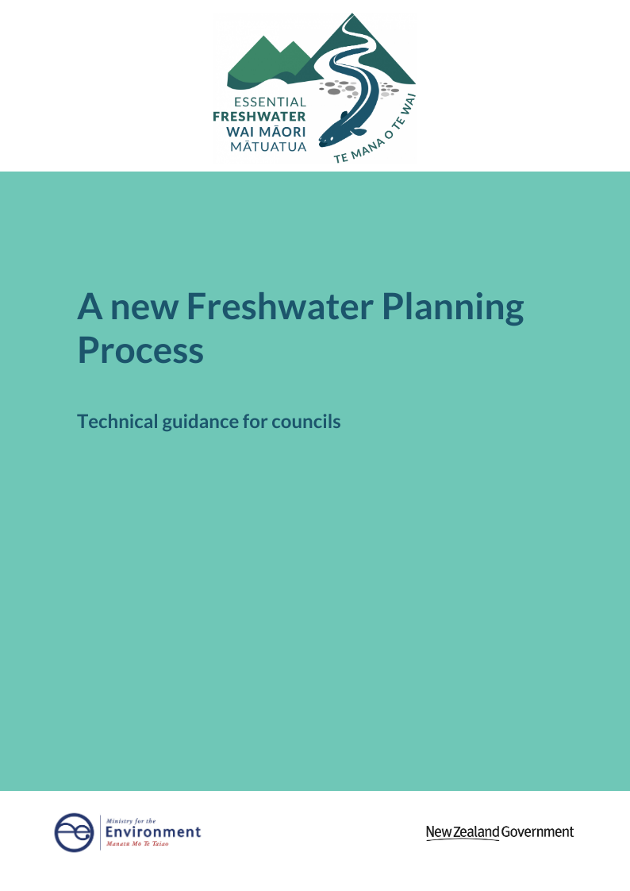mes

**Disclaimer**

The information in this publication is, according to the Ministry for the Environment’s best efforts, accurate at the time of publication. However, users of this publication are advised that:

* the information provided has no official status and does not alter the laws of New Zealand and other official guidelines or requirements
* it does not constitute legal advice, and users should take specific advice from a qualified professional (with expertise in resource management) before undertaking any action as a result of information obtained from this publication
* the Ministry for the Environment does not accept any responsibility or liability whatsoever whether in contract, tort, equity or otherwise, for any action taken as a result of reading, or reliance placed on this publication because of having read, any part, or all, of the information in this publication, or for any error, inadequacy, deficiency, flaw in, or omission from the information provided in this publication
* all references to websites, organisations or people not within the Ministry for the Environment are provided for convenience only and should not be taken as endorsement of those websites or information contained in those websites, nor of the organisations or people referred to.

This document may be cited as: Ministry for the Environment. 2020. ***A new Freshwater Planning Process: Technical guidance for councils***. Wellington: Ministry for the Environment.

Published in September 2020 by the  
Ministry for the Environment   
Manatū Mō Te Taiao  
PO Box 10362, Wellington 6143, New Zealand

ISBN: 978-1-99-003312-4 (online)  
Publication number: ME 1524

© Crown copyright New Zealand 2020

This document is available on the Ministry for the Environment website: [www.mfe.govt.nz](http://www.mfe.govt.nz).



# Contents

Freshwater Planning Process at a glance 5

Part one – introduction 7

Purpose of this guide 7

Background to the 2020 amendments 7

Part two – new roles under the Freshwater Planning Process 8

Chief Freshwater Commissioner 8

Freshwater commissioners 9

Part three – the Freshwater Planning Process 11

Step 1: Pre-notification plan development and consultation 11

Step 2: Notification and pre-hearing stages 13

Step 3: Hearing on freshwater planning instrument 14

Step 4: Freshwater hearings panel provides recommendations 19

Step 5: Regional council considers recommendations and publicly notifies decisions 20

Step 6: Right of appeal 21

Step 7: Approving the freshwater planning instrument and making it operative 22

Requesting an extension to the Freshwater Planning Process timeframes 23

Variations to a freshwater planning instrument 23

Implications for relevant iwi participation legislation, joint management agreement, Mana Whakahono ā Rohe 24

Other process matters for the Freshwater Planning Process 25

Part 1 of Schedule 1 processes that apply to the Freshwater Planning Process 25

The Freshwater Planning Process and other planning processes 26

# Figures

Figure 1: Steps in the Freshwater Planning Process 6

Figure 2: Freshwater Commissioners and Freshwater Hearings Panels 8

Figure 3: Appeal rights under the Freshwater Planning Process 22

# Table

Table 1: Duties and powers of freshwater hearings panels 15

# Freshwater Planning Process at a glance

* The Freshwater Planning Process (FPP) is a new plan-making process that regional councils must follow when preparing, changing, or varying regional policy statements and regional plans that give effect to any national policy statement for freshwater management, or otherwise relate to freshwater (‘freshwater planning instruments’).
* Regional councils must use the FPP for all freshwater planning instruments even if they are not intended to give effect to the National Policy Statement for Freshwater Management 2020 (NPS-FM 2020). If parts of a policy statement or plan relate to freshwater and parts do not, only the freshwater related parts can use the FPP.
* The FPP is overseen by the Chief Freshwater Commissioner, who is supported by highly-skilled freshwater commissioners – all appointed by the Minister for the Environment.
* A FPP starts when the freshwater planning instrument is publicly notified and must be completed within two years.
* If the purpose of the freshwater planning instrument is to give effect to the NPS-FM 2020, it must be publicly notified by no later than 31 December 2024. Extensions can be sought to any part of the process within the 2-year timeframe up to a total of 12 months but changes to the notification date are not possible.
* Shortly after a proposed freshwater planning instrument or change is notified, the Chief will convene a freshwater hearings panel to hear submissions and make recommendations. The freshwater hearings panel will normally be made up of two freshwater commissioners, two council nominees and one tangata whenua nominee.
* The freshwater hearings panel must provide the report and recommendations to the council 40 days before the 2-year decision making timeframe expires. The regional council must make decisions on the freshwater hearing panel’s recommendations within 40 working days of receiving them.
* Appeal rights are limited compared to the standard plan-making process under the RMA. Where a council accepts the panel’s recommendation, a person who submitted on that matter can appeal to the High Court on a point of law. Where a council rejects the panel’s recommendation, a merit appeal is available to the Environment Court by a person whose submission addressed that particular matter.

Figure 1 summarises the main steps of the freshwater planning process and statutory timeframes.

Figure 1: Steps in the Freshwater Planning Process

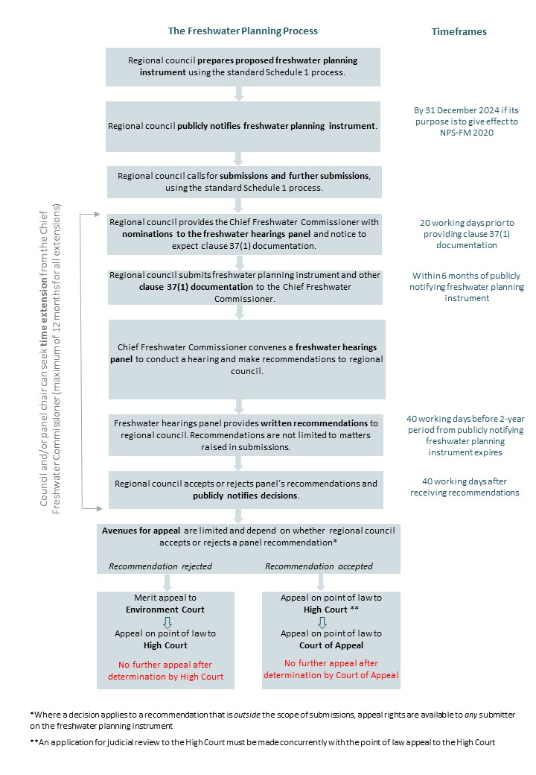

# Part o**ne –** introduction

## Purpose of this guide

The purpose of this guide is to assist regional councils and unitary authorities (‘regional councils’) who are preparing regional policy statements and regional plans (including changes) under the Freshwater Planning Process (FPP). The FPP is set out in section 80A and [Part 4 of Schedule 1](http://www.legislation.govt.nz/act/public/1991/0069/latest/DLM7236566.html) of the Resource Management Act 1991 (RMA).

**Part one** of this guide provides background information, summarises the FPP and sets out which requirements of the standard Part 1 Schedule 1 process still apply.

**Part two** details the new freshwater commissioner and hearing panel roles created for the process.

**Part three** sets out the main steps of the FPP and other process matters.

This guide has been written for a regional council audience. Regional councils are welcome to share this guide with the public, or use information in the guide to develop their own customer information about the FPP. Please note this guide has no legal status and is not a legal interpretation of the RMA.

## Background to the 2020 amendments

To address the declining quality of freshwater, the Government provides national direction on freshwater management through the National Policy Statement for Freshwater Management.[1] The NPS-FM 2020 came into force on 3 September 2020.

In 2017 the Ministry for the Environment reviewed regional councils’ progress in implementing the previous NPS-FM 2014 (amended 2017).[2] The review found that most councils were unable to fully implement the NPS-FM 2014 for up to another decade. There were several reasons identified for this, including that the standard Schedule 1 plan making process would not deliver plan changes in an acceptable timeframe to achieve improved freshwater outcomes.

A new plan-making process, referred to as the Freshwater Planning Process (FPP) was introduced by the [Resource Management Amendment Act 2020](http://www.legislation.govt.nz/act/public/2017/0015/latest/whole.html?search=sw_096be8ed815777da_offsetting_200_se&p=1) (Amendment Act) to support the need for urgent action to improve freshwater outcomes. This process is set out in section 80A and new Part 4 of Schedule 1 of the RMA.[3] The Amendment Act came into force on 1 July 2020.

The FPP will enable the timely implementation of the NPS-FM by imposing a deadline for notifying proposed freshwater planning instruments that give effect to the NPS-FM 2020, retaining a two-year time limit for decision-making, and restricting certain appeals.

# Part two – new roles under the Freshwater Planning Process

New freshwater commissioner roles and freshwater hearings panels have been created to support the FPP – see figure 2.

Figure 2: Freshwater Commissioners and Freshwater Hearings Panels

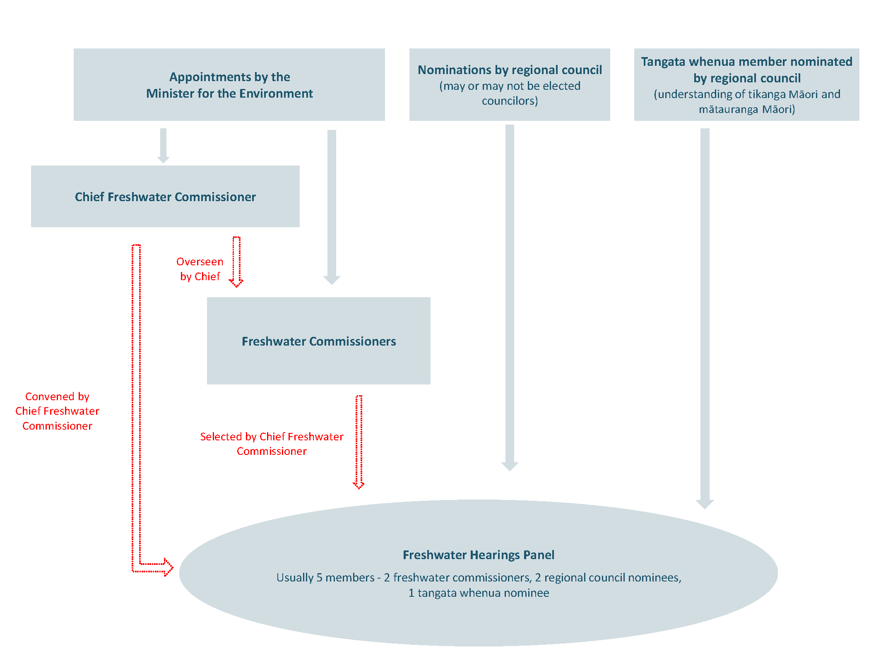

## Chief Freshwater Commissioner

The Chief Freshwater Commissioner[4] (‘Chief’) is appointed by the Minister for the Environment and must be a current or retired Environment Court Judge (Schedule 1, clause 65(3)).

The Chief is tasked with overseeing the scheduling of freshwater hearings, convening each freshwater hearings panel, and managing the group of freshwater commissioners.

The Chief has the following powers and functions:

* deciding when freshwater hearings panels are to be convened (clause 58)
* determining the appropriate size and composition of a freshwater hearings panel (clauses 58, 59)
* considering council and tangata whenua nominations to a freshwater hearings panel (clauses 58, 59)
* appointing members to a freshwater hearings panel, including the chairperson who may be the Chief (clauses 58, 59, 60)
* approving or declining requests from the chair of a freshwater hearings panel or a regional council to extend any part of the two-year freshwater planning process, including approving the request but with a different timeframe (clause 47)
* to direct that a hearings panel be split into two panels to hear a freshwater planning instrument, and to appoint additional chairpersons if required (clause 58)
* to notify, remove and appoint new members to a freshwater hearings panel (clause 62)
* to accept or reject a variation to the freshwater planning instrument made after the council has provided documentation (clause 53).

The Chief will be supported by secretariat services provided by the Government (such as the Ministry for the Environment or Environmental Protection Authority). The Crown is responsible for funding the Chief and support for the role. Regional councils will only be responsible for the costs of the Chief if they are appointed to a specific freshwater hearings panel.

## Freshwater commissioners

The Minister for the Environment will appoint freshwater commissioners[5] (clause 65(1)). The purpose of these appointments is to create a group of highly skilled commissioners who will be placed on specific freshwater hearings panels (in a similar way that the Chief Environment Court Judge appoints Environment Commissioners). This group of freshwater commissioners will be overseen by the Chief Freshwater Commissioner.

### Skills and experience of freshwater commissioners

Freshwater commissioners must be accredited under section 39A of the RMA and collectively they must have knowledge of and expertise in (clause 65(2)):

* judicial processes and cross-examination
* freshwater quality, quantity and ecology
* the RMA
* tikanga Māori and mātauranga Māori.

### Roles and funding of freshwater commissioners

The principal role of freshwater commissioners is to chair and/or otherwise sit on freshwater hearings panels. When convening a freshwater hearings panel, clause 59 requires the Chief to appoint two freshwater commissioners to the panel (or one freshwater commissioner if the panel consists of fewer than five members). The Chief is also required to appoint one of those freshwater commissioners as the chairperson (clause 60(1) and (3)).

From time-to-time, freshwater commissioners may also be called on by the Chief to perform non-hearings related tasks. For example, the Chief may hold induction, scheduling and procedural meetings.

When freshwater commissioners perform tasks as part of or related to their role on a specific freshwater hearings panel, the costs of those commissioners are paid by the relevant regional council. However, when freshwater commissioners perform tasks that are directed by the Chief and are not specific to a freshwater hearings panel, the costs will be met by the Government (clauses 63(1) and 66(2)(c)).

# **Part three – the Freshwater Planning Process**

## Step 1: Pre-notification plan development and consultation

The freshwater planning process[6] does not affect regional councils’ pre-notification requirements under the RMA. The standard Schedule 1 processes will apply until the proposed freshwater planning instrument is notified, submissions and further submissions are called for and documentation is provided to the Chief (clause 37).

### Pre-notification consultation on the proposed freshwater planning instrument and section 32 evaluation report

Before the proposed freshwater planning instrument can be notified, as with Part 1 of Schedule 1 regional councils must consult with:[7]

* the Minister for the Environment
* other Ministers of the Crown who may be affected by the regional policy statement or regional plan
* local authorities who may be affected
* the tangata whenua of the area who may be affected, through iwi authorities
* any customary marine title group in the area.

The regional council can also consult with anyone else during the preparation of a proposed plan.

As required under the standard Schedule 1 process, regional councils must prepare an evaluation report under section 32. This will include a summary of all advice concerning the proposal received from iwi authorities and the response to the advice, including any provisions of the proposal that are intended to give effect to the advice.

### Requirements where the freshwater planning instrument gives effect to the National Policy Statement for Freshwater Management 2020

Regional councils must publicly notify any freshwater planning instruments by 31 December 2024 if the purpose of the instrument is to give effect to the NPS-FM 2020.[8] This is a critical deadline for the FPP which aims to ensure that the NPS-FM 2020 is implemented swiftly to improve freshwater outcomes.

We recommend that regional councils start planning to meet this timeframe as soon as possible. Regional councils should begin to consider where gaps lie in technical information required to implement the NPS-FM 2020 in their regional policy statement and regional plans, for example, to identify baselines and set targets for attribute states. Consideration also needs to be given about how best to engage with tangata whenua, particularly regarding the requirement to give effect to Te Mana o te Wai. Bearing in mind that this must be carried out in a manner that is consistent with obligations under existing iwi participation legislation, Mana Whakahono ā Rohe or joint management agreements, and within the time constraints of the notification deadline.

The Ministry for the Environment (‘the Ministry’) is developing an implementation support package for regional councils, Treaty partners, the primary sector, Environmental Non‑Governmental Organisations, and the wider public to help give effect to the NPS-FM 2020. Contact freshwater@mfe.govt.nz for further information on the implementation programme.

### When will a planning instrument need to use the freshwater planning process?

A ‘freshwater planning instrument’ means a proposed regional policy statement or regional plan (or change or variation) that will give effect to the NPS-FM 2020, or otherwise relates to freshwater (section 80A(2)). This does not include proposed regional coastal plans.[9]

Therefore, when preparing or changing regional policy statements and regional plans, councils will need to consider whether all or part of the proposed provisions must use the FPP. Proposed provisions that do not relate to freshwater cannot be considered using the FPP.

This exercise will be straightforward if the proposed provisions are included in a specific regional freshwater plan, or a plan change that only gives effect to the NPS-FM 2020. In these situations, provisions will go through the FPP.

However, it will be more complicated where proposed provisions are not limited to freshwater and NPS-FM 2020 matters. For example, when changes are proposed across a number of domains (such as freshwater, coast, air, urban etc) during the review of a regional policy statement, or development or review of a combined planning document (such as a combined regional policy statement and regional plan, or unitary plan). In these situations, a regional council will need to identify which provisions will go through FPP and which provisions will go through the standard Schedule 1 process. Councils are required to provide reasons for which parts will undergo the FPP and which parts will not in the public notice, and reasons could be discussed in the relevant section 32 report. Refer to Step 2: Notification and pre-hearing stages for more information on what is required in the public notice.

Contact freshwater@mfe.govt.nz for further information on the freshwater planning process.

#### Separate hearing panels needed for Freshwater Planning Process and another Schedule 1 plan-making process

Regional councils will need to use two separate hearings processes where the council determines that only some of the proposed planning instrument provisions implement the NPS-FM 2020 or are otherwise freshwater related. Non-freshwater provisions will need to use another Schedule 1 process. To maintain consistency across these separate hearings, councils could consider the following:

* utilising one or more hearing members for both hearing panels (eg, the regional council and tangata whenua nominated members of the freshwater hearings panel)
* hold both hearings concurrently if timetabling can accommodate
* sequencing the hearings so that the provisions of the planning instrument that drive/guide content of the other provisions are heard first (eg, giving effect to Te Mana o te Wai may act as a driver for other plan provisions).

### Freshwater Planning Process must be consistent with obligations to Treaty partners

Regional councils will need to consider if the FPP will impact any iwi participation legislation, joint management agreement or Mana Whakahono ā Rohe that are relevant[10] to iwi participation in the RMA plan-making process. The FPP must be consistent with any obligations set out in these documents, so the nature of these obligations must be well understood as regional councils begin to plan for the process.

Considerations will not be limited to obligations under the RMA and NPS-FM 2020 to engage with iwi through the development of regional policy statement/regional plan content, but also the size and composition of the freshwater hearings panel and the decision-making arrangements for approving the final regional policy statement/regional plan or changes. Refer to ‘Implications for any relevant iwi participation legislation, joint management agreement or Mana Whakahono ā Rohe’ for further information.

## Step 2: Notification and pre-hearing stages

### Notification and submissions

Once a freshwater planning instrument is prepared, it must be publicly notified.[11] Public notification occurs in the same way as the Part 1 Schedule 1 plan-making process, but the public notice must also state (clause 5(2A)):

* whether all of part of the instrument is subject to the FPP
* if applicable, state which part will undergo the FPP and which part will undergo the standard Part 1 process, with reasons why*.*

Form 4A of the Resource Management (Forms, Fees, and Procedure) Regulations 2003 provides the template form: ‘Public notice for freshwater planning instruments under the Freshwater Planning Process’.

While rules in a proposed plan will generally not have any legal effect until after decisions on submissions have been made, rules in a freshwater planning instrument will have immediate legal effect on notification if they protect or relate to water (section 86B(3)(a)).

Under the FPP, regional councils will administer the submission and further submission stages as they would under the standard plan-making process.

### Council to provide documentation to the Chief

Within **six months** of notifying the freshwater planning instrument, regional councils must provide the following documentation to the Chief Freshwater Commissioner (section 80A(4)(c) and clause 37(1)):

* the freshwater planning instrument that was publicly notified
* any variation made to the freshwater planning instrument
* the section 32 evaluation report
* submissions and further submissions received, including a summary of the decisions requested by submitters
* late submissions, including information on when these were received
* any planning documents recognised by an iwi authority and lodged with the regional council
* documentation relevant to any obligations arising under relevant iwi participation legislation, joint management agreements, or Mana Whakahono ā Rohe
* any other relevant information.

Regional councils must give the Chief at least **20 working days’ notice** of when they intend to provide this documentation (section 80A(4)(c) and clause 37(2)). However, it is anticipated that the Chief will be in regular contact with regional councils about their work programme to ensure that hearings can be scheduled promptly and appropriately resourced.

Regional councils must also provide nominations to the freshwater hearings panel from the council and tangata whenua at the same time (further information on nominees is provided in ‘Freshwater Hearings Panels’). Councils should contact tangata whenua about providing a nominee to freshwater hearings panels during the development of freshwater planning instruments.

### Regional councils can request an extension to the timeframe for providing documentation

There may be situations where a regional council requires longer than six months to provide some of the clause 37 documentation. For example, when a proposed freshwater planning instrument receives a large number of submissions that cannot be summarised in time. We recommend that the council raises this with the Chief as soon as possible. A regional council may seek an extension of timeframes under clause 47 if appropriate. Refer to Requesting an extension to the timeframes for further information.

## Step 3: Hearing on freshwater planning instrument

The Chief must convene a freshwater hearings panel as soon as practicable after receiving the clause 37(1) documentation (clause 38). The chief will discuss the scheduling of upcoming freshwater planning instruments with councils to ensure a panel can be convened promptly.

The freshwater hearings panel will conduct the hearing of submissions on a freshwater planning instrument and make recommendations on submissions and proposed provisions to the relevant regional council.

### Freshwater hearings panels

A freshwater hearings panel[12] is independent from the regional council. The Chief will determine the appropriate size and composition of each freshwater hearings panel, and convenes the panel.

#### Functions of freshwater hearings panels

The functions of freshwater hearings panels are to (clause 39):

* conduct a hearing of submissions on a freshwater planning instrument
* make recommendations to the relevant regional council or unitary authority after the hearing of submissions has concluded
* hear any objections relating to a decision to strike out a submission.

Freshwater hearings panels have enhanced powers in comparison to hearings panels under the standard plan-making process. This is necessary to robustly test the freshwater planning instrument and submitter information because appeal rights are constrained to certain circumstances under the FPP. A summary of freshwater hearings panel duties and powers is provided in table 1.

Table 1: Duties and powers of freshwater hearings panels

|  |  |
| --- | --- |
| Standard duties and powers (also applicable to freshwater hearings panels) | Additional duties and powers that apply to Freshwater hearings panels specifically |
| * hearings to be public and without unnecessary formality (section 39, except restrictions on cross-examination) * limit number of parties with the same interest to speak or call evidence (section 40) * exercise powers under the Commissions of Inquiry Act 1908 (section 41, eg, power to maintain order and summon witnesses) * direct applicants to provide briefs of evidence before the hearing (section 41B) * direct order of business, take evidence and submissions as read, and limit speaking time (section 41C) * request further information (section 41C) * strike out a submission (section 41D) * protect sensitive information (section 42) * commission hearings reports (section 42A). | * permit, regulate or prohibit cross examination (clause 48(2)) * convene pre-hearing meetings (clause 41) * direct a conference of experts (clause 43) * refer submitters to alternative dispute resolution, such as mediation (clause 44) * commission reports (clause 45) * appoint a special advisor(s) (clause 46) * appoint a friend of the submitter (clause 46) * accept or reject any late submissions (clause 40(3)) * recommend to the relevant regional council that a variation be made to a freshwater planning instrument (clause 40(4)). |

Freshwater hearings panels are required to regulate their proceedings in a manner that is appropriate and fair in the circumstances, and keep a full record of proceedings (clause 48).

#### Size and composition of a freshwater hearings panel

Under most circumstances a freshwater hearings panel will consist of five members as follows (clause 59):

* two freshwater commissioners
* two members who are nominated by the relevant council, who may be elected councillors
* one member with an understanding of tikanga Māori and mātauranga Māori who is nominated by tangata whenua. If no nomination is received, the Chief will appoint an accredited person to this role.

However, there may be circumstances in which more panel members are necessary. For example, the FPP does not alter any existing obligations on hearings panel membership/representation that arise from iwi participation legislation, joint management agreements, or Mana Whakahono ā Rohe. Clause 59(5) requires the Chief to convene each freshwater hearings panel in a manner consistent with these obligations, which could potentially require a larger panel (refer to ‘Implications for any relevant iwi participation legislation, joint management agreement or Mana Whakahono ā Rohe’ for further information).

In addition, clause 59(2)(a) enables a panel to have more than five members if the Chief considers there are “special circumstances” in the region. We recommend that as soon as possible in the process, regional councils consider whether more than five panel members would be appropriate. While “special circumstances” is not defined in relation to clause 58(2)(a) the following may be relevant:

* the complexity of the freshwater planning instrument
* the number of catchments in the region and differences between them
* the number of different iwi/hapū in the region
* the range of freshwater interests in the region.

A panel of fewer than five members (but no less than three) may be convened if the Chief considers that the scale and complexity of the freshwater planning instrument does not warrant five members.

If a regional council considers that there is good reason to have more, or less than the default of five members, it should provide this information to the Chief as soon as possible in the process, and at least at the time of providing nominations to the freshwater hearings panel under clause 37(2).

#### Tangata whenua freshwater hearings panel nominations

Clause 37(2)(b) requires a regional council to provide the Chief with a nomination made by tangata whenua for one person with an understanding of tikanga Māori and mātauranga Māori to sit on a freshwater hearings panel. It is intended that regional councils will use their established iwi engagement channels to request a nominee and pass this information to the Chief.

If no nomination is received, clause 59(1)(c)(ii) enables the Chief to appoint an accredited person with an understanding of tikanga Maori and Mātuaranga Māori of his/her own choosing. The RMA does not specify the process if tangata whenua submit more than one nomination to a regional council. In this situation, a regional council would be obliged to forward all nominations to the Chief for his/her consideration. As noted above, there may be situations where the Chief considers it appropriate to convene a larger panel with more tangata whenua nominees.

#### Skills and experience of members on a freshwater hearings panel

Panel members must be accredited under section 39A of the RMA unless the Chief is satisfied there are “special circumstances” (clause 59(7)). In practice, this means that panel members must normally be accredited under the Making Good Decisions programme. What amounts to “special circumstances” is not defined, but it is anticipated this could apply to people with specialist technical skills, such as those with mātauranga Māori expertise, hydrologists and other scientists.

In appointing members to a freshwater hearings panel, the Chief Freshwater Commissioner will consider the need for the panel to collectively have knowledge of and expertise across the following areas (clause 59(6)):

* judicial processes and cross-examining witnesses
* freshwater quality, quantity and ecology
* the RMA
* tikanga Māori and mātauranga Māori
* Te Mana o te Wai
* water use in the local community
* subject areas likely to be relevant to the work of the panel.

#### Regional councils are responsible for costs of freshwater hearings panels

Regional councils are responsible for all costs associated with freshwater hearings panels, in the same way they are responsible for hearing costs under the standard plan-making process (clause 63). Costs include:

* remuneration and expenses of freshwater hearings panel members
* administrative costs of each hearing session, including venue hire and public notices
* remuneration of any expert, mediator or other dispute resolution facilitator, or other person whose services are engaged by the panel as part of this process
* allowances payable to any witness called by the panel
* costs of any special advisor or friend of a submitter appointed by the panel
* administrative and secretarial support services to the panel as required.

A regional council will be required to pay costs for the freshwater hearings panel from the date members are appointed to the panel. The fees for members’ time are set by the Minister for the Environment and will apply to all members on a panel except accredited councillors. Regional councils will continue to have control over the fees payable to any accredited councillors on a freshwater hearings panel.

### The role of regional councils during the hearing process

Under the FPP regional councils can perform a number of roles during the hearing process, including:

* attending pre-hearing meetings, which may be convened by the panel chair to clarify or facilitate the resolution of a matter or issue, or to address administrative or procedural matters (clause 41(2)(b))
* producing a section 42A hearings report at the request of the panel (clause 42(5))
* attending hearings to assist the panel by clarifying/discussing matters in the freshwater planning instrument, giving evidence, speaking to submissions or addressing issues raised by them, providing relevant information requested by the panel (clause 42(1))[13]
* attending a conference of experts and/or participating in mediation or other alternative dispute resolution (clauses 43 and 44).

Regional councils are responsible for providing administrative and secretarial support services to the panel as required (clause 63(3)(f)). Regional councils are also responsible for:

* making reports commissioned by the panel available for inspection on the relevant regional council’s internet site and at its offices (clause 45(4)(b))
* publicly notifying the freshwater hearings panel’s recommendations report, the council’s decision on the recommendations, and where the report and decisions may be viewed or accessed (clause 52(8)).

### Consider whether a Friend of Submitter role would be beneficial

Clause 46(3) enables the chair of a freshwater hearings panel to appoint a ‘friend of submitter’ to support submitters during the hearing process. However, the chair is required to consult with the relevant council before making an appointment. The intent of the friend of submitter role is to provide assistance to submitters on the hearing process because of the more formal nature of a freshwater hearing (such as the ability for cross examination) and potential complexities where some parts of a proposed regional policy statement or regional plan are being addressed through the FPP and others through the standard Schedule 1 process.

If a regional council considers that a friend of submitter role would be beneficial to support its communities, we recommend this is raised with the chair as soon as possible (or even with the Chief if the need is anticipated prior to convening a freshwater hearings panel). The council could also assist the chair by identifying a person who would be suitable to fulfil the role.

## Step 4: Freshwater hearings panel provides recommendations

The freshwater hearings panel is required to make recommendations on the freshwater planning instrument in one or more reports (clause 49(3)).

### Recommendation report contents

Unlike the standard Schedule 1 process, the panel is not limited to making recommendations within the scope of matters raised in submissions. The panel can make recommendations on any matters relating to the freshwater planning instrument identified by the panel or any other person during the hearing.

Each report must include:

* the panel’s recommendations on the provisions of the freshwater planning instrument, identifying any recommendations that are outside the scope of submissions
* the panel’s recommendations on the provisions and matters raised in submissions
* the panel’s reasons for accepting or rejecting submissions (these may relate to groups of submissions)
* a further evaluation in accordance with section 32AA of the RMA (clause 50(b)).

The panel’s written report(s) may also include matters relating to any consequential alterations arising from submissions, and any other matter that the panel considers relevant to the freshwater planning instrument that arises from submissions.

### Matters to consider when making recommendations

In formulating recommendations under clause 50, the freshwater hearings panel must (in summary only):

1. **have regard to:**

* hearing reports (section 42A)
* pre-hearing meeting report (clause 41)
* conference of expert report (clause 43)
* reports commissioned by the hearings panel (clause 45)
* any advice or other assistance produced by a special advisor appointed under clause 46
* any other technical or other reports commissioned by the panel.

1. **take into account** any outcomes reported from alternative dispute resolution under clause 44
2. **include a further evaluation of the freshwater planning instrument under section 32AA**
3. **be sure** that the recommendations, if accepted by the regional council, where relevant would comply with:

* national environmental standards (section 43B)
* all regional policy statement and regional plan requirements (sections 59-68)
* requirements for rules relating to water quality (section 69), rules about discharges (section 70), and discharge of greenhouse gases (sections 70A and 70B)
* protected customary rights (sections 85A and 85B(2))
* any other provision of any enactment, including the RMA, that applies to the council’s preparation of the freshwater planning instrument.

A freshwater hearings panel must provide written recommendations to the relevant council on the freshwater planning instrument, no later than 40 working days before the two year period from publicly notifying the proposed instrument expires (clause 51).

### Freshwater hearings panels can request an extension to the recommendations report timeframe

As a freshwater hearing progresses, it may be become evident to the panel that the time required to hear submitters or to deliberate on the evidence and prepare recommendations will exceed the required timeframe. Clause 47 provides the ability for the chair of a freshwater hearings panel to seek an extension from the Chief for providing its recommendations report. Refer to Requesting an extension to the timeframes for further information.

## Step 5: Regional council considers recommendations and publicly notifies decisions

A regional council has 40 working days to consider the recommendations of the freshwater hearings panel and publicly notify its decisions on them (clause 52). The council must also notify the availability of the recommendations report at the same time.

In considering the report, a regional council must decide whether to accept or reject each recommendation.

For every recommendation it rejects, the council must decide an alternative solution. Where the regional council proposes an alternative solution, it must provide an assessment of each alternative solution in the further evaluation report required under section 32AA. Where it rejects a recommendation that is outside the scope of submissions, the alternative solution it provides may also be outside the scope of submissions.

When making its decisions, the regional council:

* is not required to consult any person or consider submissions or other evidence from any persons
* must not consider any submissions or other evidence unless it was made available to the freshwater hearings panel before the panel made its recommendations
* must make decisions in a manner that is consistent with any relevant requirements of any iwi participation legislation, joint management agreement or Mana Whakahono ā Rohe.

### Regional councils can request an extension to the 40 working day timeframe to notify decisions

There may be situations where a regional council foresees it will require longer than 40 working days to make decisions. For example, if the freshwater hearings panel has indicated that it will make a number of recommendations that are outside the scope of submissions, or through the hearing the council becomes aware of possible recommendations that it would like to investigate in more detail. If a regional council anticipates that it will require longer to make a decision, it should raise this as soon as possible with the Chief, who will consider whether to grant an extension under clause 47. Total extensions granted by the Chief cannot exceed 12 months. Refer to Requesting an extension to the timeframes for further information.

### Notifying decisions

Regional councils are required to publicly notify decisions within the same 40 working day timeframe (clause 52(5)-(8)). On notification, the freshwater planning instrument will be considered amended in accordance with the decisions.

Regional councils must also publicly notify the availability of the freshwater hearings panels’ report(s) and where the report and decisions can be viewed or accessed.

## Step 6: Right of appeal

The right of appeal is restricted to certain circumstances under FPP compared to the standard plan-making process (clauses 54-56). Figure 3 illustrates the avenues for appeal and judicial review.

Avenues for appeal depend on whether the regional council accepts or rejects the panel’s recommendation. Where a regional council *accepts a recommendation*, an appeal is available to the High Court on a point of law only, and a further appeal to the Court of Appeal (subject to leave being granted). There is no avenue of appeal to the Supreme Court (clause 54(2)).

Where a council *rejects the panel’s recommendation*, a merit appeal is available to the Environment Court, and a further appeal on a point of law to the High Court. There is no avenue of appeal to the Court of Appeal (clause 55(4)(a)) or the Supreme Court (clause 54(2)).

Appeals are available to people who made a submission or further submission on the freshwater planning instrument:

* where a panel makes a recommendation that is *within* the scope of submissions, appeals related to a decision on that recommendation are open to a person *who addressed that provision or matter in his/her submission*
* where a panel makes a recommendation that is *outside* the scope of submissions, appeals related to a decision on that recommendation are open to *any person who made a submission* on the freshwater planning instrument.

Judicial review remains available (clause 57). However, if a person wishes to apply for both a judicial review and make an appeal to the High Court on a point of law, these must be lodged at the same time.

Refer to Form 7 of the Resource Management (Forms, Fees, and Procedure) Regulations 2003 for the relevant information to provide when lodging an appeal.

Figure 3: Appeal rights under the Freshwater Planning Process

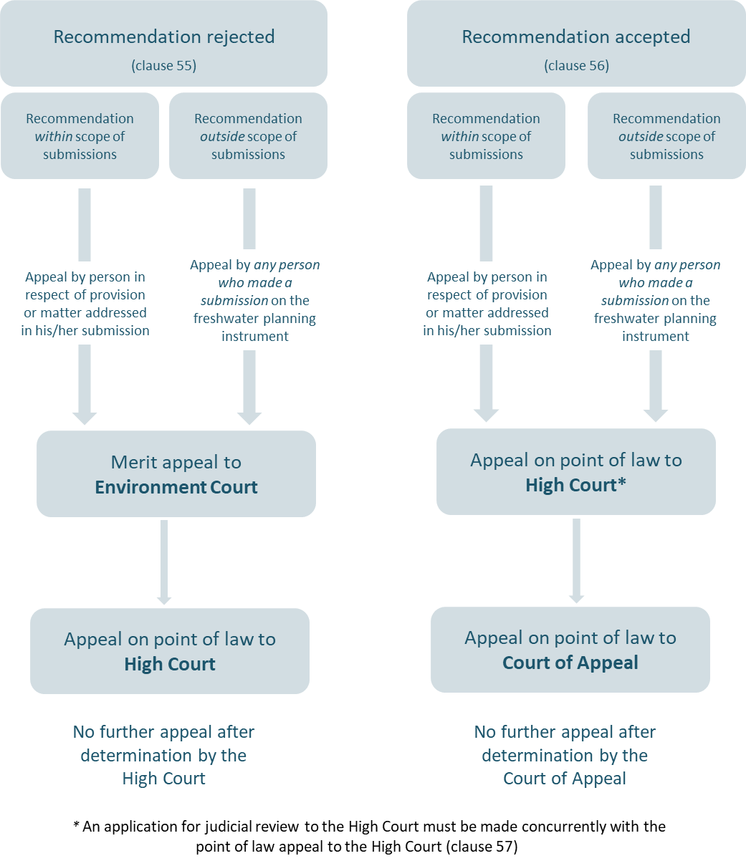

## Step 7: Approving the freshwater planning instrument and making it operative

The standard Schedule 1 processes prescribed by clauses 17 and 20 apply to approving the freshwater planning instrument and making it operative. The FPP does not affect any dual decision-making roles that exist between the relevant council and iwi under any iwi participation legislation, joint management agreement, or Mana Whakahono ā Rohe (refer to ‘Implications for any relevant iwi participation legislation, joint management agreement or Mana Whakahono ā Rohe’ for further information).

As with the standard plan-making process, a regional council may approve part of a freshwater planning instrument if all submissions or appeals relating to that part have been disposed of (clause 17).

An approved freshwater planning instrument becomes operative on a date which is to be publicly notified at least five working days before it becomes operative (clause 20).

## Requesting an extension to the Freshwater Planning Process timeframes

The chair of a freshwater hearings panel and/or the relevant council can seek an extension from the Chief to the two-year planning timeframe (clause 47). Extensions can be sought for the following timeframes:

* the requirement to provide documentation to the Chief within six months of notification (clause 37)
* provision of the report under section 42A (clause 40)
* the time by which the panel must provide its recommendation (clause 51)
* the requirement for councils to make decisions no later than 40 working days after it is provided with the panel’s recommendations report (clause 52).

An extension cannot be granted to the deadline of 31 December 2024 for notifying a freshwater planning instrument that gives effect to the NPS-FM 2020.

More than one extension can be sought for the same freshwater planning instrument, but the total additional time of all extensions cannot exceed **12 months**.

In seeking an extension, the council and/or chair of the freshwater hearings panel must specify the new timeframe, why additional time is required, and how the new timeframe will be met.

When considering a timeframe extension, the Chief Freshwater Commissioner may decline the request, partially accept the request (accept the extension but impose a different timeframe), or accept the request in full (accept the extension with the timeframe as requested).

**Note:** The regional council’s discretion to extend or waive timeframes under section 37(1)(a) of the RMA does not apply to the FPP.[14]

## Variations to a freshwater planning instrument

Regional councils are still able to make a variation to a proposed freshwater planning instrument in line with the standard plan-making process (clauses 16A and 16B). However, the process for undertaking a variation to a freshwater planning instrument differs depending on the stage at which the need for a variation arises.

If a regional council wishes to initiate a variation to the freshwater planning instrument *after* it has provided the clause 37(1) documentation to the Chief, the council must seek approval for the variation from the Chief (clause 53). This is to manage the risk of variations delaying the implementation of the NPS-FM 2020 by 31 December 2026.

To seek approval for a variation, the regional council must notify the Chief in writing of the need for the variation and provide any additional information requested by the Chief to assist him/her in determining whether to accept or reject the variation.

In determining whether to accept or reject a variation, the Chief will consult with the relevant freshwater hearings panel and must consider the following matters:

* whether the variation is needed to correct a significant defect in the freshwater planning instrument
* whether the variation is needed for the effective functioning of the freshwater planning instrument
* the impact of accepting the variation on the decision date of the freshwater planning instrument.

A freshwater hearings panel can also recommend to a regional council that it undertakes a variation (clause 40(4)). If the council agrees to seek a variation, the above process applies.

The Chief’s approval is not required for variations to freshwater planning instruments that are proposed prior to the regional council providing clause 37(1) documentation to the Chief. In this situation, the council must insert the variation into the freshwater planning instrument before providing the documentation.

## Implications for relevant iwi participation legislation, joint management agreement, Mana Whakahono ā Rohe

The FPP must be consistent with obligations under relevant iwi participation legislation, joint management agreement, or Mana Whakahono ā Rohe. The RMA defines these terms in [section 58L](http://www.legislation.govt.nz/act/public/1991/0069/latest/DLM7236239.html). Iwi participation legislation means legislation (other than the RMA) providing a role for iwi and hapū in processes under the RMA, and includes any legislation listed in [Schedule 3 of the Treaty of Waitangi Act, 1975](http://www.legislation.govt.nz/act/public/1975/0114/latest/whole.html#DLM1347539).

The statutory and policy basis for each regional council’s arrangement for working with iwi is unique to that local authority and iwi. Regional councils must identify all the relevant iwi participation legislation or agreements in place, how they relate to participation in RMA plan‑making processes, and how they may be affected by the FPP.

We recommend that regional councils, together with iwi, consider the implications for any iwi participation legislation, joint management agreement, or Mana Whakahono ā Rohe for three main stages of the FPP:

* preparing the freshwater planning instrument
* determining membership on a freshwater hearings panel – for example, are there any obligations on the size or composition of a hearing panel?
* decision-making on the freshwater planning instrument – for example, are there any obligations for joint council-iwi decision making?

### Documentation to be provided to the Chief Freshwater Commissioner

Regional councils must provide all documentation relevant to any obligations arising under any (clause 37(1)):

* iwi participation legislation
* joint management agreement
* Mana Whakahono ā Rohe.

This information will be important for determining an appropriate freshwater hearings panel. Under clause 59(5), the Chief is required to convene each panel in a manner consistent with any relevant iwi participation legislation, Mana Whakahono ā Rohe, or joint management agreement. While panels will normally have five members (two freshwater commissioners, two council nominated members, and one tangata whenua nominated member), the Chief can increase the size of a panel in special circumstances (clause 59(2)), which may include the need to meet obligations under these documents (refer to ‘Size and composition of a freshwater hearings panel’ for further information).

## Other process matters for the Freshwater Planning Process

This section provides information on other process matters for FPP as follows:

* Schedule 1 processes that apply to FPP
* withdrawing a freshwater planning instrument
* calling in a freshwater planning instrument
* FPP and private plan changes
* FPP and the Streamlined Planning Process
* transitional provisions.

### **Part 1 of Schedule 1 processes that apply to the Freshwater Planning Process**

Regional councils are still required to comply with many processes in Part 1, Schedule 1 when using the FPP. The relevant provisions of Part 1 and 2, Schedule 1 are set out in section 80A(6) and identified where relevant in the above guidance:

1. time limits – clause 1(3)
2. pre-notification preparation and consultation – clauses 1A, 1B, 2(1), 3-3C and 4A
3. notification – clause 5
4. submissions and further submissions – clauses 6, 7(1), 7(2), 8 and 8(A)
5. withdrawal of proposed policy statements and plans – clause 8D
6. amendments to proposed freshwater planning instrument – clauses 16
7. variations to proposed freshwater planning instrument – clauses 16A and 16B (subject to approval by the Chief under clause 53 after planning documentation delivered to the Chief)
8. final consideration of freshwater planning instrument and operative date – clauses 17 and 20
9. correcting minor errors to operative freshwater planning instruments – clause 20A
10. for private plan change requests to a freshwater planning instrument – Part 2 of Schedule 1 applies.

**Note:** The remainder of Part 1 does not apply, unless it is expressly applied by subpart 4 of Part 5 (Section 80A) or Part 4 of Schedule 1 of the RMA.

### Withdrawing a freshwater planning instrument

A regional council can withdraw a freshwater planning instrument using the standard process contained in Schedule 1, clause 8D. A regional council can withdraw the instrument at any time if an appeal has not been made (or the appeal has been withdrawn), or an appeal has been made but the court hearing has not commenced.

The regional council must give public notice of the withdrawal, including reasons for the withdrawal.

## The Freshwater Planning Process and other planning processes

### Calling-in a freshwater planning instrument

The Minister for the Environment may still call-in a freshwater planning instrument as a proposal of national significance under section 142 (see section 80A(7)).

### Freshwater Planning Process and the Streamlined Planning Process

The Streamlined Planning Process is not available for freshwater planning instruments or freshwater related parts of planning instruments (section 80C(2)).

However, where a planning instrument contains non-freshwater related provisions, a regional council may apply for a direction for a streamlined planning process for those aspects.

### Freshwater Planning Process and private plan changes

Parties may still seek a private plan change for freshwater planning instruments (section 80A(6)(c)).

If a regional council receives a request to change provisions that are relevant to a freshwater planning instrument before the council has given effect to the NPS-FM 2020, the council should consider whether the private plan change is premature or may otherwise undermine the development of the freshwater planning instrument.

1. The National Policy Statement for Freshwater Management was first produced in 2011 and amended in 2014 and 2017. The latest version is the NPS-FM 2020.
2. Ministry for the Environment. 2017. National Policy Statement for Freshwater Management Implementation Review: National Themes Report. Wellington: Ministry for the Environment.
3. As well as new clause 5(2A) in Schedule 1 and new and amended definitions in section 2(1) of the RMA.
4. “**Chief Freshwater Commissioner** means the Chief Freshwater Commissioner appointed under clause 65(3) of Schedule 1” (section 2(1)).
5. “**Freshwater commissioner** means a person appointed by the Minister under clause 62 of Schedule 1” (section 2(1)).
6. “**Freshwater planning process** means the process set out in subpart 4 of Part 5 (section 80A) and Part 4 of Schedule 1” (section 2(1))
7. Section 80A of the RMA indicates that pre-notification processes under Schedule 1, clause 3.
8. Section 80A(4)(b).
9. Note the section 2(1) definition of “fresh water” specifically excludes coastal water.
10. “Relevant” here means applicable to the iwi of the area, to the planning matters involved and to the freshwater planning instrument being proposed.
11. Section 80A(4) RMA.
12. “**Freshwater hearings panel** means a panel convened under clause 38 of Schedule 1” (section 2(1)).
13. Note a regional council may be excused by the panel from attending or remaining at the hearing (clause 42(2)).
14. Resource Management Act 1991, section 80A(9).