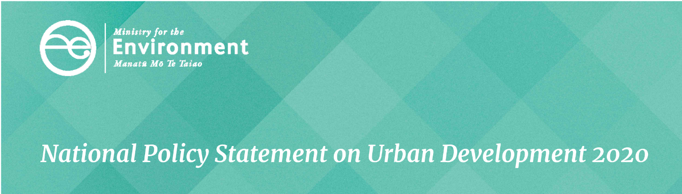

Well-functioning urban environments
This is one of a series of seven factsheets that give an overview of the National Policy Statement on Urban Development (NPS-UD). This fact sheet provides information on objective 1 and policy 1.
These provisions come into force on commencement of the NPS-UD.

Purpose
The purpose is to establish a non-exhaustive list of important and nationally consistent matters that contribute to good urban outcomes, but do not consistently receive adequate consideration in planning practice. Emphasising these factors in planning and decision-making will help ensure our cities work for the benefit of all people, communities and future generations, enabling access to opportunities and thereby maximising social benefits and minimising social costs.

Requirements
Policy 1 on well-functioning urban environments articulates a set of outcomes for local authorities to use when preparing plans and making decisions, and sets direction for the intended outcomes of the NPS-UD. Policy 1 is reproduced below:
Policy 1: Planning decisions contribute to well-functioning urban environments, which are urban environments that, as a minimum:
- have or enable a variety of homes that:
i. meet the needs, in terms of type, price and location of different households; and
ii. enable Māori to express their cultural traditions and norms; and
- have or enable a variety of sites that are suitable for different business sectors in terms of location and site size; and
- have good accessibility for all people between housing, jobs, community services, natural spaces, and open spaces, including by way of public or active transport; and
- support, and limit as much as possible adverse impacts on, the competitive operation of land and development markets; and
- support reductions in greenhouse gas emissions; and
- are resilient to the likely current and future effects of climate change.
Local authorities should be able to demonstrate how their plans, resource consents and other Resource Management Act 1991 (RMA) decisions contribute to the outcomes outlined in policy 1, and should be proactive in removing barriers that create social costs or limit social benefits.

What has changed from the National Policy Statement on Urban Development Capacity?
The National Policy Statement on Urban Development Capacity 2016 (NPS-UDC) contained direction on ‘effective and efficient’ urban environments. The NPS-UD builds on this direction by including factors important to consider in achieving good urban outcomes, such as enabling good accessibility to employment, amenity and services.

Things to be aware of
The NPS-UD does not provide an exhaustive list of factors that contribute to well-functioning urban environments. There are other factors that contribute to the outcomes that councils and other decision-makers may wish to consider alongside those of the NPS-UD, such as principles of urban design.
The term ‘accessibility’ in policy 1 refers to the ease and cost of accessing opportunities (eg, amenity, employment) across an urban area. The term is not intended to refer to accessibility at a site-specific level. However, to enable all people and communities to provide for their wellbeing, councils should ensure that activities such as housing jobs and services are readily accessible within urban environments. This means there should be places where, for example, disabled people, older people and the very young are able to fully participate, interact and move about with ease and dignity. The Office of Disability Issues has produced guidance on accessibility for the disabled that is useful in considering these matters.
The outcomes referenced in the well-functioning urban environments policy are interrelated and need to be considered together. For example, housing and transport choices that relate to Policies 1(a) and 1(c) have an impact on greenhouse gas emissions, policy 1(e).
The well-functioning urban environments policy is central to the NPS-UD and is to be read alongside other key policies, such as the intensification and responsive planning policies.

Fact sheets in this series
This is one of a series of seven fact sheets providing an overview of the National Policy Statement on Urban Development.
The full set of fact sheets is available on our website: www.mfe.govt.nz/about-national-policy-statement-urban-development.
Find out more
Contact the Ministry for the Environment by emailing npsurbandevelopment@mfe.govt.nz, or visit: www.mfe.govt.nz/contact.

Disclaimer
The information in this publication is, according to the Ministry for the Environment’s best efforts, accurate at the time of publication. The information provided does not alter the laws of New Zealand and other official guidelines or requirements. Users should take specific advice from qualified professional people before undertaking any action as a result of information obtained from this publication.
The Ministry for the Environment does not accept any responsibility or liability whether in contract, tort, equity or otherwise for any action taken as a result of reading, or reliance placed on the Ministry for the Environment because of having read any part, or all, of the information in this publication or for any error, or inadequacy, deficiency, flaw in or omission from the information provided in this publication.
Published in July 2020 by the
Ministry for the Environment
Publication number: INFO 961




