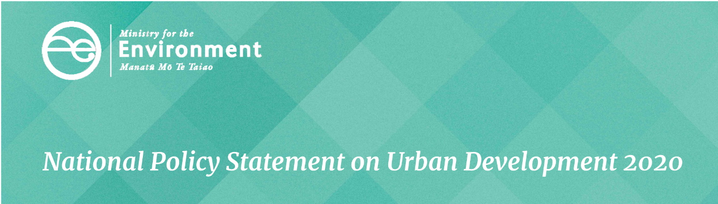

# Taking into account the principles of the Treaty of Waitangi

This is one of a series of seven fact sheets that give an overview of the National Policy Statement on Urban Development (NPS-UD). This fact sheet provides information on objective 5 and policy 9.

These provisions come into force on commencement of the NPS-UD.

## Purpose

The NPS-UD emphasises the existing requirements in the Resource Management Act 1991 (RMA) to take into account the principles of the Treaty of Waitangi (te Tiriti o Waitangi or the Treaty) in urban development and ensure iwi/Māori are engaged in processes to prepare plans and strategies that shape urban environments. The provisions recognise the strong traditional, and continuing, associations iwi/Māori have with urban environments throughout Aotearoa.

## Requirements

Objective 5 and policy 9 apply to tier 1, 2 and 3 urban environments. Nothing in the NPS-UD limits the obligations of local authorities under any primary legislation, including the RMA, the Local Government Act 2002, Te Ture Whenua Māori Act 1993 or any iwi participation legislation.

Objective 5 requires councils to ensure planning decisions relating to urban environments, and decisions on future development strategies (FDSs), take into account the Treaty.

Policy 9 sets out the minimum requirements for local authorities when taking into account the principles of the Treaty in relation to urban environments. This includes consulting with hapū and iwi in a way that is early, meaningful, and in accordance with tikanga Māori. Local authorities must also take into account the values and aspirations of hapū and iwi for urban development, provide opportunities for hapū and iwi involvement in decision-making, and operate in a way that is consistent with iwi participation legislation.

## What has changed from the National Policy Statement on Urban Development Capacity?

The RMA requires local authorities to take into account the Treaty, this was the case under the NPS-UDC and these obligations remain unchanged. However, the NPS-UD introduces:

* a new objective and policy to emphasise existing local authority obligations under the RMA
* a requirement for FDSs to take into account the principles of the Treaty
* direction on minimum requirements for local authorities in taking into account the principles of the Treaty in relation to urban environments.

## Things to be aware of

Policy 1 requires planning decisions to contribute to urban environments that, at a minimum, have or enable a variety of homes so Māori may express their cultural traditions and norms. The intent of this policy is to ensure homes (including where they are located, the type of homes provided and the cost of the homes) enable Māori to live in urban environments that meet their needs for cultural expression. For example, enabling kaumātua and papakāinga housing, housing located in relation to the whenua and sites of cultural significance, or housing that enables whānau to undertake cultural practices.

Policy 8 requires local authorities to be responsive to plan changes that would add significantly to development capacity even if the development capacity is unanticipated by RMA planning documents or out-of-sequence with planned land release. Regional councils will need to develop criteria to determine ‘significant development capacity’. These criteria could consider whether the development fulfils needs for identified demand, including demand for housing that enables Māori to express cultural traditions and norms. The intent is to ensure local authorities consider plan changes that would add significantly to meeting the needs of iwi/Māori for development capacity.

Clause 3.14 of Part 3 states the matters that must inform every future development strategy (FDS). The values and aspirations of hapū and iwi as well as Māori that do not hold mana whenua over the urban environment in which they live is one of these matters. This clause recognises that all Māori communities need opportunities to contribute to FDSs. Local authorities should engage with tangata whenua to determine appropriate methods for incorporating values and aspirations of Māori that do not hold mana whenua over the urban environment in which they live.

Clause 3.23 of Part 3 requires an analysis of the housing market and the impact of planning on the housing market. The analysis of the housing market must include an assessment of how well the current and likely future demands for housing by Māori are met, including the demand for different types and forms of housing (eg, papakāinga, kaumātua housing, housing in particular areas or of a particular type). The intent of this clause is to ensure visibility of Māori housing demand and therefore, to ensure enough development capacity is provided to meet that demand.

Local authorities should in particular be aware of their obligations with regard to other legislation in including Te Ture Whenua Māori Act 1993, the Local Government Act 2002, Treaty settlement legislation, iwi participation legislation and the Treaty. Local authorities should also be aware of their obligations in any Mana Whakahono ā Rohe agreement they may have with relevant hapū and iwi.

## Additional support

Further guidance on engaging with iwi/Māori and guidance to determine Māori housing demand is being developed and will be made available on the Ministry for the Environment’s [website](https://www.mfe.govt.nz/about-national-policy-statement-urban-development).

Fact sheets in this series

This is one of a series of seven fact sheets providing an overview of the National Policy Statement on Urban Development.

The full set of fact sheets is available on our website: **www.mfe.govt.nz/about-national-policy-statement-urban-development**.

**Find out more**

Contact the Ministry for the Environment by emailing [**npsurbandevelopment@mfe.govt.nz**](mailto:npsurbandevelopment@mfe.govt.nz)**,** or visit: [**www.mfe.govt.nz/contact**](http://www.mfe.govt.nz/contact).

### Disclaimer

The information in this publication is, according to the Ministry for the Environment’s best efforts, accurate at the time of publication. The information provided does not alter the laws of New Zealand and other official guidelines or requirements. Users should take specific advice from qualified professional people before undertaking any action as a result of information obtained from this publication.

The Ministry for the Environment does not accept any responsibility or liability whether in contract, tort, equity or otherwise for any action taken as a result of reading, or reliance placed on the Ministry for the Environment because of having read any part, or all, of the information in this publication or for any error, or inadequacy, deficiency, flaw in or omission from the information provided in this publication.

Published in July 2020 by the  
Ministry for the Environment   
Publication number: INFO 962

