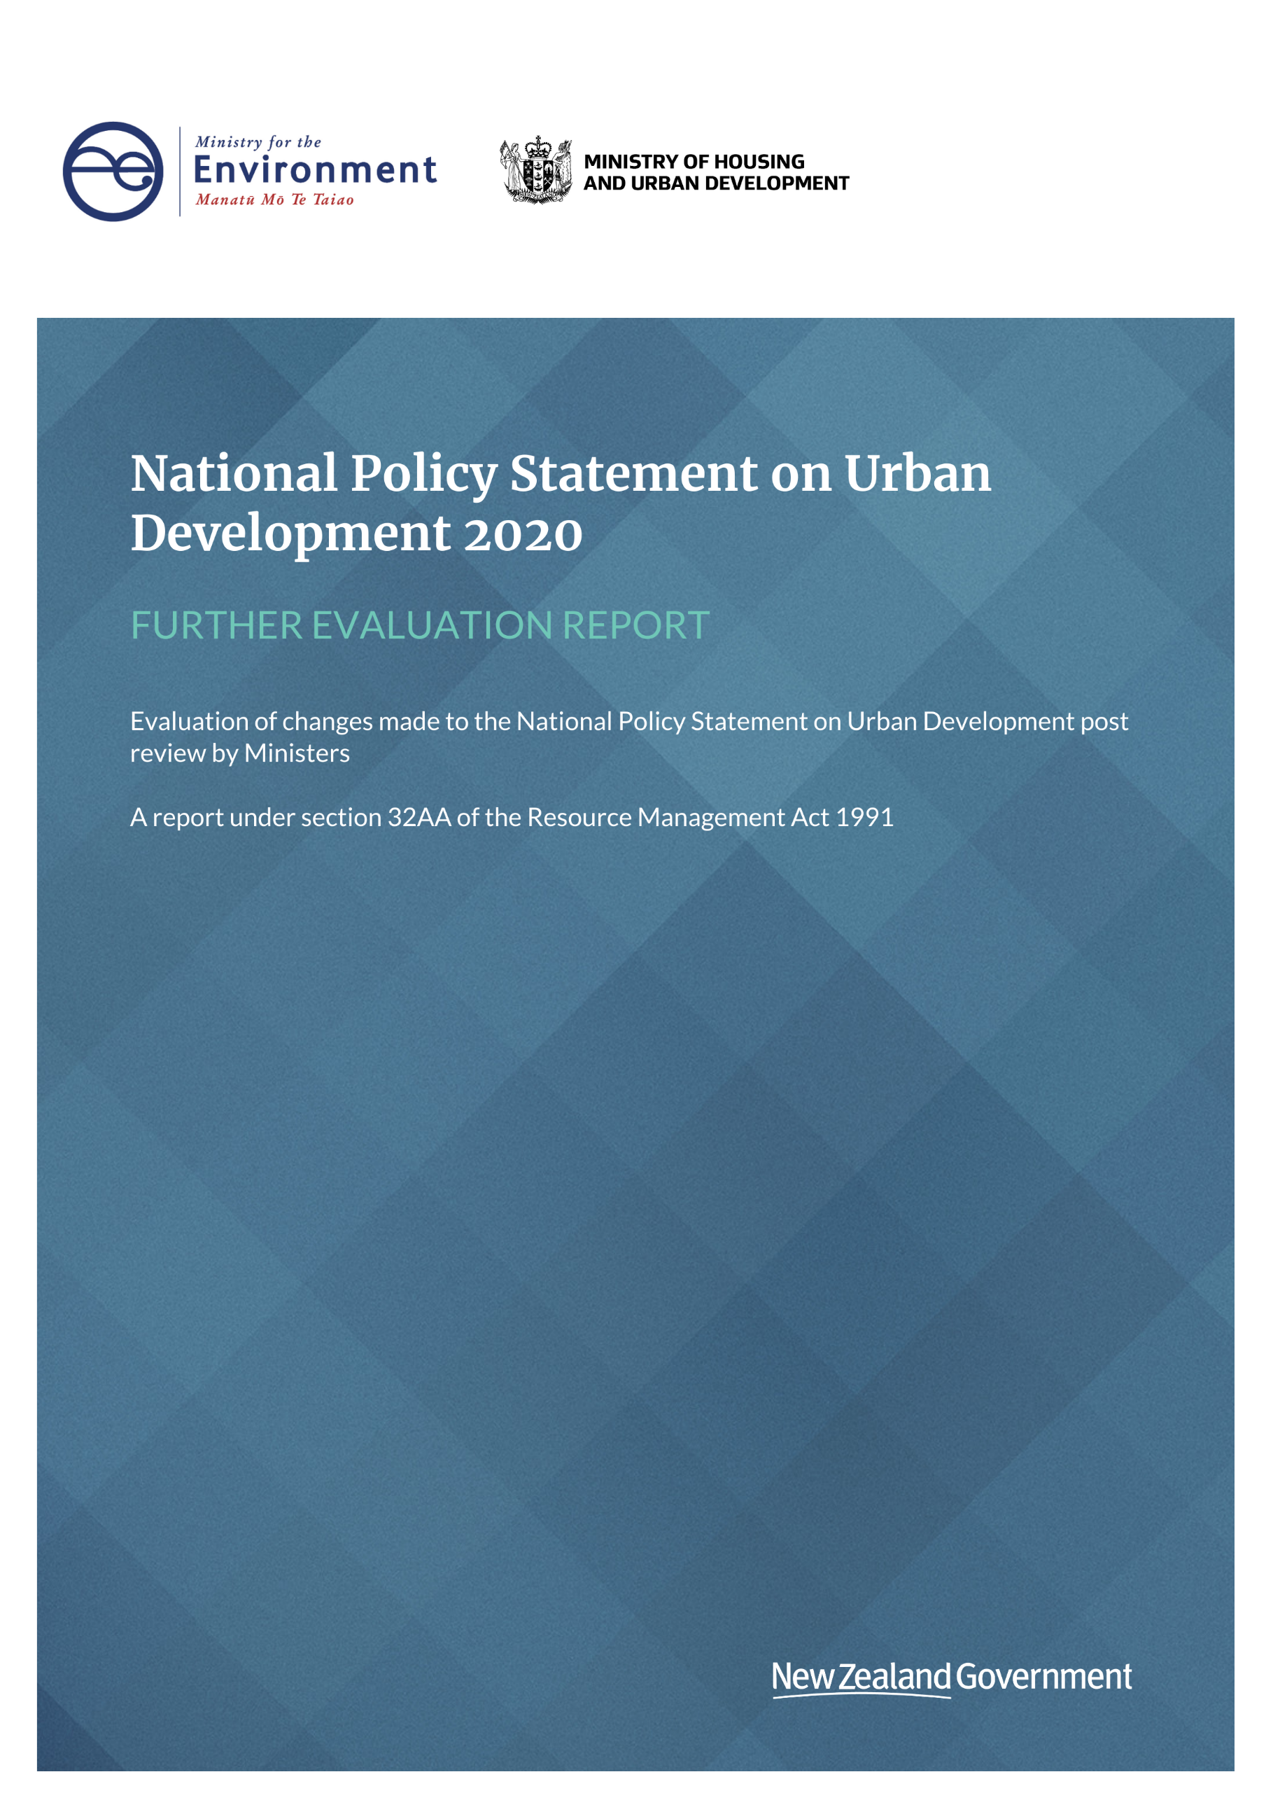
This document may be cited as: Ministry for the Environment. 2020. National Policy Statement on Urban Development further evaluation report 2020 – Evaluation of changes made to the draft NPS-UD post review by Ministers – A report under section 32AA of the Resource Management Act 1991. Wellington: Ministry for the Environment.

Published in July 2020 by the
Ministry for the Environment
Manatū Mō Te Taiao
PO Box 10362, Wellington 6143, New Zealand
ISBN: 978-1-99-003302-5 (online)
Publication number: ME 1512
© Crown copyright New Zealand 2020
This document is available on the Ministry for the Environment website: www.mfe.govt.nz.


Contents
Overview 4
Why is this report needed? 4
Section 32 analysis of the proposed National Policy Statement 5
Evaluation approach used in this report 5
Policy objectives 5
Overview of change 6
Analysis of policy change 7
Reasons for the change 7
Scale and significance 8
Options considered 8
Options evaluation 8
Conclusion/summary of rationale for the preferred option 11
Implementation support 12
Appendix 1: Tier 1 and tier 2 urban environments and local authorities and relevant
definitions on urban environments 13

Overview

Why is this report needed?
This report provides an evaluation under section 32AA (s32AA) of the Resource Management Act 1991 (RMA) of a change to the draft National Policy Statement on Urban Development (NPS-UD) 2020 since it was submitted to Ministers to consider on 27 March 2020. The package included draft policies and the associated policy recommendations report, as well as a section 32 analysis and a cost benefit analysis.
Section 32AA of the RMA requires further evaluation of changes made to the draft NPS-UD since the original evaluation report was completed. This further evaluation must be undertaken as per the requirements of section 32 of the RMA, with a level of detail that corresponds to the scale and significance of the changes.
(1) A further evaluation required under this Act—
(a) is required only for any changes that have been made to, or are proposed for, the proposal since the evaluation report for the proposal was completed (the changes); and
(b) must be undertaken in accordance with section 32(1) to (4); and
(c) must, despite paragraph (b) and section 32(1)﻿(c), be undertaken at a level of detail that corresponds to the scale and significance of the changes; and
(d) must—
(i) be published in an evaluation report that is made available for public inspection at the same time as the approved proposal (in the case of a national policy statement or a New Zealand coastal policy statement or a national planning standard), or the decision on the proposal, is notified; or
(ii) be referred to in the decision-making record in sufficient detail to demonstrate that the further evaluation was undertaken in accordance with this section.
(2) To avoid doubt, an evaluation report does not have to be prepared if a further evaluation is undertaken in accordance with subsection (1)﻿(d)﻿(ii).
(3) In this section, proposal means a proposed statement, national planning standard, plan, or change for which a further evaluation must be undertaken under this Act.
Only one substantive change occurred to the proposed policy, which related to the car parking policy applying to some councils. In the recommendations report, we proposed the car parking policy apply only to district plans in tier 1 urban environments.

Section 32 analysis of the proposed National Policy Statement
This report should be read in conjunction with the s32 analysis of the draft National Policy Statement on Urban Development prepared by Beca Limited for the Ministry for the Environment and the Ministry of Housing and Urban Development. This 32AA report updates that earlier report and draws upon its findings where necessary. Read the original s32 assessment report on the Ministry for the Environment’s website.

Evaluation approach used in this report
The difference between a s32 analysis of a notified policy and a s32AA analysis of subsequent changes to the proposed policy can be summed up as follows and seen in figure 1.
- As32 analysis should assess the overall costs and benefits of the proposed policy relative to the status quo established by existing policies and features of the market.
- A s32AA analysis should assess the marginal costs and benefits of changes to the proposed policy, relative to the version assessed in the s32 analysis.
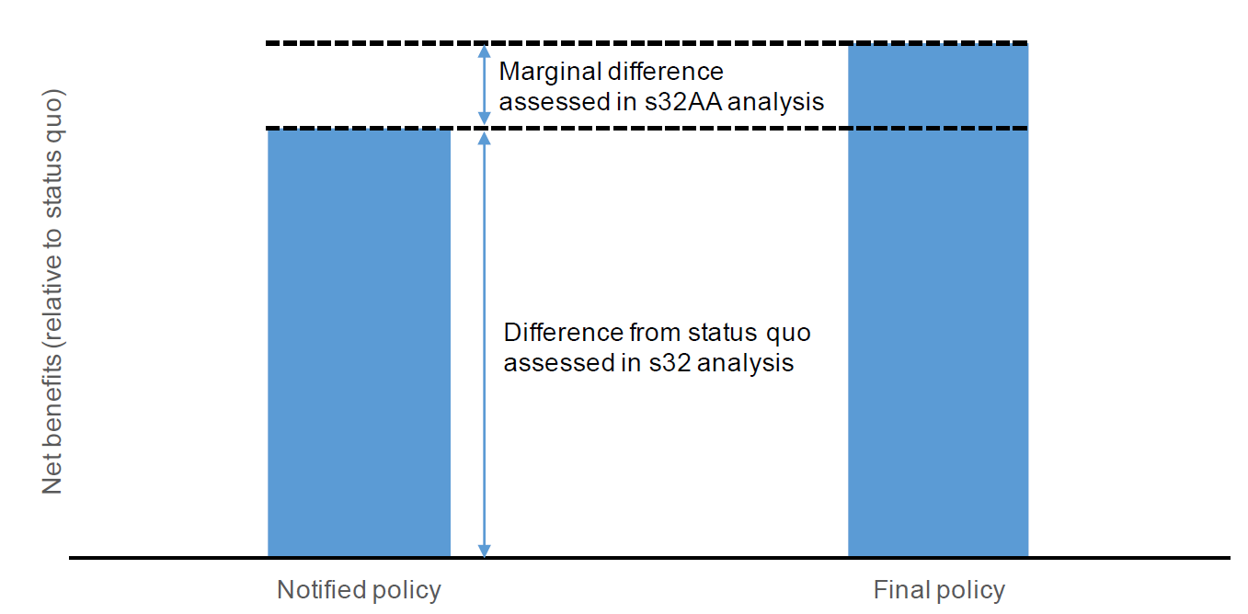
Figure 1: s32 analysis versus s32AA analysis

Consequently, this evaluation focuses on the changes from the proposed NPS-UD recommendations report. In particular, this evaluation report provides an assessment of the preferred option, including the degree to which it is likely to improve the effectiveness and efficiency of the NPS-UD car parking policy.
A regulatory impact statement (RIS) summary has also been prepared for the NPS-UD and is a higher level document than the section 32 and s32AA evaluation reports.

Policy objectives
Objectives 1 and 4 are relevant to the removal of minimum car parking rates. The objectives outline the intended outcome of the policy and help in testing reasonable alternatives, including the targeting of the policy. No further changes to the objectives are proposed in this further evaluation.
Objective 1: New Zealand has well-functioning urban environments that enable all people and communities to provide for their social, economic, and cultural wellbeing, and for their health and safety, now and into the future.
Objective 4: New Zealand’s urban environments, including their amenity values, can develop and change over time in response to the diverse and changing needs of people, communities, and future generations.

Overview of change
Table 1 analyses the change to the previous draft policies of the NPS-UD.
Table 1: Summary of change proposed and assessed in this report
Matter | Draft approach (s.32) | Proposed approach (s.32AA)
Extend the application of policy 11(b), which removes the ability for district plans to set minimum parking rates  The Minister, as well as some submitters, were concerned this policy had benefits for well-functioning urban environments in more places than just tier 1 areas | Apply parking policy 11(b) to all district plans within tier 1 territorial authorities | Apply parking policy 11(b) to all district plans within tier 1, 2 and 3 territorial authorities
To know the full the extent of changes since the public consultation, read the Recommendations and the decisions report on the Ministry for the Environment’s website.
Analysis of policy change
This section assesses the options to reconsider the targeting of the car parking policies against the two relevant objectives for car parking in the draft NPS-UD.

Reasons for the change
Ministers and many submitters wanted the policy proposal for removing minimum parking rates to be extended from only tier 1 urban areas (formerly referred to as major urban centres) to include all other urban environments.
Ministers and submitters considered the benefit of removing minimum parking rates apply to all urban environments. The economic cost benefit analysis prepared by PwC to support the NPS-UD found that no city is too small to remove minimum parking rates:
The costs of the Minimum Car Parking policy decline in proportion with the benefits, meaning the policy change will most likely either be neutral or net positive. Moreover, as a conservative assumption, we calculate the costs of removing MPRs [minimum parking rates] assuming that additional parking management activities will be needed and provided by councils. The approach does not consider potential net revenue increases from parking management, which would further strengthen the (financial) case for removal. To the extent that councils take action to shift the full social cost of parking onto users of parking then, the costs of removing minimums will approach zero.
The section 32 report was informed by the above cost benefits analysis. However, in our recommendations report we did not recommend extending the targeting of this policy beyond tier 1 local authorities, to maintain a balance between keeping the initial policy intent and the strength of the evidence base. All ‘urban environments’ (as defined in the NPS-UD) are located in tier 1 – 3 local authorities, and are listed in the appendix of the NPS-UD.
For technical reasons it is not reasonably practicable to only target the actual spatial extent of built-up urban areas. It would require local authorities to ring fence the spatial extent of the parking policy by mapping it. This would have unintended consequences on the application of the urban environments for other policies in the NPS-UD. It would also require those local authorities to update their plans as their urban areas grow. Instead, it is simpler and more effective to apply the car parking policy to the entire district of a local authority. Given there are few to no costs from the policy applying in low-density urban areas, there is little to no benefit with an approach that would effectively set up two overlay controls for minimum parking. A two overlay approach would introduce ongoing costs to update the plan in these areas. This is the same reason why the policy was not applied exclusively to built-up areas in tier 1 urban centres, and it follows that the same approach should apply to other tiers when the policy is extended to include tiers 1-3.
Given the tier 3 category is ‘flexible’, there is a technical matter when applying a policy that isn’t subject to the preparation of a plan variation, and which must not be prepared using a Schedule 1 RMA process. Whereas the local authorities in tiers 1 and 2 are fixed and listed in the appendix of the NPS-UD (and are reviewed every five years), local authorities are defined as meeting the tier 3 threshold when they have an urban settlement that is, or is intended to be, part of a housing and labour market of at least 10,000 people (and is not listed in the appendix of the NPS-UD).
A national policy statement is capable of direct insertion, or removal of a policy. This can apply to all or any defined part of the country, and it need not be listed. The Ministry for the Environment would work with these local authorities to provide guidance and assistance, ensuring appropriate and timely application of the policies which apply under the NPS-UD, including the requirement to remove minimum parking rates.

Scale and significance
Section 32(1)(c) of the RMA states that a section 32AA evaluation must contain a level of detail that corresponds to the scale and significance of the effects of the proposal and change. It is considered the policies of the NPS-UD as a package are of a large scale and high significance. However, each individual policy has a varying scale and significance.
The extension the car parking policy to other areas beyond tier 1 urban environments is considered high scale and medium-to-low significance, depending on the location where the policy will apply, and depending on the density of the urban environment. For example, in urban settlements (smaller than urban environments) the impact would be nil to almost no impact, and rural areas would have no impact at all. In some smaller urban settlements the costs may be very low to nil, but there may be some instances where net benefits are experienced, such as within a town centre that has minimum parking rates that are higher than the actual demand for parking.

Options considered
Under section 32(1)(b) of the RMA, the Ministry is required to identify and examine ‘reasonably practicable options’ for achieving the proposed objectives. ‘Reasonably practicable’ is not defined in the RMA, but may include options that:
- are both regulatory and non-regulatory
- are targeted towards achieving the goal/objective
- are within the Ministry’s resources, duties and powers
- represent a reasonable range of possible alternatives.
Table 4 in the section below details an evaluation of options relating to the costs and benefits to determine the effectiveness and efficiency of the approach, and whether it is the most appropriate way to achieve the relevant objectives.

Options evaluation
Table 3 lists some possible alternatives (options) for targeting the policies which remove the ability of district plans to set minimum parking rates. Table 2 restates the relevant objectives which the options are to be assessed against. The assessment is set out in table 4, evaluating the costs, benefits, efficiency and effectiveness of the options.
Table 2: Relevant objectives
Relevant objectives
Objective 1: New Zealand has well-functioning urban environments that enable all people and communities to provide for their social, economic, and cultural wellbeing, and for their health and safety, now and into the future. | Objective 4: New Zealand’s urban environments, including their amenity values, can develop and change over time in response to the diverse and changing needs of people, communities, and future generations.

Table 3: Options for targeting policy
Further options in relation to targeting of parking policy 11(b)
District plans of tier X territorial authorities do not set car parking minimum requirements, other than for accessible car parks.
Apply parking policy to all district plans in tier 1 and 2 territorial authorities
Apply parking policy to all district plans in tier 1, 2 and 3 territorial authorities
Apply parking policy to all district plans in Aotearoa New Zealand
Preferred option from the recommendations report version s32 analysis
Apply parking policy to all district plans within tier 1 territorial authorities

Table 4: Further evaluation of additional options
NB: Each option is ordered from ‘more limited’ to ‘wider targeting’. Each descending option does not re-evaluate the benefits and costs of the options before it, unless when they are different, they are stated as such. Also note that the evaluation is assessing the marginal difference compared to the section 32 evaluation report.
Option 1: Apply parking policy to all district plans in tier 1 and 2 territorial authorities
 | Costs | Benefits
 | - No significant new costs because costs to deliver car parking in smaller cities and other urban environments will be lower due to lower costs of land  - In the longer term, comprehensive parking management plans (CPMPs) may be required in locations where there is high demand for car parking and constrained supply. There would be cost to develop CPMPs for the tier 2 councils (except Queenstown, whose status will shift from tier 1 to tier 2)  - Slower and less likely for any costs to be realised as urban change occurs slowly, especially in smaller tier 2 centres when compared to the rate of change in tier 1 centres. The impacts of car parking supply can be more easily managed in smaller urban environments than the main urban environments in the tier 1 centres. | - The benefits identified in the initial s32 analysis will be realised in more urban environments beyond tier 1, but not in tier 3.
Effectiveness and efficiency | Effectiveness  This option is effective as:  - Targeting medium sized cities as well as higher growth cities means that these locations will be more likely to achieve well-functioning urban environments, particularly into the future as transportation needs change, and the ability to respond to more flexible applications of car parking policies continues to improve.  This option is not effective as:  - Not all urban environments are captured, as anticipated by the relevant objectives, missing urban environments in tier 3 local authorities. | Efficiency  - There are no additional efficiency characteristics identified by adding tier 2 urban areas, compared with only tier 1.
Overall evaluation | This option is considered to be reasonably practicable, however it misses out on other urban environments which would benefit from the removal of minimum parking rates, as anticipated by the objective, therefore making it less effective and efficient than other options in this report, but more effective than the preferred option identified in the s32 evaluation.
Option 2: Apply parking policy to all district plans tier 1, 2 and 3 territorial authorities
 | Costs |  | Benefits
 | - No additional costs identified, other than those identified in option 1. |  | - Additional urban environments captured by including tier 2 and 3 local authorities means that the benefits are targeted to all urban environments  - Benefits may be realised in other urban settlements smaller 10,000 people within the tier 2 – 3 areas. For example this would benefit small scale affordable housing developments made more affordable by not needing to provide car parking.
Effectiveness and efficiency | Effectiveness  This option is considered to be an effective option because:  - It would capture all urban environments in Aotearoa, as defined by the NPS-UD  - It would enable well-functioning urban environments and make it easier for them to adapt and change over time, by having a more flexible parking management system, capturing all urban centres (tiers 1 – 3). |  | Efficiency  - This option would also capture small settlements and non-settlements where there would be very little or no benefit, however it is not considered to reduce efficiency given there would be no costs in the same locations, with the potential for benefits in certain circumstances in settlements that currently have parking controls.
Overall evaluation | Overall this option is considered to be effective, efficient and reasonably practicable, and is the preferred option. It captures all urban environments, therefore providing for well-functioning urban environments as anticipated by objective 1. It also allows all urban environments to more readily develop and change over time, through a less rigid parking management system, therefore benefitting present and future generations as anticipated by objective 4. Costs decrease proportionately to the rate that benefits decrease, dependant on the size and density of the urban environments.
Option 3: Apply parking policy to all district plans in Aotearoa
 | Costs |  | Benefits
 | - Costs will be generated as smaller territorial authorities, not in tiers 1 – 3, (eg, Wairoa, Hurunui) would be required to update their plans to remove minimum parking rates, and while there may be small benefits, there may be some costs, particularly if a CPMP is required in the future. However, given the slow rate of change in these settlements, a CPMP is unlikely to be required.  - Local authorities that are not in tier 1 - 3 may overlook the requirement to remove car parking rates, as the remainder of the NPS-UD does not apply to them. This would result in unintended non-compliance. |  | - Clear and simple application as applied to all parts of nation, and no territorial authorities left out.  - Other urban settlements would be able to benefit, such as locations that have minimum parking rates that are set higher than actual demand.
Effectiveness and efficiency | Effectiveness  This option is considered to be effective as it includes all urban environments in local authorities in tiers 1 – 3, and also captures other urban settlements that may in some circumstances have similar characteristics as urban environments, and a similar need to have more responsive/ market-led car parking supply. |  | Efficiency  In the short term, this option is considered to be inefficient as it targets locations beyond tiers 1 -3 as anticipated by the relevant objective. In the long term, it could be efficient because it would establish new urban environments without parking minimums regimes in advance of the settlement reaching, or intended to reach, a population of 10,000 people.
Overall evaluation | Option 3 is not the preferred option. This option is not the most efficient means of achieving the relevant objectives of the NPS-UD, which seeks to only target urban environments/local authorities in tiers 1 -3. In other words, it is beyond the scope of the NPS-UD. However, this option is considered to have the greatest benefits, with few additional costs compared to all other options. Option 3 is not the preferred option.

Conclusion/summary of rationale for the preferred option
This evaluation has been undertaken as per section 32AA of the RMA, to identify the benefits, costs and the appropriateness of the proposal to extend the targeting of the car parking policy. This must be done while having regard to its effectiveness and efficiency relative to other means to achieving the purpose of the RMA.
This evaluation demonstrates that the policy becomes more effective as it is applied to more urban environments. Given the benefits decrease in proportion to a decrease in costs, relative to the density of urban environments, the policy maintains its efficiency regardless of location application. While option 3 (applying the policy to all district plans in Aotearoa) may have the greatest benefit, as it is applied to other urban settlements with similar characteristics to some urban environments, it is not the most effective means of achieving the relevant objectives, which refer to urban environments only. Option 2 is recommended because it limits the policy application to Tiers 1 – 3 only, which is aligned with the rest of the NPS-UD and its objectives.

Implementation support
The Ministry for the Environment, with other government agencies such as Waka Kotahi NZTA, intends to provide a package of implementation support for councils during the implementation period for car parking. This will include guidance and one-on-one council support where deemed necessary. The Ministry will prioritise action to ensure the implementation of the NPS-UD results in the greatest possible impact.
The Ministry and agencies will stay in close contact with councils, and will monitor the uptake of the policies and assess implementation needs over time. The Ministry will also work with local authorities that are making a transition to tier 3, to ensure appropriate and timely application of the NPS-UD policies, including the requirement to remove minimum parking rates.

Appendix 1: Tier 1 and tier 2 urban environments and local authorities and relevant definitions on urban environments
Relevant definitions on urban environments
tier 1 urban environment means an urban environment listed in column 1 of table 1 in the appendix
tier 2 urban environment means an urban environment listed in column 1 of table 2 in the Appendix
tier 3 urban environment means an urban environment that is not listed in the appendix
urban environment means any area of land (regardless of size, and irrespective of local authority or statistical boundaries) that:
- is, or is intended to be, predominantly urban in character; and
- is, or is intended to be, part of a housing and labour market of at least 10,000 people
Tier 1 and tier 2 urban environments and local authorities
Table 1
Tier 1 urban environment | Tier 1 local authorities
Auckland | Auckland Council
Hamilton | Waikato Regional Council, Hamilton City Council, Waikato District Council, Waipā District Council
Tauranga | Bay of Plenty Regional Council, Tauranga City Council, Western Bay of Plenty District Council
Wellington | Wellington Regional Council, Wellington City Council, Porirua City Council, Hutt City Council, Upper Hutt City Council, Kāpiti Coast District Council
Christchurch | Canterbury Regional Council, Christchurch City Council, Selwyn District Council Waimakariri District Council
Table 2
Tier 2 urban environment | Tier 2 local authorities
Whāngarei | Northland Regional Council, Whangarei District Council
Rotorua | Bay of Plenty Regional Council, Rotorua District Council
New Plymouth | Taranaki Regional Council, New Plymouth District Council
Napier Hastings | Hawke’s Bay Regional Council, Napier City Council, Hastings District Council
Palmerston North | Manawatū-Whanganui Regional Council, Palmerston North City Council
Nelson Tasman | Nelson City Council, Tasman District Council
Queenstown | Otago Regional Council, Queenstown Lakes District Council
Dunedin | Otago Regional Council, Dunedin City Council

See policy 11(b) and corresponding implementation policy 3.38(1). Other minor and technical changes were made across the policies, ensuring that the policy is worded more clearly to meet the policy intent.

