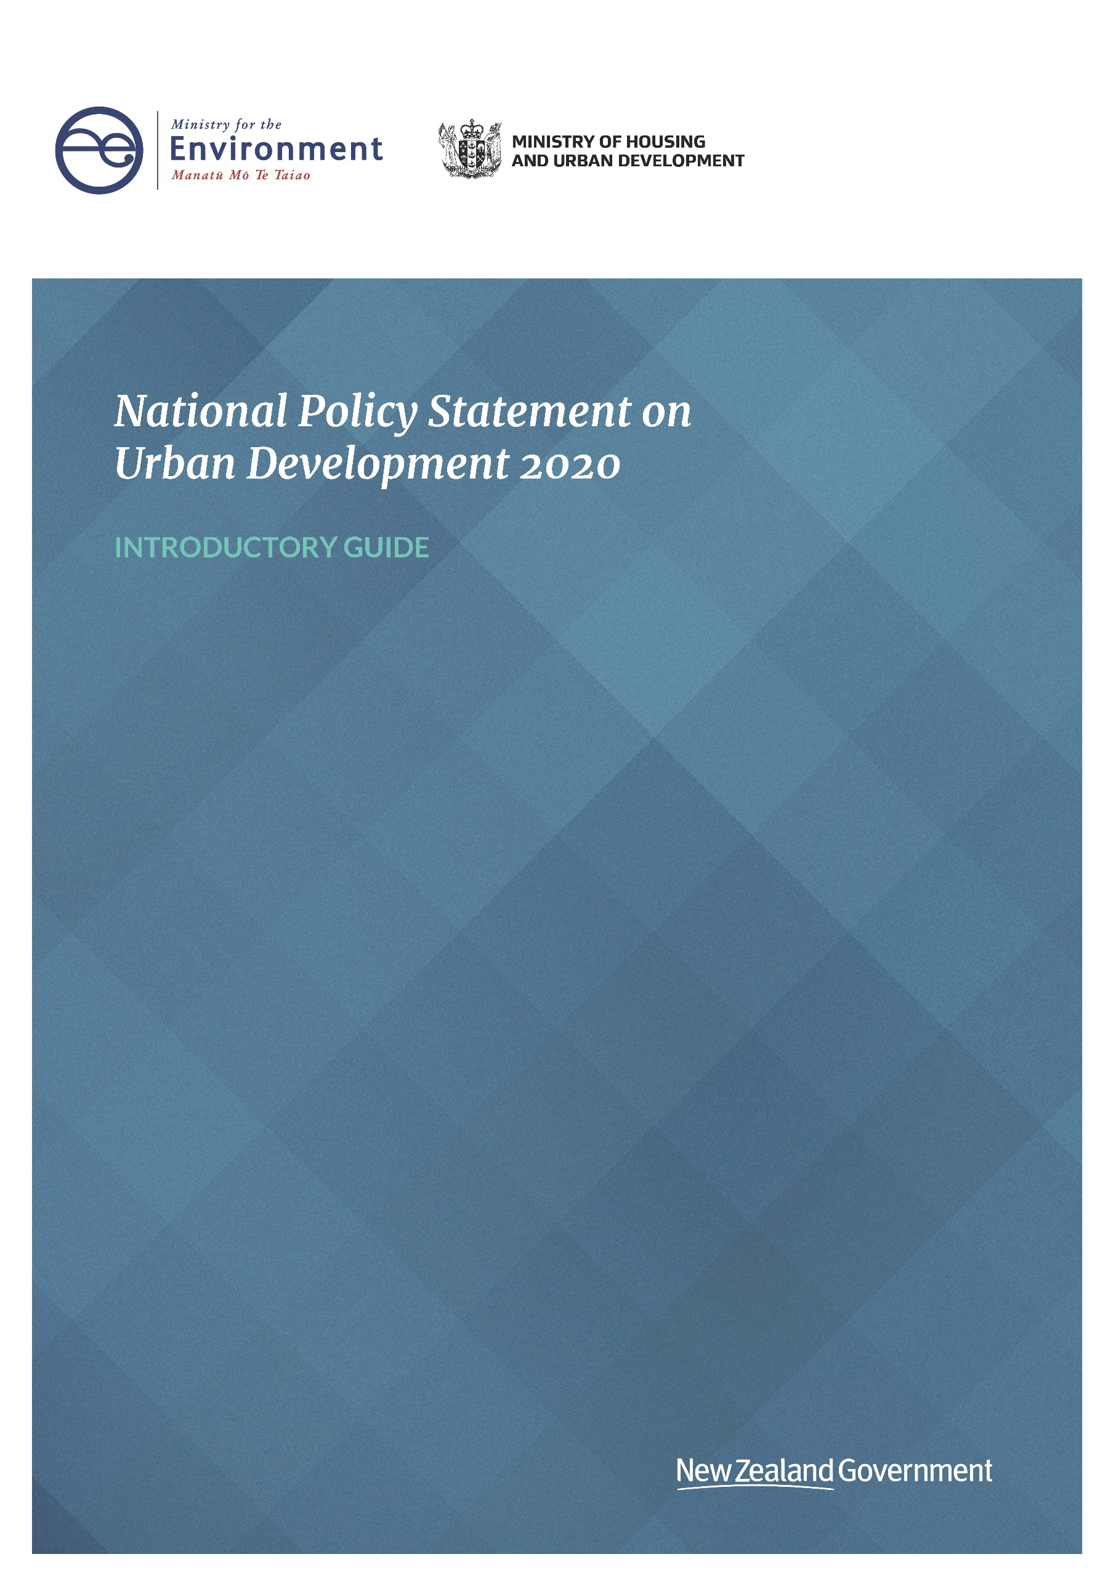

**Disclaimer**

The information in this publication is, according to the Ministry for the Environment’s best efforts, accurate at the time of publication. The information provided does not alter the laws of New Zealand and other official guidelines or requirements. Users should take specific advice from qualified professional people before undertaking any action as a result of information obtained from this publication.

The Ministry for the Environment does not accept any responsibility or liability whether in contract, tort, equity or otherwise for any action taken as a result of reading, or reliance placed on the Ministry for the Environment because of having read any part, or all, of the information in this publication or for any error, or inadequacy, deficiency, flaw in or omission from the information provided in this publication.

This document may be cited as: Ministry for the Environment. 2020. *Introductory guide to the National Policy Statement on Urban Development 2020*. Wellington: Ministry for the Environment.

Published in July 2020 by the  
Ministry for the Environment   
Manatū Mō Te Taiao  
PO Box 10362, Wellington 6143, New Zealand

ISBN: 978-1-99-003303-2 (online)

Publication number: ME 1514

© Crown copyright New Zealand 2020

This document is available on the Ministry for the Environment website: [www.mfe.govt.nz](http://www.mfe.govt.nz).



# Contents

Introduction 5

National Policy Statement on Urban Development 6

Intent of the National Policy Statement on Urban Development 6

Geographic application of the policies by tiers 7

How does the National Policy Statement on Urban Development differ from the National Policy Statement on Urban Development Capacity? 8

Overview of the objectives and policies 8

Interactions of objectives and policies 10

National Policy Statement on Urban Development implementation programme 12

Support provided to local authorities 12

Monitoring, compliance and enforcement 13

Interactions with other national direction 14

Review of the National Policy Statement on Urban Development 14

# Tables

Table 1: Tier 1, 2 and 3 urban environments for the purposes of the National Policy Statement on Urban Development 7

Table 2: Summary of the National Policy Statement on Urban Development 8

Table 3: Overview of timeline for implementing policies 13

# Figures

Figure 1: Interdependencies of the National Policy Statement on Urban Development policies 11

Figure 2: National Policy Statement on Urban Development local authority implementation actions 12

# Introduction

This document provides a high-level overview of the National Policy Statement on Urban Development 2020 (NPS-UD), introducing a series of fact sheets and guides to help with implementation. More in-depth implementation guidance will follow, tailored to feedback from councils and other stakeholders. This implementation guidance may be particularly useful for urban planners, developers, local authorities and their decision-makers, designers, homeowners, and urban planning experts or academics.

National policy statements (NPSs) allow government to prescribe objectives and policies for matters of national significance relevant to sustainable management under the Resource Management Act 1991 (RMA). The National Policy Statement on Urban Development Capacity 2016 (NPS-UDC) required councils to improve planning processes to enable more development. It has been replaced by the NPS-UD, which gives further direction in certain areas, such as where development capacity should be provided and how councils can be more responsive to development opportunities.

This guide provides a general overview of what the NPS-UD intends to achieve and the key changes from the NPS-UDC, and outlines what is required of local authorities.

This guide can be read alongside the NPS-UD and other documents available on the Ministry for the Environment website, including the:

* Cabinet paper seeking approval of the policies in the NPS-UD
* evaluation and further evaluation reports under section 32 and 32AA of the RMA
* cost-benefit analysis undertaken by PricewaterhouseCoopers (PwC)
* decisions and recommendations report
* regulatory impact statement (RIS).

The guidance provided is for information purposes only and does not have statutory weight.

# National Policy Statement on Urban Development

## Intent of the National Policy Statement on Urban Development

The National Policy Statement on Urban Development (NPS-UD) is part of the urban planning pillar of the Government’s Urban Growth Agenda (UGA).[1] To support productive and well-functioning cities, it is important that regional policy statements (RPSs) and regional and district plans provide adequate opportunity for land development for business and housing to meet community needs.

The NPS-UD is designed to improve the responsiveness and competitiveness of land and development markets. In particular, it requires local authorities to open up more development capacity, so more homes can be built in response to demand. The NPS-UD provides direction to make sure capacity is provided in accessible places, helping New Zealanders build homes in the places they want – close to jobs, community services, public transport, and other amenities our communities enjoy.

Potential benefits of flexible urban policy include higher productivity and wages, shorter commute times, lower housing costs, social inclusion, and more competitive urban land markets.

According to the cost-benefit analysis completed by PricewaterhouseCoopers (PwC), lower socio-economic groups and future generations will benefit most from greater land-use flexibility (increasing options for how land owners can develop their land). New Zealand’s cities will also be better equipped to respond to many urban problems, such as changing patterns of wealth inequality, housing unaffordability and climate change.

Most of the NPS-UD’s provisions contribute to more competitive land markets in some form, but three are key.

* The **intensification** policies (Policies 3, 4 and 5) seek to improve land-use flexibility in the areas of highest demand – areas with good access to the things people want and need, such as jobs and community services, and good public transport services. These factors are indicators of the best areas for development, and there is strong evidence to demonstrate that reducing constraints on development in these locations would have the biggest impact.
* The **responsive planning policy** (Policy 8) seeks to improve land-use flexibility generally by ensuring local authorities have particular regard to plan changes that would add significantly to development capacity as they arise.
* The **removal of minimum parking rates** in district plans (Policy 11) seeks to improve land-use flexibility in urban environments. It will allow more housing and commercial developments, particularly in higher density areas where people do not necessarily need a car to access jobs, services or amenities. Urban space can then be used for higher value purposes than car parking. Developers will still provide car parking in many areas, and must still provide accessible car parking, but the number of car parks will be driven by market demand.

The NPS-UD is also intended to:

* improve accessibility for all people between housing, jobs, opportunities for social interaction, services, and public open space, including by way of public and active transport (Policy 1)
* improve the evidence used by decision-makers in planning decisions (Objective 7, subpart 3 of Part 3)
* provide direction on minimum requirements for local authorities in taking into account the principles of the Treaty of Waitangi (te Tiriti o Waitangi) in relation to urban environments (Policy 9)
* ensure zones have provisions that individually and cumulatively support the purpose of the zone (Policy 3, subpart 7 of Part 3)
* support reductions in greenhouse gas emissions (Objective 8, Policy 1).

In achieving these outcomes, the NPS-UD will contribute to the UGA’s objectives, and address restrictive Resource Management Act 1991 (RMA) planning practices. Ultimately, it will help local authorities allow more urban development and housing through their plans, to better meet the different housing needs and preferences of New Zealanders.

## Geographic application of the policies by tiers

The NPS-UD applies to all urban environments,[2] categorised into the three tiers outlined in table 1. The three tiers were informed by population size and growth rates. This approach allows the most directive policies to be targeted towards the largest and fastest growing urban centres, where the greatest benefits will be realised.

Table 1: Tier 1, 2 and 3 urban environments for the purposes of the National Policy Statement on Urban Development

|  |  |  |
| --- | --- | --- |
| Tier 1 | Tier 2 | Tier 3 |
| * Auckland * Hamilton * Tauranga * Wellington * Christchurch | * Whangārei * Rotorua * New Plymouth * Napier Hastings * Palmerston North * Nelson Tasman * Queenstown * Dunedin | All other urban environments that are not in tier 1 or 2 (see definition of urban environments in footnote 2). |

## How does the National Policy Statement on Urban Development differ from the National Policy Statement on Urban Development Capacity?

The NPS-UD replaces the National Policy Statement on Urban Development Capacity 2016 (NPS-UDC), but maintains and builds on some of its policies. Several policies are more directive than those in the NPS-UDC, particularly in our largest and fastest growing urban environments. Key changes in the NPS-UD include:

* a requirement for planning decisions to contribute to well-functioning urban environments (as defined in Policy 1 of the NPS-UD), which is at the core of all of the policies in the NPS-UD
* specific reference to amenity values, climate change, housing affordability and the Treaty of Waitangi (te Tiriti o Waitangi)
* a requirement for local authorities to enable greater intensification in areas of high demand and where there is the greatest evidence of benefit – city centres, metropolitan centres, town centres and near rapid transit stops
* removal of minimum car parking rates from district plans
* a requirement for local authorities to be responsive to unexpected plan change requests where these would contribute to desirable outcomes.

## Overview of the objectives and policies

Table 2 gives a simplified summary of the NPS-UD, identifying policies from the NPS-UDC, with or without significant changes, and objective and policies that are new. It also indicates which tier(s) each policy applies to.

Table 2: Summary of the NPS-UD

|  |  |  |  |
| --- | --- | --- | --- |
| Strategic planning for growth | Section | Where | Status |
| Requires councils to prepare a future development strategy (FDS) every six years and update them every three years. | Clause 3.12 | Tier 1 and 2 | changed |
| Provides new direction on what an FDS needs to include, and how they should be developed. | Clauses 3.13–3.16 | Tier 1 and 2 | changed |
| Requires councils to have an implementation plan for their FDS. | Clause 3.18 | Tier 1 and 2 | new |
| Making room for growth | Section | Where | Status |
| *Well-functioning urban environments* | | | |
| Enables communities and future generations to provide for their wellbeing. | Objective 1 | all | existing |
| Provides a non-exhaustive list of features of well-functioning urban environments for councils to use as an outcomes framework for planning and decision-making. | Policy 1 | all | changed |

| *Housing affordability* | | | |
| --- | --- | --- | --- |
| Sets an objective for councils to contribute to housing affordability through planning decisions that support competitive land and development markets. | Objective 2 | all | new |
| *Climate change* | | | |
| Sets direction for New Zealand’s urban environments to support reductions in greenhouse gas emissions, and be resilient to the effects of climate change. | Objective 8, Policies 1(e), 1(f) and 6(e) | all | new |
| *Clarifying amenity and change in urban environments* | | | |
| Directs councils to enable New Zealand's urban environments, including their amenity values, to change over time. | Objective 4, Policy 6 | all | changed |
| *Enabling opportunities for development* | | | |
| Councils must provide, at minimum, enough capacity to meet the diverse demands of their communities. | Policy 2, clauses 3.2–3.5 and 3.10 | all | changed |
| Requires bottom lines for development capacity to be set, including competitive margins. | Policy 7, clause 3.6 | Tier 1 and 2 | changed |
| Councils must consider whether development capacity is reasonably expected to be realised. | Clause 3.26 | all | new |
| Councils must notify the Minister for the Environment if they have insufficient development capacity in the short, medium or long term. | Clause 3.7 | all | new |
| *Ensuring plan content provides for expected levels of development* | | | |
| Include in their plans a description of each zone's expected development outcomes over the life of the plan and beyond, and ensure that policies and rules in their plans are individually and cumulatively consistent with those outcomes. | Clauses 3.35 and 3.36 | all | new |
| Monitor the uptake of development capacity in higher density zones. | Clause 3.37 | Tier 1 | new |
| *Providing for intensification* | | | |
| Sets an objective for councils to enable greater intensity in areas of high access or demand. | Objective 3 | All | new |
| Enable minimum heights and densities in and near city and metropolitan centres and near existing and planned rapid transit stops, unless a qualifying matter applies. In all other areas, enabled building heights and densities should reflect the relative demand for use and the level of accessibility from planned or existing active and public transport. | Policies 3 and 4, clauses 3.31–3.34 | Tier 1 | new |
| Enable building heights and densities that reflect the relative demand for use, and the level of accessibility from planned or existing active transport. | Policy 5 | Tier 2 and 3 | new |
| *Responsive planning* | | | |
| Local authorities must be responsive to plan changes for unanticipated or out-of-sequence developments. | Policy 8, clause 3.8 | all | **new** |
| *Removing minimum car parking requirements* | | | |
| Plans must not set minimum car parking rates, other than for accessible car parks. Local authorities are encouraged to manage effects of car parking supply and demand through comprehensive parking management plans. | Policy 11, clause 3.38 | all | new |
| *Decision-making* | | | |
| Councils have particular regard to the following when making planning decisions: anticipated outcomes, the benefits of urban development that are consistent with well-functioning urban environments, the need for urban environments to change, development capacity requirements and the effects of climate change. | Policy 6 | all | changed |
| Evidence for good decision-making | Section | Where | Status |
| Sets an objective for local authorities to have robust and frequently updated information to inform planning and decision-making. | Objective 7 | all | existing |
| Requires councils to monitor a range of indicators about their housing and business markets. | Clause 3.9 | all | changed |
| Requires a housing and business development capacity assessment (HBA), which serves as part of the evidence base to inform their planning. A range of technical and timing changes will make them more effective and better able to inform plans as intended. The analysis must include an assessment of how well the current and likely future demands for housing are met for Māori and different groups in the community (such as older people, renters, homeowners, low-income households, visitors, and seasonal workers). | Clauses 3.19–3.30 | Tier 1 and 2 | changed |
| Local authorities must, when making or changing plans, clearly identify resource management issues and use evidence to assess the impact of intervention on achieving the aims of this NPS. | Clause 3.11 | all | new |
| Engagement in urban planning | Section | Where | Status |
| *Taking into account the principles of the Treaty of Waitangi (te Tiriti o Waitangi)* | | | |
| Sets an objective for planning decisions and FDSs to take into account the principles of the Treaty of Waitangi. | Objective 5 | all | new |
| Sets minimum requirements for local authorities when taking into account the principles of the Treaty of Waitangi in relation to urban environments. | Policy 9 | all | new |
| *Integrated management* | | | |
| Sets an objective for planning decisions to be integrated, strategic and responsive. | Objective 6 | all | changed |
| Encourages councils to work together with infrastructure providers and the development sector. | Policy 10 | all | changed |

## Interactions of objectives and policies

Policies in the NPS-UD interact and affect the interpretation and implementation of each other. These interdependencies (summarised in figure 1) will need to be accounted for in the implementation of NPS-UD.

Figure : Interdependencies of the National Policy Statement on Urban Development policies

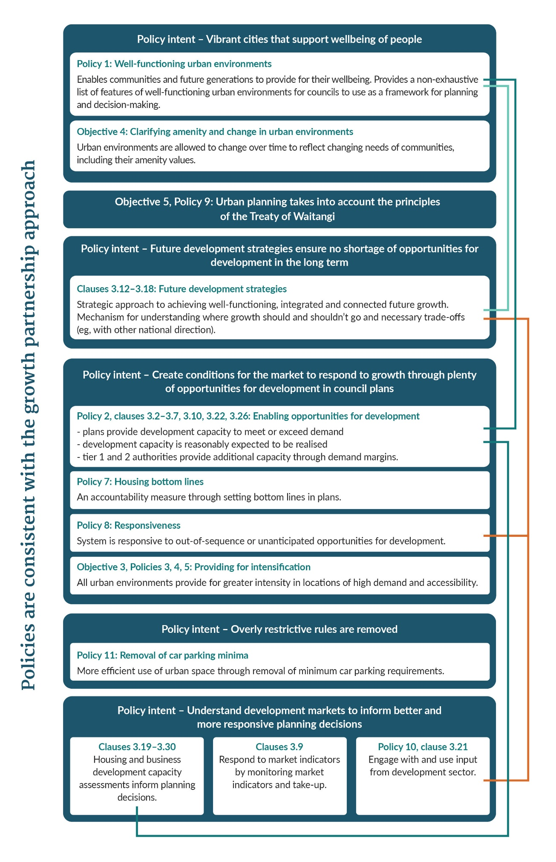

# National Policy Statement on Urban Development implementation programme

## Support provided to local authorities

The Ministry of Housing and Urban Development and the Ministry for the Environment are jointly responsible for implementing the NPS-UD, and will be working to provide effective guidance and support to local authorities. The Ministries will also use existing growth partnerships[3] to support plan change implementation, and ensure alignment.

Figure 2 shows the requirements on local authorities in terms of their regulatory response, evidence and strategic planning. Table 3 details the timeline for local authorities to meet the various requirements.

Figure : National Policy Statement on Urban Development local authority implementation actions

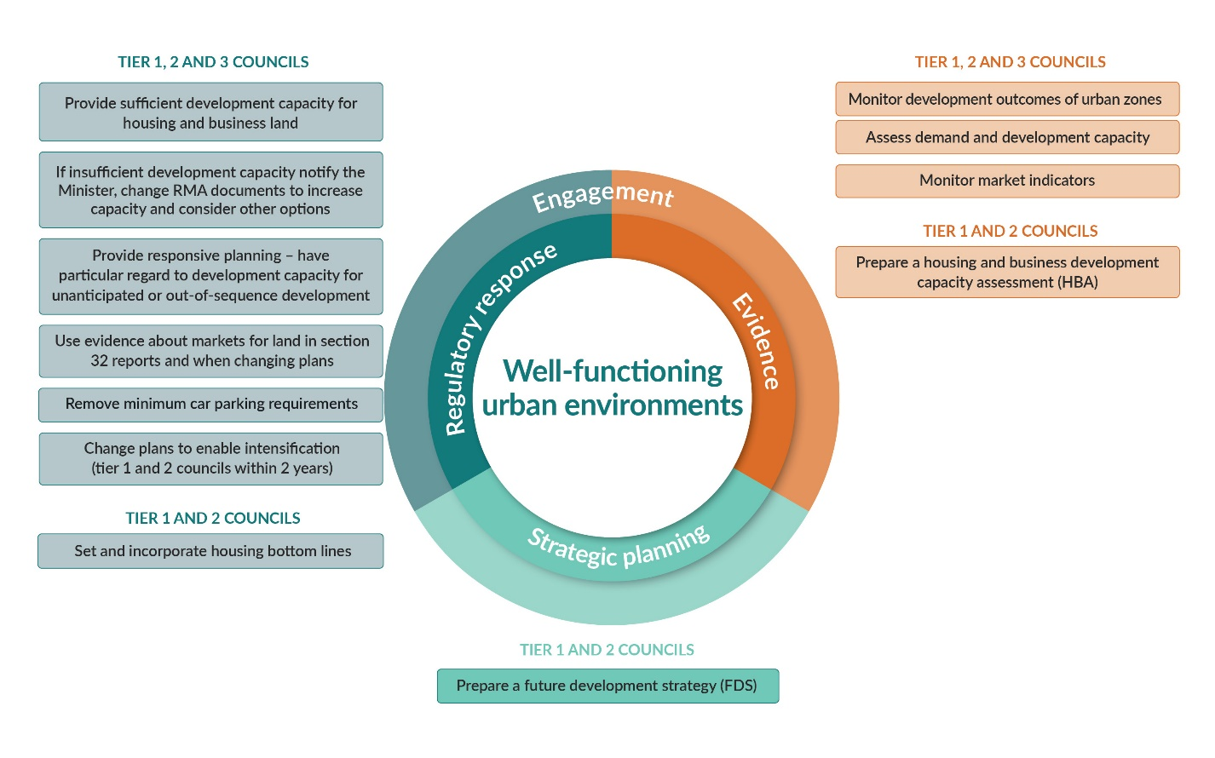

Table 3: Overview of timeline for implementing policies

| Time | Requirements |
| --- | --- |
| *Initial implementation* | |
| Immediately from commencement date (28 days following gazettal) | All objectives apply. |
| No later than 31 July 2021 | Tier 1 and 2 local authorities have completed the housing assessment aspect of the new housing and business development capacity assessment (HBA). |
| 18 months from commencement date | Tier 1, 2 and 3 territorial authorities have removed provisions in plans relating to minimum parking rates. |
| Two years from commencement date | Tier 1 and 2 local authorities have notified plan changes implementing intensification policies. |
| As soon as practicable | Tier 3 local authorities have notified plan changes implementing intensification policies. |
| In time to inform 2024 long-term plans | * Tier 1 and 2 local authorities have completed HBAs. * Tier 1 and 2 local authorities have prepared or reviewed future development strategies (FDSs). |
| *Ongoing timeframes* | |
| Quarterly | * Tier 1, 2 and 3 local authorities must monitor housing indicators. * Tier 1 local authorities must also monitor development uptake in medium- and high-density zones. |
| At least annually | Tier 1, 2 and 3 local authorities must publish the results of their monitoring. |
| As soon as practicable and within 12 months of publishing the relevant monitoring report | Tier 1 territorial authorities evaluate zone rules, where uptake is not meeting the development outcomes anticipated and notify plan changes if required. |
| Every three years | * Tier 1 and 2 local authorities update HBAs to inform FDSs, long-term plans, infrastructure strategies. * Tiers 1 and 2 local authorities update FDSs. |
| Every six years | Tier 1 and 2 local authorities prepare new FDSs. |

The Ministry for the Environment and the Ministry for Housing and Urban Development will continue to engage with local authorities to provide support on specific areas and will issue further guidance where required. Where additional guidance is required it will be provided ahead of policy deadlines, to ensure local authorities can deliver the intended outcomes. The Ministries will also ensure collaboration across central government agencies within the Urban Growth Agenda (UGA) work programme.

## Monitoring, compliance and enforcement

The Ministry of Housing and Urban Development and the Ministry for the Environment will monitor the effectiveness of the NPS-UD in achieving its intent and objectives, as well as in contributing to the objectives of the UGA.

The Ministries will report to the Minister for the Environment and Minister for Urban Development on the NPS-UD. This will be informed by information gathered, including:

* decisions relating to urban development to meet the NPS-UD requirements
* local authorities’ completion, timeliness and quality of required products such as HBAs and FDSs
* required reporting, including bottom lines and monitoring of housing and development markets
* whether councils contact Ministers regarding a lack of capacity, as they are required to do.

The Ministry for the Environment’s National Monitoring System (NMS) will play an important role in data gathering. The NMS collects data from all local authorities on their RMA processes, including any plan changes needed to implement national direction, such as the NPS-UD. Other information will be gathered from local authorities. Ongoing relationships, including strategic partnerships, will be a particularly valuable source of information on implementation progress, as well as potentially helping resolve compliance issues.

## Interactions with other national direction

Four other areas of national direction are currently being developed: freshwater management, highly productive land, indigenous biodiversity, and air quality. These areas of national direction will work alongside the NPS-UD, and involve particular consideration of effects (the FDS is one area where this consideration will be made).

Officials developing these instruments have worked to reduce the complexity and clarify the intended outcomes of the different areas of national direction.

## Review of the National Policy Statement on Urban Development

The Minister of the Environment intends to review the NPS-UD within five years of its commencement, as indicated in the regulatory impact statement. The review will draw on the monitoring and evaluation done under the NPS-UD, and through broader UGA monitoring and ongoing engagement with local authorities and other central government agencies. Other ongoing monitoring of the NPS-UD will also be in place, as outlined above.

1. For more information on the UGA see <https://www.hud.govt.nz/urban-development/urban-growth-agenda/>
2. Defined in the NPS-UD as any area of land (regardless of size, and irrespective of local authority or statistical boundaries) that: (a) is, or is intended to be, predominantly urban in character; and (b) is, or is intended to be, part of a housing and labour market of at least 10,000 people.
3. For more information on these partnerships see <https://www.hud.govt.nz/urban-development/urban-growth-agenda/>