

Housing and business development capacity assessments, monitoring requirements, and providing development capacity
This is part of a series of seven fact sheets that give an overview of the National Policy Statement on Urban Development (NPS-UD). This fact sheet provides information on objectives 2 and 7, policy 2, policy 7 and subparts 1, 3, 5 and 7 of Part 3.
These provisions come into force on commencement of the NPS-UD.

Purpose
This direction is to ensure that local authorities provide at least sufficient development capacity to meet demand for housing and business land, and have robust and frequently updated information on the supply and demand for housing and business land. These policies are designed to work together to enable well informed planning decisions and at least sufficient development capacity. The purpose of each subpart is outlined below.

Policy 2, and Part 3, subpart 1 – Providing development capacity
The NPS-UD requires tier 1, 2 and 3 local authorities to provide at least sufficient development capacity for housing and business land, to ensure there is sufficient developable land to meet demand, plus a competitiveness margin for tier 1 and 2 local authorities (clause 3.22). Subpart 1 describes the requirements for development capacity for both housing and business land, as well as requirements to insert bottom lines in regional policy statements and district plans that clearly state the amount of development capacity needed to meet expected housing demand (plus the appropriate competitiveness margin).

Part 3, subpart 3 – Evidence-based decision-making
Tier 1, 2 and 3 local authorities are required to monitor available data on business land and a set of key housing market indicators quarterly, and publish the results at least annually. This will provide local authorities with a robust and frequently updated evidence base that can be used to inform planning decisions, future development strategies, and to ensure at least enough development capacity is enabled at all times.

Part 3, subpart 5 – Housing and business development capacity assessments
Tier 1 and 2 local authorities need to prepare housing and business development capacity assessments (HBAs) every three years, to ensure their planning decisions are well-informed by the demand and supply of housing and business land. This will mean planning is based on evidence, and that local authorities understand their development market. HBAs will help inform Local Government Act 2002 long-term plans, future development strategies and RMA planning documents.

Part 3, subpart 7 – Ensure development outcomes for zones are achieved
The HBA policy is supported by requirements for tier 1 territorial authorities to monitor development within certain zones against the development outcomes expected (see clause 3.37 and the monitoring requirements in clause 3.9(2)). This will help territorial authorities understand if the cumulative effect of rules and spatial layers (overlays) is preventing zone outcomes from being achieved and limiting development capacity. This will provide evidence to inform subsequent plan changes to increase development capacity or to address other factors preventing zone outcomes from being achieved.

Requirements
The key requirements of local authorities are outlined below for each subpart.

Subpart 5 – Housing and business development capacity assessments
Tier 1, 2 and 3 local authorities must assess the demand for housing and business land in their urban environments, and determine how much development capacity is needed to sufficiently meet that demand (clause 3.10). Tier 1 and 2 local authorities must do this by preparing an HBA for their urban environment, that:
- analyses the affordability and competitiveness of the housing market and the impact of planning decisions and infrastructure on this market
- estimates demand for housing and business land, by type and location, in the short, medium and long term
- quantifies development capacity for housing and its feasibility and what is reasonably expected to be realised in the short, medium and long term
- provides the basis for ‘bottom lines’ for sufficient housing development capacity
- quantifies development capacity for business land and its suitability in the short, medium and long term
- quantifies any insufficiencies in development capacity for housing or business land, and whether the shortfalls are due to planning or infrastructure constraints.
HBAs prepared by tier 2 local authorities may present a simpler assessment of feasible housing development capacity and simpler business land demand projections than tier 1 HBAs.
Local authorities that share an urban environment must work together on their HBA. HBAs must be prepared three-yearly in time to inform long-term plans. The next HBA must be published as soon as practicable, but before 31 July 2021. It may update only the housing part of the assessment. An HBA relating to both the housing and business land must be made publicly available in time to inform long-term plans in 2024.

Subpart 3 – Evidence-based decision-making
Tier 1, 2 and 3 local authorities must monitor a range of indicators in relation to each of their urban environments. Monitoring must be done quarterly, and results published at least annually. The indicators include:
- demand, supply, price and rents of dwellings
- housing affordability
- realised housing capacity in brownfield and greenfield areas
- available data on business land.
In addition to these monitoring requirements, when preparing or changing RMA planning documents that affect urban development, local authorities must use evidence about land and development markets (including any relevant HBAs) to assess the impact of different options for urban development. Local authorities must demonstrate this analysis in the relevant section 32 and 32AA evaluation reports.
Tier 1 territorial authorities have additional monitoring requirements. They must monitor the proportion of development capacity that is realised in zones specified in clause 3.37(1), which are higher-density zones. This is to ensure that the outcomes described by the zone objectives are being achieved.
Local authorities sharing an urban environment are jointly responsible for monitoring.

Subpart 1 – Providing development capacity
Tier 1, 2 and 3 local authorities are required to ensure their planning documents provide sufficient development capacity to meet expected demand for housing (categorised by type and location) in the short, medium, and long term. The same requirement exists for business capacity, but demand must be categorised by business sector. It is important to note these requirements are not a target, but a minimum that local authorities must provide.
Local authorities with jurisdiction over tier 1 or 2 urban environments must produce housing bottom lines. A housing bottom line is the amount of development capacity that is sufficient to meet demand plus the competitiveness margin. For regional councils this means inserting housing bottom lines into regional policy statements for the short, medium, and long term. For territorial authorities the same is required but for district plans. Figure 1 outlines the requirements of local authorities:

Figure 1: Local authority requirements for providing development capacity
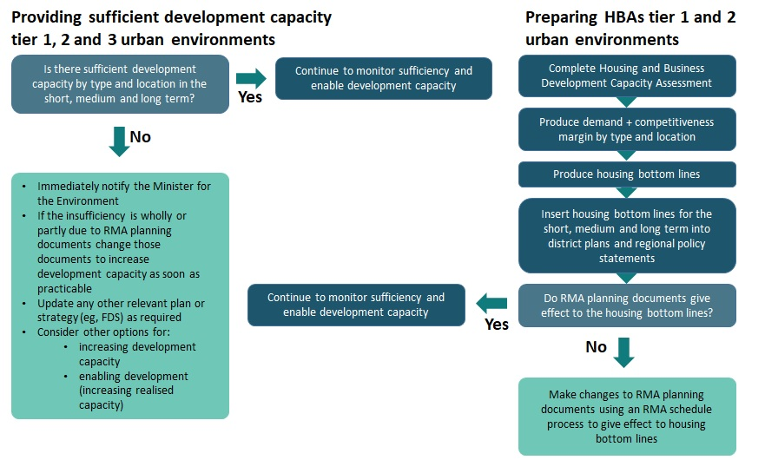
What has changed from the National Policy Statement on Urban Development Capacity?
While the policies are worded differently, the NPS-UD includes many of the same requirements that were included in the National Policy Statement on Urban Development Capacity 2016 (NPS-UDC) in relation to HBAs, evidence-based decision-making and providing development capacity requirements. Key changes and differences are outlined below.

Housing and business development capacity assessment
The following are the new or substantively different HBA policies.
- All HBAs must be completed in time to inform long-term plans.
- There are different assessment requirements for tier 1 and tier 2 local authorities.
- HBAs must include an analysis of the affordability and competitiveness of housing markets and the impact of planning and infrastructure on these markets.
- HBAs must present a range of housing demand projections, and tier 1 HBAs must present a range of business land demand projections.
- HBAs may estimate the long term feasibility of housing development capacity by changing the current relationship between costs and revenue.
- HBAs are required to assess the ‘suitability’ of development capacity for business land, rather than its feasibility or take-up.
- HBAs include a margin for competition in the calculation of sufficient development capacity for housing and business land.
- The sufficiency of housing development capacity must be assessed by type and location.
- The assessment must be used to inform housing bottom lines.
- The analysis of the housing market needs to include an assessment of how well the current and likely future demands for housing by Māori and other groups in the community are met, including the demand for different types and forms of housing (including, but not limited to papakāinga).

Evidence-based decision-making
The following are new or substantively different policies.
- Tier 3 local authorities are now required to monitor housing and business market indicators just like tier 1 and 2 local authorities.
- The monitoring must be done quarterly, and results published annually (previously this was a recommendation not a requirement).
- Tier 1 territorial authorities are now required to monitor the proportion of development realised in each zone identified in clause 3.37(1).
- When making plans that affect urban development and preparing section 32 and 32AA evaluation reports, local authorities must use evidence from monitoring and HBAs to assess the impacts of regulatory and non-regulatory options for urban development. They must consider how these options contribute to well-functioning urban environments and to providing at least sufficient development capacity.

Providing development capacity
The main changes in the NPS-UD are that development capacity has been redefined, housing bottom lines have been introduced and there are new measures to follow if there is insufficient development capacity.
In the NPS-UDC, local authorities were required to provide development capacity that was plan-enabled, infrastructure serviced and commercially feasible. NPS-UD replaces this with provisions stating that development capacity for housing must be ‘reasonably expected to be realised’. Development capacity for business land must be plan-enabled, infrastructure-ready and ‘suitable’ to meet the demand for different business sectors.
It builds on the concept of ‘take-up of development capacity’ that was in the NPS-UDC (guidance released for the NPS-UDC discusses take-up). The ‘reasonably expected to be realised’ provision recognises that not all commercially feasible land will be realised, for many reasons. For example, landowners’ preferences may mean that development capacity is not put on the market to be developed. Clause 3.26 allows local authorities flexibility to determine how to model ‘feasible and reasonably expected to be realised development capacity’, but they must outline and justify their methods, inputs and assumptions.
HBAs produced under the NPS-UDC found that some local authorities had enough feasible development capacity, but that this was not being developed (realised). This meant that the policy did not lead to sufficient housing or commercial development. Therefore, the concept of ‘reasonably expected to be realised’ is now factored into development capacity under the NPS-UD.
Figure 2 illustrates that there can be an array of plan-enabled, infrastructure ready and commercially feasible land, but only some of that is reasonably expected to be realised. The diagram also highlights that there is generally more commercially feasible land than reasonably expected to be realised development. Local authorities are likely to have to provide more capacity than under the NPS-UDC. It is important to note that figure 2 is a stylised diagram and in reality, the relative sizes and overlapping of circles will be more complicated.
Figure 2: Development capacity
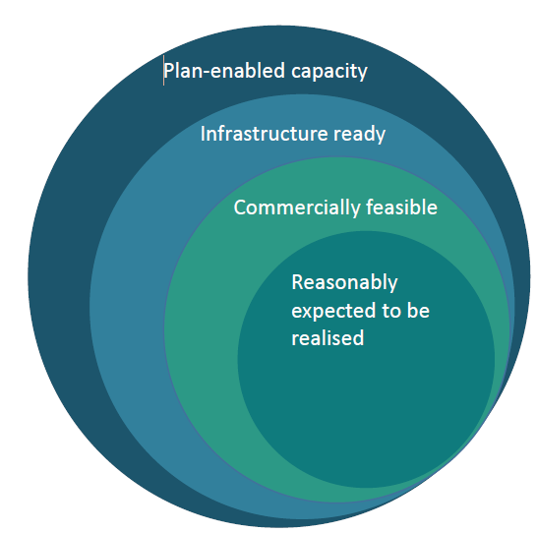

Insufficient development capacity
The NPS-UD adds a requirement for local authorities to notify the Minister for the Environment if there is insufficient development capacity. This policy has been included to alert central government to potential constraints on development capacity.

Integrated policies
The new housing bottom lines policy requires local authorities to put the amount of development capacity sufficient to meet housing demand plus the competitiveness margin from their HBAs into their regional policy statements and district plans. This policy was introduced to integrate evidence into planning processes at a regional and district level, providing a link between RMA planning documents and the development capacity evidence base. The process for implementing this is outlined in figure 1 above.

Additional support
Government will support local authorities to implement these requirements by providing:
- written guidance on methods for meeting the housing assessment requirements and monitoring requirements, to be released at commencement of the NPS-UD
- written guidance on the business land assessment requirements to be released later in 2020
- facilitation of a central government-local government evidence network to share good practice
- an interactive online dashboard of housing market data and indicators
- all past HBAs and evaluations on the Ministry of Housing and Urban Development’s website
- formal written evaluation of the next HBAs
- evidence and monitoring report templates.
It is important to note there has been extensive guidance provided on each of the subparts discussed above in conjunction with the NPS-UDC. Although the policies have been reworded, the NPS-UDC guidance is still relevant. The written guidance to be released with the NPS-UD will only focus on new and amended policies. For those sections that are unchanged, the NPS-UDC guidance is still useful and relevant and can be found on the Ministry for the Environment’s website.

Fact sheets in this series
This is one of a series of seven fact sheets providing an overview of the National Policy Statement on Urban Development.
The full set of fact sheets is available on our website: www.mfe.govt.nz/about-national-policy-statement-urban-development.
Find out more
Contact the Ministry for the Environment by emailing npsurbandevelopment@mfe.govt.nz, or visit: www.mfe.govt.nz/contact.

Disclaimer
The information in this publication is, according to the Ministry for the Environment’s best efforts, accurate at the time of publication. The information provided does not alter the laws of New Zealand and other official guidelines or requirements. Users should take specific advice from qualified professional people before undertaking any action as a result of information obtained from this publication.
The Ministry for the Environment does not accept any responsibility or liability whether in contract, tort, equity or otherwise for any action taken as a result of reading, or reliance placed on the Ministry for the Environment because of having read any part, or all, of the information in this publication or for any error, or inadequacy, deficiency, flaw in or omission from the information provided in this publication.
Published in July 2020 by the
Ministry for the Environment
Publication number: INFO 960




