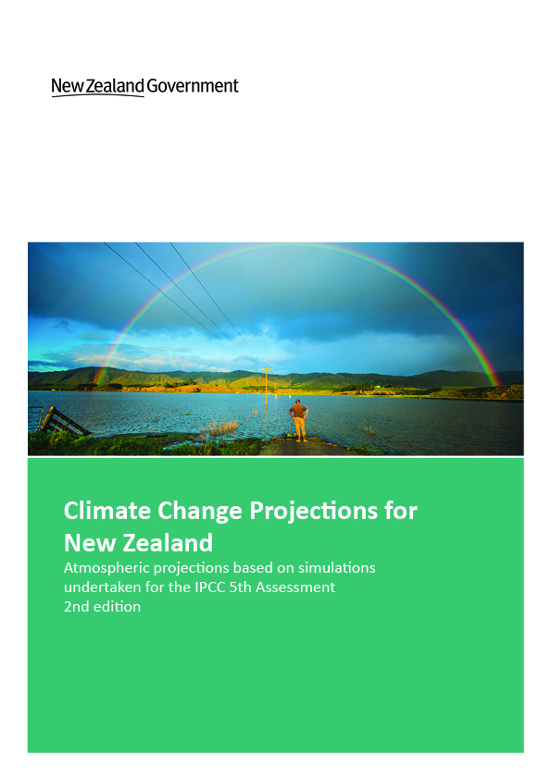
Acknowledgements
Prepared for the Ministry for the Environment by Mullan B, Sood A, Stuart S, Carey-Smith T, National Institute of Water and Atmospheric Research (NIWA).

This report may be cited as:
Ministry for the Environment 2018. Climate Change Projections for New Zealand: Atmosphere Projections Based on Simulations from the IPCC Fifth Assessment, 2nd Edition. Wellington: Ministry for the Environment.

This 2018 “2nd Edition” is the same as the original 2016 report, except for incorporation of results from a 2018 report on very extreme rainfall – the “HIRDS” report (Carey-Smith et al., 2018).

Published in September 2018 by the
Ministry for the Environment
Manatū Mō Te Taiao
PO Box 10362, Wellington 6143, New Zealand
ISBN: 978-1-98-852587-7
Publication number: ME 1385
© Crown copyright New Zealand 2018
This document is available on the Ministry for the Environment website: www.mfe.govt.nz.

Contents
Executive summary 13
Summary of findings 14
1 Introduction 19
2 CMIP5 scenarios, models and downscaling approaches 22
2.1 Concentration pathways 22
2.2 CMIP5 models 23
2.3 Statistical downscaling 27
2.4 Dynamical downscaling 27
2.5 Evapotranspiration and drought 30
3 Projected changes in New Zealand atmospheric climate 32
3.1 Patterns of change 33
3.2 Mean temperature projections 34
3.3 Maximum and minimum temperature projections 55
3.4 Comparing changes in New Zealand versus global temperatures 73
3.5 Limits and uncertainty in New Zealand warming 74
3.6 Precipitation projections 75
3.7 Pressure and wind 100
3.8 Evapotranspiration and drought 107
3.9 Other climate variables 110
Glossary of abbreviations and terms 124
References 127
Appendix A: Potential evapotranspiration deficit and relative humidity 131

Tables
Table 1: Main features of New Zealand climate change projections. 17
Table 2: List of AR5 model data on NIWA CMIP5 archive that contains at least the monthly variables psl (mean sea-level pressure), pr (precipitation) and tas (air temperature at the surface), which are all required for the statistical downscaling 24
Table 3: Periods of the regional climate model (RCM) simulations, for each the six CMIP5 models and pathways. Four models go beyond 2100, and so are available for 2110 projections. The ranks are taken from Table 4 29
Table 4: List of AR5 models used in this report showing their overall ranking (1=best) on 63 validation metrics over the historical period, and their local ‘climate sensitivity’ based on raw global climate model air temperature changes (in degrees celsius) from 1986–2005 to 2081–2100, averaged over 33–48°S, 160–190°E, for each RCP 35
Table 5: Projected changes in seasonal and annual mean temperature (in °C) between 1986–2005 and 2031–2050, by region, as derived from statistical downscaling. The changes are given for four RCPs (8.5, 6.0, 4.5 and 2.6), where the ensemble-average is taken over (41, 18, 37, 23) models respectively 38
Table 6: As Table 5, but for projected changes between 1986–2005 and 2081–2100. Also included are the 2081–2100 annual global projections from the IPCC (Collins et al, 2013) 39
Table 7: As Table 5, but for projected changes between 1986–2005 and 2101–2120 41
Table 8: Average number of ‘hot days’ per year (maximum temperature ≥25°C), by region, for the present day (1986–2005) and for two future periods (2040, 2090) under the four RCPs. The averages are calculated over all models but only for VCSN grid-points below 500 metres altitude. Results are based on statistical downscaled projections 68
Table 9: Average number of ‘cold nights’ per year (minimum temperature ≤0°C), by region, for the present day (1986–2005) and for two future periods (2040, 2090) under the four RCPs. The averages are calculated over all models but only for VCSN grid-points below 500 metres altitude. Results are based on statistical downscaled projections 69
Table 10: Projected changes in seasonal and annual precipitation (in percentage) between 1986–2005 and 2031–50, by region, as derived from statistical downscaling. The changes are given for four RCPs (8.5, 6.0, 4.5 and 2.6), where the ensemble-average is taken over (41, 18, 37, 23) models respectively 76
Table 11: As Table 10, but for changes between 1986–2005 and 2081–2100 79
Table 12: As Table 10, but for changes between 1986–2005 and 2101–10 82
Table 13: Percentage change factors to estimate the increase in rainfall depth that is expected to result from a 1 degree increase in temperature. 100
Table 14: New Zealand land-average temperature increase, in degrees, relative to 1986—2005 for four future emissions scenarios to be used with percentage change factors for extreme rainfall 100

Figures
Figure 1: Comparison of New Zealand and global annual surface air temperature anomalies (in °C) over land, relative to a 1981–2010 baseline 20
Figure 2: Atmospheric carbon dioxide concentrations for the IPCC Fourth Assessment (dotted lines, SRES concentrations) and for the IPCC Fifth Assessment (solid lines, RCP concentrations) 23
Figure 3: Surface air temperature variations from 1900 to 2005, relative to 1986–2005, for 41 historical model simulations as averaged over the “New Zealand box” (land and ocean, 33–48°S by 160–190°E, used for the statistical downscaling), and for the New Zealand seven-station series (land only, NZT7) 26
Figure 4: Bias-adjusted sea surface temperatures, averaged over the RCM domain, for six CMIP5 global climate models, and for the historical simulations (here 1960–2005) and four future simulations (RCPs 2.6, 4.5, 6.0 and 8.5), relative to 1986–2005 28
Figure 5: The most common patterns of annual temperature (left) and precipitation (right) change between 1995 (1986–2005) and 2090 (2081–2100), as assessed from the statistical downscaling results. The temperature pattern is the ensemble average of 24 models, and precipitation of 26 models (out of 41), for the 2090 projected changes under RCP8.5 33
Figure 6: Map of New Zealand showing the 15 regions over which temperature projections are averaged. Place names (and green dots) identify those sites for which precipitation projections are calculated 34
Figure 7: Projected New Zealand-average temperatures relative to 1986–2005, for six CMIP5 global climate models, and for the historical simulations (here 1971–2005) and four future simulations (RCPs 2.6, 4.5, 6.0 and 8.5) 36
Figure 8: Seasonal changes in mean temperature (in °C), derived by statistically downscaling CMIP5 models, for three future time periods under RCP2.6 44
Figure 9: Seasonal changes in mean temperature (in °C), derived by statistically downscaling CMIP5 models, for three future time periods under RCP4.5. Note the change of scale from Figure 8 45
Figure 10: Seasonal changes in mean temperature (in °C), derived by statistically downscaling CMIP5 models, for three future time periods under RCP6.0. No 2110 projections are calculated 46
Figure 11: Seasonal changes in mean temperature (in °C), derived by statistically downscaling CMIP5 models, for three future time periods under RCP8.5 47
Figure 12: Seasonal changes in mean temperature (in °C), derived by downscaling CMIP5 models via NIWA’s regional climate model, for three future time periods under RCP2.6. Results are for the average over six RCMs, except for 2110 (see Table 3). The colour scale is the same as for Figure 8 48
Figure 13: Seasonal changes in mean temperature (in °C), derived by downscaling CMIP5 models via NIWA’s regional climate model, for three future time periods under RCP4.5. Note the change of scale from Figure 12 49
Figure 14: Seasonal changes in mean temperature (in °C), derived by downscaling CMIP5 models via NIWA’s regional climate model, for three future time periods under RCP6.0 50
Figure 15: Seasonal changes in mean temperature (in °C), derived by downscaling CMIP5 models via NIWA’s regional climate model, for three future time periods under RCP8.5 51
Figure 16: Projected temperature changes for Hawke’s Bay Region, for 2040 (top panel) and 2090 (bottom panel), for all seasons (plus annual), all RCPs (vertical bars) and all models (coloured stars), as derived by statistical downscaling. The black stars correspond to the six-model RCM-downscaling, and the horizontal bars the average over all downscaled results (statistical and RCM) 53
Figure 17: Projected temperature changes for all regional council areas for 2090, for summer (top panel) and winter (bottom panel) seasons, for all RCPs (bars) and all models (coloured stars), as derived by statistical downscaling. The black stars correspond to the six-model RCM-downscaling 54
Figure 18: Seasonal changes in daily maximum temperature (in °C), derived by downscaling six CMIP5 models via NIWA’s regional climate model, for three future time periods under RCP2.6. Results are for the average over six RCMs, except for 2110 (see Table 3) 56
Figure 19: Seasonal changes in daily minimum temperature (in °C), derived by downscaling six CMIP5 models via NIWA’s regional climate model, for three future time periods under RCP2.6 57
Figure 20: Seasonal changes in diurnal temperature range ((Tmax minus Tmin, in °C), derived by downscaling CMIP5 models via NIWA’s regional climate model, for three future time periods under RCP2.6 58
Figure 21: Seasonal changes in daily maximum temperature (in °C), derived by downscaling CMIP5 models via NIWA’s regional climate model, for three future time periods under RCP4.5 59
Figure 22: Seasonal changes in daily minimum temperature (in °C), derived by downscaling CMIP5 models via NIWA’s regional climate model, for three future time periods under RCP4.5 60
Figure 23: Seasonal changes in diurnal temperature range ((Tmax minus Tmin, in °C), derived by downscaling CMIP5 models via NIWA’s regional climate model, for three future time periods under RCP4.5 61
Figure 24: Seasonal changes in daily maximum temperature (in °C), derived by downscaling CMIP5 models via NIWA’s regional climate model, for three future time periods under RCP6.0 62
Figure 25: Seasonal changes in daily minimum temperature (in °C), derived by downscaling CMIP5 models via NIWA’s regional climate model, for three future time periods under RCP6.0 63
Figure 26: Seasonal changes in diurnal temperature range ((Tmax minus Tmin, in °C), derived by downscaling CMIP5 models via NIWA’s regional climate model, for three future time periods under RCP6.0 64
Figure 27: Seasonal changes in daily maximum temperature (in °C), derived by downscaling CMIP5 models via NIWA’s regional climate model, for three future time periods under RCP8.5 65
Figure 28: Seasonal changes in daily minimum temperature (in °C), derived by downscaling CMIP5 models via NIWA’s regional climate model, for three future time periods under RCP8.5 66
Figure 29: Seasonal changes in diurnal temperature range ((Tmax minus Tmin, in °C), derived by downscaling CMIP5 models via NIWA’s regional climate model, for three future time periods under RCP8.5 67
Figure 30: Number of days per year of ‘hot days’ (maximum temperature of 25°C or above, top row) and ‘cold nights’ (minimum temperature of 0°C or below, bottom row): ‘current’ climate (1986–2005), left; 2090 climate under RCP8.5 (right) 70
Figure 31: RCM-projected increases in the annual number (in days) of ‘hot days’ (25°C or above), with respect to the baseline 1995 period, for all four RCPs and three future time periods. Results are for the average over six RCMs, except for 2110 (see Table 3) 71
Figure 32: RCM-projected changes in the annual number (in days) of ‘cold nights’ (0°C or below), with respect to the baseline 1995 period, for all four RCPs and three future time periods, as averaged over six RCMs. Note that the changes are all negative 72
Figure 33: Temperature changes relative to the 1986–2005 baseline under RCP 8.5, from 34 GCMs with archived sea temperature data (Table 2) 73
Figure 34: Time series of air temperature anomalies: seven-station series of New Zealand land temperature (black line) and its linear extrapolation to 2100 (dashed black line); historical air temperatures over the New Zealand ‘box’ for 1900–2005 (purple histogram), as simulated by 41 GCMs; simulations of future projected New Zealand box air temperatures for RCP2.6 (blue) and RCP8.5 (orange) 74
Figure 35: Fraction of models where the New Zealand-region air temperature increase exceeds 1°C, relative to 1986–2005, for the RCPs 2.6, 4.5, 6.0 and 8.5, as calculated by counting the number of models at each year (of a smoothed time series) that exceed the nominated threshold out of a total of 23, 37, 18 and 41 models, respectively 75
Figure 36: Seasonal changes in precipitation (in per cent), derived by statistically downscaling CMIP5 models, for three future time periods under RCP2.6 85
Figure 37: Seasonal changes in precipitation (in per cent), derived by statistically downscaling CMIP5 models, for three future time periods under RCP4.5 86
Figure 38: Seasonal changes in precipitation (in per cent), derived by statistically downscaling CMIP5 models, for three future time periods under RCP6.0 (no 2110 projections presented) 87
Figure 39: Seasonal changes in precipitation (in per cent), derived by statistically downscaling CMIP5 models, for three future time periods under RCP8.5 88
Figure 40: Seasonal changes in precipitation (in per cent), derived by downscaling CMIP5 models via NIWA’s regional climate model, for three future time periods under RCP2.6. Results are for the average over six RCMs, except for 2110 (see Table 3) 89
Figure 41: Seasonal changes in precipitation (in per cent), derived by downscaling CMIP5 models via NIWA’s regional climate model, for three future time periods under RCP4.5 90
Figure 42: Seasonal changes in precipitation (in per cent), derived by downscaling CMIP5 models via NIWA’s regional climate model, for three future time periods under RCP6.0 91
Figure 43: Seasonal changes in precipitation (in per cent), derived by downscaling CMIP5 models via NIWA’s regional climate model, for three future time periods under RCP8.5 92
Figure 44: Projected precipitation changes for Napier, for 2040 (top panel) and 2090 (bottom panel), for all seasons (plus annual), all RCPs (vertical bars) and all models (coloured stars), as derived by statistical downscaling. The black stars correspond to the six-model RCM-downscaling, and the horizontal bars the average over all downscaled results (statistical and RCM) 93
Figure 45: Projected precipitation changes for selected sites within all regions for 2090, for summer (top panel) and winter (bottom panel) seasons, for all RCPs (bars) and all models. Coloured stars refer to statistical downscaling, whereas the black stars correspond to the six-model RCM-downscaling 94
Figure 46: RCM-projected changes in the annual number (in days) of ‘dry days’ (precipitation below 1 millimetre/day), with respect to the baseline 1995 period, for all four RCPs and three future time periods. Results are for the average over six RCMs, except for 2110 (see Table 3) 97
Figure 47: Change in the magnitude of the 99th percentile of daily precipitation (in per cent), for all four RCPs and three future time periods, relative to the daily 99th percentile in the baseline 1986–2005 period 98
Figure 48: Change in the 50-year rainfall event magnitude for four different event durations. Each map combines all 24 different RCM simulations and shows the percentage change per degree of warming 99
Figure 49: Seasonal changes in mean sea level pressure (MSLP, in hPa) for RCP2.6 model-average (contour every 0.5 hPa) for three future time periods, and change in 10-metre wind field show by wind arrows, as derived by downscaling CMIP5 models via NIWA’s regional climate model 102
Figure 50: Seasonal changes in mean sea level pressure (MSLP, in hPa) for RCP4.5 model-average (contour every 0.5 hPa) for three future time periods, and change in 10-metre wind field show by wind arrows, as derived by downscaling CMIP5 models via NIWA’s regional climate model 103
Figure 51: Seasonal changes in mean sea level pressure (MSLP, in hPa) for RCP6.0 model-average (contour every 0.5 hPa) for three future time periods, and change in 10-metre wind field shown by wind arrows, as derived by downscaling CMIP5 models via NIWA’s regional climate model. Note that only one model (CESM1-CAM5) is available for the final period centred on 2110 104
Figure 52: Seasonal changes in mean sea level pressure (MSLP, in hPa) for RCP8.5 model-average (contour every 0.5 hPa) for three future time periods, and change in 10-metre wind field shown by wind arrows, as derived by downscaling CMIP5 models via NIWA’s regional climate model 105
Figure 53: Change in the magnitude of the 99th percentile of daily-mean wind speed, for all four RCPs and three future time periods, relative to the daily 99th percentile in the baseline 1986–2005 period 106
Figure 54: Number of days of potential evapotranspiration deficit (PED) (in millimetres accumulation over the July–June ‘water year’), exceeding 300 millimetres in a calendar year for Wairarapa, North Island; upper panel for RCP2.6, and lower panel for RCP8.5. The results from individual models are stacked where more than one model exhibits a drought risk 107
Figure 55: RCM-projected changes in potential evapotranspiration deficit (PED) (in millimetres accumulation over the July–June ‘water year’), with respect to the baseline 1995 period, for all four RCPs and three future time periods 109
Figure 56: Summer (left) and winter (right) seasonal-average solar radiation (top, in MJ m⁻² day⁻¹) and 9am relative humidity (bottom, in per cent), calculated from VCSN data over the 1986–2005 baseline period. Note that the contour intervals for solar radiation are very different between the summer and winter seasons 111
Figure 57: RCM seasonal changes in incident solar radiation at the surface (in per cent), for three future periods, under RCP2.6 112
Figure 58: RCM seasonal changes in incident solar radiation at the surface (in per cent), for three future periods, under RCP4.5 113
Figure 59: RCM seasonal changes in incident solar radiation at the surface (in per cent), for three future periods, under RCP6.0 114
Figure 60: RCM seasonal changes in incident solar radiation at the surface (in per cent), for three future periods, under RCP8.5 115
Figure 61: RCM seasonal changes in relative humidity (in per cent), for three future periods under RCP2.6 116
Figure 62: RCM seasonal changes in relative humidity (in per cent), for three future periods under RCP4.5 117
Figure 63: RCM seasonal changes in relative humidity (in per cent), for three future periods under RCP6.0 118
Figure 64: RCM seasonal changes in relative humidity (in per cent), for three future periods under RCP8.5 119
Figure 65: Projected changes in the annual number of ‘snow days’ (in days per year) for four RCPs and three time periods, averaged over up to six regional climate model simulations 121
Figure 66: Southern Oscillation Index (SOI, smoothed to remove sub-decadal variations) over period 1950–2100, interpolated from the raw CMIP5 model pressure field (to Tahiti and Darwin), under RCP8.5. The SOI time series for the six models used in NIWA’s RCM downscaling are shown as coloured lines (according to the inset legend), while all other models are shown as black dotted lines 122
Figure 67: Change in winter Southern Hemisphere storm track between 1986–2005 and 2081–2100, under RCP8.5, from a 29-member CMIP5 multi-model ensemble 123

Executive summary
The climate is changing. It is accepted internationally that further changes will result from increasing amounts of greenhouse gases in the atmosphere. The climate will also vary from year to year and decade to decade due to natural processes such as El Niño. Climate change effects over the next decades are predictable with some level of certainty, and will vary from place to place throughout New Zealand. This report addresses those expected changes in New Zealand’s climate (temperature and many other climate variables) out to 2120, and draws heavily on climate model simulations from the Intergovernmental Panel on Climate Change (IPCC) Fifth Assessment Report.
Projected overall changes for New Zealand are similar to those from the previous assessment published in 2008. This report is notable, however, for including not only predictions from interpreting global climate models but, for the first time, also those from a detailed New Zealand regional climate model run on the NIWA supercomputer. This means more interpretation of the two sets of results is required, but also allows an unprecedented level of detail and robustness in the information provided.
The mid-range estimate for projected New Zealand temperature change is for an expected increase of about 0.8°C by 2040, 1.4°C by 2090, and 1.6°C by 2110, relative to the 1986–2005 period. Owing to the different possible pathways for the concentrations of greenhouse gases in the atmosphere, however, as well as the differences in climate model response to those pathways, the possible projections for future warming span a wide range: 0.2–1.7°C by 2040, 0.1–4.6°C by 2090, and 0.3–5.0°C by 2110.
Projected changes in rainfall show a marked seasonality and variability across regions. It is very likely that for winter and spring there will be an increase in rainfall for the west of both the North and South Islands, with drier conditions in the east and north. This is a robust prediction both in 2040 and 2090, caused by the westerly winds over New Zealand increasing during these seasons. For summer it is likely that there will be wetter conditions in the east of both islands, with drier conditions in the west and central North Island.
Moderately extreme rainfall is likely to increase in most areas, with the largest increases being seen in areas where mean rainfall is also increasing, such as the West Coast. Very extreme rainfall is likely to increase in all areas with increases more pronounced for shorter duration events. Drought severity is projected to increase in most areas of the country, except for Taranaki-Manawatu, West Coast and Southland. Although these last two findings on extremes are not new, they are more robust because of more detailed regional information compared to the 2008 assessment, made possible through the inclusion of the latest regional climate modelling results.

Summary of findings
A new set of four scenarios, known as representative concentration pathways (RCPs), are used in this report. These pathways are identified by their approximate total radiative forcing at 2100 relative to 1750:
- 2.6 W m-2 for RCP2.6
- 4.5 W m-2 for RCP4.5
- 6.0 W m-2 for RCP6.0
- 8.5 W m-2 for RCP8.5.
These RCPs include:
- one mitigation pathway (RCP2.6, which requires removal of some of the CO2 presently in the atmosphere)
- two stabilisation pathways (RCP4.5 and RCP6.0)
- one pathway with very high greenhouse gas concentrations (RCP8.5).
Although the Fourth and Fifth Assessment scenarios do not correspond directly to each other, CO₂ concentrations under the Fifth Assessment RCP4.5 and RCP8.5 are very similar to those of the Fourth Assessment SRES B1 and A1FI, respectively.
Detailed projections on a 5 kilometre-grid covering New Zealand are produced by downscaling output from IPCC Fifth Assessment global climate models (GCMs). Statistical downscaling of temperature and precipitation changes is applied to between 18 and 41 GCMs, dependent on RCP. Dynamical downscaling is applied to a subset of six GCMs to produce projections for a large number of weather variables. The six GCMs selected have simulations for all four RCPs, and validate well in the New Zealand region in their historical simulations.
The main findings for these scenarios are as follows:
- The temperature projections generally increase with time and with the strength of the radiative forcing.
- By 2040 (2031–50, relative to 1986–2005), temperatures are projected to increase by between 0.7°C (RCP2.6) and 1.0°C (RCP8.5) nationally. There is a small gradient from north to south, with the northern North Island (Northland to Taranaki) ranging from 0.7°C (RCP2.6) to 1.1°C (RCP8.5), and Southland ranging from 0.6°C (RCP2.6) to 0.9°C (RCP8.5).
- By 2090 (2081–2100, relative to 1986–2005), temperatures are projected to increase by between 0.7°C (RCP2.6) and 3.0°C (RCP8.5). By 2110 (2101–20, relative to 1986–2005), temperatures are projected to increase by between 0.7°C (RCP2.6) and 3.7°C (RCP8.5).
- The warming is generally highest in summer and autumn and lowest in winter and spring. With the exception of temperature projections for RCP2.6 in the 2110 period, the warming trend is not observed to abate in any season.
- The regional climate model (RCM) warming signal has more spatial structure than the pattern produced by statistical downscaling. A strong warming signal from the RCM simulations over higher elevations is evident in all seasons, but is most prominent in the spring and summer seasons.
- The NIWA RCM simulations distinguish between day and night trends. Overall, the daily maximum temperature is expected to increase faster than the overnight daily minimum temperature, meaning that the daily temperature range (maximum minus minimum) is also expected to increase over time.
- Precipitation projections are highly variable by region and time and between models. The overall pattern in annual precipitation trend is for a reduction in the north and east of the North Island, and increases almost everywhere else, especially on the South Island’s West Coast.
- There is often no strong consensus between models on precipitation changes at the regional and seasonal scale. The clearest precipitation trends by the end of the century are for the winter season, when it is very likely (90–100 per cent) to have increases in mean precipitation under the highest radiative forcing at:
- Taumarunui
- Hokitika
- Tekapo
- Queenstown
- Invercargill.
It is likely there will be precipitation increases at:
- Ruakura
- Taupo
- New Plymouth
- Paraparaumu
- Wellington
- Blenheim
- Nelson
- Dunedin.
- In general, the spring season tends to be like winter in terms of projected precipitation changes, and autumn intermediate between summer and winter.
- The largest precipitation trends of all occur for the West Coast in the winter season, with area-average changes up to a 40 per cent increase under RCP8.5 by 2090.
- The frequency of dry days (< 1 millimetre precipitation) increases with time and RCP for much of the North Island, and for high altitude inland regions in the South Island. The frequency of dry days decreases on the west and east coastal regions in the South Island.
- Moderately extreme daily precipitation, as determined from the 99th percentile on wet days, increases over most of the country except for parts of Northland and Hawke’s Bay. Increases are small for the remainder of the North Island, larger for the South Island, and largest of all (20 per cent or more) in the south of the South Island.
- Very extreme precipitation, defined as events with a recurrence interval of 2 years or greater, increases throughout the country. Percentage increases per degree of warming range from 5% for 5-day duration events to 14% for 1-hour duration events.
- Drought intensity, as measured by potential evapotranspiration deficit (PED), is projected to increase in magnitude with increase in forcing (RCP) and time period. The strongest increases are over the northern and eastern North Island and in the lee of the main divide over the South Island, and later in the century under the strongest forcing.
- Mean sea level pressure is projected to increase over the North Island and east and south of the South Island in the summer season, resulting in more north-easterly airflow and more anticyclonic (high pressure) conditions. Pressures decrease south of New Zealand in winter, resulting in stronger mean westerlies over central and southern New Zealand.
- Daily extreme winds increase in eastern regions, especially in Marlborough and Canterbury.
- Relative humidity reduces almost everywhere, except for the West Coast in winter where there are large rainfall increases.
Additional findings are:
- Comparing the change patterns from statistical versus dynamical (RCM) downscaling, the precipitation patterns are generally comparable, particularly in the winter and spring seasons when the changes are driven by the trends in large-scale circulation. In summer and autumn, when small-scale convection can dominate, the agreement between the two downscaling approaches is not as close. For temperature, the RCM downscaling shows more spatial structure; in particular, the largest temperature increases occur consistently at high altitude South Island locations, co-located with the largest reduction in snow days.
- Air temperatures over the New Zealand region (land and sea) are projected to increase at a rate about 75 per cent of the global air temperature increase (over land and sea). Projected regional sea temperatures have a slightly smaller warming trend than the air temperatures.
- New Zealand land temperatures, as represented by NIWA’s seven-station series, have increased more slowly over the past century than global air temperatures over land (83 per cent over 1909–2015).
Table 1 summarises briefly some of the key findings of this report. Numerical values in this table refer to model averages. Chapter 3 provides much greater detail on the atmospheric climate projections, and the variation between models, from which inferences can be drawn about consistency and confidence in the projections.

Table 1: Main features of New Zealand climate change projections.
Climate variable | Direction of change | Magnitude of change | Spatial and seasonal variation
Mean temperature | Progressive increase with concentration.  Only for RCP2.6 does warming trend peak and then decline. | By 2040, from +0.7°C [RCP2.6] to +1.0°C [RCP8.5].  By 2090, +0.7°C to +3.0°C.  By 2110, +0.7°C to +3.7°C. | Warming greatest at higher elevations. Warming greatest summer/autumn and least winter/spring.
Minimum and maximum temperatures | As mean temperature. | Maximum increases faster than minimum. Diurnal range increases by up to 2°C by 2090 (RCP8.5). | Higher elevation warming particularly marked for maximum temperature.
Daily temperature extremes: frosts | Decrease in cold nights (minimum temperature of 0°C or lower). | By 2040, a 30% [2.6] to 50% [8.5] decrease.  By 2090, 30% [2.6] to 90% [8.5] decrease. | Percentage changes similar in different locations, but number of days of frost decrease (hot day increase) greatest in the coldest (hottest) regions.
Daily temperature extremes: hot days | Increase in hot days (maximum temperature of 25°C or higher). | By 2040, a 40% [2.6] to 100% [8.5] increase.  By 2090, a 40% [2.6] to 300% [8.5] increase.
Mean precipitation | Varies around the country and with season. Annual pattern of increases in west and south of New Zealand, and decreases in north and east. | Substantial variation around the country (see section 3.6.1), increasing in magnitude with increasing emissions. | Winter decreases: Gisborne, Hawke’s Bay and Canterbury.  Winter increases: Nelson, West Coast, Otago and Southland.  Spring decreases: Auckland, Northland and Bay of Plenty.
Daily precipitation extremes: dry days | More dry days throughout North Island, and in inland South Island. | By 2090 [8.5], up to 10 or more dry days per year (~5% increase). | Increased dry days most marked in north and east of North Island, in winter and spring.
Daily precipitation extremes: very wet days | Increased moderately extreme daily rainfalls, especially where mean rainfall increases. | More than 20% increase in 99th percentile of daily rainfall by 2090 [8.5] in South West of South Island. A few percentage decrease in north and east of North Island. | Increase in western regions, and in south of South Island. Decrease in extremes in parts of north and east of North Island.
Very extreme precipitation events: greater than 2-year average recurrence interval | Increase. | Percentage increases per degree of warming range from 5% for 5-day duration events to 14% for 1-hour duration events. | Little robust regional variability. Possibly larger increases in the very north and very south of the country.
Snow | Decrease. | Snow days per year reduce by 30 days or more by 2090 under RCP8.5. | Large decreases confined to high altitude or southern regions of the South Island.
Drought | Increase in severity and frequency. | By 2090 [8.5], up to 50mm or more increase per year, on average, in July–June PED. | Increases most marked in already dry areas.
Circulation | Varies with season. | Generally, the changes are only a few hectopascals, but the spatial pattern matters. | More northeast airflow in summer. Strengthened westerlies in winter.
Extreme wind speeds | Increase. | Up to 10% or more in parts of the country. | Most robust increases occur in southern half of North Island, and throughout the South Island.
Storms | Likely poleward shift of mid-latitude cyclones and possibly also a small reduction in frequency. | More analysis needed. | See section 3.7.
Solar radiation | Varies around the country and with season. | Seasonal changes generally lie between -5% and +5%. (See section 3.9.1.) | By 2090 [8.5], West Coast shows the largest changes: summer increase (~5%) and winter decrease (5%).
Relative humidity | Decrease. | Up to 5% or more by 2090 [8.5], especially in the South Island. (See section 3.9.1.) | Largest decreases in South Island in spring and summer.

1 Introduction
Global and regional climates are changing as a consequence of increasing greenhouse gas concentrations in the atmosphere. The Fifth Assessment Report of the Intergovernmental Panel on Climate Change (IPCC) (IPCC, 2013a) (the most recent) has rigorously assessed the current and future states of the climate system, and reached a number of conclusions:
- Warming of the climate system is unequivocal, and since the 1950s many of the observed changes are unprecedented over decades to millennia. The atmosphere and ocean have warmed, the amounts of snow and ice have diminished, sea level has risen, and concentrations of greenhouse gases have increased.
- The atmospheric concentrations of carbon dioxide, methane, and nitrous oxide have increased to levels unprecedented in at least the last 800,000 years. Carbon dioxide concentrations have increased by 40 per cent since pre-industrial times, primarily from fossil fuel emissions and secondarily from net land-use change emissions. The ocean has absorbed about 30 per cent of the emitted anthropogenic carbon dioxide, causing ocean acidification.
- Human influence has been detected in warming of the atmosphere and the ocean, in changes in the global water cycle, in reductions in snow and ice, in global mean sea level rise, and in changes in some climate extremes. This evidence for human influence has grown since AR4 (the Fourth Assessment) (IPCC, 2007). It is extremely likely (95–100 per cent) that human influence has been the dominant cause of the observed warming since the mid-20th century.
- Global surface temperature change for the end of the 21st century is likely (66–100 per cent) to exceed 1.5°C relative to 1850–1900 for all Representative concentration pathways except RCP2.6. It is likely to exceed 2°C for RCP6.0 and RCP8.5, and more likely than not (51–100 per cent) to exceed 2°C for RCP4.5. Warming will continue to exhibit interannual-to-decadal variability, and will not be regionally uniform.
New Zealand temperatures, as represented by the seven-station series (Mullan et al, 2010), have increased by about 1°C over the last century or so. Figure 1 shows a comparison of the seven-station annual anomaly series (NZT7) against three global anomaly series (GISS, NOAA, HadCRU4), updated to 2015. The global series apply just to land air temperature: that is, they do not include ocean temperatures, which show a smaller warming trend than land temperatures. Over 1909–2015, the linear trends are:
- +0.92°C/century (NZT7)
- +1.12°C/century (GISS)
- +1.16°C/century (NOAA)
- +1.03°C/century (CRUTEM4).
In other words, the New Zealand land air temperature trend is slightly smaller than the global land air temperature trend, warming at 83 per cent of the average trend of the three global series.
Part of the New Zealand warming trend is probably due to natural variability (Salinger & Mullan, 1999; Mullan et al, 2010), but a significant contribution to the warming can be attributed to greenhouse gas increases (Dean & Stott, 2009). The local (NZT7) series displays much larger year-to-year variability than the global series. In large part, this is due to circulation fluctuations (for example, one year with more northerly airflow and the next year with more southerlies), which are absent in the global average. Note that all four of the time series presented in Figure 1 show a cooling response to large volcanic eruptions during the century, such as Mt Agung in 1963, and Mt Pinatubo in 1991.
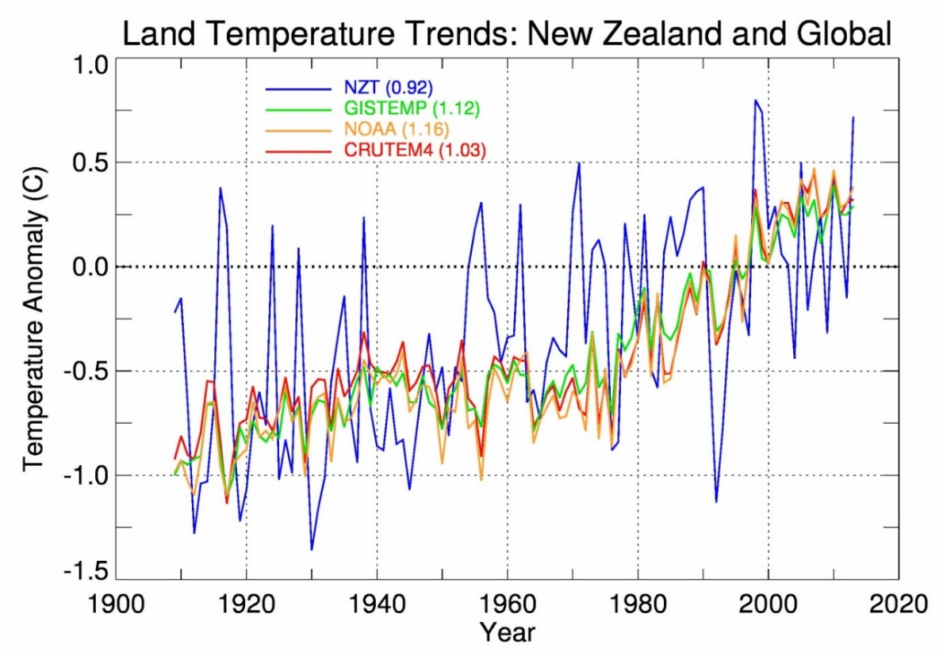
Figure 1: Comparison of New Zealand and global annual surface air temperature anomalies (in °C) over land, relative to a 1981–2010 baseline
Coloured lines refer to: New Zealand seven-station series (blue, Mullan et al 2010) and global land temperature anomalies from: NASA-GISS (green, Hansen et al 2010), NOAA-NCDC, (orange, Smith et al 2008), and CRUTEM4 (red, Jones et al 2012). The inset legend gives the 1909–2015 trends in °C per century.
This report focuses on the future changes in New Zealand climate (temperature and many other climate variables) out to 2120, and draws heavily on the IPCC Fifth Assessment Report (AR5) (IPCC 2013a) climate model simulations, which are referred to in more technical literature as the CMIP5 simulations (see Glossary for definitions of some of these terms). This report therefore updates Climate Change Effects and Impacts Assessment: A guidance manual for local government in New Zealand (Ministry for the Environment, 2008), which assessed New Zealand changes based on the IPCC Fourth Assessment (AR4, or CMIP3 simulations).
The current report differs from Ministry for the Environment (2008) in two important ways:
- The Ministry for the Environment (2008) report included a large amount of guidance material on how regional government might interpret and apply the climate projections (Chapters 4 and 5), undertake risk assessments (Chapter 6), and incorporate the projections into planning decisions (Chapter 7). We consider this material to be excellent guidance, and still completely relevant to the new projections. Therefore, it is not included in the current report, but should be referred to by regional government for all the issues mentioned above.
- This report focuses on the more recent AR5 projections rather than AR4 projections (Ministry for the Environment, 2008). Climate models have improved since the AR4. IPCC (2013a) notes that “models reproduce observed continental-scale surface temperature patterns and trend over many decades, including the more rapid warming since the mid-20th century and the cooling immediately following large volcanic eruptions”. Many more global model projections are available from AR5 compared to AR4. This gives us a much larger sample to assess New Zealand changes, and generally increases our confidence in the likely range of impacts. Also, simulations from NIWA’s regional climate model (RCM) are used much more extensively than in the previous report (Ministry for the Environment, 2008).
This report also includes a section on future drought severity, which extends earlier work based on AR4 model projections by Clark et al (2011).
Other climate change reports are currently in preparation, dealing with issues of:
- hydrological impacts on river flows, driven by the RCM precipitation and other changes described in this report
- sea level rise and coastal impacts
- return periods of extreme precipitation, used extensively for engineering applications.

2 CMIP5 scenarios, models and downscaling approaches
- This report considers the consequences for the future New Zealand climate of four concentration pathways from the Intergovernmental Panel on Climate Change (IPCC) Fifth Assessment (IPCC, 2013a). The pathways are known as representative concentration pathways (RCPs), and abbreviated as RCP2.6, RCP4.5, RP6.0, and RCP8.5, in order of increasing radiative forcing by greenhouse gases.
- The number of global climate model (GCM) simulations available to the IPCC varies with the RCP selected. In this report, the maximum numbers of GCMs are:
– 41 (‘historical period’, 1800s to 2005)
– 23 (RCP2.6)
– 37 (RCP4.5)
– 18 (RCP6.0)
– 41 (RCP8.5).
The future simulations begin in 2006, and extend beyond 2100 in many cases. Statistical downscaling has been applied to temperature and precipitation projections from all available models.
- Six GCMs have been selected for dynamical downscaling; that is, sea surface temperatures from six models are used to drive an atmospheric global model, which in turn drives a higher resolution regional climate model (RCM) over New Zealand. The six models are chosen to validate well on present climate, and to be as different as possible in the parent global model, so as to span the likely range of model sensitivity. The output data fields are further downscaled to an approximate 5 kilometre grid, and bias-corrected relative to a 1986–2005 climatology.

2.1 Concentration pathways
The global climate models (GCMs) used to make future climate change projections require information about future concentrations of greenhouse gases and aerosols. The latest development in GCMs, known as earth system models (ESMs), also need information on land-use changes that are consistent with socio-economic developments through the century. To date, such scenarios have not included information on possible future volcanic eruptions or changes in solar radiation; even though it is clear that such fluctuations will occur, the timing over the century cannot be specified.
For the IPCC Fourth Assessment (IPCC, 2007), a set of scenarios known as the SRES scenarios were used. This acronym was taken from the IPCC report which developed the scenarios, the special report on emissions scenarios (Nakicenovic & Swart, 2000). Climate Change Effects and Impacts Assessment: A guidance manual for local government in New Zealand (Ministry for the Environment, 2008) gives an overview of the SRES scenarios in Appendix 1.
For the IPCC Fifth Assessment, a new set of four forcing scenarios was developed, known as representative concentration pathways (RCPs) (van Vuuren et al, 2011a). These pathways are identified by their approximate total (accumulated) radiative forcing at 2100 relative to 1750:
- 2.6 W m⁻² for RCP2.6
- 4.5 W m⁻² for RCP4.5
- 6.0 W m⁻² for RCP6.0
- 8.5 W m⁻² for RCP8.5.
These RCPs include one mitigation pathway (RCP2.6. which requires removal of some of the CO₂ presently in the atmosphere), two stabilisation pathways (RCP4.5 and RCP6.0), and one pathway (essentially ‘business as usual’) with very high greenhouse gas concentrations by 2100 and beyond.
Figure 2 compares the SRES and RCP atmospheric carbon dioxide concentrations. Although the AR4 and AR5 concentrations do not correspond directly to each other, CO₂ concentrations under RCP4.5 and RCP8.5 are very similar to those of the SRES scenarios B1 and A1FI, respectively.
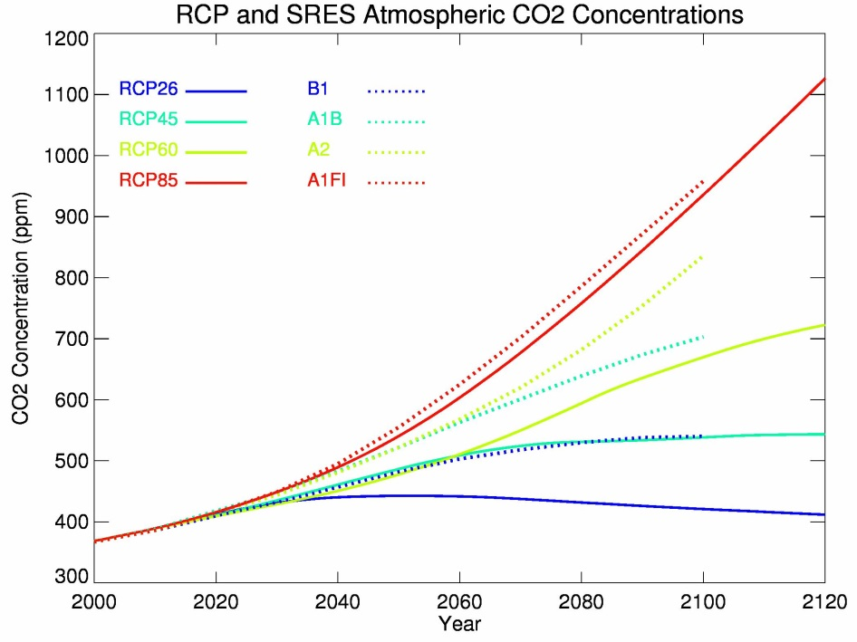
Figure 2: Atmospheric carbon dioxide concentrations for the IPCC Fourth Assessment (dotted lines, SRES concentrations) and for the IPCC Fifth Assessment (solid lines, RCP concentrations)

2.2 CMIP5 models
As the IPCC AR5 report notes (Flato et al, 2013), climate models have continued to be developed and improved since the AR4, and many models have been extended into Earth system models by including representation of biogeochemical cycles that interact with climate variations and changes. There are also many more models available for analysis in AR5 than in AR4. Table 2 lists the global models accessed by NIWA in this study. The IPCC AR5 Report (particularly Figure 12.1 and Table 12.1 in Collins et al, 2013) provides a lot more detail about the individual models.
Table 2 gives the model names, as used in the NIWA AR5 data archive, and lists the time periods and RCPs for which each model provided simulations. (These model names are often abbreviated later in this report.) A maximum of 41 models were available for the historical period and RCP8.5, with fewer modelling institutions running simulations for the other RCPs, especially RCP6.0. Not all models archived their sea surface temperature data, which is needed for the regional climate model (RCM) simulations and other analyses.
There is end-user interest in extending projections beyond 2100; for example, future versions of the New Zealand Coastal Policy Statement aim to give guidance out 100 years, and thus extend beyond the 2100 limit used in Ministry for the Environment, 2008. Table 2 highlights such simulations; note that RCP6.0 has only two models that extend their simulation beyond 2100.
Table 2: List of AR5 model data on NIWA CMIP5 archive that contains at least the monthly variables psl (mean sea-level pressure), pr (precipitation) and tas (air temperature at the surface), which are all required for the statistical downscaling
The table shows start and end years for each model: the Historical period usually ends 2005; the future RCP simulations all start in 2006. A cross (X) means no data available. The X in the last column indicates those models for which sea surface temperature data (SST, tos) are not available for the RCP8.5 simulation (see section 2.2.1). Highlighted data extend beyond 2100, as used in the 2110 projections. The last row shows the total of models available for each RCP, including (in brackets) those that extend their simulations beyond 2100.
model_name | Historical | RCP2.6 | RCP4.5 | RCP6.0 | RCP8.5 | SST
bcc-csm11 | * 1850-2012 | 2006-2300 | 2006-2300 | 2006-2100 | 2006-2300
bcc-csm11m | * 1850-2012 | 2006-2100 | 2006-2100 | 2006-2100 | 2006-2100
bnu-esm | * 1850-2005 | X | 2006-2100 | X | 2006-2100 | X
cccma-canesm2 | * 1850-2005 | 2006-2300 | 2006-2300 | X | 2006-2100
cmcc-cesm | * 1850-2005 | X | X | X | 2006-2100
cmcc-cm | * 1850-2005 | X | 2006-2100 | X | 2006-2100
cmcc-cms | * 1850-2005 | X | 2006-2100 | X | 2006-2100
cnrm-cm5 | * 1850-2005 | 2006-2100 | 2006-2300 | X | 2006-2300
csiro-access10 | * 1850-2005 | X | 2006-2100 | X | 2006-2100
csiro-access13 | * 1850-2005 | X | 2006-2100 | X | 2006-2100
csiro-mk360 | * 1850-2005 | X | 2006-2300 | X | 2006-2300
fio-esm | * 1850-2005 | X | 2006-2100 | X | 2006-2100
ec-earth | * 1850-2009 | X | X | X | 2006-2100
inm-cm4 | * 1850-2005 | X | 2006-2100 | X | 2006-2100
ipsl-cm5a-lr | * 1850-2005 | 2006-2300 | 2006-2300 | 2006-2100 | 2006-2300
ipsl-cm5a-mr | * 1850-2005 | 2006-2100 | 2006-2300 | 2006-2100 | 2006-2100
ipsl-cm5b-lr | * 1850-2005 | X | 2006-2100 | X | 2006-2100
lasg-cess-fgoals-g2 | * 1850-2005 | 2006-2101 | 2006-2275 | X | 2006-2101 | X
lasg-iap-fgoals-s2 | * 1850-2005 | X | X | X | 2006-2100
miroc-esm | * 1850-2005 | 2006-2100 | 2006-2300 | 2006-2100 | 2006-2100 | X
miroc-esm-chem | * 1850-2005 | 2006-2100 | 2006-2100 | 2006-2100 | 2006-2100 | X
miroc5 | * 1850-2012 | 2006-2100 | 2006-2100 | 2006-2100 | 2006-2100
mohc-hadgem2-cc | * 1860-2005 | X | 2006-2100 | X | 2006-2100
mohc-hadgem2-es | * 1860-2005 | 2006-2299 | 2006-2299 | 2006-2099 | 2006-2299
mpi-esm-lr | * 1850-2005 | 2006-2300 | 2006-2300 | X | 2006-2300
mpi-esm-mr | * 1850-2005 | 2006-2100 | 2006-2100 | X | 2006-2100
mri-cgcm3 | * 1850-2005 | 2006-2100 | 2006-2100 | 2006-2100 | 2006-2100
mri-esm1 | * 1851-2005 | X | X | X | 2006-2100 | X
nasa-giss-e2-h | * 1850-2005 | 2006-2300 | 2006-2300 | 2006-2100 | 2006-2300
nasa-giss-e2-h-cc | * 1850-2010 | X | 2006-2100 | X | 2006-2100 | X
nasa-giss-e2-r | * 1850-2005 | 2006-2300 | 2006-2300 | 2006-2100 | 2006-2300
nasa-giss-e2-r-cc | * 1850-2010 | X | 2006-2100 | X | 2006-2100 | X
ncar-ccsm4 | * 1850-2005 | 2006-2300 | 2006-2300 | 2006-2300 | 2006-2299
ncc-noresm1-m | * 1850-2005 | 2006-2100 | 2006-2300 | 2006-2100 | 2006-2100
ncc-noresm1-me | * 1850-2005 | 2006-2101 | 2006-2102 | 2006-2101 | 2006-2100
nimr-kma-hadgem2-ao | * 1860-2005 | X | 2006-2100 | X | 2006-2100
noaa-gfdl-cm3 | * 1860-2005 | 2006-2100 | 2006-2300 | 2006-2100 | 2006-2100
noaa-gfdl-esm2g | * 1861-2005 | 2006-2100 | 2006-2100 | 2006-2100 | 2006-2100
noaa-gfdl-esm2m | * 1861-2005 | 2006-2100 | 2006-2100 | 2006-2100 | 2006-2100
nsf-doe-ncar-cesm1bgc | * 1850-2005 | X | 2006-2100 | X | 2006-2100
nsf-doe-ncar-cesm1cam5 | * 1850-2005 | 2006-2300 | 2006-2300 | 2006-2300 | 2006-2100
TOTAL # (>2100) | * 41 (n/a) | 23 ( 9) | 37 (16) | 18 ( 2) | 41 ( 9) | 34

In this report, projections are given for all four RCPs, and for three future time periods which are usually abbreviated as 2040, 2090 and 2110. The three time periods represent changes for the 20-year periods 2031–50, 2081–2100 and 2101–20, respectively, relative to the baseline 1986–2005. This is the same baseline as used in the IPCC AR5 Report (IPCC, 2013), and is the last 20 years of what CMIP5 refer to as the “historical period”.

2.2.1 Validation of CMIP5 global models
Many different approaches can be taken to validate or assess global climate models and their future projections. Broadly speaking, three categories have been considered:
- how well do the models represent the ‘current’ climate?
- to what extent do the models agree on future projections?
- how well do models simulate observed past climate changes, in either the instrumental or paleoclimate record?
The approach taken so far by NIWA climate scientists is the first of these three options; specifically, the model climatological characteristics are compared to observations over a common recent period. Climate models incorporate input data on such things as solar radiation and carbon dioxide and aerosol concentrations, but the coupled ocean-atmosphere models are otherwise ‘free-running’ and not constrained by observations. For example, an El Niño event will be simulated by a model, but the computer programmer does not ‘tell the model’ that an event must occur in a particular year. Thus, year-to-year variability in a model does not match up in time with the year-to-year variability in observations. This is why the validation procedure examines the match between climatological patterns rather than time series.
Model performance was quantified in terms of a metric that aggregates many different circulation and climatic factors:
- the position and intensity of the westerly wind maximum and the subtropical high-pressure belt
- spatial patterns in the key climate variables (eg, correlation of summer minus winter rainfall, temperature and pressure patterns, observed versus modelled)
- El Niño-Southern Oscillation teleconnections (correlations of the Southern Oscillation Index versus rainfall, temperature and pressure fields)
- annual cycles in key circulation indices such as the Trenberth Z1 and M1 indices (used in the statistical downscaling).
This validation exercise was carried out on the AR4 models (Mullan & Dean, 2009), and resulted in 12 models being retained for the previous climate impact assessment (Ministry for the Environment, 2008). The AR5 models have been treated similarly (Mullan et al, 2013a, 2013b). There is a general improvement in the CMIP5 models in simulating mean climate and seasonal and interannual variability in the New Zealand-Pacific region. Of the 49 models assessed, 16 of the CMIP5 models were better than the best of the CMIP3 models, according to the metric used. The five worst CMIP3 models, excluded from Ministry for the Environment (2008), all performed worse than the worst of the 49 CMIP5 models.
Therefore, in this current report, we have decided to use all available CMIP5 models. The maximum number of models used (Table 2) was reduced to 41 since some of the ‘historical’ models either did not make future simulations over a period long enough for our purposes, or some of the data was unable to be downloaded to the NIWA servers for technical reasons. Table 4, later in this report, gives the ranking of the retained 41 models as derived by Mullan et al (2013a, 2013b).
The metric used to assess the historical simulations did not include any consideration of historical trends. It is of interest, therefore, to examine the model simulated trends of surface air temperature over the past century. Figure 3 shows the variations over the period 1900–2005 of the ‘historical’ simulations (see Table 2). The annual temperature is raw data from the global models, with no downscaling. Temperature was first averaged over the “New Zealand box” (see section 2.3), 33–48°S by 160–190°E, and then smoothed with a filter designed to remove sub-decadal fluctuations (without smoothing, the time series are too noisy to interpret). Thus, these model temperatures include air temperature over the seas around New Zealand, as well as air temperature over land; the latter tends to have larger trends (ie, warm faster, see Figure 1 discussion).
The land temperature record over New Zealand (the seven-station series) was treated similarly. Comparing linear warming trends over 1909–2005 (the seven-station record now begins in 1909), the NZT7 trend is 0.92°C/century, which is near the 90th percentile of the model warming rates (which include air temperature over the ocean). Four of the CMIP5 models have larger trends than NZT7 over this historical period; only five have statistically insignificant trends over the period. All six GCMs used in the RCM downscaling have smaller 1909–2005 trends (including surrounding ocean) than NZT7 (Figure 3).
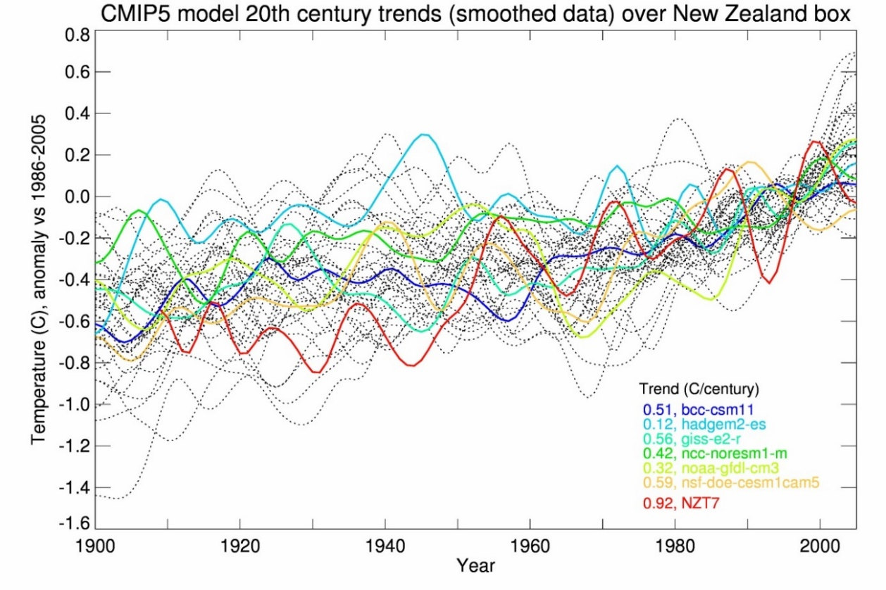
Figure 3: Surface air temperature variations from 1900 to 2005, relative to 1986–2005, for 41 historical model simulations as averaged over the “New Zealand box” (land and ocean, 33–48°S by 160–190°E, used for the statistical downscaling), and for the New Zealand seven-station series (land only, NZT7)
The six GCMs used for boundary conditions in NIWA’s RCM simulations are shown in colour and identified in the inset legend. The New Zealand seven-station temperature series is shown in red.

2.3 Statistical downscaling
The statistical downscaling for up to 41 GCMs in this report follows the methodology of (Mullan et al, 2001), and is essentially the same as used in the previous Ministry for the Environment (2008) report. The statistical downscaling generates regression equations, stratified by season, describing how monthly temperature and precipitation vary with large-scale climatic and circulation features. The circulation over New Zealand is quantified in terms of two of the Trenberth indices Z1 (westerlies) and M1 (southerlies) (Trenberth, 1976). The predictors, then, are the (Z1, M1) values plus regional temperature (for the temperature prediction) and precipitation (for the precipitation prediction) at the latitude of the VCSN grid-point. Essentially, the downscaling adjusts the large-scale field value according to how westerlies or southerlies modify the temperature and rainfall patterns over New Zealand. Bias in the model circulation is accounted for by a correction term derived by comparing the year-to-year variability in Z1 or M1 in the model compared to observations in Transient model scenarios of climate changes for New Zealand (Mullan et al, 2001).
The only difference between Ministry for the Environment (2008) downscaling and the approach in this report is that the regression coefficients have been updated to use ERA-Interim Reanalysis observational data (Dee et al, 2011) rather than the NCEP/NCAR Reanalysis (Kalnay et al, 1996) used previously. Note that the downscaling regressions take no account of trends in the underlying data, which over the recent climatological period are much smaller than year-to-year fluctuations.

2.4 Dynamical downscaling
The ‘added value’ in dynamical downscaling lies in the realistic simulations of a physically consistent set of temporally and spatially highly resolved fields. The interactions of the large-scale circulation with higher resolution orography and other surface features (eg, land-sea interface, vegetation cover, large lakes) are well captured in RCM simulations resolving a diverse range of climatic features. Despite this, errors inherent in representing local surface conditions, atmospheric processes and external forcing in RCMs lead to considerable systematic biases in simulating regional variables. Reducing biases in RCM data is necessary to improve confidence in regional climate impact studies. The iterative dynamical downscaling procedure developed at NIWA is designed to reduce systematic biases over a wide range of spatiotemporal scales.
The weakness in the dynamical compared to statistical approach is the reliance on just one global atmosphere model. The NIWA dynamical procedure involves a free-running atmospheric global climate model (AGCM), in this case HadAM3P (Anagnostopoulou et al, 2008), forced by sea surface temperatures (SST) and sea ice fields from the CMIP5 models. The SST data exhibit considerable biases in the historical period, at both global and regional scales. The monthly SST climatologies are bias corrected over the baseline period (1961–2000) with respect to a high resolution gridded SST observational dataset (HadISSTv1.1, Rayner et al (2003)), to reduce the general circulation biases. The biases in variables strongly influenced by SST, such as precipitation and wind patterns, are also considerably reduced by such a procedure, according to Nguyen et al (2012). The sea-ice fields were directly interpolated from the CMIP5 sea-ice model data. Though biases in modelled sea-ice are well known to considerably bias the large scale circulation patterns, the necessary corrections are more complex and will be attempted at a later stage.
In the next step, the improved lateral boundary conditions are extracted from AGCM simulations described above to drive the regional climate model, HadRM3P (Jones et al, 2004), a limited-area version of HadAM3, to dynamically downscale projections over the New Zealand domain. The regional SST for the RCM domain are again bias corrected on the finer spatial scale to improve regional projections. The models in Table 3 were selected based on the performance metric described in Table 4, and the availability of data for all RCPs. This selection approximately spans the climate sensitivity of the complete set of CMIP5 models (Figure 3).
Figure 4 shows the bias-adjusted sea surface temperatures used to force the NIWA GCM and RCM, presented here only for the average over the RCM domain (Ackerley et al, 2012). For the mitigation pathway (RCP2.6), sea temperatures increase to a maximum around mid-century, and thereafter decline slightly. In the other pathways, SSTs continue to increase throughout the period, with a much larger rate of change from the high greenhouse gas pathway (RCP8.5).
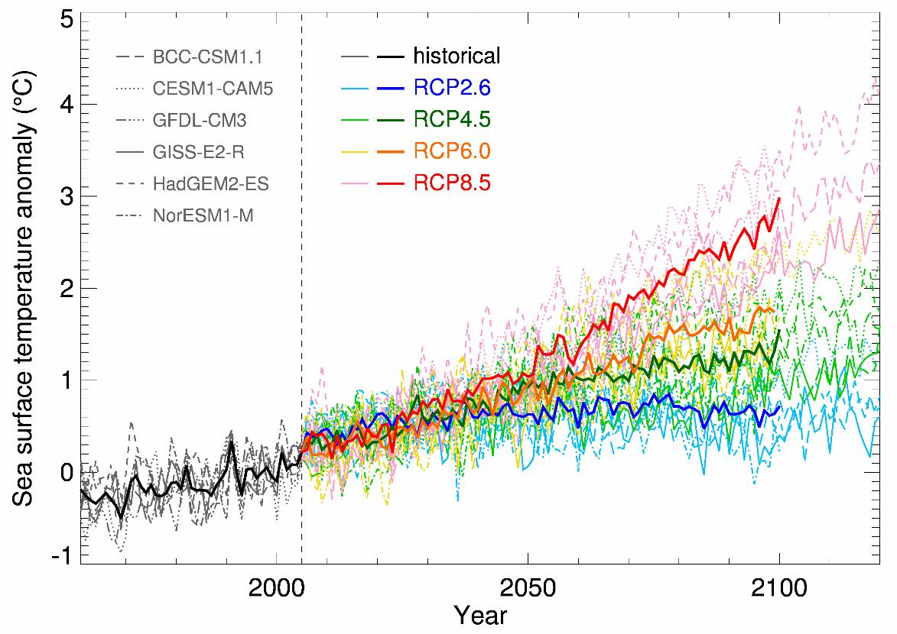
Figure 4: Bias-adjusted sea surface temperatures, averaged over the RCM domain, for six CMIP5 global climate models, and for the historical simulations (here 1960–2005) and four future simulations (RCPs 2.6, 4.5, 6.0 and 8.5), relative to 1986–2005
Individual models are shown by thin dotted or dashed or solid lines (as described in the inset legend), and the six-model ensemble-average by thicker solid lines, all of which are coloured according to the RCP pathway.

Table 3: Periods of the regional climate model (RCM) simulations, for each the six CMIP5 models and pathways. Four models go beyond 2100, and so are available for 2110 projections. The ranks are taken from Table 4
Model names (Rank) Institute (Country) | Historical | RCP2.6 | RCP4.5 | RCP6.0 | RCP8.5
HadGEM2-ES (2)  MOHC (UK) | 1971–2005 | 2006–2120 | 2006–2120 | 2006–2099 | 2006–2120
CESM1-CAM5 (1)  NSF-DOE-NCAR (USA) | 1971–2005 | 2006–2120 | 2006–2120 | 2006–2120 | 2006–2100
NorESM1-M (9)  NCC (Norway) | 1971–2005 | 2006–2100 | 2006–2100 | 2006–2100 | 2006–2100
GFDL-CM3 (10)  NOAA-GFDL (USA) | 1971–2005 | 2006–2100 | 2006–2120 | 2006–2100 | 2006–2100
GISS-E2-R (14)  NASA-GISS (USA) | 1971–2005 | 2006–2120 | 2006–2120 | 2006–2100 | 2006–2120
BCC-CSM1.1 (17)  BCC (China) | 1971–2005 | 2006–2120 | 2006–2120 | 2006–2099 | 2006–2120

2.4.1 Bias correction and downscaling from RCM to 5 kilometre VCSN
The bias correction and downscaling procedures are performed separately on regional climate model (RCM) data for the primary climate variables of minimum and maximum temperature and precipitation. A newly-devised ”Linked empirical Modelled and Observed Distribution (LeMOD)” correction method is applied for bias correction, and the data are subsequently downscaled using local wind direction and topographic elevation data. The primary feature of the “LeMOD” procedure is to consistently correct biases in climate simulation data by removing highest order systematic local model errors. The method is designed to remain valid even under non-stationary climatic conditions. The large-scale circulation biases inherent in the driving fields of the climate models are, however, not corrected. The LeMOD bias-corrected daily temperature and precipitation data were evaluated on the RCM (27 kilometres) and high-resolution (5 kilometres) grids against observed gridded data from the virtual climate station network (VCSN) (Sood, 2014).
The LeMOD technique uses a semi-empirical statistical approach to correct errors in the frequency distribution of model data. In RCM simulations forced by the ERA-40 reanalysis (Uppala et al, 2005), biases in meteorological variables occur primarily due to model errors and the representation of local conditions, as large-scale circulation errors at the lateral boundaries are strongly suppressed by the reanalysis forcing (Ackerley et al, 2012). This new approach to correct biases in RCM simulations uses correction terms based on differences between the reanalysis-forced regional climate hindcast data and gridded observations on a daily time scale (Sood, 2014). Even though the distribution changes over time under non-stationary climatic conditions, most of the weather states that occur will be similar to the ones in the past. A sufficiently long 20-year model hindcast and observation period ensures adequate sampling of the model errors. If the training period used to sample model errors is representative, the model biases under similar conditions remain the same. This will be valid even in the case of non-stationary climate change where the distribution changes. The correction factors to daily biases determined for the training period (1980–1999) are applied consistently to correct daily RCM data for the historical period and the future projections.
To facilitate climate impact assessment with respect to observations, an additional adjustment for temperature and precipitation data is implemented. For each model simulation, this involves calculating the mean bias at each grid point between VCSN observations and the model, over the period 1986–2005. The bias is then subtracted from the model data over the entire 130–150-year time series, past and future. This means that, when climate impacts models make use of the RCM daily data, the model climatology will be exactly the same as the VCSN observations, although the year-to-year variability will be different.
The bias-corrected data exhibits lower root-mean-square-error and higher temporal correlations relative to uncorrected data or the most commonly used ‘quantile matching’ bias correction procedure. Since reducing model biases is expected to reduce the spread in model results in the past climate, except where the spread is related to internal variability, this feature is expected to persist in transient climate future projections and help reduce uncertainties in model projections.

2.5 Evapotranspiration and drought
The increase in frequency and intensity of droughts in a changing climate is of deep concern for New Zealand society and economy, not least for stakeholders in the primary sector. Drought intensity is affected by increasing temperature, which in turn increases moisture loss through higher evapotranspiration rates, and also by the lack of moderate intensity precipitation to recharge aquifers and replenish soil moisture. A key factor in the water balance is evapotranspiration, which is the combined loss of soil water by transpiration through plants and evaporative loss from the soil and other surfaces. The measure for lack of soil moisture, a major source of plant stress, is potential evapotranspiration deficit (PED). Days when water demand is not met, and pasture growth is reduced, are often referred to as days of potential evapotranspiration deficit. As a rule of thumb, an accumulation of 30 millimetres more PED corresponds to an extra week of reduced grass growth.
Potential evapotranspiration is affected by a number of variables, describing the meteorological conditions:
- solar radiation incident on the land surface
- winds
- temperature
- moisture.
It also depends on the ability of plants to extract and transpire water from the ground, which in turn is dependent on soil conditions. The overall best-performing Penman-Monteith (FAO-56) approach is selected to estimate potential evapotranspiration, as recommended in a recent report evaluating several different methods for Great Britain (Prudhomme et al, 2012).
$$PET \left[mm {day}^{-1}\right]=\frac{λ^{-1}Δ\left(R_{n}-G\right)+γ\frac{900}{{273+T}_{mean}}U_{2}(e_{s}-e_{d})}{Δ+γ(1+0.34U_{2})}$$
Where:
- PET is the potential evapotranspiration [mm day⁻¹]
- λ is the latent heat of vaporisation [MJ kg⁻¹]
- R_{n} is the incident solar radiation [MJ m⁻² day⁻¹]
- G is soil heat flux [MJ m⁻² day⁻¹] (set to 0)
- T_{mean} is the daily mean temperature [°C]
- U₂ is the 2-metre wind speed [m s⁻¹]
- (e_{s} - e_{d}) is the water vapour deficit [kPa]
- Δ is the gradient of the vapour pressure curve [kPa °C⁻¹]
- $γ$ is the psychrometric constant [kPa °C⁻¹]
- 900 is the coefficient of reference crop in [kJ⁻¹ kg °C day⁻¹]
- 0.34 is the coefficient for a reference crop [s m⁻¹].
The details of the terms in equation (above) are presented in Appendix A. The changes in temperature, precipitation, solar radiation and relative humidity (ie, the ratio of actual water vapour pressure e_{d} and saturated water vapour pressure e_{s}) are presented for all four RCPs in section 3.8.

3 Projected changes in New Zealand atmospheric climate
- Projected changes are presented for 2040 (2031–2050 average), 2090 (2081–2100), and 2110 (2101–2120), all relative to the IPCC current-climate ‘baseline’ of 1986–2005.
- Temperature and precipitation projections are derived from both statistical (up to 41 models) and dynamical (six models) downscaling approaches.
Temperature:
i. The magnitude of the projected temperature changes increases with the RCP, with approximate increases by 2090 of +0.7°C under RCP2.6, +1.4°C under RCP4.5, +1.8°C under RCP6.0, and +3.0°C under RCP8.5. Warming is largest in the summer season, and least in winter and spring.
ii. The spatial variation in the warming trend is not large, except for faster warming in higher altitude South Island areas with the regional model dynamical downscaling.
iii. Temperature extremes change significantly. By the end of the century, the frequency of ‘hot days’ (maximum temperatures at least 25°C) doubles under the modest RCP4.5 forcing, and changes by a factor of 4 under RCP8.5. The frequency of ‘cold nights’ reduces dramatically at elevations below 50 metres – typically by around 90 per cent by 2090 under the highest RCP8.5 forcing.
iv. Air temperatures in the New Zealand region (over land and sea) are projected to increase at a rate about 75 per cent of the global warming rate, averaged across the models.
Precipitation:
i. The most common pattern of annual precipitation change shows the largest increases in the west of the South Island and the largest decreases in the east of the North Island and coastal Marlborough.
ii. Annual precipitation changes are small in many places, partly due to inter-model variability, but also to seasonal compensation, eg, in Hawke’s Bay, models predict an increase in summer rainfall but a decrease in winter.
iii. The largest projected changes in precipitation occur on the West Coast in the winter season, with area-average increases of up to 40 per cent under RCP8.5 by 2090.
iv. The number of dry days per year increases over time in many places, especially in the North Island. Conversely, the 99th percentile rainfall amount on rain-days increases in most places, especially in the South Island.
v. Very extreme precipitation, defined as events with a recurrence interval of 2 years or greater, increases throughout the country. Percentage increases per degree of warming range from 5 per cent for 5-day duration events to 14 per cent for 1-hour duration events.
Other atmospheric climate variables:
i. Mean Circulation: More north-easterly airflow in summer (higher pressures to southeast of country), and strong westerly flow in winter (lower pressures to south).
ii. Wind: The southern half of the North Island and all the South Island are projected to experience stronger extreme daily winds, for most of the RCPs and time periods.
iii. Drought: Drought severity is projected to increase in most regions of New Zealand, except for Taranaki-Manawatu, West Coast, and Southland.
iv. Relative humidity: Relative humidity is projected to decrease almost everywhere in all seasons, with the largest reductions in inland South Island.

3.1 Patterns of change
Spatial patterns and magnitudes of temperature and precipitation change will be described in detail later in this chapter, but Figure 5 provides an overview of the national pattern of projected changes which is really only possible with the very large ensemble of simulations from the CMIP5 experiment. The ‘most common patterns’ of temperature and precipitation change shown in Figure 5 were determined by cross-correlating the statistically downscaled changes of every model with every other model. Cross correlations above 0.70 were collated into groups.
The most common pattern of annual temperature change (24 of 41 models) is the one shown in Figure 5 (left), where there is a north-south gradient in the warming, and the highest rate of warming is in the north of New Zealand. (Incidentally, the analysis of the seven-station temperature record (Mullan et al, 2010) also showed greater historical warming in the north of the country). The second most common temperature warming pattern (nine models, not shown) was one of a west-east gradient, with higher warming in the west and higher overall warming nationally than the most common pattern.
The most common pattern of annual precipitation change (26 of 41 models) is the one in Figure 5 (right), where there is a west-east gradient in rainfall, with the largest increases in the west of the South Island, and the largest decreases in the east of the North Island and in coastal Marlborough and North Canterbury. The second most common pattern (seven models) has a fairly weak gradient, with the largest increase in the south-west of the South Island, and in Bay of Plenty–Gisborne.
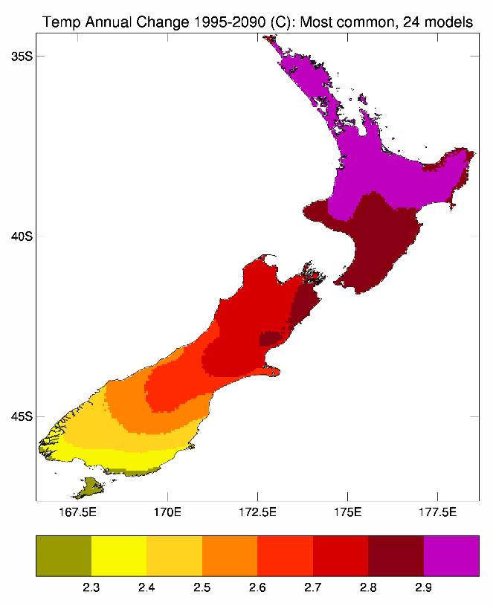 | 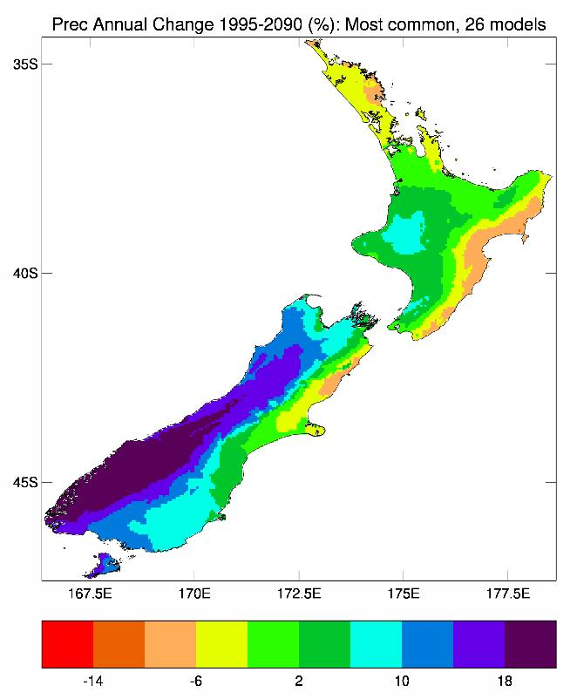
Figure 5: The most common patterns of annual temperature (left) and precipitation (right) change between 1995 (1986–2005) and 2090 (2081–2100), as assessed from the statistical downscaling results. The temperature pattern is the ensemble average of 24 models, and precipitation of 26 models (out of 41), for the 2090 projected changes under RCP8.5
The temperature contours are given every 0.1°C, and the precipitation contours every 4 per cent with the lime green colour representing the –2 per cent to +2 per cent band of very little change.

3.2 Mean temperature projections
In the following pages, climate change temperature projections are presented in terms of tables (Tables 5 to 7) and figures (Figures 8 to 29) for three future periods (2040, 2090, and 2110) and four RCPs (2.6, 4.5, 6.0, and 8.5). The tables give changes averaged over each of 15 regions (Table 5). The maps of projected changes give the national picture, while the tables provide a breakdown of the projections at the regional council scale. The maps, which show how the projections vary with season, are split into two parts:
- Figures 8 to 11 are changes as derived from the large ensemble of global models (Table 2) by statistical downscaling
- Figures 12 to 15 and 18 to 29 are derived by dynamical downscaling via NIWA’s regional climate model (RCM).
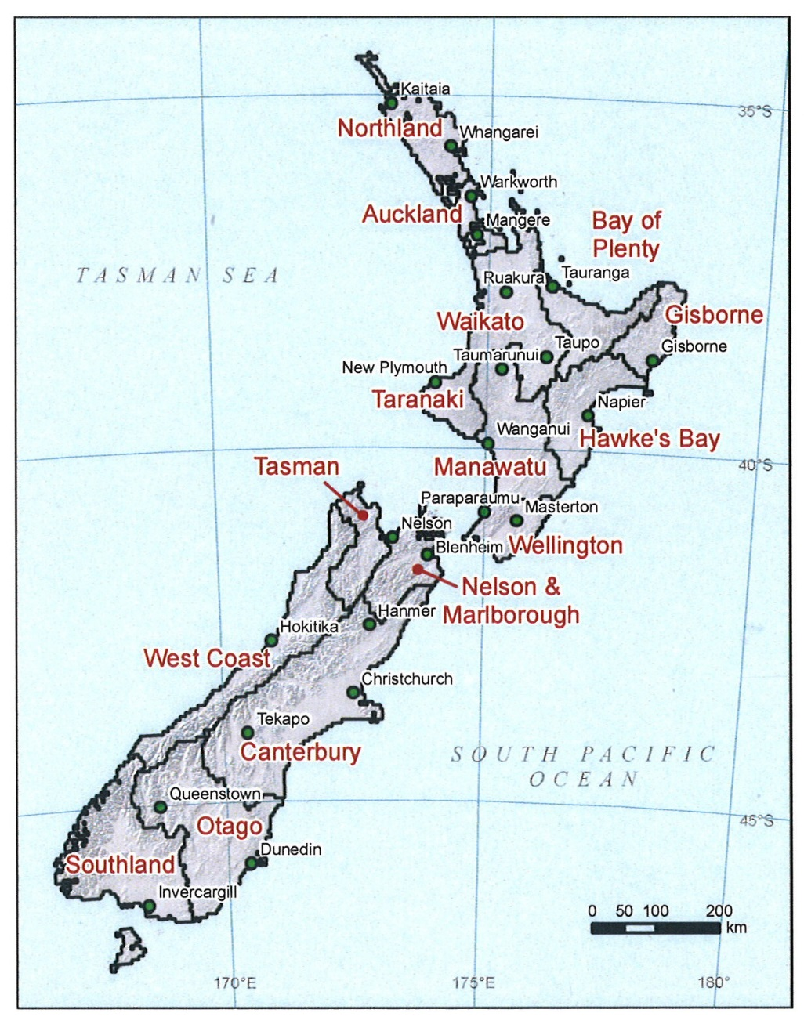
Figure 6: Map of New Zealand showing the 15 regions over which temperature projections are averaged. Place names (and green dots) identify those sites for which precipitation projections are calculated
Table 4: List of AR5 models used in this report showing their overall ranking (1=best) on 63 validation metrics over the historical period, and their local ‘climate sensitivity’ based on raw global climate model air temperature changes (in degrees celsius) from 1986–2005 to 2081–2100, averaged over 33–48°S, 160–190°E, for each RCP
The six highlighted models are used in the RCM downscaling.
Model Name | Ranking |  | Warming Signal
 |  |  | RCP26 | RCP45 | RCP60 | RCP85
bcc-csm11 | * | 17 | 0.55 | 0.95 | 1.36 | 2.40
bcc-csm11m | * | 25 | 0.56 | 1.08 | 1.39 | 2.58
bnu-esm | * | 38 |  | 1.62 |  | 3.42
cccma-canesm2 | * | 7 | 1.28 | 1.96 |  | 3.72
cmcc-cesm | * | 40 |  |  |  | 2.70
cmcc-cm | * | 13 |  | 1.41 |  | 3.23
cmcc-cms | * | 16 |  | 1.69 |  | 3.39
cnrm-cm5 | * | 5 | 0.81 | 1.46 |  | 2.70
csiro-access10 | * | 3 |  | 1.72 |  | 3.05
csiro-access13 | * | 12 |  | 1.22 |  | 2.56
csiro-mk360 | * | 33 |  | 1.30 |  | 2.35
fio-esm | * | 31 |  | 1.61 |  | 3.54
ec-earth | * | 6 |  |  |  | 2.34
inm-cm4 | * | 23 |  | 1.02 |  | 2.07
ipsl-cm5a-lr | * | 37 | 0.61 | 1.60 | 2.07 | 4.10
ipsl-cm5a-mr | * | 32 | 0.82 | 2.10 | 2.62 | 4.04
ipsl-cm5b-lr | * | 36 |  | 1.07 |  | 2.36
lasg-cess-fgoals-g2 | * | 29 | 0.46 | 1.05 |  | 2.61
lasg-iap-fgoals-s2 | * | 34 |  |  |  | 4.45
miroc-esm | * | 41 | 1.01 | 1.58 | 2.09 | 3.54
miroc-esm-chem | * | 39 | 0.93 | 1.68 | 2.35 | 3.63
miroc5 | * | 30 | 0.55 | 1.33 | 1.49 | 2.65
mohc-hadgem2-cc | * | 8 |  | 1.65 |  | 3.56
mohc-hadgem2-es | * | 2 | 0.83 | 1.91 | 2.52 | 3.52
mpi-esm-lr | * | 19 | 0.42 | 1.34 |  | 2.72
mpi-esm-mr | * | 15 | 0.32 | 1.01 |  | 2.48
mri-cgcm3 | * | 22 | 0.50 | 0.87 | 1.09 | 2.27
mri-esm1 | * | 21 |  |  |  | 2.27
nasa-giss-e2-h | * | 35 | 0.44 | 0.95 | 1.34 | 2.27
nasa-giss-e2-h-cc | * | 27 |  | 0.94 |  | 2.17
nasa-giss-e2-r | * | 14 | 0.44 | 0.99 | 1.62 | 2.36
nasa-giss-e2-r-cc | * | 26 |  | 1.17 |  | 2.62
ncar-ccsm4 | * | 20 | 0.81 | 1.41 | 2.03 | 3.17
ncc-noresm1-m | * | 9 | 0.37 | 1.12 | 1.26 | 2.32
ncc-noresm1-me | * | 18 | 0.53 | 1.09 | 1.21 | 2.32
nimr-kma-hadgem2-ao | * | 4 |  | 1.71 |  | 2.79
noaa-gfdl-cm3 | * | 10 | 0.90 | 1.37 | 1.85 | 3.04
noaa-gfdl-esm2g | * | 28 | 0.12 | 0.69 | 1.00 | 1.95
noaa-gfdl-esm2m | * | 24 | 0.44 | 1.16 | 1.50 | 2.23
nsf-doe-ncar-cesm1bgc | * | 11 |  | 1.29 |  | 3.06
nsf-doe-ncar-cesm1cam5 | * | 1 | 1.24 | 2.01 | 2.38 | 3.41
Ensemble-average warming |  |  | 0.65 | 1.35 | 1.73 | 2.88
Before considering the tables and maps in detail, it is worthwhile considering the overview in Table 4. For each of the 41 models that have simulations for both the ‘historical’ period and RCP8.5, the table shows the regional-average (New Zealand ‘box’) annual air temperature change for 2090 (2081–2100), derived from the raw GCM output. Because these projections cover air temperature over both land and sea, they may be expected to be somewhat smaller than those over land alone. Table 4, however, allows one to see at a glance the progression in warming as the greenhouse gas concentration become more extreme, and also to see the variation between models. There are fewer models running RCP6.0, but note that the RCP8.5 average warming over the 23 models not running RCP6.0 (at 2090) is exactly the same (to two decimal places) as the all 41-model average (2.88°C).
Also shown in Table 4 is the validation metric (ranking) discussed earlier in section 2.2.1, where a ranking of 1 indicates the best-validating model. There is no clear relationship between the model validation rankings and their projected century warming trends. The six GCMs run through NIWA’s RCM have a regional temperature increase by 2090 under the highest forcing RCP8.5 of:
- 2.40°C (bcc-csm11)
- 3.52°C (hadgem2-es)
- 2.36°C (giss-e2-r)
- 3.04°C (gfdl-cm3)
- 2.32°C (nor-esm1-m)
- 3.41°C (ncar-cesm1-cam5).
These projected changes are neither the lowest nor the highest of the full set of CMIP5 models analysed, and the six-model average (2.84°C change from 1986–2005 to 2081–2100) is very close to the all-model average warming. Thus, even though only six GCMs were analysed via NIWA’s RCM, we consider these six to be well-representative of the larger 41-model suite.
New Zealand temperature projections specific to the six dynamically-downscaled GCMs are shown in Figure 7, after bias-correcting the RCM output and further downscaling to the VCSN grid. This is the New Zealand-average land temperature trend, driven by the sea surface temperature forcing of Figure 4.
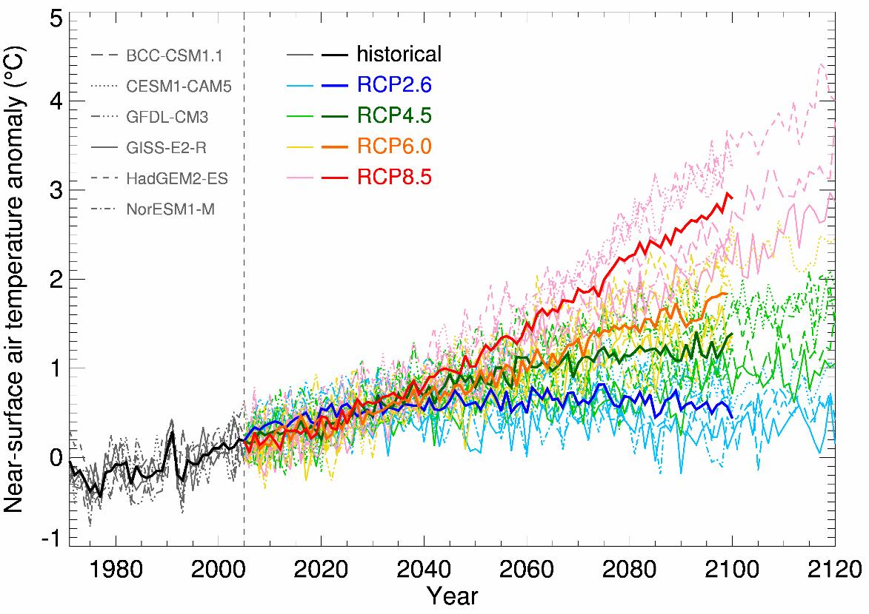
Figure 7: Projected New Zealand-average temperatures relative to 1986–2005, for six CMIP5 global climate models, and for the historical simulations (here 1971–2005) and four future simulations (RCPs 2.6, 4.5, 6.0 and 8.5)
Individual models are shown by thin dotted or dashed or solid lines (as described in the inset legend), and the six-model ensemble-average by thicker solid lines, all of which are coloured according to the RCP.

3.2.1 Main features of tables and figures
The following tables (Tables 5 to 7) and figures (Figures 8 to 15) summarise a lot of detailed information. The main features are as follows:
- The temperature projections generally increase with time and with the strength of the radiative forcing.
- By 2040 (2031–2050, relative to 1986–2005), temperatures are projected to increase by between 0.7°C (RCP2.6) and 1.0°C (RCP8.5). In terms of the spatial detail, there is a small gradient from north to south, with the northern North Island (Northland to Taranaki) varying from 0.7°C (RCP2.6) to 1.1°C (RCP8.5), and Southland ranging from 0.6°C (RCP2.6) to 0.9°C (RCP8.5).
- By 2090 (2081–2100, relative to 1986–2005), temperatures are projected to increase by between 0.7°C (RCP2.6) and 3.0°C (RCP8.5), as represented by the seven-station average. Note that the mitigation pathway (RCP2.6) change is the same at 2090 as for 2040, whereas all the other pathways show increased warming at 2090 relative to 2040.
- At 2110, there are fewer models in the ensemble-average (see Table 2), but for all pathways except RCP2.6, there is further warming projected relative to the 2090 changes.
- There is a seasonal pattern to the warming, such that warming is generally highest in the summer season (somewhat dependent on latitude) and lowest in spring. This is a consequence of associated circulation changes discussed in section 3.7.
- Temperature projections are also provided for an additional ‘region’, referred to as the ‘seven-station average’. These are evaluated as the averages over the seven VCSN grid-points closest to the locations of NIWA’s seven-station series sites.
- Further spatial detail is provided in the maps (Figures 8 to 15).
- The RCM has a considerable additional amount of detail than can be provided by the statistical downscaling. In particular, while the statistical approach only produces a mean temperature change, the RCM distinguishes between day and night trends. Overall, the daily maximum temperature is expected to increase faster than the overnight daily minimum temperature, meaning that the daily temperature range (maximum minus minimum) is also expected to increase over time. (See further discussion later in this section.)

Table 5: Projected changes in seasonal and annual mean temperature (in °C) between 1986–2005 and 2031–2050, by region, as derived from statistical downscaling. The changes are given for four RCPs (8.5, 6.0, 4.5 and 2.6), where the ensemble-average is taken over (41, 18, 37, 23) models respectively
The values in each column represent the ensemble average, and in brackets the range (5th percentile to 95th percentile) over all models within that ensemble. Projections for the Chatham Islands are a direct interpolation from the global CMIP5 models (ie, not statistically downscaled). Projections for the ‘seven-station average’ are taken from the seven VCSN grid-points co-located with the NIWA seven-station locations.
Region | Summer | Autumn | Winter | Spring | Annual
Northland
rcp 8.5  rcp 6.0  rcp 4.5  rcp 2.6 | 1.1 (0.5, 1.6)  0.9 (0.5, 1.5)  1.0 (0.4, 1.5)  0.8 (0.3, 1.3) | 1.1 (0.7, 1.5)  0.9 (0.5, 1.3)  0.9 (0.4, 1.4)  0.8 (0.4, 1.1) | 1.1 (0.6, 1.4)  0.8 (0.4, 1.2)  0.9 (0.5, 1.2)  0.7 (0.4, 1.0) | 1.0 (0.5, 1.3)  0.8 (0.3, 1.1)  0.8 (0.4, 1.1)  0.7 (0.4, 1.0) | 1.1 (0.7, 1.4)  1.1 (0.7, 1.4)  0.9 (0.5, 1.2)  0.7 (0.4, 1.0)
Auckland
rcp 8.5  rcp 6.0  rcp 4.5  rcp 2.6 | 1.1 (0.5, 1.6)  0.9 (0.4, 1.6)  1.0 (0.5, 1.5)  0.8 (0.3, 1.3) | 1.1 (0.7, 1.5)  0.9 (0.5, 1.2)  0.9 (0.4, 1.4  0.8 (0.3, 1.1) | 1.1 (0.6, 1.5)  0.8 (0.4, 1.2)  0.9 (0.6, 1.2)  0.7 (0.4, 1.0) | 0.8 (0.4, 1.2)  0.8 (0.3, 1.1)  0.8 (0.4, 1.1)  0.7 (0.4, 1.0) | 0.8 (0.3, 1.1)  0.8 (0.4, 1.2)  0.9 (0.5, 1.2)  0.7 (0.4, 1.0)
Waikato
rcp 8.5  rcp 6.0  rcp 4.5  rcp 2.6 | 1.1 (0.5, 1.8)  0.9 (0.4, 1.6)  0.9 (0.4, 1.5)  0.8 (0.3, 1.3) | 1.1 (0.7, 1.6)  0.9 (0.4, 1.2)  0.9 (0.4, 1.4)  0.8 (0.3, 1.2) | 1.1 (0.7, 1.5)  0.8 (0.4, 1.2)  0.9 (0.6, 1.3)  0.7 (0.3, 1.0) | 0.9 (0.5, 1.3)  0.7 (0.2, 1.2)  0.8 (0.4, 1.1)  0.7 (0.3, 1.1) | 1.1 (0.6, 1.6)  0.8 (0.3, 1.2)  0.9 (0.5, 1.3)  0.7 (0.3, 1.1)
Bay of Plenty
rcp 8.5  rcp 6.0  rcp 4.5  rcp 2.6 | 1.1 (0.5, 1.7)  0.9 (0.4, 1.5)  0.9 (0.4, 1.4)  0.8 (0.3, 1.2) | 1.1 (0.7, 1.6)  0.9 (0.4, 1.2)  0.9 (0.4, 1.4)  0.8 (0.3, 1.2) | 1.1 (0.6, 1.5)  0.8 (0.3, 1.3)  0.9 (0.5, 1.3)  0.7 (0.4, 1.1) | 0.9 (0.5. 1.3)  0.7 (0.2. 1.2)  0.8 (0.4. 1.1)  0.7 (0.3. 1.0) | 1.1 (0.6, 1.5)  0.8 (0.3, 1.2)  0.9 (0.5, 1.3)  0.7 (0.3, 1.1)
Taranaki
rcp 8.5  rcp 6.0  rcp 4.5  rcp 2.6 | 1.1 (0.5, 1.8)  0.9 (0.3, 1.6)  0.9 (0.4, 1.5)  0.8 (0.2, 1.3) | 1.1 (0.7, 1.6)  0.9 (0.3, 1.2)  0.9 (0.4, 1.4)  0.8 (0.3, 1.2) | 1.1 (0.7, 1.5)  0.8 (0.3, 1.2)  0.9 (0.6, 1.2)  0.7 (0.3, 1.0) | 0.9 (0.5, 1.3)  0.7 (0.2, 1.2)  0.8 (0.3, 1.1)  0.6 (0.3, 1.0) | 1.1 (0.6, 1.6)  0.8 (0.3, 1.2)  0.9 (0.5, 1.2)  0.7 (0.3, 1.1)
Manawatu-Whanganui
rcp 8.5  rcp 6.0  rcp 4.5  rcp 2.6 | 1.1 (0.5, 1.8)  0.9 (0.3, 1.6)  0.9 (0.4, 1.5)  0.7 (0.2, 1.3) | 1.1 (0.7, 1.6)  0.9 (0.3, 1.2)  0.9 (0.4, 1.4)  0.8 (0.3, 1.2) | 1.1 (0.7, 1.5)  0.8 (0.3, 1.2)  0.9 (0.6, 1.2)  0.7 (0.3, 1.1) | 0.9 (0.4, 1.3)  0.7 (0.2, 1.1)  0.8 (0.3, 1.2)  0.6 (0.3, 1.0) | 1.1 (0.6, 1.6)  0.8 (0.3, 1.1)  0.9 (0.5, 1.2)  0.7 (0.3, 1.1)
Gisborne
rcp 8.5  rcp 6.0  rcp 4.5  rcp 2.6 | 1.1 (0.6, 1.7)  0.9 (0.4, 1.4)  0.9 (0.4, 1.4)  0.7 (0.2, 1.2) | 1.1 (0.7, 1.6)  0.9 (0.4, 1.2)  0.9 (0.4, 1.4)  0.8 (0.3, 1.1) | 1.1 (0.6, 1.5)  0.8 (0.4, 1.2)  0.9 (0.5, 1.3)  0.7 (0.4, 1.0) | 1.0 (0.4, 1.3)  0.7 (0.2, 1.1)  0.8 (0.4, 1.2)  0.7 (0.3, 1.0) | 1.1 (0.6, 1.5)  0.8 (0.3, 1.1)  0.9 (0.5, 1.3)  0.7 (0.3, 1.0)
Hawke’s Bay
rcp 8.5  rcp 6.0  rcp 4.5  rcp 2.6 | 1.1 (0.5, 1.7)  0.8 (0.4, 1.4)  0.9 (0.4, 1.4)  0.7 (0.2, 1.2) | 1.1 (0.7, 1.6)  0.9 (0.3, 1.2)  0.9 (0.4, 1.4)  0.8 (0.3, 1.1) | 1.1 (0.7, 1.5)  0.8 (0.3, 1.2)  0.9 (0.6, 1.2)  0.7 (0.3, 1.0) | 1.0 (0.4, 1.3)  0.7 (0.2, 1.1)  0.8 (0.5, 1.1)  0.7 (0.3, 1.0) | 1.1 (0.6, 1.5)  0.8 (0.3, 1.1)  0.9 (0.5, 1.2)  0.7 (0.3, 1.0)
Wellington
rcp 8.5  rcp 6.0  rcp 4.5  rcp 2.6 | 1.1 (0.5, 1.7)  0.8 (0.3, 1.4)  0.9 (0.4, 1.4)  0.7 (0.2, 1.2) | 1.1 (0.7, 1.5)  0.9 (0.2, 1.2)  0.9 (0.4, 1.4)  0.8 (0.3, 1.2) | 1.2 (0.7, 1.6)  0.8 (0.3, 1.3)  1.0 (0.6, 1.3)  0.7 (0.3, 1.1) | 0.9 (0.4, 1.3)  0.7 (0.2, 1.1)  0.8 (0.4, 1.1)  0.7 (0.3, 1.0) | 1.1 (0.6, 1.6)  0.8 (0.3, 1.2)  0.9 (0.5, 1.2)  0.7 (0.3, 1.1)
Tasman-Nelson
rcp 8.5  rcp 6.0  rcp 4.5  rcp 2.6 | 1.0 (0.3, 1.7)  0.9 (0.3, 1.7)  0.9 (0.4, 1.6)  0.7 (0.2, 1.3) | 1.1 (0.7, 1.6)  0.9 (0.3, 1.2)  0.9 (0.4, 1.4)  0.8 (0.3, 1.2) | 1.1 (0.7, 1.5)  0.8 (0.3, 1.2)  0.9 (0.6, 1.3)  0.7 (0.3, 1.1) | 0.9 (0.4, 1.4)  0.7 (0.1, 1.2)  0.7 (0.3, 1.2)  0.6 (0.2, 1.0) | 1.0 (0.6, 1.6)  0.8 (0.2, 1.2)  0.9 (0.5, 1.3)  0.7 (0.3, 1.1)
Marlborough
rcp 8.5  rcp 6.0  rcp 4.5  rcp 2.6 | 1.0 (0.5, 1.6)  0.8 (0.3, 1.5)  0.9 (0.4, 1.4)  0.7 (0.2, 1.2) | 1.1 (0.7, 1.5)  0.9 (0.2, 1.2)  0.9 (0.4, 1.4)  0.8 (0.3, 1.2) | 1.1 (0.7, 1.6)  0.8 (0.3, 1.3)  0.9 (0.6, 1.3)  0.7 (0.3, 1.1) | 0.9 (0.4, 1.3)  0.7 (0.2, 1.1)  0.8 (0.4, 1.1)  0.6 (0.2, 1.0) | 1.0 (0.6, 1.6)  0.8 (0.2, 1.2)  0.9 (0.5, 1.2)  0.7 (0.3, 1.1)
West Coast
rcp 8.5  rcp 6.0  rcp 4.5  rcp 2.6 | 1.0 (0.3, 1.8)  0.9 (0.2, 1.7)  0.9 (0.3, 1.7)  0.7 (0.2, 1.4) | 1.1 (0.7, 1.7)  0.9 (0.3, 1.3)  0.9 (0.3, 1.4)  0.7 (0.2, 1.2) | 1.1 (0.6, 1.5)  0.8 (0.3, 1.3)  0.9 (0.6, 1.3)  0.7 (0.2, 1.1) | 0.8 (0.4, 1.4)  0.7 (0.0, 1.3)  0.7 (0.1, 1.2)  0.6 (0.2, 1.0) | 1.0 (0.6, 1.6)  0.8 (0.2, 1.2)  0.8 (0.5, 1.3)  0.7 (0.3, 1.1)
Canterbury
rcp 8.5  rcp 6.0  rcp 4.5  rcp 2.6 | 1.0 (0.4, 1.6)  0.8 (0.2, 1.4)  0.8 (0.3, 1.5)  0.7 (0.2, 1.3) | 1.0 (0.6, 1.5)  0.8 (0.1, 1.2)  0.8 (0.4, 1.3)  0.7 (0.3, 1.1) | 1.2 (0.7, 1.6)  0.9 (0.3, 1.4)  1.0 (0.6, 1.4)  0.8 (0.2, 1.3) | 0.9 (0.3, 1.3)  0.7 (0.1, 1.1)  0.7 (0.3, 1.1)  0.6 (0.2, 0.9) | 1.0 (0.6, 1.6)  0.8 (0.2, 1.2)  0.8 (0.5, 1.2)  0.7 (0.4, 1.1)
Otago
rcp 8.5  rcp 6.0  rcp 4.5  rcp 2.6 | 0.9 (0.3, 1.7)  0.8 (0.1, 1.4)  0.8 (0.2, 1.4)  0.6 (0.2, 1.3) | 1.0 (0.6, 1.5)  0.8 (0.1, 1.2)  0.8 (0.3, 1.3)  0.7 (0.2, 1.1) | 1.1 (0.7, 1.5)  0.8 (0.3, 1.3)  0.9 (0.6, 1.4)  0.7 (0.2, 1.2) | 0.8 (0.3, 1.3)  0.6 (0.0, 1.0)  0.7 (0.3, 1.1)  0.5 (0.1, 0.9) | 0.9 (0.6, 1.5)  0.7 (0.1, 1.1)  0.8 (0.4, 1.2)  0.6 (0.3, 1.1)
Southland
rcp 8.5  rcp 6.0  rcp 4.5  rcp 2.6 | 0.9 (0.2, 1.7)  0.7 (0.1, 1.4)  0.7 (0.1, 1.3)  0.6 (0.2, 1.3) | 0.9 (0.5, 1.5)  0.8 (0.1, 1.2)  0.8 (0.3, 1.2)  0.7 (0.2, 1.2) | 1.1 (0.7, 1.4)  0.7 (0.2, 1.3) 0.9 (0.6, 1.3) 0.7 (0.2, 1.1) | 0.8 (0.3, 1.3)  0.6 (0.0, 1.0)  0.6 (0.2, 1.1)  0.5 (0.1, 0.9) | 0.9 (0.5, 1.5)  0.7 (0.1, 1.0)  0.7 (0.4, 1.1)  0.6 (0.2, 1.1)
Chatham Islands
rcp 8.5  rcp 6.0  rcp 4.5  rcp 2.6 | 1.0 (0.5, 1.7)  0.7 (0.3, 1.3)  0.8 (0.2, 1.3)  0.7 (0.3, 1.3) | 1.0 (0.6, 1.9)  0.8 (0.3, 1.7)  0.8 (0.2, 1.6)  0.7 (0.2, 1.4) | 1.1 (0.6, 1.7)  0.8 (0.3, 1.7)  0.9 (0.4, 1.5)  0.8 (0.3, 1.3) | 0.9 (0.3, 1.5)  0.7 (0.1, 1.5)  0.7 (0.3, 1.5)  0.7 (0.2, 1.4) | 1.0 (0.5, 1.6)  0.8 (0.2, 1.5)  0.8 (0.3, 1.5)  0.7 (0.3, 1.4)
Seven-station average
rcp 8.5  rcp 6.0  rcp 4.5  rcp 2.6 | 1.0 (0.3, 1.9)  0.8 (0.3, 1.4)  0.9 (0.3, 1.5)  0.7 (0.1, 1.4) | 1.1 (0.6, 1.8)  0.9 (0.2, 1.2)  0.9 (0.3, 1.5)  0.7 (0.1, 1.3) | 1.1 (0.5, 1.8)  0.8 (0.3, 1.2)  0.9 (0.5, 1.4)  0.7 (0.2, 1.2) | 0.9 (0.4, 1.5)  0.7 (0.2, 1.1)  0.7 (0.7, 1.2)  0.6 (0.6, 1.3) | 1.0 (0.5, 1.7)  0.8 (0.3, 1.1)  0.8 (0.4, 1.3)  0.7 (0.2, 1.3)

Table 6: As Table 5, but for projected changes between 1986–2005 and 2081–2100. Also included are the 2081–2100 annual global projections from the IPCC (Collins et al, 2013)
Region | Summer | Autumn | Winter | Spring | Annual
Northland
rcp 8.5  rcp 6.0  rcp 4.5  rcp 2.6 | 3.3 (2.4, 5.0)  2.0 (1.4, 3.3)  1.5 (0.9, 2.5)  0.7 (0.4, 1.3) | 3.2 (2.2, 4.3)  1.9 (1.1, 2.8)  1.5 (0.9, 2.1)  0.7 (0.3, 1.3) | 3.0 (2.3, 3.8)  1.8 (1.1, 2.4)  1.4 (0.8, 1.9)  0.7 (0.4, 1.2) | 2.8 (2.1, 3.6)  1.7 (1.2, 2.3)  1.3 (0.8, 1.8)  0.7 (0.3, 1.2) | 3.1 (2.4, 4.1)  1.9 (1.2, 2.6)  1.4 (0.9, 2.0)  0.7 (0.4, 1.3)
Auckland
rcp 8.5  rcp 6.0  rcp 4.5  rcp 2.6 | 3.3 (2.3, 5.1)  2.0 (1.2, 3.6)  1.5 (0.8, 2.6)  0.7 (0.2, 1.4) | 3.2 (2.2, 4.4)  1.9 (1.1, 2.8)  1.5 (0.9, 2.1)  0.7 (0.4, 1.4) | 3.0 (2.3, 4.0)  1.9 (1.2, 2.6)  1.5 (0.9, 2.0)  0.7 (0.4, 1.2) | 2.8 (2.1, 3.5)  1.7 (1.1, 2.3)  1.3 (0.8, 1.8)  0.6 (0.3, 1.2) | 3.1 (2.3, 4.3)  1.9 (1.2, 2.8)  1.4 (0.9, 2.1)  0.7 (0.4, 1.3)
Waikato
rcp 8.5  rcp 6.0  rcp 4.5  rcp 2.6 | 3.3 ( 2.2, 5.3)  2.0 ( 1.1, 3.8)  1.5 ( 0.7, 2.7)  0.7 ( 0.2, 1.4) | 3.2 ( 2.3, 4.5)  2.0 ( 1.1, 2.9)  1.5 ( 0.8, 2.2)  0.7 ( 0.3, 1.4) | 3.1 ( 2.4, 4.0)  1.9 ( 1.2, 2.6)  1.5 ( 0.9, 2.0)  0.7 ( 0.4, 1.3) | 2.7 ( 2.0, 3.5)  1.7 ( 1.0, 2.3)  1.3 ( 0.8, 1.8)  0.6 ( 0.2, 1.1) | 3.1 ( 2.3, 4.4)  1.9 ( 1.2, 2.9)  1.4 ( 0.9, 2.1)  0.7 ( 0.4, 1.3)
Bay of Plenty
rcp 8.5  rcp 6.0  rcp 4.5  rcp 2.6 | 3.3 (2.3, 5.0)  2.0 (1.2, 3.6)  1.5 (0.8, 2.6)  0.7 (0.2, 1.3) | 3.2 (2.3, 4.5)  2.0 (1.1, 2.9)  1.5 (0.8, 2.2)  0.7 (0.3, 1.4) | 3.1 (2.3, 3.9)  1.8 (1.2, 2.5)  1.5 (0.9, 2.0)  0.7 ( 0.3, 1.2) | 2.8 (2.0, 3.5)  1.7 (1.1, 2.3)  1.3 (0.8, 1.9)  0.6 (0.3, 1.2) | 3.1 (2.3, 4.3)  1.9 (1.2, 2.8)  1.4 (0.9, 2.1)  0.7 (0.4, 1.3)
Taranaki
rcp 8.5  rcp 6.0  rcp 4.5  rcp 2.6 | 3.3 (2.2, 5.2)  1.9 (1.0, 3.9)  1.5 (0.7, 2.7)  0.6 (0.1, 1.4 ) | 3.2 (2.3, 4.5)  1.9 (1.0, 2.9)  1.5 (0.8, 2.2)  0.7 (0.2, 1.4) | 3.1 (2.4, 4.1)  1.9 (1.2, 2.8)  1.5 (0.9, 2.1)  0.7 (0.3, 1.3) | 2.7 (1.9, 3.5)  1.6 (1.0, 2.3)  1.3 (0.8, 1.9)  0.6 (0.3, 1.1) | 3.1 (2.2, 4.4)  1.8 (1.1, 2.9)  1.4 (0.9, 2.1)  0.7 (0.4, 1.3)
Manawatu- Whanganui
rcp 8.5  rcp 6.0  rcp 4.5  rcp 2.6 | 3.3 (2.3, 4.7)  1.9 (1.0, 3.6)  1.5 (0.7, 2.7)  0.7 (0.1, 1.4) | 3.2 (2.3, 4.5)  1.9 (1.0, 2.9)  1.5 (0.8, 2.2)  0.7 (0.2, 1.5) | 3.2 (2.4, 4.1)  1.9 (1.2, 2.8)  1.5 (0.9, 2.1)  0.7 (0.3, 1.3) | 2.7 (1.9, 3.5)  1.6 (1.0, 2.3)  1.3 (0.7, 1.9)  0.6 (0.2, 1.1) | 3.1 (2.2, 4.4)  1.8 (1.1, 2.9)  1.4 (0.9, 2.1)  0.7 (0.4, 1.3)
Gisborne
rcp 8.5  rcp 6.0  rcp 4.5  rcp 2.6 | 3.2 (2.3, 4.6)  2.0 (1.2, 3.4)  1.5 (0.9, 2.5)  0.7 (0.3, 1.3) | 3.2 (2.3, 4.5)  1.9 (1.1, 2.9)  1.5 (0.9, 2.2)  0.7 (0.3, 1.4) | 3.1 (2.3, 3.9)  1.8 (1.2, 2.5)  1.5 (0.9, 2.0)  0.7 (0.4, 1.2) | 2.8 (2.1, 3.6)  1.7 (1.1, 2.4)  1.3 (0.8, 1.9)  0.7 (0.4, 1.2) | 3.1 (2.2, 4.2)  1.9 (1.2, 2.8)  1.4 (1.0, 2.1)  0.7 (0.4, 1.3)
Hawke’s Bay
rcp 8.5  rcp 6.0  rcp 4.5  rcp 2.6 | 3.1 (2.3, 4.5)  1.9 (1.2, 3.5)  1.4 (0.8, 2.6)  0.7 (0.3, 1.3) | 3.1 (2.3, 4.4)  1.9 (1.0, 3.0) 1.5 (0.8, 2.2)  0.7 (0.2, 1.5) | 3.1 (2.4, 4.1)  1.9 (1.2, 2.7)  1.5 (0.9, 2.1)  0.7 (0.3, 1.3) | 2.8 (2.0, 3.6)  1.7 (1.1, 2.6)  1.3 (0.8, 2.0)  0.7 (0.4, 1.2) | 3.1 (2.2, 4.2)  1.9 (1.2, 2.9)  1.4 (1.0, 2.1)  0.7 (0.4, 1.3)
Wellington
rcp 8.5  rcp 6.0  rcp 4.5  rcp 2.6 | 3.1 (2.2, 4.7)  1.9 (1.0, 3.6)  1.4 (0.7, 2.6)  0.7 (0.2, 1.4) | 3.1 (2.2, 4.4)  1.9 (1.0, 3.1)  1.5 (0.8, 2.2)  0.7 (0.1, 1.5) | 3.2 (2.4, 4.2)  1.9 (1.2, 2.9)  1.5 (0.9, 2.1)  0.7 (0.3, 1.3) | 2.7 (1.9, 3.6)  1.6 (1.0, 2.4)  1.3 (0.7, 1.9)  0.6 (0.2, 1.2) | 3.0 (2.2, 4.3)  1.8 (1.1, 2.8)  1.4 (0.9, 2.1)  0.7 (0.3, 1.3)
Tasman-Nelson
rcp 8.5  rcp 6.0  rcp 4.5  rcp 2.6 | 3.2 (2.1, 5.4)  1.8 (0.8, 4.1)  1.4 (0.7, 2.7)  0.6 (0.2, 1.4) | 3.2 (2.3, 4.7)  1.9 (1.0, 3.1)  1.5 (0.8, 2.3)  0.7 (0.1, 1.5) | 3.1 (2.3, 4.1)  1.8 (1.1, 2.6)  1.5 (0.8, 2.1)  0.7 (0.3, 1.2) | 2.6 (1.9, 3.5)  1.5 (0.9, 2.3)  1.3 (0.7, 1.8)  0.6 (0.1, 1.1) | 3.0 (2.3, 4.5)  1.8 (1.0, 3.0)  1.4 (0.9, 2.2)  0.6 (0.3, 1.3)
Marlborough
rcp 8.5  rcp 6.0  rcp 4.5  rcp 2.6 | 3.1 (2.1, 4.8)  1.8 (0.9, 3.6)  1.4 (0.7, 2.6)  0.6 (0.1, 1.4) | 3.1 (2.2, 4.5)  1.9 (1.0, 2.9)  1.5 (0.8, 2.3)  0.7 (0.1, 1.5) | 3.2 (2.4, 4.2)  1.9 (1.2, 2.9)  1.5 (0.9, 2.1)  0.7 (0.3. 1.3) | 2.7 (2.0, 3.6)  1.6 (0.9, 2.4)  1.3 (0.7, 1.9)  0.6 (0.1, 1.1) | 3.0 (2.3, 4.3)  1.8 (1.1, 2.8)  1.4 (0.9, 2.2)  0.7 (0.3, 1.3)
West Coast
rcp 8.5  rcp 6.0  rcp 4.5  rcp 2.6 | 3.2 (1.9, 5.6)  1.8 (0.6, 4.2)  1.4 (0.7, 2.7)  0.6 (0.1, 1.4) | 3.1 (2.2, 4.8)  1.9 (1.0, 3.2)  1.5 (0.8, 2.4)  0.7 (0.1, 1.5) | 3.1 (2.4, 4.1)  1.9 (1.1, 2.8)  1.5 (0.8, 2.1)  0.7 (0.3, 1.1) | 2.5 (1.6, 3.5)  1.4 (0.7, 2.3)  1.2 (0.6, 1.8)  0.6 (0.0, 1.0) | 3.0 (2.2, 4.5)  1.7 (0.9, 3.1)  1.4 (0.8, 2.2)  0.6 (0.1, 1.3)
Canterbury
rcp 8.5  rcp 6.0  rcp 4.5  rcp 2.6 | 3.0 (2.0, 4.9)  1.7 (0.7, 3.7)  1.3 (0.6, 2.6)  0.6 (0.0, 1.3 | 3.0 (2.2, 4.5)  1.8 (1.0, 3.0)  1.4 (0.8, 2.2)  0.7 (0.1, 1.5) | 3.3 (2.5, 4.4)  2.0 (1.1, 3.5)  1.6 (0.9, 2.2)  0.7 (0.2,1.4) | 2.6 (1.9, 3.6)  1.5 (0.8, 2.4)  1.2 (0.6, 1.8)  0.6 (0.0, 1.1) | 3.0 (2.2, 4.3)  1.8 (1.0, 2.8)  1.4 (0.8, 2.2)  0.7 (0.1, 1.3)
Otago
rcp 8.5  rcp 6.0  rcp 4.5  rcp 2.6 | 2.9 (1.8, 4.6)  1.6 (0.6, 3.6)  1.2 (0.6, 2.6)  0.5 (0.0, 1.2) | 2.9 (2.0, 4.3)  1.7 (0.9, 2.8)  1.3 (0.8, 2.1)  0.7 (0.0, 1.4) | 3.1 (2.3, 4.2)  1.8 (1.0, 3.4)  1.5 (0.8, 2.2)  0.7 (0.2, 1.2 | 2.5 (1.7, 3.4)  1.4 (0.6, 2.1)  1.1 (0.6, 1.8)  0.5 (-0.1, 1.0) | 2.8 (2.1, 4.0)  1.6 (0.8, 2.7)  1.3 (0.8, 2.1)  0.6 (0.1, 1.2)
Southland
rcp 8.5  rcp 6.0  rcp 4.5  rcp 2.6 | 2.8 (1.7, 4.5)  1.5 (0.5, 3.5)  1.2 (0.6, 2.5)  0.5 (0.0, 1.2) | 2.8 (1.9, 4.3)  1.7 (0.9, 2.8)  1.3 (0.8, 2.1)  0.7 (0.0, 1.3) | 3.0 (2.2, 4.1)  1.7 (0.9, 3.1)  1.4 (0.8, 2.1)  0.7(0.2, 1.1) | 2.4 (1.7, 3.4)  1.2 (0.5, 2.0)  1.1 (0.5, 1.7)  0.5 (0.2, 0.9) | 2.8 (2.0, 3.9)  1.6 (0.8, 2.7)  1.3 (0.8, 2.1)  0.6 (0.1, 1.2)
Chatham Islands
rcp 8.5  rcp 6.0  rcp 4.5  rcp 2.6 | 2.8 (1.7, 4.2)  1.6 (0.8, 3.5)  1.3 (0.6, 2.4)  0.6 (-0.2, 1.3) | 3.0 (2.0, 5.1)  1.8 (0.9, 3.4)  1.4 (0.8, 2.7)  0.7 (0.2, 1.3) | 3.0 (1.9, 4.5)  1.8 (1.0, 3.0)  1.4 (0.6, 2.5)  0.7 (0.2, 1.3) | 2.6 (1.7, 3.9)  1.5 (0.7, 2.6)  1.2 (0.6, 2.2)  0.7 (0.1, 1.3) | 2.8 (1.8, 4.6)  1.7 (0.8, 3.1)  1.3 (0.7, 2.4)  0.7 (0.1, 1.2)
Seven-station average
rcp 8.5  rcp 6.0  rcp 4.5  rcp 2.6 | 3.1 (2.0, 5.5)  1.8 (0.9, 3.6)  1.4 (0.5, 2.9)  0.6(-0.1, 1.4) | 3.1 (2.0, 5.1)  1.9 (1.0, 2.9)  1.4 ( 0.8, 2.3)  0.7 ( 0.1, 1.5) | 3.1 (2.2, 4.5)  1.9 (1.1, 2.9)  1.5 (0.8, 2.2)  0.7 (0.3, 1.4) | 2.7 (1.7, 4.0)  1.6 (0.9, 2.3)  1.3 (0.7, 2.0)  0.6 (0.1, 1.3) | 3.0 (2.0, 4.6)  1.8 (1.0, 2.8)  1.4 (0.7, 2.2)  0.7 (0.1, 1.4)
Global (from IPCC, Table 12.2)
rcp 8.5  rcp 6.0  rcp 4.5  rcp 2.6 |  |  |  |  | 3.7 (2.6, 4.8)  2.2 (1.4, 3.1)  1.8 (1.1, 2.6)  1.0 (0.3, 1.7)

Table 7: As Table 5, but for projected changes between 1986–2005 and 2101–2120
No results are shown for RCP6.0 because only two models in the NIWA CMIP5 archive have data available beyond 2100 for this RCP (see Table 2).
Region | Summer | Autumn | Winter | Spring | Annual
Northland
rcp 8.5  rcp 6.0  rcp 4.5  rcp 2.6 | 4.1 (2.9, 5.9)  1.8 (1.1, 2.5)  0.8 (0.2, 1.3) | 4.0 (3.0, 5.5)  1.8 (1.2, 2.3)  0.8 (0.3, 1.3) | 3.6 (2.7, 4.5)  1.6 (1.0, 2.2)  0.7 (0.5, 1.2) | 3.4 (2.8, 4.2)  1.5 (1.0, 2.2)  0.7 (0.3, 1.2) | 3.7 (2.9, 5.0)  1.7 (1.2, 2.2)  0.8 (0.4, 1.3)
Auckland
rcp 8.5  rcp 6.0  rcp 4.5  rcp 2.6 | 4.1 (2.9, 6.1)  1.8 (1.1, 2.9)  0.7 (0.0, 1.5) | 4.0 (3.0, 5.6)  1.8 (1.2, 2.3)  0.8 (0.3, 1.4) | 3.6 (2.8, 4.7)  1.6 (1.0, 2.2)  0.7 (0.4, 1.2) | 3.4 (2.7, 4.3)  1.5 (1.0, 2.2)  0.7 (0.4, 1.2) | 3.8 (2.9, 5.2)  1.7 (1.2, 2.3)  0.7 (0.4, 1.3)
Waikato
rcp 8.5  rcp 6.0  rcp 4.5  rcp 2.6 | 4.2 (2.9, 6.2)  1.8 (1.0, 3.1)  0.7 (-0.1, 1.6) | 4.0 (3.0, 5.8)  1.8 (1.2, 2.4)  0.8 (0.3, 1.4) | 3.7 (2.8, 4.7)  1.6 (1.0, 2.2)  0.7 (0.4, 1.1) | 3.3 (2.6, 4.3)  1.5 (0.9, 2.2)  0.7 (0.4, 1.1) | 3.8 (2.9, 5.2)  1.7 (1.1, 2.3)  0.7 (0.4, 1.3)
Bay of Plenty
rcp 8.5  rcp 6.0  rcp 4.5  rcp 2.6 | 4.1 (2.9, 6.0)  1.8 (1.0, 2.9)  0.7 (0.1, 1.5) | 4.1 (3.0, 5.8)  1.8 (1.2, 2.4)  0.8 (0.3, 1.4) | 3.6 (2.7, 4.6)  1.6 (0.9, 2.2)  0.7 (0.4, 1.1) | 3.3 (2.7, 4.3)  1.5 (1.0, 2.2)  0.7 (0.4, 1.1) | 3.8 (2.9, 5.2)  1.7 (1.1, 2.3)  0.7 (0.4, 1.3)
Taranaki
rcp 8.5  rcp 6.0  rcp 4.5  rcp 2.6 | 4.2 (2.9, 6.1)  1.8 (0.9, 3.2)  0.7 (-0.1, 1.6) | 4.0 (3.0, 5.8)  1.8 (1.2, 2.3)  0.8 (0.3, 1.4) | 3.7 (2.8, 4.8)  1.7 (1.0, 2.2)  0.7 (0.3, 1.1) | 3.3 (2.6, 4.3)  1.5 (0.9, 2.2)  0.7 (0.4, 1.1) | 3.8 (2.9, 5.2)  1.7 (1.1, 2.3)  0.7 (0.3, 1.3)
Manawatu-Whanganui
rcp 8.5  rcp 6.0  rcp 4.5  rcp 2.6 | 4.1 (2.8, 6.0)  1.8 (0.9, 3.1)  0.7 (-0.1, 1.7) | 4.0 (3.0, 5.7)  1.8 (1.2, 2.3)  0.8 (0.3, 1.4) | 3.7 (2.8, 4.8)  1.7 (1.0, 2.2)  0.7 (0.3, 1.1) | 3.3 (2.5, 4.3)  1.5 (0.9, 2.2)  0.7 (0.4, 1.1) | 3.8 (2.9, 5.2)  1.7 (1.1, 2.3)  0.7 (0.3, 1.3)
Gisborne
rcp 8.5  rcp 6.0  rcp 4.5  rcp 2.6 | 4.0 (2.8, 5.8)  1.8 (1.0, 2.7)  0.8 (0.2, 1.4) | 4.0 (3.0, 5.7)  1.8 (1.2, 2.3)  0.8 (0.3, 1.4) | 3.6 (2.7, 4.6)  1.6 (1.0, 2.2)  0.7 (0.4, 1.1) | 3.4 (2.7, 4.4)  1.5 (1.0, 2.2)  0.7 (0.4, 1.2) | 3.8 (2.9, 5.1)  1.7 (1.2, 2.3)  0.7 (0.4, 1.3)
Hawke’s Bay
rcp 8.5  rcp 6.0  rcp 4.5  rcp 2.6 | 4.0 (2.8, 5.7)  1.8 (0.9, 2.8)  0.7 (0.2, 1.4) | 4.0 (3.0, 5.6)  1.8 (1.2, 2.3)  0.8 (0.3, 1.4) | 3.7 (2.8, 4.8)  1.6 (1.0, 2.2)  0.7 (0.4, 1.1) | 3.4 (2.8, 4.4)  1.5 (1.0, 2.2)  0.7 (0.4, 1.2) | 3.7 (2.9, 5.1)  1.7 (1.1, 2.3)  0.7 (0.3, 1.3)
Wellington
rcp 8.5  rcp 6.0  rcp 4.5  rcp 2.6 | 4.0 (2.7, 5.6)  1.7 (0.8, 3.0)  0.7 (0.1, 1.6) | 3.9 (2.9, 5.5)  1.8 (1.2, 2.3)  0.8 (0.3, 1.4) | 3.7 (2.8, 4.9)  1.7 (1.0, 2.2)  0.7 (0.3, 1.1) | 3.3 (2.5, 4.4)  1.5 (1.0, 2.1)  0.7 (0.4, 1.1) | 3.7 (2.8, 5.1)  1.7 (1.0, 2.3)  0.7 (0.3, 1.3)
Tasman-Nelson
rcp 8.5  rcp 6.0  rcp 4.5  rcp 2.6 | 4.1 (2.7, 6.2)  1.7 (0.8, 3.4)  0.7 (-0.3, 1.7) | 4.0 (3.0, 5.9)  1.8 (1.2, 2.4)  0.8 (0.3, 1.4) | 3.6 (2.8, 4.8)  1.6 (1.0, 2.2)  0.7 (0.3, 1.1) | 3.1 (2.5, 4.3)  1.4 (0.9, 2.0)  0.7 (0.3, 1.1) | 3.7 (2.8, 5.3)  1.6 (1.0, 2.4)  0.7 (0.3, 1.3)
Marlborough
rcp 8.5  rcp 6.0  rcp 4.5  rcp 2.6 | 3.9 (2.7, 5.7)  1.7 (0.8, 3.0)  0.7 (0.0, 1.6) | 3.9 (2.9, 5.6)  1.8 (1.2, 2.4)  0.8 (0.3, 1.4) | 3.7 (2.8, 4.9)  1.7 (1.0, 2.2)  0.7 (0.3, 1.2) | 3.2 (2.5, 4.3)  1.5 (1.0, 2.1)  0.7 (0.4, 1.1) | 3.7 (2.8, 5.1)  1.7 (1.0, 2.3)  0.7 (0.3, 1.3)
West Coast
rcp 8.5  rcp 6.0  rcp 4.5  rcp 2.6 | 4.1 (2.6, 6.1)  1.7 (0.8, 3.5)  0.7 (-0.4, 1.8) | 4.0 (2.9, 6.0)  1.8 (1.2, 2.5)  0.8 (0.4, 1.5) | 3.6 (2.8, 4.8)  1.6 (1.0, 2.2)  0.7 (0.3, 1.2) | 3.0 (2.4, 4.1)  1.4 (0.8, 2.0)  0.7 (0.3, 1.0) | 3.7 (2.7, 5.3)  1.6 (1.0, 2.5)  0.7 (0.3, 1.3)
Canterbury
rcp 8.5  rcp 6.0  rcp 4.5  rcp 2.6 | 3.8 (2.5, 5.4)  1.7 (0.8, 3.1)  0.7 (0.0, 1.7) | 3.8 (2.8, 5.4)  1.7 (1.1, 2.4)  0.8 (0.3, 1.4) | 3.8 (2.8, 5.0)  1.7 (1.1, 2.3)  0.8 (0.2, 1.3) | 3.2 (2.4, 4.2)  1.5 (1.0, 2.1)  0.7 (0.4, 1.1) | 3.6 (2.7, 5.0)  1.6 (1.0, 2.4)  0.7 (0.3, 1.3)
Otago
rcp 8.5  rcp 6.0  rcp 4.5  rcp 2.6 | 3.8 (2.4, 5.1)  1.6 (0.8, 3.2)  0.7 (-0.1, 1.8) | 3.7 (2.6, 5.0)  1.7 (1.0, 2.3)  0.7 (0.3, 1.5) | 3.7 (2.7, 4.7)  1.7 (1.1, 2.3)  0.7 (0.2, 1.2) | 3.0 (2.4, 3.8)  1.4 (1.0, 2.0)  0.7 (0.4, 1.1) | 3.5 (2.6, 4.7)  1.6 (1.0, 2.4)  0.7 (0.3, 1.4)
Southland
rcp 8.5  rcp 6.0  rcp 4.5  rcp 2.6 | 3.7 (2.3, 5.0)  1.6 (0.8, 3.1)  0.7 (-0.1, 1.8) | 3.7 (2.5, 5.0)  1.7 (1.0, 2.3)  0.7 (0.3, 1.5) | 3.6 (2.6, 4.5)  1.6 (1.1, 2.3)  0.7 (0.3, 1.2) | 2.9 (2.2, 3.9)  1.3 (0.9, 1.9)  0.7 (0.3, 1.0) | 3.5 (2.5, 4.6)  1.5 (1.0, 2.3)  0.7 (0.3, 1.3)
Chatham Islands
rcp 8.5  rcp 6.0  rcp 4.5  rcp 2.6 | 3.5 (2.1, 5.4)  1.6 (0.6, 3.0)  0.7 (0.1, 1.3) | 3.8 (2.5, 6.3)  1.8 ( 0.9, 3.0)  0.8 ( 0.2, 1.6) | 3.4 (2.0, 5.7)  1.7 (0.6, 2.8) 0.8 (0.1, 1.6) | 3.0 (1.7, 5.1)  1.5 (0.6, 2.6)  0.8 (0.1, 1.5) | 3.4 (2.2, 5.7)  1.7 (0.7, 2.8)  0.8 (0.1, 1.5)
Seven-station average
rcp 8.5  rcp 6.0  rcp 4.5  rcp 2.6 | 3.9 (2.6, 5.6)  1.7 (0.9, 3.0)  0.7 (0.0, 1.6) | 3.9 (2.9, 5.5)  1.7 ( 1.1, 2.3)  0.8 ( 0.3, 1.4) | 3.6 (2.8, 4.8)  1.6 (1.1, 2.2) 0.7 (0.3, 1.1) | 3.2 (2.5, 4.3)  1.5 (1.0, 2.1)  0.7 (0.4, 1.1) | 3.7 (2.8, 5.0)  1.6 (1.0, 2.3)  0.7 (0.3, 1.3)

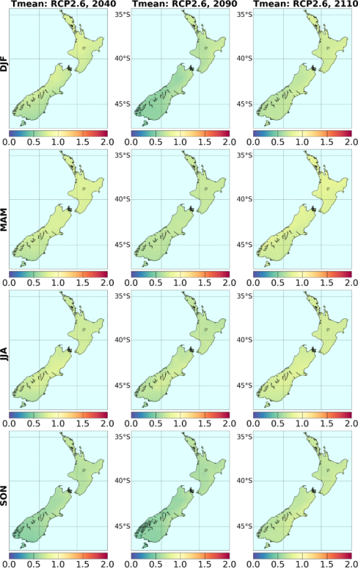
Figure 8: Seasonal changes in mean temperature (in °C), derived by statistically downscaling CMIP5 models, for three future time periods under RCP2.6

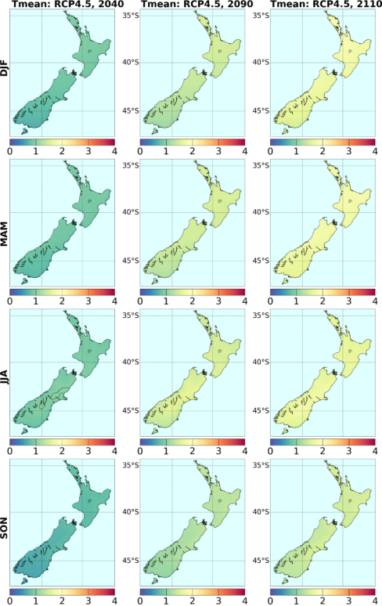
Figure 9: Seasonal changes in mean temperature (in °C), derived by statistically downscaling CMIP5 models, for three future time periods under RCP4.5. Note the change of scale from Figure 8

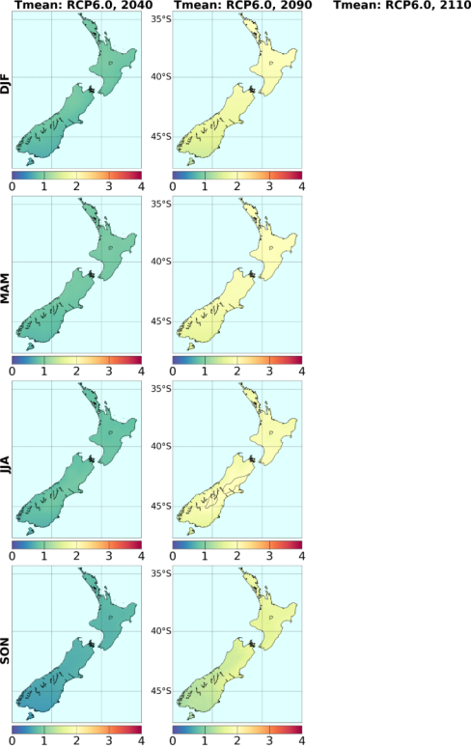
Figure 10: Seasonal changes in mean temperature (in °C), derived by statistically downscaling CMIP5 models, for three future time periods under RCP6.0. No 2110 projections are calculated

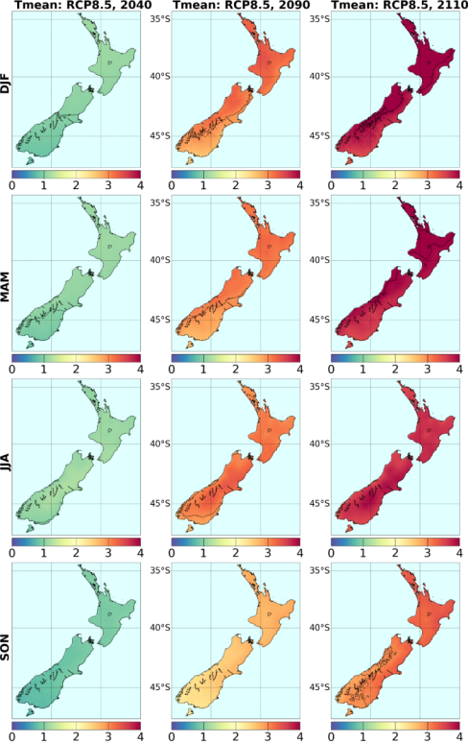
Figure 11: Seasonal changes in mean temperature (in °C), derived by statistically downscaling CMIP5 models, for three future time periods under RCP8.5

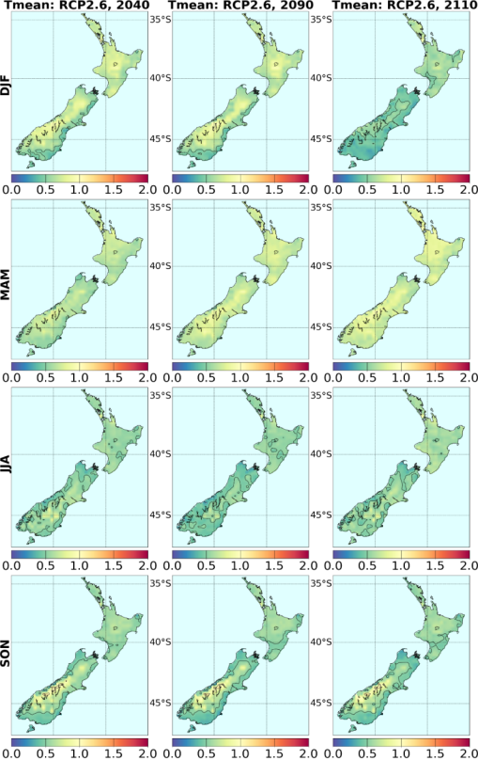
Figure 12: Seasonal changes in mean temperature (in °C), derived by downscaling CMIP5 models via NIWA’s regional climate model, for three future time periods under RCP2.6. Results are for the average over six RCMs, except for 2110 (see Table 3). The colour scale is the same as for Figure 8

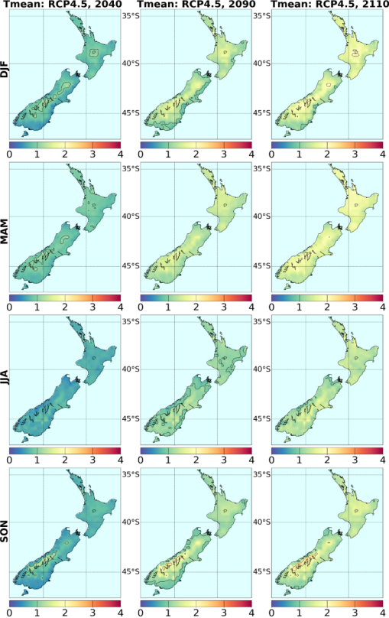
Figure 13: Seasonal changes in mean temperature (in °C), derived by downscaling CMIP5 models via NIWA’s regional climate model, for three future time periods under RCP4.5. Note the change of scale from Figure 12

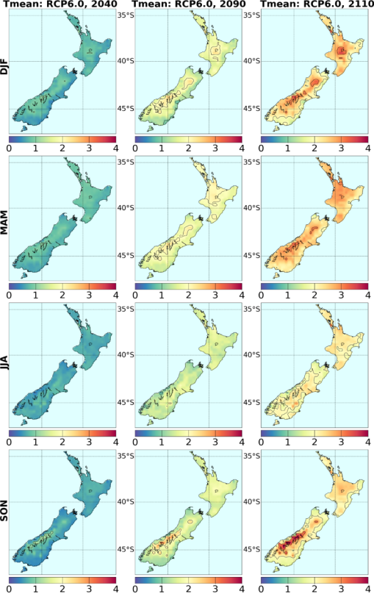
Figure 14: Seasonal changes in mean temperature (in °C), derived by downscaling CMIP5 models via NIWA’s regional climate model, for three future time periods under RCP6.0

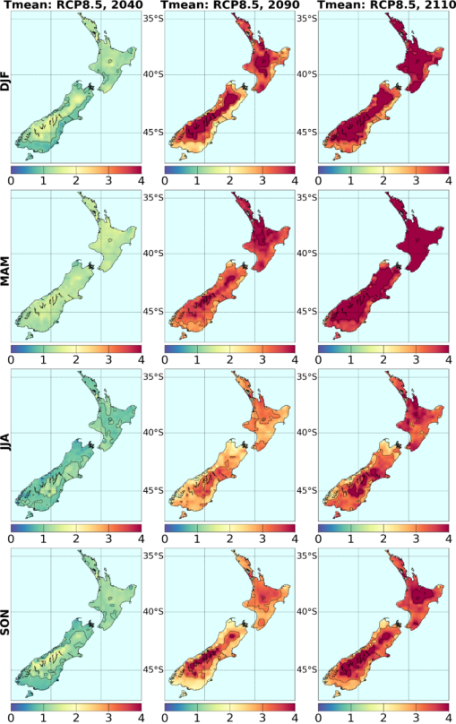
Figure 15: Seasonal changes in mean temperature (in °C), derived by downscaling CMIP5 models via NIWA’s regional climate model, for three future time periods under RCP8.5

3.2.2 Mean temperature changes by region
Tables 5 to 7 above show the projected changes in mean temperature, as a function of season, RCP and regional council region. Figures 8 to 15 show regional patterns of mean temperature change, by season, by RCP, and for statistical and dynamical (RCM) downscaling separately. Figures 16 and 17 provide a graphical summary of the temperature projections in an alternate format.
Dynamically downscaled (RCM) projections of mean temperatures for all periods (2040, 2090 and 2110) follow a similar general pattern and magnitude as statistically downscaled results based on the larger ensemble of CMIP5 models. The RCM projections, however, show considerably enhanced spatial variability, which is because of more detailed representation of physical processes (such as precipitation phase change, boundary layer, air-sea breeze) and local conditions (such as orography, land-sea interface). The warming is weaker over coastal locations tempered by cooler ocean temperatures, whereas it is most enhanced over high elevations due to loss of snow cover.
The general warming signal has north-south and east-west gradients, with the strongest warming over the north-eastern North Island. The strong warming signal over higher elevations is also evident in all seasons but is most prominent in the spring and summer seasons. With exception of RCP2.6 temperature projections at 2110, the warming trend is not observed to abate in any season.
Figure 16 illustrates the temperature projections by season and RCP, for the two time periods of 2040 and 2090. Hawke’s Bay is selected as an example, where the temperature changes are averaged over all VCSN grid-points within the regional council region. The coloured vertical bars, and inset stars, show all the individual models, so the complete range is displayed (unlike Tables 5 to 7 where the 5th to 95th percentile range has been calculated). Figure 16 is an excellent way of not only demonstrating the difference with season and RCP, but also the range of model sensitivity. The black stars within each vertical bar represent the results of the six RCM simulations; the RCM projections tend to be in the lower half of the statistically-downscaled results, owing to the bias-correction applied to the raw RCM output.
Figure 17 presents a similar picture to Figure 16, except that the extreme seasons (summer and winter) are shown for all regional council regions on a single graph. This makes it easy to compare the range of projections in different regions of New Zealand. There is not a great deal of difference between regions for temperature, but it is apparent that the north of the country warms slightly faster than the south (horizontal bars for model averages), but also that some southern regions have a larger uncertainty in the projected change. The model uncertainty range for the lower RCP2.6 pathway crosses zero in all South Island regions in summer, indicating that at least one model simulates similar temperatures to the current climate.
If the IPCC Fifth Assessment “likelihood” definitions (IPCC, 2013) are applied to the temperature projections, and the model spread is used to calculate the probabilities of a particular outcome, then it can be said that a rise in temperature above the present-day is virtually certain (99–100 per cent probability) for almost all locations and seasons at 2040 and 2090. There are a few exceptions for the 2090 projections under the RCP2.6 pathway where a warmer future is very likely (90–100 per cent); for example, all South Island regions in the summer season (Figure 16). Obviously, other temperature thresholds could be assessed in the same way.
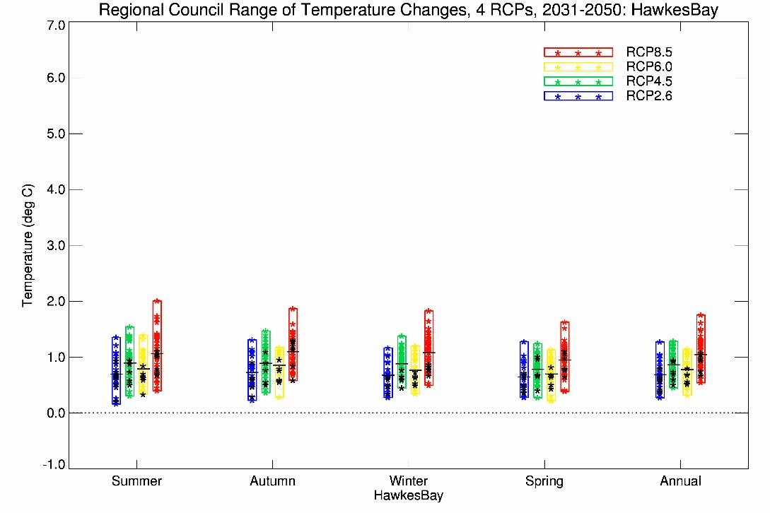
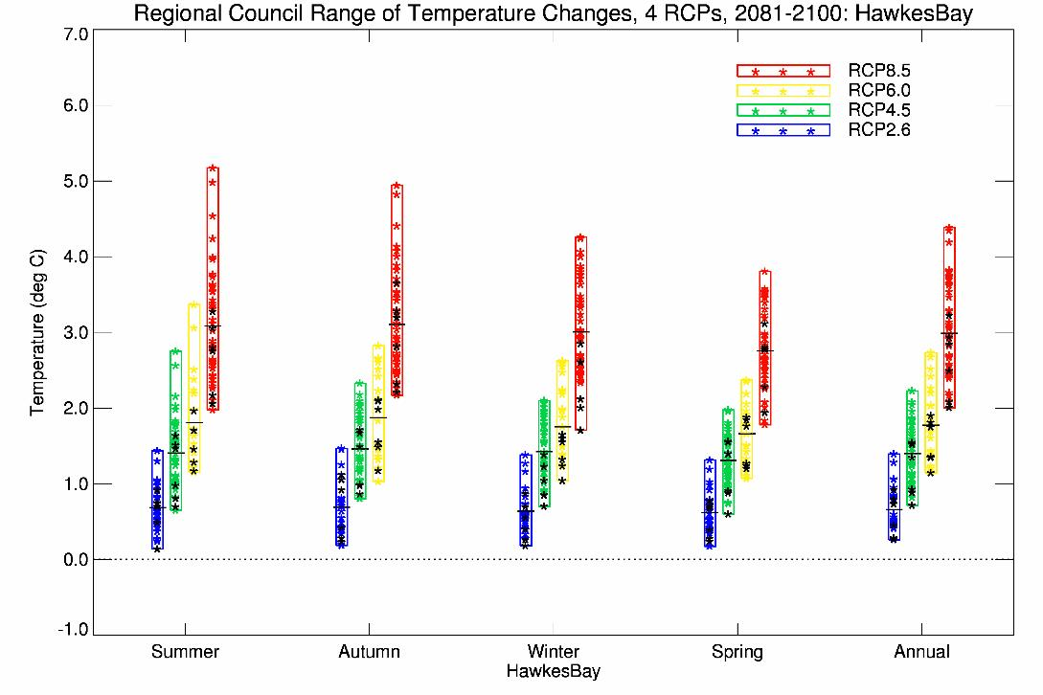
Figure 16: Projected temperature changes for Hawke’s Bay Region, for 2040 (top panel) and 2090 (bottom panel), for all seasons (plus annual), all RCPs (vertical bars) and all models (coloured stars), as derived by statistical downscaling. The black stars correspond to the six-model RCM-downscaling, and the horizontal bars the average over all downscaled results (statistical and RCM)

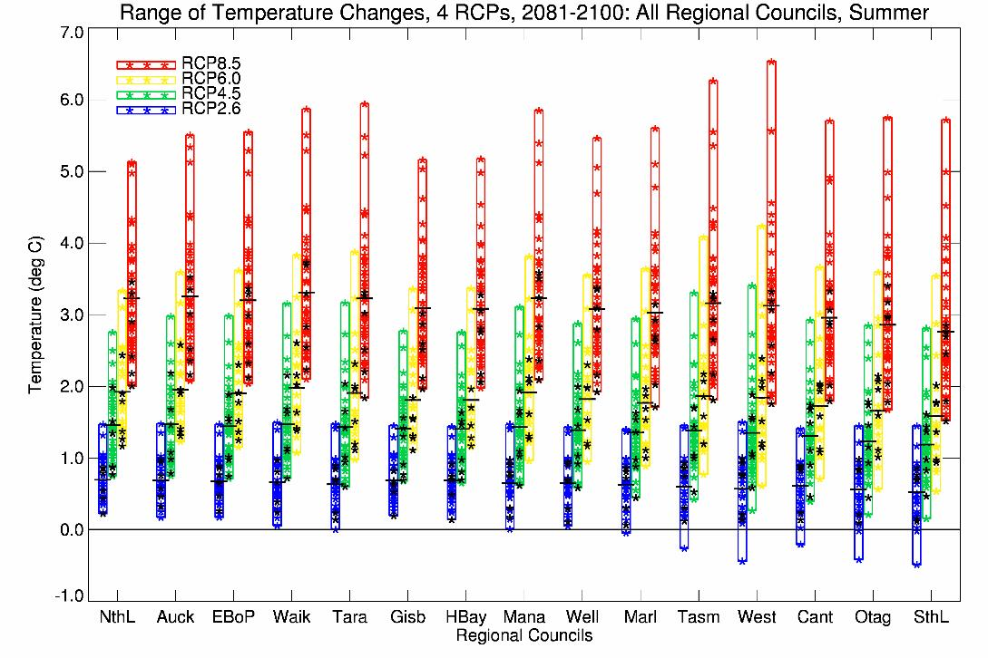
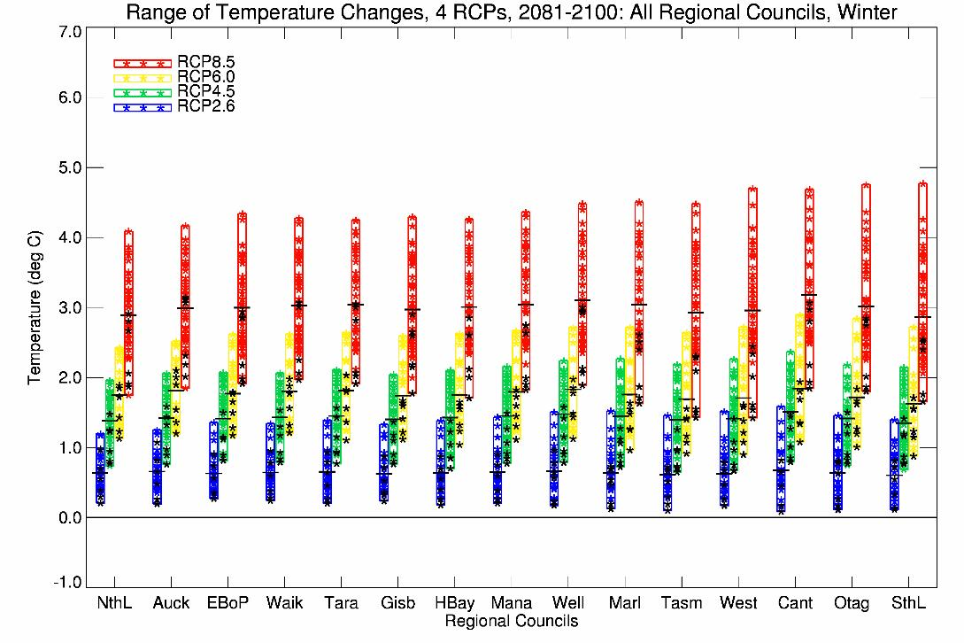
Figure 17: Projected temperature changes for all regional council areas for 2090, for summer (top panel) and winter (bottom panel) seasons, for all RCPs (bars) and all models (coloured stars), as derived by statistical downscaling. The black stars correspond to the six-model RCM-downscaling
The regional council abbreviations (in order) represent: Northland, Auckland, Environment Bay of Plenty, Waikato, Taranaki, Gisborne, Hawke’s Bay, Horizons Manawatu-Whanganui, Wellington, Marlborough, Tasman (including Nelson City), West Coast, Environment Canterbury, Otago, and Southland.

3.3 Maximum and minimum temperature projections
The maps of projected changes now continue with changes in daytime maximum (Tmax), night-time minimum (Tmin), and the diurnal range (Trange, the difference between Tmax and Tmin). These parameters are available only from the RCM dynamical downscaling, as the statistical downscaling does not distinguish between day and night temperature changes.
The ensemble of regional climate model temperature projections is based on the six best performing models for the New Zealand region (see Tables 3 and 4). The temperature trends are positive over all regions and for all RCPs, but are neither spatially homogeneous nor of equal magnitude. The mean, minimum, maximum and the diurnal range of temperature changes are documented for all seasons and periods in Figures 18 to 29.
The positive maximum temperature trends (Tmax) are mostly larger than minimum temperature trends (Tmin), resulting in an increase in the diurnal temperature range (Trange). The Trange increase is largest in the spring and summer seasons over eastern North Island and most of the South Island. The northern North Island experiences a decrease in diurnal temperature range in all seasons, however, corresponding to a greater warming rate for the minimum temperature compared to the maximum temperature. In general, for NIWA’s seven-station series, the historical warming rates have been higher for the minimum than the maximum at all but one site (Nelson).
Further research is needed to establish the robustness of these differences in the projected maximum and minimum temperatures, and the consequent effect on diurnal temperature range. The issue is complex, with future trends influenced by changes in circulation, cloudiness and the hydrological cycle. Errors in model physics or parameter settings may also play a role (Ackerley et al, 2012). There is internal consistency between the temperature changes and changes to other model variables. For example, the diurnal range decreases on the West Coast in the winter season, at the same time that the precipitation increases and the solar radiation decreases (ie, cloudiness increases).
In an international study of projected changes in diurnal range in 20 CMIP5 models, Lindvall & Svensson (2015) concluded that model differences (in Trange) vary regionally and seasonally. The majority of models project a globally-averaged reduction in Trange over land, but with regional changes being both positive and negative. In particular, this study noted that three models (ncar-cesm1-cam5, gfdl-esm2m, and ncc-noresm1-m) project a globally-averaged increase in Trange; two of these models are used in the NIWA RCM study, and a related GFDL model is also one of the six used in the RCM downscaling.

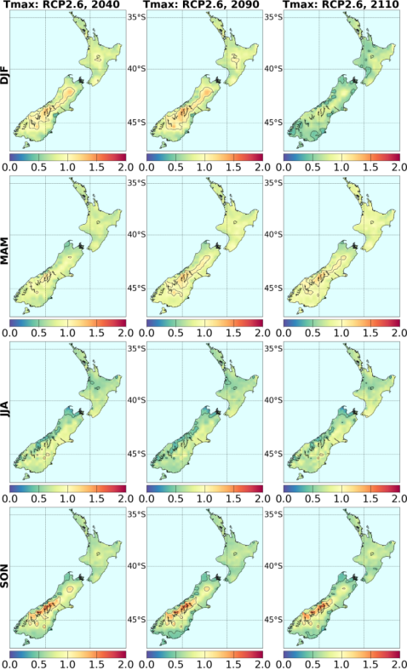
Figure 18: Seasonal changes in daily maximum temperature (in °C), derived by downscaling six CMIP5 models via NIWA’s regional climate model, for three future time periods under RCP2.6. Results are for the average over six RCMs, except for 2110 (see Table 3)

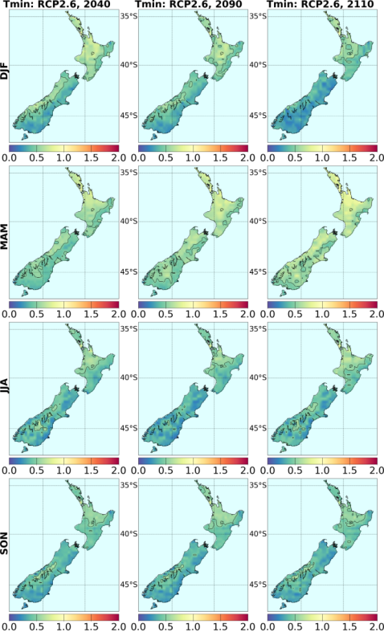
Figure 19: Seasonal changes in daily minimum temperature (in °C), derived by downscaling six CMIP5 models via NIWA’s regional climate model, for three future time periods under RCP2.6

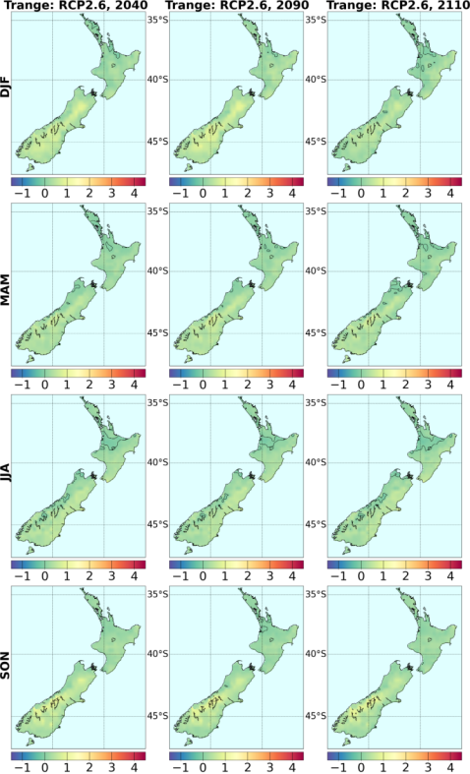
Figure 20: Seasonal changes in diurnal temperature range ((Tmax minus Tmin, in °C), derived by downscaling CMIP5 models via NIWA’s regional climate model, for three future time periods under RCP2.6
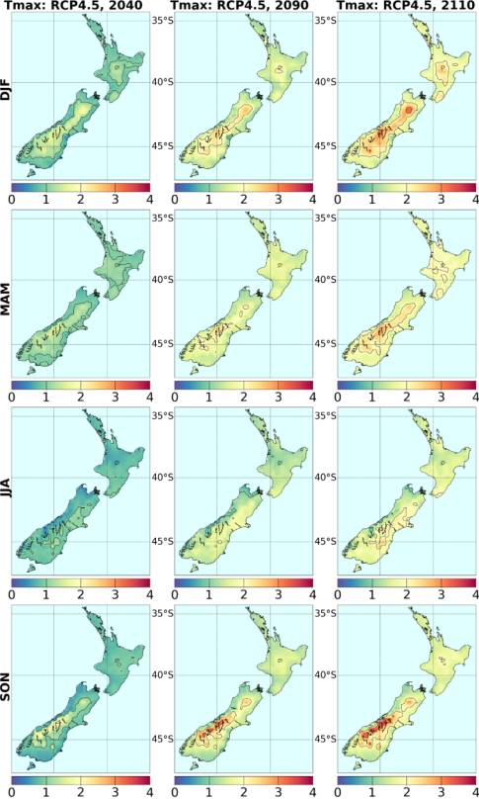
Figure 21: Seasonal changes in daily maximum temperature (in °C), derived by downscaling CMIP5 models via NIWA’s regional climate model, for three future time periods under RCP4.5

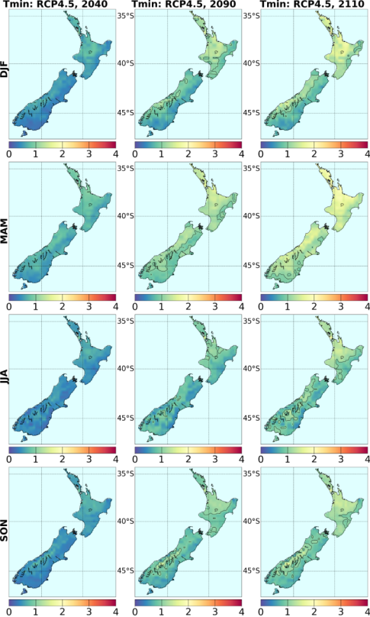
Figure 22: Seasonal changes in daily minimum temperature (in °C), derived by downscaling CMIP5 models via NIWA’s regional climate model, for three future time periods under RCP4.5
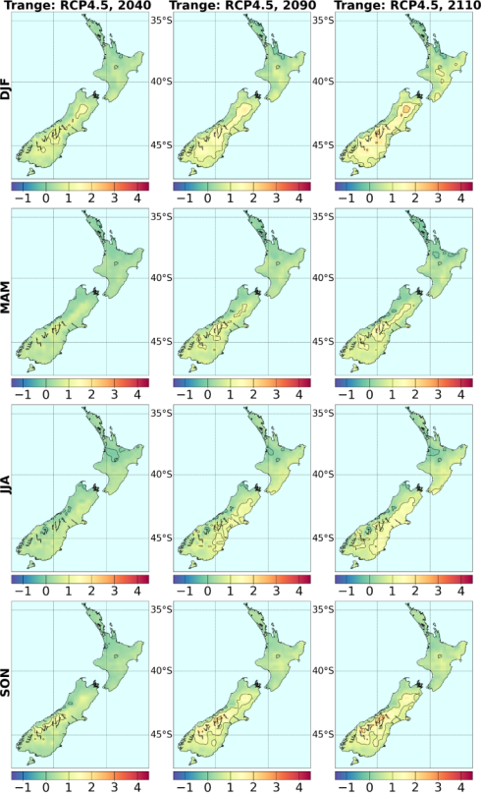
Figure 23: Seasonal changes in diurnal temperature range ((Tmax minus Tmin, in °C), derived by downscaling CMIP5 models via NIWA’s regional climate model, for three future time periods under RCP4.5

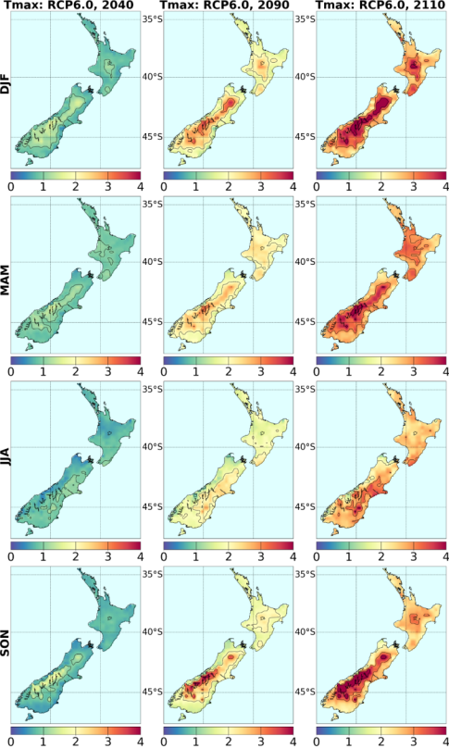
Figure 24: Seasonal changes in daily maximum temperature (in °C), derived by downscaling CMIP5 models via NIWA’s regional climate model, for three future time periods under RCP6.0

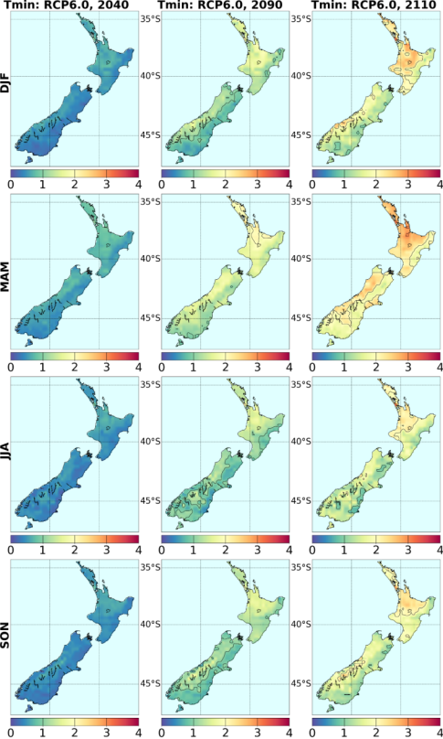
Figure 25: Seasonal changes in daily minimum temperature (in °C), derived by downscaling CMIP5 models via NIWA’s regional climate model, for three future time periods under RCP6.0

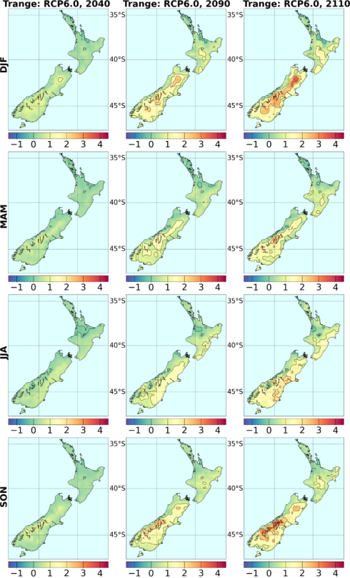
Figure 26: Seasonal changes in diurnal temperature range ((Tmax minus Tmin, in °C), derived by downscaling CMIP5 models via NIWA’s regional climate model, for three future time periods under RCP6.0
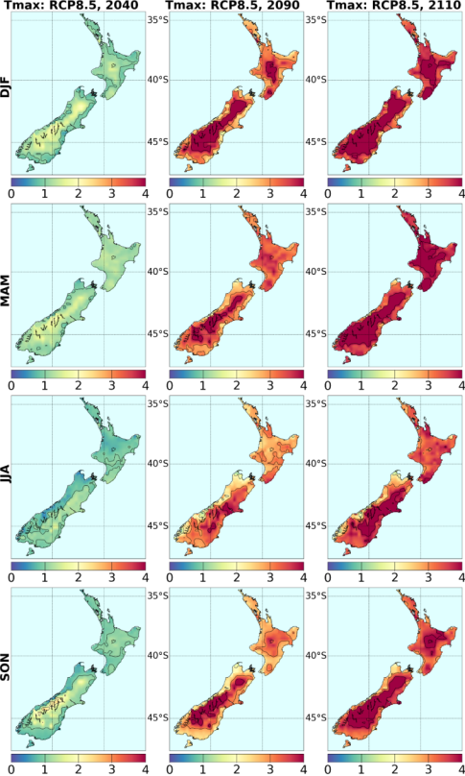
Figure 27: Seasonal changes in daily maximum temperature (in °C), derived by downscaling CMIP5 models via NIWA’s regional climate model, for three future time periods under RCP8.5

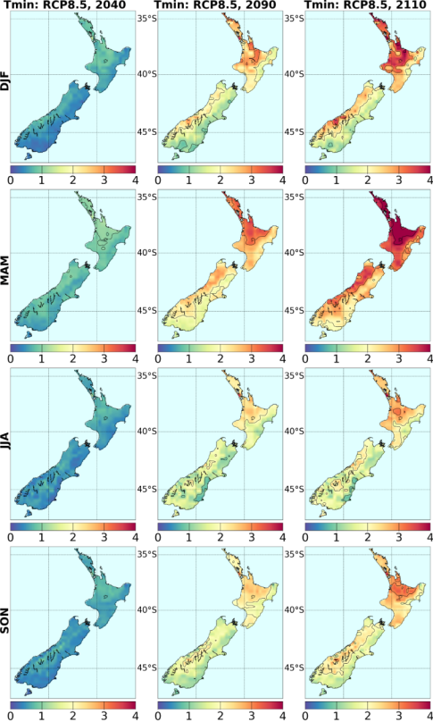
Figure 28: Seasonal changes in daily minimum temperature (in °C), derived by downscaling CMIP5 models via NIWA’s regional climate model, for three future time periods under RCP8.5

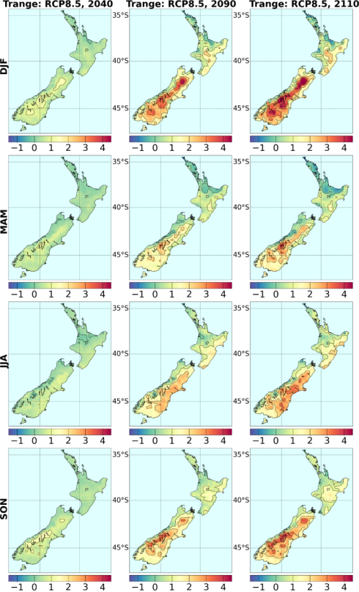
Figure 29: Seasonal changes in diurnal temperature range ((Tmax minus Tmin, in °C), derived by downscaling CMIP5 models via NIWA’s regional climate model, for three future time periods under RCP8.5

3.3.1 Temperature extremes
As the seasonal mean temperature increases over time (Tmax, Tmin, and Tmean), we would expect to see changes in extremes. In general, we would expect an increase in high temperature extremes, and a decrease in low temperature extremes. Natural variability will, of course, continue to influence particular years, and the specific time evolution of this variability cannot be predicted by the climate models due to the chaotic interactions that affect development of individual weather systems and larger-scale climate modes (such as the El Niño events).
We consider ‘high temperature’ extremes to be the number of days per year of 25°C or above, and ‘low temperature’ extremes the number of ‘days’ (actually nights) per year of 0°C or below. These extremes have been calculated directly from the RCM downscaling by counting the number of exceedances in the daily maximum/minimum temperature output (Figures 31 and 32). They have also been calculated from the statistical downscaling results (Figure 30), by adding the projected monthly mean temperature offsets to the VCSN daily maximum and minimum observations over 1986–2005, then counting exceedances and finally averaging over all models. (Note that adding the monthly offsets to the climatological maximum or minimum temperature gives the wrong answer.)
Table 8: Average number of ‘hot days’ per year (maximum temperature ≥25°C), by region, for the present day (1986–2005) and for two future periods (2040, 2090) under the four RCPs. The averages are calculated over all models but only for VCSN grid-points below 500 metres altitude. Results are based on statistical downscaled projections
Council | Present | 2031–2050 period |  |  |  | 2081–2100 period
 |  | RCP2.6 | RCP4.5 | RCP6.0 | RCP8.5 | RCP2.6 | RCP4.5 | RCP6.0 | RCP8.5
Northland | 24.5 | 38.1 | 42.1 | 41.1 | 46.0 | 37.2 | 55.1 | 67.3 | 99.3
Auckland | 19.7 | 32.0 | 35.5 | 34.8 | 39.1 | 30.7 | 47.6 | 59.3 | 89.7
Bay of Plenty | 16.3 | 26.1 | 28.6 | 28.4 | 31.8 | 25.1 | 38.6 | 48.4 | 75.6
Waikato | 23.6 | 34.9 | 37.8 | 37.5 | 40.9 | 33.3 | 47.8 | 57.7 | 84.0
Taranaki | 6.5 | 12.0 | 13.5 | 13.4 | 15.3 | 11.1 | 19.7 | 26.6 | 47.7
Gisborne | 24.2 | 32.7 | 35.2 | 34.5 | 37.8 | 32.3 | 43.6 | 51.5 | 75.5
Hawke’s Bay | 27.5 | 36.3 | 38.8 | 38.2 | 41.6 | 36.1 | 47.6 | 55.2 | 78.1
Manawatu | 18.6 | 26.9 | 29.0 | 28.8 | 31.3 | 25.7 | 36.7 | 44.2 | 65.5
Wellington | 20.1 | 26.8 | 28.6 | 28.3 | 30.6 | 26.3 | 35.2 | 41.3 | 60.1
Marlborough | 14.0 | 19.7 | 21.2 | 21.0 | 23.0 | 19.3 | 27.3 | 33.1 | 51.8
Tasman | 11.0 | 17.1 | 18.5 | 18.7 | 20.5 | 16.0 | 25.2 | 32.5 | 53.9
West Coast | 8.0 | 12.3 | 13.1 | 13.4 | 14.4 | 11.3 | 17.7 | 23.1 | 39.4
Canterbury | 27.3 | 33.5 | 34.8 | 34.6 | 36.8 | 33.1 | 40.9 | 45.9 | 62.3
Otago | 17.8 | 21.9 | 22.6 | 22.7 | 23.9 | 21.4 | 26.8 | 30.3 | 42.3
Southland | 7.6 | 10.1 | 10.5 | 10.6 | 11.3 | 9.7 | 13.1 | 15.5 | 24.0

Table 9: Average number of ‘cold nights’ per year (minimum temperature ≤0°C), by region, for the present day (1986–2005) and for two future periods (2040, 2090) under the four RCPs. The averages are calculated over all models but only for VCSN grid-points below 500 metres altitude. Results are based on statistical downscaled projections
Council | Present | 2031–2050 period |  |  |  | 2081–2100 period
 |  | RCP2.6 | RCP4.5 | RCP6.0 | RCP8.5 | RCP2.6 | RCP4.5 | RCP6.0 | RCP8.5
Northland | 0.5 | 0.2 | 0.2 | 0.2 | 0.2 | 0.3 | 0.1 | 0.1 | 0.1
Auckland | 1.9 | 0.9 | 0.8 | 0.9 | 0.7 | 1.0 | 0.5 | 0.3 | 0.1
Bay of Plenty | 17.3 | 11.5 | 10.3 | 10.9 | 9.2 | 11.9 | 7.3 | 5.7 | 2.3
Waikato | 15.2 | 10.3 | 9.2 | 9.7 | 8.2 | 10.6 | 6.5 | 5.0 | 1.9
Taranaki | 6.3 | 3.1 | 2.5 | 2.8 | 2.0 | 3.3 | 1.4 | 0.9 | 0.2
Gisborne | 8.5 | 4.9 | 4.2 | 4.6 | 3.6 | 5.1 | 2.7 | 2.0 | 0.7
Hawke’s Bay | 16.0 | 10.1 | 8.9 | 9.4 | 7.8 | 10.4 | 5.9 | 4.4 | 1.2
Manawatu | 18.2 | 12.0 | 10.6 | 11.3 | 9.4 | 12.4 | 7.2 | 5.5 | 1.7
Wellington | 14.4 | 9.0 | 7.8 | 8.4 | 6.8 | 9.3 | 5.1 | 3.8 | 1.1
Marlborough | 21.7 | 14.5 | 13.0 | 13.8 | 11.6 | 15.0 | 9.2 | 7.3 | 2.8
Tasman | 36.2 | 26.8 | 24.8 | 25.7 | 22.9 | 27.4 | 19.3 | 16.3 | 8.2
West Coast | 21.0 | 13.6 | 12.1 | 12.9 | 10.7 | 14.1 | 8.4 | 6.7 | 2.6
Canterbury | 46.7 | 33.7 | 30.9 | 32.3 | 28.1 | 34.2 | 23.4 | 19.4 | 8.8
Otago | 64.6 | 51.0 | 48.0 | 49.6 | 45.0 | 51.3 | 39.4 | 34.8 | 20.1
Southland | 37.0 | 26.4 | 24.1 | 25.4 | 22.0 | 26.7 | 18.2 | 15.4 | 7.0

Figure 30 shows the spatial distribution of hot days and cold nights, for the present day and at 2090 for the most extreme warming pathway (RCP8.5). The largest increase in hot days occurs for the northern half of the North Island and for coastal Gisborne and Hawke’s Bay. Frosty nights continue to occur at higher altitudes in both the North and South Islands.
‘Hot days’ increase everywhere and with all RCPs. For example (Table 8), in the Auckland region at 2090, the number of hot days increases by 11 days (~55 per cent increase) for RCP2.6, and by 70 days per year under RCP8.5 (almost four times as many hot days as occur currently). By 2090 under RCP8.5, Southland is projected to have as many hot days as Northland does in the current climate (about 24 per year). As with the mean temperature change, the increase in hot days is most pronounced in northern North Island.
Conversely, the frequency of cold days (or cold nights) decreases everywhere, varying from a typical reduction of about 50 per cent at 2090 under RCP2.6, through to a 70–80 per cent reduction throughout the South Island under RCP8.5 at 2090 (Table 9, Figure 30). There is no need, of course, for a seasonal breakdown to be shown: the hot days will occur in the summer (December–February), with extensions to the shoulder seasons of autumn and spring in some instances; the cold nights will likewise be concentrated in the winter months (June–August).

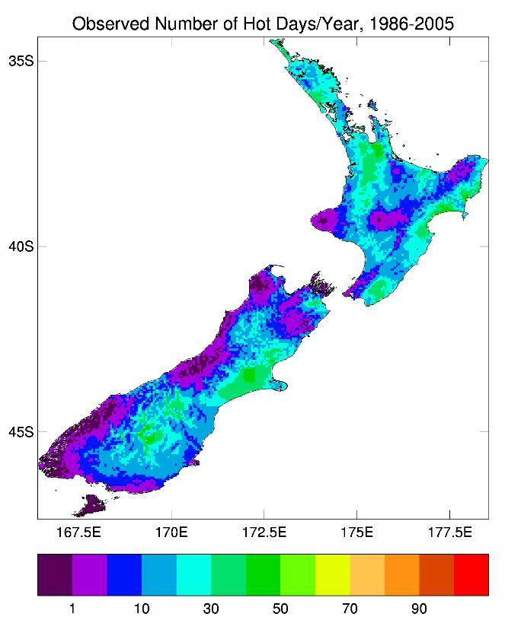 | 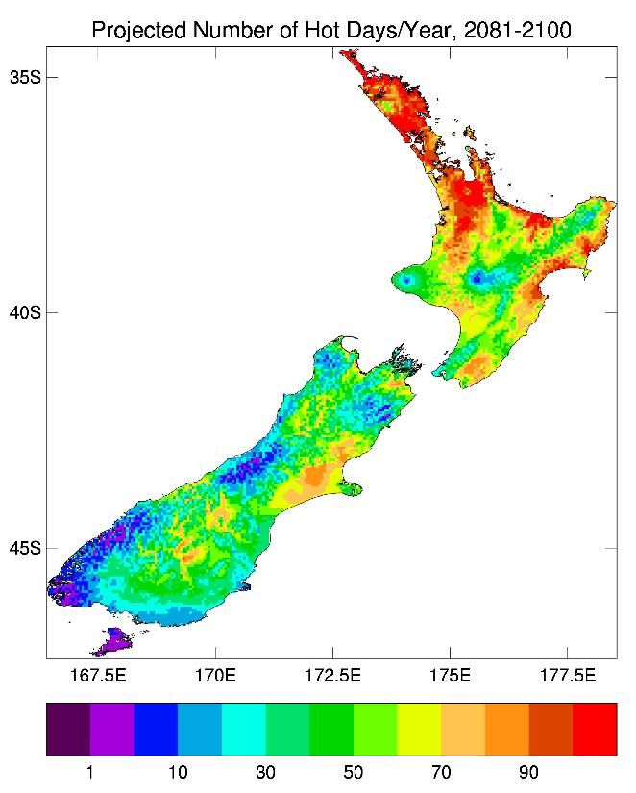
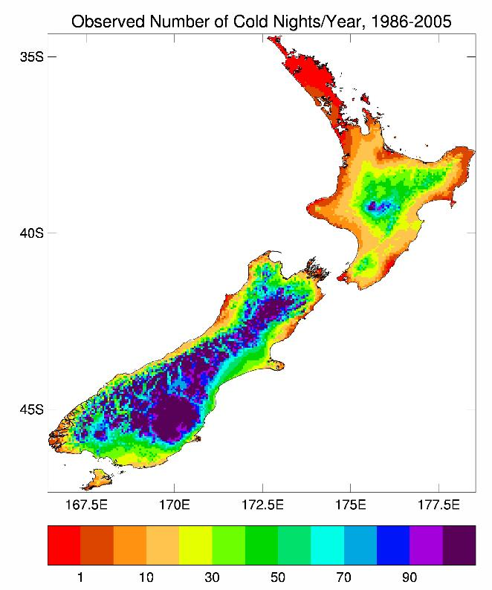 | 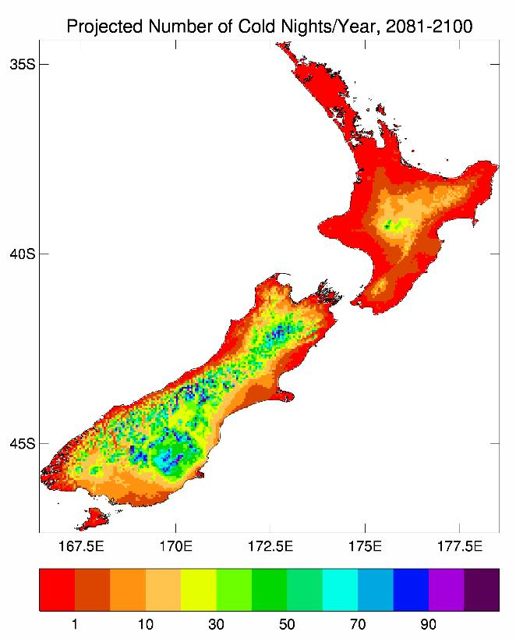
Figure 30: Number of days per year of ‘hot days’ (maximum temperature of 25°C or above, top row) and ‘cold nights’ (minimum temperature of 0°C or below, bottom row): ‘current’ climate (1986–2005), left; 2090 climate under RCP8.5 (right)
Note that the right-hand panels show the total number of extreme days, not the change, as presented in Figures 31 and 32.

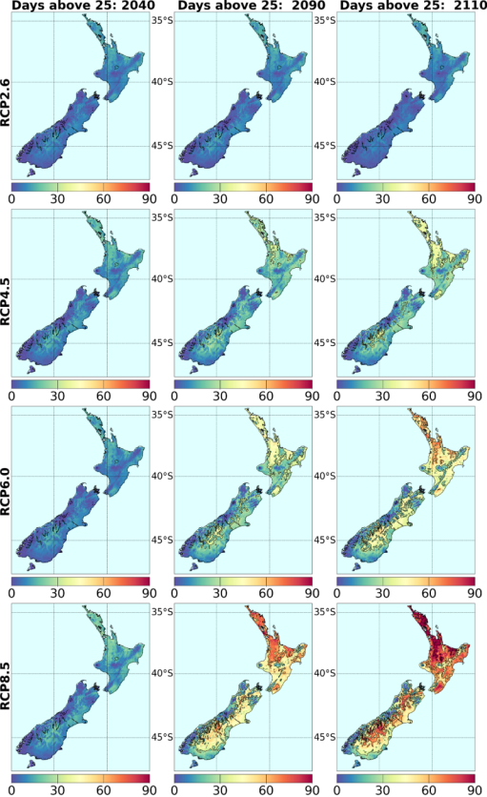
Figure 31: RCM-projected increases in the annual number (in days) of ‘hot days’ (25°C or above), with respect to the baseline 1995 period, for all four RCPs and three future time periods. Results are for the average over six RCMs, except for 2110 (see Table 3)

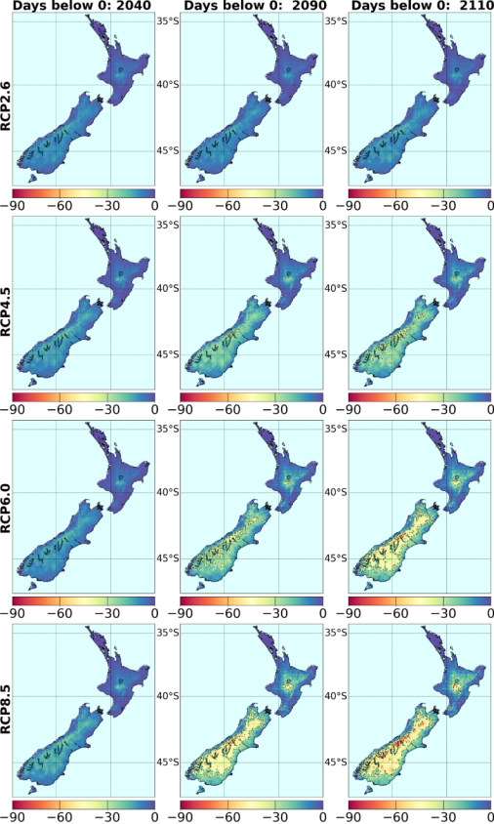
Figure 32: RCM-projected changes in the annual number (in days) of ‘cold nights’ (0°C or below), with respect to the baseline 1995 period, for all four RCPs and three future time periods, as averaged over six RCMs. Note that the changes are all negative

3.4 Comparing changes in New Zealand versus global temperatures
There is ongoing interest about how projected changes in New Zealand land temperatures compare with changes in surrounding sea surface temperature and with global (land and sea) temperatures. Figure 33 helps to clarify these relationships, as determined from the full set of CMIP5 global models.
Annual values of air and sea surface temperature were extracted from the global CMIP5 model archive for both the global-average and for the New Zealand ‘box’ (33–48°S, 160–190°E). Time series of the ensemble-average under RCP8.5 are shown in Figure 33. The highest concentration pathway (RCP8.5) is used in this example, as we would expect the carbon dioxide forcing to be strongest in this case, and most likely to dominate over natural variability. Thus, the ‘true’ anthropogenic signal is most likely to be evident in the highest forcing.
It is evident from the figure that global air temperature (over land and sea) increases faster than air temperature (land and sea) over the New Zealand ‘box’ (on average, across the 34 models). Regional sea temperatures have a slightly smaller warming trend than the New Zealand air temperatures. The right-hand side of Figure 33 shows two ratios, both for all models individually and for the 34-model ensemble-average. The first ratio, of New Zealand land to regional sea temperatures (blue stars), is greater than 1.0 for all models, with an average ratio of 1.10 and a model range from 1.02 to 1.20. The second ratio, of global air temperature change to the New Zealand box air temperature change, is much larger on average, as well as having a greater uncertainty: the 34-model average ratio is 1.32, but varies from a low of 0.77 to a high of 2.05.
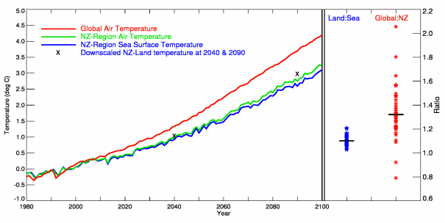
Figure 33: Temperature changes relative to the 1986–2005 baseline under RCP 8.5, from 34 GCMs with archived sea temperature data (Table 2)
The left side of the graph shows changes in the raw global model output for:
- air temperature averaged over the entire globe (red)
- air temperature (green) and sea surface temperature (SST, blue) averaged over the ‘New Zealand box’ region 33–48°S, 160–190°E.
The two crosses show the air temperature changes from the statistical downscaling at 2040 and 2090, averaged over all VCSN grid-points of New Zealand (‘Land’). The right side of the graph shows the 2090 ratio of New Zealand land temperature increase to SST in the New Zealand region (blue stars, with horizontal bar denoting the 34-model average), and the 2090 ratio of global air temperature change to the New Zealand region air temperature change (red stars, with horizontal bar denoting the 34-model average).

3.5 Limits and uncertainty in New Zealand warming
Much has been written about the challenge of preventing global mean temperatures from rising beyond 2°C above pre-industrial levels – see, for example, Reisinger et al (2011) and van Vuuren et al (2011b), and their references. This short section looks at what the AR5 models show about holding the New Zealand-region warming to 1°C above the 1986–2005 baseline. This would correspond to a global warming of approximately 2°C above pre-industrial levels (ie, 0.7°C + 1.3*1.0°C = 2.0°C, from section 3.4).
Figure 34 shows the time-series of air temperature, observed for New Zealand land (the seven-station series), and simulated over the New Zealand ‘box’ (33–48°S, 160–190°E) from the raw (not downscaled) GCMs for the historical period (1900–2005) and future period to 2100 under the two extreme RCPs (2.6 and 8.5). The observed seven-station series stays within the simulated ensemble envelope throughout the CMIP5 so-called ‘historical period’, which ends in 2005. The linear extrapolation of the seven-station trend indicates a warming of about another 1°C by 2100. The lowest concentration pathway (RCP2.6) contains this extrapolation within its ensemble envelope, although the RCP2.6 ensemble average would drop below the extrapolation by about 2060–70. On the other hand, the highest pathway (RCP 8.5) increases New Zealand region temperatures well above the seven-station extrapolation, showing a clear separation from about the mid-21st century.
The time series for a single selected model (miroc5, Table 2) is included in Figure 34, covering the period 2006–2100, to illustrate the level of inter-annual variability that might be expected. The result is very similar to the inter-annual variability of the seven-station series in the past. A single model is used because the ensemble average would give a false picture of the inter-annual variability (variations would be much too small).
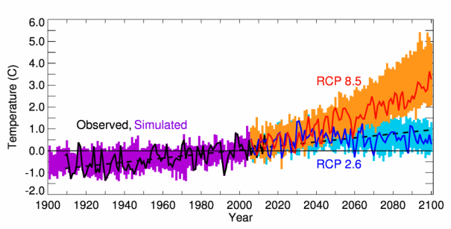
Figure 34: Time series of air temperature anomalies: seven-station series of New Zealand land temperature (black line) and its linear extrapolation to 2100 (dashed black line); historical air temperatures over the New Zealand ‘box’ for 1900–2005 (purple histogram), as simulated by 41 GCMs; simulations of future projected New Zealand box air temperatures for RCP2.6 (blue) and RCP8.5 (orange)
The histograms show the full model range at each year. The blue and red lines show the time series for one selected model (miroc5), which sits near the middle of the 2.6 and 8.5 ensembles. All data are normalised relative to the 1986–2005 base period.
From Figure 34, RCP2.6 asymptotes at slightly more than 0.5°C above the 1986–2005 period by the end of this century. Over land only, as opposed to land plus sea in the New Zealand ‘box’, the downscaled results suggest a warming average of about 0.7°C by 2090 for RCP2.6 and 3.0°C for RCP8.5 (Table 6). How these different warming rates of Table 6 and Figure 34 play out over the century is illustrated in Figure 35. Again, the New Zealand ‘box’ air temperatures are used since they are available every year, whereas the statistically downscaled results are not. (The RCM results are also transient experiments with changes every year, but the sample is a lot smaller.)
In Figure 35, the fraction of CMIP5 models where the air temperature exceeds +1°C above the baseline 1986–2005 temperature is calculated for each year from 2006 to 2100. The air temperature time series are first smoothed (a five-year running mean) before calculating the percentage of models above the threshold (otherwise, the graphs are very ‘noisy’). By 2070, 100 per cent of the RCP8.5 models have reached the +1°C threshold, while only about 20 per cent of RCP2.6 models have. The other two pathways, RCPs 4.5 and 6.0, have about a 70 per cent chance of exceeding +1°C by 2070.
Figure 35 therefore illustrates how critical future emission paths are to constraining future New Zealand warming. The large range over projections from individual models (Figure 17) does not guarantee local warming will remain below +1°C, even for RCP2.6. For example, during the period 2040–90, four to five of the RCP2.6 models reach this threshold (ie, 0.2 * 23).
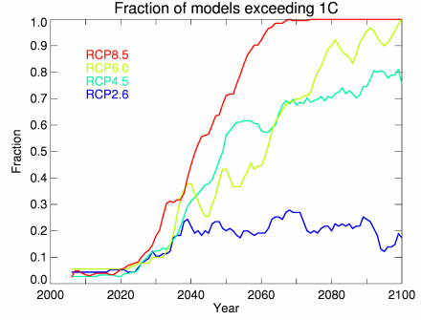
Figure 35: Fraction of models where the New Zealand-region air temperature increase exceeds 1°C, relative to 1986–2005, for the RCPs 2.6, 4.5, 6.0 and 8.5, as calculated by counting the number of models at each year (of a smoothed time series) that exceed the nominated threshold out of a total of 23, 37, 18 and 41 models, respectively

3.6 Precipitation projections
As with temperature, climate change precipitation projections are now presented in terms of tables (Tables 10 to 12) and figures (Figures 36 to 43) for three future periods (2040, 2090, 2110) and four RCPs (2.6, 4.5, 6.0, and 8.5). The maps of projected changes give the national picture, while the tables provide a breakdown of the projections at regional council scale. The maps, which show how the projections vary with season, are split into two parts:
- Figures 36 to 39 are changes as derived from the large ensemble of global models (Table 2) by statistical downscaling
- Figures 40 to 43 are derived by dynamical downscaling six global models via NIWA’s regional climate model (RCM).
The main features of the tables and maps of projected precipitation changes are as follows:
- The magnitudes (positive and negative) of the precipitation projections generally increase with time, and with the strength of the radiative forcing. Unlike temperatures, it does not make sense to average precipitation over regional council area, especially if (as with Wellington) part of the region is on the west coast and part on the east. Thus, we have selected indicative locations (the VCSN grid-point co-located with the named climate station) to present the changes. Sometimes this is only one location, but sometimes two sites (and three in Canterbury). These locations are the same as in Ministry for the Environment (2008).
- For a number of regions of New Zealand, there is no clear direction of precipitation change, even at 2090 under RCP8.5. The ensemble-average is often smaller than ±5 per cent, with the model range (the 5th-percentile and 95th-percentile model values) varying between quite large (>10 per cent) decreases and increases.
- The largest changes of all occur for the West Coast in the winter season, with area-average changes up to a 30 per cent increase under RCP8.5 by 2090.
Again, the RCM has more spatial detail than can be provided by the statistical downscaling; but note that the RCM maps cover only six models, while the statistical downscaling includes up to 41, so we would expect a smoother pattern from the larger ensemble. The RCM can also provide guidance on changes in daily extreme precipitation (see further discussion later in this section).

3.6.1 Mean precipitation changes by region
The largest precipitation changes by the end of the century are seen at the seasonal scale:
- in spring, decreases for Northland, Auckland, and Bay of Plenty, and increases for Otago (Queenstown) and Southland
- in winter, decreases for Gisborne, Hawke’s Bay and Canterbury (Christchurch and Hanmer), and increases for Tasman-Nelson (Nelson), West Coast, Canterbury (Tekapo), Otago (Dunedin), Southland and Chatham Islands.
Further spatial detail is provided in the following tables (Table 10 to 12) and maps (Figures 36 to 39 (statistical) and 40 to 43 (RCM)).
Table 10: Projected changes in seasonal and annual precipitation (in percentage) between
1986–2005 and 2031–50, by region, as derived from statistical downscaling. The changes are given for four RCPs (8.5, 6.0, 4.5 and 2.6), where the ensemble-average is taken over (41, 18, 37, 23) models respectively
The values in each column represent the ensemble average, and in brackets the range (5th percentile to 95th percentile) over all models within that ensemble. Projections for the Chatham Islands are a direct interpolation from the global CMIP5 models (ie, not statistically downscaled).
Region | Summer | Autumn | Winter | Spring | Annual
Northland
Kaitaia
rcp 8.5  rcp 6.0  rcp 4.5  rcp 2.6 | 1 ( -6, 13)  1 (-12, 24)  1 (-12, 14)  1 ( -8, 12) | 1 ( -6, 10)  3 ( -5, 10)  2 ( -7, 3)  1 ( -5, 10) | -1 (-12, 7)  1 ( -9, 7)  0 (-11, 8)  1 ( -5, 7) | -5 (-12, 4)  -3 (-12, 8)  -3 (-12, 8)  -2 (-11, 6) | -1 ( -8, 4)  0 ( -5, 8)  0 ( -6, 5)  0 ( -3, 5)
Whangarei
rcp 8.5  rcp 6.0  rcp 4.5  rcp 2.6 | 1 ( -8, 10)  2 (-12, 25)  1 (-12, 13)  1 ( -8, 13) | 2 ( -7, 13)  4 (-10, 13)  3 ( -9, 17)  1 ( -9, 10) | -2 (-15, 10)  -2 (-17, 11)  -2 (-15, 9)  0 (-14, 11) | -7 (-16, 5)  -3 (-19, 14)  -4 (-18, 10)  -4 (-17, 8) | -2 ( -8, 5)  0 ( -7, 11)  -1 ( -7, 6)  -1 ( -7, 6)
Auckland
Warkworth
rcp 8.5  rcp 6.0  rcp 4.5  rcp 2.6 | 1 ( -8, 12)  0 (-14, 19)  0 (-11, 12)  1 ( -7, 12) | 1 ( -8, 12)  0 (-14, 19)  0 (-11, 12)  1 ( -7, 12) | 1 ( -9, 9)  1 (-12, 9)  1 (-11, 9)  1 ( -6, 7) | -5 (-11, 4)  -2 (-13, 10)  -2 (-13, 9)  -2 (-10, 7) | -1 ( -7, 4)  0 ( -5, 7)  0 ( -5, 5)  0 ( -4, 4)
Mangere
rcp 8.5  rcp 6.0  rcp 4.5  rcp 2.6 | 1 ( -8, 12)  0 (-14, 17)  0 (-11, 12)  1 ( -6, 13) | 0 ( -7, 9)  1 ( -6, 10)  1 (-10, 9)  0 ( -6, 7) | 2 ( -7, 9)  3 ( -7, 9)  2 ( -9, 12)  2 ( -3, 9) | -4 ( -9, 6)  -2 (-10, 9)  -1 ( -8, 8)  -1 ( -8, 7) | 0 ( -5, 4)  1 ( -3, 5)  1 ( -4, 5)  1 ( -3, 5)
Waikato
Ruakura
rcp 8.5  rcp 6.0  rcp 4.5  rcp 2.6 | 1 ( -9, 12)  0 (-14, 13)  0 (-11, 9)  0 ( -6, 11) | 0 ( -8, 8)  1 ( -9, 11)  0 ( -9, 7)  1 ( -7, 9) | 4 ( -6, 13)  4 ( -6, 12)  4 ( -7, 14)  3 ( -5, 12) | -2 (-11, 6)  -1 ( -7, 5)  0 ( -9, 8)  0 ( -8, 7) | 1 ( -5, 5)  1 ( -3, 5)  1 ( -4, 6)  1 ( -3, 7)
Taupo
rcp 8.5  rcp 6.0  rcp 4.5  rcp 2.6 | 1 ( -9, 12)  1 (-11, 16)  1 ( -8, 10)  1 ( -5, 12) | 1 ( -5, 8)  2 ( -6, 9)  1 ( -6, 9)  1 ( -7, 7) | 4 ( -7, 13)  4 ( -8, 13)  3 ( -8, 12)  2 ( -4, 9) | -3 (-11, 5)  -2 ( -9, 6)  -1 ( -8, 9)  -1 ( -9, 6) | 1 ( -3, 5)  1 ( -2, 6)  1 ( -3, 5)  1 ( -4, 6)
Bay of Plenty
Tauranga
rcp 8.5  rcp 6.0  rcp 4.5  rcp 2.6 | 1 ( -9, 13)  2 (-13, 19)  0 (-10, 12)  1 ( -6, 13) | 2 ( -4, 9)  3 ( -6, 9)  2 ( -8, 11)  1 ( -6, 8) | 1 ( -8, 8)  1 (-12, 9)  1 (-12, 8)  1 ( -6, 7) | 1 ( -8, 8)  1 (-12, 9)  1 (-12, 8)  1 ( -6, 7) | 0 ( -4, 4)  1 ( -3 8)  0 ( -5, 6)  0 ( -3, 4)
Taranaki
New Plymouth
rcp 8.5  rcp 6.0  rcp 4.5  rcp 2.6 | 0 ( -8, 11)  -1 (-13, 8)  0 ( -9, 8)  0 ( -7, 11) | 1 ( -8, 9)  1 (-12, 12)  1 ( -9, 12)  2 ( -8, 11) | 4 ( -6, 14)  5 ( -5, 15)  4 ( -6, 15)  3 ( -6, 14) | -1 (-11, 12)  -1 ( -9, 8)  1 ( -9, 10)  0 ( -9, 8) | 1 ( -4, 7)  1 ( -5, 8)  2 ( -5, 7)  1 ( -4, 7)
Manawatu-Whanganui
Whanganui
rcp 8.5  rcp 6.0  rcp 4.5  rcp 2.6 | 0 (-10, 11)  -1 (-11, 9)  0 ( -9, 9)  0 ( -8, 11) | -1 (-10, 7)  0 (-11, 7)  -1 ( -9, 8)  0 ( -8, 5) | 5 ( -6, 16)  6 ( -5, 16)  5 ( -6, 15)  3 ( -9, 16) | 0 ( -9, 14)  0 ( -7, 9)  1 ( -8, 10)  1 ( -8, 9) | 1 ( -5, 7)  1 ( -4, 8)  1 ( -4, 6)  1 ( -4, 7)
Taumarunui
rcp 8.5  rcp 6.0  rcp 4.5  rcp 2.6 | 0 ( -7, 11)  -1 (-13, 9)  0 ( -9, 9)  0 ( -6, 11) | -1 (-11, 9)  0 (-16, 12)  0 (-13, 11)  0 ( -8, 11) | 8 ( -8, 24)  7 ( -7, 21)  7 ( -7, 19)  4 (-13, 18) | 1 ( -9, 17)  0 (-10, 8)  2 (-12, 12)  1 ( -9, 11) | 2 ( -3, 10)  2 ( -5, 10)  2 ( -4, 8)  2 ( -4, 9)
Gisborne
Gisborne
rcp 8.5  rcp 6.0  rcp 4.5  rcp 2.6 | 0 (-16, 11)  4 (-12, 24)  0 (-14, 13)  3 (-10, 18) | 1 (-12, 15)  2 (-17, 13)  2 (-13, 16)  -1 (-12, 12) | -4 (-18, 6)  -3 (-18, 10)  -4 (-16, 7)  -1 (-15, 12) | -6 (-20, 10)  -2 (-17, 15)  -2 (-17, 17)  -4 (-16, 11) | -2 (-11, 7)  0 (-10, 11)  -1 ( -9, 7)  -1 ( -8, 8)
Hawke’s Bay
Napier
rcp 8.5  rcp 6.0  rcp 4.5  rcp 2.6 | 0 (-23, 13)  6 (-12, 29)  1 (-11, 17)  4 (-10, 17) | 2 (-11, 13)  3 (-16, 14)  2 ( -8, 14)  0 (-10, 10) | -6 (-21, 5)  -4 (-18, 8)  -6 (-18, 9)  -2 (-18, 13) | -5 (-17, 7)  -2 (-15, 11)  -2 (-16, 16)  -3 (-17, 9) | -2 (-12, 5)  0 (-10, 12)  -1 ( -8, 6)  -1 ( -8, 7)
Wellington
Paraparaumu
rcp 8.5  rcp 6.0  rcp 4.5  rcp 2.6 | 0 ( -8, 10)  -1 (-10, 10)  0 ( -8, 9)  0 ( -6, 9) | 1 ( -6, 8)  2 ( -6, 9)  1 ( -8, 9)  2 ( -6, 8) | 6 ( -4, 19)  6 ( -6, 20)  6 ( -5, 15)  4 ( -8, 15) | 1 (-10, 14)  0 ( -9, 12)  1 ( -9, 11)  1 ( -8, 10) | 2 ( -3, 9)  2 ( -4, 9)  2 ( -4, 8)  2 ( -3, 8)
Masterton
rcp 8.5  rcp 6.0  rcp 4.5  rcp 2.6 | 0 (-12, 7)  3 ( -8, 18)  1 ( -8, 13)  2 ( -6, 10) | 1 ( -8, 8)  2 (-12, 10)  1 ( -8, 9)  0 ( -6, 9) | -2 (-11, 6)  0 ( -5, 8)  -1 (-10, 10)  0 ( -8, 6) | -1 ( -8, 8)  0 ( -7, 10)  1 ( -6, 10)  0 ( -7, 9) | -1 ( -6, 4)  1 ( -3, 6)  0 ( -4, 6)  0 ( -3, 5)
Tasman-Nelson
Nelson
rcp 8.5  rcp 6.0  rcp 4.5  rcp 2.6 | 1 ( -9, 10)  2 ( -7, 17)  1 ( -6, 10)  1 ( -8, 9) | 3 ( -4, 10)  4 ( -4, 12)  3 ( -6, 13)  3 ( -6, 9) | 5 ( -4, 16)  4 (-11, 19)  4 ( -9, 14)  3 ( -3, 9) | -1 (-11, 6)  -1 (-11, 12)  0 (-10, 10)  -1 (-11, 7) | 2 ( -2, 8)  2 ( -3, 9)  2 ( -3, 8)  2 ( -3, 5)
Marlborough
Blenheim
rcp 8.5  rcp 6.0  rcp 4.5  rcp 2.6 | 1 ( -8, 9)  2 ( -6, 16)  1 ( -5, 9)  1 ( -6, 9) | 2 ( -4, 8)  3 ( -6, 8)  2 ( -6, 10)  2 ( -4, 9) | 2 ( -5, 9)  3 ( -7, 12)  2 ( -5, 10)  2 ( -3, 9) | -1 (-10, 6)  0 ( -9, 12)  0 ( -8, 9)  0 (-10, 6) | 1 ( -3, 6)  2 ( -2, 7)  1 ( -4, 7)  1 ( -2, 4)
West Coast
Hokitika
rcp 8.5  rcp 6.0  rcp 4.5  rcp 2.6 | 1 ( -9, 14)  -2 (-10, 16)  1 ( -9, 16)  0 (-10, 9) | 2 (-10, 14)  2 ( -9, 13)  2 ( -8, 14)  4 ( -4, 15) | 12 ( -4, 29)  10 ( -7, 32)  10 ( -8, 23)  7 (-13, 21) | 4 (-11, 18)  2 (-11, 16)  3 (-10, 16)  3 ( -8, 14) | 5 ( -2, 14)  3 ( -4, 14)  4 ( -3, 13)  3 ( -4, 12)
Canterbury
Christchurch
rcp 8.5  rcp 6.0  rcp 4.5  rcp 2.6 | 1 ( -5, 9)  3 ( -3, 14)  2 ( -8, 11)  2 ( -3, 7) | 3 ( -8, 14)  3 (-10, 14)  2 ( -9, 14)  1 ( -7, 9) | -4 (-19, 6)  -1 ( -9, 10)  -3 (-14, 14)  0 (-14, 11) | 1 ( -7, 10)  2 ( -6, 14)  2 ( -8, 10)  1 ( -3, 10) | 0 ( -7, 6)  1 ( -5, 8)  0 ( -5, 7)  1 ( -5, 6)
Hanmer
rcp 8.5  rcp 6.0  rcp 4.5  rcp 2.6 | 1 ( -8, 9)  3 ( -4, 15)  1 ( -7, 11)  2 ( -4, 8) | 1 ( -7, 8)  1 ( -7, 9)  1 ( -8, 9)  1 ( -3, 6) | -3 (-15, 6)  0 ( -8, 8)  -2 (-14, 13)  0 ( -9, 10) | 1 ( -6, 7)  1 ( -6, 12)  2 ( -3, 9)  1 ( -4, 10) | 0 ( -5, 5)  1 ( -3, 7)  0 ( -3, 6)  1 ( -3, 5)
Tekapo
rcp 8.5  rcp 6.0  rcp 4.5  rcp 2.6 | 2 ( -6, 11)  0 ( -7, 13)  2 ( -6, 13)  1 ( -8, 7) | 0 ( -6, 8)  0 ( -7, 6)  -1 (-10, 7)  0 ( -4, 7) | 11 ( -1, 26)  8 ( -8, 27)  9 ( -8, 20)  6 ( -7, 17) | 6 ( -6, 19)  3 ( -8, 14)  4 ( -9, 19)  5 ( -7, 15) | 6 ( -6, 19)  3 ( -8, 14)  4 ( -9, 19)  5 ( -7, 15)
Otago
Dunedin
rcp 8.5  rcp 6.0  rcp 4.5  rcp 2.6 | 2 ( -5, 11)  1 ( -5, 13)  2 ( -5, 12)  1 ( -4, 8) | 0 ( -5, 7)  0 ( -6, 7)  0 ( -7, 6)  1 ( -5, 7) | 4 ( -4, 13)  4 ( -3, 11)  4 ( -5, 10)  3 ( -3, 11) | 3 ( -4, 11)  3 ( -6, 18)  4 ( -5, 12)  3 ( -3, 10) | 2 ( -3, 6)  2 ( -1, 7)  3 ( -2, 7)  2 ( 0, 4)
Queenstown
rcp 8.5  rcp 6.0  rcp 4.5  rcp 2.6 | 3 (-10, 17)  -1 (-13, 18)  3 (-10, 15)  0 (-11, 11) | 2 (-10, 11)  1 ( -8, 12)  1 ( -8, 11)  3 ( -7, 12) | 16 ( -4, 36)  13 (-11, 35)  13 (-12, 28)  8 (-19, 21) | 16 ( -4, 36)  13 (-11, 35)  13 (-12, 28)  8 (-19, 21) | 7 ( -1, 19)  4 ( -7, 18)  6 ( 0, 14)  4 ( -5, 14)
Southland
Invercargill
rcp 8.5  rcp 6.0  rcp 4.5  rcp 2.6 | 2 ( -9 13)  -1 (-14, 19)  2 ( -7, 16)  0 ( -7, 8) | 1 (-12, 9)  0 ( -9, 10)  1 ( -8, 11)  2 ( -7, 10) | 8 ( -7, 20)  7 ( -6, 21)  8 ( -4, 18)  5 (-10, 23) | 6 ( -6, 15)  4 (-11, 22)  5 ( -7, 16)  5 ( -4, 17) | 4 ( -1, 11)  2 ( -5, 12)  4 ( 0, 10)  3 ( -3, 9)
Chatham Islands
rcp 8.5  rcp 6.0  rcp 4.5  rcp 2.6 | 1 (-12, 15)  2 ( -8, 13)  1 (-11, 12)  2 ( -8, 14) | 1 (-8, 12)  2 ( -7, 8)  0 ( -8, 10)  3 ( -5, 13) | 5 ( -7, 21)  6 ( -1, 18)  4 ( -6, 16)  5 ( -3, 16) | 4 ( -7, 17)  2 (-11, 16)  4 ( -7, 15)  4 ( -6, 18) | 3 ( -4, 12)  3 ( -1, 12)  2 ( -4, 10)  3 ( -2, 11)

Table 11: As Table 10, but for changes between 1986–2005 and 2081–2100
Region | Summer | Autumn | Winter | Spring | Annual
Northland
Kaitaia
rcp 8.5  rcp 6.0  rcp 4.5  rcp 2.6 | 4 (-14, 29)  6 (-13, 28)  2 (-12, 19)  3 (-11, 14) | 0 (-12, 9)  4 ( -4, 21)  2 ( -6, 13)  2 ( -4, 11) | -6 (-19, 8)  0 (-15, 15)  -1 (-13, 10)  1 ( -3, 8) | -12 (-27, 1)  -5 (-17, 6)  -5 (-14, 8)  -1 ( -8, 5) | -4 (-14, 7)  1 (-10, 9)  -1 ( -8, 6)  1 ( -2, 4)
Whangarei
rcp 8.5  rcp 6.0  rcp 4.5  rcp 2.6 | 6 (-11, 30)  6 ( -8, 26)  2 (-11, 19)  2 (-12, 13) | 5 ( -7, 16)  4 (-10, 15)  3 ( -7, 16)  1 ( -8, 13) | -9 (-28, 14)  -5 (-35, 12)  -3 (-25, 11)  -1 ( -7, 10) | -17 (-38, -2)  -11 (-53, 9)  -7 (-18, 8)  -3 (-14, 8) | -4 (-15, 12)  -2 (-25, 8)  -2 (-12, 6)  0 ( -4, 5)
Auckland
Warkworth
rcp 8.5  rcp 6.0  rcp 4.5  rcp 2.6 | 4 (-13, 25)  5 (-15, 26)  2 (-13, 16)  3 ( -9, 14) | -1 (-10, 9)  3 ( -5, 18)  2 ( -7, 10)  2 ( -5, 9) | -1 (-17, 14)  2 (-13, 17)  1 (-15, 12)  2 ( -4, 9) | -13 (-27, -1)  -7 (-28, 6)  -5 (-14, 8)  -1 ( -7, 6) | -3 (-12, 9)  0 ( -9, 9)  0 ( -8, 7)  1 ( -2, 6)
Mangere
rcp 8.5  rcp 6.0  rcp 4.5  rcp 2.6 | 4 (-14, 24)  5 (-16, 26)  2 (-13, 15)  3 ( -8, 13) | -2 (-12, 8)  3 ( -8, 27)  1 ( -8, 12)  2 ( -7, 9) | 1 (-11, 12)  5 (-11, 21)  2 (-10, 11)  3 ( -4, 11) | -10 (-22, 0)  -4 (-12, 4)  -3 (-11, 7)  0 ( -6, 6) | -2 (-10, 6)  2 ( -8, 16)  1 ( -6, 6)  2 ( -2, 8)
Waikato
Ruakura
rcp 8.5  rcp 6.0  rcp 4.5  rcp 2.6 | 3 (-16, 23)  4 (-18, 24)  2 (-13, 15)  2 ( -6, 14) | -3 (-16, 9)  2 (-13, 36)  1 ( -8, 10)  2 ( -7, 9) | 5 (-10, 17)  8 (-10, 35)  4 ( -7, 16)  4 ( -4, 14) | -6 (-20, 4)  -1 (-11, 9)  -2 ( -9, 7)  2 ( -5, 8) | 0 (-11, 7)  3 (-10, 26)  1 ( -5, 7)  3 ( -3, 11)
Taupo
rcp 8.5  rcp 6.0  rcp 4.5  rcp 2.6 | 8 ( -4, 26)  2 (-20, 22)  2 ( -4, 13)  0 (-11, 10) | 1 (-13, 11)  3 ( -8, 13)  2 ( -6, 11)  2 ( -6, 9) | 6 ( -7, 18)  7 ( -9, 23)  4 ( -8, 13)  4 ( -3, 12) | -6 (-20, 4)  -3 (-12, 5)  -2 ( -9, 6)  1 ( -8, 7) | 2 ( -7, 10)  2 ( -7, 12)  2 ( -4, 7)  2 ( -5, 8)
Bay of Plenty
Tauranga
rcp 8.5  rcp 6.0  rcp 4.5  rcp 2.6 | 7 ( -5, 28)  4 (-12, 22)  2 ( -8, 15)  1 –(10, 13) | 3 (-10, 13)  4 ( -4, 15)  3 ( -6, 14)  2 ( -7, 9) | -1 (-15, 13)  1 (-13, 16)  1 (-14, 11)  2 ( -4, 9) | -11 (-25, 2)  -7 (-35, 6)  -5 (-13, 6)  -1 ( -8, 5) | 0 ( -7, 10)  1 (-11, 10)  0 ( -6, 6)  1 ( -3, 8)
Taranaki
New Plymouth
rcp 8.5  rcp 6.0  rcp 4.5  rcp 2.6 | 1 (-16, 22)  2 (-23, 23)  2 (-10, 14)  2 ( -9, 15) | 0 (-16, 12)  4 (-17, 30)  2 ( -8, 12)  3 ( -9, 13) | 8 ( -6, 21)  9 ( -8, 33)  5 ( -9, 18)  5 ( -4, 16) | -2 (-21, 10)  2 (-14, 18)  0 ( -8, 9)  3 ( -7, 12) | 2 (-12, 11)  4 (-13, 26)  2 ( -5, 10)  3 ( -4, 13)
Manawatu-Whanganui
Whanganui
rcp 8.5  rcp 6.0  rcp 4.5  rcp 2.6 | 0 (-20, 20)  2 (-25, 35)  2 (-13, 14)  3 ( -8, 14) | -5 (-16, 7)  0 (-15, 23)  0 ( -7, 8)  2 ( -8, 6) | 10 (-12, 28)  11 ( -8, 43)  6 (-10, 21)  6 ( -5, 20) | -1 (-19, 10)  3 (-12, 18)  1 ( -8, 11)  3 ( -8, 14) | 1 (-11, 10)  4 (-12, 30)  2 ( -5, 11)  3 ( -3, 13)
Taumarunui
rcp 8.5  rcp 6.0  rcp 4.5  rcp 2.6 | 2 (-15, 22)  2 (-22, 21)  2 (-10, 13)  2 (-10, 15) | -5 (-24, 10)  2 (-22, 45)  0 (-11, 12)  2 (-10, 12) | 16 (-10, 36)  15 ( -6, 65)  9 (-14, 28)  7 ( -5, 24) | 0 (-22, 14)  5 (-16, 42)  1 ( -9, 12)  4 ( -6, 18) | 4 (-14, 14)  7 (-13, 44)  3 ( -7, 11)  4 ( -4, 15)
Gisborne
Gisborne
rcp 8.5  rcp 6.0  rcp 4.5  rcp 2.6 | 11 ( -5, 36)  4 (-70, 26)  3 (-15, 18)  -2 (-16, 11) | 5 ( -8, 21)  0 (-47, 21)  2 (-17, 20)  0 (-13, 10) | -13 (-35, 6)  -10 (-56, 7)  -5 (-28, 9)  -2 ( -8, 8) | -15 (-37, 22)  -11 (-75, 9)  -6 (-20, 9)  -3 (-13, 11) | -3 (-13, 15)  -4 (-60, 10)  -2 (-17, 7)  -1 ( -9, 4)
Hawke’s Bay
Napier
rcp 8.5  rcp 6.0  rcp 4.5  rcp 2.6 | 16 ( -3, 43)  3 (-106, 30)  4 (-13, 21)  -4 (-19, 10) | 7 ( -7 19)  1 (-48 19)  2 (-14 17)  1 (-10 11) | -17 (-39, 4)  -12 (-70, 8)  -7 (-29, 9)  -2 (-11, 9) | -13 (-33, 1)  -9 (-72, 9)  -5 (-16, 7)  -2 (-14, 9) | -3 (-15, 13)  -5 (-72, 10)  -2 (-18, 8)  -2 ( -9, 4)
Wellington
Paraparaumu
rcp 8.5  rcp 6.0  rcp 4.5  rcp 2.6 | 1 (-19, 19)  1 (-23, 20)  2 ( -9, 14)  2 ( -7, 17) | 1 (-13, 12)  2 (-10, 14)  2 ( -8, 7)  3 ( -6, 11) | 13 ( -4, 29)  11 ( -5, 28)  8 ( -7, 21)  5 ( -4, 19) | 1 (-15, 14)  3 (-11, 13)  2 ( -5, 13)  3 ( -7, 13) | 5 ( -8, 12)  5 ( -9, 15)  4 ( -5, 11)  3 ( -2, 13)
Masterton
rcp 8.5  rcp 6.0  rcp 4.5  rcp 2.6 | 8 ( -4, 28)  2 (-39, 16)  3 ( -8, 13)  -1 (-11, 8) | 3 (-10, 12)  0 (-30, 8)  1 ( -9, 10)  1 ( -6, 11) | -7 (-24, 5)  -4 (-31, 12)  -2 (-14, 8)  1 ( -5, 8) | -3 (-18, 10)  -1 (-23, 11)  0 ( -7, 7)  2 ( -5, 9) | -1 ( -8, 5)  -1 (-30, 9)  0 ( -5, 4)  1 ( -6, 6)
Tasman-Nelson
Nelson
rcp 8.5  rcp 6.0  rcp 4.5  rcp 2.6 | 10 ( -1, 25)  2 (-34, 22)  3 ( -6, 11)  0 (-14, 9) | 7 ( -5, 17)  4 (-14, 17)  4 ( -8, 11)  3 ( -8, 14) | 11 ( -5, 28)  8 ( -7, 26)  7 ( -8, 17)  4 ( -4, 13) | -1 (-19, 10)  -1 (-28, 8)  0 ( -8, 8)  1 ( -7, 7) | 6 ( -1, 15)  3 (-18, 15)  3 ( -3, 9)  2 ( -4, 8)
Marlborough
Blenheim
rcp 8.5  rcp 6.0  rcp 4.5  rcp 2.6 | 9 ( -2, 23)  2 (-33, 19)  3 ( -6, 13)  0 (-12, 8) | 5 ( -6, 14)  2 (-20, 12)  3 ( -7, 10)  3 ( -5, 14) | 4 (-11, 14)  3 (-11, 20)  3 ( -7, 11)  3 ( -4, 10) | -1 (-18, 10)  -1 (-29, 9)  0 ( -8, 8)  1 ( -7, 7) | 4 ( -3, 10)  2 (-23, 13)  2 ( -3, 8)  2 ( -3, 8)
West Coast
Hokitika
rcp 8.5  rcp 6.0  rcp 4.5  rcp 2.6 | 2 (-31, 21)  2 (-30, 32)  3 ( -9, 20)  4 ( -7, 19) | 2 (-14, 16)  4 (-15, 27)  4 ( -6, 16)  5 ( -8, 20) | 29 ( 6, 59)  22 ( -6, 57)  16 ( -5, 38)  8 ( -8, 27) | 9 ( -8, 27)  8 (-11, 26)  5 ( -6, 21)  4 ( -2, 13) | 11 ( -8, 23)  9 ( -9, 35)  7 ( -4, 16)  5 ( -2, 18)
Canterbury
Christchurch
rcp 8.5  rcp 6.0  rcp 4.5  rcp 2.6 | 8 ( -2, 23)  2 (-36, 11)  3 ( -4, 13)  1 ( -6, 6) | 8 ( -4, 21)  0 (-47, 21)  3 ( -9, 13)  2 ( -8, 9) | -12 (-29, 8)  -7 (-45, 9)  -4 (-21, 10)  1 (-13, 16) | 1 ( -9, 13)  0 (-37, 17)  2 ( -6, 11)  2 ( -5, 11) | 0 ( -9, 11)  -2 (-42, 11)  1 ( -7, 7)  1 ( -6, 6)
Hanmer
rcp 8.5  rcp 6.0  rcp 4.5  rcp 2.6 | 9 ( -1, 26)  2 (-43, 13)  3 ( -7, 12)  0 ( -9, 5) | 2 ( -7, 12)  0 (-15, 7)  1 ( -8, 9)  2 ( -4, 10) | -10 (-24, 7)  -6 (-45, 12)  -3 (-17, 10)  1 ( -9, 10) | 1 ( -9, 12)  1 (-21, 15)  2 ( -6, 9)  2 ( -2, 10) | 0 ( -8, 8)  -1 (-31, 10)  1 ( -5, 6)  1 ( -3, 7)
Tekapo
rcp 8.5  rcp 6.0  rcp 4.5  rcp 2.6 | 5 (-12, 17)  2 (-16, 14)  3 ( -8, 16)  4 ( -5, 13) | -2 (-10, 8)  -2 (-13, 8)  0 ( -8, 10)  3 ( -4, 10) | 28 ( 4, 49)  17 ( -4, 38)  14 ( -7, 31)  6 ( -6, 20) | 13 ( -4, 29)  11 ( -5, 41)  7 ( -4, 21)  6 ( -2, 17) | 11 ( 2, 22)  7 ( -1, 20)  6 ( -1, 15)  5 ( -1, 13)
Otago
Dunedin
rcp 8.5  rcp 6.0  rcp 4.5  rcp 2.6 | 3 (-13, 16)  3 (-13, 16)  4 ( -6, 12)  4 ( -3, 10) | 2 ( -7, 11)  -1 (-11, 10)  1 ( -5, 12)  3 ( -4, 10) | 10 ( -5, 22)  7 ( -6, 15)  5 ( -7, 16)  4 ( -3, 14) | 9 ( -2, 21)  6 ( -5, 16)  5 ( -3, 13)  3 ( -2, 10) | 6 ( 1, 14)  3 ( -1, 9)  4 ( -1, 9)  4 ( 1, 8)
Queenstown
rcp 8.5  rcp 6.0  rcp 4.5  rcp 2.6 | 4 (-20, 20)  3 (-28, 28)  4 (-10, 20)  5 ( -4, 16) | 1 (-11, 14)  3 (-14, 35)  3 ( -8, 12)  5 ( -5, 15) | 4 ( -3, 14)  27 ( -7, 84)  19 (-10, 52)  10 ( -6, 30) | 17 ( -9, 40)  14 (-10, 64)  8 ( -6, 28)  7 ( -3, 19) | 16 ( -1, 28)  12 ( -5, 53)  9 ( -4, 21)  7 ( -1, 18)
Southland
Invercargill
rcp 8.5  rcp 6.0  rcp 4.5  rcp 2.6 | 1 (-25, 17)  3 (-29, 48)  4 ( -9, 16)  6 ( -6, 18) | 0 (-10, 13)  1 (-13, 28)  2 ( -9, 10)  4 ( -5, 13) | 22 ( -2, 42)  16 ( -8, 48)  15 ( -3, 36)  7 ( -2, 17) | 15 ( -3, 36)  12 ( -6, 46)  8 ( -7, 24)  6 ( -4, 18) | 9 ( -3, 20)  8 ( -5, 42)  6 ( -3, 17)  6 ( -1, 14)
Chatham Islands
rcp 8.5  rcp 6.0  rcp 4.5  rcp 2.6 | 1 (-16, 20)  2 (-18, 19)  2 (-14, 17)  4 ( -5, 14) | 1 (-14, 18)  2 (-16, 17)  1 (-15, 13)  5 ( -4, 14) | 11 ( -9, 35)  11 (-11, 38)  7 ( -8, 21)  5 ( -9, 19) | 8 ( -8, 33)  8 ( -7, 26)  6 ( -4, 23)  7 ( -5, 16) | 5 ( -6, 21)  6 ( -7, 20)  4 ( -3, 12)  5 ( -1, 12)
Table 12: As Table 10, but for changes between 1986–2005 and 2101–10
Region | Summer | Autumn | Winter | Spring | Annual
Northland
Kaitaia
rcp 8.5  rcp 6.0  rcp 4.5  rcp 2.6 | -1 (-21, 38)  2 ( -9, 19)  4 ( -7, 15) | 0 ( -9, 10)  1 ( -7, 10)  2 ( -6, 9) | -7 (-21, 8)  -1 (-12, 7)  2 ( -4, 7) | -16 (-30, 5)  -4 (-18, 12)  -1 ( -8, 5) | -7 (-20, 8)  -1 ( -8, 9)  2 ( 0, 4)
Whangarei
rcp 8.5  rcp 6.0  rcp 4.5  rcp 2.6 | 1 (-19, 40)  3 ( -7, 17)  3 (-12, 15) | 7 ( -3, 21)  3 ( -3, 14)  3 ( -1, 11) | -13( -35, 10)  -4 (-22, 10)  1 (-12, 9) | -23 (-42, 11)  -7 (-18, 8)  -3 (-15, 5) | -8 (-23, 14)  -2 (-12, 9)  1 ( -3, 5)
Auckland
Warkworth
rcp 8.5  rcp 6.0  rcp 4.5  rcp 2.6 | -1 (-25, 36)  2 (-11, 17)  4 ( -9, 14) | -1 ( -9, 9)  0 ( -7, 8)  1 ( -3, 7) | -4 (-17, 14)  1 (-11, 9)  2 ( -6, 9) | -17 (-33, 7)  -5 (-14, 8)  -1 ( -8, 2) | -6 (-17, 9)  0 ( -7, 9)  2 ( -1, 5)
Mangere
rcp 8.5  rcp 6.0  rcp 4.5  rcp 2.6 | -1 (-27, 35)  2 (-11, 16)  4 ( -9, 14) | -3 (-12, 9)  -1 ( -7, 6)  1 ( -3, 5) | 1 (-11, 17)  4 ( -7, 12)  3 ( -2, 9) | -13 (-26, 5)  -3 (-11, 9)  -1 ( -3, 1) | -4 (-14, 7)  1 ( -5, 9)  2 ( -1, 5)
Waikato
Ruakura
rcp 8.5  rcp 6.0  rcp 4.5  rcp 2.6 | -2 (-28, 32)  2 (-13, 15)  3 ( -7, 15) | -6 (-27, 9)  -2 (-10, 6)  -1 ( -5, 4) | 5 ( -6, 24)  6 ( -5, 16)  4 ( -4, 12) | -7 (-18, 5)  -1 ( -9, 12)  1 ( -2, 3) | -2 (-14, 11)  1 ( -5, 10)  2 ( -1, 7)
Taupo
rcp 8.5  rcp 6.0  rcp 4.5  rcp 2.6 | 5 (-22, 37)  3 ( -8, 12)  2 ( -8, 9) | -1 (-20, 10)  0 ( -9, 8)  -1 ( -4, 8) | 5 ( -7, 25)  6 ( -6, 15)  4 ( -4, 12) | -9 (-21, 7)  -2 (-15, 12)  0 ( -8, 6) | 0 (-14, 12)  2 ( -4, 10)  2 ( -2, 6)
Bay of Plenty
Tauranga
rcp 8.5  rcp 6.0  rcp 4.5  rcp 2.6 | 3 (-15, 38)  3 ( -8, 14)  3 (-10, 9) | 3 ( -6, 15)  1 ( -4, 9)  1 ( -4, 8) | -3 (-16, 15)  2 (-10, 10)  3 ( -4, 8) | -16 (-30, 8)  -5 (-15, 11)  -1 (-11, 5) | -3 (-14, 11)  0 ( -5, 10)  1 ( -2, 4)
Taranaki
New Plymouth
rcp 8.5  rcp 6.0  rcp 4.5  rcp 2.6 | -3 (-32, 29)  1 (-17, 14)  2 ( -5, 17) | -5 (-36, 11)  -1 (-13, 13)  -1 ( -7, 7) | 7 ( -5, 28)  7 ( -4, 17)  4 ( -5, 14) | -2 (-11, 15)  0 (-11, 14)  2 ( -3, 7) | 0 (-17, 14)  2 ( -8, 11)  2 ( -2, 9)
Manawatu-Whanganui
Whanganui
rcp 8.5  rcp 6.0  rcp 4.5  rcp 2.6 | -4 (-34, 28)  1 (-21, 14)  2 (-10, 19) | -8 (-32, 6)  -3 (-13, 7)  -2 ( -9, 4) | 10 ( -9, 31)  9 ( -1, 24)  5 ( -6, 14) | 0 (-10, 15)  1 ( -9, 9)  2 ( -3, 8) | 0 (-12, 11)  2 ( -7, 11)  2 ( -2, 8)
Taumarunui
rcp 8.5  rcp 6.0  rcp 4.5  rcp 2.6 | -2 (-32, 30)  2 (-16, 14)  2 ( -5, 16) | -10 (-44, 8)  -4 (-17, 9)  -3 ( -7, 3) | 15 (-10, 41)  12 ( -3, 33)  5 (-10, 20) | 2 ( -9, 18)  2 ( -7, 14)  3 ( -3, 7) | 2 (-13, 18)  3 ( -6, 14)  2 ( -1, 10)
Gisborne
Gisborne
rcp 8.5  rcp 6.0  rcp 4.5  rcp 2.6 | 8 ( -9, 40)  4 ( -9, 18)  0 (-15, 9) | 9 ( -7, 26)  2 ( -5, 13)  2 ( -3, 10) | -15 (-37, 8)  -5 (-29, 10)  1 ( -7, 12) | -21 (-41, 12)  -7 (-21, 7)  -3 (-15, 9) | -5 (-19, 16)  -2 (-14, 7)  0 ( -6, 6)
Hawke’s Bay
Napier
rcp 8.5  rcp 6.0  rcp 4.5  rcp 2.6 | 15 ( -6, 44)  5 (-12, 22)  -2 (-18, 12) | 9 ( -2, 21)  3 ( -5, 11)  1 ( -4, 11) | -18 (-39, 8)  -7 (-36, 11)  1 ( -7, 13) | -18 (-36, 11)  -6 (-18, 6)  -2 (-15, 9) | -4 (-18, 17)  -2 (-16, 7)  0 ( -8, 7)
Wellington
Paraparaumu
rcp 8.5  rcp 6.0  rcp 4.5  rcp 2.6 | -1 (-34, 28)  1 (-19, 15)  2 ( -7, 18) | -2 (-21, 11)  0 ( -9, 12)  -1 ( -6, 10) | 11 ( -4, 34)  9 ( -3, 23)  5 ( -7, 17) | 2 (-12, 19)  2 (-12, 11)  2 ( -5, 11) | 3 ( -9, 16)  3 ( -6, 13)  2 ( -3, 11)
Masterton
rcp 8.5  rcp 6.0  rcp 4.5  rcp 2.6 | 6 ( -5, 37)  3 ( -6, 11)  -1 ( -7, 5) | 3 ( -7, 14)  1 ( -8, 10)  0 ( -6, 10) | -7 (-32, 8)  0 (-13, 9)  3 ( -2, 8) | -5 (-20, 7)  -1 ( -9, 6)  1 ( -5, 6) | -1 (-17, 10)  1 ( -5, 7)  1 ( -4, 4)
Tasman-Nelson
Nelson
rcp 8.5  rcp 6.0  rcp 4.5  rcp 2.6 | 11 (-18, 37)  4 ( -6, 11)  1 ( -8, 10) | 5 ( -9, 16)  3 ( -5, 17)  0 ( -7, 14) | 8 ( -6, 30)  6 ( -7, 16)  4 ( -5, 16) | -4 (-21, 13)  0 (-15, 11)  1 (-11, 10) | 5 ( -7, 16)  3 ( -3, 10)  2 ( -3, 8)
Marlborough
Blenheim
rcp 8.5  rcp 6.0  rcp 4.5  rcp 2.6 | 9 (-16, 37)  4 ( -6, 9)  1 ( -6, 7) | 4 ( -6, 14)  2 ( -5, 13)  0 ( -6, 13) | 2 (-16, 18)  4 ( -7, 10)  4 ( -1, 9) | -3 (-20, 12)  0 (-13, 10)  2 ( -9, 9) | 3 (-10, 11)  3 -3, 7)  2 ( -3, 6)
West Coast
Hokitika
rcp 8.5  rcp 6.0  rcp 4.5  rcp 2.6 | 0 (-43, 24)  2 (-25, 22)  3 (-10, 25) | -4 (-36, 10)  1 (-10, 20)  -1 (-10, 12) | 27 ( -3, 56)  16 ( -5, 45)  7 (-16, 29) | 11 ( -2, 29)  7 ( -4, 15)  5 ( -3, 11) | 8 ( -9, 26)  6 ( -4, 21)  4 ( -3, 15)
Canterbury
Christchurch
rcp 8.5  rcp 6.0  rcp 4.5  rcp 2.6 | 7 ( -5, 34)  3 ( -2, 10)  1 ( -2, 6) | 8 ( -2, 23)  4 ( -6, 15)  2 ( -6, 15) | -8 (-31, 12)  -1 (-25, 11)  3 (-11, 12) | -1 (-16, 11)  2 ( -8, 13)  2 ( -3, 6) | 1 (-11, 12)  2 ( -9, 9)  2 ( -2, 5)
Hanmer
rcp 8.5  rcp 6.0  rcp 4.5  rcp 2.6 | 9 ( -3, 36)  3 ( -4, 10)  0 ( -5, 7) | 0 ( -9, 10)  1 (-11, 9)  0 ( -8, 11) | -8 (-34, 8)  -1 (-22, 10)  3 ( -6, 11) | 0 (-13, 9)  2 ( -6, 9)  2 ( -1, 6) | 0 (-14, 11)  1 ( -6, 9)  1 ( -3, 4)
Tekapo
rcp 8.5  rcp 6.0  rcp 4.5  rcp 2.6 | 4 (-28, 28)  3 (-12, 16)  3 ( -7, 18) | -6 (-17, 2)  0 (-12, 9)  -1 (-10, 8) | 25 ( 2, 49)  14 ( -4, 34)  6 -13, 24) | 17 ( 0, 31)  9 ( -2, 17)  5 ( -1, 14) | 10 ( 2, 21)  7 ( 0, 16)  3 ( -1, 11)
Otago
Dunedin
rcp 8.5  rcp 6.0  rcp 4.5  rcp 2.6 | 3 (-17, 24)  3 (-10, 15)  4 ( -4, 20) | 0 ( -8, 12)  2 ( -7, 12)  1 ( -6, 8) | 14 ( 1, 28)  9 ( -2, 16)  3 ( -3, 13) | 11 ( 2, 21)  6 ( -1, 15)  3 ( 0, 13) | 7 ( 1, 13)  5 ( 0, 9)  3 ( -1, 5)
Queenstown
rcp 8.5  rcp 6.0  rcp 4.5  rcp 2.6 | 3 (-39, 27)  4 (-18, 23)  5 (-10, 27) | -5 (-34, 7)  1 ( -7, 13)  -1 ( -6, 9) | 38 ( -6, 63)  21 ( -8, 60)  6 (-20, 30) | 23 ( 1, 42)  11 ( -1, 24)  6 ( -4, 18) | 15 ( -1, 29)  9 ( -1, 27)  4 ( -2, 15)
Southland
Invercargill
rcp 8.5  rcp 6.0  rcp 4.5  rcp 2.6 | -2 (-30, 20)  3 (-22, 23)  5 ( -5, 30) | -6 (-30, 5)  1 ( -5, 13)  -1 ( -7, 7) | 25 ( -4, 47)  14 ( -3, 37)  4 ( -9, 18) | 21 ( 6, 37)  9 ( 0, 19)  5 ( -2, 20) | 9 ( -1, 18)  6 ( 1, 18)  3 ( -4, 9)
Chatham Islands
rcp 8.5  rcp 6.0  rcp 4.5  rcp 2.6 | -4 (-19, 33)  0 (-19, 16)  2 (-10, 14) | -5 (-24, 7)  2 (-11, 15)  0 (-11, 17) | 9 (-15, 55)  11 ( -7, 24)  6 ( -7, 21) | 7 (-16, 31)  6 ( -8, 26)  5 ( -1, 11) | 2 -14, 17)  5 ( -7, 16)  3 ( -2, 10)

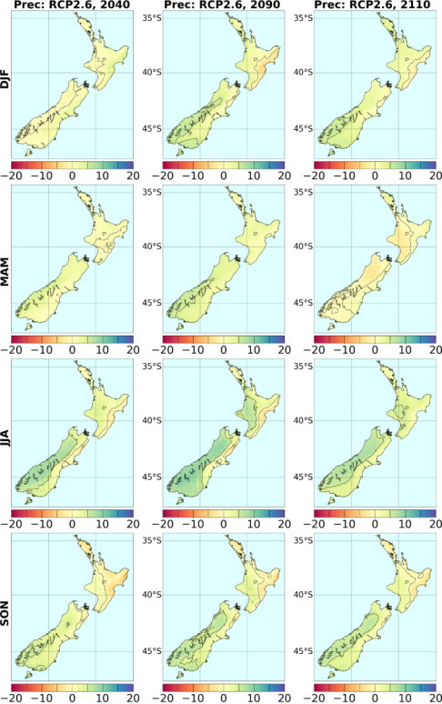
Figure 36: Seasonal changes in precipitation (in per cent), derived by statistically downscaling CMIP5 models, for three future time periods under RCP2.6

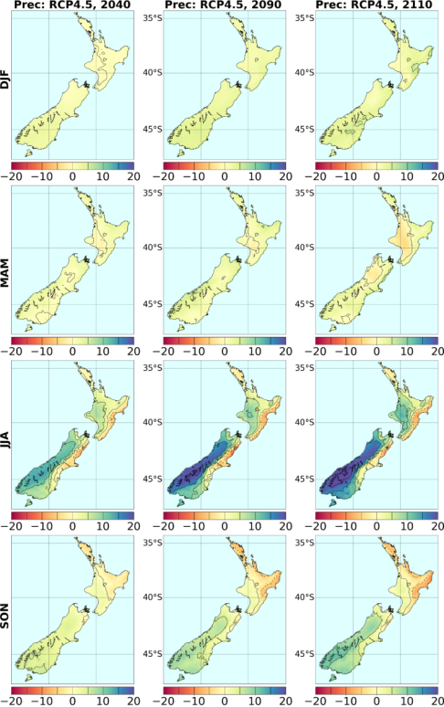
Figure 37: Seasonal changes in precipitation (in per cent), derived by statistically downscaling CMIP5 models, for three future time periods under RCP4.5

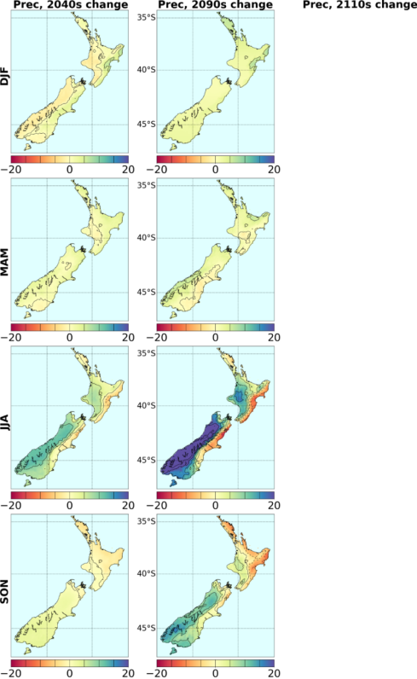
Figure 38: Seasonal changes in precipitation (in per cent), derived by statistically downscaling CMIP5 models, for three future time periods under RCP6.0 (no 2110 projections presented)

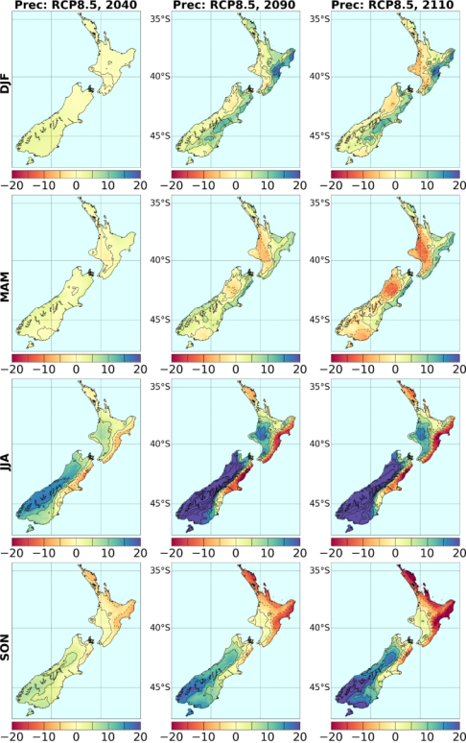
Figure 39: Seasonal changes in precipitation (in per cent), derived by statistically downscaling CMIP5 models, for three future time periods under RCP8.5
Note that the West Coast JJA change over-saturates, and is well above the +20 per cent upper limit of the colour bar (compare with Figure 43).

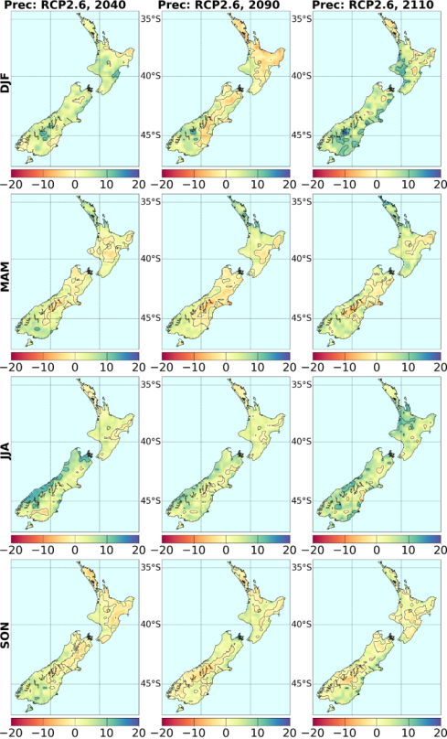
Figure 40: Seasonal changes in precipitation (in per cent), derived by downscaling CMIP5 models via NIWA’s regional climate model, for three future time periods under RCP2.6. Results are for the average over six RCMs, except for 2110 (see Table 3)

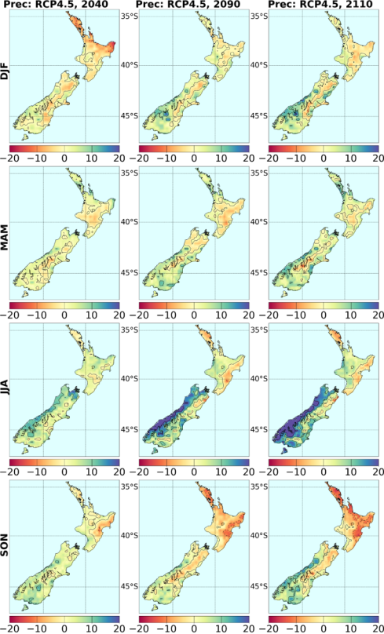
Figure 41: Seasonal changes in precipitation (in per cent), derived by downscaling CMIP5 models via NIWA’s regional climate model, for three future time periods under RCP4.5

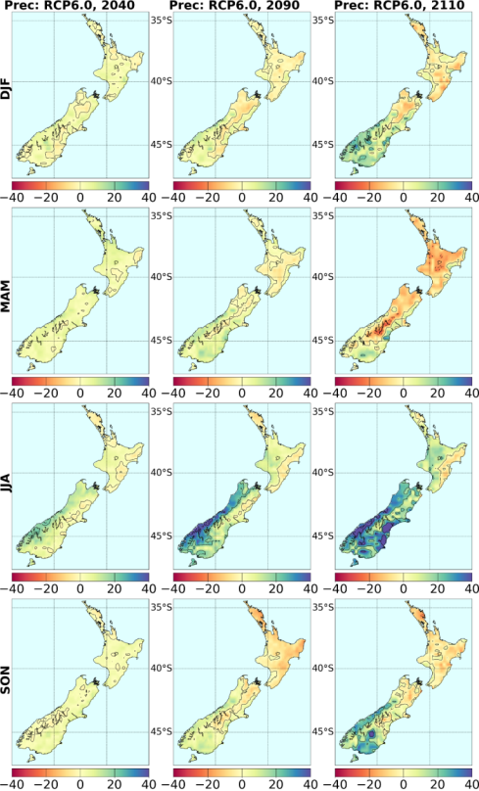
Figure 42: Seasonal changes in precipitation (in per cent), derived by downscaling CMIP5 models via NIWA’s regional climate model, for three future time periods under RCP6.0

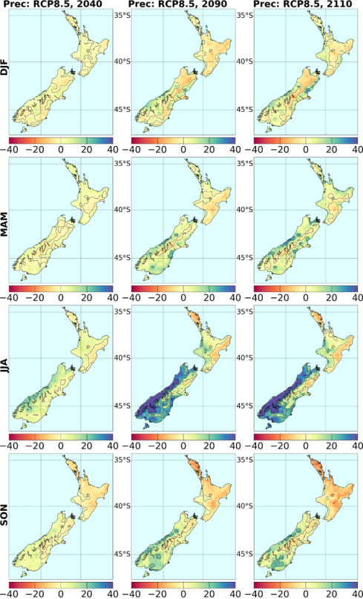
Figure 43: Seasonal changes in precipitation (in per cent), derived by downscaling CMIP5 models via NIWA’s regional climate model, for three future time periods under RCP8.5

Tables 10 to 12 above show the projected changes in mean precipitation, separated by season, by RCP and by regional council region. Figures 36 to 43 show regional patterns of mean precipitation change, separated by season, by RCP, and for statistical and dynamical (RCM) downscaling separately. Figures 44 and 45 below provide a graphical summary of the precipitation projections in an alternate format.

45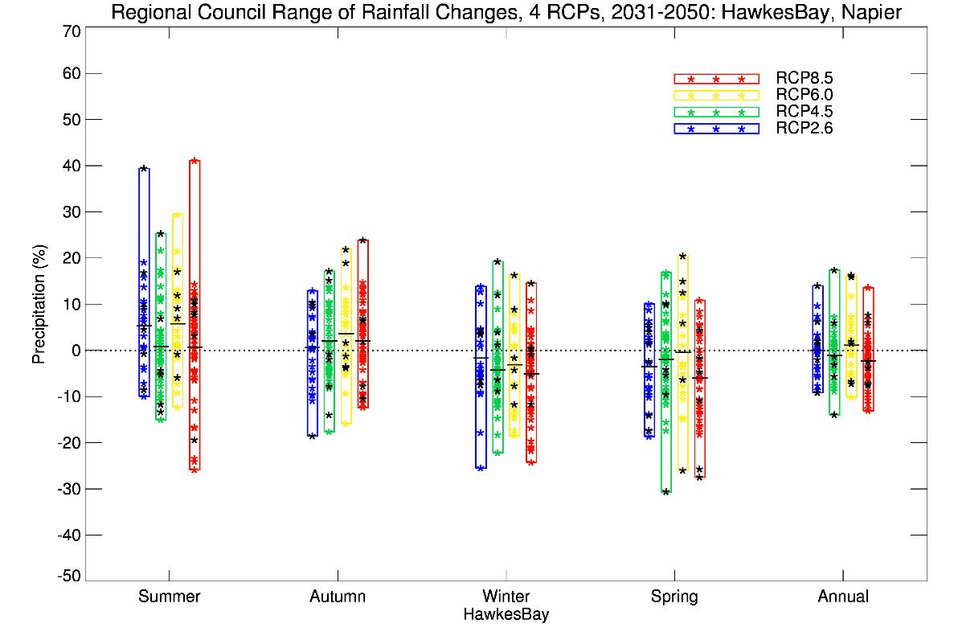
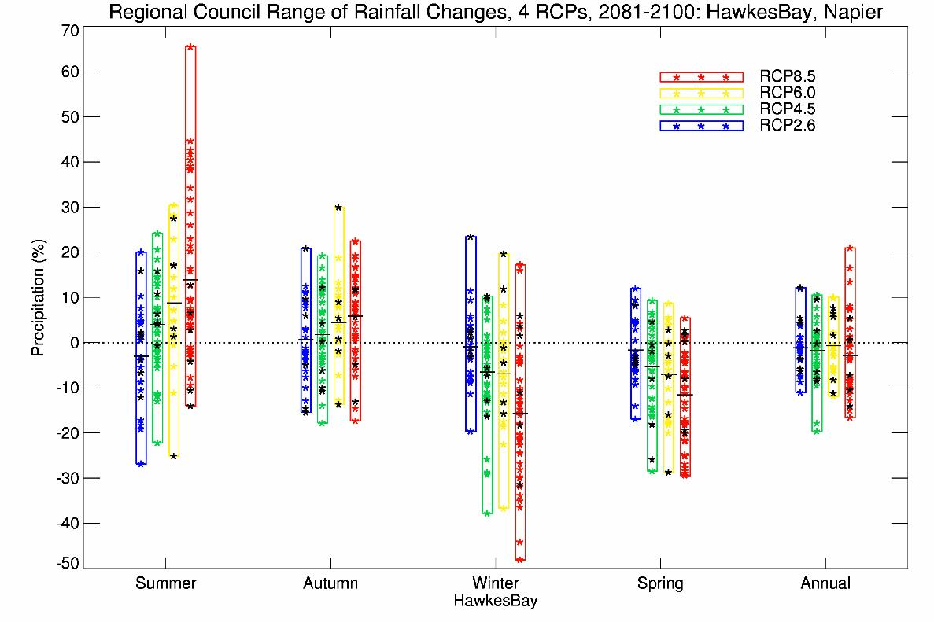
Figure 44: Projected precipitation changes for Napier, for 2040 (top panel) and 2090 (bottom panel), for all seasons (plus annual), all RCPs (vertical bars) and all models (coloured stars), as derived by statistical downscaling. The black stars correspond to the six-model RCM-downscaling, and the horizontal bars the average over all downscaled results (statistical and RCM)
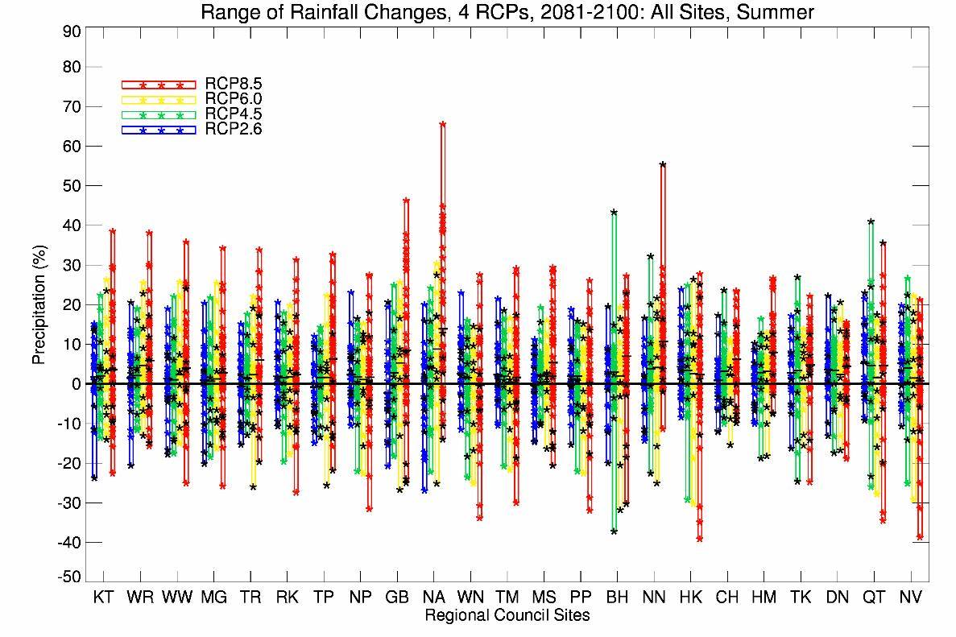
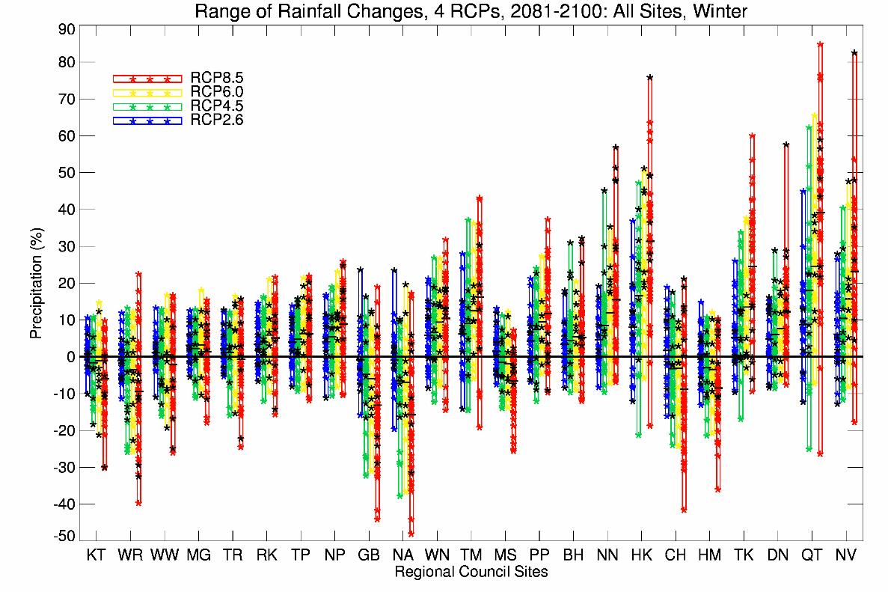
Figure 45: Projected precipitation changes for selected sites within all regions for 2090, for summer (top panel) and winter (bottom panel) seasons, for all RCPs (bars) and all models. Coloured stars refer to statistical downscaling, whereas the black stars correspond to the six-model RCM-downscaling
The sites chosen (and regions) are: Kaitaia [KT] and Whangarei [WR] (Northland); Warkworth [WW] and Mangere [MG] (Auckland); Tauranga [TR] (Environment Bay of Plenty); Ruakura [RK] and Taupo [TP] (Waikato); New Plymouth [NP] (Taranaki); Gisborne [GB] (Gisborne); Napier [NA] (Hawke’s Bay); Whanganui [WN] and Taumarunui [TM] (Horizons Manawatu-Whanganui); Masterton [MS] and Paraparaumu [PP] (Wellington); Blenheim [BH] (Marlborough); Nelson [NN] (Tasman); Hokitika [HK] (West Coast); Christchurch [CH], Hanmer [HM] and Tekapo [TK] (Canterbury); Dunedin [DN] and Queenstown [QT] (Otago); and Invercargill [NV] (Southland).
Figure 44 illustrates the precipitation projections by season and RCP, for the two time periods of 2040 and 2090. Hawke’s Bay has again been selected as an example, but in the case of precipitation a specific site within the region is used (instead of the region-average); here it is the VCSN grid-point co-located with Napier. The coloured vertical bars, and inset stars, show all the individual models, so the complete range is displayed (unlike Tables 10 to 12 where the 5th to 95th percentile range has been calculated). Figure 44 is an excellent way of demonstrating not only the difference with season and RCP, but also the range of model sensitivity. Note that there is one outlier model (ipsl-cm5a-lr), which gives a much greater summer precipitation change in the North Island than any of the other models. The black stars within each vertical bar represent the results of the six RCM simulations.
Figure 45 presents a similar picture to Figure 44, except that the extreme seasons (summer and winter) are shown for selected sites in all regional council regions on a single graph. This makes it easy to compare the range of projections in different regions of New Zealand. It may appear that there is no clear precipitation signal anywhere, since every bar graph crosses zero (ie, there is at least one model projecting a decrease in precipitation and at least one projecting an increase). A model-average change of about 10 per cent (increase or decrease), however, could be considered as a significant change.
The clearest signals of change occur for the highest concentration pathway (RCP8.5) for particular sites and seasons: for example, in summer, precipitation is most likely to increase on the east coast of the North Island (Gisborne and Hawke’s Bay regions); in winter, precipitation is most likely to decrease in the same locations, but increase in Hokitika, Tekapo and Queenstown.
If the IPCC Fifth Assessment ‘likelihood’ definitions are applied to the precipitation projections, and the model spread is used to calculate the probabilities of a particular outcome, then likelihoods of precipitation increase or decrease can be described as follows:
- Simulated ‘natural variability’ in the models is too large to give much of a precipitation signal at 2040. By 2090, the signal has risen above the noise in a number of locations.
- At 2090 in the summer season, it is likely (66–100 per cent probability) there will be increases in precipitation, especially at higher greenhouse gas concentrations, at: Kaitaia, Whangarei, Tauranga, Taihape, Gisborne, Napier, Masterton, Blenheim, Nelson, Christchurch, Hanmer, Tekapo, Dunedin, and Queenstown. There are no higher likelihoods (ie, very likely or higher) of a precipitation increase than in these places.
- In summer at 2090, none of the sites in Figure 45 are likely to receive decreased precipitation.
- At 2090 in the winter season, it is very likely (90–100 per cent) there will be increases in mean precipitation under the higher greenhouse gas concentrations at: Taumarunui, Hokitika, Tekapo, Queenstown, and Invercargill. It is likely there will be precipitation increases at: Ruakura, Taupo, New Plymouth, Paraparaumu, Wellington, Blenheim, Nelson, and Dunedin.
- At 2090 in winter, it is likely (66–100 per cent) there will be decreased precipitation at: Kaitaia, Whangarei, Gisborne, Napier, Masterton, Christchurch, and Hanmer.
- In general, the spring season tends to be similar to winter, and the autumn season is intermediate between summer and winter.

3.6.2 Precipitation extremes
This section provides information on how New Zealand precipitation extremes may change under a warming climate, at both the ‘dry end’ and the ‘wet end’ of the distribution of precipitation amounts. Figure 46 shows projected changes in ‘dry days’, defined as days with precipitation below 1 millimetres/day. Figure 47 shows projected changes in moderate extremes, defined as the 99th percentile of the rain-day distribution. Figure 48 shows projected changes in very extreme events, in this case, those with an average return periods of 50 years.
The 99th percentile of the rain-day distribution is estimated from daily precipitation at each VCSN point after eliminating dry days. It is calculated by first ranking daily precipitation for all days in the 20-year baseline period (1986–2005), and determining the precipitation amount at the 99th percentile. Similar calculations are done for the three future periods of 2031–50 (labelled as 2040), 2081–2100 (2090) and 2101–20 (2110). For example, if 100 millimetres was the 99th percentile in the baseline years (1995), and 120 millimetres the 99th percentile at 2090, this would be plotted as a 20 per cent increase in Figure 47.
All these calculations are made first from each of the six RCM simulations separately, and then the six results are averaged (or fewer than six for 2110, see Table 3). The maps show a breakdown according to RCP but not by season, although dry days are more likely to occur in the North Island in summer rather than winter. Extreme high precipitation can occur at any time of year, although obviously the seasonal changes in mean precipitation (such as the very large West Coast increase projected for winter) will have some impact.
In Figure 46, blue and green shading indicates a decrease in dry days (ie, more rain-days), yellow little change, and orange and red an increase in the number of dry days per year. The frequency of dry days increases with time and RCP for much of the North Island, and for high altitude inland regions in the South Island. The frequency of dry days decreases on the west and east coastal regions in the South Island. These changes are not unexpected, given the trends in mean rainfall above.
In Figure 47, the red colours indicate a decrease in extreme rainfall, orange little change, and yellow, green and blue a progressive increase in extremes. The frequency of moderately extreme precipitation, as quantified by the changes in the 99th percentile of the daily precipitation distribution, shows a systematic increase in much of the South Island, with both time and increasing greenhouse gas concentration. Over the North Island, however, projected changes are small and erratic. To some degree, this is because a 20-year period is too short to obtain a robust signal in the precipitation extremes. This pattern of changes in extreme rainfall is quite robust in that five of the six RCMs show a very similar pattern, with only one (NorESM1-M) showing a substantial increase in extremes in the North Island. Further analysis will be needed to understand the causes of these differences.
Focusing on the 2090 changes under RCP8.5 (all six models and strongest forcing), the only coherent regions to show a decrease in moderately extreme rainfall are Northland and parts of the Wairarapa and Hawke’s Bay on the east coast of the North Island. These are the same areas where precipitation in winter (the wettest season) shows the largest reduction (Figure 43). As a cautionary aside, the climate models being used do not have the resolution to realistically simulate tropical cyclones, so extreme rainfall from these phenomena are likely to be underestimated in our results.
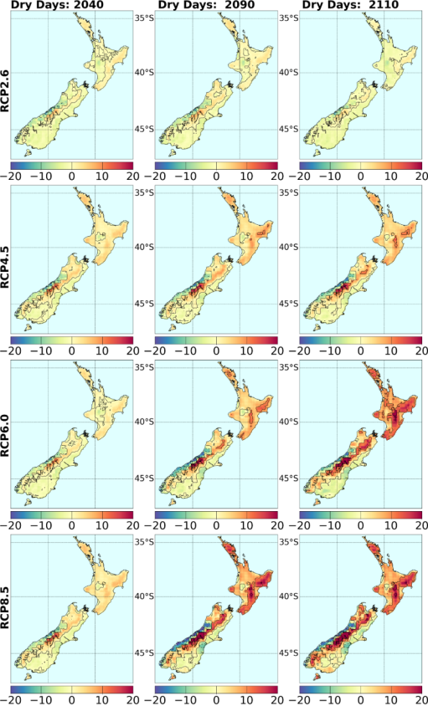
Figure 46: RCM-projected changes in the annual number (in days) of ‘dry days’ (precipitation below 1 millimetre/day), with respect to the baseline 1995 period, for all four RCPs and three future time periods. Results are for the average over six RCMs, except for 2110 (see Table 3)
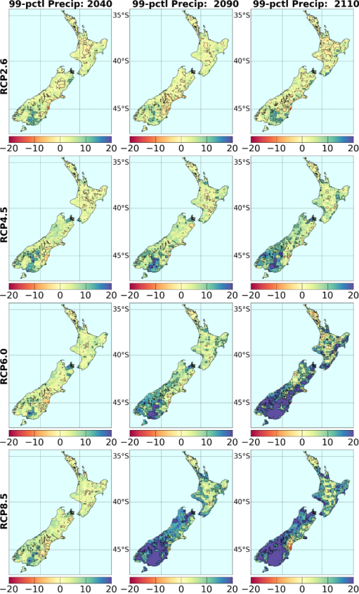
Figure 47: Change in the magnitude of the 99th percentile of daily precipitation (in per cent), for all four RCPs and three future time periods, relative to the daily 99th percentile in the baseline 1986–2005 period
Projected changes in very extreme precipitation have been adapted from the version 4 report of the High Intensity Rainfall Design System, HIRDSv4 (Carey-Smith et al, 2018). That analysis used the 24 RCM simulations described in section 2.4 to estimate changes in the magnitude of rare precipitation events as a function of the change in temperature. This was done for different event durations (from 1 hour to 5 days) and different return periods (from 2 years to 100 years). Changes in rainfall magnitude were estimated by fitting a non-stationary version of the generalised extreme value distribution to all points on the RCM domain, with projected New Zealand-average temperature (Figure 7) used as the covariate. A full description of the methodology can be found in Carey-Smith et al (2018).
The expected percentage change in precipitation depth per degree of warming for an event with a 50-year return period is shown in Figure 48. This figure shows that, for this return period, the change in magnitude is positive throughout New Zealand and for all durations. It is also clear that as the event duration decreases, the increase in magnitude becomes more pronounced. There is also an indication that for shorter durations, regions in the north of the North Island and south-east of the South Island have larger increases than elsewhere in New Zealand. However, Carey-Smith et al (2018) found the large regional variability between RCM simulations does not provide enough confidence in these regional patterns and recommended that until further information suggests otherwise, climate change rainfall augmentation factors should be assumed to be uniform over New Zealand.
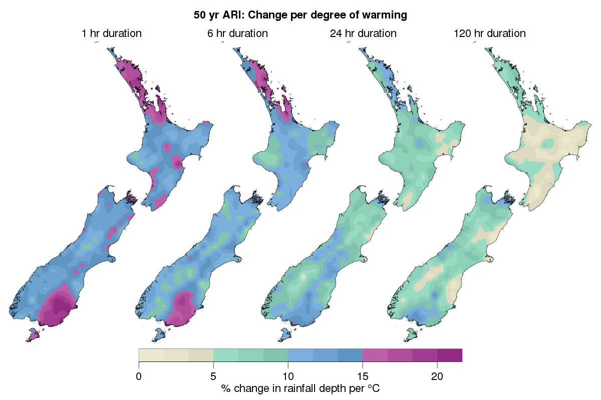
Figure 48: Change in the 50-year rainfall event magnitude for four different event durations. Each map combines all 24 different RCM simulations and shows the percentage change per degree of warming
Augmentation factors can be used to take a rainfall depth valid for the current climate and estimate the expected increase in this depth due to the projected temperature increase in a future climate. The augmentation factors provided in Table 13 have been estimated by taking an average over New Zealand. For each event duration and return period the median over New Zealand has been taken as the most likely estimate, and the 5th and 95th percentiles have been used to indicate the range of values that might be expected.
It is important that any projected temperature increase used in conjunction with the augmentation factors be from the same source as that used to estimate the augmentation factors. For this purpose, Table 14 contains the mean temperature change for each RCP at three future time periods relative to 1986—2005 derived from the RCM New Zealand land average temperature.
Table 13: Percentage change factors to estimate the increase in rainfall depth that is expected to result from a 1 degree increase in temperature.

ARI:  Duration | 2 yr | 5 yr | 10 yr | 20 yr | 30 yr | 50 yr | 100 yr
1 hour | 12.2 | 12.8 | 13.1 | 13.3 | 13.4 | 13.5 | 13.6
 | 9.8 – 17.5 | 10.6 – 18.1 | 10.7 – 18.5 | 10.7 – 18.8 | 10.7 – 18.9 | 10.7 – 19.1 | 10.7 – 19.4
2 hours | 11.7 | 12.3 | 12.6 | 12.8 | 12.9 | 13.0 | 13.1
 | 9.2 – 18.0 | 9.9 – 18.4 | 10.0 – 18.7 | 10.1 – 19.0 | 10.1 – 19.1 | 10.1 – 19.3 | 10.1 – 19.6
6 hours | 9.8 | 10.5 | 10.8 | 11.1 | 11.2 | 11.3 | 11.5
 | 7.5 – 14.9 | 8.0 – 15.4 | 8.3 – 15.9 | 8.4 – 16.4 | 8.5 – 16.6 | 8.5 – 17.0 | 8.5 – 17.4
12 hours | 8.5 | 9.2 | 9.5 | 9.7 | 9.8 | 9.9 | 10.1
 | 5.7 – 13.5 | 6.5 – 13.9 | 6.8 – 14.2 | 7.1 – 14.5 | 7.2 – 14.8 | 7.3 – 15.1 | 7.3 – 15.4
24 hours | 7.2 | 7.8 | 8.1 | 8.2 | 8.3 | 8.4 | 8.6
 | 4.0 – 11.9 | 4.6 – 12.0 | 4.8 – 12.1 | 4.9 – 12.2 | 5.0 – 12.3 | 5.1 – 12.5 | 5.2 – 12.8
48 hours | 6.1 | 6.7 | 7.0 | 7.2 | 7.3 | 7.4 | 7.5
 | 2.6 – 11.0 | 3.1 – 11.1 | 3.3 – 11.2 | 3.4 – 11.3 | 3.4 – 11.3 | 3.4 – 11.4 | 3.5 – 11.5
72 hours | 5.5 | 6.2 | 6.5 | 6.6 | 6.7 | 6.8 | 6.9
 | 2.1 – 10.5 | 2.6 – 10.6 | 2.7 – 10.8 | 2.8 – 10.9 | 2.9 – 11.0 | 2.9 – 11.1 | 2.9 – 11.2
96 hours | 5.1 | 5.7 | 6.0 | 6.2 | 6.3 | 6.4 | 6.5
 | 1.7 – 10.0 | 2.2 – 10.2 | 2.4 – 10.5 | 2.5 – 10.7 | 2.6 – 10.9 | 2.6 – 11.0 | 2.7 – 11.2
120 hours | 4.8 | 5.4 | 5.7 | 5.8 | 5.9 | 6.0 | 6.1
 | 1.3 – 9.6 | 1.9 – 9.7 | 2.1 – 10.0 | 2.3 – 10.2 | 2.3 – 10.4 | 2.4 – 10.5 | 2.4 – 10.7
The most likely percentage change is shown on the top of each row and the range provided below it shows the variability that could be expected across New Zealand based on the RCM results. To obtain change factors for a temperature change that is not 1 degree, the values in this table should be multiplied by the projected temperature change.
Table 14: New Zealand land-average temperature increase, in degrees, relative to 1986—2005 for four future emissions scenarios to be used with percentage change factors for extreme rainfall

 | 2031—2050 | 2081—2100 | 2101—2120
RCP 2.6 | 0.59 | 0.59 | 0.59 (4 model avg)
RCP 4.5 | 0.74 | 1.21 | 1.44 (5 model avg)
RCP 6.0 | 0.68 | 1.63 | 2.31 (CESM1-CAM5 only)
RCP 8.5 | 0.85 | 2.58 | 3.13 (3 model avg)
The mid- and late-21st century projections result from the average of six RCM model simulations (driven by different global climate models). The early 22nd century projections are based only on the subset of models that were available and so should be used with caution. These projected temperature changes are different to those provided in Tables 5, 6 and 7 as they are derived from the RCM simulations and because they represent changes over all of New Zealand rather than selected locations or the seven station series.

3.7 Pressure and wind
Projected changes in New Zealand climate are not just limited to changes in temperature and precipitation. The remainder of this chapter examines changes in circulation (mean sea-level pressure and wind), drought, solar radiation and relative humidity. All these projections are derived from the RCM simulations, which provide much more information about weather parameters than is readily available from statistical downscaling. In all cases, there is a maximum of six models available for analysis for each RCP and time period; four models are available beyond 2100 for RCPs 2.6 and 8.5, five models for RCP4.5, and only one model for RCP6.0.
The key projected changes in mean sea-level pressure (MSLP) and mean winds are shown in Figures 49 to 52.
- MSLP tends to increase in summer (December–January–February (DJF)), especially to the south-east of New Zealand. In other words, the airflow becomes more north-easterly, and at the same time more anticyclonic (high pressure systems). This is consistent with the model projections of generally increased summer precipitation on the north-east coast of the North Island (eg, Figures 36 and 40).
- MSLP tends to decrease in winter (June–July–August (JJA)), especially over and south of the South Island, resulting in stronger westerlies over central New Zealand. This is consistent with the model projections of increased precipitation on the West Coast in this season (eg, Tables 8 to 10, and Figures 36 to 43, and 45).
- In the other seasons (autumn and spring), the pattern of MSLP change is less consistent with increasing time and increasing emissions. There is, however, still general agreement for autumn changes to be similar to those of summer (ie, more anticyclonic), and for spring changes to be similar to those of winter (lower pressures south of the South Island, and stronger mean westerly winds over southern parts of the country.
As far as extreme daily wind speeds are concerned, Figure 53 illustrates results of an analysis very similar to that carried out for extreme daily rainfall. The 99th percentile of daily-mean wind speed is evaluated over the historical 1986–2005 period at each VCSN grid-point in the downscaled (but not bias-corrected) regional model output data. Figure 53 then maps how the 99th percentiles in future periods differ from the current climate for each of the four RCPs.
In this figure, yellow shading means little or no change from present, green a decrease in extreme wind speed, and red an increase. For most of the RCPs and time periods, the southern half of the North Island and all the South Island are shown as having stronger extreme daily winds in future. This is especially noticeable in the South Island, east of the Southern Alps. The regional model is able to resolve speed-up in the lee of the mountain ranges, and shows increases of up to 10 per cent or greater in Marlborough and Canterbury by the end of the century under the highest RCP8.5 forcing. There is, however, a decrease in extreme winds in the North Island from Northland to Bay of Plenty, probably because of increasing anticyclonic conditions.
No seasonal breakdown of extremes is given, but it is expected that the higher winds in the east of the South Island are primarily due to the increased westerly pressure gradient in winter and spring. Very localised extreme winds from more vigorous summer convection are also potentially a problem in the future, but such events are not resolved by the regional model being used here.
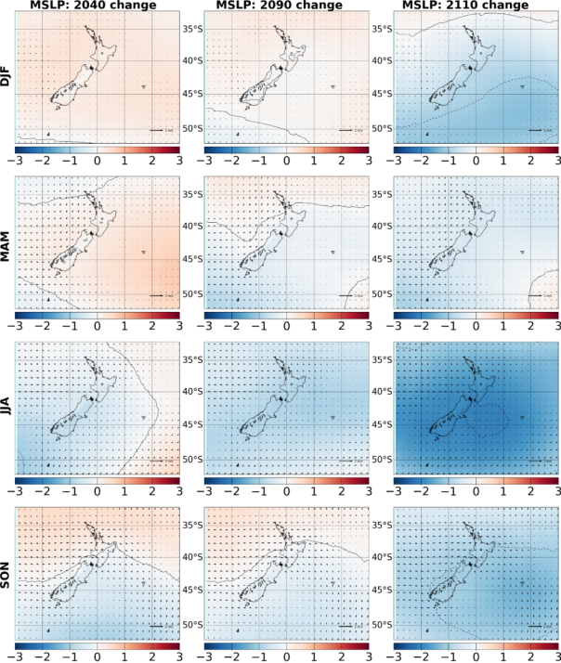
Figure 49: Seasonal changes in mean sea level pressure (MSLP, in hPa) for RCP2.6 model-average (contour every 0.5 hPa) for three future time periods, and change in 10-metre wind field show by wind arrows, as derived by downscaling CMIP5 models via NIWA’s regional climate model

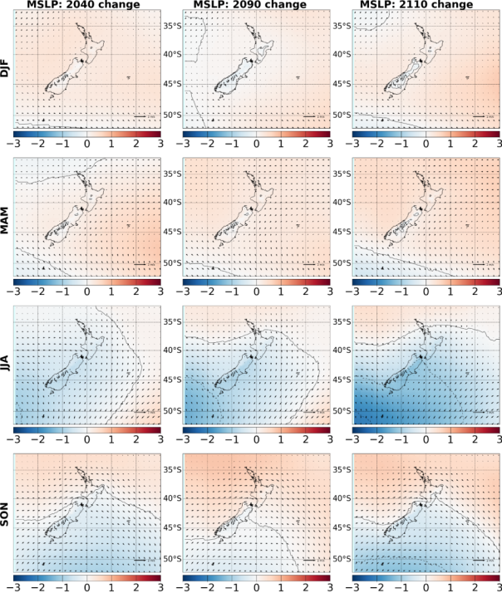
Figure 50: Seasonal changes in mean sea level pressure (MSLP, in hPa) for RCP4.5 model-average (contour every 0.5 hPa) for three future time periods, and change in 10-metre wind field show by wind arrows, as derived by downscaling CMIP5 models via NIWA’s regional climate model

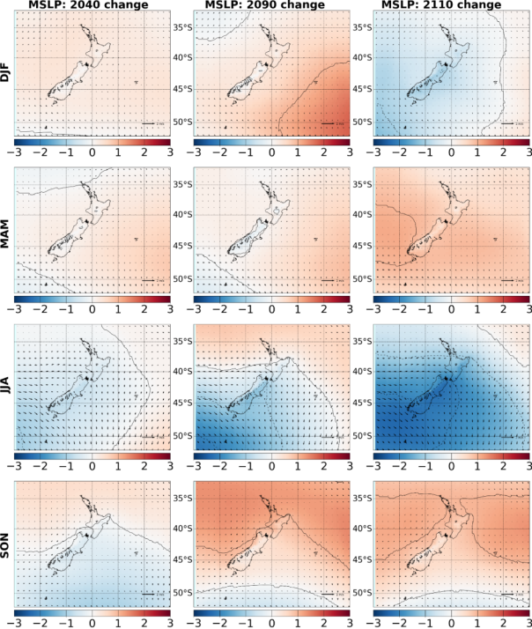
Figure 51: Seasonal changes in mean sea level pressure (MSLP, in hPa) for RCP6.0 model-average (contour every 0.5 hPa) for three future time periods, and change in 10-metre wind field shown by wind arrows, as derived by downscaling CMIP5 models via NIWA’s regional climate model. Note that only one model (CESM1-CAM5) is available for the final period centred on 2110
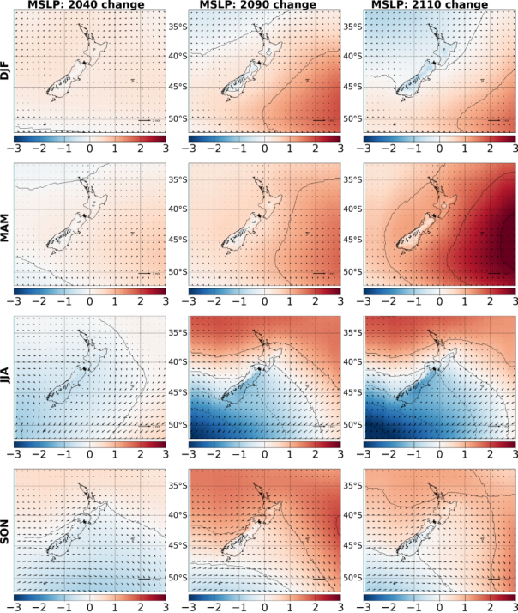
Figure 52: Seasonal changes in mean sea level pressure (MSLP, in hPa) for RCP8.5 model-average (contour every 0.5 hPa) for three future time periods, and change in 10-metre wind field shown by wind arrows, as derived by downscaling CMIP5 models via NIWA’s regional climate model

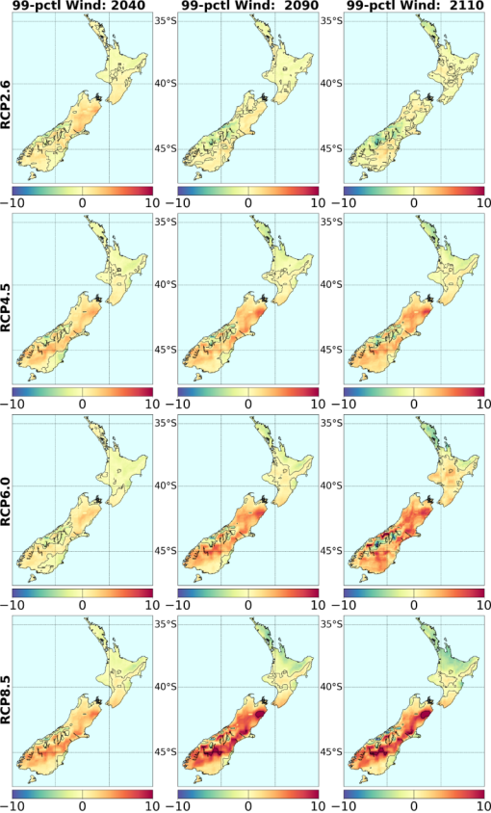
Figure 53: Change in the magnitude of the 99th percentile of daily-mean wind speed, for all four RCPs and three future time periods, relative to the daily 99th percentile in the baseline 1986–2005 period

3.8 Evapotranspiration and drought
Potential evapotranspiration deficit (PED) is the cumulative sum of the difference between potential evapotranspiration (PET) and precipitation from 1 July of a calendar year to 30 June of the next year, for days of soil moisture under half of available water capacity (AWC), where an AWC of 150 millimetres for silty-loamy soils is consistent with estimates in previous studies (eg, Mullan et al, 2005). PED, in units of millimetres, can be thought of as the amount of rainfall needed to keep pastures growing at optimum levels.
The PED changes are largely based on, and consistent with, the bias corrected temperature and precipitation change patterns in the regional climate model. Changes in other uncorrected climate variables (radiation, relative humidity and wind) also influence calculated PED changes, but to a lesser degree. The increase in the magnitude of the climatological mean PED anomaly is in general a stochastic function of time and radiative forcing. The spatial variability of PED is mostly well captured over most of New Zealand. The change in PED is considerable, especially in the drought-prone northern and eastern coasts of the North and the South Island for all RCPs other than RCP2.6. Further research validating PED for the ‘past’ period, and removing biases from uncorrected climate variables, will enhance confidence in future projections and change signals.
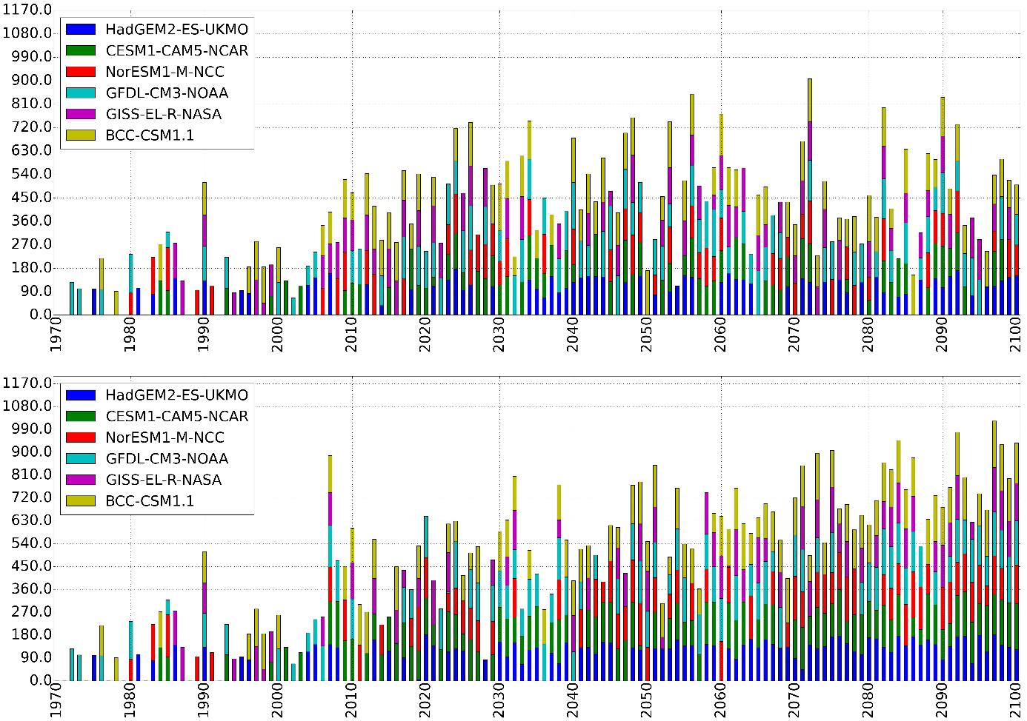
Figure 54: Number of days of potential evapotranspiration deficit (PED) (in millimetres accumulation over the July–June ‘water year’), exceeding 300 millimetres in a calendar year for Wairarapa, North Island; upper panel for RCP2.6, and lower panel for RCP8.5. The results from individual models are stacked where more than one model exhibits a drought risk
To illustrate the changes in frequency and intensity of drought risk over time, the results for one location in the lower North Island (Wairarapa; 175.525N, -36.825S) are presented in Figure 54 for all six RCM model projections for the historical period (1971–2005) and the future climate based on the two extreme RCPs: 2.6 (low) and 8.5 (high). The drought risk is expressed here as the number of days in each ‘water year’ (July–June) where PED exceeds 300 millimetres. The increase in both frequency (more bars) and intensity (higher bars) over time is evident in the low forcing RCP2.6 and considerably more intensive and frequent in the high RCP8.5 future projections. Longer bars of the same model (colour) indicate a heightened drought risk, and more bars are indicative of increased drought frequency. More models showing similar results over a common period suggests higher likelihood indicative of a more robust signal. Using differently coloured bars for different models enables one to see easily where ‘back to back’ droughts occur. For example, two models (HadGEM2-ES and CESM1-CAM5) for RCP8.5 indicate continuous drought in the latter half of the 21st century, with few singular exceptions. RCP2.6, even though the drought frequency increases, shows droughts interspaced by drought-free years, and less likely to occur.
National maps of changes in potential evapotranspiration deficit (PED drought index) are presented in Figure 55. A consistent increase in PED of more than 50 millimetres is seen over much of the North Island, with strongest changes over northern and eastern regions, and north-eastern and central South Island east of the main divide indicating long-term drying of these regions. The maps are plotted with a range of up to 200 millimetres of accumulated PED anomaly with respect to the historical average, which is roughly twice the magnitude of the observed PED anomaly of the extreme 2012/13 historical drought over most of the North Island and large parts of the South Island (Porteous et al, 2013). The spatial patterns of change in PED is fairly consistent among models, and more so with increasing radiative forcing. There is, however, considerable variability between models in the intensity of PED change. For RCP8.5, the GFDL-CM3 model shows the strongest increase for the 2081–2100 period, followed by BCC-CSM1.1. The weakest signal is seen in the GISS-E2-R change.
The regions experiencing significant increase in PED are often fairly localised. The region expands spatially with increasing radiative forcing (RCP) and time. Again, it is noted that there is more uncertainty in the future early 22nd century period, since the results are based only on a more limited number models from 5 (RCP4.5) to 1 (RCP6.0). Nevertheless, the regions of drought increase generally agree with vulnerable locations identified in two previous NIWA drought studies (Mullan et al, 2005; and Clark et al, 2011).
The model results suggest that larger fluctuations in PED occur over time and forcing, suggesting increased climate variability. In fact, the PED increase tends to spread spatially in some regions over time with increasing radiative forcing (eg, Bay of Plenty), leading to heightened drought risk. Increasing trends in PED anomaly are mostly absent over the western regions and not as pronounced as for temperature over the other regions and hotspots due to considerable temporal variability in the precipitation change patterns.
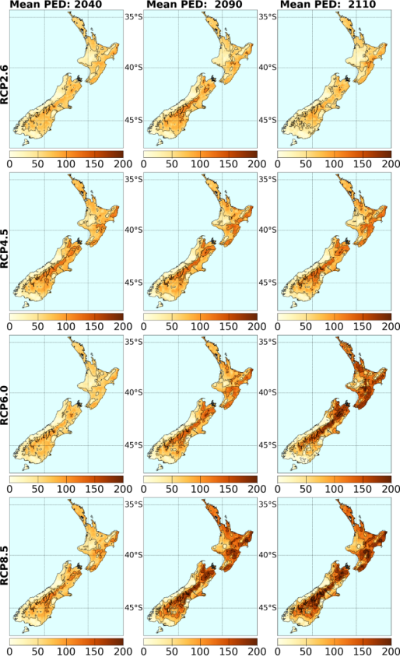
Figure 55: RCM-projected changes in potential evapotranspiration deficit (PED) (in millimetres accumulation over the July–June ‘water year’), with respect to the baseline 1995 period, for all four RCPs and three future time periods

3.9 Other climate variables
Climate variables other than temperature and precipitation are important to New Zealand society, from both a human perspective and an agricultural one. This section discusses potential changes in solar radiation reaching the surface (very dependent on clouds), relative humidity, snow days, the El Niño-Southern Oscillation, and (very briefly) tropical and mid-latitude storms.

3.9.1 Solar radiation and relative humidity
The regional climate model calculates all climatological variables typically available from a weather forecast. Figures 57 to 60 show maps of changes in incident total solar radiation (direct plus diffuse) at the surface, and Figures 61 to 64 show maps of changes in relative humidity. In all cases, the changes are with respect to the model 1986–2005 climatology, followed by averaging over up to six available RCM simulations for each RCP. Note that these data have not been bias-corrected as has been done for temperature and precipitation.
As an introduction to these projected changes, it is instructive to examine the observed climatology of these two variables. Figure 56 shows summer and winter 1986–2005 climatologies of solar radiation and relative humidity, from the NIWA VCSN data sets. Solar radiation is typically three to four times higher in summer than in winter. The geographic distribution depends not only on astronomical factors but also local rainfall (and cloudiness) patterns. The highest solar radiation levels are recorded in Nelson-Marlborough and in central Otago regions in summer months, and in northern North Island and Nelson-Marlborough in winter months.
Relative humidity (a 9am reading in the VCSN data set) also has distinctive seasonal and geographic patterns. Eastern regions have lower relative humidity than the wetter western parts of the country. Winter is usually 5–10 per cent more humid than summer, with the largest seasonal variation in central Otago (exceeding 10 per cent).
The seasonal patterns of projected changes are clearest for the most extreme RCP (Figures 60 and 64). For solar radiation, the RCM suggests increases of up to 10 per cent on the West Coast in summer, and smaller increases elsewhere with notable exception of the coastal Canterbury where sunshine is predicted to decrease. The reduced summer sunshine levels in coastal Canterbury are consistent with increased rainfall there (Figure 43). The winter changes are almost the reverse of the summer ones (but now relative to a much lower climatology, Figure 56): about a 5 per cent decrease in radiation in western parts of the North Island, and 10 per cent or more in western and southern South Island. Eastern North Island is projected to have an increase in winter sunshine levels.
The projections of relative humidity (no longer for 9am, but averaged over all time steps in the model simulation) have a much simpler pattern, with reduced relative humidity almost everywhere in all seasons, and the largest decreases in the South Island. The only notable exception to this pattern is an increase in relative humidity in a narrow strip down the West Coast in winter, a reflection of increased rainfall (Figure 43), reduced number of dry days (Figure 46), and reduced solar radiation (Figure 60). The lower relative humidity is a consequence of the higher temperatures. The absolute water content, as measured by specific humidity, increases with time, but the temperature effect is larger; the rate of decrease in relative humidity over New Zealand is mostly 1–2 per cent per degree increase in mean temperature, consistent with estimates from a recent international study (Byrne & O’Gorman, In press). This is also in line with evidence in the recent observations (Simmons et al, 2010) in reanalysis and station data over low and mid latitudes.
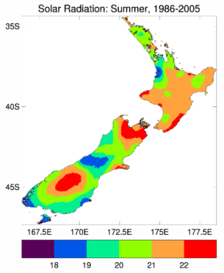 | 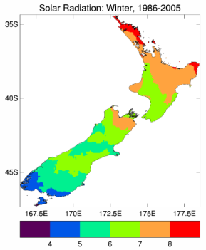
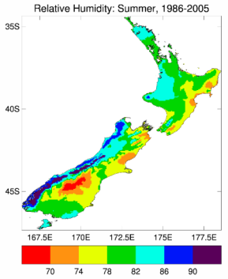 | 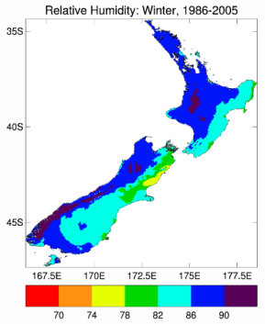
Figure 56: Summer (left) and winter (right) seasonal-average solar radiation (top, in MJ m⁻² day⁻¹) and 9am relative humidity (bottom, in per cent), calculated from VCSN data over the 1986–2005 baseline period. Note that the contour intervals for solar radiation are very different between the summer and winter seasons
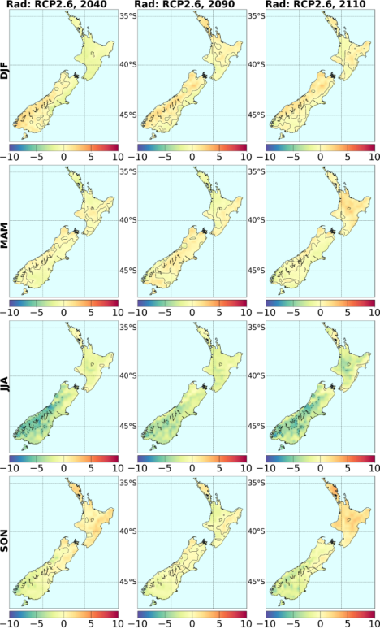
Figure 57: RCM seasonal changes in incident solar radiation at the surface (in per cent), for three future periods, under RCP2.6

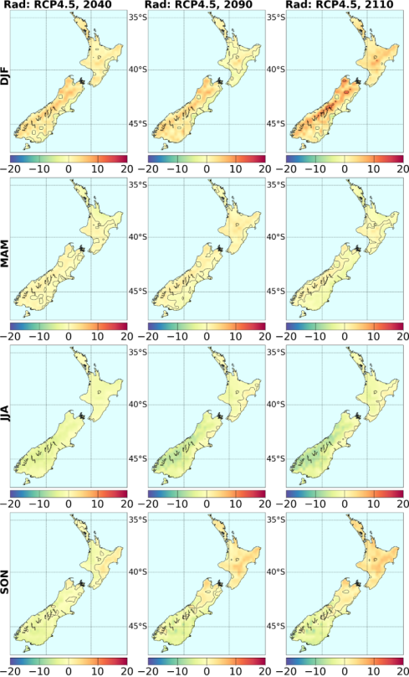
Figure 58: RCM seasonal changes in incident solar radiation at the surface (in per cent), for three future periods, under RCP4.5

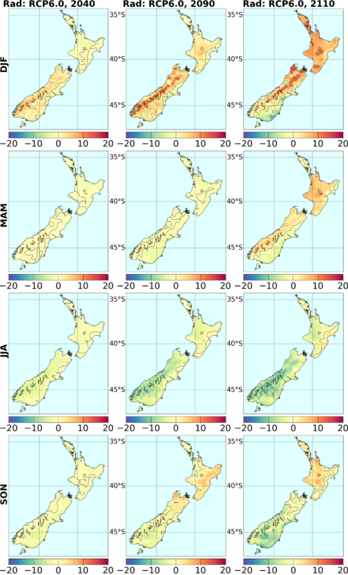
Figure 59: RCM seasonal changes in incident solar radiation at the surface (in per cent), for three future periods, under RCP6.0

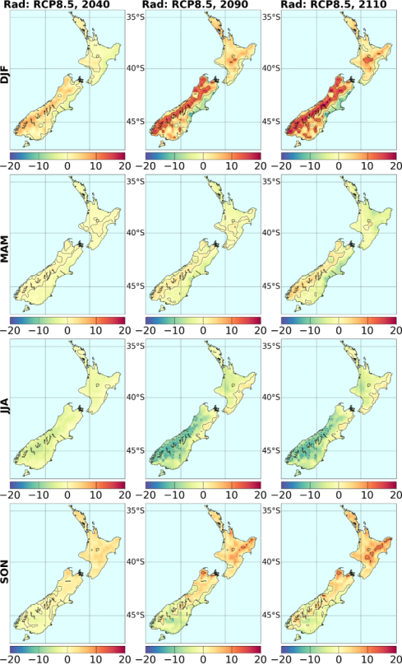
Figure 60: RCM seasonal changes in incident solar radiation at the surface (in per cent), for three future periods, under RCP8.5

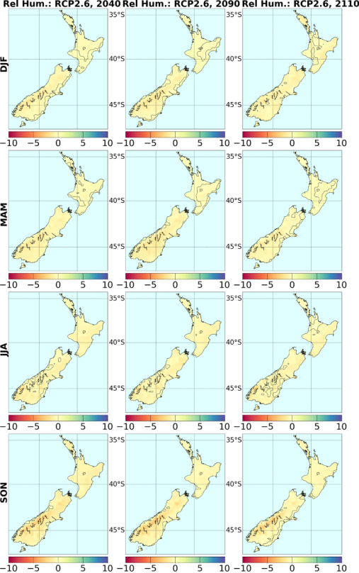
Figure 61: RCM seasonal changes in relative humidity (in per cent), for three future periods under RCP2.6

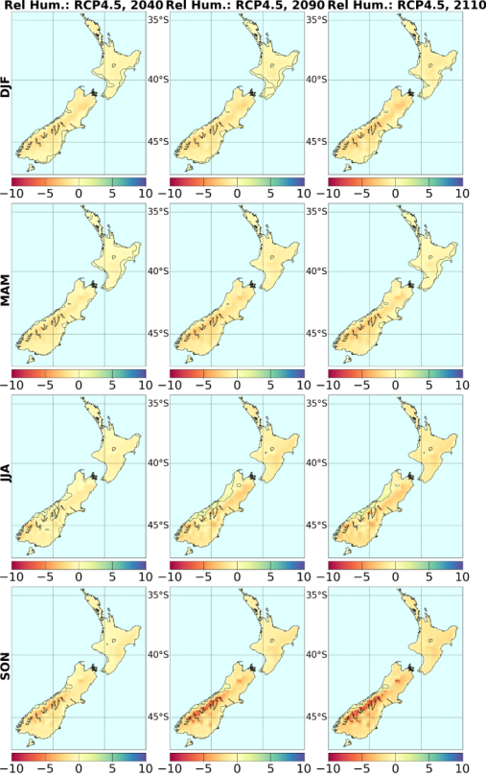
Figure 62: RCM seasonal changes in relative humidity (in per cent), for three future periods under RCP4.5

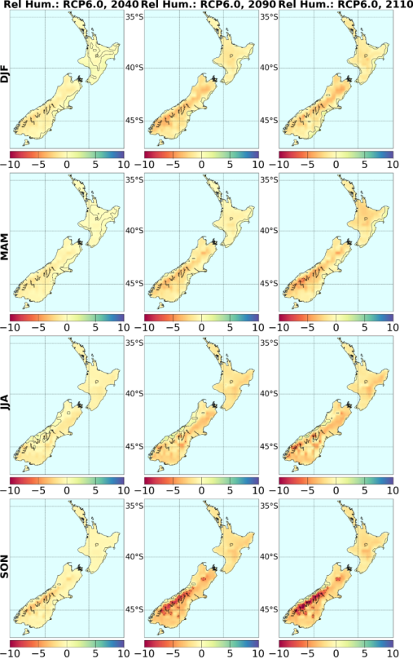
Figure 63: RCM seasonal changes in relative humidity (in per cent), for three future periods under RCP6.0
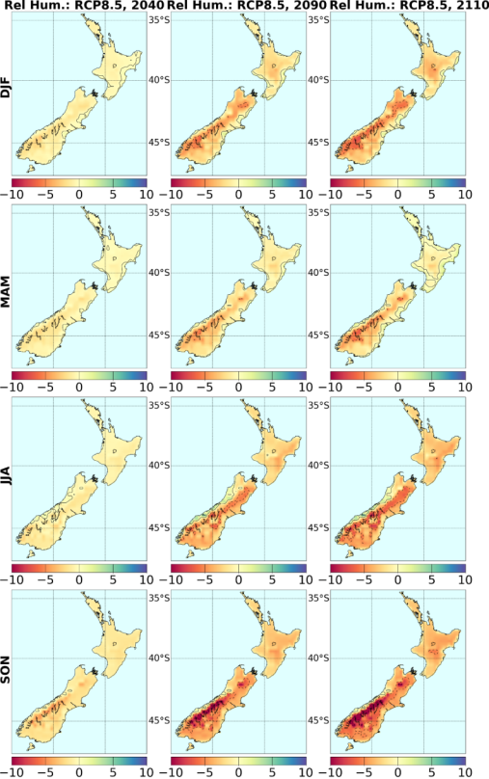
Figure 64: RCM seasonal changes in relative humidity (in per cent), for three future periods under RCP8.5

3.9.2 Snow days
Changes in snow days were also estimated from the RCM output. This was done by counting precipitation days where the mean temperature was below the freezing point. Figure 65 shows the changes in ‘snow days’ calculated in this way, as a function of time period and RCP. The number of snow days per year essentially reduces everywhere, with the largest reduction in the coldest regions where there are a large number of snow days in the present climate. In the South Island high country and inland basins, a reduction in the snow season of 30 days or more is typical of the end-of-century results under the strongest forcing (RCP8.5).
Reduced snow storage over the winter period will also influence seasonality of snow melt and river flow. Further analysis would need to be carried out to determine how this could affect viability of ski fields.
Another factor needing further analysis is the potential change in snow amounts. In general, the model simulations show a reduction in snow amount, along with the reduction in snow days. It is possible snow amount could increase with rising temperatures in special circumstances; a warmer atmosphere can hold more moisture, and on a day where the temperatures are higher but still below freezing, there is the potential for increased heavy snowfalls. No analysis of snow extremes has been carried out at this point, however.

3.9.3 El Niño-Southern Oscillation
During El Niño periods (persistent negative Southern Oscillation Index), New Zealand tends to experience stronger or more frequent winds from the west in summer, typically leading to drought in east coast areas and more rain in the west. In winter, the winds tend to be more from the south, bringing colder conditions to both the land and the surrounding ocean. In spring and autumn south-westerly winds are more common.
Figure 66 shows Southern Oscillation Index (SOI) changes, as derived from raw CMIP5 global MSLP in Tahiti and Darwin. Some models show little change, while some (such as noresm1-m) have substantial increases in the index (La Niña-like trends). The changes have been smoothed to remove sub-decadal variability, so do not show individual events.
Collins et al (2010) analysed changes in the equatorial Pacific, as projected by CMIP3 models. Their findings are summarised in the IPCC Fifth Assessment report (Christensen et al, 2013). In this analysis, the sea surface temperatures increase throughout the tropical Pacific, of course, but (after removal of the basin-average linear trend) increases are largest east of the dateline along the equator, which is an anomaly pattern seen during El Niño episodes. A similar eastward shift in the region of maximum warming is seen in CMIP5 models. The consequences for El Niño activity of such a change in the background is not clear, however. Models also predict reduced year-to-year variability in the tropical sea temperatures (in the NINO3 region) in the future.
The IPCC notes (Stocker et al, 2013) that there is high confidence that the El Niño-Southern Oscillation (ENSO) will remain the dominant mode of natural climate variability in the 21st century. Variations in the amplitude and the spatial pattern of ENSO-induced fluctuations are so large, however, that confidence in projected changes is low.
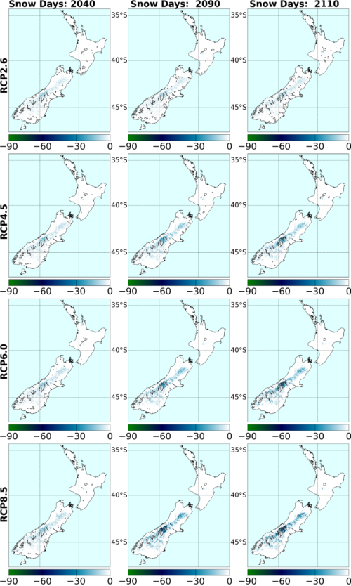
Figure 65: Projected changes in the annual number of ‘snow days’ (in days per year) for four RCPs and three time periods, averaged over up to six regional climate model simulations

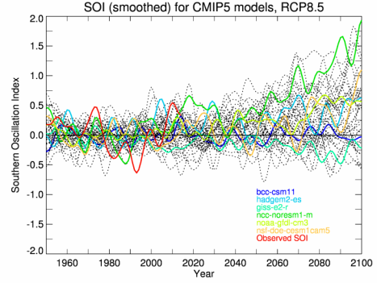
Figure 66: Southern Oscillation Index (SOI, smoothed to remove sub-decadal variations) over period 1950–2100, interpolated from the raw CMIP5 model pressure field (to Tahiti and Darwin), under RCP8.5. The SOI time series for the six models used in NIWA’s RCM downscaling are shown as coloured lines (according to the inset legend), while all other models are shown as black dotted lines

3.9.4 Storms
According to the IPCC (Stocker et al, 2013), it is considered likely that the global frequency of tropical cyclones will either decrease or remain essentially unchanged over the 21st century. It is likely, however, that maximum wind speeds and rainfall rates will increase; in other words, the tropical cyclones will likely be stronger and cause more damage when making landfall. There is low confidence in region-specific projections. (Italicisation follows IPCC protocol.)
The IPCC also comments that the global number of extra-tropical cyclones (the low pressure systems that affect New Zealand every few days) is unlikely to decrease by more than a few per cent, and future changes in storms are likely to be small compared to natural inter-annual variability. This statement applies globally, and regionally-specific changes can be quite different. The storm track response to global warming is more consistent between AR5 models (and between AR4 and AR5 models) in the Southern Hemisphere than in the Northern Hemisphere. Extratropical storm tracks will tend to shift poleward by several degrees (Figure 67), but the reduction in storm frequency is only a few per cent.
The mid-latitude jet associated with the storm tracks (usually lying well south of New Zealand) is projected to increase in strength (Barnes & Polvani, 2013). This analysis also found that the pattern of variability of the Southern Hemisphere jet was predicted to change in the CMIP5 models; less north-south vacillation was expected in the future, but more pulsing in intensity (with the opposite behaviour in the Northern Hemisphere jet). Just what this means for New Zealand is unclear, however, and further analysis of regional consequences is needed.
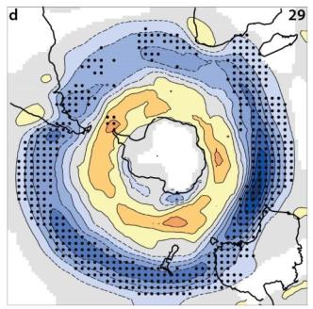
Figure 67: Change in winter Southern Hemisphere storm track between 1986–2005 and
2081–2100, under RCP8.5, from a 29-member CMIP5 multi-model ensemble. (Source: IPCC 5th Assessment, WGI, Chapter 12, Figure 12.20d)
Blue shading indicates a decrease, and yellow-orange shading an increase in the number of storm ’centres’. Stippling is added where 90 per cent of the models agree on the sign of the change. Reproduced from IPCC AR5 Figure 12.20(d), which gives further detail on the figure and underlying analysis.
One regional study is that of Dowdy et al (2013), who analysed the IPCC Fourth Assessment projections of what the Australians call “East Coast Lows”. These are low pressure systems which develop in the Tasman Sea off the east coast of Australia, usually in the winter season, and can have serious consequences with extreme rainfall, winds and waves. Such lows then generally move south-eastwards and affect New Zealand. Dowdy et al (2013) found that such lows reduced in frequency by 30 per cent (mainly in winter) between the late 20th century and the late 21st century.
Further information on possible local changes can be found in Mullan et al (2011) regarding storminess and extreme winds (based on AR4 global models). Evidence is presented in that report that suggests some increase in storm intensity, small-scale wind extremes and thunderstorms is likely to occur in the New Zealand region.

Glossary of abbreviations and terms
Anthropogenic | Human-induced; man-made.
AR4 | IPCC Fourth Assessment Report 2007.
AR5 | IPCC Fifth Assessment Report 2013/14.
AOGCM | Atmosphere-ocean global climate model – a comprehensive climate model containing equations representing the behaviour of the atmosphere, ocean and sea ice and their interactions.
CMIP5 | Coupled Model Inter-comparison Project, Phase 5. This project involved a number of experiments with coupled atmosphere-ocean global climate models, most of which were reported on in the IPCC Fifth Assessment Report, Working Group I. See http://cmip-pcmdi.llnl.gov/cmip5/ for more information.
Downscaling | Deriving local climate information (at the 5 kilometre grid-scale in this report) from larger-scale model or observational data. Two main methods exist – statistical and dynamical. Statistical methods develop statistical relationships between large-scale atmospheric variables (eg, circulation and moisture variations) and local climate variables (eg, rainfall variations). Dynamical methods use the output of a regional climate/weather model driven by a larger-scale global model.
ENSO | El Niño-Southern Oscillation.
ESM | Earth system model. Refers to an AOGCM that also includes interactions with biological processes and natural cycles of chemical components such as ozone, carbon dioxide, nitrogen, and sulphur.
GCM | Global climate model. These days almost all GCMs are AOGCMs.
Humidity | Specific humidity is the ratio of the mass of water vapour to the total mass of the system (water plus air) in a parcel of moist air. Relative humidity is the ratio of the vapour pressure to the saturation vapour pressure (the latter having a strong dependence on temperature).
IPCC | Intergovernmental Panel on Climate Change. This body was established in 1988 by the World Meteorological Organisation (WMO) and the United Nations Environment Programme (UNEP) to objectively assess scientific, technical and socioeconomic information relevant to understanding the scientific basis of risk of human-induced climate change, its potential impacts and options for adaptation and mitigation. Its latest reports (the Fifth Assessment) were published in 2013/14 (see www.ipcc.ch/).
Likelihood estimates | IPCC terminology (see Introduction chapter or Technical Summary) for indicating the assessed likelihood of an outcome or result:  virtually certain: More than 99 per cent probability of occurrence  extremely likely: More than 95 per cent probability  very likely: More than 90 per cent probability  likely: More than 66 per cent probability  more likely than not: More than 50 per cent probability  very unlikely: Less than 10 per cent probability  extremely unlikely: Less than 5 per cent probability.
PED | Potential evapotranspiration deficit. PED can be thought of as the amount of water needed to be added as irrigation, or replenished by rainfall, to keep pastures growing at levels that are not constrained by a shortage of water.
Precipitation | Describes all forms of moisture that falls from clouds (rain, sleet, hail, snow, etc). ‘Rainfall’ describes just the liquid component of precipitation.
Pre-industrial | Conditions at or before 1750.
Radiative forcing | A measure of the energy absorbed and retained in the lower atmosphere. More technically, radiative forcing is the change in the net (downward minus upward) irradiance (expressed in W m^{–2}, and including both short-wave energy from the sun, and long-wave energy from greenhouse gases) at the tropopause, due to a change in an external driver of climate change, such as, for example, a change in the concentration of carbon dioxide or the output of the sun.
RCM | Regional climate model. Such models run at higher spatial and time resolution than GCMs but over a limited area of the globe. RCMs take boundary conditions from GCMs, and provide a physically consistent downscaling of the large-scale climate changes simulated by the GCM. They can cater for relatively small-scale features such as New Zealand’s Southern Alps.
RCP | Representative concentration pathway. A concentration scenario identified by its approximate total radiative forcing at 2100 relative to 1750.
Scenario | In common English parlance, a ‘scenario’ is an imagined sequence of future events. The IPCC Fifth Assessment describes a ‘climate scenario’ as:  A plausible and often simplified representation of the future climate, based on an internally consistent set of climatological relationships that has been constructed for explicit use in investigating the potential consequences of anthropogenic climate change, often serving as input to impact models.  The word ‘scenario’ is often given other qualifications, such as ‘emission scenario’ or ‘socio-economic scenario’. For the purpose of forcing a global climate model, the primary information needed is the time variation of greenhouse gas and aerosol concentrations in the atmosphere. In New Zealand, the climate impacts community prefers to limit the term ‘scenario’ to describing a storyline consistent with a particular combination of greenhouse gas and socio-economic ‘pathways’. Therefore, with results from climate model simulations, we endeavour to use the term RCP or pathway, rather than scenario.
Seven-station series | This refers to seven long-term temperature records used to assess New Zealand’s warming on the century time-scale. The sites are located in Auckland, Wellington, Masterton, Nelson, Hokitika, Lincoln, and Dunedin.
SOI | Southern Oscillation Index, representing seesaws of atmospheric pressure in the tropical Pacific, one pole being at Tahiti and the other at Darwin, Australia. Extreme states of this index are indicative of El Niño or La Niña events in the equatorial Pacific. Typically, El Niño events produce more south-westerly flow than usual over New Zealand and associated cooler conditions, with more rainfall in western parts and frequently drought conditions in the east. La Niña events produce more high pressures over the South Island and warmer north-easterly airflow over the North Island, sometimes with drought conditions in the South Island.
Surface temperature | Air temperatures measured near or ‘at’ the surface (usually 1.5 metres above the ground). Soil temperatures at the ground or below can also be measured, but are not presented in this report.
SST | Sea surface temperature.
VCSN | Virtual Climate Station Network. Made up of observational datasets of a range of climate variables: maximum and minimum temperature, precipitation, relative humidity, solar radiation, and wind. Daily data are interpolated onto a 0.05° longitude by 0.05° latitude grid (approximately 4 kilometres longitude by 5 kilometres latitude), covering all of New Zealand (11,491 points). Primary reference to the spline interpolation methodology is Tait et al (2006).
W m⁻² | Watts per square meter (a measure of radiation intensity).

References
Ackerley D, Dean S, Sood A, Mullan AB. 2012. Regional climate modeling in New Zealand: Comparison to gridded and satellite observations. Weather and Climate 32(1): 3–22.
Anagnostopoulou CHR, Tolika K, Maheras P, Kutiel H, Flocas HA. 2008. Performance of the general circulation HadAM3P model in simulating circulation types over the Mediterranean region. International Journal of Climatology, 28(2): 185–203.
Barnes EA, Polvani L. 2013. Response of the midlatitude jets and of their variability to increased greenhouse gases in the CMIP5 models. Journal of Climate 26(18): 7117–7135.
Byrne M, O’Gorman PA. In press. Understanding decreases in land relative humidity with global warming: conceptual model and GCM simulations. Journal of Climate.
Carey-Smith, T, Henderson R, Singh S. 2018. High Intensity Rainfall Design System Version 4. Prepared for Envirolink by NIWA. NIWA Client Report 2018022CH.
Christensen JH, Krishna Kumar K, Aldrian E, An S-I, Cavalcanti IFA, de Castro M, Dong W, Goswami P, Hall A, Kanyanga JK, Kitoh A, Kossin J, Lau N-C, Renwick J, Stephenson DB, Xie S-P, Zhou T. 2013. Climate Phenomena and their Relevance for Future Regional Climate Change. In: TF Stocker, FD Qin, G-K Plattner, M Tignor, SK Allen, J Boschung, A Nauels, Y Xia, V Bex and PM Midgley (eds) Climate Change 2013: The Physical Science Basis. Contribution of Working Group I to the Fifth Assessment Report of the Intergovernmental Panel on Climate Change. Cambridge: Cambridge University Press.
Clark A, Mullan B, Porteous A. 2011. Scenarios of regional drought under climate change. Prepared for the Ministry of Agriculture and Forestry by NIWA. Wellington: NIWA.
Collins M et al. 2010. The impact of global warming on the tropical Pacific Ocean and El Niño. Nature Geoscience 3: 391–397.
Collins M, Knutti R, Arblaster J, Dufresne J-L, Fichefet T, Friedlingstein P, Gao X, Gutowski WJ, Johns T, Krinner G, Shongwe M, Tebaldi C, Weaver AJ, Wehner M. 2013. Long-term Climate Change: Projections, Commitments and Irreversibility. In: TF Stocker, D Qin, G-K Plattner, M Tignor, SK Allen, J Boschung, A Nauels, Y Xia, V Bex, PM Midgley (eds) Climate Change 2013: The Physical Science Basis. Contribution of Working Group I to the Fifth Assessment Report of the Intergovernmental Panel on Climate Change. Cambridge: Cambridge University Press.
Dean SM, Stott PA. 2009. The effect of local circulation variability on the detection and attribution of New Zealand temperature trends. Journal of Climate 22(23): 6217–6229.
Dee DP et al. 2011. The ERA-Interim reanalysis: configuration and performance of the data assimilation system. Quarterly Journal of the Royal Meteorological Society 137 (656): 553–597.
Dowdy AJ, Mills GA, Timbal B, Wang Y. 2013. Changes in the risk of extratropical cyclones in eastern Australia. Journal of Climate 26(4): 1403–1417.
Flato G, Marotzke J, Abiodun B, Braconnot P, Chou SC, Collins W, Cox P, Driouech F, Emori S, Eyring V, Forest C, Gleckler P, Guilyardi E, Jakob C, Kattsov V, Reason C, Rummukainen M. 2013. Evaluation of Climate Models. In: TF Stocker, D Qin, GK Plattner, M Tignor, SK Allen, J Boschung, A Nauels, Y Xia, V Bex, PM Midgley (eds). Climate Change 2013: The Physical Science Basis. Contribution of Working Group I to the Fifth Assessment Report of the Intergovernmental Panel on Climate Change. Cambridge: Cambridge University Press.
Hansen J, Ruedy R, Sato M, Lo K. 2010. Global surface temperature change. Reviews of Geophysics 48(4).
Hendrikx J, Hreinsson EÖ, Clark MP, Mullan AB. 2012. The potential impact of climate change on seasonal snow in New Zealand; Part I – An analysis using 12 GCMs. Theoretical and Applied Climatology 110(4): 607–618.
Intergovernmental Panel on Climate Change (IPCC). 2007. Solomon, S. Qin, D. Manning, M. Chen, Z. Marquis, M. Averyt, K.B. Tignor, M. and Miller, H.L., ed., Climate Change 2007: The Physical Science Basis, Contribution of Working Group I to the Fourth Assessment Report of the Intergovernmental Panel on Climate Change. Cambridge University Press, ISBN 978-0-521-88009-1 (pb: 978-0-521-70596-7).
Intergovernmental Panel on Climate Change (IPCC). 2013a. Climate Change 2013: The Physical Science Basis. Contribution of Working Group I to the Fifth Assessment Report of the Intergovernmental Panel on Climate Change [Stocker, T.F, D. Qin, G.-K. Plattner, M. Tignor, S.K. Allen, J. Boschung, A. Nauels, Y. Xia, V. Bex and P.M. Midgley (eds.)]. Cambridge University Press, Cambridge, United Kingdom and New York, NY, USA, 1535 pp, doi:10.1017/CBO9781107415324.
Intergovernmental Panel on Climate Change (IPCC). 2013b. Summary for Policymakers. In: Stocker, D Qin, GK Plattner, M Tignor, SK Allen, J Boschung, A Nauels, Y Xia, V Bex, PM Midgley. (eds) Climate Change 2013: The Physical Science Basis. Contribution of Working Group I to the Fifth Assessment Report of the Intergovernmental Panel on Climate Change. Cambridge: Cambridge University Press.
Jones PD, Lister DH, Osborn TJ, Harpham C, Salmon M, Morice CP. 2012. Hemispheric and large-scale land-surface air temperature variations: An extensive revision and an update to 2010. Journal of Geophysical Research: Atmospheres 117(D5).
Jones RG, Noguer M, Hassell D, Hudson D, Wilson S, Jenkins G, Mitchell J. 2004. Generating high resolution climate change scenarios using PRECIS. Exeter: Hadley Centre for Climate Prediction and Research.
Kalnay E et al. 1996. The NCEP/NCAR 40-year reanalysis project. Bulletin of the American Meteorological Society 77(3): 437–471.
Lawrence MG. 2005. The Relationship between Relative Humidity and the Dewpoint Temperature in Moist Air: A Simple Conversion and Applications. Bulletin of the American Meteorological Society 86(2): 225–233.
Lindvall J, Svensson G. 2015. The diurnal temperature range in the CMIP5 models. Climate Dynamics 44(1): 405–421.
Ministry for the Environment. 2008. Climate Change Effects and Impacts Assessment: A guidance manual for local government in New Zealand. Prepared for the Ministry for the Environment by NIWA, MWH NZ Ltd, Earthwise Consulting Ltd, and the Ministry for the Environment. Wellington: Ministry for the Environment.
Mullan AB, Wratt DS, Renwick JA. 2001. Transient model scenarios of climate changes for New Zealand. Weather and Climate 21: 3–33.
Mullan AB, Stuart SJ, Hadfield MG, Smith MJ. 2010. Report on the Review of NIWA’s ‘Seven-Station’ Temperature Series – NIWA Information Series No. 78. Wellington: NIWA. Retrieved from www.niwa.co.nz/sites/niwa.co.nz/files/import/attachments/Report-on-the-Review-of-NIWAas-Seven-Station-Temperature-Series_v3.pdf.
Mullan B, Porteous A, Wratt D, Hollis M. 2005. Changes in drought risk with climate change. Prepared for Ministry for the Environment by NIWA. Wellington: Ministry for the Environment. Retrieved from www.mfe.govt.nz/publications/climate-change/changes-drought-risk-climate-change).
Mullan B, Dean S. 2009. AR4 climate model validation and scenarios for New Zealand. Retrieved from www.researchgate.net/publication/237709502_AR4_CLIMATE_MODEL_VALIDATION_AND_SCENARIOS_FOR_NEW_ZEALAND (13 June 2016).
Mullan B, Carey-Smith T, Griffiths G, Sood A. 2011. Scenarios of storminess and regional wind extremes under climate change. Prepared for Ministry of Agriculture and Forestry by NIWA. Wellington: NIWA.
Mullan B, Dean S, Stuart S. 2013a. How good are the CMIP5 models? Abstract and presentation for New Zealand Climate Change Centre Conference, 4-5 June 2013, Palmerston North. www.nzcccconference.org/images/custom/mullan,_bret_-_how_good_are_the_cmip5.pdf.
Mullan B, Dean S, Stuart S. 2013b. Validation of fifth assessment global climate models in the New Zealand region. Abstract and presentation for Joint Conference of the New Zealand Hydrological Society and Meteorological Society of New Zealand, 19-22 November 2013, Palmerston North. (Conference Handbook, p. 152-153).
Nakicenovic N, Swart R. (eds) 2000. Special Report on Emissions Scenarios. A Special Report of Working Group III of the Intergovernmental Panel on Climate Change. Cambridge: Cambridge University Press. Retrieved from www.grida.no/publications/other/ipcc_sr/?src=/climate/ipcc/emission/.
Nguyen KC, Katzfey JJ, McGregor JL. 2012. Global 60 km simulations with CCAM: evaluation over the tropics. Climate Dynamics 39(3): 637–654.
Porteous A, Mullan B. 2013. The 2012–13 drought: an assessment and historical perspective. Prepared for the Ministry for Primary Industries by NIWA. Wellington: Ministry for Primary Industries.
Prudhomme C, Crooks S, Boelee L, Williamson J, Davies H. 2012. Derivation of RCM-driven potential evapotranspiration for Great Britain. Wallingford: Centre for Ecology and Hydrology.
Rayner NA, Parker DE, Horton EB, Folland CK, Alexander LV, Rowell DP, Kent EC, Kaplan A. 2003. Global analyses of sea surface temperature, sea ice, and night marine air temperature since the late nineteenth century, Journal of Geophysical Research: Atmospheres 108(D14): 4407.
Reisinger A, Mullan AB, Manning M, Wratt DW, Nottage RAC. 2010. Global and local climate change scenarios to support adaptation in New Zealand. In: RAC Nottage, DS Wratt, JF Bornman, K Jones. (eds) Climate change adaptation in New Zealand: Future scenarios and some sectoral perspectives. Wellington: New Zealand Climate Change Centre.
Reisinger A, Nottage R, Lawrence J. 2011. NZCCC Climate Brief No 1: The Challenge of limiting warming to two degrees. Wellington: New Zealand Climate Change Centre. Retrieved from www.niwa.co.nz/climate/climate-variability-and-change/the-challenge-of-limiting-warming-to-two-degrees.
Salinger MJ, Mullan AB. 1999. New Zealand climate: Temperature and precipitation variations and their links with atmospheric circulation 1930–1994. International Journal of Climatology 19(10): 1049–1071.
Salinger MJ, Griffiths GM. 2001. Trends in New Zealand daily temperature and rainfall extremes. International Journal of Climatology 21(12): 1437–1452.
Simmons AJ, Willett KM, Jones PD, Thorne PW, Dee DP. 2010. Low-frequency variations in surface atmospheric humidity, temperature, and precipitation: Inferences from reanalyses and monthly gridded observational data sets. Journal of Geophysical Research: Atmospheres 115(D1).
Smith TM, Reynolds RW, Peterson TC, Lawrimore J. 2008. Improvements to NOAA’s historical merged land-ocean surface temperature analysis (1880–2006). Journal of Climate 21(10): 2283–2296.
Sood A. 2014. Improved bias corrected and downscaled regional climate model data for climate impact studies: Validation and assessment for New Zealand. Retrieved from www.researchgate.net/publication/265510643_Improved_Bias_Corrected_and_Downscaled_Regional_Climate_Model_Data_for_Climate_Impact_Studies_Validation_and_Assessment_for_New_Zealand.
Stocker TF et al. 2013. Technical Summary. In: TF Stocker, D Qin, G-K Plattner, M Tignor, SK Allen, J Boschung, A Nauels, Y Xia, V Bex, PM Midgley (eds). Climate Change 2013: The Physical Science Basis. Contribution of Working Group I to the Fifth Assessment Report of the Intergovernmental Panel on Climate Change. Cambridge: Cambridge University Press.
Tait A, Henderson R, Turner R, Zheng X. 2006. Thin plate smoothing spline interpolation of daily rainfall for New Zealand using a climatological rainfall surface. International Journal of Climatology 26(14): 2097–2115.
Tait A, Macara G. 2014. Evaluation of interpolated daily temperature data for high elevation areas in New Zealand. Weather and Climate 34: 36–49.
Tait AB. 2008. Future projections of growing degree days and frost in New Zealand and some implications for grape growing. Weather and Climate 28: 17–36.
Trenberth KE. 1976. Fluctuations and trends in indices of the Southern Hemisphere circulation. Quarterly Journal of the Royal Meteorological Society 102: 65–75.
Uppala SM et al. 2005. The ERA-40 re-analysis. Quarterly Journal of the Royal Meteorological Society, 131(612): 2961–3012.
van Vuuren DP, Edmonds J, Kainuma M, Riahi K, Thomson A, Hibbard K, Hurtt GC, Kram T, Krey V, Lamarque JF, Masui T, Meinshausen M, Nakicenovic N, Smith S, Rose SK. 2011a. The representative concentration pathways: an overview. Climatic Change 109: 5–31.
van Vuuren DP, Stehfest E, den Elzen MGJ, Kram T, val Vliet J, Deetman S, Isaac M, Golderwijk KK, Hof A, Beltran AM, Oostenrijk R, van Ruiven B. 2011b. RCP2.6: exploring the possibility to keep global mean temperature increase below 2°C. Climatic Change 109: 95–116.

Appendix A: Potential evapotranspiration deficit and relative humidity

Method:
The individual terms in the PET [mm day⁻¹] are determined first and inserted into the equation (section 2.5).
- $λ=2.501-0.00236{ T}_{mean}$, where $λ$ is the latent heat of vaporisation [MJ kg⁻¹]
- $R_{n}$ is the incident solar radiation [MJ m⁻² day⁻¹] taken from RCM data (Figures 57 to 60)
- $T_{mean}$ is the bias corrected daily mean temperature $[℃]$
- ${ U}_{2 }$ is the 2 metre wind speed [m s⁻¹] computed from ${ U}_{10}: U_{2}={ U}_{z}\frac{4.87}{ln⁡(67.8 z- 5.42 )}; z=10m$
- $e_{s}=0.61094\exp\left(\frac{17.625T_{mean}}{{243.04+T}_{mean}}\right)$ is the saturated water vapour pressure [kPa] (Lawrence, 2005)
- $e_{d}=RH e_{s }/100$ , where $e_{d}$ is the actual water vapour pressure and RH is taken from RCM data (Figures 61 to 64)
- $Δ=\frac{de_{s}}{dT_{mean}}$ is the gradient of vapour pressure curve ${[kPa ℃}^{-1}]$
- $γ= \left(\frac{c_{p}P_{surf}}{ϵ λ}\right)$ is the ‘psychrometric constant’ ${[kPa ℃}^{-1}]$, $c_{p}$ is specific heat of moist air (=1.1013${) [kJ {kg}^{-1} ℃}^{-1}]$, $ϵ$ is the ratio of molecular weight of water vapour to that of dry air (=0.622) and $P_{surf}=MSLP {\left(1-\frac{0.0065z}{T_{mean}}\right)}^{5.26}$ , where z is elevation in [m] and MSLP is taken from RCM data (Figures 49 to 52).
The results are preliminary since, for all input meteorological variables other than the mean temperature, considerable biases present in the modelled data relative to ‘observed’ VCSN data were not corrected. In particular, the biases in clouds strongly impact solar radiation incident on land surface and consequently the potential evapotranspiration. A tuning correction parameter (of 0.5) was applied to adjust the modelled to observed values of PET for the historical period. This factor is applied to PET in the past and future time series.
The soil moisture deficit (SMD) [mm day⁻¹] for each day is determined from the water balance equation and PED is accumulated for a year beginning on 1 July each year:
- $SMD={SMD}_{-1}+PET-Prec$, where ${SMD}_{-1}$is the soil moisture deficit of the previous day and $Prec$ is the bias corrected precipitation data
- ${PED}_{acc}={PED}_{acc}+PED$, where PED is PET for days where SMD falls below half the available water content AWC (=150 mm).

See Glossary for interpretation of ‘scenario’ and other technical terms.
The temperature changes quoted here are the average over many climate models for the indicated RCP. See Tables 5 to 7 for the full range that takes account of model variability.
Following IPCC convention (IPCC, 2013b); see Glossary. The IPCC likelihood terms are in italics throughout this report.
https://www.niwa.co.nz/climate/information-and-resources/nz-temperature-record.
http://data.giss.nasa.gov/gistemp/.
www.ncdc.noaa.gov/monitoring-references/faq/anomalies.php.
www.cru.uea.ac.uk/cru/data/temperature /#datdow.
For the purposes of this report, in future these scenarios are referred to as “pathways” (see Glossary for more information on terminology).
IPCC, 2007.
www.doc.govt.nz/coastalpolicy
VCSN, or ‘Virtual Climate Station Network’, comprises observational datasets of a range of climate variables, interpolated onto an approximately 4km by 5km grid covering all of New Zealand (11,491 points). See references Tait et al (2006) and Tait & Macara (2014) for further technical information, and Tait (2008) for an application example. (See Glossary).
www.niwa.co.nz/climate/information-and-resources/drought
For the purpose of this report, the term ‘region’ or ‘regional council’ includes unitary authorities such as Auckland, Gisborne District and Tasman District. Nelson City (a unitary authority) has been combined with Marlborough District (another unitary authority).
Other regions are available from NIWA on request.
Note that the 99th percentile is a relatively low threshold for engineering purposes (see Ministry for the Environment (2008), chapter 5.2). We would expect that, on average, approximately one day per year would exceed this threshold.
Note on interpreting the relative humidity changes: a reduction of 10 per cent means a change from, for example, 70 per cent to 60 per cent, and not 70 per cent to 63 per cent relative humidity.

