National Planning Standards: Zones
and overlays – Spatial layers in plans
Discussion paper C

Disclaimer
The opinions and options contained in this document are for consultation purposes only and do not reflect final Government policy. Please seek specific legal advice from a qualified professional person before undertaking any action based on the contents of this publication. The contents of this discussion document must not be construed as legal advice.
The Government does not accept any responsibility or liability whatsoever whether in contract, tort, equity or otherwise for any action taken as a result of reading, or reliance placed because of having read any part, or all, of the information in this discussion document, or for any error, inadequacy, deficiency, flaw in or omission from this document.

This document may be cited as: Ministry for the Environment. Ministry for the Environment. 2017. National Planning Standards: Zones and overlays – spatial layers in plans: Discussion paper C. Wellington: Ministry for the Environment.

Published in May 2017 by the
Ministry for the Environment
Manatū Mō Te Taiao
PO Box 10362, Wellington 6143, New Zealand
ISBN: 978-0-908339-91-4 (online)
Publication number: ME 1319
© Crown copyright New Zealand 2017
This document is available on the Ministry for the Environment website: www.mfe.govt.nz.


Contents
Context 5
What do we mean by ‘spatial layers’? 5
What is the problem and opportunity here? 6
What our research tells us 8
Zones 8
Overlays 9
Zone-specific layers 10
How spatial planning tools fitted together in the research 12
Lessons from the Auckland and Christchurch planning processes 12
Mapping of layers 13
Framework options 13
Our take on the research 20
Zone framework 20
Sub-zones 22
District wide nationally significant matters 23
District wide amenity matters 24
How it all fits together 25
Plan content 25
Benefits of standardisation 32
Next steps 33
Feedback 33
Contact 33
Appendix 1: Research referenced in this report 34
Appendix 2: Victoria Planning Provisions 35
Appendix 3: Indicative zone layer descriptions 38

Tables
Table 1: Common core zones in district plans 8
Table 2: Example overlays: Restrictive and permissive (Planz) 10
Table 3: Comparison of key residential zone objectives and/or policies in New Zealand plans with Australian plan templates 26
Table 4: Common permitted activities 27
Table 5: Proposed approach to zones and layers in the National Planning Standards 30

Figures
Figure 1: How the National Planning Standards outcomes can be addressed through standards in this paper 5
Figure 2: Connection between spatial planning tools (SPTs) as detailed in the research 12
Figure 3: Option 1 – common suite of zones 14
Figure 4: Option 2 – Medium suite of framework of zones 16
Figure 5: Option 3 – Large suite of zones 18
Figure 6: Option 3 compared with the Auckland Unitary Plan and Christchurch Replacement District Plan 21
Figure 7: How our approach proposed in this paper fits together 25

Context
Unnecessary plan variation affects the planning system by making plans difficult to interpret and onerous to prepare. The first set of National Planning Standards addresses this by including minimum requirements for structure, form and core content for policy statements and plans.
This paper seeks your feedback on our ideas for how the National Planning Standards could provide a more consistent approach to zones, overlays and other spatial layers in plans. Specifically, it focuses on how a consistent framework for zoning and spatial layers can be implemented. The paper also discusses the provision of common content for urban zones. Any national planning standard needs to address these core elements of plan structure and form to ensure the benefits of standardisation are achieved. Figure 1 demonstrates which of the National Planning Standards outcomes can be addressed through the development of standards detailed in this discussion paper.
Figure 1: How the National Planning Standards outcomes can be addressed through standards in this paper
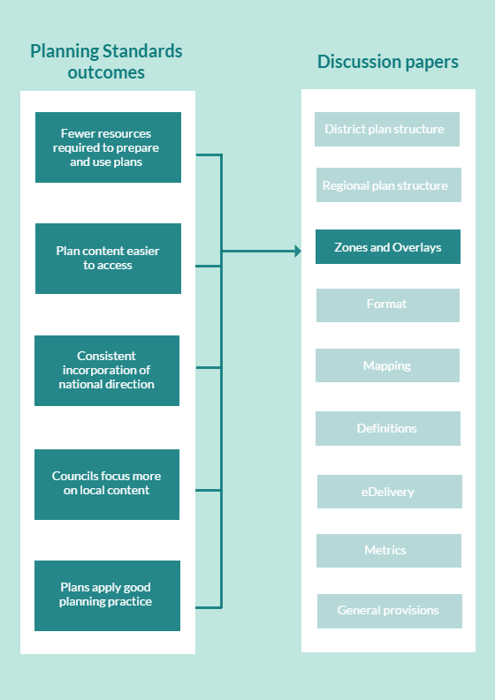

What do we mean by ‘spatial layers’?
By ‘spatial layers’ we mean zones, overlays, notations, precincts, appendices and other variously named layers that spatially define an area to which specific provisions apply.
Every plan uses a type of zoning to apply plan provisions (objectives, policies and rules) to manage effects on the environment. Zoning is the primary planning tool used to organise activities or manage environmental effects in a defined spatial area. Zoning is the foundation of planning systems in many developed countries and has been used in New Zealand since the 1926. It is used mostly by local authorities in their district plans but also by regional councils in regional plans, although the terms ‘catchment areas’ or ‘resource areas’ may be used instead. Zones often form key chapters of a plan.
Plans frequently use additional layers to show additional planning controls over and above those of the underlying zone. Overlays are spatial layers that usually extend more than one zone and manage a district wide issue or activity. Examples include natural hazards, outstanding natural landscapes and heritage overlays. In some plans, overlays have been reserved for addressing matters of national importance under section 6 of the Resource Management Act 1991 (RMA), while in others they have also included district wide matters that cross zone boundaries, such as infrastructure (eg, electricity transmission).
Other spatial layers, such as precincts, appendix maps and notations, have been used to achieve particular outcomes on a smaller scale (eg, building height restrictions or urban design in a particular area). They may also enable development, for example, by providing for a higher density of development. They may or may not be directly associated with a particular zone, such as verandah cover in a business zone. They can be represented as a polygon, line or point on a map. They have been used for section 7 matters of the RMA, such as the maintenance and enhancement of amenity in a character neighbourhood.

What is the problem and opportunity here?
There are no standard or consistent principles underpinning the use of spatial layers in plans. Their functions vary greatly across the country. There is considerable variation in the names used to describe them and in how they are displayed on planning maps. Layers with the same names have different functions in different parts of the country.
This creates uncertainty for plan users, and takes more time and money to understand how spatial layers in each plan work, particularly for users who work across regions and districts. Councils also spend time and money developing and litigating these aspects of each district plan over and over, where this could be avoided by standardisation at a national level.
There is an opportunity to standardise spatial layers so that they function in the same way across plans. We are exploring a standardised national framework that sets out the names, functions and the visual representation of spatial layers. The visual display of spatial layers, such as standard colours, is explored in the ‘Mapping Standards’ paper.
Some spatial layers may also benefit from standardised content (eg, objectives, policies, rules, metrics and definitions). We expect these to be where there is agreement on the role, function and intent of the layer, which will reduce unnecessary variety and make it easier for plan users to navigate plans and establish what provisions apply to their situation. This will allow councils to focus their local plan-making process on issues that matter to the community. We do not expect content to be provided for all included topics in the first set of standards, and could be progressively developed over time.
An important topic explored in this paper is the concept of mandatory content within the zone framework. At this stage, we have not looked at content for other spatial layers, such as ‘overlays’. This will be discussed subsequent planning standards.
Most of our research and preferred approach focuses on district plan spatial layers. We are looking for feedback on how the framework of spatial layers proposed in this paper could be applied to regional plans. We want to know what terminology works best, and whether there are other layers not considered.
For regional councils, this could mean standardisation of:
- region wide section 6 RMA matters (ie, topic overlays)
- environmental management areas that divide the entire region into areas for the management of a resource (eg, soil into soil type, water into catchments)
- identification of certain areas where specific controls are imposed to manage a particular issue or resource (eg, air sheds).

Questions: Regional plans
C.1. What level of detail would be helpful for the Planning Standards to prescribe in a regional plan framework?
C.2. What terminology should be used?
C.3. What modifications are necessary to the proposed framework to accommodate spatial layers commonly found in regional plans?

What our research tells us
The research used the term ‘spatial planning tools’ (SPTs) to describe spatial layers. If you read the research, you will notice it calls overlays ‘core SPTs’, and precincts, sub-zones, areas and notations are called ‘zone-specific SPTs’. We prefer the term ‘spatial layer’. It has the same meaning as SPT, which is the spatial demarcation of an area subject to planning controls.
The research portrayed that there is a hierarchy of SPTs. It did not go into detail where individual SPTs sat within that hierarchy. To make the research easier to understand, we have separated the results into:
- zones
- overlays
- other zone-specific layers.
More detail on the research that informed this paper is included in appendix 1.

Zones

Number and nature of zones
The research confirmed that the number and nature of zones used by councils vary by council type (ie, large metropolitan, provincial or predominantly rural). Larger, predominantly urban councils use more zones than smaller councils. This trend was also consistent for both urban and non-urban zones. For example, the Hamilton City District Plan has 23 urban zones, while smaller councils typically have fewer than ten. The most common number was five urban zones per plan. For non-urban zones, Christchurch has 19 non-urban zones, whereas Waimate has one.
It was common to have a single residential, commercial and industrial zone, though larger councils generally use more urban zones. There is a trend towards consolidation of zones, rather than increasing fragmentation. Urban and non-urban ‘core zones’ could easily be identified in district plans. These are the most common zones where content is also similar (see table 1). Zones were also called by different names between plans, for example, ‘living areas’ in the Christchurch City Plan and ‘resource areas’ in Central Otago.
Table 1: Common core zones in district plans
Urban | Non-urban
Residential | Rural
Commercial | Open space
Industrial | Special purpose

Common zone content
There is clear ‘common core content’ for some zones, including the standard residential, general commercial and industrial zones. The similarity between similar zones suggests that a level of content standardisation is possible.
Residential zones have the most common core content of all urban zones. Provisions focus on controlling activities that put residential amenity at risk. The common provisions in this zone appear to be generally accepted with limited interest or opposition through submissions, particularly in the smaller districts. The residential zone category was the most likely to be split into different types of zones (eg, a separate zone or sub-zone for medium density housing). This reflects a desire by councils to split up residential areas based on a range of factors, such as density, brownfield/greenfield areas and character. A number of zones were also not applicable for all councils. For example, medium density residential and mixed use zones were typically not used in smaller districts where there is limited growth and development pressure.
Commercial zone provisions tend to focus on allowing a wide variety of activities, provided they do not undermine the viability of town centres or adversely affect adjacent sensitive activities.
Industrial zone provisions focus on protecting the surrounding environment from adverse effects generated within the zone, while protecting industrial activities from reverse sensitivity effects.
Medium density and town centre zones are more likely to be used by medium to large councils and also have similar provisions. However, an interesting finding was that, although objectives and policies often signal increased density levels in these zones, the associated development controls are often very similar to standard residential controls. This suggests that, often, medium density zones are not actually enabling greater building densities.

Overlays
The research demonstrated that overlays were used in a number of different ways and located in different places across the researched plans:
- overlays could be located in multiple locations within a single plan making it difficult to identify all relevant for a site
- maps, figures and appendix schedules were presented differently
- issues could be dealt with either as a zone or an overlay (eg, medium density housing zone or through another layer)
- referencing to underlying data sources identifying the various layers and features of overlays was inconsistent and made it difficult to determine whether sufficient investigations had been undertaken to identify their boundaries.
The Auckland Unitary Plan (AUP) Independent Hearings Panel identified that ‘overlays’ should be reserved for addressing section 6 matters. To date, overlays have not exclusively been reserved for these matters, because infrastructure and airport activities have commonly been included.
Table 2 sets out the most commonly identified overlays that functioned in the same way in district plans.
Table 2: Example overlays: Restrictive and permissive (Planz)
Overlay type | Finding | Provisions restrictive and permissive?
Heritage | Was included in all district plans within the sample. | Generally introduce more restrictive rules on a property than the underlying zone.
Natural feature | Included in each of the sample plans.  It was noted that there were different types of natural features, which were included in the natural features overlay. This could be due to local variation or the existence of unique local features. | Generally introduce more restrictive built form controls than apply to the underlying zone.
Natural hazard | Consistently found within the sample plans (84%) were common features including: flooding, coastal hazard areas and geological/fault lines. However, similar to natural features, there were additional unique local hazards included in some of the sample plans. | Generally introduce more restrictive built form controls than apply to the underlying zone.
Utilities, eg, national grid, roads and designations | The road hierarchy and transmission lines were illustrated on most of the planning maps as well as transmission corridors. | Generally introduce more permissive controls than the underlying zone. However, the identification of these overlays can result in more restrictive rules being imposed on adjoining properties.
Urban design | Ninety-two percent of plans sampled included some form of urban design layer. | Generally introduce more restrictive built form controls than apply to the underlying zone.
Airports | While only identified in 60% of the sample plans, the mapping and detail contained in these overlays was uniform across that 60%, reflecting the legislative framework within which these overlays are prepared. | Generally introduce more permissive controls than the underlying zone for the site. However, the identification of these overlays can have more restrictive rules imposed on adjoining properties to protect airport operations.
The fact that a high percentage of plans contained similar overlays suggests it could be possible to standardise some of the content of these layers to avoid unnecessary variation. This would help in achieving greater national consistency, although is not expected to form part of the first set of planning standards. Matters addressed by overlays were represented as a point, line or polygon on planning maps. Map notations are another form of SPT commonly used to represent heritage buildings, notable trees and sites of significance, and are represented by a line or polygon.

Zone-specific layers
For this section of the paper, spatial layers that seek to control character, amenity or values addressed by section 7 of the RMA within a zone are called ‘zone-specific SPTs’. These types of spatial layers are variously known as spot zonings, appendix areas and areas known by their ‘purpose’, for example, the ‘Courtenay Place area’ in the Wellington City District Plan.
These are effectively a third layer of place-specific provisions. They can be enabling or restrictive and are represented by an overlay, line, polygon or appendix map.
This type of approach was most recently used in the AUP as a spatial layer that enabled local differences to be recognised by providing more detailed place-based provisions. ‘Precincts’ were used in the AUP to control certain outcomes and could apply within a zone or across multiple zones. Precincts vary the outcomes sought by the underlying zone and could be more restrictive or enabling.
The types of controls that precincts addressed included:
- building height coverage
- structure plans
- character amenity areas
- noise
- density
- future urban growth
- amenity and urban design.

How spatial planning tools fitted together in the research
Figure 2 represents how the research saw the different SPTs linking together within an example zone framework.
Figure 2: Connection between spatial planning tools (SPTs) as detailed in the research
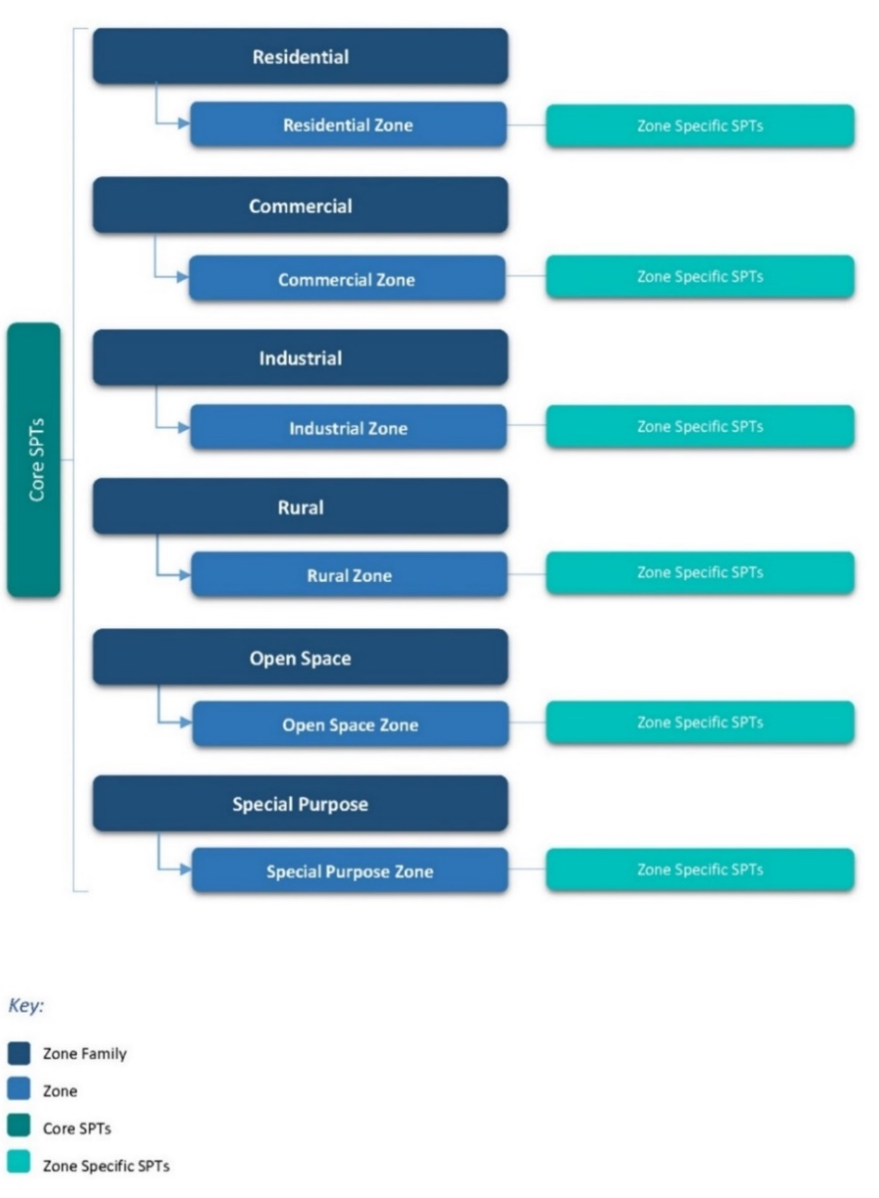

Lessons from the Auckland and Christchurch planning processes
The recent AUP and Christchurch Replacement District Plan (CRDP) processes provide useful learnings on the use of spatial layers. Both independent panels required that spatial layers be applied on the basis of robust cost–benefit analysis. If sufficient analysis did not demonstrate the need for controls, the provisions were removed from the plan. The AUP Panel recommended the removal of five overlays because, in its view, the evidence did not demonstrate they were the most appropriate method of achieving the objectives of the AUP.
The AUP Panel’s approach was to establish a clear descending hierarchy from overlay to zone to precinct. Precincts were contained within a separate chapter of the plan, distinct from the underlying zone and overlay.
An important principle throughout both the CRDP and AUP Panel decisions was the recommendation to apply the appropriate zone to the land. If any constraints on that land then needed to be managed, this would be through an overlay not by down-zoning the land. Both panels also recommend that zoning should not be applied on the basis of factors that are addressed more directly by the overlays or district wide controls. The need to provide ‘robust evidential foundations’ for its resource management issues, policies and methods was a key message throughout the AUP Panel’s recommendations.

Mapping of layers
The research explored how SPTs are mapped and included in district plans. This paper addresses the location of information about the SPT and where it is placed in the plan. Ideas about how spatial layers are visually displayed are addressed within the Mapping Standards paper and how they are accessed electronically in the eDelivery paper.
International comparison
Victorian Planning Provisions (VPP) – Victoria, Australia
The VPP are a comprehensive set of standard planning provisions developed by the Victorian Government. The zone and overlay planning provisions specify:
- the type of use and development allowed in each zone and performance standards for permitted activity
- which types of activities require a planning permit
- additional requirements for subdivision, buildings and works on land that is affected by an overlay
- requirements for any specific uses and development.
Appendix 2 sets out a specific example of the VPP for a low density residential zone. What this demonstrates is the level of detail that the state prescribes to local government. We are interested in your feedback on the level of detail that should be included in the first set of National Planning Standards.

Framework options
Our research identified three zone framework options, and provided supporting descriptions. These framework options are presented below and should be read in conjunction with the zone layer tables in appendix 3.
The three option packages contain a ‘menu’ of spatial layers progressing from basic to more complex. The zones included within each option are organised under a set of six zone ‘families’, based on six common zone types (standard residential, general commercial, industrial, rural, open space, and special purpose). Each option builds on its predecessor by offering a broader selection of spatial layers for councils to choose from and apply.
The initial three options each provide a package that standardises:
- the range of spatial layers available and their names
- the purpose statements and intent of the layer
- where spatial layers should be located in the plan
- how spatial layers should appear on the planning maps (see Mapping paper)
- some of the provisions for each zone.

Option 1: Common suite of zones
This option is based on the ‘common’ zones identified in the scan of district plans and is shown below. It comprises six zones nested under the six corresponding zone family groupings (see figure 3).
Figure 3: Option 1 – common suite of zones
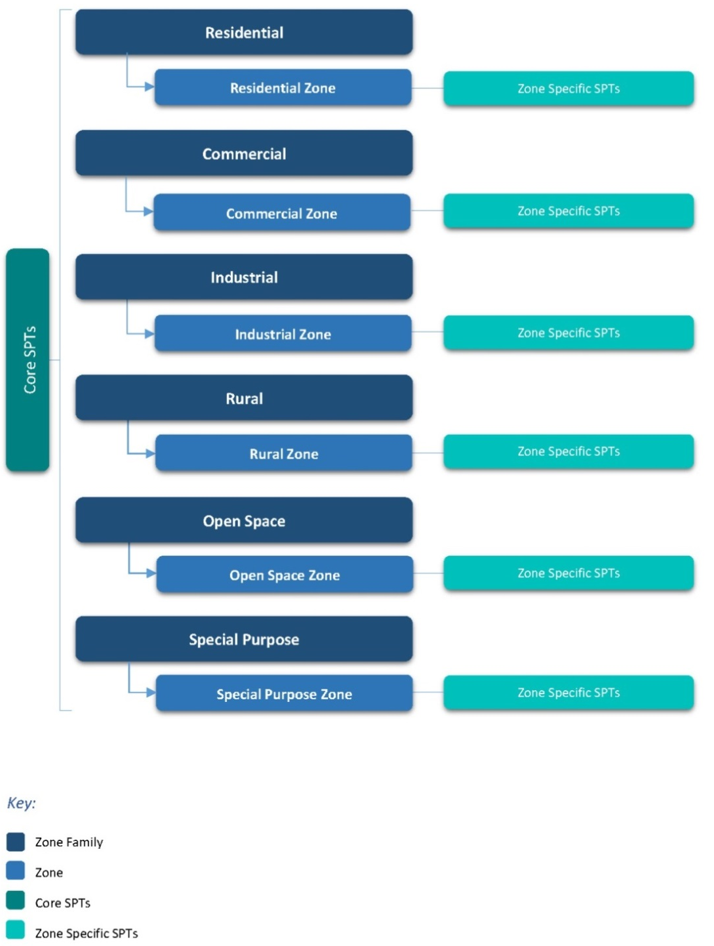

Option 1: Common suite of zones
Advantages | Disadvantages
Would achieve a basic level of zone standardisation and consistency across plans. | Offers a simplistic ‘menu’ that could be perceived as lacking sufficient flexibility and diversity at a zone level to accommodate local variation and distinctiveness.
Combined ‘menu’ of zones and spatial layers would enable a wide range of land use planning outcomes to be achieved (eg, differing densities in residential zones through use of spatial layers). | Effectiveness is likely to be highly reliant on the application of a complex range of spatial layers to achieve required and/or anticipated variation within zones (eg, density and height, particularly at a metropolitan or larger provincial centre level).
Relatively simple to implement (ie, 6 zones versus 12 or 27 zones), resulting in potential for increased administrative efficiencies. | Extensive use of spatial layers could affect the level of complexity and legibility of plan maps and detail embedded in the spatial layers.
Offers a simple and highly legible framework at a base zone level (ie, 6 zones). | Potential time, cost and complexity associated with retrofitting existing plans, particularly at a provincial and/or metropolitan centre level.
Strongly aligns with the common zones identified in the district plans sampled. | Potential for pressure to be applied to broaden the scope of zones (or add new zones), which could create unnecessary duplication and result in increased cost if additional regulation or amending legislation is required.
Would particularly suit smaller territorial authorities and/or cater to districts that lack a high degree of diversity.
Potential time and cost savings in preparing a supporting package of common plan provisions and definitions relative to options 2 and 3 (ie, 6 versus 12 and 27 zones).

Option 2: Medium suite of zones
This option expands on Option 1. It includes seven additional, less common zones identified in the research. It comprises 12 zones nested under the six corresponding zone family groupings (see figure 4).
Figure 4: Option 2 – Medium suite of framework of zones
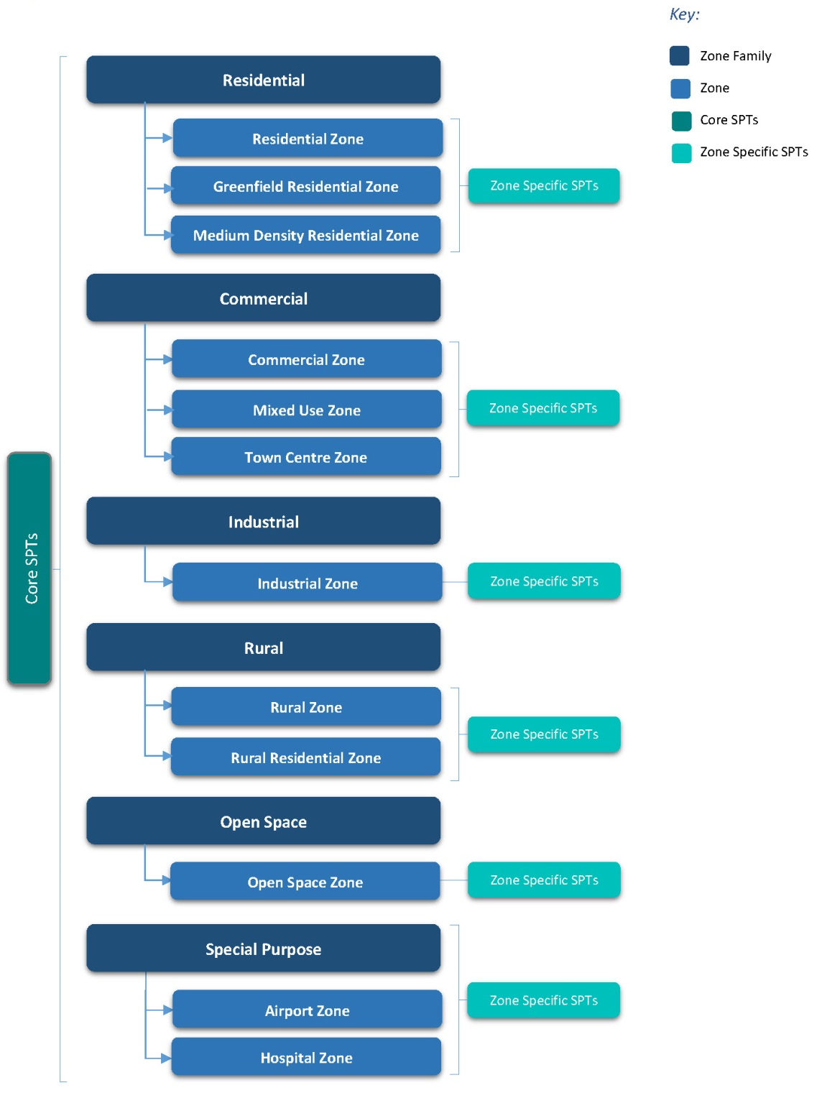

Option 2: Medium suite of zones
Advantages | Disadvantages
Provides a wider degree of zone choice, relative to Option 1, and would achieve an enhanced level of standardisation and consistency across plans. | Could still be perceived as insufficiently flexible to accommodate local variation and distinctiveness, particularly at metropolitan centre level.
Broader range of choice of zone type may reduce the need for, and reliance on, applying a complex range of spatial layers to achieve required and/or anticipated variation within zones. | Effectiveness could still be largely dependent on the application of a range of spatial layers to achieve required and/or anticipated variation within zones (eg, density and height, particularly at a metropolitan centre level).
Relatively simple to implement, compared with Option 3 (ie, 12 versus 27 zones), resulting in potential for increased administrative efficiencies. | Extensive reliance on the use of spatial layers may affect the level of complexity and legibility of plan maps and detail embedded in the spatial layers.
Offers a simple and legible zone framework, relative to Option 3 (ie, 12 versus 27 zones). | Provides only a limited ‘menu’ of zone choice to address unique local activity conditions (ie, airport, hospital).
Strong alignment with the common zones identified in the district plans sampled. | Potential time, cost and complexity associated with retrofitting existing plans, particularly at the level of smaller, predominantly rural, territorial authorities.
Likely to suit the requirements of a broader range of territorial authorities relative to Option 1 (ie, rural and provincial territorial authorities). | Potential for pressure to be applied to broaden the scope of zones (or add new zones), which could create unnecessary duplication and result in increased cost if additional regulation or amending legislation is required.
Potential time and cost savings in preparing a supporting package of common plan provisions and definitions relative to Option 3 (ie, 12 versus 27 zones).

Option 3: Large suite of zones
Under Option 3 (see figure 5), an expanded ‘menu’ of 27 zones would be available to territorial authorities to select from. These include ‘outlier’ zones identified in the research, along with more common zone types generally applied in larger provincial and metropolitan centre contexts. It is anticipated that the degree to which councils apply the zone types available in this option will be dependent on local requirements or circumstances.
Figure 5: Option 3 – Large suite of zones
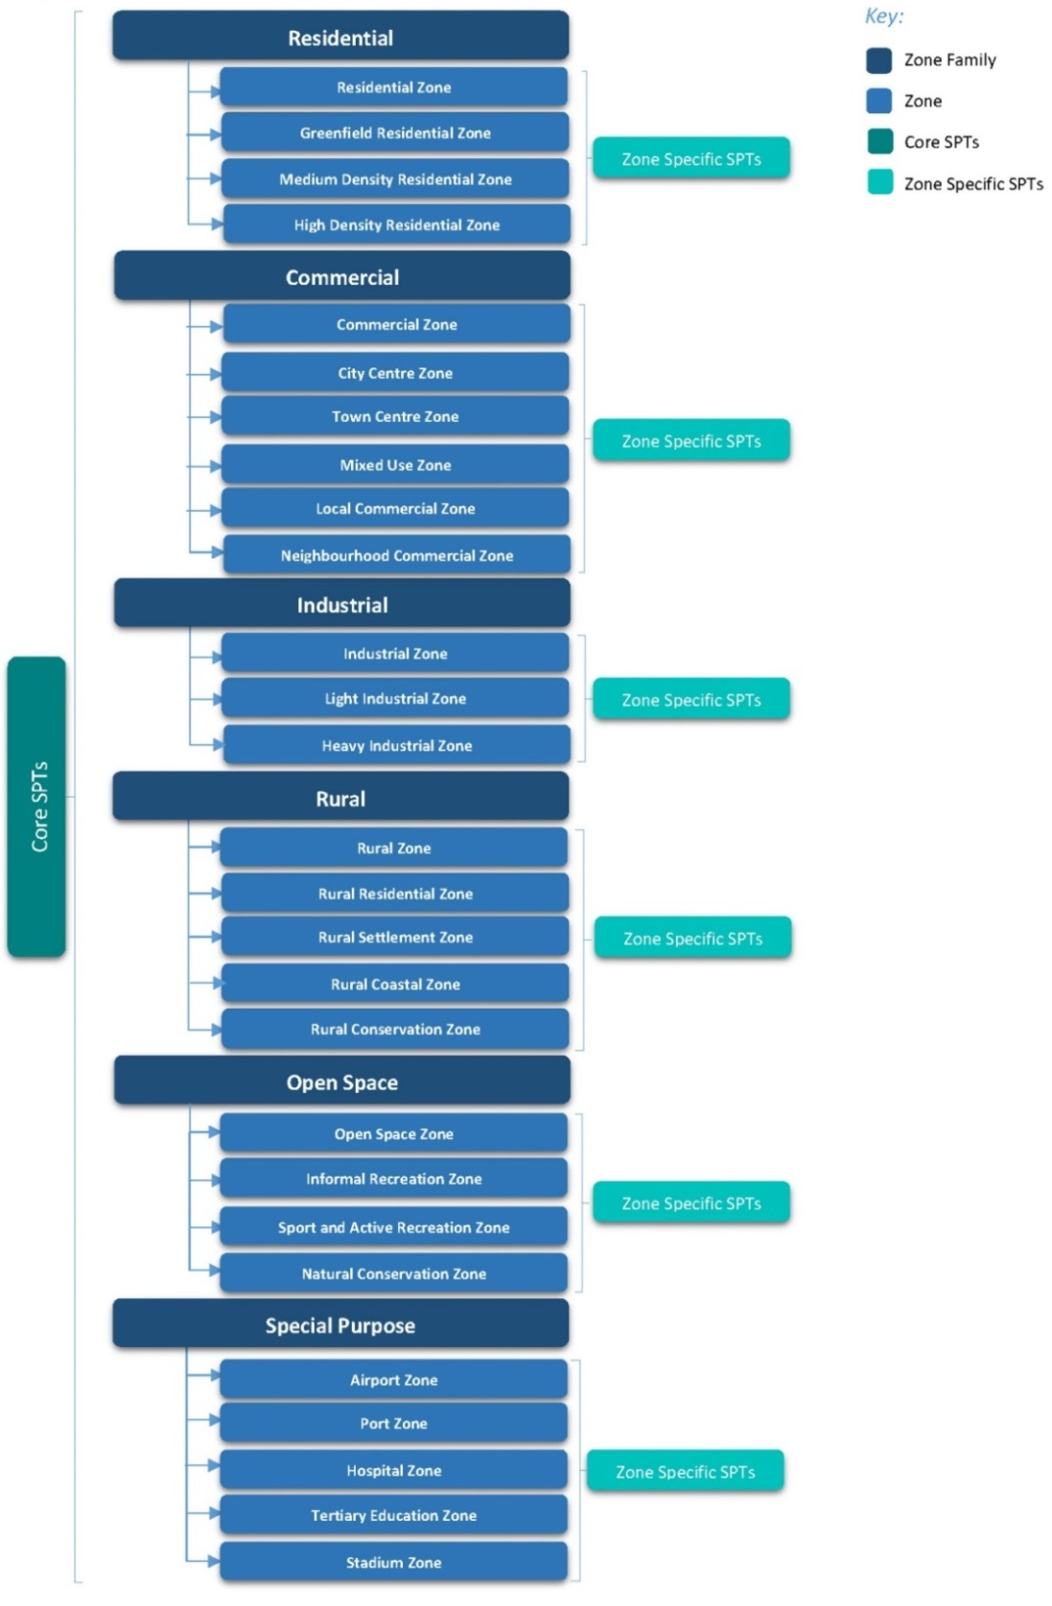

Option 3: Large suite of zones
Advantages | Disadvantages
Provides a wider degree of zone choice, relative to options 1 and 2, and would achieve a high level of standardisation and consistency across plans. | Could be perceived as overly complex and unduly nuanced by smaller or less diverse territorial authorities (eg, city centre zone, town centre zone, mixed use zone, local commercial zone, neighbourhood commercial zone).
Broader ‘menu’ of zones offered could reduce the perceived need for, and reliance on, a complex range of spatial layers to achieve the required and/or anticipated variation within zones. | Reflects a wider range of ‘outlier’ versus ‘common’ zones identified in the plans sampled, some of which may be perceived as unnecessary because the outcome sought could be alternatively achieved through an SPT (eg, medium–high density).
Reduced reliance on use of spatial layers to differentiate between activities is likely to result in improved legibility of spatial information represented on plan maps relative to options 1 and 2. | Likely to result in a more complex and less legible zone framework, relative to options 1 and 2, which could create interpretive confusion in the absence of appropriate guidance.
Highly flexible and would provide sufficient scope to enable local variation and distinctiveness to be more transparently and effectively accommodated. | Potential time and cost involved in preparing a supporting package of common plan provisions and definitions relative to options 1 and 2 (ie, 27 versus 6 to 12 zones).
Enables plans to be scaled up or down, depending on local circumstances (eg, reliance on more limited choice of zone type in a rural versus urban context). | Potential time, cost and complexity associated with retrofitting existing plans, particularly at the level of small to medium sized territorial authorities.
Capable of meeting the needs and requirements of most territorial authorities and plans compared with options 1 and 2 (ie, rural, provincial and metropolitan territorial authorities). | Some potential pressure may continue to exist for the scope of zones to be broadened (or new zones added), which could create unnecessary duplication and result in increased cost, if additional regulation or amending legislation is required.
Has potential to increase plan user confidence by ensuring consistency across a wide range of zone types. | Could potentially result in reduced administrative and implementation efficiencies, given the more complex nature of the zone framework relative to options 1 and 2.

Our take on the research
This paper and the ‘District Plan Structure’ paper establish a framework for thinking about how content is categorised in plans. The papers explore and question what level of detail could be included in each category. This allows us to have a common understanding of the elements of plan structure that are currently referred to in different ways. Some of the terminology we use may be different from that in the plans you commonly use. This demonstrates the current inconsistencies between plans, and it also shows the rationale for adopting a common language and way of using each spatial layer before we can make further progress.
The following sections present our interpretation of the research and options for the function and use of zones and overlays. An indicative outline of our proposed approach is presented on page 30.

Zone framework
Our preferred approach is Option 3. It provides more flexibility than the two other options, limiting the need for councils to want to create other additional zones. A lesson learned from the Australian planning templates is it is best to adopt a framework that most suits the needs of the larger, more complex environments, knowing that the smaller councils will only use what they need from the framework.
Option 3 provides the greatest scope to fit the majority of existing plan zoning frameworks, reducing the transition costs for most councils. The Planning Standards will require councils to retrofit their existing zones with those provided in the final zone framework. We were interested in how the CRDP and AUP zone frameworks would compare with Option 3 (see figure 6). While Option 3 has a reasonably high degree of compatibility, we note there is not a complete match. Some zones were not able to be accommodated in our proposed Option 3 (eg, large lot zone and business park zones). We expect the feedback on this paper will help identify any other zones that may be required to supplement the framework set out in Option 3.
We expect the common core zones will be mandatory, although they will not have to be used where they are clearly not applicable in a given area. For example, we do not expect a predominantly rural-based council will need to use a medium density zone in its plan. Councils will be able to manage context-specific issues within their district or region through the use of ‘sub-zones’ (described below) and other layers.
If Option 3 is pursued, the National Planning Standards would require that only the specified zones may be used in plans. A standardised set of zones is the basis for establishing a system that is consistent across the country.
Figure 6: Option 3 compared with the Auckland Unitary Plan and Christchurch Replacement District Plan

Questions: Zone framework options
C.4. To what extent does Option 3 provide sufficient flexibility for all councils?
C.5. Is there a suitable range and number of zones?
C.6. Are there other frequently used zones that should be provided?
C.7. How compatible is this option with the plan you work with most often?
C.8. What problems do you anticipate could occur from applying these zone options?
C.9. For what matters should zones be used, as opposed to an overlay or other spatial layers (eg, sub-zone), and why?
C.10. Should zones have names that more accurately reflect the type of building expected, similar to the approach adopted in the Auckland Unitary Plan (eg, single house zone, terraced house and apartment zone, mixed housing suburban zone)?
C.11. What timeframe do you think is achievable to change your plan into a different zone framework? (eg 2 years, 5 years?)

Sub-zones
We think sub-zones could be included to manage zone or area-specific effects and activities. These are complementary controls that define a smaller, specific area within a zone. Within this sub-zone, one or two specific rules or performance standards would apply that differentiate it from the underlying zone controls. The additional rule or performance standard may be more enabling or more restrictive and used to manage an identified issue (eg, character) or one aspect of character that is different (eg, height). These are likely to be currently defined in plans as ‘areas’ or by a similar name. Examples of sub-zones in plans include:
- the ‘Residential Coastal Edge’ (Wellington City Plan), which seeks to manage effects on the coastal escarpment)
- Napier Main Residential Elevation Line (where buildings or structures west of this line cannot exceed 10 metres in height).
There are multiple ways that a sub-zone could be included in the plan, for example, as a polygon, rule in the zone provisions or an appendix map.
Questions: Sub-zones
C.12. Is there a better way to address, categorise and consider these matters?
C.13. What types of sub-zones could be standardised (eg, noise controls, building height)?
C.14. Is there a better name for sub-zones?
C.15. Will these types of issues always be located within a zone?

District wide nationally significant matters
We are proposing the standardisation of overlays that manage district wide activities, that is, resource management issues that are not specific to one zone and cover multiple zones. We agree in part with the AUP Panel that ‘overlays’ should be reserved for those matters contained within section 6 of the RMA. In addition, we are interested in exploring whether layers which address nationally significant matters could also be used for the provision of nationally significant infrastructure, and other matters that are the subject of national direction.
Matters covered would include:
- the coastal environment
- outstanding natural landscapes and features
- significant indigenous biodiversity
- public access to coastal marine areas, lakes and rivers
- sites of significance to tāngata whenua
- heritage
- nationally significant infrastructure (eg, national grid)
- natural hazards.
The above is not a finalised list and we are seeking your feedback on whether these are the right matters to include, and what else should be included.
The matters will be referred to using mandatory terminology and shown on planning maps as district wide nationally significant matters. It is important to understand that they could be represented by a line, polygon, notation, rules in the plan text, or through an appendix map. We do not anticipate providing mandatory content in the first set of National Planning Standards. A specified location for plan provisions will, however, be provided. Councils will be able to add localised content to these layers.
Councils will not be able to create additional layers to manage district wide nationally significant matters. We expect these layers to be fixed. Any additional layers provided will be as a result of new RMA section 6 matters and new national direction.
Questions: District wide nationally significant matters
C.16. Is there a better way to address, categorise and consider these types of matters?
C.17. What are your thoughts on standardising district wide nationally significant matters in the National Planning Standards?
C.18. Are these the right matters to include in this layer?
A. Are there any other matters that should be included?
C.19. Is there a better name for these layers?
C.20. Should councils be able to add more of these layers?

District wide amenity matters
We are also considering the need to standardise layers that manage district wide amenity matters. These amenity matters typically give effect to section 7 RMA matters and are not specific to one zone. This layer is to address matters such as:
- maintaining and enhancing the quality of the environment
- providing for the efficient use of natural and physical resources
- maintaining and enhancing amenity values.
These matters are dependent on local circumstances and are often influenced by legacy provisions. They are common matters that the majority of plans address to maintain a level of amenity. They can be zone specific (eg, verandah cover strips) or across multiple zones.
The types of issues that councils could control using this layer include:
- noise
- network utilities
- transport
- landscaping and screening
- signs
- three waters infrastructure
- light spill
- earthworks
- subdivision
- temporary activities.
The above is not a finalised list and we are seeking your feedback on whether these are the right matters to include, and what else should be included.
The layers will be referred to using mandatory terminology and shown on planning maps. They could be represented by a line, polygon, notation, rules in plan text, or through an appendix map. It is anticipated that there will be mandatory definitions and metrics in the first set of National Planning Standards, although these will not need to be included if they are not relevant (Definitions paper). A specified location for plan provisions will also be provided (District Plan structure).
Questions: District wide amenity matters
C.21. Is there a better way to address, categorise and consider these types of matters?
C.22. What are your thoughts on standardising district wide amenity matters in the National Planning Standards?
C.23. Are these the right matters to include in this layer?
A. Are there any other matters that should be included?
C.24. Is there a better name for these layers?

How it all fits together
Figure 7: How our approach proposed in this paper fits together
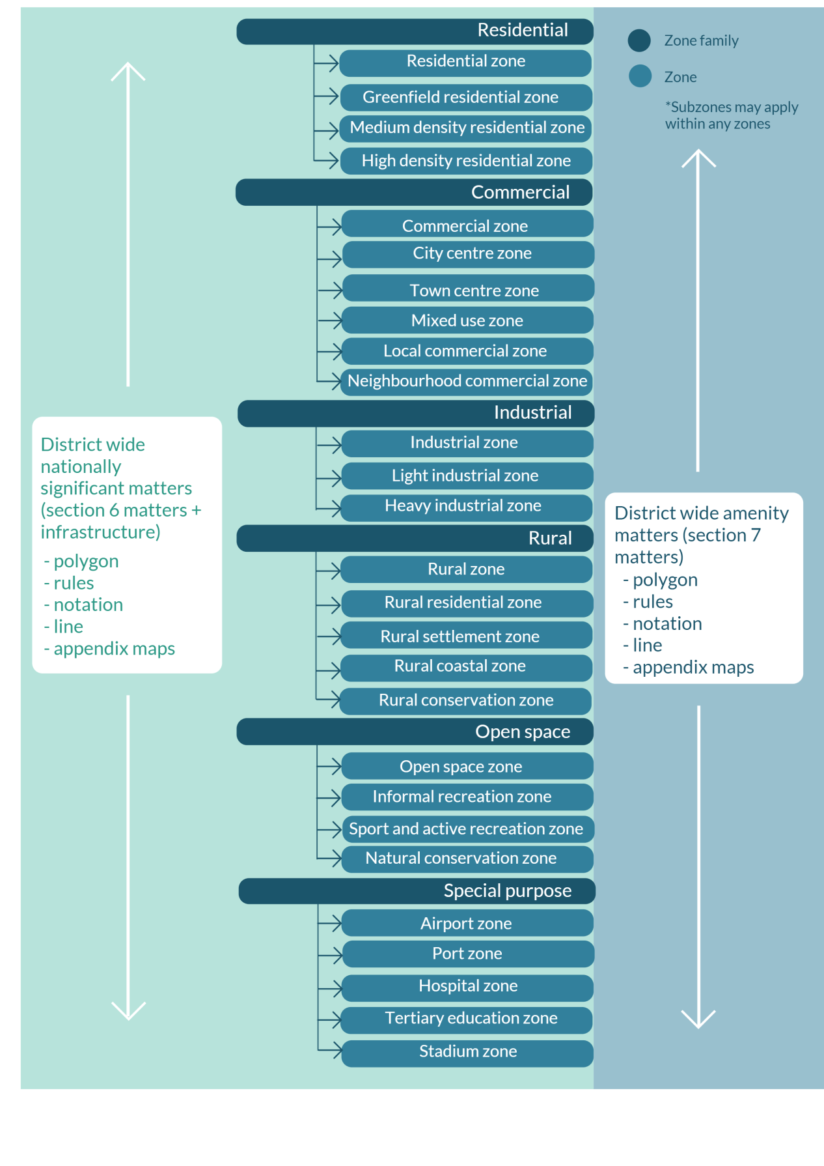
Note: Sections 6 and 7 relate to the RMA.

Plan content
The lessons learned from using Australian planning templates suggest the net benefits of adopting a standardised zoning framework in plans will only materialise if core zone content is included that sets the broad parameters for each zone. That is, there will be little benefit to the planning system if a mandatory zone framework is adopted that standardises the zone name and generally describes when it should be applied, but plans contain vastly different objectives, polices and rules.
Our research documented the most ‘common core’ objectives, policies and rules for a variety of urban zones. It shows common issues are being managed across the range of urban zones investigated. Table 3 is an example of this. It sets out thematic examples of objectives and policies used in some of the Australian planning templates for a standard residential zone. It also identifies common thematic objectives and policies for the New Zealand residential zones studied.
Table 3: Comparison of key residential zone objectives and/or policies in New Zealand plans with Australian plan templates
Template | Intent of zone
New Zealand research | 1: Policy relating to residential amenity  2: Policy relating to effects of non-residential activities  3: Policy relating to housing supply and choice
Queensland Planning Provisions | To provide for residential activities supported by a range of community uses and small-scale services, facilities and infrastructure that cater for local residents:  - development ensures a high level of amenity by minimising traffic, noise, dust, odour, glare and other local impacts  - development is designed to maximise energy efficiency and water conservation  - development is supported by transport infrastructure that promotes safe and efficient public transport use, walking and cycling  - development provides a high level of amenity and is reflective of the surrounding character of the area  - community facilities and infrastructure that directly support the local community are facilitated  - development has access to infrastructure and services.
New South Wales Standard Instrument | To:  - provide for the housing needs of the community  - provide for a variety of housing types and densities  - enable other land uses that provide facilities or services to meet the day-to-day needs of residents.
Victorian Planning Provisions | General residential zone to:  - encourage development that respects the neighbourhood character of the area  - implement neighbourhood character policy and adopted neighbourhood character guidelines  - provide a diversity of housing types and moderate housing growth in locations offering good access to services and transport  - allow educational, recreational, religious, community and a limited range of other non-residential uses to serve local community needs in appropriate locations.
Table 3 demonstrates that the main planning issues being managed in Australian residential zones are closely aligned with those in New Zealand residential zones. Despite different legislative settings and institutional arrangements, core planning responses to certain issues are largely the same.
Similarly, our collective body of research identified that there are common core permitted activities and development standards for a standard residential zone (see table 4).
Table 4: Common permitted activities
Template | Permitted activities
New Zealand research | Category | Most likely activity status
 | Residential | Residential activity – permitted  Home occupations – permitted  Visitor and traveller accommodation – permitted or discretionary (depends on scale and whether district has a tourism focus)  Minor and secondary residential units – permitted (also dependent on scale)  Managed or supported residential care – permitted or discretionary  Comprehensive, integrated, medium density residential developments – restricted discretionary  Rest homes and retirement villages – restricted discretionary or discretionary
 | Community | Places of assembly – permitted or discretionary  Small-scale education and childcare activities (ie, maximum person or floor area limit) – permitted  Larger scale education and childcare activities (ie, above maximum person or floor area limit or no upper limit specified) – restricted discretionary  Health care – mixture of activity statuses, depending on scale but often permitted, restricted discretionary or discretionary  Community centres and facilities – discretionary
 | Buildings and structures | Additions and alterations – permitted  New buildings and structures for permitted activities – permitted  Demolition, removal, relocation of buildings – permitted or controlled  Accessory buildings – mixed, depending on the activity status of the activity planning to use the building
 | Development control infringements | Restricted discretionary
 | Default activity status | Discretionary or non-complying
New South Wales Standard Instrument | Zone R1 – General residential  Permitted without consent  Home occupations  Permitted with consent  Attached dwellings; boarding houses; childcare centres; community facilities; dwelling houses; group homes; hostels; multi-dwelling housing; neighbourhood shops; places of public worship; residential flat buildings; respite day-care centres; semi-detached dwellings; seniors housing; shop top housing
Victorian Planning Provisions | General residential zone  Section 1 – Permit not required  Animal keeping (other than animal boarding)  Must be no more than two animals.  Bed and breakfast  No more than 10 people may be accommodated away from their normal place of residence. At least one car parking space must be provided for each two people able to be accommodated away from their normal place of residence.  Dependent person’s unit  Must be the only dependent person’s unit on the lot.  Dwelling (other than bed and breakfast)  Home occupation  Informal outdoor recreation  Medical centre  The gross floor area of all buildings must not exceed 250 square metres. The site must adjoin, or have access to, a road in a Road Zone.  Minor utility installation  Place of worship  The gross floor area of all buildings must not exceed 250 square metres. The site must adjoin, or have access to, a road in a Road Zone.
The National Planning Standards could include some mandatory high-level content for a given zone. This would have the benefit of reducing duplication of effort by councils in developing objectives, policies and rules on similar issues and activities. It also has the benefit of allowing councils and other participants in the plan development process to focus their efforts on the issues that matter to the community.
Content could focus on the matters most common to those zones, including:
- three to four key objectives per zone and associated policies
- a list of permitted activities that our research shows are commonly allowed across all plans
- lists of performance standards (or metrics) commonly associated with key permitted activities.
The focus will be on key urban zones in the first set of National Planning Standards, with basic content expected to be developed for the priority zones listed below:
- residential zone
- medium density residential zone
- high density residential zone
- greenfield residential
- commercial zone
- town centre zone
- industrial zone.
Developing zone content of this nature represents a significant change for plan development in the current devolved planning system. An important objective for the planning standards will be to find the right balance between mandating zone content that addresses common core planning issues in a consistent manner, while ensuring councils can still draft plan provisions to manage the issues that matter to the local community.
The requirement of the Planning Standards to be accompanied by a section 32 report will, like any plan change process, ensure the need for evidence-based drafting decisions and an examination of the benefits and costs of mandating such content.
We will also be testing this aspect of the National Planning Standards extensively with councils that have expressed an interest in working with us during the drafting stages.
Questions: Content
C.25. What are your views on the discussion about standardising zone content (objectives, policies and rules) through the National Planning Standards?
C.26. Can you identify any risks with the concept of standardising common core zone content?
C.27. Do you agree or disagree with the priority list of zones identified? Why?
Table 5 provides an indicative outline of our proposed approach.

Table 5: Proposed approach to zones and layers in the National Planning Standards
District plan section | Purpose and description of plan section | Type of provision or spatial layer required
National, regional and strategic direction | A district plan is required to give effect to a national and regional policy statement, and a national environmental standard replaces district plan rules (unless provided for in the national environmental standard). To provide a list and description of all national direction and how the district plan gives effect to it at a high level, and also provide a description of the regional policy statement and how the district plan gives effect to it.  Provide a place for identification of any district strategic issues, for example:  - growth management (high or low)  - infrastructure provision  - resources of the district that require specific management.  This section will support plan users to understand the broader resource management context, specifically the national and regional policy drivers influencing the direction of specific provisions in the district plan. | Non-statutory plan provisions.  Identification of strategic issues for the district.  Strategic objectives and policies.  Zone or district wide rules that identify where the plan is more or less restrictive than national environmental standards.*  *Note, it is expected that national environmental standards will be stand-alone documents outside the district plan.
District wide nationally significant matters | District wide nationally significant matters provide for and address section 6 Resource Management Act 1991 (RMA) matters and the provision of nationally significant infrastructure.  Matters covered would include:  - the coastal environment  - outstanding natural landscapes and features  - significant indigenous biodiversity  - public access to coastal marine areas, lakes and rivers  - sites of significance to tāngata whenua  - heritage  - nationally significant infrastructure (eg, national grid)  - natural hazards.  The matters included in this category are those identified by the RMA as a section 6 matter or as nationally significant by national direction. | Referred to and shown on planning maps as district wide nationally significant overlays – a spatial layer that identifies specific sites or areas of the district to which specific provisions apply. Generally occurs across zones.  District wide nationally significant overlay objectives and policies.  District wide nationally significant rules.  Zone-specific rules.
District wide amenity matters | Matters that give effect to section 7 of the RMA and relate to district plan provisions that:  - maintain and enhance the quality of the environment  - provide for the efficient use of natural and physical resources  - maintain and enhance amenity values.  Matters that apply across the district and include:  - noise  - network utilities  - transport  - landscaping and screening  - signs  - three waters infrastructure  - light spill  - earthworks  - subdivision  - temporary activities.  These are matters that are common across zones and that the majority of plans address. They either have the same rule or threshold across the entire district, or apply in each zone but with a different standard or threshold. These matters are dependent on local circumstances and are often influenced by legacy provisions. (Note these matters are not the only way that a plan gives effect to section 7 of the RMA; zone and sub-zone provisions are also relevant to giving effect to section 7.) | These provisions include objectives, policies and rules.  They can be represented by:  - polygons or lines on maps (within zones, eg, verandah cover strips, or across zones, eg, vehicle access restrictions or roading hierarchy)  - district wide rules, eg, temporary activities or zone-specific rules, eg, noise and signs  - map notations or appendix maps.  Provisions may apply to all zones, but the thresholds for certain activities may change due to influences of the underlying zone.
Managing land use and development | Spatially defining areas to manage land use and development. Areas are identified that have similar character and land use or are identified to create a specific character or land use desired in the future.  May include zones for (not a comprehensive list):  - residential  - commercial  - industrial  - open space  - future growth areas. | These provisions include objectives, policies and rules.  Zoning (on the planning maps) – the spatial division of the entire district into areas where certain provisions apply.  Sub-zone (on planning maps) – parts of a larger zone where one or two specific rules or performance standards apply. The additional rule or performance standard may be more enabling or more restrictive and used to manage an identified issue, for example, character or one aspect of character that is different, for example, height.

Benefits of standardisation
The benefits of a standardised approach to how the different spatial layers are addressed in plans include the following:
- a simple, easy-to-use structure with standard zone and overlay names – plan users will be able to easily identify the section of the plan most relevant to them
- a more efficient plan-making process for councils because they will be applying a set structure of zones, thereby reducing repetition, and can focus their resources on applying this to the local context
- improved plan usability for those who work across different plans – a standard zone structure reduces the time and costs spent on assessing every plan to identify the relevant zone and associated provisions for their activity
- a standard suite of zones will prevent the creation of zones that are simply variations of others that already exist and for which an overlay or layer may be more appropriate
- reduced inconsistency with private plan change requests, because they will need to be consistent (and not conflict) with the standard suite of zones. Currently, provisions relating to a private plan change may not easily fit with the existing plan structure. Applicants for a private plan change would need to carefully consider how their proposal fits with the standard zones.

Next steps
We are currently in a scoping phase for the National Planning Standards. The ‘Introduction to the National Planning Standards’ overview document details the process and engagement opportunities during each stage of development. The flow chart below shows each stage of the development process and the anticipated timeframes.
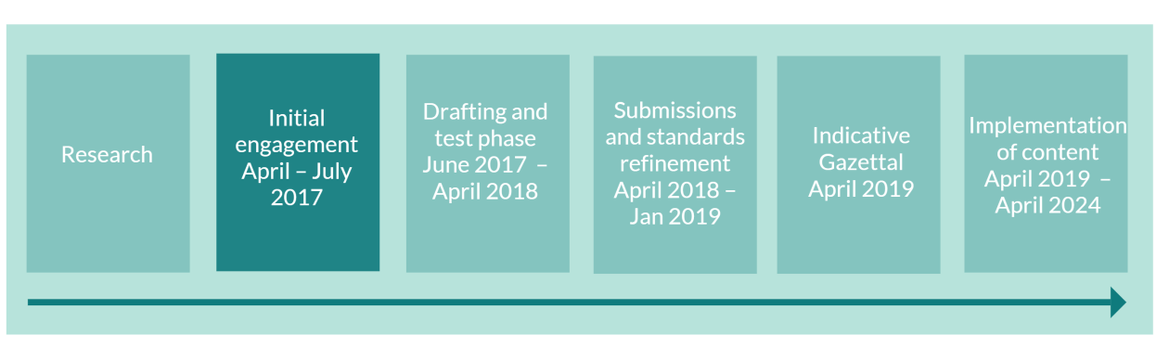

Feedback
We welcome your feedback on the ideas and options presented in this paper. Please use the questions in this paper as a guide. You do not have to answer them all and can give other constructive comments where you wish. To ensure your point of view is clearly understood, please explain your rationale and provide supporting evidence where appropriate.
We encourage you to send us feedback throughout the initial engagement period, which closes on 31 July 2017. Please send feedback to the email address below.

Contact
Email: planningstandards@mfe.govt.nz
Website: www.mfe.govt.nz
Phone: +64 4 439 7400

Appendix 1: Research referenced in this report
(Available at www.mfe.govt.nz)
We commissioned three research studies on spatial layers in district plans. The purpose of this research was to develop a clearer picture of how spatial layers have been used and which parts would benefit from standardisation.
4Sight Consulting (2015), Urban Zone Research:
- understanding the most commonly used provisions and main differences in provisions in the core urban zones through reviewing a range of plans that are representative of the urban areas within New Zealand
- identifying the most common provisions within each urban zone to determine what can be categorised as the ‘common core content’ and the main benefits, costs and issues identified with this common core content.
Planz Consultants (2015), Spatial Planning Terminology Research Study:
- the types of information contained in spatial layers
- the terminology used to describe spatial layers
- how information contained in spatial layers is presented in district, unitary and regional plans
- the commonalities and differences between the use of spatial layers across New Zealand.
Boffa Miskell Ltd (2016), Proposed National Planning Template – Zones and Associated Spatial Planning Tool Framework Options:
- identifying and analysing relevant non-urban zones
- researching, analysing and developing three to four feasible zoning framework options comprising a ‘core’ framework of common zones and associated spatial layers for possible inclusion in a proposed national planning template.

Methodology
Each piece of research above followed a similar methodology. Twenty-five to 30 district plans and four regional plans were selected for analysis (the Boffa Miskell and Planz reports). The sample took into account:
- urban–rural mix (ie, metropolitan, provincial, rural) and population
- geographic spread (North Island and South Island)
- currency and age (ie, first generation and second generation plan)
- plan type (ie, city, district, unitary)
- population and high or low growth territorial authority areas.
More detail on the methodologies used in the three research studies is available by viewing the full reports on our website.

Appendix 2: Victoria Planning Provisions
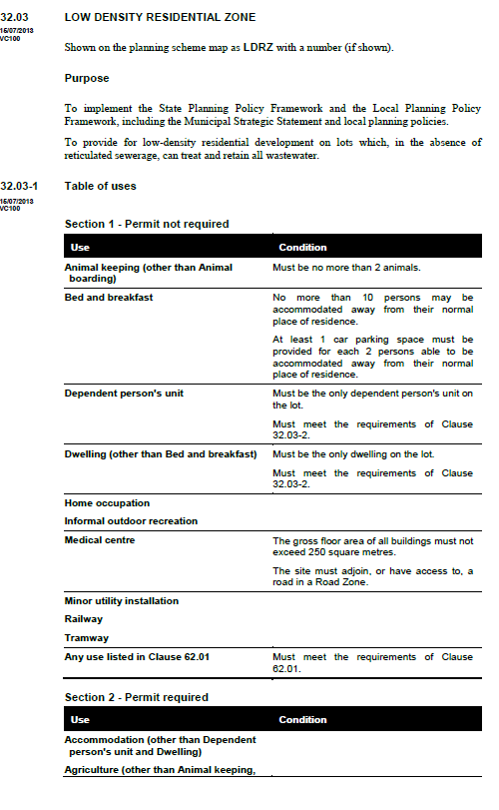

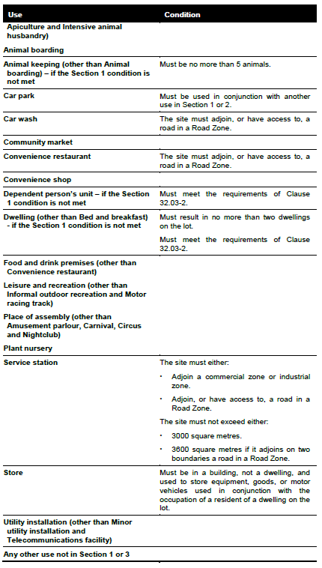

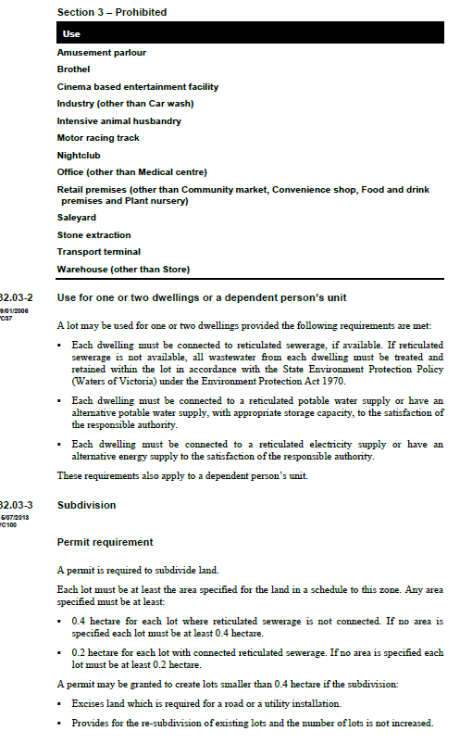

Appendix 3: Indicative zone layer descriptions
Zone | Summary description
Residential | This zone applies to areas that contain a broad variety of residential densities and housing types, and where full infrastructural services are available or can be provided. It is generally characterised by a single detached dwelling per site (ie, one or two storeys), surrounded by private open space.
Greenfield residential | This zone generally applies to areas of land that are intended to transition to residential (eg, undeveloped land within an identified urban growth area). It is primarily focused on enabling residential development, with some provision also made for complementary commercial or community activities to meet the needs of future residents (eg, small-scale supermarket, health-care facilities). Often the urban form and layout of the greenfield area are guided by a location-specific structure plan.
Medium density residential | This zone applies to areas where a range of medium density housing is encouraged to provide greater housing choice. It is generally located close to the city or town centre areas and is characterised by a higher density than that which normally applies to a standard residential zone (eg, average density of 350 square metres per unit or less) and a mix of housing type including semi-detached and terraced housing and low-rise apartments.
High density residential | This zone generally applies to areas that are either within or in close proximity to city or town centres, or along major transport routes, and provides residents with ready access to a wide range of activities (eg, retail, commercial, leisure, cultural services and facilities). It is typically characterised by high-rise apartment development but may also include alternative housing forms that deliver higher dwelling yields (eg, multi-storey terrace housing).
Commercial | This zone applies to areas where a broad range of retail, commercial and employment activities are accommodated (eg, retail or large format retail, offices, supermarkets, banks). It is typically characterised by low- to medium-rise development. It may also have a pedestrian orientation and provide for residential, recreational, leisure, community and accommodation activities and facilities that complement its core commercial and retail functions (eg, health and social services, museums, art galleries, libraries, movie theatres, restaurants, hotels).
City centre | This zone applies to areas that are the principal civic, employment and commercial centre of major cities and associated regions and sub-regions, and the primary destination for comparison shopping, entertainment, events, cultural and tourism activities. It is typically characterised by high-rise, higher density development and a strong pedestrian orientation, and generally also provides for a range of residential, recreational, leisure and community activities and facilities to complement its core commercial and retail functions (eg, health and social services, museums, art galleries, libraries, movie theatres, restaurants).
Town centre | This zone applies to areas that are the civic, employment and commercial centre of rural and provincial centres, along with some suburban centres in major cities. It is the primary destination for comparison shopping, entertainment, events, cultural and tourism activities and is typically characterised by medium- to high-rise development and a strong pedestrian orientation. It generally also provides for residential, recreational, leisure and community activities and facilities that complement its core commercial and retail functions (eg, health and social services, museums, art galleries, libraries, movie theatres, restaurants).
Mixed use | This zone applies to areas where a compatible mix of residential and small-scale retail, commercial and/or light industrial activities are encouraged. It typically acts as a transition zone between residential areas and the city or town centre and is generally located on the periphery of these areas.
Local commercial | This zone applies to medium sized, low- to medium-rise local centres that typically service the surrounding residential catchment. It is generally characterised by activities that provide for the daily and weekly convenience needs of the local catchment (eg, local retail shops, banks, hairdressers, restaurants and cafes, supermarkets) and is often located on a major or minor arterial road.
Neighbourhood commercial | This zone applies to small-scale, low-rise convenience shops or small shopping strips that directly support the immediate residential neighbourhood. It typically provides for the day-to-day shopping and service needs of local residents and is generally accessible by walking and cycling from the surrounding neighbourhood it serves.
Industrial | This zone applies to areas where a wide range of industrial-related activities are accommodated (eg, manufacturing, production, logistics, storage, transport and distribution). It is generally characterised by activities and buildings with a functional level of amenity (eg, manufacturing, processing). It is also typically located away from residential areas and other sensitive activities (eg, schools) due to the possibility of objectionable environmental impacts, such as light spill, odour, dust or noise emissions.
Light industrial | This zone applies to areas where the nature of the industrial activities is unlikely to produce objectionable environmental impacts, such as light spill, odour, dust or noise emissions (eg, light manufacturing and production, logistics, storage, transport and distribution). It may be located closer to residential areas as a result and is generally characterised by medium-to-large lot sizes (particularly for activities involving storage and distribution) and medium- to large-scale functional buildings.
Heavy industrial | This zone applies to areas where the nature of the industrial activities is likely to produce objectionable environmental impacts, such as light spill, odour, dust or noise emissions (eg, processing of raw materials). It is generally characterised by larger lot sizes, large-scale functional buildings and activities with low levels of amenity. It is also typically located away from residential areas and other sensitive activities (eg, schools).

Zone | Summary description
Rural | This zone applies to areas where farming and associated agricultural activities predominate. It also typically provides for other non-farming activities to establish, provided they are compatible with the agricultural, environmental and landscape qualities of the area.
Rural residential | This zone applies to areas where provision is made for residential housing in a rural setting, often adjacent to a town or city. It is typically characterised by larger lot sizes (eg, 1 to 2 hectares), with size being influenced by factors such as servicing availability, topography, vegetation and surrounding agricultural activities.
Rural settlement | This zone applies to small settlements or villages within a predominantly rural area. It is intended to act as a flexible zone that enables a mix of residential, retail, business, industrial and other compatible activities to be provided to service local rural communities.
Rural coastal | This zone applies to rural areas that adjoin the coastline, including coastal harbours and estuaries. It is principally focused on maintaining the high amenity values and recreational opportunities associated with coastal areas but may also play an important role in relation to hazard avoidance (eg, coastal hazard buffer).
Rural conservation | This zone applies to rural areas with important ecological or landscape qualities (eg, indigenous vegetation, wildlife habitat, high landscape values). These are often large-scale areas and may be in Crown ownership (eg, high country under pastoral leases or national parks).
Open space | This zone applies to publicly owned open space (eg, small neighbourhood reserves, sportsgrounds, regional parks). It covers a wide range of informal and active recreational activities (eg, walking, cycling, picnics, indoor and outdoor organised sports) along with associated facilities (eg, picnic facilities, playgrounds, shelters, toilets and changing facilities, sport and community clubrooms).
Informal recreation | This zone applies to publicly owned open space (eg, small neighbourhood reserves, walking and cycling tracks) that is used for a range of informal outdoor recreational activities and community uses (eg, walking, running, cycling, relaxing and socialising, picnics). It is generally characterised by few buildings and structures, with these limited to those that support associated informal recreational activities (eg, barbeques and picnic facilities, playgrounds, skate parks, informal hard courts, shelters, toilets).
Sport and active recreation | This zone applies to publicly owned open space used for indoor and outdoor organised sports, active recreation and community activities, including associated facilities (eg, sports fields, hard-court areas, greens). It typically also includes provision of buildings associated with these activities (eg, grandstands, swimming pools, sport and community clubrooms, toilets and changing facilities).
Natural conservation | This zone applies to publicly owned open space areas with high natural, ecological, landscape, and/or cultural and historic heritage values (eg, bush reserves, historic reserves, wetlands). Given the distinct and often sensitive nature of these areas, it is generally characterised by minimal buildings and structures and largely undeveloped, open expanses of land.
Airport | This zone applies to airports, airfields and associated operational areas. It typically provides for the ongoing operation and development of these facilities by enabling aircraft operations, including associated maintenance and repair, while ensuring that any impacts on surrounding properties are appropriately managed. It generally also makes limited provision for commercial and industrial activities associated with aviation (eg, retail, engineering workshops, administrative offices, hotels).
Port | This zone applies to major ports and associated operational areas. It typically provides for the ongoing operation and development of these facilities by enabling port-related operations (eg, mooring, berthing and maintenance and repair of vessels, cargo storage) and development, while ensuring that any impacts on surrounding properties are appropriately managed. It generally also makes limited provision for ancillary commercial and industrial activities associated with operation of the facility (eg, engineering workshops, administrative offices, staff facilities).
Hospital | This zone applies to hospitals and supporting health-care facilities. It typically provides for the ongoing operation of these facilities by enabling a range of health-care related and supporting activities (eg, medical assessment, diagnosis, treatment, rehabilitation and in-patient and out-patient care services, dispensaries) and development, while ensuring that any impacts on surrounding properties are appropriately managed. It generally also makes provision for associated non-medical, support activities (eg, administrative offices, laundries, kitchens, cafeterias, gift shops, storage facilities, workshops, staff rooms, car parking).
Tertiary education | This zone applies to tertiary education activities and supporting educational facilities (eg, universities, polytechnics). It typically provides for the ongoing operation of these facilities by enabling a range of education and research-related activities (eg, teaching, training, learning and research) and development, while ensuring that any impacts on surrounding properties are appropriately managed. It generally also makes provision for associated non-educational support activities (eg, administrative offices, accommodation, health services, kitchens, cafeterias, staff rooms, car parking).
Stadium | This zone applies to major sports and recreation facilities (eg, sports stadia, indoor sports arenas). It typically provides for the ongoing operation of these facilities by enabling a range of relevant related activities (eg, sport and recreation activities and events, entertainment activities, trade fairs, conferences) and development, while ensuring that any impacts on surrounding properties are appropriately managed. It generally also makes provision for any ancillary activities necessary for the functioning of the facility (eg, administrative offices, ticket sales, catering facilities, car parking).

4Sight Consulting. 2015. Urban Zone Research. Prepared for the Ministry for the Environment by 4Sight Consulting. Wellington: Ministry for the Environment.
Planz Consultants. 2015. Spatial Planning Terminology Research Study. Prepared for the Ministry for the Environment by Planz Consultants. Wellington: Ministry for the Environment.
The research found urban design to be an overlay; however, as shown in the section ‘Our take on the research’, we do not think this is its natural home.
Planz Consultants. 2015. Spatial Planning Terminology Research Study. Prepared for the Ministry for the Environment by Planz Consultants. Wellington: Ministry for the Environment.
4Sight Consulting. 2015. Urban Zone Research. Prepared for the Ministry for the Environment by 4Sight Consulting. Wellington: Ministry for the Environment.
Note: the concept of restricting this zoning to land that is solely in public ownership could benefit from further exploration through future engagement on the proposed option frameworks.
Ibid.
Ibid.
Note: the concept of restricting this zoning to land that is solely in public ownership could benefit from further exploration through future engagement on the proposed option frameworks.

