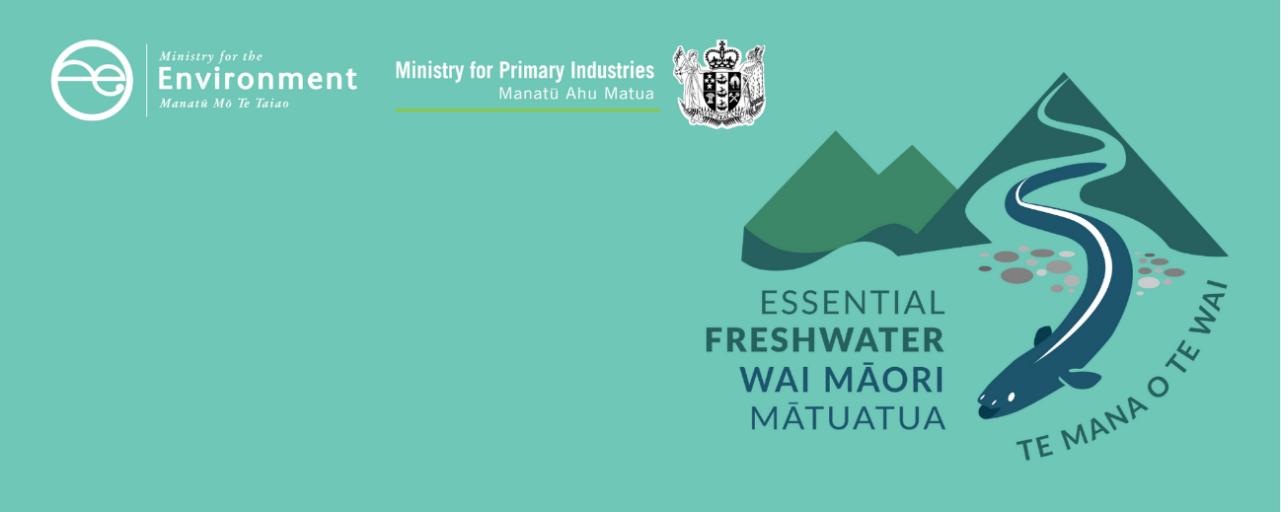

# Managing sediment factsheet

Essential Freshwater is part of a new national direction to protect and improve our rivers, streams, lakes and wetlands. The Essential Freshwater package aims to:

* stop further degradation of our freshwater
* start making immediate improvements so water quality improves within five years
* reverse past damage to bring our waterways and ecosystems to a healthy state within a generation.

Te Mana o te Wai is fundamental to all freshwater management

Te Mana o te Wai recognises the vital importance of water. It expresses the special connection that New Zealanders have with freshwater. By protecting the health of freshwater, we protect the health and well-being of people and our ecosystems. When managing freshwater, Te Mana o te Wai ensures the health and well-being of the water is protected before providing for human needs or enabling other uses of water. Through discussions with regional councils, tangata whenua and communities will have a say on how Te Mana o te Wai is applied in freshwater management locally. More information can be found in the [**Te Mana o te Wai factsheet**](http://www.mfe.govt.nz/publications/fresh-water/essential-freshwater-te-mana-o-te-wai-factsheet)**.**

## Who should read this factsheet

This factsheet is part of a [series](https://www.mfe.govt.nz/fresh-water/freshwater-guidance/factsheets-policies-and-regulations-essential-freshwater) and provides information on the new policies for managing sediment (including deposited and suspended sediment) in the National Policy Statement for Freshwater Management 2020 (NPS-FM 2020). It is primarily intended for council staff, but may also be of interest to land users, iwi, the wider agricultural industry, farm advisors and consultants, and anyone else with an interest in freshwater policy.

## What are the policies?

New provisions are in place for monitoring and managing sediment in the NPS-FM 2020:

* a limit-setting attribute for **suspended sediment** in rivers
* an action plan attribute for **deposited sediment** in wadeable rivers.

Councils must set target attribute states for suspended and deposited sediment in consultation with tangata whenua and communities.

The suspended and deposited sediment attributes are part of 22 compulsory attributes in the NPS-FM 2020, many of which have a minimum standard or national bottom line – these contribute to understanding how freshwater provides for ecosystem health and human contact. More information about can be found in the [Values and attributes factsheet](https://www.mfe.govt.nz/publications/fresh-water/essential-freshwater-values-and-attributes-factsheet).

Different forms of sediment in the NPS-FM

* **Suspended sediment** is sediment in the water and can make the water murky or cloudy.
* **Deposited sediment** is mud, silt or sand on the bed of the river or stream.

### Different bottom lines for different areas

Because natural levels of in-stream suspended and deposited fine sediment vary significantly around the country, four different sediment thresholds are in place for each attribute. This means different bottom-lines and bands apply in different places.

New Zealand’s terrain and natural sediment levels vary from place to place. The bottom lines are based on a spatial classification system called the River Environment Classification (REC). The REC system sorts river segments into groups based on their climate, topography and geology.

By using a spatial classification system, streams with naturally high suspended and deposited sediment levels can have different bottom lines from those with naturally lower levels.

### Places with naturally high sediment levels

Areas with specific characteristics, such as glacial headwaters, can be exempted from some requirements. For example, streams coming from glaciers are naturally unclear. Where these processes affect water bodies, councils are not required to set target states above bottom lines because that would be impossible to achieve. However, they are required to maintain or improve freshwater and ensure the provision of ecosystem health.

The deposited sediment attribute does not apply in naturally soft-bottomed streams. In those areas, the NPS-FM 2020 requires freshwater habitat monitoring, and it details a process for councils to determine, on a priority basis, whether streams that are currently soft bottomed are in that state due to human actions.

## How will regional councils need to manage sediment?

The council and community must set target attribute states at or above the bottom line (where applicable) and plan what actions they will take to meet these targets. They are required to improve or at the very least maintain the current state of waterways. Regions can choose to add additional attributes or higher targets.

The regional council must then work out what needs to be managed to achieve the target attribute states (eg, contaminants, habitat or land use), set limits on these and develop rules about resource use, to achieve the objectives it has set.

Councils must also monitor and report on the extent to which the target attribute states are being achieved.

Note that other actions may also be required to achieve ecosystem health. For example, no attribute is in place relating to the volume of water flowing through a waterway, but managing this will contribute to desired outcomes.

Councils will work towards target attribute states in different ways, as shown in figure 1.

Figure 1: Different ways of setting and working towards target attribute states for sediment

Note: NBL = national bottom line.

## When do the policies apply?

Councils need to notify their plans by 31 December 2024, with final decisions made by 2026 (or 2027 if they are granted an extension).

## Why these policies?

When soil erodes, it can be carried into waterways as sediment. Suspended and deposited fine sediment are among the most significant stressors on freshwater and coastal environments. Sediment is a major driver of biodiversity loss. It is a stressor in its own right, and it exacerbates other stressors.

## More about the Essential Freshwater package

An overview of the Essential Freshwater package, including when different aspects commence or must be implemented, can be found in this [summary and milestones](https://www.mfe.govt.nz/publications/fresh-water/essential-freshwater-milestones-what-happens-when).

The package includes several new national rules and regulations including:

* new [National Environmental Standards for Freshwater](http://www.legislation.govt.nz/regulation/public/2020/0174/latest/LMS364099.html)
* new [stock exclusion regulations](http://www.legislation.govt.nz/regulation/public/2020/0175/latest/LMS379869.html) under section 360 of the Resource Management Act 1991 (RMA)
* amendments to the [Resource Management (Measurement and Reporting of Water Takes) Regulations 2010](http://www.legislation.govt.nz/regulation/public/2020/0176/latest/LMS351161.html)
* the [National Policy Statement for Freshwater Management](https://www.mfe.govt.nz/publications/fresh-water/national-policy-statement-freshwater-management-2020) 2020, which replaces the NPS‑FM 2017
* [amendments to the RMA](https://www.mfe.govt.nz/rma/improving-our-resource-management-system), to provide for a faster freshwater planning process
* [amendments to the RMA](https://www.mfe.govt.nz/fresh-water/freshwater-acts-and-regulations/regulations-freshwater-farm-plans-and-reporting-of-sales), to enable mandatory and enforceable freshwater farm plans and the creation of regulations for reporting nitrogen fertiliser sales.

Factsheets in this series

The full set of Essential Freshwater factsheets is available [**on our website**](https://www.mfe.govt.nz/fresh-water/freshwater-guidance/factsheets-policies-and-regulations-essential-freshwater).

Find out more and give us feedback

Contact us by emailing [**freshwater@mfe.govt.nz**](mailto:freshwater@mfe.govt.nz), or visit [the **Essential Freshwater page**](https://www.mfe.govt.nz/fresh-water/freshwater-guidance/factsheets-policies-and-regulations-essential-freshwater) on our website.

### Disclaimer

The information in this publication is, according to the Ministry for the Environment’s best efforts, accurate at the time of publication. The information provided does not alter the laws of New Zealand and other official guidelines or requirements. Users should take specific advice from qualified professional people before undertaking any action as a result of information obtained from this publication.

The Ministry for the Environment does not accept any responsibility or liability whether in contract, tort, equity or otherwise for any action taken as a result of reading, or reliance placed on the Ministry for the Environment because of having read any part, or all, of the information in this publication or for any error, or inadequacy, deficiency, flaw in or omission from the information provided in this publication.

Published in December 2020 by the  
Ministry for the Environment with input from the Ministry for Primary Industries  
Publication number: INFO 1004

