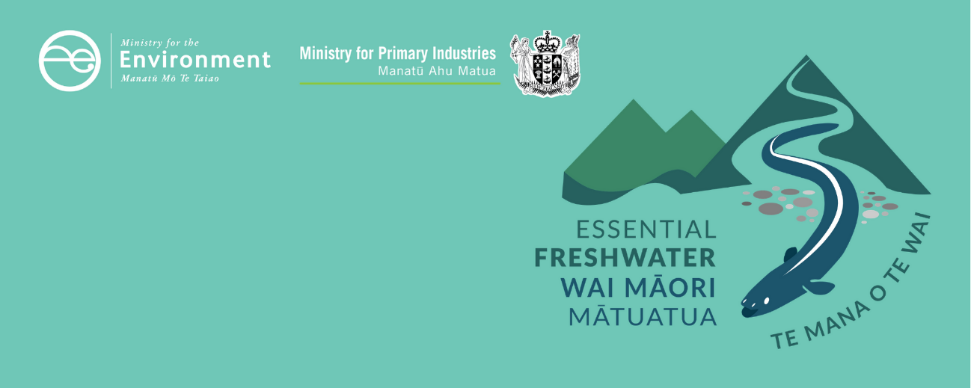

Dissolved reactive phosphorus factsheet
Essential Freshwater is part of a new national direction to protect and improve our rivers, streams, lakes and wetlands. The Essential Freshwater package aims to:
- stop further degradation of our freshwater
- start making immediate improvements so water quality improves within five years
- reverse past damage to bring our waterways and ecosystems to a healthy state within a generation.
Te Mana o te Wai is fundamental to all freshwater management
Te Mana o te Wai recognises the vital importance of water. It expresses the special connection that New Zealanders have with freshwater. By protecting the health of freshwater, we protect the health and well-being of people and our ecosystems. When managing freshwater, Te Mana o te Wai ensures the health and well-being of the water is protected before providing for human needs or enabling other uses of water. Through discussions with regional councils, tangata whenua and communities will have a say on how Te Mana o te Wai is applied in freshwater management locally. More information can be found in the Te Mana o te Wai factsheet.

Who should read this factsheet
This factsheet is part of a series and provides information on the new policies for managing dissolved reactive phosphorus (DRP) in the National Policy Statement for Freshwater Management 2020 (NPS-FM 2020). It is primarily intended for council staff, but may also be of interest to land users, iwi, the wider agricultural industry, farm advisors and consultants, and anyone else with an interest in freshwater policy.

What are the policies?
New provisions are in place in the NPS-FM 2020 for monitoring and managing DRP in rivers:
- an action plan attribute for DRP without a bottom line
- a new requirement to manage DRP in rivers, to provide for other ecosystem health attributes (such as dissolved oxygen and macroinvertebrates).
Regional councils must:
- monitor DRP in rivers at representative sites in every freshwater management unit
- at least maintain DRP at its current state, and improve if the community chooses to do so
- set desired outcomes – or ‘target attribute states’ – for DRP and work towards these over time
- respond to any deterioration.
Regional councils must also set target attribute states for DRP in rivers that are sufficient to provide for ecosystem health national bottom lines in the NPS-FM 2020, such as periphyton and macroinvertebrates. This is because phosphorus influences growth of plants, periphyton and bacteria, which can have follow-on effects for dissolved oxygen, macroinvertebrates and other attributes.
DRP target attribute states must also be set to provide for nutrient-sensitive downstream receiving ecosystems such as lakes and estuaries. A compulsory attribute is already in place for total phosphorus in lakes; estuaries do not have set phosphorus attributes.
The DRP attribute is part of 22 compulsory attributes in the NPS-FM 2020, many of which (unlike DRP) have a minimum standard or national bottom line – these contribute to understanding how freshwater provides for ecosystem health and human contact. More information about can be found in the Values and attributes factsheet.

When do the policies apply?
Councils need to notify their plans by 31 December 2024, with final decisions made by 2026 (or 2027 if they are granted an extension).

Why these policies?
Phosphorus is a nutrient that is necessary for all plant growth. However, excessive phosphorus can:
- contribute to problematic growth of periphyton (slime) or macrophytes (rooted plants), or phytoplankton (microscopic algae), affecting ecosystem health and people’s use and enjoyment of the water body
- change the ways that microbes and invertebrates break down and recycle organic matter (such as leaf litter) in rivers, which changes the way the ecosystem functions.
Excessive phosphorus can affect all freshwater ecosystems such as rivers, wetlands, lakes and estuaries.
DRP was not an attribute in the NPS-FM 2017, but councils were required to:
- measure and monitor DRP
- manage concentrations in rivers to provide for periphyton (slime)
- manage for objectives in downstream ecosystems such as lakes and estuaries.
Because periphyton usually grows in hard-bottomed (stony or gravelly) rivers, no clear requirements were in place for soft-bottomed (silty and muddy) rivers that do not grow periphyton. The new attribute gives stronger direction to maintain or improve DRP everywhere.

More about the Essential Freshwater package
An overview of the Essential Freshwater package, including when different aspects commence or must be implemented, can be found in this summary and milestones.
The package includes several new national rules and regulations including:
- new National Environmental Standards for Freshwater
- new stock exclusion regulations under section 360 of the Resource Management Act 1991 (RMA)
- amendments to the Resource Management (Measurement and Reporting of Water Takes) Regulations 2010
- the National Policy Statement for Freshwater Management 2020, which replaces the NPS-FM 2017
- amendments to the RMA, to provide for a faster freshwater planning process
- amendments to the RMA, to enable mandatory and enforceable freshwater farm plans and the creation of regulations for reporting nitrogen fertiliser sales.
Factsheets in this series
The full set of Essential Freshwater factsheets is available on our website.
Find out more and give us feedback
Contact us by emailing freshwater@mfe.govt.nz, or visit the Essential Freshwater page on our website.

Disclaimer
The information in this publication is, according to the Ministry for the Environment’s best efforts, accurate at the time of publication. The information provided does not alter the laws of New Zealand and other official guidelines or requirements. Users should take specific advice from qualified professional people before undertaking any action as a result of information obtained from this publication.
The Ministry for the Environment does not accept any responsibility or liability whether in contract, tort, equity or otherwise for any action taken as a result of reading, or reliance placed on the Ministry for the Environment because of having read any part, or all, of the information in this publication or for any error, or inadequacy, deficiency, flaw in or omission from the information provided in this publication.
Published in December 2020 by the
Ministry for the Environment with input from the Ministry for Primary Industries
Publication number: INFO 1003





Phosphorus is typically measured as total phosphorus and dissolved reactive phosphorus. Most phosphorus in waterways is bound to sediment and not available for plant growth. The dissolved fraction is readily taken up by plants.

