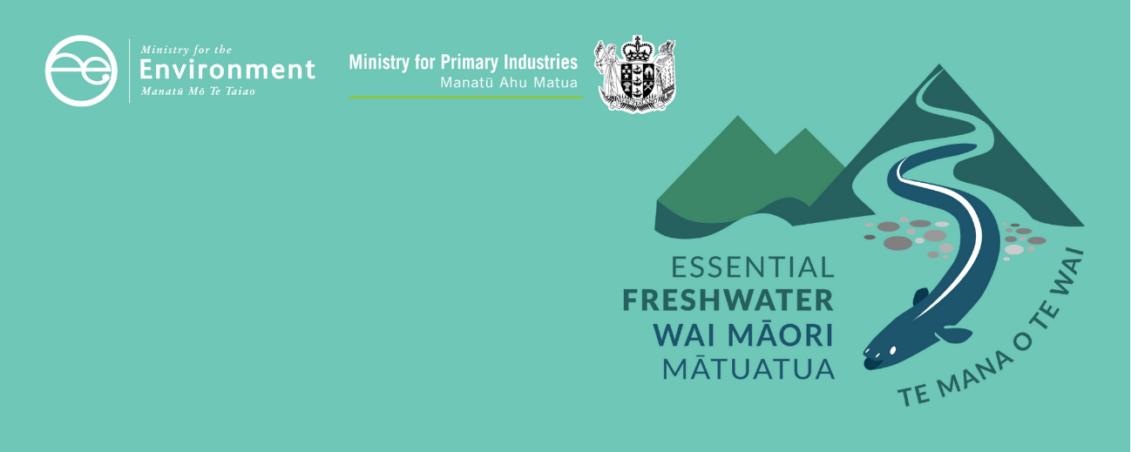

# Managing nitrogen factsheet

Essential Freshwater is part of a new national direction to protect and improve our rivers, streams, lakes and wetlands. The Essential Freshwater package aims to:

* stop further degradation of our freshwater
* start making immediate improvements so water quality improves within five years
* reverse past damage to bring our waterways and ecosystems to a healthy state within a generation.

Te Mana o te Wai is fundamental to all freshwater management

Te Mana o te Wai recognises the vital importance of water. It expresses the special connection that New Zealanders have with freshwater. By protecting the health of freshwater, we protect the health and well-being of people and our ecosystems. When managing freshwater, Te Mana o  te Wai ensures the health and well-being of the water is protected before providing for human needs or enabling other uses of water. Through discussions with regional councils, tangata whenua and communities will have a say on how Te Mana o te Wai is applied in freshwater management locally. More information can be found in the [**Te Mana o te Wai factsheet**](http://www.mfe.govt.nz/publications/fresh-water/essential-freshwater-te-mana-o-te-wai-factsheet).

## Who should read this factsheet

This factsheet is part of a [series](https://www.mfe.govt.nz/fresh-water/freshwater-guidance/factsheets-policies-and-regulations-essential-freshwater) and provides information on the new policies for managing nitrogen in the National Policy Statement for Freshwater Management 2020 (NPS-FM 2020). It is primarily intended for council staff, but may also be of interest to land users, iwi, the wider agricultural industry, farm advisors and consultants, and anyone else with an interest in freshwater policy.

The factsheet covers total nitrogen, ammonia, nitrate and dissolved inorganic nitrogen (DIN). A separate factsheet is available on managing synthetic nitrogen fertiliser use.

## What are the policies?

New provisions are in place in the NPS-FM 2020 for monitoring and managing nitrogen:

* **new bottom lines for nitrate and ammonia toxicity**: stricter limits to provide protection from nitrogen toxicity for 95 per cent of freshwater species, up from 80 per cent under the NPS-FM 2017
* **a new requirement** to manage DIN to provide for other ecosystem health attributes (such as dissolved oxygen and macroinvertebrates).

**Further work** will be undertaken to review whether DIN should be included as an attribute over the next year.

The nitrate and ammonia toxicity attributes are part of 22 compulsory attributes in the NPS‑FM 2020, many of which have a minimum standard or national bottom line, and that contribute to understanding how freshwater provides for ecosystem health and human contact. More information about can be found in the [Values and attributes factsheet](https://www.mfe.govt.nz/publications/fresh-water/essential-freshwater-values-and-attributes-factsheet).

Regional councils must:

* monitor different forms of nitrogen at representative sites in every freshwater management unit
* at least maintain nitrogen levels at their current state, and improve if the community chooses to do so (or if the current state is below the national bottom line, unless within a specified vegetable growing area)
* set desired outcomes – or ‘target attribute states’ – for nitrate and ammonia and work towards these over time (with interim states set for no longer than 10 years)
* respond to any deterioration
* set targets for DIN in rivers that are sufficient to provide for ecosystem health bottom lines in the NPS-FM 2020, such as periphyton and macroinvertebrates (note there is no DIN attribute table but this is a requirement of policy 3.13)
* set targets for DIN to provide for nutrient-sensitive downstream receiving ecosystems such as lakes and estuaries. A compulsory attribute is already in place for total nitrogen in lakes; estuaries do not have pre-defined nitrogen attributes.

## When do the policies apply?

Councils need to notify their plans by 31 December 2024, with final decisions made by 2026 (or 2027 if they are granted an extension).

|  |
| --- |
| Different forms of nitrogen in the NPS-FM 2020  Dissolved inorganic nitrogen (DIN) includes three different forms of nitrogen: nitrate, nitrite and ammonia. In most waterways, DIN is mostly made up of nitrate.  Nutrients such as DIN can fuel growth of nuisance plants, periphyton (slime) and bacteria that have negative follow-on effects for other parts of the ecosystem. This happens at lower concentrations than toxic effects.  The NPS-FM 2017 controlled nitrogen through nitrate and ammonia toxicity, total nitrogen in lakes, and the periphyton attribute in rivers. Periphyton usually only grows in hard-bottomed (stony and gravelly) rivers. That meant all hard-bottomed rivers already had strict nitrogen constraints, but soft-bottomed (silty and sandy) rivers only had strict constraints if they had a lake downstream.  The toxicity attributes do not protect against other ecosystem health effects. In soft-bottomed streams where periphyton does not grow, effects of nitrogen will need to be managed through new and updated ecosystem health measures (ie Macroinvertebrate Community Index) and the requirement on councils under policy 3.13 of the NPS-FM 2020 to set DIN targets to manage for ecosystem health.  In addition, the national bottom lines for nitrate and ammonia toxicity were previously set at protecting 80 per cent of species from toxicity effects, this has now been strengthened to 95 per cent. |

## Why these policies?

Nitrogen is a nutrient that is necessary for all plant growth. However, excessive nitrogen can:

* contribute to problematic growth of periphyton (slime) or macrophytes (rooted plants), or phytoplankton (microscopic algae), affecting ecosystem health and people’s use and enjoyment of the water body
* change the ways that microbes and invertebrates break down and recycle organic matter (such as leaf litter) in rivers, which changes the way the ecosystem functions
* have direct toxic effects on aquatic animals, such as limiting their growth or causing mortality. Toxic effects usually happen at higher concentrations than effects on growth of periphyton and plants.

Excessive nitrogen can impact all freshwater ecosystems such as rivers, wetlands, lakes and estuaries.

## More about the Essential Freshwater package

An overview of the Essential Freshwater package, including when different aspects commence or must be implemented, can be found in this [summary and milestones](https://www.mfe.govt.nz/publications/fresh-water/essential-freshwater-milestones-what-happens-when).

The package includes several new national rules and regulations including:

* new [National Environmental Standards for Freshwater](http://www.legislation.govt.nz/regulation/public/2020/0174/latest/LMS364099.html)
* new [stock exclusion regulations](http://www.legislation.govt.nz/regulation/public/2020/0175/latest/LMS379869.html) under section 360 of the Resource Management Act 1991 (RMA)
* amendments to the [Resource Management (Measurement and Reporting of Water Takes) Regulations 2010](http://www.legislation.govt.nz/regulation/public/2020/0176/latest/LMS351161.html)
* the [National Policy Statement for Freshwater Management](https://www.mfe.govt.nz/publications/fresh-water/national-policy-statement-freshwater-management-2020) 2020, which replaces the NPS‑FM 2017
* [amendments to the RMA](https://www.mfe.govt.nz/rma/improving-our-resource-management-system), to provide for a faster freshwater planning process
* [amendments to the RMA](https://www.mfe.govt.nz/fresh-water/freshwater-acts-and-regulations/regulations-freshwater-farm-plans-and-reporting-of-sales), to enable mandatory and enforceable freshwater farm plans and the creation of regulations for reporting nitrogen fertiliser sales.

Factsheets in this series

The full set of Essential Freshwater factsheets is available [**on our website**](https://www.mfe.govt.nz/fresh-water/freshwater-guidance/factsheets-policies-and-regulations-essential-freshwater).

Find out more and give us feedback

Contact us by emailing freshwater@mfe.govt.nz, or visit [the **Essential Freshwater page**](https://www.mfe.govt.nz/fresh-water/freshwater-guidance/factsheets-policies-and-regulations-essential-freshwater) on our website.

### Disclaimer

The information in this publication is, according to the Ministry for the Environment’s best efforts, accurate at the time of publication. The information provided does not alter the laws of New Zealand and other official guidelines or requirements. Users should take specific advice from qualified professional people before undertaking any action as a result of information obtained from this publication.

The Ministry for the Environment does not accept any responsibility or liability whether in contract, tort, equity or otherwise for any action taken as a result of reading, or reliance placed on the Ministry for the Environment because of having read any part, or all, of the information in this publication or for any error, or inadequacy, deficiency, flaw in or omission from the information provided in this publication.

Published in December 2020 by the  
Ministry for the Environment with input from the Ministry for Primary Industries  
Publication number: INFO 1002

