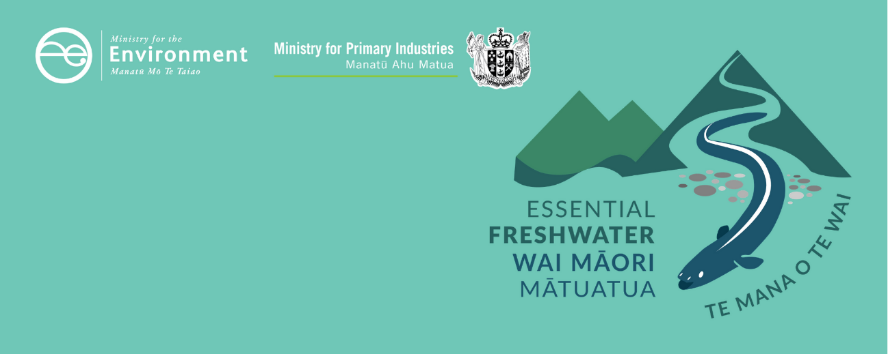

Limit setting and action plans factsheet
Essential Freshwater is part of a new national direction to protect and improve our rivers, streams, lakes and wetlands. The Essential Freshwater package aims to:
- stop further degradation of our freshwater

- start making immediate improvements so water quality improves within five years
- reverse past damage to bring our waterways and ecosystems to a healthy state within a generation.
Te Mana o te Wai is fundamental to all freshwater management
Te Mana o te Wai recognises the vital importance of water. It expresses the special connection that New Zealanders have with freshwater. By protecting the health of freshwater, we protect the health and well-being of people and our ecosystems. When managing freshwater, Te Mana o te Wai ensures the health and well-being of the water is protected before providing for human needs or enabling other uses of water. Through discussions with regional councils, tangata whenua and communities will have a say on how Te Mana o te Wai is applied in freshwater management locally. More information can be found in the Te Mana o te Wai factsheet.

Who should read this factsheet
This factsheet is part of a series and provides information about policies for limit setting and action plans in the National Policy Statement for Freshwater Management 2020 (NPS-FM 2020). It is intended for council staff, land users, iwi, the wider agricultural industry, farm advisors and consultants, and anyone else with an interest in freshwater policy.

What are the policies?
To achieve target attribute states and environmental outcomes for the NPS-FM 2020 compulsory attributes (eg, appendix 2A and appendix 2B), and any other target attribute states the regional council sets with its community to meet environmental outcomes, regional councils:
- must identify limits on resource use and include these as rules in their regional plans (appendix 2A attributes)
- must prepare an action plan for achieving the target attribute state within a specified timeframe (appendix 2B attributes)
- may impose conditions on resource consents.
Table 1 shows the minimum intervention needed for attributes in appendix 2A and appendix 2B of the NPS-FM 2020. Please note these are the compulsory attributes requiring interventions. Regional councils, in consultation with communities and tangata whenua, can identify other relevant attributes (or alternative criteria) and set limits on resource use or create action plans accordingly.
For attributes requiring limits on resource use, regional councils may choose to set out additional methods in an action plan. Similarly, for attributes requiring action plans, councils may also choose to set limits to achieve the target attribute states.
Table 1: Minimum intervention for NPS-FM 2020 attributes
Attributes requiring limits (appendix 2A) | Attributes requiring action plans (appendix 2B)
Phytoplankton in lakes | Macroinvertebrates (MCI, QMCI) in rivers
Periphyton in rivers | Macroinvertebrates (ASPM) in rivers
Total nitrogen in lakes | Submerged plants in lakes
Total phosphorus in lakes | Deposited fine sediment in rivers
Ammonia in lakes and rivers | Dissolved oxygen in rivers
Nitrate in rivers | Lake-bottom dissolved oxygen
Dissolved oxygen in rivers (below point sources) | Mid-hypolimnetic dissolved oxygen in lakes
Suspended fine sediment in rivers | Fish in rivers
Escherichia coli in rivers and lakes (year round) | Dissolved reactive phosphorus in rivers
Cyanobacteria in lakes | Ecosystem metabolism in rivers
 | E. coli (primary contact sites during the bathing season)
Note: ASPM = Average Score Per Metric; MCI = Macroinvertebrate Community Index; QMCI = Quantitative Macroinvertebrate Community Index.

Setting limits on resource use
Limits on resource use must be expressed as regional rules in a regional plan.
Limits on resource use may:
- apply to any activity or land use
- apply at any scale (eg, to all or any part of a freshwater management unit (FMU))
- be expressed as a land use control (eg, a restriction on whether, how or where a specified activity can be done) an input control (eg, the amount of fertiliser that may be applied) or an output control (eg, a volume or rate of discharge)
- describe the circumstances in which the limit applies.
Limits on resource use must also ensure instream dissolved inorganic nitrogen (DIN) and dissolved reactive phosphorus (DRP) concentrations or exceedance criteria are met.
When setting limits on resource use, regional councils must have regard to the long-term vision for the water body and the foreseeable impacts of climate change. Regional councils must also use the best information available and take into account results or information from freshwater accounting systems.

Preparing action plans
Action plans do not have regulatory effect of themselves. Instead they describe all a regional council’s commitments and planned actions in relation to relevant attributes in relevant FMUs.
Action plans may:
- be prepared for whole FMUs, parts of FMUs or multiple FMUs
- set out a phased approach to achieving environmental outcomes
- be ‘prepared’ by adding to, amending or replacing an existing action plan
- describe regulatory and/or non-regulatory measures.
If the action plan’s purpose is to achieve a target attribute state, it must identify the environmental outcome the target attribute state is aimed at achieving and set out how the council plans to achieve the target state.
Action plans must also:
- involve a reasonable level of consultation
- be published as soon as practicable (whether in a regional plan or separately)
- be reviewed within five years of being published.

Responding to degradation
If a regional council detects that an FMU, or part of an FMU, is degraded or degrading it must take action to halt or reverse the degradation. These actions may include preparing an action plan, enforcement action, or making or changing a regional plan.
Actions taken must be proportionate to the trend and risk of adverse effects, and every action plan prepared to respond to a deteriorating trend must identify the causes of deterioration, methods to address them and an evaluation of the effectiveness of methods.

When do the policies apply?
Councils need to notify their plans by 31 December 2024, with final decisions made and plans operational no more than two years later (or three years if they are granted an extension).

Why these policies?

More certainty about limits
In previous national policy statements, limits have generated much uncertainty for councils and others.
The NPS-FM 2020 clarifies that a limit may:
- apply to any activity or land use
- apply at any scale
- be expressed as an input (eg, fertiliser application) or output control (discharge of nitrogen).
By setting out what is meant by a limit on resource use, the activities known to generate contaminants (or the results of those activities) will be constrained by limits in regional rules. Subsequently, clearer connections will be made between those activities, the target attribute states and the environmental outcomes for the water bodies.
While limits are commonly discussed in terms of water takes and discharge of contaminants, a broader view of a limit may be required to meet some attribute requirements. For example, a limit could be expressed as a maximum stocking rate or a prohibited activity with a zero allocation.

Action plans for attributes where limit setting is not as appropriate
While limit setting is necessary to meet many target attribute states, some attributes that measure important parts of the ecosystem health (eg, macroinvertebrates) are more difficult to link to resource use but still need to be managed to protect ecosystem health. The new requirements to prepare action plans for these attributes will ensure councils, in consultation with communities, set out how chosen actions will contribute to achieving target states and undertake a review within five years.

More about the Essential Freshwater package
The package includes several new national rules and regulations including:
- new National Environmental Standards for Freshwater
- new stock exclusion regulations under section 360 of the Resource Management Act 1991 (RMA)
- amendments to the Resource Management (Measurement and Reporting of Water Takes) Regulations 2010
- the National Policy Statement for Freshwater Management 2020, which replaces the NPS-FM 2017
- amendments to the RMA, to provide for a faster freshwater planning process
- amendments to the RMA, to enable mandatory and enforceable freshwater farm plans and the creation of regulations for reporting nitrogen fertiliser sales.
Factsheets in this series
The full set of Essential Freshwater factsheets is available on our website.
Find out more and give us feedback
Contact us by emailing freshwater@mfe.govt.nz, or visit the Essential Freshwater page on our website.

Disclaimer
The information in this publication is, according to the Ministry for the Environment’s best efforts, accurate at the time of publication. The information provided does not alter the laws of New Zealand and other official guidelines or requirements. Users should take specific advice from qualified professional people before undertaking any action as a result of information obtained from this publication.
The Ministry for the Environment does not accept any responsibility or liability whether in contract, tort, equity or otherwise for any action taken as a result of reading, or reliance placed on the Ministry for the Environment because of having read any part, or all, of the information in this publication or for any error, or inadequacy, deficiency, flaw in or omission from the information provided in this publication.
Published in December 2020 by the
Ministry for the Environment with input from the Ministry for Primary Industries
Publication number: INFO 998




Note that these are the compulsory attributes requiring interventions. Regional councils, in consultation with communities and tangata whenua, should identify other relevant attributes (or alternative criteria) and set limits on resource use or create action plans accordingly.
For more information, refer to the NPS-FM 2020.
Every regional council must set DIN and DRP concentrations and exceedance criteria to achieve target states for attributes affected by nutrients (eg, periphyton). See clause 3.13 of the NPS-FM 2020 for more information.
Freshwater accounting systems record, aggregate and update FMU-level information on contaminants (for freshwater quality accounting systems) and takes (for freshwater quantity accounting systems). See clause 3.29 of the NPS-FM 2020 for more information.
Regulatory measures can be those under the Resource Management Act 1991 or any other enactment.

