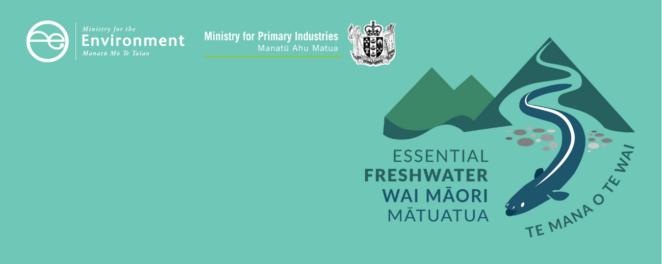

# Measuring and reporting of water takes factsheet

Essential Freshwater is part of a new national direction to protect and improve our rivers, streams, lakes and wetlands. The Essential Freshwater package aims to:

* stop further degradation of our fresh water
* start making immediate improvements so water quality improves within five years
* reverse past damage to bring our waterways and ecosystems to a healthy state within a generation.

Te Mana o te Wai is fundamental to all freshwater management

Te Mana o te Wai recognises the vital importance of water. It expresses the special connection that New Zealanders have with fresh water. By protecting the health of fresh water, we protect the health and well-being of people and our ecosystems. When managing fresh water, Te Mana o te Wai ensures the health and well-being of the water is protected before providing for human needs or enabling other uses of water. Through discussions with regional councils, tangata whenua and communities will have a say on how Te Mana o te Wai is applied in freshwater management locally. More information can be found in the [**Te Mana o te Wai factsheet**](http://www.mfe.govt.nz/publications/fresh-water/essential-freshwater-te-mana-o-te-wai-factsheet).

## Who should read this factsheet

This factsheet is part of a [series](https://www.mfe.govt.nz/fresh-water/freshwater-guidance/factsheets-policies-and-regulations-essential-freshwater) and provides information on the amended regulations for measuring and reporting water takes. It is primarily intended for council staff but may also be of interest to land users, iwi, the wider agricultural industry, farm advisors and consultants, and anyone else with an interest in freshwater policy.

## What are the regulations and to whom do they apply?

This factsheet is about the [Resource Management (Measurement and Reporting of Water Takes) Regulations 2010](http://www.legislation.govt.nz/regulation/public/2010/0267/latest/DLM3174201.html#DLM3174217) (the Regulations).

The Regulations have been amended to state that holders of resource consents that allow taking fresh water at a rate of 5 litres per second or more, must:

* measure their water use every 15 minutes
* store their records
* electronically submit their records to their regional council every day, or as instructed by their regional council.

The Regulations apply if you have a resource consent to take 5 litres per second or more of water, and you will need to install a device that is capable of measuring your water use every 15 minutes every day. This information must then be sent to the regional council that issued the consent.

### Regulations do not apply to households and others

The Regulations **do not** apply to people who do not require a resource consent for their water take (permitted takes), including:

* individual households or businesses that take water from a reticulated supply
* takes that are specifically permitted in section 14 of the Resource Management Act 1991 (RMA)
* any takes that are permitted by a rule in a regional plan
* holders of consents for water takes that only allow water to be taken at a rate of less than 5 litres per second.

The Regulations also **do not** apply to holders of consents for:

* takes of coastal or geothermal water
* non-consumptive takes (irrespective of the rate of that take). Non-consumptive takes are takes where the same amount of water is returned to the same water body at or near the location from which it was taken and no significant delay occurs between the taking and returning of the water.

## When do the regulations apply?

### Important information and timelines for consent holders

The Regulations use in a staged approach, applying to consent holders with larger water takes first. The Regulations specify compliance dates, depending on water take consents, as follows.

|  |  |
| --- | --- |
| Consented water take | Date to be compliant from |
| 20 litres per second or more | must comply with these requirements from 3 September 2022 |
| 10 litres per second or more but less than 20 litres per second | must comply from 3 September 2024 |
| 5 litres per second or more but less than 10 litres per second | must comply from 3 September 2026 |

An overview of the timeline for implementing the Regulations can be found in the [Summary and milestones factsheet](https://www.mfe.govt.nz/publications/fresh-water/essential-freshwater-milestones-what-happens-when).

### Requirements and timelines for councils

Regional council records systems should be reviewed so they can accommodate daily electronic records of water permit information from 3 September 2022.

An overview of other important timelines for implementing the Regulations can be found in the [Summary and milestones factsheet](https://www.mfe.govt.nz/publications/fresh-water/essential-freshwater-milestones-what-happens-when).

#### Regional councils can set conditions that are more or less stringent than the Regulations

* On future consents covered by the Regulations, councils may impose more stringent measurement and/or reporting requirements than the Regulations require.
* On water takes not covered by the Regulations (eg, non-consumptive takes, takes of geothermal or coastal water, or takes of fresh water of less than 5 litres per second), councils can specify any measuring or reporting requirements, including more or less stringent requirements than those in the Regulations.

## Why these regulations?

#### New Zealand lacks accurate water-take data

When published in 2010, the original Regulations established a nationally consistent regime for measuring water use, but they were relatively permissive in terms of reporting water use to the relevant regional council. In addition, the original Regulations allowed for a range of methods of reporting, and these records could be in either hard copy or electronic formats. In practice, reporting ranged from hand-written records being posted to the council, to excel spreadsheets being emailed, to real-time time data being sent electronically directly to regional councils. This made it difficult for the data to be nationally assessed.

The original Regulations provided for a staged implementation to manage demand for water meters and verification services.[1]

In 2016, the Regulations were amended to require water consent holders for every consumptive[2] consented water take 5 litres per second or more to install an appropriate independently verified measuring device and to annually provide a continuous record of water use data to their regional council.

Despite the amendment, in many cases, data accuracy was lacking for the actual amount taken for many resource use consents. The data supplied to regional councils has been of poor and irregular quality, which limits how useful it can be. These data quality issues have been identified by the [Auditor-General](https://oag.parliament.nz/2018/irrigation) and through state of the environment reporting ([Environment Aotearoa 2019](https://www.mfe.govt.nz/publications/environmental-reporting/environment-aotearoa-2019)).

The 2020 amendments introduce stricter regular measuring and reporting requirements to address these issues.

## More about the Essential Freshwater package

An overview of the Essential Freshwater package, including when different aspects start or must be implemented, can be found in the [summary and milestones](https://www.mfe.govt.nz/publications/fresh-water/essential-freshwater-milestones-what-happens-when).

The package includes several new national rules and regulations including:

* new [National Environmental Standards for Freshwater](http://www.legislation.govt.nz/regulation/public/2020/0174/latest/LMS364099.html)
* new [stock exclusion regulations](http://www.legislation.govt.nz/regulation/public/2020/0175/latest/LMS379869.html) under section 360 of RMA
* amendments to the [Resource Management (Measurement and Reporting of Water Takes) Regulations 2010](http://www.legislation.govt.nz/regulation/public/2020/0176/latest/LMS351161.html)
* the [National Policy Statement for Freshwater Management](https://www.mfe.govt.nz/publications/fresh-water/national-policy-statement-freshwater-management-2020) 2020 (NPS-FM 2020), which replaces the NPS‑FM 2017
* [amendments to the RMA](https://www.mfe.govt.nz/rma/improving-our-resource-management-system) to provide for a faster freshwater planning process
* [amendments to the RMA](https://www.mfe.govt.nz/fresh-water/freshwater-acts-and-regulations/regulations-freshwater-farm-plans-and-reporting-of-sales) to enable mandatory and enforceable freshwater farm plans, and the creation of regulations for reporting nitrogen fertiliser sales.

Factsheets in this series

The full set of Essential Freshwater factsheets is available [**on our website**](https://www.mfe.govt.nz/fresh-water/freshwater-guidance/factsheets-policies-and-regulations-essential-freshwater).

Find out more and give us feedback

Contact us by emailing [**freshwater@mfe.govt.nz**](mailto:freshwater@mfe.govt.nz), or visit [the **Essential Freshwater page**](https://www.mfe.govt.nz/fresh-water/freshwater-guidance/factsheets-policies-and-regulations-essential-freshwater) on our website.

### Disclaimer

The information in this publication is, according to the Ministry for the Environment’s best efforts, accurate at the time of publication. The information provided does not alter the laws of New Zealand and other official guidelines or requirements. Users should take specific advice from qualified professional people before undertaking any action as a result of information obtained from this publication.

The Ministry for the Environment does not accept any responsibility or liability whether in contract, tort, equity or otherwise for any action taken as a result of reading, or reliance placed on the Ministry for the Environment because of having read any part, or all, of the information in this publication or for any error, or inadequacy, deficiency, flaw in or omission from the information provided in this publication.

Published in December 2020 by the  
Ministry for the Environment with input from the Ministry for Primary Industries  
Publication number: INFO 996

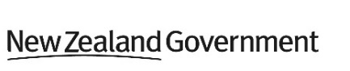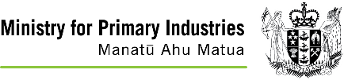

1. The original 2010 Regulations came into effect for water takes of 20 litres per second or more in November 2012, for takes of 10 litres per second or more but less than 20 litres per second in November 2014, and for takes of 5 litres per second or more but less than 10 litres per second in November 2016.
2. Non-consumptive uses include most hydro-electric electricity generation, because water is not extracted from the source and so remains available downstream.