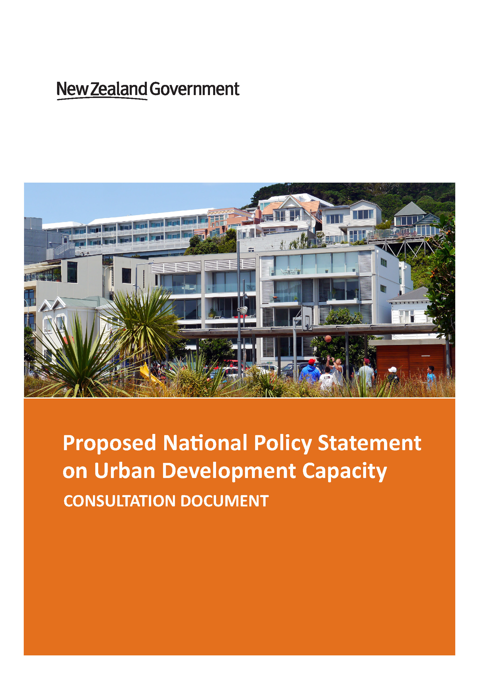

This report may be cited as:
Ministry for the Environment and Ministry of Business, Innovation and Employment. 2016. Proposed National Policy Statement on Urban Development Capacity: Consultation Document. Wellington: Ministry for the Environment.

Published in June 2016 by the
Ministry for the Environment
Manatū Mō Te Taiao
PO Box 10362, Wellington 6143, New Zealand
ISBN: 978-0-908339-42-6
Publication number: ME 1241
© Crown copyright New Zealand 2016
This document is available on the Ministry for the Environment’s website:
www.mfe.govt.nz.

Contents
Message from the Minister 5
Proposed National Policy Statement on Urban Development Capacity 2016 6
Preamble 6
1 Title 8
2 Commencement 8
3 Interpretation 8
4 National significance 10
5 Objectives 11
6 Policies 12
Appendix – Statistical Information 17
Introduction to consultation 20
Understanding urban environments 20
Local government planning in urban areas 21
Providing for housing needs 22
Providing for business needs 23
Constraints on providing sufficient development capacity for business and housing needs 24
Structure of the proposed National Policy Statement 25
Key themes throughout the proposed NPS 28
1 Enabling growth and development while managing the effects 28
2 Meeting a range of demands 28
3 Understanding and enabling the market 29
4 Implications for infrastructure 33
5 Roles and relationships between councils 34
Implementation programme 36
Consultation process 37
How to make a submission 37
Contact for queries 37
What happens next? 38

Figures
Figure 1: Plan-enabled and feasible development capacity 30
Figure 2: Councils and the Christchurch Main Urban Area 34

Table
Table 1: High and medium growth urban areas 26

Message from the Minister
This new national direction on urban development is required to make the Resource Management Act work better for housing and business growth. It complements an amendment Bill currently before Parliament that puts specific new legal requirements on councils to provide enough development capacity to meet demand.
Three critical issues are addressed in this policy.
Firstly, it connects planning decisions with economics. This is crucial, given the greatest increase in house prices over the past two decades has been in the cost of sections rather than the built house. Price signals, commercial feasibility and ensuring sufficient competition in supply will become required legal considerations in land use planning decisions.
Secondly, this policy requires more responsive planning. Auckland is currently stuck in rules developed more than 20 years ago. This new policy will require short, medium and long-term policies to manage growth and regular reviews for ensuring plans are up-to-date and relevant.
Thirdly, this policy rebalances the national and local interests. A major problem in the current framework is that housing affordability is a national issue but the key regulatory levers to address supply rest with councils whose consideration is very locally focused. This policy requires councils and the Environment Court to put greater weight on the national importance of sufficient land supply for housing and business growth.
This policy is carefully nuanced to the different growth pressures across New Zealand’s towns and cities. There are requirements for all urban areas in this policy but these become greater in medium-growth areas and are most demanding in high-growth areas.
This new approach to issues of urban development is heavily influenced by the comprehensive work by the Productivity Commission with its 2015 report on land supply and its influence on housing affordability.
This new urban policy statement is part of the Government's broader reforms to strengthen national direction under the Resource Management Act. We are progressing more national policies, standards and regulations than any previous government on key issues like water, coastal management, telecommunications, forestry, pest control and now urban development.
This proposed national policy statement is a powerful tool to make our urban environments work better in supporting growth of housing and employment. We welcome your feedback so we can get it right.

Hon Dr Nick Smith
Minister for the Environment
Minister for Building and Housing

Proposed National Policy Statement on Urban Development Capacity 2016

Preamble

New Zealand is one of the most urbanised countries in the world, with 73 percent of us living in cities of at least 30,000 people.
Cities are characterised by their intensity, the access they provide to things that people value, their scale, and often by high rates of population and economic growth. These have both positive and negative impacts: successful cities maximise the positives and minimise the negatives. Successful cities provide people with access to a choice of homes and opportunities to earn income, and attractive built and natural environments. They have good quality physical and social infrastructure and open space. They use resources efficiently, and they minimise their environmental footprint. They make the most of their ability to connect to other parts of the world. Such cities attract people and investment, and are therefore constantly changing, dynamic places that make a significant contribution to national economic performance.
Local authorities play an important role in shaping the success of our cities by planning for growth and change, and providing critical infrastructure. Ideally, urban planning should enable people and communities to provide for their social, economic and cultural wellbeing through development, while managing its effects. This is a challenging role, because cities are complex places; they develop as a result of numerous individual decisions, and this often involves conflict between diverse preferences.
This National Policy Statement provides direction to decision-makers under the RMA on urban planning. It has a particular focus on ensuring that planning enables development through providing sufficient development capacity for housing and businesses.
The National Policy Statement aims to help reduce regulatory barriers to the supply of housing, and reduce the cost of housing relative to income. High house prices drive wealth inequality, increase the fiscal burden of housing-related welfare, and pose a risk to the national economy.
It is also important that planning provides good accessibility between housing and businesses, and the social infrastructure necessary in a successful city.
An overarching theme running through this National Policy Statement is that planning decisions must actively enable growth and development in urban areas, and accommodate that in such a way as to maximise wellbeing now and in the future.
The National Policy Statement requires plans to provide sufficient development capacity to meet long term demand. This includes both the total number of dwellings and the amount of business space needed, and the range of demands for different sizes, types and locations.

Another key theme running through the National Policy Statement is for planning to better understand the property market and enable it to provide for the community’s needs. While taking account of all factors that affect well-being, planning should respond to demand, enable what is commercially feasible, and promote competitive land and development markets. The National Policy Statement requires planning to place a greater emphasis on monitoring what is happening on the ground, and responding to that.
This National Policy Statement requires development capacity provided in plans to be serviced or likely to be serviced with infrastructure. This will necessitate better integration and coordination between land use and infrastructure planning and will require local authorities, infrastructure providers and central government to work co-operatively.
This National Policy Statement also places a strong emphasis on planning coherently across urban housing and labour markets, which will require coordinated planning between local authorities that share jurisdiction over Main Urban Areas.
The National Policy Statement targets different policies to different local authorities, as per the table below.
 | All local authorities | Local authorities that have a Medium Growth Urban Area within their jurisdiction | Local authorities that have a High Growth Urban Area within their jurisdiction
Objectives that apply | All | All | All
Policies that apply | PA1 – PA3 | PA1 – PA3 | PA1 – PA3
 |  | PB1 – PB5  PC1 – PC3  PD1 – PD4 | PB1 – PB5  PC1 – PC3  PD1 – PD4
 |  |  | PD5 – PD9

1 Title

This national policy statement is the National Policy Statement on Urban Development Capacity 2016.

2 Commencement

This national policy statement comes into force on the 28th day after the date on which it is notified in the New Zealand Gazette.

3 Interpretation

In this national policy statement, unless the context otherwise requires, –
Act means the Resource Management Act 1991.
Business land means land that is zoned for productive economic activities in urban areas, including but not limited to the following:
- industrial
- commercial
- retail
- business and business parks
- mixed use and centres, to the extent that it is available for productive economic activities.
but does not include residential dwellings that are also used for a productive economic activity such as home occupations.
Decision-maker means all persons exercising functions and powers under the Act.
Demand means:
In relation to residential development, the demand for residential dwellings within an urban area in the short, medium and long-terms, having particular regard to:
- the total number of dwellings required to meet projected household growth;
- demand for different types of dwellings;
- the demand for different locations within the urban area; and
- the demand for different price points.
recognising that people will trade off (b), (c) and (d) to meet their own needs and preferences.

In relation to business land, the demand for floor area in the short, medium and long-terms, having particular regard to:
- the quantum of floor area to meet forecast growth in different sectors;
- the demands of both land extensive and intensive activities; and
- the demand for different locations within the urban area.
Development capacity means in relation to residential and business land, the capacity of land for urban development to meet demand, taking into account the following factors:
- the zoning, objectives, policies, rules and overlays that apply to the land; and
- the provision of adequate infrastructure, existing or likely to exist, to support the development of the land, having regard to—
- the relevant proposed and operative regional policy statements, regional plans and district plans; and
- any relevant management plans and strategies prepared under other Acts.
Feasible means the commercial viability of development, taking into account the current likely costs, revenue and yield of developing.
High-Growth Urban Area means:
- Any Main Urban Area that, according to the most recent Statistics New Zealand growth projections set out in Appendix A2, is projected to experience population growth of more than 10% over the medium-term; or
- Any Secondary Urban Area that at any point in the year has a combined resident and visitor population of over 30,000, and according to the most recent Statistics New Zealand growth projections set out in Appendix A2, is projected to experience population growth of more than 10% over the medium-term.
Infrastructure means network infrastructure for water supply, wastewater, stormwater, transport, and passenger transport services.
Local authority has the same meaning as in section 2 of the Resource Management Act 1991.
Long-term means within the next thirty years.
Main Urban Area means as defined by Statistics New Zealand set out in Appendix A1.

Medium-Growth Urban Area means:

- Any Main Urban Area that, according to the most recent Statistics New Zealand growth projections set out in Appendix A2, is projected to experience population growth of between 5% and 10% over the medium-term; or
- Any Secondary Urban Area that at any point in the year has a combined resident and visitor population of over 30,000, and according to the most recent Statistics New Zealand growth projections set out in Appendix A2, is projected to experience population growth of between 5% and 10% over the medium-term.
Medium-term means within the next ten years.
Plan means an operative or proposed regional plan or a district plan.
Planning decisions means any decision on a regional policy statement, regional or district plan, or plan change.
Secondary Urban Area means as defined by Statistics New Zealand set out in Appendix A1.
Short-term means within the next three years.
Sufficient means the provision of enough development capacity to meet residential and business demand, plus, to take account of the likelihood that not all capacity will be developed, an additional margin of at least:
- 20% over and above projected short and medium-term residential and business demand; and
- 15% over and above projected long-term residential and business demand.
The total capacity should reflect the demands for different types and locations.
Urban area means an area with urban characteristics and a moderate to high concentration of population, irrespective of local authority boundaries.
Urban form means the overall pattern of development within an urban area, and the relationship of its constituent parts to each other.

4 National significance

This National Policy Statement is about the national significance of the contribution that urban areas make to the social, economic and cultural wellbeing of people and communities, and the need to enable urban development and change in order to provide for this.

5 Objectives

The following objectives apply to all local authorities.

Objective Group A – Outcomes for decision-making
OA1: To support effective and efficient urban areas that enable people and communities to provide for their social, economic and cultural wellbeing.
OA2: To provide sufficient residential and business development capacity to enable urban areas to meet residential and business demand.
OA3: To enable ongoing development and change in urban areas.

Objective Group B – Evidence and monitoring to support decision-making
OB1: To ensure plans and regional policy statements are based on a robust, accurate and frequently-updated evidence base.

Objective Group C – Coordinated evidence and decision-making
OC1: To promote coordination within and between local authorities and infrastructure providers in urban areas, consistent planning decisions, integrated land use and infrastructure planning, and responsive planning processes.

Objective Group D – Responsive planning
OD1: To ensure that planning decisions enable urban development in the short, medium and long-terms.
OD2: To ensure that in the short and medium terms local authorities adapt and respond to market activity.

6 Policies

Outcomes for decision-making
Policies PA1 to PA3 apply to all local authorities.
PA1: By decision-makers:
- Providing for an urban form that maximises the potential for social and economic exchange within the urban area.
- Providing for the efficient use of resources, having particular regard to scarce urban land and infrastructure.
- Enabling the competitive operation of land and development markets.
PA2: By local authorities providing at all times sufficient residential and business development capacity for the short, medium and long terms.
PA3: When considering the effects of urban development, decision-makers must:
- Recognise and provide for the contribution that urban development will make to the ability for people and communities and future generations to provide for their social, economic and cultural wellbeing.
- Provide sufficient development capacity, whilst maximising the positive effects of development, and minimising the adverse effects of development.
- Have particular regard to the positive effects of urban development at a national, regional and district scale, as well as its local effects.

Evidence and monitoring to support decision-making
Policies PB1 to PB5 and PC1 to PC3 apply to all local authorities that have part, or all, of either a Medium Growth Urban Area or High Growth Urban Area within their jurisdiction.
PB1: Local authorities must, by the end of 2018, or within 12 months of becoming a Medium or High Growth Urban Area, and thereafter on at least a three-yearly basis, carry out:
- A Housing Assessment that estimates the demand for dwellings, including the demand of different groups in the population for different types of dwellings, locations and price points, and the supply of development capacity to meet that demand, in the short, medium and long-terms; and
- A Business Land Assessment that estimates the demand for the different types and locations of floor area for the local business sectors, and the supply of development capacity to meet that demand, in the short, medium and long-terms.
Local authorities must have regard to the benefits of publishing the assessments under policy PB1.
PB2: In carrying out the assessments required under policy PB1, local authorities must have particular regard to:

- Demographic change, including population growth and household size projections, using the most recent Statistics New Zealand growth projections set out in Appendix A2.
- Future changes in the sectoral composition of the local economy and the impacts that this might have on residential and business demand.
- Information on the market’s response to planning obtained through monitoring under PB5.
PB3: In carrying out the assessments required under policy PB1, local authorities must estimate the sufficiency of development capacity provided by its plans and proposed and operative regional policy statements, having particular regard to:
- The cumulative effect of all zoning, objectives, policies, rules and overlays in plans, and the effect this will have on opportunities for development being taken up.
- The actual and likely availability of infrastructure.
- The current physical and commercial feasibility of development capacity.
- The likelihood of opportunities for development being taken up.
and must estimate the additional development capacity needed if any of these factors indicate that the supply of development capacity is not likely to meet demand in the short, medium or long-term.
PB4: In carrying out the assessments required under policy PB1, local authorities must consult with infrastructure providers, community and social housing providers, the property development sector and any other stakeholders as they see fit.
PB5: To ensure that local authorities are well-informed about the market’s response to planning, local authorities must monitor a range of indicators on a quarterly basis, or as frequently as possible, including:
- The relative affordability of housing, including the ratio of house price to income and the relative cost to rent;
- The increase in house prices and rents;
- The number of resource and building consents granted relative to the growth in population;
- Vacancy rates for business land;
- The ratio of the value of land between rural and urban zoned land; and
- The ratio of the value of improvements to the value of land within the urban area.
Local authorities must have regard to the benefits of publishing the results of its monitoring under policy PB5.

Co-ordinated evidence and decision-making
PC1: When developing plans and regional policy statements to implement this National Policy Statement, local authorities must consult with other local authorities, local infrastructure providers and central government infrastructure providers that share jurisdiction over a Medium Growth Urban Area or a High Growth Urban Area.
PC2: The relevant local authorities and infrastructure providers will work together to agree on data and projections used in the development of the assessments required under policy PB1.
PC3: The relevant local authorities and infrastructure providers will work together to, as far as possible, ensure coordinated land use planning and infrastructure provision, including expected levels of service for infrastructure.

Responsive planning
Policies PD1 to PD4 apply to all local authorities that have part, or all, of either a Medium Growth Urban Area or High Growth Urban Area within their jurisdiction.
PD1: When the evidence base or monitoring obtained in accordance with policies PB1 to PB5 indicates that development capacity is not sufficient in any of the short, medium or long terms, local authorities must respond by providing further development capacity in accordance with policies PD2 and PD3 as soon as possible.
PD2: A local authority must consider all options available to it under the Act to enable sufficient development capacity to meet residential and business demand, including but not limited to:
- Changes to plans and regional policy statements, including changes to:
  - Objectives, policies and rules, zoning and the application of those in both existing urban and undeveloped areas;
  - Activity status;
  - Provisions about the notification of applications for resource consent;
  - Existing overlays, or the introduction of overlays which enable development; and
  - Make them simpler to interpret.
- Consenting processes that are customer-focused and coordinated within the local authority; and
- In granting consent, the conditions of consent imposed.
PD3: Local authorities must consider the following responses:
- In the short term, further enable development through customer-focused consenting processes and, where appropriate, amending the relevant plans.

- In the medium term, amending the relevant plans and policy statements to provide more development capacity.
- In the long term, providing a broad indication of the location, timing and sequencing of development capacity in order to demonstrate that it will be sufficient.
PD4: In giving effect to policy PD1 with respect to residential development capacity local authorities should have particular regard to enabling capacity:
- In the locations that the Housing Assessment, required under policy PB1, indicates are of highest demand; and
- That is feasible.
such that it maximises the contribution to meeting demand for residential development.
Local authorities that have a Medium Growth or High Growth Urban Area within their jurisdiction should not restrict their responses to meeting demand to only the area that lies within the Medium Growth Urban Area or High Growth Urban Area.
Policies PD5 to PD9 apply to all local authorities that have part, or all, of a High Growth Urban Area within their jurisdiction.
Regional councils must have amended their proposed and operative regional policy statement to give effect to policies PD5 to PD6 by:
- The end of 2018; or
- Earlier if the Housing Assessment required under policy PB1 shows development capacity is insufficient to meet demand; or
- Within 12 months of becoming a High Growth Urban Area.
Regional councils must amend their proposed and operative regional policy statements to give effect to policies PD5 to PD6 in accordance with section 55(2A) of the Act without using the process in Schedule 1 of the Act.
PD5: Regional councils must set minimum targets for the supply of sufficient residential development capacity that must be achieved, in accordance with its Housing Assessment, and incorporate these into the relevant regional policy statement.
These minimum targets must specify:
- The total number of dwellings; and
- Different types of dwellings.
To take account of the likelihood that not all capacity will be developed, it must require an additional margin of at least:

- 20% over and above projected short and medium-term demand; and
- 15% over and above projected long-term demand.
PD6: A regional council’s minimum targets set under policy PD5 must be set for the medium and long terms, and must be reviewed every three years. When a regional council’s Housing Assessment required under policy PB1 shows that the minimum targets set in the regional policy statement are insufficient to meet demand, regional councils must revise those minimum targets in accordance with policy PD5 and incorporate those targets into its regional policy statement in accordance with section 55(2A) of the Act without using the process in Schedule 1 of the Act.
Local authorities shall give effect to policies PD7 to PD9 within the following timeframes:
- By the end of 2018; or
- Within 12 months of becoming a High Growth Urban Area.
PD7: Local authorities must provide a future land release and intensification strategy alongside the relevant plans and regional policy statements to demonstrate that there will be sufficient development capacity in the medium and long terms, and that minimum targets will be met.
PD8: The future land release and intensification strategy must:
- Identify the location, timing and sequencing of future development capacity over the long term; and
- Provide a process for flexible implementation.
PD9: In developing this strategy, local authorities must:
- Be informed by the Housing Assessment and Business Land Assessment required under policy PB1;
- Take into account the views of infrastructure providers, land owners, the property development sector and any other stakeholders as they see fit; and
- Have particular regard to policy PA1.

Appendix – Statistical Information

A1: Statistics New Zealand: Classification of Urban Areas
Main Urban Areas | Secondary Urban Areas
Whangarei | Pukekohe
Northern Auckland Zone | Tokoroa
Western Auckland Zone | Taupo
Central Auckland Zone | Whakatane
Southern Auckland Zone | Hawera
Hamilton Zone | Feilding
Cambridge Zone | Levin
Te Awamutu Zone | Masterton
Tauranga | Greymouth
Rotorua | Ashburton
Gisborne | Timaru
Napier Zone | Oamaru
Hastings Zone | Rangiora
New Plymouth | Queenstown
Whanganui
Palmerston North
Upper Hutt Zone
Lower Hutt Zone
Porirua Zone
Wellington Zone
Nelson
Christchurch
Dunedin
Invercargill
Kapiti
Blenheim

Source: Statistics New Zealand (sourced May 2016)
Classification of Urban Areas

A2: Statistics New Zealand: Projected Total Population by Urban Area

 | Year at 30 June
Urban Area | 2013 | 2018 | 2023 | 2028 | 2033 | 2038 | 2043
Whangarei | 53,600 | 55,000 | 56,000 | 56,800 | 57,400 | 57,600 | 57,600
Northern Auckland Zone | 288,000 | 315,900 | 335,400 | 355,000 | 375,000 | 393,900 | 411,900
Western Auckland Zone | 217,100 | 242,700 | 266,300 | 290,100 | 312,400 | 334,000 | 355,000
Central Auckland Zone | 450,900 | 500,600 | 539,000 | 578,400 | 616,700 | 652,500 | 686,100
Southern Auckland Zone | 425,800 | 463,200 | 491,700 | 520,300 | 547,100 | 571,600 | 594,200
Hamilton Zone | 180,600 | 196,600 | 208,700 | 220,600 | 232,200 | 243,200 | 253,800
Cambridge Zone | 18,400 | 19,850 | 20,600 | 21,200 | 21,800 | 22,300 | 22,700
Te Awamutu Zone | 15,850 | 16,600 | 17,250 | 17,800 | 18,300 | 18,700 | 18,950
Tauranga | 125,700 | 135,500 | 144,700 | 153,900 | 162,900 | 171,500 | 179,800
Rotorua | 55,800 | 56,100 | 56,200 | 56,000 | 55,400 | 54,400 | 53,000
Gisborne | 35,200 | 36,100 | 36,700 | 37,100 | 37,400 | 37,400 | 37,200
Napier Zone | 60,600 | 62,500 | 63,400 | 64,100 | 64,300 | 64,200 | 63,700
Hastings Zone | 67,000 | 69,300 | 70,500 | 71,400 | 71,900 | 71,800 | 71,400
New Plymouth | 54,800 | 57,900 | 59,900 | 61,600 | 63,100 | 64,300 | 65,400
Whanganui | 39,300 | 39,000 | 38,700 | 38,300 | 37,600 | 36,600 | 35,500
Palmerston North | 81,500 | 84,500 | 87,000 | 89,400 | 91,600 | 93,400 | 95,000
Upper Hutt Zone | 39,000 | 40,500 | 41,400 | 42,200 | 42,600 | 42,800 | 42,800
Lower Hutt Zone | 100,500 | 101,300 | 101,800 | 102,000 | 101,500 | 100,300 | 98,500
Porirua Zone | 53,500 | 55,600 | 56,700 | 57,500 | 57,900 | 57,800 | 57,400
Wellington Zone | 196,500 | 207,100 | 214,400 | 221,600 | 228,300 | 234,400 | 239,800
Nelson | 63,300 | 66,600 | 68,700 | 70,400 | 71,600 | 72,400 | 72,800
Christchurch | 369,200 | 395,400 | 410,100 | 424,300 | 437,000 | 448,200 | 457,800
Dunedin | 115,100 | 118,000 | 119,300 | 120,400 | 121,100 | 121,300 | 121,100
Invercargill | 49,300 | 50,600 | 51,100 | 51,400 | 51,400 | 51,100 | 50,500
Kapiti | 40,700 | 42,100 | 43,500 | 44,800 | 46,100 | 47,100 | 47,900
Blenheim | 30,100 | 30,900 | 31,500 | 31,900 | 32,100 | 32,100 | 32,100

Source: Statistics New Zealand (sourced May 2016)
Projected Total Population at 30 June 2018-2043 (2013-base)

_______________________
Clerk of the Executive Council

Explanatory note
This note is not part of this national policy statement, but is intended to indicate its general effect.

This national policy statement comes into force 28 days after the date of its notification in the New Zealand Gazette. It provides that ensuring sufficient development capacity is a matter of national significance under the Resource Management Act 1991 and prescribes objectives and policies to guide the making of resource management decisions.

Introduction to consultation
The Minister for the Environment has released a proposed National Policy Statement (NPS) on Urban Development Capacity (the proposed NPS) for public consultation.
The proposed NPS is a priority for the Government. The particular scope relates to the provision of development capacity in local authority plans to address both housing and business needs. This document explains:
- why we have developed the proposed NPS
- our objectives, policies and key themes
- how to give your feedback on the proposal.
Submissions close at 5.00pm on Friday 15 July 2016.

Understanding urban environments
New Zealand urbanisation is among the highest in the world. Over 72 per cent of our population live in areas with a population of 30,000 or more people. Our outstanding natural environment and rural economy are internationally recognised. However, day to day most New Zealanders rely on the choices and opportunities our cities provide – including access to goods, services, housing, employment and recreation. The challenges of rapid growth are not unique to New Zealand cities. But New Zealand’s future success and prosperity will depend on the quality of both our rural and urban environments. Each comes with different opportunities and challenges, particularly when it comes to managing natural and physical resources sustainably.
Urban areas are in a state of constant change. The density and constant growth and development of cities can have positive and negative impacts. People are drawn to urban areas for their employment opportunities, the prospect of higher income, a choice of housing, their community, shopping and cultural facilities, and the social interactions on offer. Some businesses need to be close to large populations and the markets they create for goods and services. Smart businesses use close proximity to labour markets, other businesses, and to education and research facilities to improve productivity and innovation. Urban areas also offer greater efficiency when it comes to providing services, allowing them to cater to greater numbers located in a relatively small area.
If done well, urban growth and development support the success of the city, bringing in new people and skills, offering increased choices and opportunities, and supporting investment into the infrastructure and services needed for a resilient future. However, without good planning, cities can become victims of their own success, burdened by rising traffic congestion and house prices and poor quality environments. Managing competition for resources such as land needed for housing or businesses can mean making hard decisions about how, when and where opportunities for growth will be provided.

Local government planning in urban areas
Local authorities play a vital role in the success of urban areas, shaping urban development by determining how land will be used through land-use planning under the Resource Management Act 1991 (RMA). Local authorities also plan for and provide necessary infrastructure such as public transport, local roads, water, parks and public spaces.
The main purpose of the RMA is to promote the sustainable management of natural and physical resources, to enable people and communities to provide for their current and future social, economic and cultural well-being. When resources are under pressure in growing urban areas, this is extremely challenging.
Urban areas are complex, bringing together people with diverse lifestyles and backgrounds. Local authorities must balance often competing or conflicting interests on behalf of their community. Their plans and planning decisions will inevitably involve choices that advantage some people and disadvantage others.
When making decisions, local authorities must consider the needs of the whole community and the impact planning decisions will have for future generations. This can be difficult when planning processes often favour those who are most vocal and able to make their views known to decision-makers, and when the future and wider costs and benefits of individual planning decisions are hard to quantify. This can lead to decisions that protect current, local interests at the expense of broader outcomes and future generations. For instance, plans that do not supply enough development opportunities to build sufficient housing to meet demand contribute to increasing house prices. While this may benefit current home owners it effectively locks out future generations from home ownership as well as those currently saving to buy their first homes.
Decision-makers for urban areas need to better understand that constraints on development to protect and manage precious natural and physical resources, such as heritage, landscapes and amenity values, come at a cost. While these attributes play an inherent role in making our urban spaces distinctive and special, planning decisions that do not adequately balance their use and protection against the need to provide opportunities for the city to adapt and change can deny significant parts of the current and future community access to housing and employment.

Government reform
The Government is working on a range of options to improve urban planning, including its response to the Productivity Commission’s recent inquiry, Using Land for Housing and the Better Local Services reforms.
Of particular relevance is the Resource Legislation Amendment Bill (the Bill), which proposes an amendment to sections 30 and 31 of the RMA that will create a new function for regional and territorial authorities to provide enough development capacity to meet demand. The proposed NPS will support this new function if it becomes law; however, it could stand alone if required. The definition of development capacity in the Bill will be aligned with the proposed definition in the NPS, once consultation on the proposal has been completed.
The proposed NPS will complement these initiatives and focuses on helping local authorities to allow development in areas experiencing growth.

Providing for housing needs
In many of our growing urban areas, the supply of housing has not kept up with demand. This has contributed to high and rapidly increasing house prices as well as housing affordability challenges and overcrowding. Families have had to make compromises about the size, quality and location of their homes.
The Government is concerned about the national impact of this because:
- shortages of housing affect people on lower incomes the most. Overcrowding contributes to social and health problems and a lack of housing choices close to employment makes it difficult for people to move to new jobs, increasing congestion and travel costs. It can also polarise communities, increasing the difference in income levels between areas
- greater demand is placed on the welfare system to meet housing needs. Government spending on housing assistance is estimated to be over $2 billion for 2015/16
- high house prices reduce how much New Zealanders have to invest elsewhere, such as in the production of exports
- unstable house prices are a risk to the national economy, with New Zealand’s housing stock worth eight times the share market.
Many things, including global financial trends, are contributing to the current state of the housing market. Government is running a comprehensive work programme aimed to make housing more affordable for all New Zealanders. The proposed NPS focuses on reducing the barriers to increasing housing supply, enabling a quicker and more fit-for-purpose response to housing demand.

Barriers to increasing the supply of houses
Local authorities can influence housing supply through resource management plans. These set development capacity through the use of zones and development controls. For example, they set how many and what type of homes can be built – and where. Planning both enables and limits the amount of homes that may eventually be built on a site. Taken across a whole plan, these limitations can mean there is not enough development capacity to provide for housing demand, so housing capacity for new developments becomes scarce and prices rise.
Zoning and development controls need to provide certainty to communities about what can and cannot be developed, and confidence that what does get developed will not lead to poor environmental outcomes. These controls also need to allow the development of enough housing and employment to meet the needs of the community in the long term as well as current demand. The challenge is greatest in redeveloping already established (brownfield) areas. But it is important to do so, to make efficient use of resources and to provide for people’s needs.
This means that decision-makers need to understand the demand for housing and jobs, and the impact that zoning and development controls will have on people’s ability to meet that demand.

Providing for business needs
Under the proposed NPS, councils are required to provide sufficient development capacity for businesses in urban areas. This means business land zoned for productive uses including retail, consumer and business services, manufacturing, transport and storage and utilities. Local authorities use different zones for these types of activities, depending on their effects (such as noise, traffic movements, odour and discharges to air or water).
People need access to homes and jobs; however, this need is constantly changing. Local authority planning should provide enough development capacity for both employment and housing close to each other, in ways that make efficient use of land and services, with as few conflicts as possible. When the planning system struggles to facilitate spatial change associated with ongoing economic development, it may constrain productivity growth.
There is less information about the demand for and supply of development capacity for business than there is about housing. Research for the proposed NPS suggests that:
- different types of businesses have different land and space requirements. For example, manufacturers and wholesalers often need large plots of land buffered from other activities, while business services are often found in high-rise office buildings in city centres and retail and consumer services often choose locations near residential areas
- in cities, employment and production growth tends to be in services rather than traditional manufacturing.
In general, the property market for business land does not appear to have the same extent of problems as the housing market. In most areas and for most types of business, the land available appears to be broadly sufficient and prices do not seem to increase as rapidly as they do with housing. In some urban areas there is even a possibility of oversupply of some kinds of business land. This can lead to underfunded infrastructure and struggling town centres.
Despite plans providing in total enough development capacity for businesses, for some sectors the development capacity provided is not aligned with business needs for type or location. This appears to be an issue for the users of land zoned for industrial use. This includes manufacturers, transport and logistics operators, and utility providers. The effects of these activities often make them incompatible with other uses (for example, noise, odour and traffic movements). These operations are also often capital intensive and difficult or costly to move.
Older industrial businesses in areas developing with newer businesses and housing often experience reverse sensitivity. This is where they face the costs of addressing complaints about their effects from new, more sensitive land users. Some industrial businesses that would be expensive to move should arguably be protected from this, while others should be encouraged to move to make way for higher value users. However, zoned and serviced land is not always available in suitable locations to move to.
The topic of reverse sensitivity is very complex. The focus of the proposed NPS is to further enable development capacity, and addressing reverse sensitivity would require significantly more analysis than has been possible.

Constraints on providing sufficient development capacity for business and housing needs
In developing the proposed NPS, the following have been identified as contributing to an insufficient supply of development capacity for housing and business needs.
- The planning system is slow to identify and respond to changes in demand (especially unexpected demands like the recent high net migration). This is because it takes a large amount of time and money to make plan changes or to get resource consent decisions on developments that the public must be consulted on. Once consents are gained, developers spend considerable time and money dealing with different parts of councils and other groups to make their projects happen.
- Planning decisions respond to groups in the community that are most vocal and well-resourced in consultation processes. As a result, decisions tend to be biased towards protecting current, local interests at the expense of wider outcomes and future generations.
- Local authorities do not often have all the information they need, especially about the impact their planning will have on housing markets and on business land needs. For example, the impact that zoning decisions and development controls have on the type of development that will occur (or not) in particular locations is not assessed against what the market can reasonably provide.
- Often land-use planning and infrastructure planning are not well integrated. This creates uncertainty about whether zoned areas will have the necessary services. There is also often some misalignment in the planning decisions between neighbouring local authorities that impact on a single urban market.

Structure of the proposed National Policy Statement
The proposed NPS contains several requirements to ensure that councils provide, in their urban planning decisions, sufficient development capacity for residential and business development to meet demand.
The proposed NPS is made up of requirements across four key elements. These provide objectives and policies to address the problems identified above. The four elements are:
- the outcomes of decision-making
- the evidence to support decisions
- coordinated evidence base and decision-making
- enabling responsive planning.
The proposed NPS is made up of a tiered set of requirements targeted to different urban areas. The tiered structure of the proposed NPS is designed to target policies to those places facing the greatest growth challenges while minimising the costs of meeting national direction in places where this is not necessary.
The tiered approach is applied in the proposed NPS as follows.
- The objectives and high-level policies apply to all local authorities when they are making decisions on urban planning.
- Additional policies apply to medium and high growth urban areas. Medium growth urban areas are defined as local authorities with jurisdiction over all or part of a Main Urban Area or a Secondary Urban Area with a combined resident and visitor population of 30,000 or more, which is projected to experience population growth of 5–10 per cent over 10 years. Currently, this definition includes the urban areas of New Plymouth, Palmerston North, Wellington, Nelson and Kapiti.
- Further policies which apply only to high growth urban areas. High growth urban areas are defined as local authorities with jurisdiction over all or part of a Main Urban Area or a Secondary Urban Area with a combined resident and visitor population of 30,000 or more, which is projected to experience population growth of over 10 per cent in the next 10 years. Currently, this definition picks up the five urban areas of Auckland, Tauranga, Hamilton, Christchurch and Queenstown.
Table 1 illustrates the Main Urban Areas and relevant local authorities captured by medium and high growth urban areas.

Table 1: High and medium growth urban areas
Main Urban Area | Projected population growth 2013–23 (%) | Relevant council
High growth
Auckland* | 18.1 | Auckland Council
Tauranga | 15.1 | Tauranga City, Western Bay of Plenty District, Bay of Plenty Regional Council
Hamilton* | 14.8 | Hamilton City, Waipa District, Waikato District, Waikato Regional Council
Queenstown** | 14.0 | Queenstown Lakes District, Otago Regional Council
Christchurch | 11.1 | Christchurch City, Waimakariri District, Selwyn District, Environment Canterbury
Medium growth
New Plymouth | 9.3 | New Plymouth District, Taranaki Regional Council
Nelson | 8.5 | Nelson City, Tasman District
Kapiti | 6.9 | Kapiti District, Greater Wellington Regional Council
Palmerston North | 6.7 | Palmerston North City, Manawatu District, Horizons Regional Council
Wellington* | 6.4 | Wellington City, Porirua City, Lower Hutt City, Upper Hutt City, Greater Wellington Regional Council
Other Main Urban Areas
Napier/Hastings* | 4.9 | Napier City, Hastings District, Hawke’s Bay Regional Council
Blenheim | 4.7 | Marlborough
Whangarei | 4.5 | Whangarei District, Northland Regional Council
Gisborne | 4.3 | Gisborne District
Invercargill | 3.7 | Invercargill City, Southland Regional Council
Dunedin | 3.6 | Dunedin City, Otago Regional Council
Rotorua | 0.7 | Rotorua District, Bay of Plenty Regional Council
Whanganui | –1.5 | Whanganui District, Horizons Regional Council
* The Main Urban Areas for Auckland, Hamilton, Wellington and Napier/Hastings are made up of many smaller areas joined together.
** Queenstown is a Secondary Urban Area, but its combined resident and annual visitor population exceeds 30,000 people.

Implementation
Councils would apply the objectives and policies that relate to frequent monitoring as soon as the proposed NPS became operative (scheduled for October this year).
A number of policies on developing a more comprehensive evidence base and setting minimum targets for development capacity must be implemented within three years of the proposed NPS becoming operative. Both may trigger additional plan changes to enable further development capacity.
To support the proposed NPS, the Government intends to put in place an implementation programme that will include the development of guidance and likely training and monitoring.
Key question:
- What do you think of the proposal to target policies to different areas?

Key themes throughout the proposed NPS

1 Enabling growth and development while managing the effects
A key component of successful urban areas is urban planning that enables growth and development. Urban development has both positive and negative effects; however, current planning decisions appear to focus more on the negative effects of development rather than the positive contribution development can make. For example, if a development is turned down because of specific local effects (ie, traffic effects), the wider community may miss out on additional homes, additional local services or opportunities for employment. Furthermore, there is still a need for the development. This growth must then be accommodated elsewhere, in an area that may or may not be better able to manage the effects.
Objective OA3 and Policy PA3 in the proposed NPS address these issues, directing local authorities to:
- enable ongoing development and change
- recognise the contribution that urban development will make to the ability of people, communities and future generations to provide for their social, economic and cultural well-being
- have particular regard to the positive effects of urban development at district, regional and national scale, as well as its local effects.
Local effects remain important, but should be considered in the context of other impacts.
Key questions:
- Would these policies result in better decision-making under the Resource Management Act 1991 for urban development?
- What impact would the policy to recognise the positive impacts of development have?

2 Meeting a range of demands
Under the proposed NPS, demand includes not only the total quantity of demand for homes and floor area but also different types, locations and price points. Successful urban areas need to provide choice for a diverse range of residents and businesses.
All urban areas are experiencing changing demographics, which impact on demand both now and in the future. For housing needs, these include an ageing population, changes to family structure and cultural diversification. For business needs, sectoral changes in the economy also impact on demand for business space.
Policies PB1–PB4 require local authorities to carry out housing and business assessments every three years to estimate the demand for housing and business floor areas. These assessments will improve the information used to make decisions and are directly linked to policies PD1–PD4, which require councils to plan for further development if the assessment identifies a shortage.
The Housing Assessment must estimate the demand for housing in the short, medium and long term. It includes demand for different types of dwellings (such as terraced houses, apartments or stand-alone houses) at different locations and at different price points, recognising that people trade off type, location and price. By providing a range of housing choices in various places, people and families are able to stay within their communities throughout different life stages. Currently, these choices are not often available.
The Business Land Assessment must estimate the demand for different types and locations of floor area for local business sectors. When estimating demand, local authorities must also consider if the types of local businesses are changing and the impact this may have on demand.
Both assessments must estimate the sufficiency of development capacity provided by operative plans and policy statements by considering the:
- cumulative effect that all zoning, objectives, policies, rules and overlays in plans will have on the opportunities for development to be taken up
- the actual and likely availability of infrastructure
- current physical and commercial feasibility of development capacity (discussed in the next section)
- likelihood of development happening (recognising that not all land owners will be motivated to develop)
- information gathered in monitoring price signals.
If the assessments show there is not enough development capacity to meet the estimated demand, the council must estimate the extra capacity needed.
For high growth urban areas, policies PD5 and PD6 direct regional councils to set minimum targets for housing in their regional policy statement. The minimum targets should reflect the overall quantity of demand for homes and the break down by type as identified in the Housing Assessment. This must then be given effect to in local authority plans so that the market is enabled to provide for the full range of housing needs identified.
Key questions:
- What could the Government do to help local authorities carry out the assessments?
- Is three years an appropriate timeframe to update the assessments?
- Is there anything else that would contribute to better understanding the supply and demand of development capacity?

3 Understanding and enabling the market
A key theme in the proposed NPS is the need for local authorities to better understand the market and the impact planning has on how competitively the market operates.

Enabling a competitive market
The proposed NPS requires local authorities in PA1 to “seek to enable land and development markets to operate competitively”. Planning has a tangible effect on the competitiveness of land and development markets. The way that local authorities plan can promote or restrict competition. For example, the time it takes for land to be re-zoned to allow for growth, the cumulative effect of development controls, what effects are weighted in decision-making and how local authorities work with infrastructure providers to facilitate more supply can all promote or restrict competition. Greater competition between developers and land owners keeps prices down; increased opportunities for development mean a greater number of suppliers will compete to meet demand. This will help to reduce speculation.
Policies PB1 and PB3 in the proposed NPS require local authorities to estimate whether they provide sufficient development capacity to meet demand in their plans, especially regarding:
- the commercial feasibility of development capacity
- the likelihood of opportunities for development being taken up.
If either of these factors indicates that capacity is not sufficient to meet demand, local authorities must then estimate any additional capacity needed. Policy PD4 requires local authorities, when responding to any shortfalls in the supply of residential development capacity, to have particular regard to enabling capacity in the locations that the Housing Assessment indicates are of highest demand, and that is commercially feasible.

Commercial feasibility
Not all plan-enabled capacity is suitable for development. Figure 1 illustrates the relationship between plan-enabled capacity, feasible capacity and what is actually developed.
Figure 1: Plan-enabled and feasible development capacity
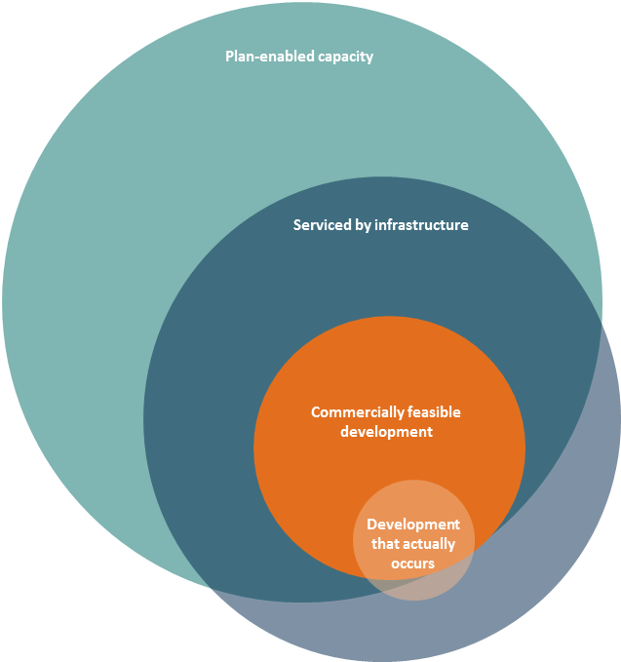
If the plan-enabled development capacity is such that, in the current market conditions it is unlikely to be developed, the development market will not operate efficiently. This will ultimately impact how many homes will be built.
The interaction between plan-enabled capacity, feasible capacity and what is actually developed is complex. A variety of things can affect the ‘feasibility’ of a development. For example, the return on investment for a four-storey apartment development on the outskirts of an urban area may not be enough that a developer would take the risk to build due to a lack of demand or uncertain returns. However, it is more likely to be commercially feasible for the same four-storey apartment to be developed in an area where there is higher amenity and more demand for homes. For example, in an attractive area like a city centre or surrounding suburbs where there is better access to public transport, recreational activities and employment centres.
Additionally, while it may be commercially feasible for a developer to build a four-storey apartment block in an attractive area, this is not necessarily the optimal development in terms of providing for housing needs. Apartments in the four-storey apartment block may sell for $1,000,000 each, but if the development controls allowed the developer to build an eight-storey apartment block in the same location, these apartments may sell for significantly less.
There are many ways councils could assess the commercial feasibility of development capacity that is fit for purpose. The Government intends to provide guidance for local authorities on options for assessing the feasibility of plan-enabled capacity.

Likelihood of opportunities for development being taken up
Land owners may not have an incentive to develop their land, even if development is commercially feasible. Reasons for this vary. For example, if a small number of land owners own a significant proportion of land planned for development, one land owner may not choose to sell their land for development, which could severely restrict development capacity. This could mean a less than ideal outcome for consumers of housing or business land.
The proposed NPS addresses this with the definition of ‘sufficient’. This requires local authorities to provide a margin of development capacity over and above projected demand to address the likelihood of development opportunities being taken up and to promote the competiveness of the market. The margins set in the definition are the minimum, so local authorities will need to identify if greater margins are needed. The minimums have been set at 20 per cent above the short and medium term projected demand, and 15 per cent above the long term projected demand.
For a variety of reasons, the likelihood of development opportunities being taken up in brownfield areas is less than greenfield areas. While the additional margins have been set in the proposed NPS across both types of development, it may be appropriate to specify different additional margins for brownfield and greenfield development.

Monitoring: price signals, market activity and how to respond
One focus of the proposed NPS is to get a better understanding of how planning is enabling the market to meet the needs of people and communities. To help achieve this, policy PB5 requires councils to monitor a range of indicators, including:
- price signals and affordability indicators
- the number of resource and building consents granted relative to the growth in population
- vacancy rates for business land.

Price signals and affordability indicators
The Government sees price signals as a key indicator of the competitiveness of the market, where the greatest demand is and whether development is commercially feasible, among other things. Affordability indicators will provide information on how much income is used up on housing costs. The proposed NPS requires local authorities in a high growth urban area or medium growth urban area to monitor the following indicators listed below.
The Government is seeking feedback on the feasibility and utility of these indicators, as well as any others that may reveal more information about how well planning is enabling the market to meet the needs of the community. Specific indicators to monitor included in the proposed NPS are:
- the relative affordability of housing, including the ratio of house price to income and the relative cost to rent. Such ratios could include the Demographia Housing Affordability Median Multiple and the Massey University Home Affordability Index. These ratios illustrate trends in affordability
- the increase in house prices and rents. This provides information about long term trends in house prices
- differences in land prices at the rural–urban boundary. This ratio is likely to be increased by limits to development within the urban area. Big or increasing differences show more development capacity is needed
- the ratio of improvement value to land value at suburb level. Higher land prices should, all else being equal and over the long term, encourage more intense (and therefore higher value) development of land. However, improvement values tend to change incrementally, and therefore short-run changes in this measure are likely to be due to high land price inflation within the urbanised area. It may provide some useful signals on suburbs where redevelopment is not keeping pace with increasing land prices.
Price signals and affordability indicators will provide useful information. The challenge will be in interpreting them and using the information to inform a meaningful and pragmatic planning response. The Government intends to do further work on other price signals, including how to interpret them.

Market activity
Monitoring the number of resource and building consents granted should provide an indication of the level of development activity. Monitoring this in an ongoing way will be particularly important as it provides an indication of developing trends, including whether the supply of dwellings is starting to diverge from the number of households being formed. Building consents give a more accurate picture than resource consents of whether development will actually occur, because applying for a building consent requires a level of investment by the developer and not all resource consents are acted on.
Many local authorities will already be collecting data on resource and building consents. One aim of the proposed NPS is to bring this data together with other information in a systematic way to inform practical planning responses to growth pressures.
Key questions:
- What else would help local authorities and the Government better understand how planning interacts with the market?
- Should there be more direction in the proposed NPS on how to assess the commercial feasibility of plan-enabled development capacity?
- Are the margins of development capacity over and above projected demand set at an appropriate level?
- Should there be a different margin for brownfield and greenfield development capacity?
- Would the proposed monitoring give a complete picture of how responsive the planning system is? What other things could you see value in monitoring?
- What challenges do you see in interpreting price signals?

4 Implications for infrastructure
The timely and adequate provision of infrastructure is critical for development. Decisions about infrastructure investment are made through long-term plans prepared under the Local Government Act 2002 and Land Transport Management Act 2003. As a tool under the RMA, the proposed NPS cannot directly affect these decisions or direct infrastructure providers. However, the definition of development capacity in the proposed NPS includes the provision of infrastructure that already exists or is likely to exist which supports the development of the land.
This means that, under the objectives and policies of the proposed NPS, development capacity must have an indication that land will be or will likely be supported by infrastructure. This is to encourage better coordination between infrastructure providers and local authorities planning for growth. To support this, the timeframes in the proposed NPS are three, 10 and 30 years to align with Local Government Act planning processes.
In policies PC1–PC3, the proposed NPS also requires local authorities and infrastructure providers to work together to agree on data and population projections used in the development of the housing and business land assessments, and then to work together to as (as far as possible) ensure coordinated land use planning and infrastructure provision, including expected levels of service for infrastructure.
Key questions:
- Would the proposed policies contribute to better coordination between land-use planning and infrastructure provision?
- What else would assist with better coordination?

5 Roles and relationships between councils
All of the B, C and D policies in the proposed NPS apply to medium and high growth urban areas. These definitions are used because they represent single urban housing and labour markets of a significant size. Because urban areas are based on markets, they do not necessarily align well with local authority boundaries. Many of the urban areas cross several territorial authority boundaries as well as the relevant regional council.
For example, the jurisdictions of Christchurch City Council, Waimakariri District, Selwyn District and Environment Canterbury are included in the Christchurch Main Urban Area. Figure 2 illustrates the boundaries of the three territorial authorities against this main urban area.
Figure 2: Councils and the Christchurch Main Urban Area
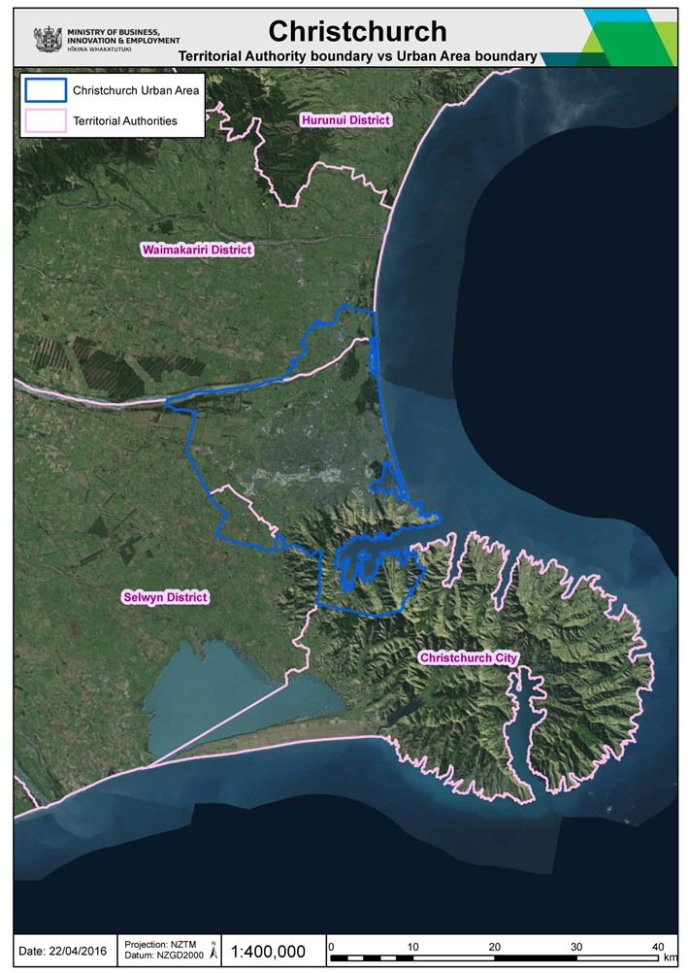
Coordination between the different local authorities is necessary to efficiently plan for growth across an urban area. Policies PC1–PC3 encourage local authorities within a medium or high growth urban area to use a common evidence base and, as much as possible, agree on how growth will be accommodated while still recognising their individual decision-making authority. Many areas already have formal or informal agreements for working with each other (including triennial agreements or non-statutory urban growth strategies). The proposed NPS aims to support and encourage this type of planning.

Regional and territorial local authorities
The minimum housing targets that are required under policies PD5 and PD6 must be set in the relevant regional policy statement, because it has effect over all of the planning documents within a single urban market and plays a coordinating role across those councils. However, the Government expects that the regional council and relevant territorial local authorities will work together closely to determine these targets.
Key questions:
- What are your views on setting minimum targets in the regional policy statement?
- Are policies in the proposed NPS clear enough on how local authorities within medium and high growth urban areas should work together?

Implementation programme
The Government proposes a package of non-statutory guidance to help councils implement the proposed NPS. This could include information on:
- best practice methodologies for assessing demand and development capacity
- best practice methodologies for specified monitoring indicators and other indicators that may provide useful information
- understanding the market, including assessing development feasibility, monitoring and interpreting price signals
- how local authorities can work with other actors, including local authorities and infrastructure providers
- assessing market failures and making the case for planning regulations (including cost–benefit analysis)
- how to balance the proposed NPS with other national direction (for example, the National Policy Statement for Freshwater Management and the New Zealand Coastal Policy Statement), or specific matters listed in sections 6 and 7 of the RMA.
Key question:
- Which of the suggested guidance information would be most useful for local authorities?
The Government is also asking for your feedback on other ways it could support the successful implementation of the proposed NPS. This could include:
- facilitating sharing of best practice between local authorities
- providing training or other ways to increase local government capability
- monitoring and reporting on the implementation of the proposed NPS
- providing local authorities with access to technical models.
Key questions:
- Would it be good to involve practitioners in the development of the guidance material? For example, one model could be a technical expert group made up of New Zealand practitioners (including local authorities, infrastructure providers and developers) with some international input.
- Apart from supplying guidance, how could the Government help local authorities to apply the NPS?

Consultation process

How to make a submission
The Government welcomes your feedback on this consultation document. The questions asked throughout this document are a guide only and all comments are welcome. You do not have to answer all the questions.
To make sure your point of view is clearly understood, you should explain your rationale and provide supporting evidence where appropriate.
There are two ways you can make a submission:
- use our online submission tool, available at www.mfe.govt.nz/more/consultations
- type your own submission preferably using a Microsoft Word document (2003 or later version).
If you are emailing your submission, send it to npsurbandevelopment@mfe.govt.nz.
If you are posting your submission, send it to NPS Urban Development Capacity, Ministry for the Environment, PO Box 106483, Auckland City 1143, and include: the title of the consultation – NPS Urban Development Capacity, your name or organisation name, postal address, telephone number and email address.
Submissions close at 5.00 pm on Friday 15 July 2016.

Contact for queries
Please direct any queries to:
Email: npsurbandevelopment@mfe.govt.nz
Postal: NPS Urban Development, Ministry for the Environment, PO Box 106483, Auckland City 1143

Publishing and releasing submissions
All or part of any written submission (including names of submitters) may be published on the Ministry for the Environment’s website, www.mfe.govt.nz. Unless you clearly specify otherwise in your submission, the Ministry will consider that you have agreed to have your submission and your name posted on its website.
Contents of submissions may be released to the public under the Official Information Act 1982 if requested. Please let us know if you do not want some or all of your submission released, stating which part(s) you consider should be withheld and the reason(s) for withholding the information.
Under the Privacy Act 1993, people have access to information held by agencies about them. Any personal information you send to the Ministry with your submission will only be used in relation to matters covered by this document. In your submission, please indicate if you prefer we do not include your name in the published summary of submissions.

What happens next?
Once submissions have been considered, the Ministry will prepare a summary of submissions report including recommendations for the Minister to consider. The Minister will then decide whether to approve the proposed NPS. If so, it is likely to take effect by the end of 2016.

According to Statistics New Zealand’s most recent estimates.
As noted in A Way Forward for National Direction, which sets out the Government’s priorities for national direction under the Resource Management Act 1991.
Development capacity means the capacity of land to support development of different types. It explicitly refers to the capacity for intensification as well as expansion, ie, the capacity to develop ‘up’ as well as ‘out’. It varies with the physical characteristics of the land, the infrastructure and the constraints that regulations impose on land use.
Statistics New Zealand defines these areas as ‘Main Urban Areas’ (contiguous settlements of 30,000 people or more).
Land-use planning uses policies and rules to control what type of development can take place, such as zoning for industrial use or residential housing. It puts in place height and density limits and controls the levels of noise allowed at different times in order to manage the effects from different activities.
This looked at other issues in the planning and development system, including the supply of infrastructure.
Defined by Statistics New Zealand as a contiguous population over 30,000 people.
As highlighted by the Productivity Commission in its report Using Land for Housing.

