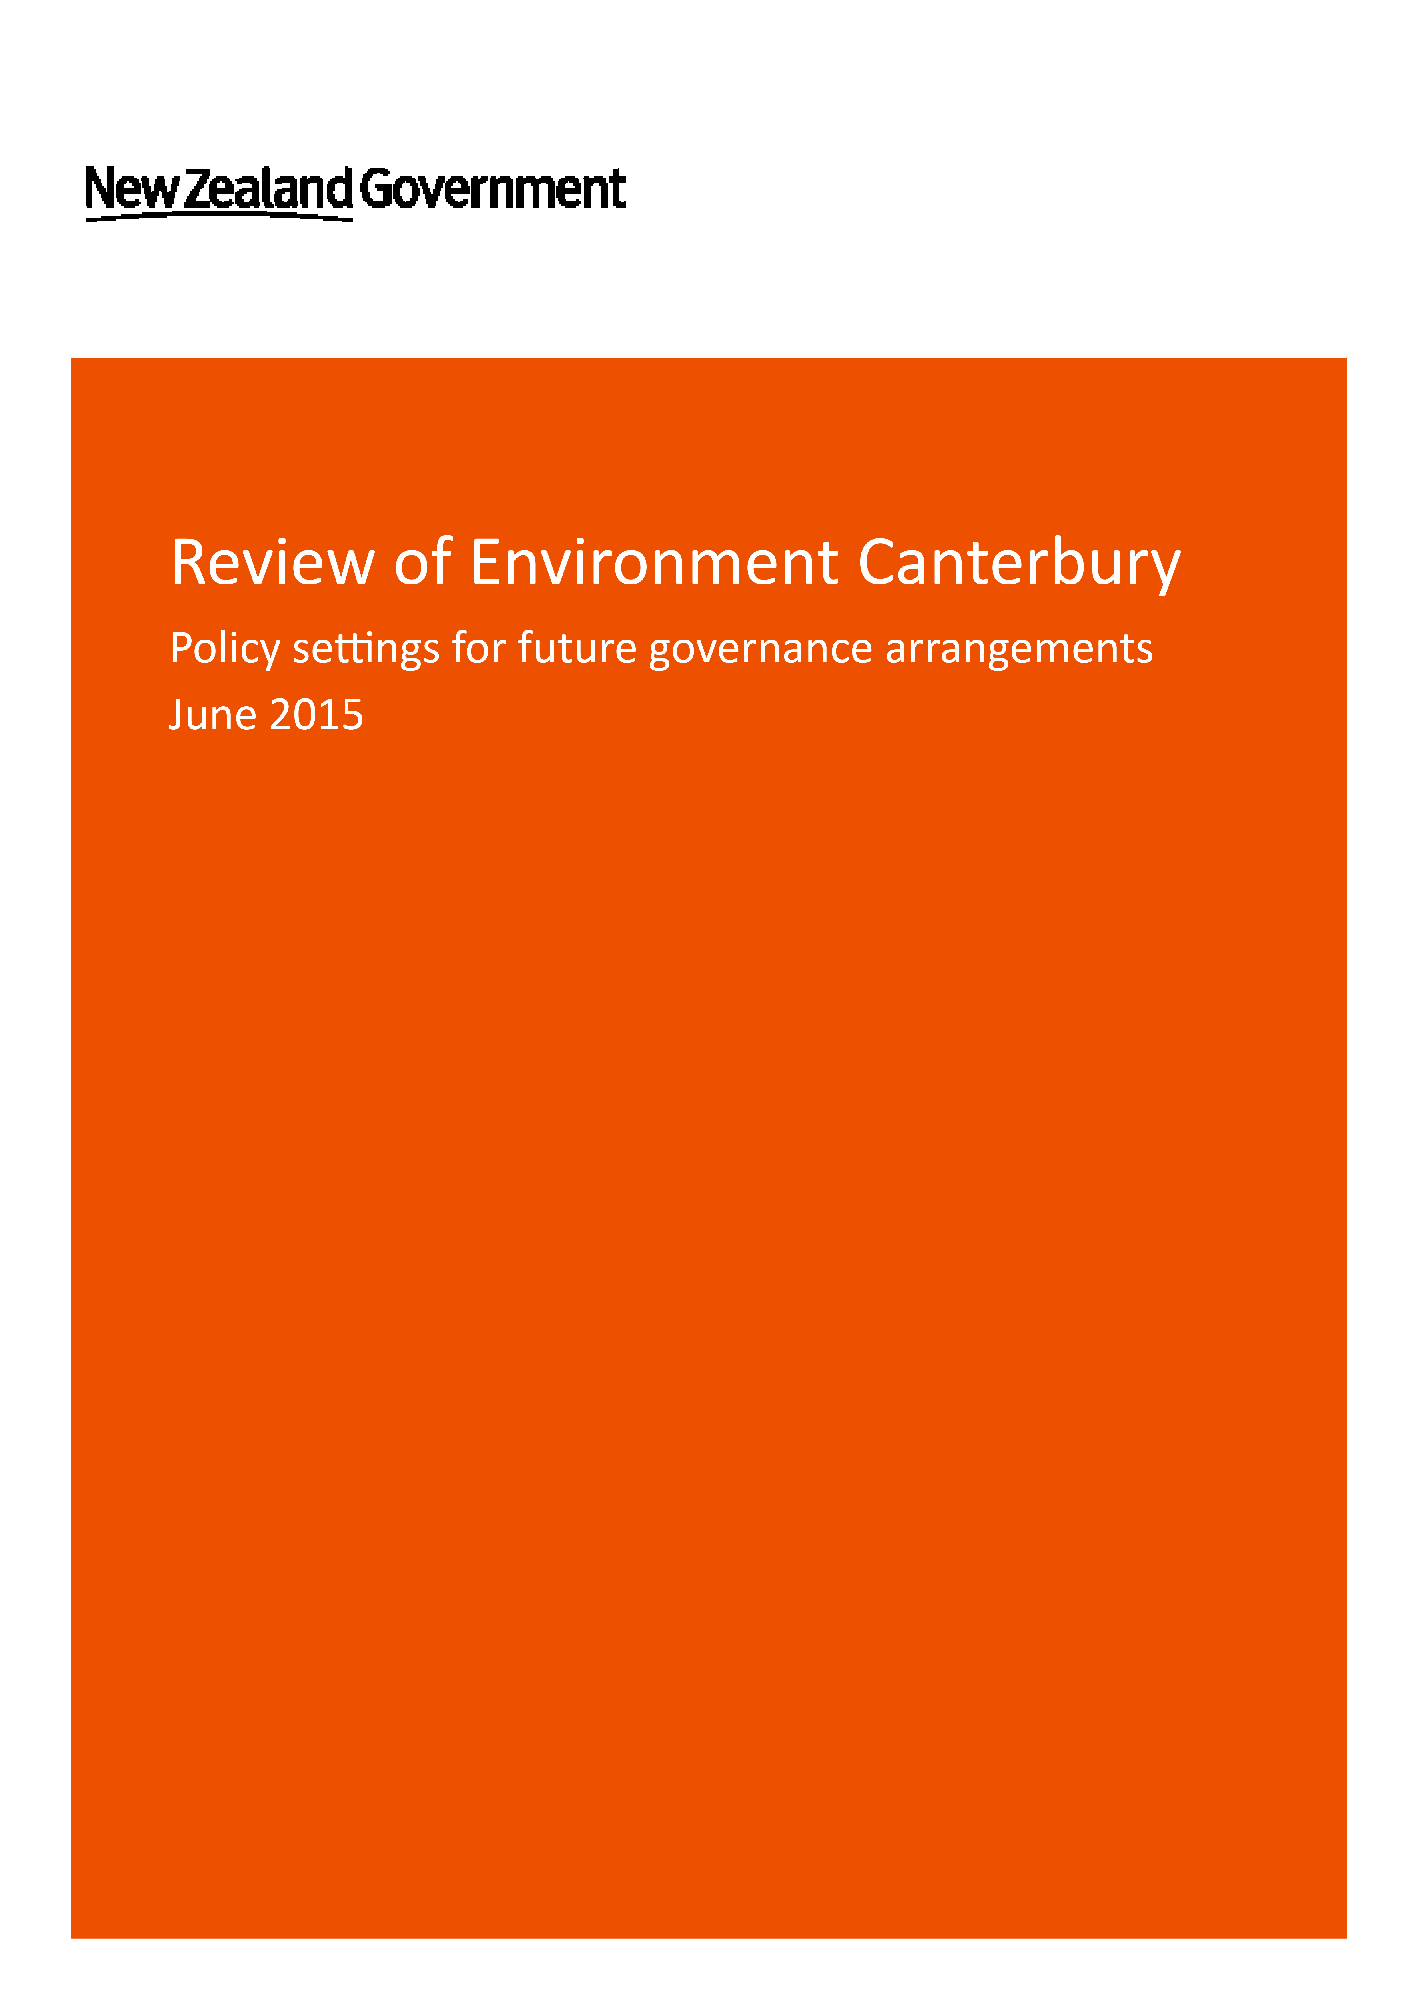

|  |
| --- |
|  |
|  |

This report may be cited as:

Ministry for the Environment. 2015. *Policy settings for future governance arrangements.* Wellington: Ministry for the Environment.

Published in June 2015 by the  
Ministry for the Environment/Internal Affairs   
Manatū Mō Te Taiao/Te Tari Taiwhenua  
PO Box 10362, Wellington 6143, New Zealand

ISBN: ISBN online version (electronic)

Publication number: xxx

© Crown copyright New Zealand 2015

This document is available on the Ministry for the Environment website:

[www.mfe.govt.nz](http://www.mfe.govt.nz)

 

# Contents

Purpose of this document 2

Introduction 3

1. General composition and structure 4

Overview 4

Composition of Environment Canterbury 4

2. Roles and responsibilities of councillors and chair 5

Overview 5

Roles and responsibilities of councillors 5

Election of chair and deputy chair 5

Other governing arrangements 5

3. Representation arrangements 6

Overview 6

Constituencies and boundaries 6

Requirement to carry out a representation review prior to elections 6

4. Appointment process 7

Overview 7

Process for appointment 7

5. Remuneration of councillors 8

Overview 8

Remuneration of governing body 8

6. Resource management arrangements 9

Overview 9

Limited appeal rights to remain until the 2019 elections 9

# Purpose of this document

On 1 March 2014, the Government began a review of the Canterbury Regional Council (known as Environment Canterbury or ECan) required under the Environment Canterbury (Temporary Commissioners and Improved Water Management) Act 2010.

The review is now complete, and the Government is preparing legislation to establish a mixed-model governance structure (the mixed-model) for ECan for the 2016 local authority elections.

This report contains the detailed policy settings for how the mixed-model is intended to be set up and operate. Some of the details in this report may be subject to change to best give effect to the overall policy intent.

# Introduction

Since 2010, Environment Canterbury (ECan) has been led by seven Commissioners appointed by the Government. This was in response to serious concerns from within the community around the capacity and capability of ECan to effectively carry out functions relating to fresh water management in the region.

An independent report in 2010 found that ECan was failing to meet statutory deadlines on resource consents, and making insufficient progress on key planning arrangements relating to the allocation and management of fresh water.

The Commissioners have since made progress on key plans for fresh water, such as the Canterbury Water Management Strategy and Land and Water Regional Plan. Remaining fresh water planning arrangements are expected to be in place by 2019.

In 2013, the Commissioners’ terms were extended for three years to maintain their progress in fresh water management, and in response to the additional challenges created by the Canterbury earthquakes.

The Environment Canterbury (Temporary Commissioners and Improved Water Management) Act 2010, which provides for Commissioners at ECan, expires from the local authority elections in 2016. On 1 March 2014, the Minister for the Environment and Minister of Local Government began a review of ECan membership, governance, and resource management powers to determine what future arrangements may be needed to maintain the progress made by the Commissioners and transition ECan back to a standard regional council.

Following public consultation via a discussion document titled *Environment Canterbury Review: A discussion document*, the Government has decided to implement a mixed-model governance structure for ECan.

The mixed-model provides for seven councillors elected by Canterbury communities, and up to six councillors appointed by the Government. The mixed-model will provide local representation at ECan, with a continued focus through appointed councillors on implementing a comprehensive and collaborative fresh water allocation and nutrient management system for the Canterbury region.

The mixed-model will be in place until the 2019 local authority elections, when it is intended that ECan will return to the standard regional council model.

# General composition and structure

This section outlines the composition and structure of the mixed-model governing body.

## Overview

The mixed-model is an arrangement for ECan that provides for both elected and appointed councillors.

The mixed-model provides for seven councillors elected from four constituencies across Canterbury, and up to six councillors appointed jointly by the Minister for the Environment and Associate Minister of Local Government.

ECan will retain all existing functions of a regional council under the mixed-model.

## Composition of Environment Canterbury

* Seven councillors will be elected from four constituencies in the Canterbury region.
* Up to six councillors will be appointed jointly by the Minister for the Environment and Associate Minister of Local Government.
* Elected councillors will come into office following the 2016 local authority elections.
* Appointed councillors will come into office once the Ministerial appointment process is completed as soon as possible after the 2016 local authority elections.
* The mixed-model is expected to be in place until the 2019 local authority elections.

# Roles and responsibilities of councillors and chair

This section outlines the roles and responsibilities of both elected and appointed Environment Canterbury (ECan) councillors, including those for the chair and deputy chair.

## Overview

The mixed-model aims to align the roles and responsibilities of elected and appointed councillors.

## Roles and responsibilities of councillors

* The roles and responsibilities of elected councillors at ECan will be based on standard arrangements for a regional council in New Zealand.
* Appointed and elected councillors will have the same governance and decision making roles and responsibilities. Each will have an equal voice and equal vote as members of ECan’s governing body.

## Election of chair and deputy chair

* The Chair and Deputy Chair of ECan will be elected by the governing body in accordance with the Local Government Act 2002.
* The Chair and Deputy Chair of ECan may be an elected or appointed councillor.
* The Chair and Deputy Chair may be removed in accordance with Local Government Act 2002.

## Other governing arrangements

* The ECan governing body under the mixed-model is expected to be subject to the same governing requirements as standard regional councils under the Local Government Act 2002. However, there may be the need to make minor modifications to support the operation of the mixed-model.

# Representation arrangements

This section outlines the constituencies and boundaries for elected councillors of Environment Canterbury (ECan).

## Overview

The mixed-model will have seven elected councillors covering the Canterbury region across four constituencies. The boundaries for these constituencies will as far as practicable, coincide with existing territorial authority boundaries in Canterbury.

## Constituencies and boundaries

* Seven elected councillors will be elected from four constituencies:
  + one councillor elected from a South Canterbury constituency comprising those parts of the Waitaki District in the ECan region and the Waimate, Timaru and Mackenzie Districts
  + one councillor elected from a Mid-Canterbury constituency comprising the Selwyn and Ashburton Districts
  + four councillors elected at-large from a constituency comprising Christchurch City
  + one councillor elected from a North Canterbury constituency comprising the Waimakariri, Kaikoura and Hurunui Districts.
* Representation arrangements, constituencies and boundaries will be outlined in legislation.

## Requirement to carry out a representation review prior to elections

* ECan will be **exempt** from the requirement to carry out a representation review for the 2016 local authority elections under the Local Electoral Act 2001.
* ECan will be **required** to conduct a representation review and decide its representation arrangements under the Local Electoral Act 2001 for the 2019 local authority elections.

# Appointment process

This section details the process that will be followed when appointing councillors to Environment Canterbury (ECan).

## Overview

Longlisting of potential candidates for appointment as councillors will begin before the triennial local authority elections. The responsible Ministers will identify suitable candidates for shortlisting after the elections, giving particular consideration to any skills or knowledge gaps among the elected councillors of the governing body.

## Process for appointment

* The appointment process will mirror the appointment process of Commissioners under the Environment Canterbury (Temporary Commissioners and Improved Water Management) Act 2010 and follow best practice for Government appointments.
* The Minister for the Environment and Associate Minister of Local Government will be jointly responsible for making appointments to ECan.
* The disqualification provisions for elected councillors under the Local Electoral Act 2001 will apply to the appointment of appointed councillors. This means candidates for appointment must be New Zealand citizens, be on the roll of electors and not be a candidate for election for another council or community board in the region.
* The responsible Ministers will consider skills, knowledge and expertise in the following areas when making appointments:
  + freshwater management
  + local authority governance and management
  + tikanga Māori, as it applies in the Canterbury region
  + the Canterbury region and its people.
* The appointment process will include expectations for the appointed councillors of ECan to perform the same functions, roles and responsibilities as elected councillors of ECan.
* After the next triennial local authority elections, a shortlist will be finalised, giving consideration to any skills gaps that may exist among the elected councillors of ECan in the criteria listed in •.
* The appointed councillors would come into office as soon as possible following the 2016 local authority elections. Some of the current Commissioners will be able to remain in office to work with the elected councillors until the appointed councillors come into office.

# Remuneration of councillors

This section outlines the process to determine remuneration and expenses for elected and appointed councillors of Environment Canterbury (ECan).

## Overview

To align elected and appointed councillors as closely as possible, all councillors will be equally entitled to the same levels of remuneration regardless of whether they are elected or appointed councillors. As with other regional councils, different rates of remuneration would apply depending on specific roles and responsibilities (ie. the chairs and deputy chairs of the governing body and committees).

## Remuneration of governing body

* The remuneration and expenses of all councillors will be based on a determination by the Remuneration Authority.
* Remuneration and expenses of all councillors will be met by ECan.

# Resource management arrangements

This section outlines the modified resource management powers given to Environment Canterbury (ECan) under the Environment Canterbury (Temporary Commissioners and Improved Water Management) Act 2010 and the arrangements that will continue past 2016.

## Overview

The Environment Canterbury (Temporary Commissioners and Improved Water Management) Act 2010 gave modified Resource Management Act 1991 (RMA) powers to the Commissioners at ECan.

These powers allowed ECan to place a moratorium on new consents for fresh water takes, impose Water Conservation Orders (usually a function of the Environment Court) and limit the appeal rights to the Environment Court for plans relating to freshwater.

The power of limited appeal rights will still be needed after the expiry of the Environment Canterbury (Temporary Commissioners and Improved Water Management) Act 2010 for key planning documents that are being progressed under the Commissioners. To ensure continuity and consistency of processes and timely completion of outstanding plans and changes, the powers will remain applicable to consents and plans notified before the 2019 local authority elections. After the 2019 local authority elections, ECan will revert to the standard RMA planning framework for plans and plan changes that have not yet been notified. Intended RMA Reforms may provide for a new collaborative process or a streamlined planning process at that time.

The powers relating to Water Conservation Orders and moratoria on new consents will be allowed to expire at the 2016 local authority elections.

## Limited appeal rights to remain until the 2019 elections

* ECan will retain powers relating to limited appeal rights after the 2016 local authority elections. These powers will cease at the 2019 local authority elections.
* Consents and plans notified by ECan before the 2019 local authority elections will be processed under the modified resource management powers as a transitional measure.