National Planning Standards:
Plan mapping standards
Discussion paper F

Disclaimer
The opinions and options contained in this document are for consultation purposes only and do not reflect final Government policy. Please seek specific legal advice from a qualified professional person before undertaking any action based on the contents of this publication. The contents of this discussion document must not be construed as legal advice.
The Government does not accept any responsibility or liability whatsoever whether in contract, tort, equity or otherwise for any action taken as a result of reading, or reliance placed because of having read any part, or all, of the information in this discussion document, or for any error, inadequacy, deficiency, flaw in or omission from this document.

This document may be cited as: Ministry for the Environment. 2017. National Planning Standards: Plan mapping standards – Discussion paper F. Wellington: Ministry for the Environment.

Published in May 2017 by the
Ministry for the Environment
Manatū Mō Te Taiao
PO Box 10362, Wellington 6143, New Zealand
ISBN: 978-0-908339-94-5 (online)
Publication number: ME 1299
© Crown copyright New Zealand 2017
This document is available on the Ministry for the Environment website: www.mfe.govt.nz.
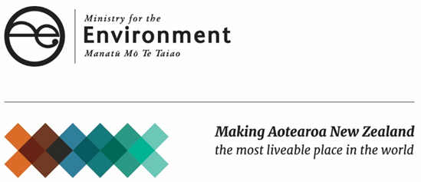

Contents
Context 5
What do we mean by mapping standards? 6
Exploring the problems and the opportunity 7
Unnecessary variation in approaches to creating plan maps 7
Use of GIS to support the interactive delivery of plan information is not widespread 7
What is the opportunity here? 8
What our research tells us 9
Our approach 12
Consistent mapping symbols, typography and colours 12
Standardised naming conventions for maps and map layers 13
Links to eDelivery of plans and policy statements 14
Next steps 16
Feedback 16
Contact 16

Figures
Figure 1: How the National Planning Standards outcomes can be addressed through standards in this paper 5
Figure 2: Required layout of map title and legend for zoning map (paper based)
– note the specified layout of information, titles and zoning framework 10
Figure 3: Map production and legend requirements – note the specified fonts, titles and dimensions 10
Figure 4: Standard zoning (layer) colours – note the standardised zones, colours (RGB/HEX code) and abbreviations 11
Figure 5: New Zealand Transport Agency viewer over Wellington 14

Context
Unnecessary plan variation affects the planning system by making plans difficult to interpret and onerous to prepare. The first set of national planning standards addresses this by including minimum requirements for structure, form and core content for policy statements and plans.
This paper sets out our ideas for how the National Planning Standards could provide a more consistent approach to mapping standards used in plans. Specifically, it focuses on the concept of standardised colours and visual display of spatial layers. Figure 1 demonstrates which of the Planning Standards outcomes can be addressed through the development of standards detailed in this discussion paper.
Figure 1: How the National Planning Standards outcomes can be addressed through standards in this paper
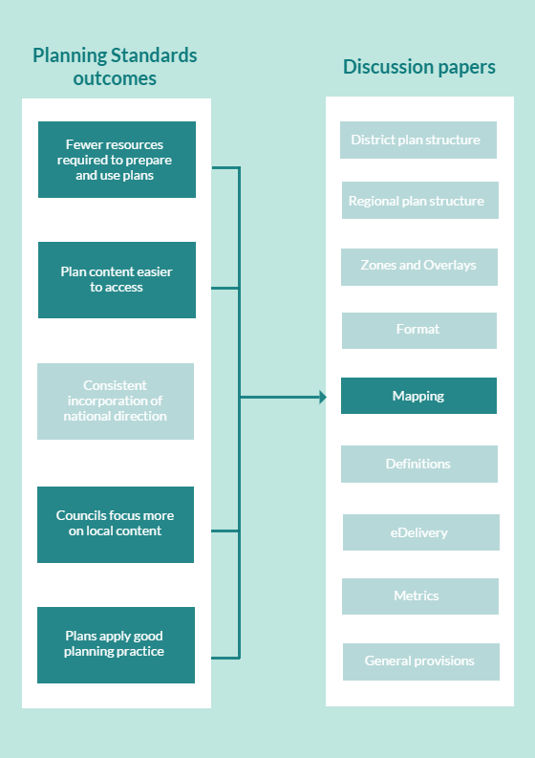

What do we mean by mapping standards?
By mapping standards, we mean the colours, symbols and designs used to represent spatial layers on planning maps, for example, zones, overlays, notable trees, heritage buildings, airsheds, high class soils, flood overlays, precincts and designations. This also includes the terminology and conventions of mapping.
This paper discusses the delivery mechanism of plan maps as being either paper based (PDFs) or using interactive Geographic Information System (GIS) viewers. One advantage of GIS viewers is it allows plan users to turn layers on and off making plans more user friendly.

Exploring the problems and the opportunity

Unnecessary variation in approaches to creating plan maps
Currently, no national standard exists for how spatial layers are displayed on a map nor are there any requirements for map layout or format. Consequently, the same layers and features are visually represented differently across the country. For example, research conducted with 12 different regional plans found that over 266 layers were used. The research report found there were no consistent trends across the regional planning documents in terms of how the maps were produced or presented. The map number, cartographic style, themes and layout varied greatly. District plan maps also have similar issues.
With no minimum standards, planning maps have different fonts, colours, layouts and layer combinations. This has resulted in a number of different presentation styles that are inconsistent, both between and even within plans. Maps have become difficult to understand and are not easily comparable between districts and regions.

Use of GIS to support the interactive delivery of plan information is not widespread
Councils have differing levels of investment, capacity and capability to produce detailed maps for plans. These differences include investment in mapping technology (generally GIS technology) through to the availability and skill sets of staff to complete the mapping processes. We know that, while most councils use GIS to manage council data and processes, not all make a GIS viewer available to the public that includes plan layers information. And, if they do, few councils have a fully interactive ePlan allowing them to connect plan text with the GIS viewer.
In the same regional plan research, the report noted two other findings on how plan maps are published.
- Most plans used static maps, either within the plan or as separate appendices, rather than interactive online maps. These maps are not interactive and are not linked back to text within the planning documents, meaning provisions are not spatially demonstrated.
- A number of map layers were accessible within an online web-based map viewer. Most of these layers were not directly linked to an online plan document or even directly to the relevant section within an online plan.
There is a significant, untapped opportunity to improve the way plan users interact with plan information, by making greater use of GIS viewers.
Differences exist between cities, districts and regions in their geography, topography, key environmental features and cultural pressures on the environment. The level of detail to which they are mapped will be reflective of their significance.
Land Information New Zealand’s (LINZ’s) Geospatial Strategy outlines:
The lack of effective governance over geospatial information and systems across the public sector is constraining the contribution that geospatial information is making, and can make, to the day-to-day business activities of all government agencies, as well as making geospatial information less effective in solving the increasingly complex problems facing society.
It is difficult to quantify the exact benefits of moving information to a uniform digital platform, but the publishing of consistent information online has wider benefits to the country’s economy.

What is the opportunity here?
The National Planning Standards could standardise the visual display of information on maps. Doing so now, when many councils are already investing in GIS and ePlanning, will help to ensure the planning system as a whole transitions more smoothly to a primarily digital platform. This will support the objectives of the National Planning Standards to make it easier for plan users to understand maps and future proof the planning system.

What our research tells us
Research on this issue was covered in different reports and interviews with plan users. Most agreed that a consistent template for district plan maps would be beneficial, although they stressed that any basic map template would need to allow flexibility to recognise unique local environments.
The interviewees thought standardisation could include:
- colours for common core zones
- overlay colours (potentially patterned – ie, outstanding natural landscapes and features)
- symbols (ie, heritage features, scheduled trees, national grid transmission lines and corridors)
- a map format (ie, use of an index map for PDF maps or a standard GIS-based online platform).
The research also found maps have been used and located in various ways in plans including:
- maps within documents that provide context to regions
- maps within documents to illustrate specific rules (locations and/or extent of areas or features to which rules apply)
- maps separated within specific schedules
- maps separated and bundled as a separate map document.

International scoping
The New South Wales (NSW) planning template in Australia, known as the Standard Instrument, adopts an extensive mapping standard (see figures 2 to 4). It sets out in detail the mapping standards for all local authorities and includes content such as:
- standard size, colour and fonts used on maps
- standard legends with a specified position, font and colour
- principles for datasets released to the public
- required map scales
- standard cover sheets
- principles for when insets are to be used and their specifications
- weight, colour and design of grids and lines
- when cadastral information should be displayed on screen
- zone and overlay colours and naming principles.
The NSW requirements are very comprehensive and give effect to the planning template adopted in NSW (see figures 2 and 3). This tool provides a good example of the level of detail to which the planning standards could specify mapping requirements. We want to know what you think could be standardised to help make maps easier to understand and use.
Figure 2: Required layout of map title and legend for zoning map (paper based) – note the specified layout of information, titles and zoning framework
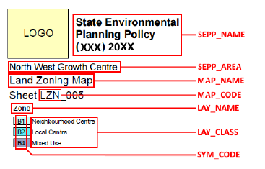
Source: Department of Planning and Environment, New South Wales, Australia – Standard Technical Requirements for Spatial Datasets and Maps (2015, page 9)
Figure 3: Map production and legend requirements – note the specified fonts, titles and dimensions
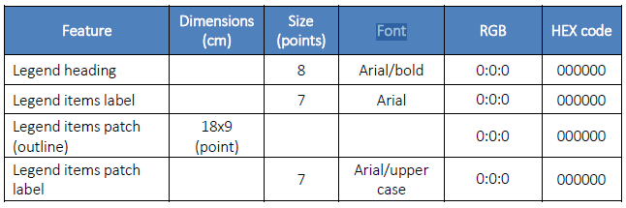
Source: Department of Planning and Environment, New South Wales, Australia – Standard Technical Requirements for Spatial Datasets and Maps (2015, page 35)
Figure 4: Standard zoning (layer) colours – note the standardised zones, colours (RGB/HEX code) and abbreviations
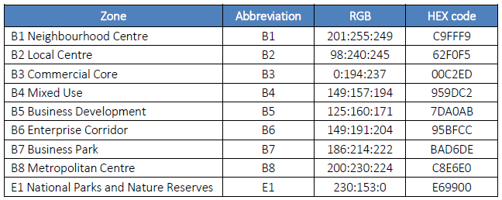
Source: Department of Planning and Environment, New South Wales, Australia – Standard Technical Requirements for Spatial Datasets and Maps (2015, page 43)

Quality Planning website
The Quality Planning website (known as QP) includes guidance relating to planning maps. Specifically, it suggests incorporating the following features:
- a legend, identified and remaining visible on each individual map
- map scales that remain visible and automatically adjust when zooming in and out
- street names and feature names that remain legible or can be zoomed in on
- individual maps that are able to be identified by clicking on an ‘index’ or ‘master’ map
- icons and symbols on the planning maps that hyperlink to relevant plan schedules or tables
- printer-friendly options (without encouraging printing)
- an electronic index that hyperlinks to features and places on the map or similar search function.

Our approach
This paper identifies the main elements of mapping that we consider require standardisation to remove the unnecessary variation in plans that currently exists. It is proposed that the mapping standards be achieved within 12 months of Gazettal. The proposals presented below correlate to the two main issues identified, being the visual display of plan information on maps and the delivery mechanism for map information.

Consistent mapping symbols, typography and colours

Symbology
The application of common symbology for common map layers and features, for example, a prescribed icon for heritage buildings and notable trees. Careful consideration should be given to the prescription of symbols that are not commonly available within GIS toolsets (most often used for map production). Symbology also includes line weight as a consideration (such as area outlines).

Colour palettes
As with symbology, colour palettes can be prescribed for zones and overlays to provide consistency across plans. The choice of colour palettes will need to consider zones and other layers that may commonly overlap.

Fonts
A standard font for map layers could be provided.

Use of grids and map layout
Set map scales and map dimensions could be established. These could be consistent with LINZ NZTopo50 map extents and NZTopo50 1 kilometre grid. Map layout comprises the arrangement of elements on a map, possibly including a title, legend, north arrow, scale bar and geographic data.
Questions
F.1. Are these the right mapping standards that we should be looking at standardising? Are there others?
F.2. Is the level of detail prescribed in the New South Wales requirements desirable? More? Less?

Standardised naming conventions for maps and map layers
The naming of maps and layers varies across plans. The mapped name of the layer would be the same as that used in the plan. The ‘Zones and overlays’ paper sets out our thinking on how this could work. In the context of plan maps, we are curious to know whether there are any obvious challenges in the naming convention approach set out in the ‘Zones and overlays’ paper. These are briefly described below.
For territorial authorities (city and district councils), this could mean standardised names for:
- zones, for example, standard residential and commercial
- sub-zones, for example, character area
- district wide nationally significant matters, for example, matters of national importance, such as heritage
- district wide amenity matters, for example, verandah and pedestrian cover layers.
For regional councils, this could mean standardised names for:
- region wide section 6 Resource Management Act 1991 matters (ie, overlays)
- environmental management areas that divide the entire region into areas for the management of a resource (eg, soil into soil type, water into catchments)
- identifying certain areas where specific controls are imposed to manage a particular issue or resource (eg, air sheds).
As detailed in the ‘Zones and overlays’ paper, we expect that layers will be standardised and, accordingly, the mapping layer will be too. We recognise that flexibility will be needed to recognise local variation and issues, as detailed in that paper.
Questions
F.3. Are there any particular mapping challenges associated with the proposal to introduce a naming convention for spatial layers?

Links to eDelivery of plans and policy statements
The ‘eDelivery’ paper, which explores the transition of plans from being primarily paper-based documents to fully interactive online plans, sets minimum requirements for plans to achieve a certain level of accessibility online. Two periods are provided: within 12 months of Gazettal of the National Planning Standards and within 5 years of Gazettal.
The 12-month minimum standards, which would also apply to plan maps (whether these are paper based or via GIS viewers), require that:
- a plan is searchable in its entirety, with information on when it was last updated
- there is clear differentiation between proposed, operative and appealed provisions
- a plan can be accessed within x number of clicks from the homepage
- plans and policy statements are hosted on a commonly named area on council websites. A single website (managed by the Ministry for the Environment) provides a central portal to all district and regional plans
- links are provided between the various planning provisions (eg, hyperlinks within the plan, the use of tabulation, or bookmarking sections).
In addition to the above, the five year mature standard expects that councils will have transitioned to a fully interactive online ePlan that is linked to the GIS viewer displaying plan map information. Interactive GIS systems allow plan users to view information in customised and more useful ways than a flat static PDF map. This brings new opportunities for plan users, but also some challenges.
These types of systems have the ability to store massive amounts of data through multiple layers and require some computer ability to use but are relatively user friendly. For example, the New Zealand Transport Agency’s Maphub (figure 5) has the ability to store and display over 300 layers, selecting the layers required to avoid visual clutter.
Figure 5: New Zealand Transport Agency viewer over Wellington
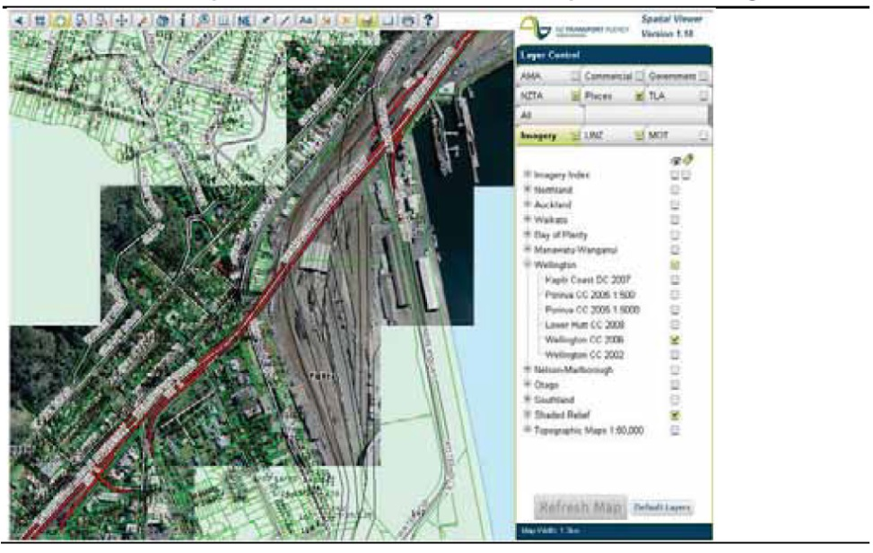
The ability to have multiple spatial layers of information needs to be balanced against the issue that plan users may not use the GIS layers accurately. That is, they may not click on a relevant layer of information, affecting the accuracy of the planning information they receive. The Independent Hearings Panel for the Proposed Auckland Unitary Plan was particularly concerned about this issue and recommended the overall number of layers of data used was collapsed into fewer layers.
Question
F.4. Are you aware of particular issues experienced in the transition of plan maps from paper-based plans to those represented on GIS viewers? Please identify these issues and outline whether it is likely to be an issue that should be addressed in a mapping standard.

Next steps
We are currently in a scoping phase for the National Planning Standards. The ‘Introduction to the National Planning Standards’ overview document details the process and engagement opportunities during each stage of development. The flow chart below shows each stage of the development process and the anticipated timeframes.

Feedback
We now welcome your feedback on the ideas and options presented in this paper. Please use the questions in this paper as a guide. You do not have to answer them all and can give other constructive comments where you wish. To ensure your point of view is clearly understood, please explain your rationale and provide supporting evidence where appropriate.
We encourage you to send us feedback throughout the initial engagement period, which closes on 31 July 2017. Please send feedback to the email address below.

Contact
Email: planningstandards@mfe.govt.nz
Website: www.mfe.govt.nz
Phone: +64 4 439 7400

GIS is an interactive mapping tool used to visualise, question, analyse and interpret data to understand relationships, patterns and trends.
Land Information New Zealand. 2007. New Zealand Geospatial Strategy. Wellington: Land Information New Zealand. Retrieved from www.linz.govt.nz/about-linz/our-location-strategy/geospatial-strategy-for-spatial-data-infrastructure/new-zealand-geospatial-strategy (April 2017).
See www.ict.govt.nz/guidance-and-resources/open-government/.
4Sight Consulting. 2016. Analysis of Efficacy of Effects-Based Planning in Relation to the National Planning Template. Prepared for the Ministry for the Environment by 4Sight Consulting. Wellington: Ministry for the Environment; Beca. 2016. Ministry for Environment – Review of Structure and Format of Regional Plans and Interaction with District Plans. Prepared for the Ministry for the Environment by Beca Ltd. Wellington: Ministry for the Environment.

