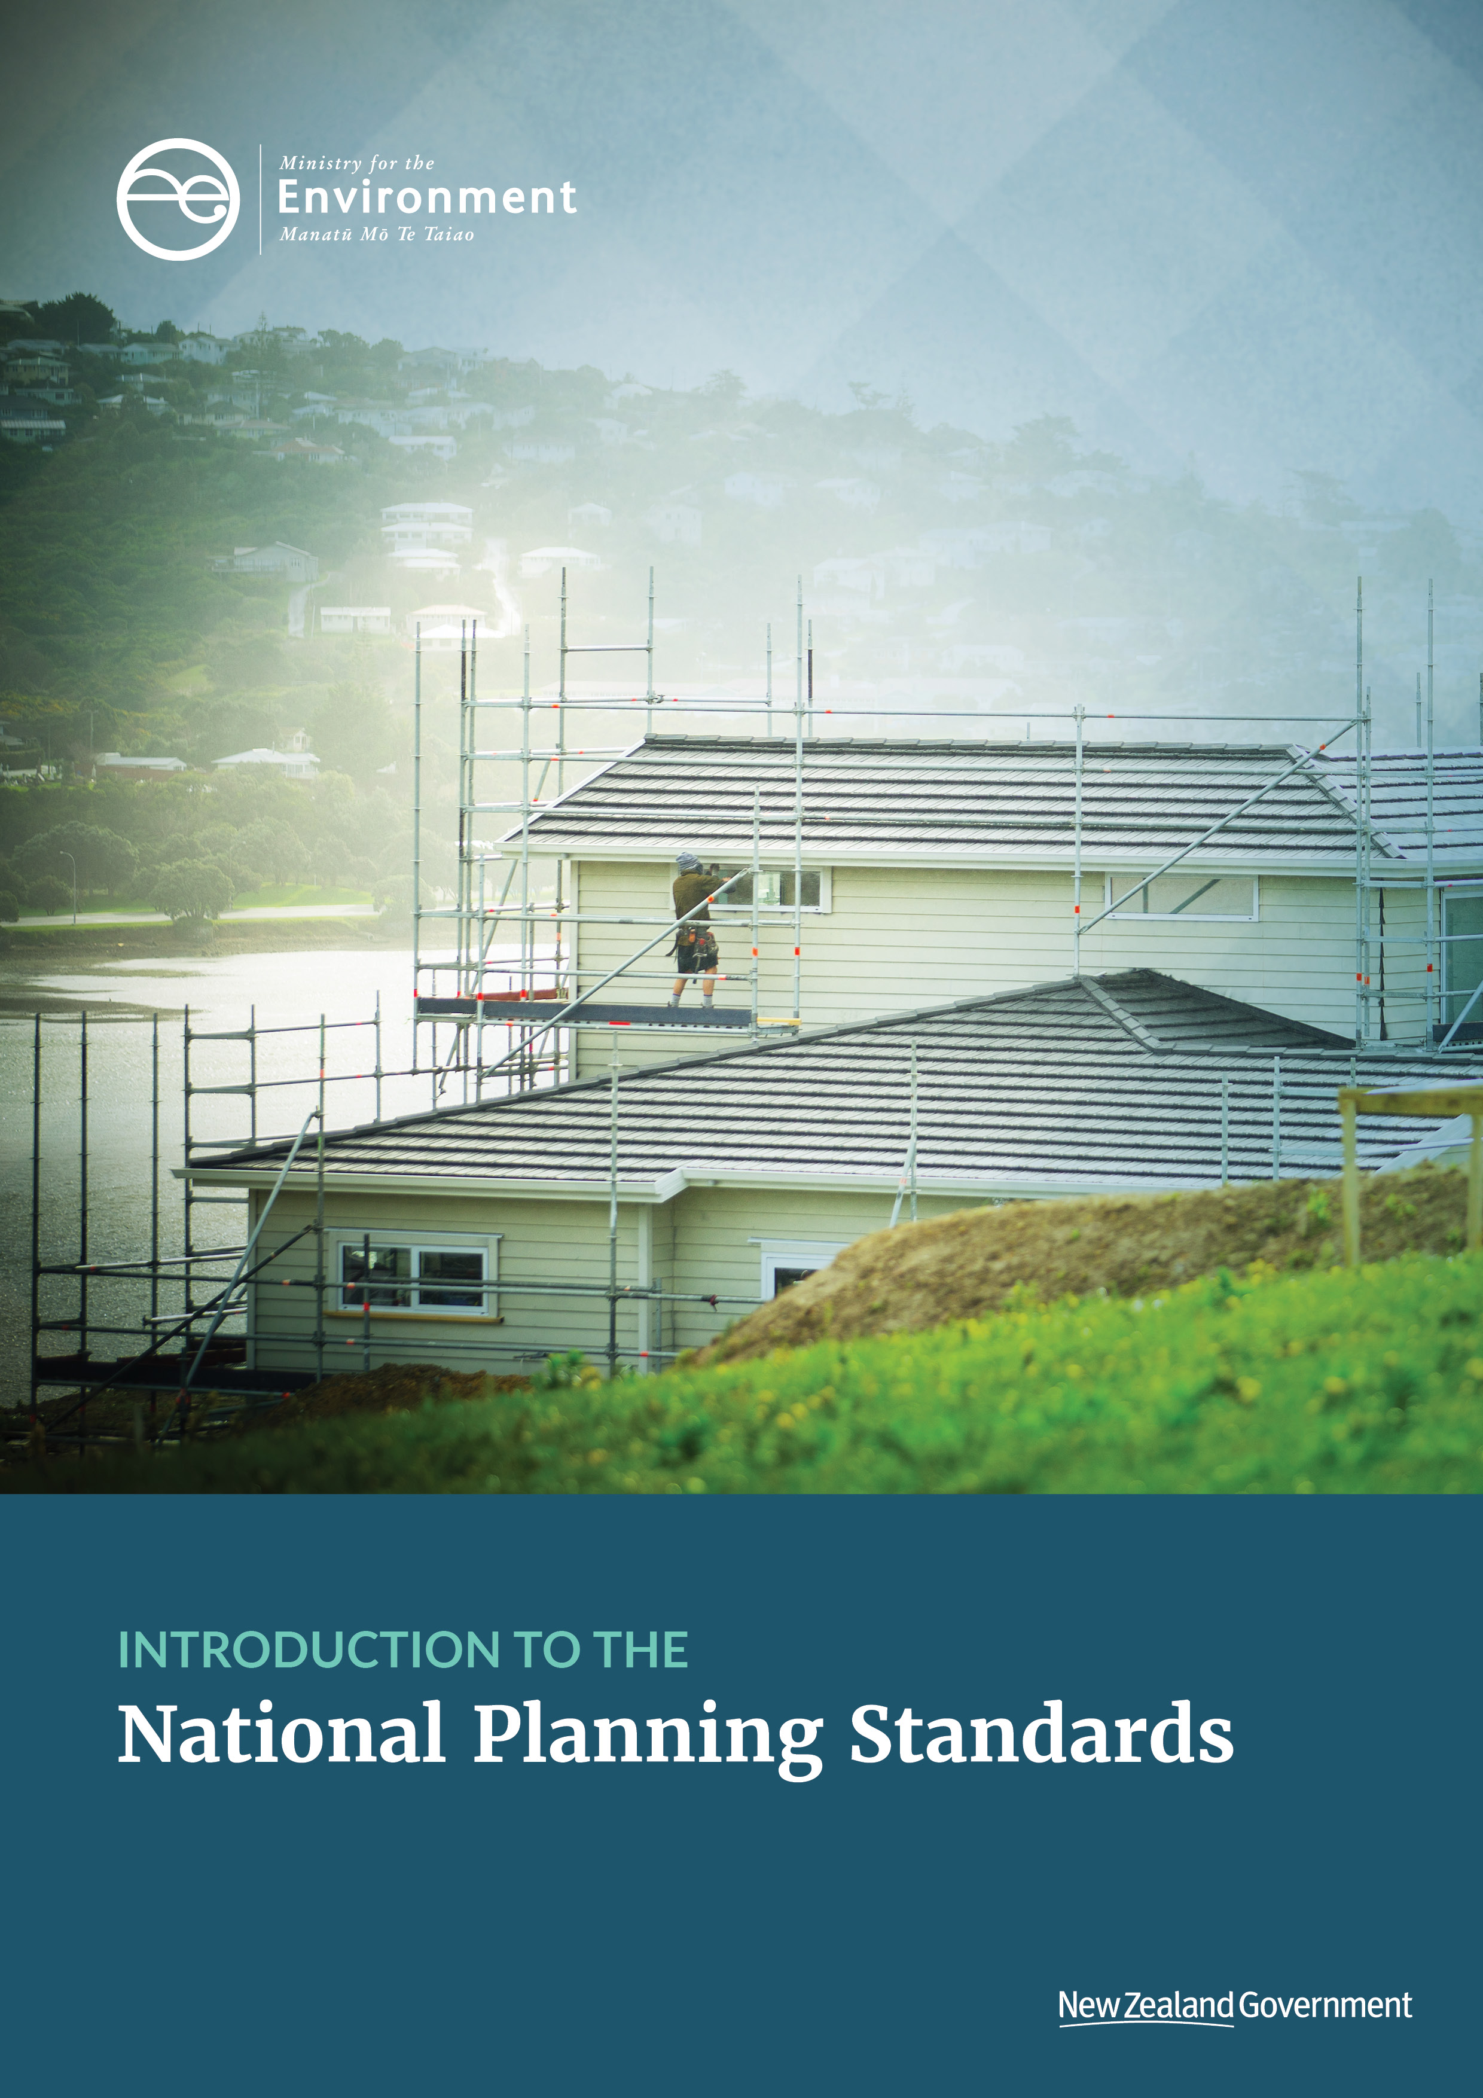

**Disclaimer**

The opinions and options contained in this document are for consultation purposes only and do not reflect final Government policy. Please seek specific legal advice from a qualified professional person before undertaking any action based on the contents of this publication. The contents of this discussion document must not be construed as legal advice.

The Government does not accept any responsibility or liability whatsoever whether in contract, tort, equity or otherwise for any action taken as a result of reading, or reliance placed because of having read any part, or all, of the information in this discussion document, or for any error, inadequacy, deficiency, flaw in or omission from this document.

This document may be cited as: Ministry for the Environment. 2017. *Introduction to the National Planning Standards*. Wellington: Ministry for the Environment.

Published in May 2017 by the  
Ministry for the Environment   
Manatū Mō Te Taiao  
PO Box 10362, Wellington 6143, New Zealand

ISBN: 978-0-908339-88-4 (online)

Publication number: ME 1294

© Crown copyright New Zealand 2017



This document is available on the Ministry for the Environment website: [www.mfe.govt.nz](http://www.mfe.govt.nz).

# Contents

[Section 1: National Planning Standards – a new planning tool 4](#_Toc477438497)

[Introduction 4](#_Toc477438498)

[Section 2: Process for developing the National Planning Standards 9](#_Toc477438499)

[Scope of the first set of National Planning Standards 9](#_Toc477438500)

[Subsequent National Planning Standards 10](#_Toc477438501)

[Phases of national planning standards preparation 11](#_Toc477438502)

[Section 3: Outcomes and Implementation of the National Planning Standards 12](#_Toc477438503)

[Anticipated outcomes 12](#_Toc477438504)

[Some plan variation will continue 12](#_Toc477438505)

[Benefits of the National Planning Standards 12](#_Toc477438506)

[Implementation considerations 13](#_Toc477438507)

[Section 4: Opportunities to be involved 15](#_Toc477438508)

[Phases of stakeholder input 15](#_Toc477438509)

[Opportunities to contribute 16](#_Toc477438510)

[Pilot councils testing the draft planning standards 17](#_Toc477438511)

[Contact for queries 17](#_Toc477438512)

[Appendix 1: Summary of technical discussion papers 18](#_Toc477438513)

[Appendix 2: National Planning Standards research 19](#_Toc477438514)

# Section 1: National Planning Standards – a new planning tool

## Introduction

The National Planning Standards (also referred to as Planning Standards and Standards in this paper) were introduced as part of the 2017 amendments to the Resource Management Act 1991 (RMA).

The Standards seek to:[[1]](#footnote-1)

* help achieve the purpose of the RMA
* set out requirements or other provisions relating to any aspect of the structure, format, or content of RMA policy statements and plans to address any matter that the Minister for the Environment considers:
  + requires national consistency
  + is required to support the implementation of a national environmental standard, a national policy statement, a New Zealand coastal policy statement, or regulations made under this Act
  + is required to assist people to comply with the procedural principles set out in section 18A of the RMA.

This paper summarises the rationale for introducing the Planning Standards, outlines the scope of the first set of Standards, how they will be developed, and how you can be involved in developing the Standards.

### Context

Plan making was devolved to councils under the RMA in 1991, as they are usually best placed to make decisions on behalf of, and in conjunction with, the local community. Each regional and district council is required to have in place a policy statement (for regions) and plans to manage the natural and physical resources in its region/district.

However, this has resulted in hundreds of plans that reflect local circumstances and community values. This process was a change from historic planning legislation, which required plans to be approved by central government and, at various times, prescribed key elements of plans.

Some councils rolled over existing “tried and true” provisions from plans prepared under the former Town and Country Planning Act 1977, but many others took a first principles approach to developing their first RMA plan. The government anticipated some local variation would occur as councils tailored their plans to achieve sustainable management in their districts and regions.

An unanticipated outcome of this process was how much the core structural elements of the plans were also varied, as summarised in table 1. Over time, the degree of unnecessary variation has become more pronounced.

Table 1: Elements that vary considerably among plans

| Plan elements | Examples of variation |
| --- | --- |
| **District plan structure** | The biggest variation in district plans occurs in how the objectives, policies and rules for different topics/themes or zones relate to each other, and where these are located in a plan (4Sight, 2015; Planz Consultants, 2015). |
| **Zones and overlays** | Current plans now contain 2,272 different zones and overlays in 170 documents. Sometimes the same planning controls have different names and are used in different ways. (Ministry for the Environment. 2013b). |
| **Definitions** | Research in 2015 on 25 district plans and 11 regional plans found 8,700 terms that were defined in the plans. The research concluded a core set of approximately 330 definitions could be developed for district and regional plans (Boffa Miskell, 2015c). |
| **Metrics** | There is wide variation in the way technical elements of plans are addressed. For example, noise is variously measured using dBA, dBA L10, dBA Lmax, and dB LAeq. (GHD, 2015). |
| **Regional plan structure** | There are four main types of plan structure, but there were multiple variations in how provisions were structured within each plan type (Beca Ltd, 2016b). |
| **Form of plans** | Plans use markedly different approaches in formatting policies, rules, contents pages, and section organisation. Numbering systems and the use and style of cross-referencing is also highly variable. Some plans are succinct, formatted well, and drafted in plain English. Other plans are more difficult to follow and interpret (Ministry for the Environment, 2013a; Beca Ltd, 2017). |
| **Plan maps** | There is no consistent way of creating plan maps. Different colours and symbols are used for similar zones and map notations in plans (Ministry for the Environment, 2015d; Planz Consultants, 2015). |
| **How plans are accessed online** | All RMA plans are online, but they appear in significantly different formats. Older formats such as static PDFs can lack the ability to be interrogated and searched by users. Increasingly councils are starting to use fully interactive ePlans (Ministry for the Environment, 2015d). |

The breadth and complexity of planning issues is increasing, and plans are becoming more expensive to prepare.[[2]](#footnote-2) While variation in how councils manage local issues is expected, it is questionable whether so much variation in the basic structure and form of plans, including definitions, is effective or efficient.

This unnecessary plan variation impacts the planning system by making plans difficult to interpret and understand, and onerous to prepare, resulting in undue time and cost pressures for both councils and plan users.

We identified five main problems heightened by unnecessary variation in plans.

#### Using a plan can be costly and time-consuming, particularly when using more than one plan

Currently, plans have a high degree of variation in their structure, form and common content. People and businesses that cross a local authority border have to learn an entirely new plan, with its own structure and rule format. For regional or national organisations working with multiple plans, it can be costly and time consuming to figure out how each plan works, generating high investment risks and compliance costs.

For example, the rules for houses on a site vary from plan to plan. This is difficult for a local builder, based in Hamilton, who also builds houses in Cambridge, Ngaruawahia and Morrinsville. All these locations are within 25 minutes of Hamilton, but each town is in a different district, with a unique district plan. A more efficient system would use the same definition, rule structure and metrics that apply to a new house, so that any local differences can be identified easily.

Similarly, national organisations experience major challenges working across all plans in the country either as an applicant or a submitter. They have to make submissions on the same issue on multiple plan changes (eg, for utilities or building setbacks), and often appeal these to the Environment Court.

There are also transition costs to councils when planners move from one council to another. The new staff need training to learn how the new council’s plan functions, and how the plan is interpreted.

Some plans have internal inconsistencies as a result of chapter-by-chapter plan changes. This can result in different approaches to setting out plan provisions, which makes it difficult to read and to understand the plan’s overall direction. These inconsistencies require costly expert legal and planning advice to interpret.

At a national level, there is no easy way to compare provisions across plans due to the vastly different plan formats. This means that plan users cannot quickly find out how their activities may be impacted by plan provisions.

|  |  |  |
| --- | --- | --- |
| ⏩“There are too many unjustified inconsistencies between the institutional arrangements and regulatory processes of different regimes. Readers will understand how this imposes unnecessary costs on business. It also makes life harder for government and officials than it needs to be. We can’t afford to run 200 bespoke regulatory regimes, and cleaning up some of the inconsistencies will be a win-win for government and business.”  (Sherwin, 2014) ⏪ |  | \\Anchor\mccutcheona$\Desktop\AUckland City Council 064.jpg |

#### Some plans are overly complex, making them difficult to use

For any planning system to work effectively, people must be able to easily engage with the plans and other information sources. The accessibility, usability and complexity of plans varies around the country. People and organisations that use more than one plan are particularly hindered by plans that are complex, difficult to use and presented in a variety of formats.

While some plans are detailed and comprehensive documents, there are ways to make them easier to access and interpret. Some councils have moved towards publishing their plans using online, interactive plan software that supports quick access to information. Other councils still rely on paper-based PDFs as the main publishing tool for their plans.

Some plans are easy to find on council websites, while others are hidden deep within the council website. Plans have different degrees of online accessibility. On one end of the spectrum, some councils are using static PDFs that do not allow for simple word searches or hyperlinks. On the other end, some councils are using interactive e-plan software.

Many existing council GIS systems are not used to their full potential to help show plan content. This low user-friendliness can be particularly difficult for people who are not used to working with plans. For users who do frequently use plans, the highly variable quality of plans is frustrating and time-consuming.

|  |  |  |
| --- | --- | --- |
| ⏩There are simply too many plans across a region. They are too diverse and they are too complicated. This has involved local authorities in considerable duplication of effort and there has been a proliferation of planning documents. The result has been ineffective and inefficient planning and poor resource management outcomes.  (Palmer and Blakeley 2016)⏪ |  |  |

#### Inconsistent implementation of national direction

Our research[[3]](#footnote-3) has found that national direction (including National Policy Statements, National Environmental Standards and regulations) is not being implemented consistently across plans, and in some cases is implemented too slowly and poorly. Councils need to implement national direction in the context of their local environment. However, the effectiveness of national direction is reduced if the direction is implemented differently across plans, or on significantly different timeframes.

Sometimes the inconsistency in plan content from implementing National Policy Statement directions stems from the submissions and appeals process. One example of this is the inconsistent implementation of the National Policy Statement on Electricity Transmission (4Sight. 2016a). The effects and risks are the same across the country for each type of transmission line, and Transpower and other national stakeholders are seeking the same provisions across the country based on the type of the transmission line. However, plans have different buffers and rules for activities near transmission lines, even across the same line, due to different drafting approaches in plans as a result of the public submissions process. Plan provisions on this topic are still debated at council hearings and are regularly appealed to the Environment Court. This wastes time and money that could be better spent on other council activities for the community, or maintaining the national grid.

One outcome of inconsistent implementation of national direction is the inability to compare provisions across plans. This makes the effectiveness of the national direction difficult to assess.

#### Duplication of resources to develop content that does not affect local plan provisions

Some provisions included in plans are not fundamentally influenced by local environmental conditions or community values. These provisions could be developed at the national level and applied in all plans for a more efficient planning system. However, current practice is for every council to figure out their own way of drafting all elements of plans, resulting in unnecessary duplication of work. Using rule structure as an example, council staff will usually evaluate different styles of rule formats, review the rule structure in neighbouring council plans (in an effort to reduce cross-boundary impacts), consider political and managerial preferences within the council, and eventually develop a rule structure.

Unnecessary duplication of work is a significant issue given the escalating costs of preparing plans and managing the environment. The Planning Standards create an opportunity to streamline these structural elements of plans. This could help councils focus their resources on those matters that directly influence resource management outcomes in their area. This efficiency would be particularly useful for smaller councils with fewer resources.

#### Best planning practice is not routinely applied

Best practice and useful innovation in plan making is not being identified and spread efficiently across regional and district plans. Leading-edge solutions and new approaches take time to be adopted in other plans, if they are adopted at all. For example, there is a wide variety of maximum height-to-boundary standards in plans. Plans use a range of angles, and the height at the boundary from which the angle is measured also varies. This has been explained as being necessary to reflect the latitude of the area and the relative angle of the sun. However, our research of this particular standard found no correlation between the angle in the standard and the latitude of the council area.

As another example, [New Zealand Standards](https://www.standards.govt.nz) are usually referenced in plans to address a specific, technical issue. However, issues arise when a New Zealand Standard is updated (to reflect best practice) but the plan references are not updated. The end result is costs, delays and frustration for people and organisations that use more than one plan, and for plan users who have a district or regional plan that is complex and difficult to use.

### Guidance alone is not sufficient to address variation problems

In the early 2000s there was a significant investment in best practice resources to support quality planning outcomes, centred on the development of the [Quality Planning website](http://www.qualityplanning.org.nz). Other organisations such as universities, the New Zealand Planning Institute and the Resource Management Law Association also support best practice through advice, training and published examples of best planning practice.

Despite this, variation still exists in the structural elements and content of plans. There is no doubt that many plans are logical, target local environmental issues and function well in their district or region. However, the issues identified above are a result of the comparative variation *among* different plans. These issues create impacts for the planning system as a whole.

|  |  |  |
| --- | --- | --- |
| ⏩ The findings [from a Simpson Grierson annual survey] are that Mayors and Chairs were supportive of intervention from central government but wanted the discretion to deal with local issues locally. Most Mayors and Chairs (70 per cent) support the concept of national plan templates. Of those who support a template, opinions are divided on the provisions they want to see. Almost all support standard definitions and terms (98 per cent). Although this is closely followed by prescribing the format of RMA provisions (78 per cent). There was less support for providing generic content for some rules (45 per cent).”  (Local Government New Zealand and Simpson Grierson, 2015)⏪ |  | \\Anchor\mccutcheona$\Desktop\MFE Urban Environments Stock 31.jpg |

# **Section 2: Process for developing the National Planning Standards**

## Scope of the first set

Under section 58C of the Resource Management Act 1991 (RMA),[[4]](#footnote-4) the National Planning Standards can be prepared for many different elements of plans, including: objectives, policies, methods (including rules) and other provisions, as well as the structure and form of plans. Standards can also be applied generally, to specific regions or districts, or to areas of New Zealand. The timeframes for implementation can also be set in the Standards.

Under section 58G(2) of the RMA, the first set of Planning Standards must as a minimum include:

* a structure and form for plans, including references to relevant national policy statements, national environmental standards, and regulations made under the RMA
* definitions
* requirements for the electronic functionality and accessibility of plans.

These centre on the elements of plans that will provide the most benefits for plan standardisation. Accordingly, the first set of National Planning Standards will likely include standards relating to:

* plan structure and form
* spatial layers
* definitions
* incorporation of national direction
* metrics
* administrative provisions
* mapping
* accessibility of plans online.

## National Planning Standards updates

Experience from Australian states using planning ‘templates’ suggests that the National Planning Standards will need to be updated over time. For example, maintaining a core list of national definitions will likely require amendments in the future.

Future standards could provide more content to help implement existing and future national policy statements. These standards could prescribe how councils should implement national direction in more detail (eg, the form of plan provisions). This would assist councils and ensure a nationally consistent approach. Similarly, other provisions in plans that would benefit from a more nationally consistent approach could also be considered for a future planning standard.

The ability to create Planning Standards on a wide variety of plan elements will need to be balanced against the impact on councils as they update their plans to reflect the Planning Standards. A likely programme of future Planning Standards will need to be considered and published in advanced.

## \\Anchor\mccutcheona$\My Pictures\DT\DSC_0789.jpgPhases of National Planning Standards preparation

The content and detail of the standards will be developed over a two-year period. Input will be sought from council staff, other planning professionals and plan users. The key phases of development are set out below.

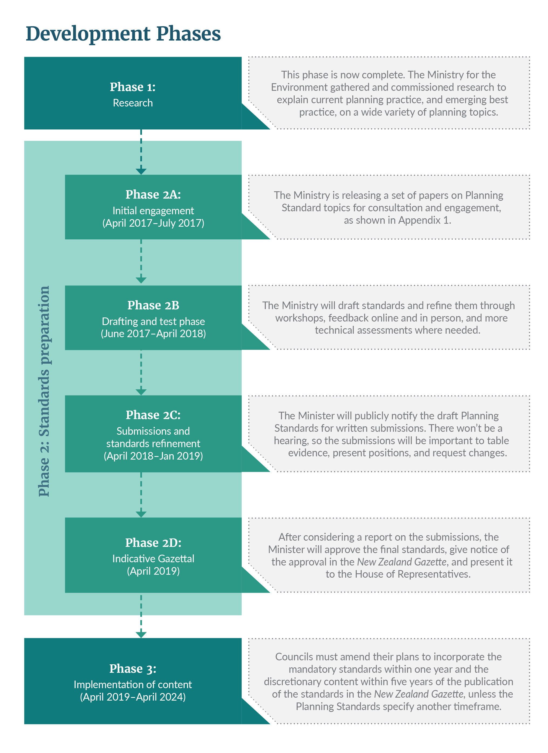

# Section 3: Outcomes and implementation of the National Planning Standards

## Anticipated outcomes

The Planning Standards are an opportunity to resolve the problems outlined in this paper.

**The key outcomes of the National Planning Standards are listed below.**

1. Less time and resources are required to prepare and use plans.
2. Plan content is easier to access, and relevant content easier to find.
3. National direction is consistently incorporated in plans, resulting in better implementation on the ground.
4. Councils focus their resources more on plan content that influences local resource management outcomes and is important to the community.
5. Good planning practice is applied quickly across councils through the National Planning Standards.

## Some plan variation will continue

Even with the Planning Standards in place, plans will continue to have some variation. However, the variation will relate to how councils are addressing a local planning issue. For example, local needs will still be the driving force behind the content of plans. Plan content will be affected by non-Resource Management Act 1991 (RMA) documents, such as strategic plans, spatial plans, transport plans and long-term plans at the district and regional scale. Provincial councils will likely continue to have smaller, simpler plans. Metropolitan councils will continue to have larger, more complex plans. Councils will still likely apply their branding to the published version of plans.

These examples of variation are not what we consider to be unnecessary variation. The National Planning Standards will provide a tool kit for councils to improve consistency in plans where it makes sense to do so. They are not a ‘cookie cutter’ that will make all plans exactly the same. A plan needs to remain a council document to address local environmental issues, and to help implement the vision for the district/region’s development.

## Benefits of the National Planning Standards

Once the Planning Standards are incorporated into plans, we anticipate a number of benefits for the planning system as a whole. Key system-wide benefits include:

* a more efficient plan-making process because the basic structure and format is pre-determined
* a shared understanding among councils and plan users of terminology and key planning techniques
* the national/regional/local policy hierarchy is clear in all plans
* ePlan software is designed around common plan form and structure, fostering innovation and efficiency.

There will also be benefits for particular groups operating in the planning system, particularly for local plan users, councils and other professionals.

### Benefits for councils

Benefits for local councils will include:

* less time and fewer resources spent on the key requirements of plan preparation, allowing councils to focus their efforts on managing local concerns
* more focussed plans that reflect local community values and environmental issues important to communities, while giving effect to national direction more effectively
* more aligned plans, creating opportunities to share resources between councils more easily
* ability to cooperate more effectively on cross-boundary resource management issues identified in plans.

### Benefits for professionals (eg, planners, lawyers, sector groups)

Benefits for professionals will include:

* greater focus on resource management issues specific to a council area, instead of spending time on basics like format and definitions
* professionals working with multiple plans can transition from one plan to another more smoothly
* easier and more efficient to compare and contrast provisions across multiple plans.

### Benefits for plan users

Benefits for plan users will include:

* ability to open any plan and generally know where to find the provisions that apply to them.
* easy navigation and interpretation of maps, particularly online.
* better understanding of what plan provisions mean, how they apply, and awareness of national and regional policies that also apply to a given area.

## Implementation considerations

While there are initial costs in developing and implementing the Planning Standards, the long-term gains to everyone using the planning system is a more effective and efficient system. A system, for example, where a plan user can feel comfortable navigating through a plan from any part of New Zealand, and quickly finding the information they need and being able to act with confidence on that information.

There is a seven-year transition phase before full implementation of the first set of Planning Standards will occur. This transition period involves cost to central government for the development of the Standards and their ongoing maintenance. Costs will also be incurred by local government for the implementation of the Standards in their plans over a 12-month and five-year period (unless a different time period is specified in the first set of Standards).

The costs to local government will be minimised where possible by providing for mandatory changes to plans to occur without a First Schedule process (eg, nationally consistent measurement of noise). The need for other plan changes (and associated resourcing impacts) will vary from council to council depending on the state of their current plan. That is, how closely the plan already aligns with the approach in the Planning Standards and whether the plan is due for a review during the implementation period for the Planning Standards.

Comparatively fewer costs are likely to be incurred for:

* councils that schedule their plan review(s) to align with implementing the Planning Standards
* plans that are already generally consistent with the National Planning Standards, so there is less reformatting and redrafting required
* councils that can work together on implementation, so the resources to update the plans can be shared
* plans that are relatively simple, so amending them is easier.

Acknowledging the above point, we will develop the Planning Standards to be fit for purpose for more complex plans, while also applicable for simpler plans.

### Implementation timeframes

The Act sets out default timeframes for when councils must amend their plans to adopt the National Planning Standards[[5]](#footnote-5). As well, the Act also provides for other timeframes to be set as part of the Planning Standards, providing some flexibility where this is needed for a given standard.

The two default implementation periods in the Act are outlined below. All dates take into account the two-year development process of the standards between 2017 and 2019 and assume that the first set of National Planning Standards is gazetted in April 2019:

* April 2019–April 2020: councils must amend their plans to align with the mandatory content in the Planning Standards, unless the Standards specify a longer timeframe for local councils to do this. While these mandatory amendments can happen without following the RMA Schedule 1 process (saving time and money for councils), there will still be a need to dedicate staff resources to making changes to the plan. The plan(s) will need to be reorganised while keeping the plan content intact, excluding consequential changes to content.
* April 2019–April 2024: councils must choose which of the Planning Standards options they will use in their plans (ie, discretionary directions), and amend their plans accordingly, using the Schedule 1 plan change process within 5 years (unless a different time is specified in the first set).

Decisions about which planning standards are mandatory and which have components that are optional will be made as part of developing the Planning Standards.

For some councils, these timeframes coincide with the need to review their plan under the 10-year deadline in section 79 of the RMA. In this case, the plan change for the review can incorporate the Planning Standards, reducing the overall impact of this change.

If a council has notified its proposed plan **before** April 2019, the five-year timeframe to implement the National Planning Standards in this plan does not start until the plan becomes operative (if no timeframe is specified in the National Planning Standards).



# Section 4: Opportunities to be involved

## Phases of stakeholder input

To ensure the Planning Standards are workable, significant stakeholder input will be required during the two-year development phase. There are three key phases where we will seek input.

### Initial engagement phase: April–July 2017

To support the first engagement phase (April–July 2017), all research reports will be publicly released along with a series of technical discussion papers on different aspects of the proposed first set of Planning Standards.

The discussion papers cover topics such as structure and form, definitions, electronic accessibility among other issues. These papers set the context and issues for a particular topic, inform readers about the research, identify and discuss options, and encourage debate on what the Planning Standards should contain. An overview of the discussion papers is given in Appendix 1.

### Drafting and testing phase: June 2017–April 2018

Initial drafts of the Planning Standards will be made available for targeted feedback. There are likely to be a number of draft iterations that will be released to selected groups, tested, improved, and released again for more testing. We will want to know if the Standards are on the right track and how they could function within existing plans.

### Formal submissions and standards refinement phase: April 2018– January 2019

The Minister for the Environment will notify the draft National Planning Standards for public written submissions. We will be seeking feedback on whether the Standards are fit for purpose. The Minister will establish a process that gives the public, local authorities and iwi authorities adequate time and opportunity to make submissions on the draft. A report and recommendations will be made to the Minister on those submissions. The Minister will consider the report and recommendations, and may make changes to the draft National Planning Standards.

## Opportunities to contribute

During each of these phases there are a number of ways that people can get involved in the process. Some of these are targeted directly at key stakeholder groups such as councils and professional organisations.

### Website and email (all phases)

The Ministry for the Environment’s website includes information about this project, including a description of the National Planning Standards, and research findings. The discussion papers will be made available on the website. Other information about the development of the Planning Standards will be added and updated over time. Anyone, including the public, can email us at [planningstandards@mfe.govt.nz](mailto:planningstandards@mfe.govt.nz), with their thoughts about the discussion papers, the development of standards, and specific questions not answered on the website.

### Online shared workspace for resource management practitioners (initial engagement, drafting and testing phases)

A shared workspace is a secure, online collaborative tool used to support collaboration between Government agencies and their partners. We are looking to use a shared workspace to generate discussion on the National Planning Standards with planning practitioners. Copies of all research documents are located on the shared workspace along with the technical papers. A range of resource management practitioner representatives will be invited to use this forum to engage in debate on the discussion papers with their peers. Most of the work in the shared workspace will take place in the initial engagement and drafting/testing phases.

### LGConnect email discussion group – council employees only (April 2017–March 2018)

If you are a council staff member, and have a question on the National Planning Standards that you think other council staff would also benefit from, subscribe to the [LGConnect](http://www.lgconnect.co.nz) email discussion group on the Resource Legislation Amendment Act. LGConnect is run by the New Zealand Society of Local Government Managers (SOLGM) for the benefit of SOLGM’s members. Local government planners can freely discuss and ask questions on the Act, including the National Planning Standards provisions. SOLGM plans to operate this discussion group for 12 months from Royal Assent of the Resource Legislation Amendment Act, while council staff are learning the changes in this Act.

### Regional workshops (initial engagement phase)

We are planning a number of practitioner workshops in conjunction with existing group meetings and professional networks. Participants will have the opportunity to fully participate in discussions with their peers about the issues and options discussed in the technical papers.

### Submissions (submissions and standards refinement phase)

After the first set of Planning Standards has been drafted, with comments and support from resource management professionals and plan users generally, we will publicly release the draft Standards and request formal submissions. An evaluation report explaining the Standards and their cost-benefit analysis will also be released. Anyone will be able to make a submission.

### Implementation post-Gazettal

We will work with councils to incorporate the gazetted National Planning Standards into their plans. Ongoing feedback from councils on how the Standards are working will be important to keep them up to date and useful to councils over time.

## Pilot councils testing the draft Planning Standards

In addition to the feedback opportunities identified above, more than 20 councils have registered their interest in joining a ‘pilot council’ group. The main purpose of this group is to have council staff trial draft standards as they are prepared, to provide feedback on workability of the standards and identify implementation issues early.

Most of these councils are reviewing their plans, or about to start a plan review process. Being involved in this way helps to ensure the Planning Standards are robust, and helps to ensure their plan review processes are more closely aligned to what the final standards will be.

## Contact for queries

Please direct any queries to:

Phone: +64 4 439 7400

Email: [planningstandards@mfe.govt.nz](mailto:planningstandards@mfe.govt.nz)

Website: <http://www.mfe.govt.nz/rma/rma-legislative-tools/national-planning-standards>

# Appendix 1:

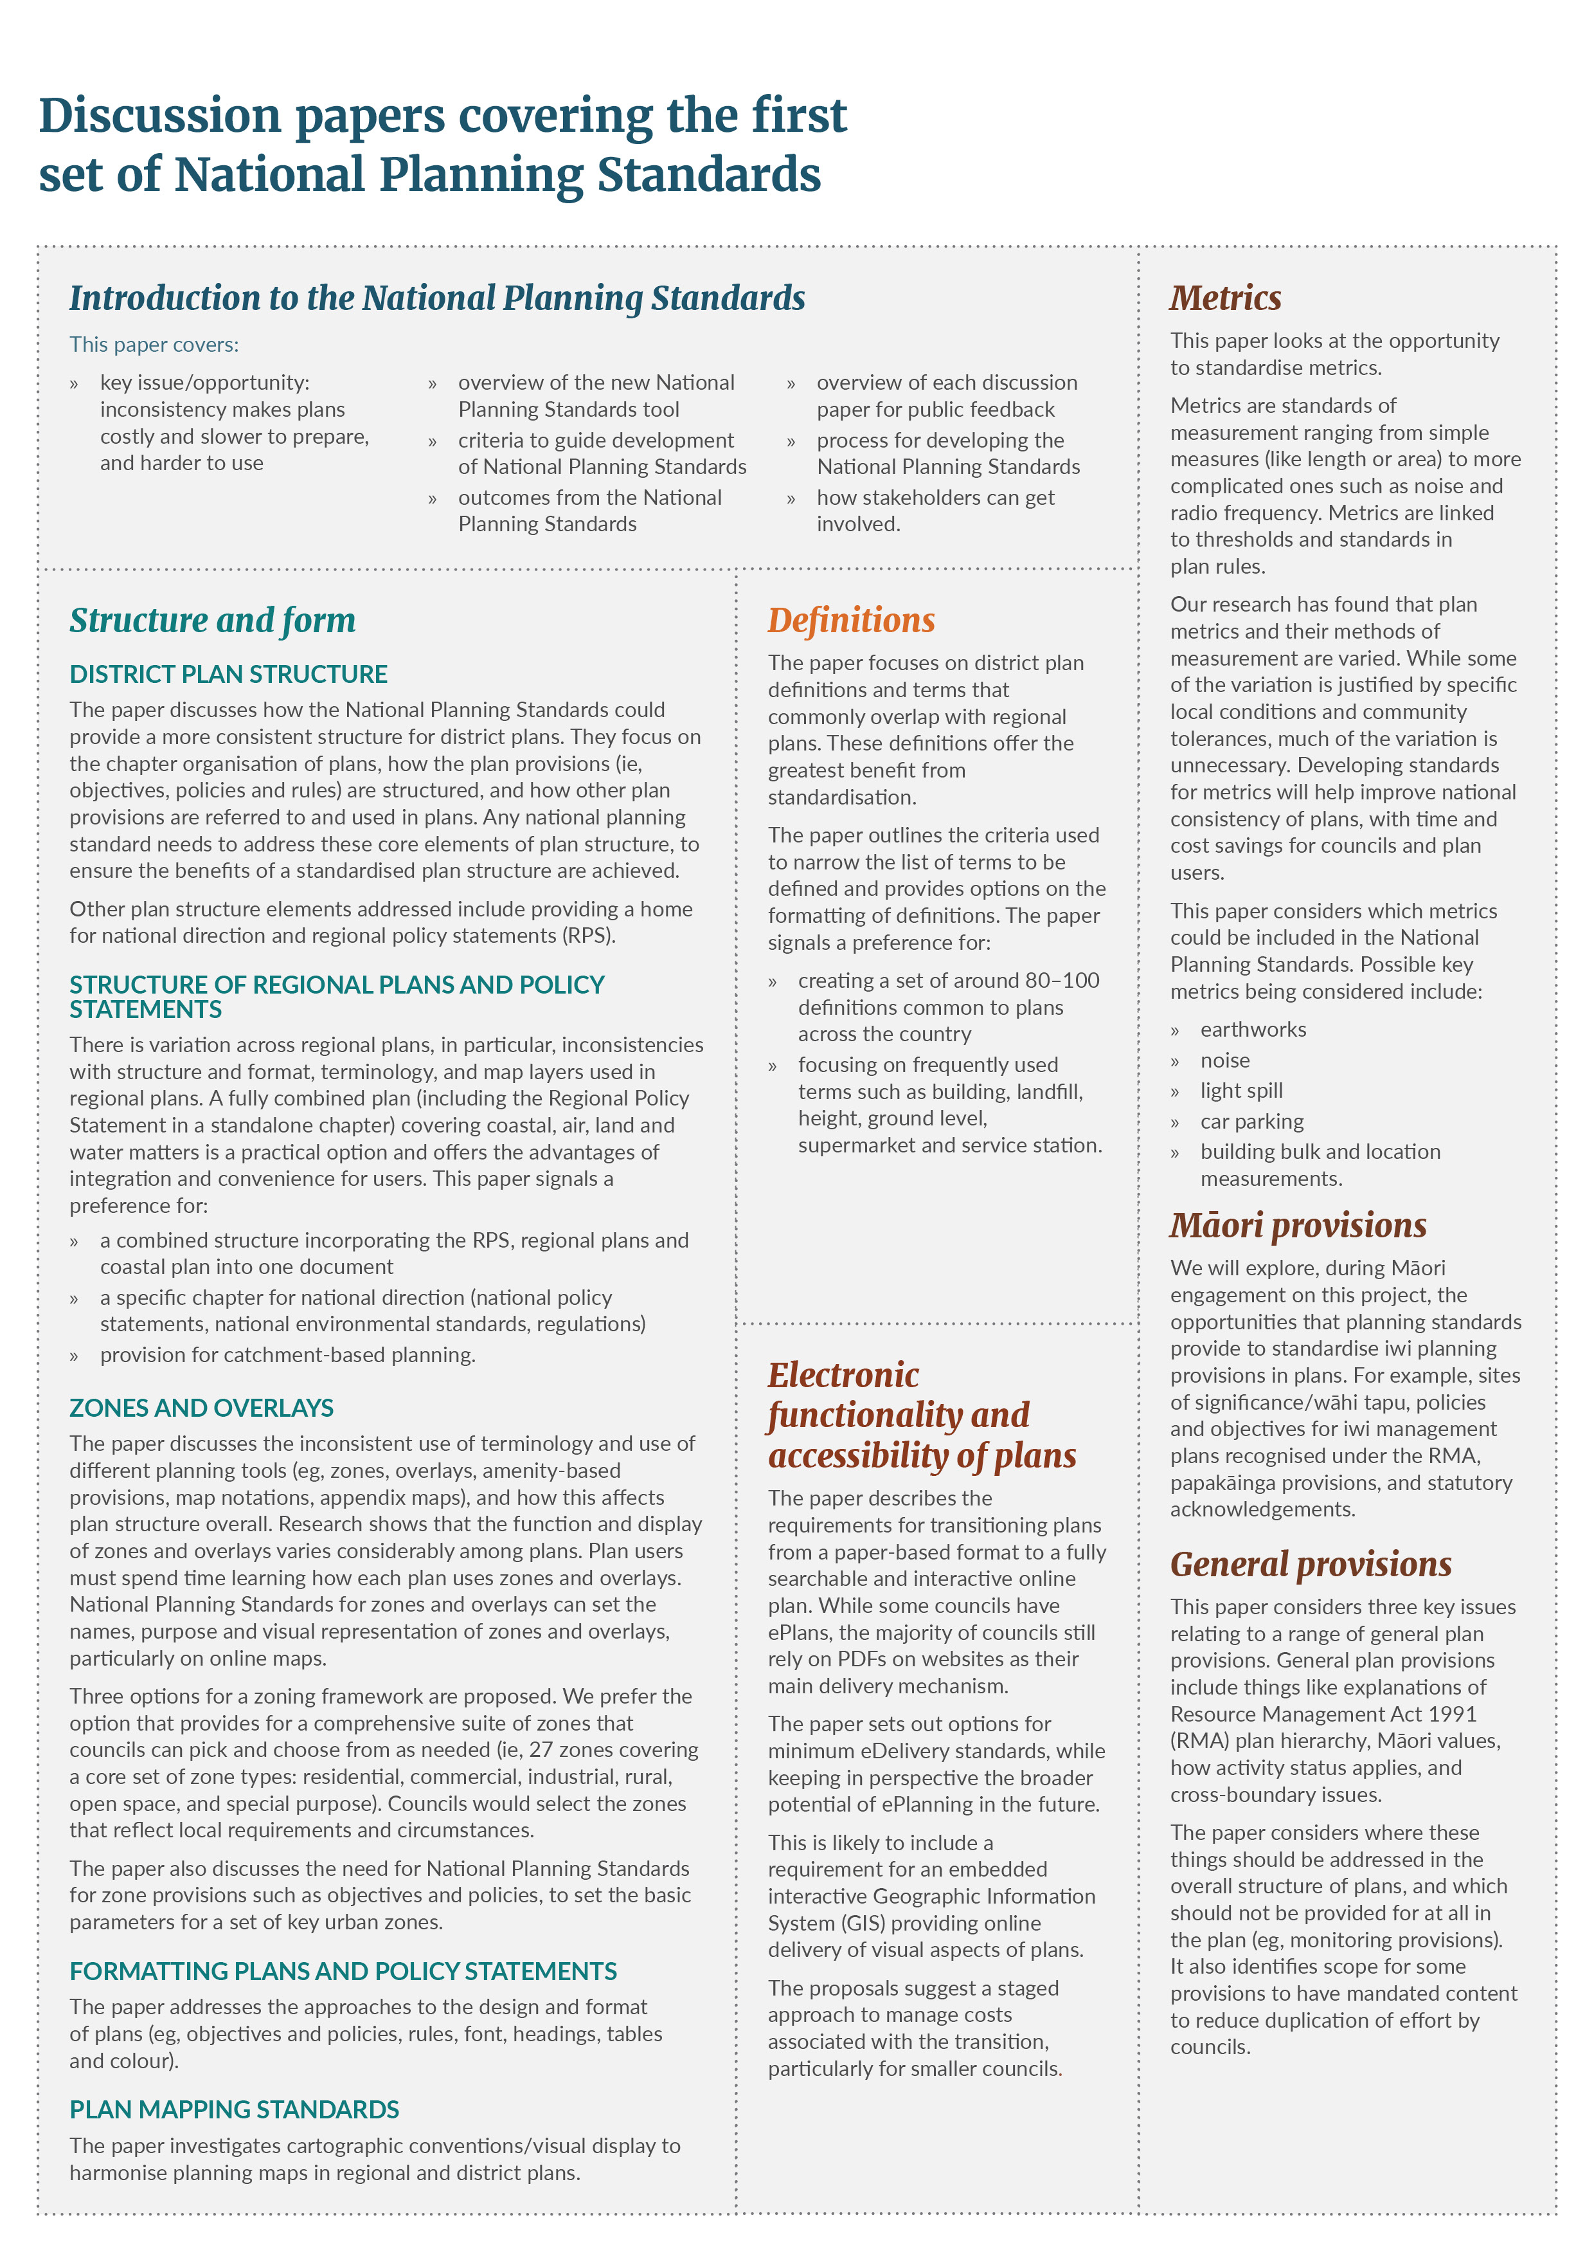

# Appendix 2: National Planning Standards research

**These research reports are available online at:**

[**http://www.mfe.govt.nz/rma/rma-legislative-tools/national-planning-standards**](http://www.mfe.govt.nz/rma/rma-legislative-tools/national-planning-standards)

4Sight. 2015. *Urban Zones*. Wellington: Ministry for the Environment.

4Sight. 2016a. *Compatibility of National Direction Instruments with NPT*. Wellington: Ministry for the Environment.

4Sight. 2016b. *Efficacy of effects-based plans*. Wellington: Ministry for the Environment.

Beca Ltd. 2014. *Potential National Standardisation of Residential Activities under the Resource Management Act.* Wellington: Ministry for the Environment (original report produced for the New Zealand Treasury).

Beca Ltd. 2016a. *Review of Regional Policy Statements*. Wellington: Ministry for the Environment.

Beca Ltd. 2016b. *Review of Structure and Format of Regional Plans, and Interaction with District Plans*. Wellington: Ministry for the Environment.

Beca Ltd. 2017. *Regional Rules Structure and Format*. Wellington: Ministry for the Environment.

Boffa Miskell., 2015a. *Interface between Regional and District Definitions.* Wellington: Ministry for the Environment.

Boffa Miskell. 2015b. *Regional Plan Definitions.* Wellington: Ministry for the Environment.

Boffa Miskell. 2015c. *RMA District Plan Definitions.* Wellington: Ministry for the Environment.

Boffa Miskell. 2015d. *Zones and Associated Spatial Planning Tool Framework Options.* Wellington: Ministry for the Environment.

GHD. 2015. *Resource Management Plan Metric Research.* Wellington: Ministry for the Environment.

Ministry for the Environment. 2013a. *Structure and Format – Internal Ministry for the Environment Research.* Wellington: Ministry for the Environment.

Ministry for the Environment. 2013b. Improving our resource management system. A discussion document. Wellington: Ministry for the Environment

Ministry for the Environment. 2015a. *Effects Based Plan Research: A review of the structure and format of a sample of district and unitary plans*. Wellington: Ministry for the Environment.

Ministry for the Environment. 2015b. *Regional Plans Structure and Format.* Wellington: Ministry for the Environment.

Ministry for the Environment. 2015c. *Regional Policy Statement Structure and Format.* Wellington: Ministry for the Environment.

Ministry for the Environment. 2015d. *Summary of Internal Research as at August 2015*. Wellington: Ministry for the Environment.

Ministry for the Environment. 2015e. *Unitary Plans Structure and Format*. Wellington: Ministry for the Environment.

Ministry for the Environment. 2016a*. Activity Status and Notification.* Wellington: Ministry for the Environment.

Ministry for the Environment. 2016b*. Coastal Planning and the National Planning Template.* Wellington: Ministry for the Environment.

Planz Consultants. 2015. *Spatial Planning Terminology.* Wellington: Ministry for the Environment.

# References

Local Government New Zealand, Simpson Grierson. 2015. Taking the Pulse of Local Government in New Zealand 2015: A report on the issues concerning Mayors and Chairs. Retrieved from: <https://www.simpsongrierson.com/attachments/LGNZ-Survey-doc_final-2015.pdf>

Ministry for the Environment. 2008. RMA Schedule 1 Processes – Preliminary Analysis of Options for Future Amendments

Palmer, G, Blakeley, R. 2016. Submission on New Zealand Productivity Commission’s Better Urban Planning, Draft Report. Retrieved from: <http://www.productivity.govt.nz/sites/default/files/sub-urban-planning-122-sir-geoffrey-palmer-and-dr-roger-blakeley-826Kb.pdf>.

Sherwin, M. 2014. What can be done about regulation? National Business Review,March 22. Retrieved from:https://www.nbr.co.nz/article/what-can-be-done-about-regulation.

1. As described in RMA Section 58B. [↑](#footnote-ref-1)
2. Average RMA plan costs increased from $2.5 million (in 2017 dollars) for first generation plans (Ministry for the Environment 2008) to $3.5 million in 2014/15 (Ministry for the Environment National Monitoring System data). This doesn’t include costs to submitters or economic impact of delays. [↑](#footnote-ref-2)
3. See research papers listed in Appendix 2. [↑](#footnote-ref-3)
4. Refer to sections 58B–58J of the RMA (as amended in 2017). [↑](#footnote-ref-4)
5. See RMA Section 58I [↑](#footnote-ref-5)