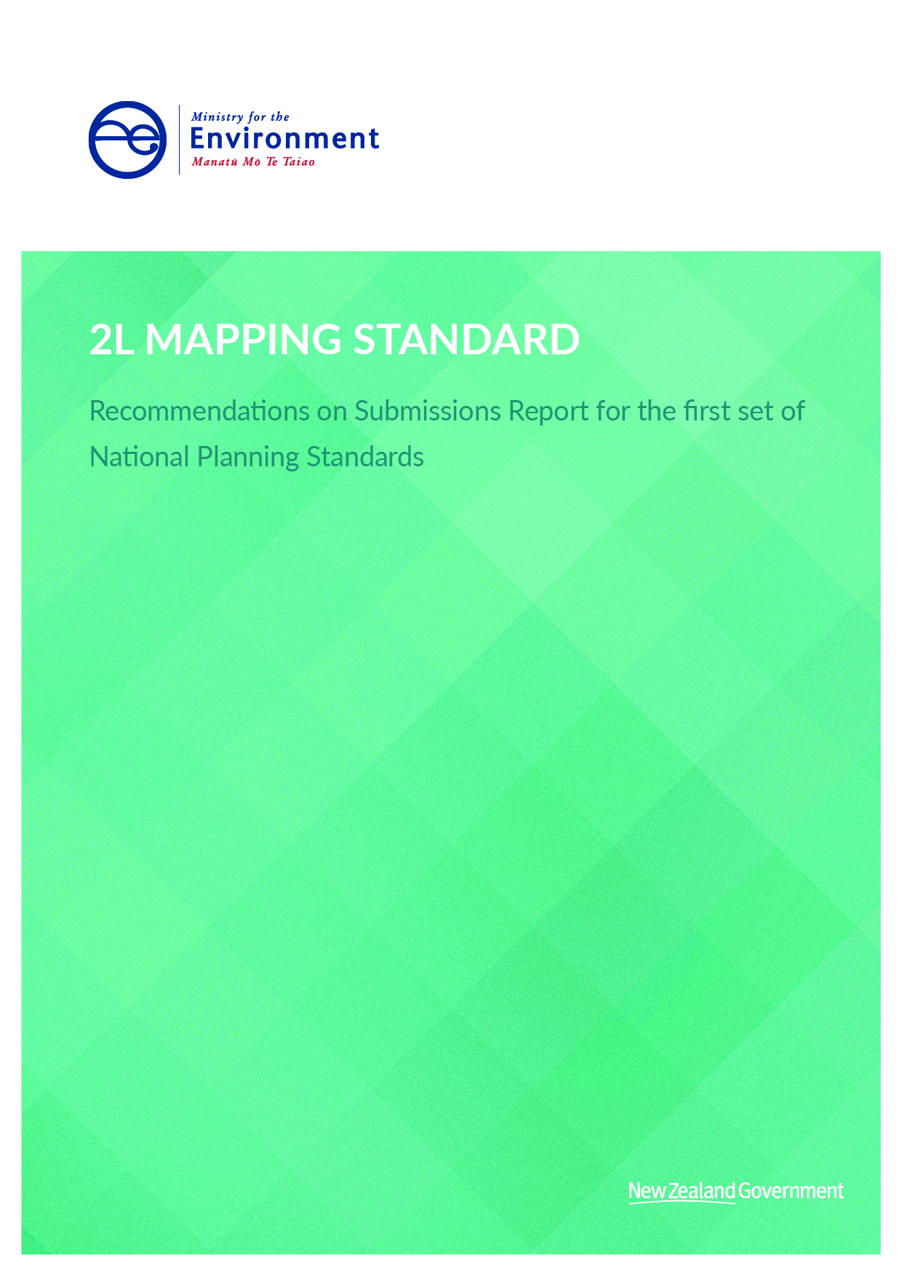

This document may be cited as: Ministry for the Environment. 2019. 2L Mapping Standard – Recommendations on Submissions Report for the first set of National Planning Standards. Wellington: Ministry for the Environment.

Published in April 2019 by the
Ministry for the Environment
Manatū Mō Te Taiao
PO Box 10362, Wellington 6143, New Zealand
ISBN: 978-1-98-857911-5 (online)
Publication number: ME 1407
© Crown copyright New Zealand 2019
This document is available on the Ministry for the Environment website: www.mfe.govt.nz.

Contents
Context to this document 4
1 Overview 4
1.1 Mandatory directions 5
1.2 Zone colour palette 6
1.3 Symbology 7

Context to this document
This document forms part of the suite of recommendations on submissions reports prepared for the National Planning Standards. It should be read in conjunction with the Overall Introduction and is likely to reference other recommendations on submissions reports listed below. The recommendations on submissions reports are organised as follows:
- Overall introduction
- Explanation of all of the recommendations on submissions reports
- High-level submissions analysis
Detailed recommendation reports
- Regional Policy Statement Structure Standard report
- Regional Plan Structure Standard report
- District Plan Structure Standard
- Combined Plan Structure Standard
- Chapter Standards report including
- Introduction and General Provisions Standard
- National Direction
- Tangata Whenua Standard
- Strategic Direction Standard
- District-wide Matters Standard
- Designations Standard
- Schedules, Appendices and Maps Standard
- Format Standard including
- Chapter Form Standard
- Status of Rules and Other Text and Numbering Form Standard
- Zone Framework Standard
- Spatial Layers Standards including
- Regional Spatial Layers Standard
- District Spatial Layers Standard
- Definitions Standard
- Noise and Vibration Metrics Standard
- Electronic Accessibility and Functionality Standard including
- Baseline electronic accessibility
- Online interactive plans
- Mapping Standard
- Implementation of the Standards

Overview
This section addresses submissions on the draft Mapping Standard.
The purpose of this standard was to define how zones and commonly used symbols are displayed on planning maps. We received 64 submissions on this standard. Of these, 21 submissions directly supported standardised mapping and improving consistency between local authority planning documents.
The following issues are covered in more detail in this section:
- mandatory directions
- zone colour palette
- symbology.
Submissions relating to the mapping of sites of significance to Māori are addressed in the Tangata Whenua Structure Standard recommendations report.

Mandatory directions

Submissions
Five submissions sought clarity on the directions to allow flexibility to include additional symbols. West Coast Regional Council requested a direction that clarifies that a symbol must only be included in plans if the features represented by the symbols are provided in plans. Christchurch City Council submitted that the symbology provided does not give sufficient flexibility to enable variations to the symbols where they are required to reflect different subcategories.

Analysis and recommendation
In the draft standards, we included a direction that local authorities may include additional symbols in maps and electronic plans (ePlans) to ensure local authorities still had flexibility. Given the feedback to provide more clarity, we have sought to do this in the revised recommended standards. We also acknowledge that from a data capture perspective, it may be necessary for a different type of vector feature to be used eg, a polygon is used ‘behind the scenes’ in the GIS tool to correctly capture data but is shown on the GIS view or plan maps as a line or point. We consider this is okay provided that the way the symbol is represented on the plan map reflects what is in the planning standards. We also recommend that:
- Symbols appearing in the symbol table apply wherever a symbol is already used in a policy statement or plan for that feature.
- Policy statements and plans may include labels to symbols.
We note the issues that Christchurch City Council raised and have considered these in the relevant discussion on individual symbols in section 1.3.

Zone colour palette

Submissions
We received 56 submissions on the zone colour palette.
The majority of the 56 submissions expressed concern that the proposed zone colours were too similar to be easily distinguished and requested further refinement to make zones distinct. Auckland Council and Christchurch City Council suggested grouping zones with graduations of shade indicating density to improve intuitive reading of the maps.
Six submitters opposed a single colour code for special purpose zones, submitting that plan users will be confused when a council uses more than one special purpose zone. Te Rūnanga o Ngāi Tahu suggested that special purpose zones have no set colour. Tauranga City Council suggested special purpose zones should include transparent hatching. Auckland Council suggested special purpose zones use shades of grey.
We received seven submissions asking for the zone colour palette to be amended to support plan users affected by colour blindness.
New Zealand Telecommunications Forum Inc and Vodafone New Zealand Limited suggested developing a black-and-white colour palette both to reduce the cost of printing and for environmental reasons.

Analysis and recommendation
We agree that the zone colour palette requires further refinement in order to improve the legibility of the zones. We also agree with the concept of grouping zones with graduations of shade to indicate density (and, in fact, did seek to do this in the draft standards), but we acknowledge that further refinement is still possible. We have made some refinements to the colour palette as a result of these submissions. We note also that as plans transition to an ePlan, a plan reader will have additional tools on the map viewer or ePlan to definitely know what zone they are looking at. That is, they will no longer need to match the colour of the zone against a legend located somewhere else in the map book.
In regard to special purpose zones, we acknowledge that a lay user may be confused over why special purpose zones are the same colour. However, interactive GIS viewers provide the ability to enquire about spatial information in detail beyond the name of the zone. We disagree with the proposal that councils can choose to use any colour, as this does not achieve our objective of improving consistency. Our approach has been to avoid cross-hatching as much as possible (as suggested by one submitter) in order to avoid conflict with any overlays developed. We have used a striped symbol for the metropolitan centre zone because Auckland Council is likely to be the only local authority to incorporate this zone and it already uses stripes in its planning maps. We acknowledge shades of grey would work if there were fewer special purpose zones, but it will not provide the desired distinguishing colours in grey scale based on the number of special purpose zones. This is likely why in practice Auckland Council uses one colour for nine special purpose zones for its planning map. Therefore we recommend the status quo of using one colour for special purpose zones. If a local authority considers it beneficial to include labels to distinguish special purpose zones, it can still do so.
Following the submissions on the need for the maps to be workable for people affected by colour blindness, we did some further research into this. We understand people can have one of several different types of colour blindness, affecting their ability to distinguish colours of red, green or blue. We tested the maps with different types of colour blindness filters and, depending on the particular colour blindness issue, one zone would be affected or the other. That is, it has not been possible to finalise a colour palette that caters completely for all types of colour blindness.
However, the shift to ePlans does help to overcome this issue in a way that paper-based plans have not been able to address. Those affected by colour blindness can use the query tools to extract more information than a user would from looking at a planning map and the map legend and then referring to the zone rules.
We disagree with the suggestion from New Zealand Telecommunications Forum Inc and Vodafone New Zealand Limited to have a black-and-white colour palette. Because of the substantial number of zones included, a black-and-white scale would not provide the differentiation needed. We do not recommend developing a black-and-white colour palette.

Symbology
Submitters raised numerous issues about the approach to symbology in the draft standards. These are each addressed in turn below.

Symbology names

Submissions
Dunedin City Council asked for overlays to be used for the matters shown in draft table 22: Symbology table. Dunedin City Council recommended identifying the following symbols as overlay symbols: heritage item, heritage item extent, heritage area, protected tree, protected tree group, marae, noise control boundary and coastal environment.

Analysis and recommendation
We agree that the mapping standard symbols should reflect the purpose statements of the spatial layers. Therefore we recommend amending the description of each name to reflect its corresponding spatial layer.

Point symbols

Submissions
The majority of the 64 submitters opposed the way the point-based symbols are displayed in the draft first set of the National Planning Standards. Auckland Council and Christchurch City Council noted that the complex symbols will not scale well and are likely to overlap with other symbols. New Plymouth District Council suggested using a white circular background in the symbols with a related colour so that is easier to see with other layers. Auckland Council, CivilPlan consultants and Heritage New Zealand suggested using a simple marker.
Most submitters opposed the proposed heritage item in particular. Heritage New Zealand submitted that the symbol represents European buildings of a type almost non-existent in New Zealand. It does not represent the majority of New Zealand buildings, nor does it represent heritage that is not a building or structure. Also it has too much detail, which will become indistinct when reduced to the size of a map marker. Heritage New Zealand argued that it is more important to have the marker connected to heritage information, preferably as a simple, inclusive shape. Porirua City Council submitted that the symbol needs to be a polygon to properly identify the complete extent.
Auckland Council, Upper Hutt City Council, Porirua City Council and Hastings District Council submitted that protected tree group should be displayed as a polygon because it allows for clear identification of a protected area’s extent. Auckland Council suggested the colour match the colour of the protected tree symbol. New Plymouth District Council suggested a white circular background and a green fill colour for the tree so that it “pops”.
New Plymouth District Council supported having a standardised symbol for marae. Heritage New Zealand suggested using a single icon for all heritage, including marae and sites of significance, because distinguishing these symbols reinforces perceived differences and fails to convey the important message that this heritage is all of ours.

Analysis and recommendation
Our approach to designing the initial symbology was to have imagery that clearly signalled what the listed feature is to help the plan user, without the use of a legend. However, in light of the weight of submissions on this issue we did some further testing (shown below in figures 1 and 2) and accept that the proposed symbols for protected tree and heritage item are overly complex shapes that will complicate planning maps, rather than making it easier for plan users, due to issues raised in submissions. Therefore we recommend that point symbols should be displayed as basic shape patterns with a related colour.
Figure 1: Example of protected tree symbology in draft standard
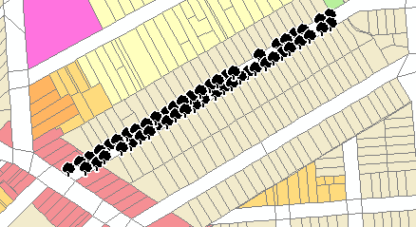
Figure 2: Example of protected tree symbology now recommended for final standard
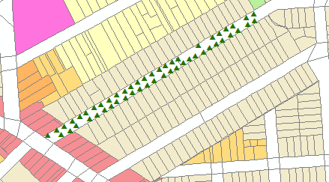
In regard to the heritage item, we accept that a Greek pantheon does not reflect New Zealand heritage. On balance, with submitters stating point symbols should be simple shapes, we recommend that this symbol be converted to a pentagon shape. Finding a colour that can be clearly seen in contrast to underlying zones is a challenge. In this case, we consider the colour should be similar to a zone type in which heritage items are possibly less common, such as industrial. Therefore, we recommend the colour should be purple but still distinguishable within the industrial zones. We also acknowledge the benefits of showing the true extent of the heritage item and recommend a tiled image of the heritage item for this.
In regard to the protected tree group submissions, we agree with submitters that protected tree group is better defined as a polygon in order to display the true extent, especially if it is a large area. We do not accept New Plymouth District Council’s suggestion as it will not resolve the issues the other submitters raised. Therefore we now recommend the protected tree group symbol is a polygon with the same RGB colour code as the protected tree.
In regard to submissions on marae, we acknowledge that the shape of the symbol is too complex for the purpose of planning maps. We accept that there is benefit in conveying the connection of marae to heritage. On balance, we recommend the marae symbol uses the same symbol as heritage item but has a different colour code that reflects traditional Māori colours – specifically, a brownish red, similar to the colour often used at the front of a wharenui.

National grid line and underground cable

Submissions
Hamilton City Council and Tauranga City Council suggested having greater national consistency in the way transmission lines and buffer corridors are displayed. The Joint Southland Councils’ technical submission stated that it is beneficial to display national grid structures on planning maps. It also asked for further guidance on how the symbols should be used.
Transpower expressed concerns about the implications of the national planning standards on appeals of the national grid for Auckland Council. Transpower stated:
Transpower has some concerns about the National Planning Standard being applied to Auckland. The corridor provisions in the Auckland Unitary Plan (Operative in Part) were resolved after both Environment Court and High Court appeals. While the restrictions are generally similar to the corridor provisions sought in other district plans, the mapping of the corridor is very different:
a. Spans are mapped as compromised or uncompromised, depending on the degree of building under the lines;
b. The corridor that applies to subdivision is mapped on a span by span approach, rather than the more generic approach that applies elsewhere.
We consider that the mapping of the subdivision corridor on a span by span approach is limited to Auckland. It resulted from significant work, including peer review by a council engineer. We consider that costs of applying such an approach elsewhere in the country would outweigh any benefit. We also consider that moving away from the approach in Auckland would not be beneficial.
Instead, we consider that it would be appropriate for the National Planning Standards to provide an exemption for certain plans/provisions. In this regard, we consider that it would be appropriate for the Auckland Unitary Plan corridor overlay to continue to apply, and Auckland be exempted from applying any future content-based standards in relation to policies 10 and 11 of the NPSET. The Auckland Unitary Plan situation lends itself to local variation provided for under Section 58D(2)(c).
Draft Mapping Standard (F-2) 42. The Draft Mapping Standard (F-2) includes specific symbols for the National Grid Line and the National Grid Underground Cable. Transpower notes that it may be necessary to distinguish different types of corridors around transmission lines (for example in the Auckland Unitary Plan different scales of hatching are used to identify compromised and uncompromised spans) and local authorities should be able to do that by varying the symbols.
Auckland Council asked for the ability to continue to use polygons to display the national grid and supported the national grid underground cable symbol.

Analysis and recommendation
The intention of the mapping standards is that, if a council uses the symbol in its plans, it must be displayed as prescribed. Auckland Council does not display the national grid line on its planning maps but displays the yard corridor. There is no risk in requiring a consistent display of the national grid line as it will not conflict with the work Auckland Council has done for displaying the national grid information in its Unitary Plan. We also note our recommendations on the implementation timeframes mean that Auckland Council (as a unitary council) will not need to implement this until their next major plan review or by 10 years.
Standardising how the buffer corridors are displayed brings a risk because some councils have multiple types of buffer corridors in their plans with specific provisions for each corridor. If the provisions were more consistent, then it would be appropriate to standardise the symbology. At this stage we do not consider this is possible.
Because the current symbol is misleading to some submitters, we recommend a simplified line with a defined colour to amend this. Auckland Council had no issue with the national grid underground cable but it should be amended to clearly link to the national grid line symbol.

Designations

Submissions
WEL Networks and New Zealand Defence Force supported a standardised symbol for designations as it will help to easily identify designations in planning maps. New Plymouth District Council supported this symbol, stating it tested well with its own submitters. Eight submitters opposed the proposed colour and line width. New Zealand Defence Force suggested representing it as an outline with no fill, given that designations commonly encompass larger areas. Canterbury Mayoral Forum, Christchurch City Council and Kāpiti Coast District Council suggested the symbol include a fill to the polygon in case a plan user looking at a more specific area within a large designation does not recognise they are within a designated area. Western Bay of Plenty District Council suggested a black broken line.

Analysis and recommendation
In regard to the designations symbol, we accept that the colour and width can be improved as blue is commonly associated with water features. Submitters clearly differed in their opinion as to whether a fill is required for this symbol. With no fill you can present more layers without overlap, making the map look less complicated. We disagree that there is a significant risk of a plan user not knowing that what they are looking at is in a designated area if they zoomed in to such a scale. If the user selects a property, it would display provisions relating to that property, including designations. Therefore we recommend amending the colour from blue to a darker brownish colour with no fill.

Heritage area

Submissions
New Plymouth District Council supported the heritage area symbol, stating the solid thick line and colour are user friendly and make polygons easy to understand for the user. Five submitters opposed the symbol. Tauranga City Council submitted the symbol looks too similar to the statutory acknowledgement areas symbol. Upper Hutt City Council expressed concern that the proposed brown colour would blend with aerial imagery. Auckland Council and Hastings District Council suggested that the colour for heritage item and heritage area should be the same.

Analysis and recommendation
We accept that the proposed line width is too large and will not work at a range of scales. We disagree that brown will lead to the symbol being indistinguishable in aerial photography, though we do consider it more appropriate to be the same colour as the heritage item symbol. Therefore we recommend reducing the line thickness and amending the colour to be consistent with the heritage item overlay.

Hazards

Submissions
Most submitters opposed the approach to mapping hazards in the standard because it involves only one type of symbol that encompasses many natural hazards. As raised earlier, Christchurch City Council noted the standard generally did not give enough flexibility to provide for subcategories of symbols. Hazards are a good example of this issue.
GNS Science submitted:
This limited range has the potential to severely limit the ability of councils to appropriately manage risks from natural hazards, including significant risk, which is a matter of national importance. GNS Science supports the concept of standards for mapping natural hazards, and recognises that the proposed standard is a minimum. However, we recommend that the overlay options for hazards, and how they are represented on planning maps, be further reviewed, and we would welcome the opportunity to contribute further to the development of this standard. Appendix 1 to this submission provides details on the key matters we suggest are considered when reviewing the mapping standard.
Waitomo District Council, Queenstown Lakes District Council, Rotorua Lakes Council and Beca Ltd commented that hazard layers often overlap with each other, which may reduce legibility. A solid fill option is undesirable. Western Bay of Plenty District Council stated in its submission that hazard layers can encompass a large proportion of a local authority’s map. For example, ashfall can cover a whole district, hiding or obscuring most other spatial information.
Western Bay of Plenty also commented that this hazard layer does not encompass the breadth of all hazards that can be displayed on maps, such as liquefaction, tsunami and instability areas. Most councils that submitted use multiple layers related to a singular type of hazard that reflect specific provisions in their plans.

Analysis and recommendation
Our initial analysis of hazard mapping in plans shows councils vary significantly in their approach to it. For example, Thames-Coromandel District Council identifies hazard as a risk in a tier system: low, medium and high. Auckland Council and Christchurch City Council provide multiple flood hazard layers. Some councils do not have hazard layers mapped in their planning documents at all. Though local authorities still have the option of presenting additional layers, the current proposed standard does not capture the different approaches to hazard mapping.
Our initial view was that, to achieve some consistency, it could be appropriate to use at least one symbol for the range of hazards and rely on the label to differentiate the type of hazard. This is similar to the approach being used for special purpose zones – one zone colour, but different labels. However, the weight of submissions on this matter suggests this approach is not appropriate either.
We recognise that having natural hazard layers looking the same raises issues and some submitters have suggested adjusting the symbol to make them more workable on planning maps. On balance, we consider there is a broader policy issue here in terms of the need for a consistent methodology for how hazards are mapped. The submissions demonstrate that local authorities are continuing to innovate with new methods for identifying, mapping and managing hazards. Because the National Planning Standards are not currently requiring plan rules, setting a requirement for a standard identifier feature for this spatial information across local authorities could have unintended consequences by limiting emerging best practice. We recommend removing the symbol for hazards at this time, but that we continue to investigate and test this for inclusion in a future planning standard.

Noise contours

Submissions
New Plymouth District Council supported the noise contours symbol, stating it received positive feedback from its community and asked for it to be retained.
Environmental Noise Analysis and Advice Service submitted:
The symbol for “Noise contours (airport, port)” in Table 22 should also apply to “Noise control boundaries” and “Noise effects areas”. Control boundaries and effects areas can define land-use controls but are often adapted from “contours”. The New Zealand Standards referenced in CM-2 recommend “control boundaries” not “contours” on planning maps. The symbol should also apply to other noise controls/control boundaries/ effects areas such as from roads, rail, quarries, industrial sites, motorsport … etc.
Kāpiti Coast District Council and Hutt City Council also requested a broader application for this symbol, rather than restricting it to just airports and ports.
Christchurch International Airport Limited, New Zealand Airports Association, Christchurch City Council and Tauranga City Council opposed this symbol as it does not give enough flexibility for differentiating the types of noise control. Christchurch International Airport Limited submitted:
…there are different sources of noise at airports which are not appropriate for inclusion in one overall overlay. For example there may need to be different contours which distinguish between noise from aircraft taking off and landing and noise from ground running of engines/engine testing.

Analysis and recommendation
We acknowledge through submissions that noise control is used in a diversity of ways that are not restricted to airports and ports in plans across the country. Views are clearly polarised on whether the noise contour should be a single symbol for all noise or allow multiple layer symbols. The National Planning Standards would not be able to prescribe all possible types of noise in planning documents. On balance, we suggest this symbol be restricted only to any noise control boundary, which will allow councils to include further rules on noise-sensitive activities as they see fit.

Coastal environment

Submissions
New Plymouth District Council supported the coastal environment symbol because it received positive feedback as part of the release of its draft district plan. Western Bay of Plenty District Council submitted this overlay will not be needed in district plans that deal with such matters through other sections such as natural environment, landscape and natural hazards. It considered the symbol will also make every map within such an area very messy, being completely covered in blue vertical lines. The council suggested deleting it or replacing it with a requirement to have a single one-page map showing the coastal environment. Trustpower Limited suggested changing the colour to an aqua blue (RGB 0, 176, 240). Waitomo District Council opposed this standard as the Waikato Regional Policy Statement requires a line, not an area of coverage.

Analysis and recommendation
In regard to Western Bay of Plenty District Council’s submission, if the overlay is not used in its plan, then it does not need to be displayed. However, we note that some councils are required to identify the coastal environment and so need a way to do this.
Though we acknowledge Trustpower’s suggestion, we do not believe it is necessary to change the colour if it has already received positive feedback from another local authority.
We considered whether this symbol should be a line or a polygon, based on the submission from Waitomo District Council. While we have a different interpretation of the Waikato Regional Policy statement (ie, it does not explicitly state a line must be used to identify the landward extent of the coastal environment), we accept that there is varied practice on this issue at present. We consider a polygon is a more appropriate vector for identifying an area based map feature and recommend that this symbol remain. This also reduces the risk that property owners within the coastal environment will miss the connection of this feature with their property. In recommending the polygon symbol, we do not agree with the concern that it could create messy plans for councils required to use it. Interactive GIS viewers allow plan users to click layers on and off, and we expect this is a layer that could be turned off as needed.

Statutory acknowledgement areas

Submissions
All six submissions on the statutory acknowledgement area symbol submission suggested using a different colour. For example, Waitomo District Council suggested it was too similar to the heritage polygon symbol and Western Bay of Plenty suggested that removing dark zones or reducing the darkness of such zones would be helpful. Christchurch City Council submitted that no fill on the symbol would mean it would not be visible if zoomed in entirely within its boundary.
New Plymouth District Council (NPDC) submitted that statutory acknowledgement areas are subject to their own legislation. NPDC recognise that statutory acknowledgement areas are common to many councils around New Zealand, but have concerns with the proposed red outline symbology colour that is proposed:
This colour doesn’t promote a positive planning message for Statutory Acknowledgement Areas to landowners. Current challenges with statutory acknowledgement areas in the New Plymouth district is that there are a vast amount of waterbodies with a lot of competing features. A recommended design solution for the standard would be to adopt a neutral/transparent polygon with a grey outline colour so that it can be seen on any basemap and features underneath are still visible.

Analysis and recommendation
Firstly we acknowledge that while not all councils currently have statutory acknowledgement areas, they are becoming increasingly common and some councils are choosing to have these reflected on planning maps.
Given the very different nature of these areas (ie, can cover very large areas, or areas that are map features for other planning purposes as signalled in the New Plymouth District Council submission illustrates) it has been difficult to identify a symbol that is appropriate, works with other symbols and the plan zone colours.
We acknowledge that it is difficult to develop a layer that needs to encompass a large area of a planning map. Our main consideration has been to find a way to make the edge of the polygon stand out from any underlying zone colours, while ensuring that the polygon is still visible if a plan user zooms in to a particular property within the statutory acknowledgement area.
We consider the red colour for the polygon outlines achieves this and aligns well with the colour applied to the marae symbol. The idea of having a transparency layer helps to manage the other concern raised, but we have also been advised that transparency layers create difficulties for accurately interpreting any printed map showing both the transparency layer and zone colours.
On balance, we’ve decided that this printing issue is one that will need to be managed by a cautionary note for plan users when printing plan maps that include the statutory acknowledgement area. Therefore we recommend a polygon layer with a red outline and white fill that has a default transparency of 70 per cent.

Requested additional symbology

Submissions
Seven submitters suggested standardising the following additional symbols:
- gas pipelines
- archaeological sites
- unstable land
- development area
- precincts
- notation for a designation (NoR) stage
- district and regional boundaries
- urban limits
- strategic roads
- formed or indicative roads
- service lanes
- railway line
- esplanade reserves or strip requirements
- surface of water
- site-specific controls
- natural environment features, such as significant natural areas
- outstanding freshwater bodies
- areas that are identified as significant areas of indigenous biodiversity (SNAs)
- outstanding natural features and landscapes (ONFLs)
- coastal marine area
- archaeological sites
- airport approach and transition lines
- network utility overlay.

Analysis and recommendation
We acknowledge that standardised symbols benefit planning maps. In light of the range of feedback received on even the most commonly used symbols, we consider further work and testing would be required before any additional symbols are proposed to be standardised. We recommend revisiting this list in any future work on mapping standards or related policy topics.

