
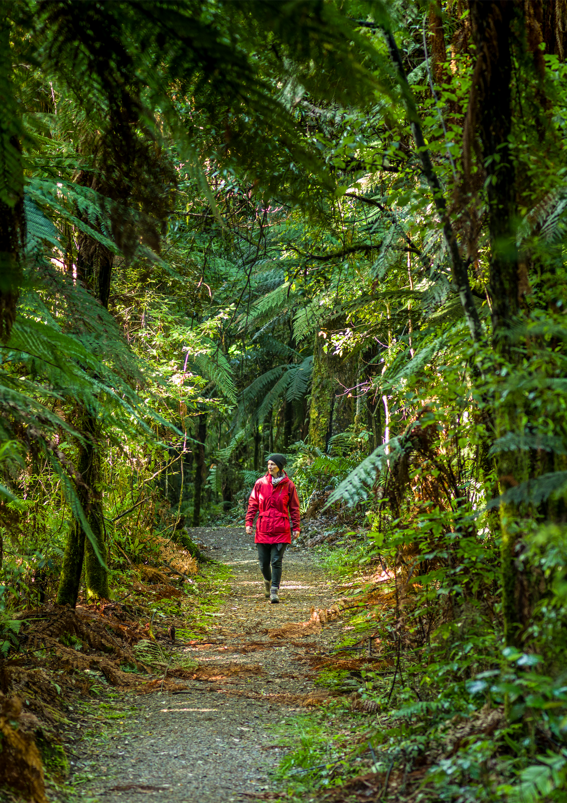

Supported by

Nature & Wellbeing Symposium 2021: Renaturing the places we live.

Summary of proceedings

Report by Dr Catherine Knight

10 August 2021



`

Contents
Contents 2
Background 3
Presentation summaries 4
Incorporating mātauranga Māori into nature and wellbeing frameworks and applications – Professor Meihana Durie 4
Bluespace and wellbeing – Professor Sebastien Chastin 5
A sweep through the nature and wellbeing research – Dr Catherine Knight 6
Getting a dose of nature: how much do we need? – Dr Danielle Shanahan 7
Wellbeing through urban ecology and nature-based design – Dr Maibritt Pedersen Zari & Dr Paul Blaschke 7
Pūniu River Care: Safe places, healthy waters, healthy people – Dr Daniel Hikuroa 8
Kaupapa mauri: weaving biodiversity with mātauranga Māori to preserve and restore mauri within local environments – Tanya Te Miringa Te Rorarangi Ruka 9
Biophilic cities: what can we learn from Singapore? – Tim Park 10
Developing the 20 Minute City in Aotearoa: opportunities and risks – Professor Iain White 11
Bringing indigenous nature back into Kirikiriroa Hamilton and some neighbouring cities – Professor Bruce Clarkson 12
Reclaiming the Ōtākaro/Avon River red zone – Chrissie Williams 12
Te Auaunga: A green infrastructure project driven by the Puketapapa community – Mark Lewis 13
Speakers/facilitators 15
Some concluding remarks 19
Appendix: Symposium programme 21

Background
This symposium, held on June 18th 2021, brought together experts from a wide range of fields to explore how we can incorporate more nature in and around the places we live in Aotearoa New Zealand. This is based on the recognition that by integrating more nature into our towns and cities, we can achieve a range of benefits: better human health and wellbeing, improved ecological and environmental outcomes and strengthened climate resilience.
As the first of its kind on the topic of nature and wellbeing, the symposium provided a valuable opportunity to reach across the disciplinary spheres, including ecology, planning, policy, public health, education, landscape architecture, engineering and academia.
About 120 people attended the symposium in person, while 88 registered to attend virtually. In addition, many people who did not register have watched video recordings of the symposium, available on Youtube and Vimeo.
This document has been prepared as a written record of the symposium presentations, their key themes and ideas. It is hoped that it will be a useful reference for those who attended, as well as anyone who has an interest in this topic, both in Aotearoa and beyond.
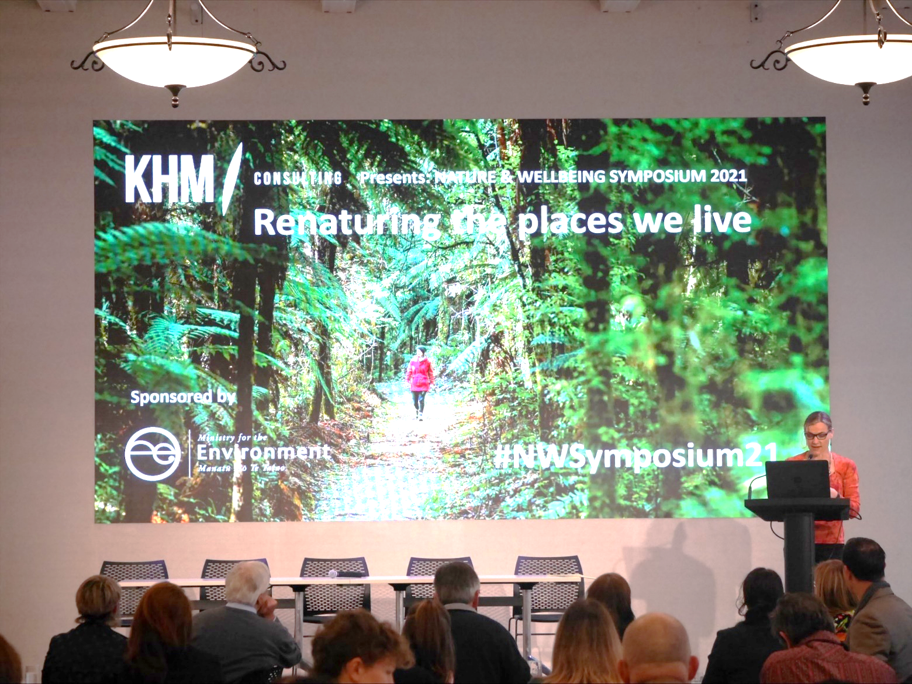

Presentation summaries
Our speakers covered a broad range of issues and ideas in their presentations. This section provides summaries focusing on the elements most relevant to the theme of this symposium – the connection between nature and wellbeing. To appreciate these presentations in their full context, we recommend watching the videos, which can be viewed at the links below.
Part 1: Welcome and Panel 1
- Panel 1 skip forward to 7.28
Part 2: Panels 2, 3 and wrap-up discussion
- Panel 3 skip forward to 1.33.54
- Wrap-up discussion skip forward to 3.17.55

Incorporating mātauranga Māori into nature and wellbeing frameworks and applications – Professor Meihana Durie
In this presentation, entitled ‘Kia toi te mana, kia tau te mauri’ (Harnessing connections between the environment and whānau wellbeing), Professor Durie examined the role of kaitiakitanga in the environment, and the interactive nature between how we give expression to kaitiakitanga and how we gain wellness through the expression of custodianship.
“When mana and mauri flourish, people and the environment flourish.”
Professor Durie provided a number of examples of how architecture, including landscape architecture, can facilitate this process. Just one example of this is ‘He ara kotahi’ (meaning ‘pathway that brings people together’), a pedestrian bridge and walkway which connects the city of Te Papaioea (Palmerston North) to the countryside east of the Manawatū River. Not only does this bridge act to physically connect these spaces, allowing the community to explore beyond the limits of the city streets and walkways, it also acts to connect through a range of narratives both past and present. In its design and construction phases, the walkway needed to negotiate physical barriers, but also the wāhi tapu (or sensitive spaces) of the mana whenua, Rangitāne. Professor Durie also explained how it has also opened up a conversation about how, as a community, the people of the Manawatū engage with the environment.
Professor Durie used a number of examples, including the Ngā Purapura (Hauora Centre) building in Ōtaki, and Mana Tamariki Te Kōhanga Reo, in Te Papaioea, to demonstrate how kaitiakitanga is activated by kawa (rituals) that emphasise space, place and thresholds.
Professor Durie also talked of the god Māui, who harnessed the sun to slow down time, and taking inspiration from this mythology, he suggested that we need to slow down our frenetic pace of life, to think about our relationship with the environment in which we live, and from that, ‘good things will come’. Professor Durie further noted that ‘when mana and mauri flourish, people and the environment flourish’.
Professor Durie also urged us to think about the idea of tapu in the context of kaitiakitanga, and in this context he defined tapu as an invisible forcefield which encircles anything we think is sacred. He invited us to think about our role as part of a collective investment to ensure that tapu is maintained, to protect the mana (spiritual vitality) and mauri (physical vitality) of the environment in which we live.

Bluespace and wellbeing – Professor Sebastien Chastin
Professor Chastin presented on the influence of blue space on human health. He noted how the therapeutic powers of water have been explored through art and mythology from ancient times and across cultures. Now, researchers are seeking evidence of the restorative capacity of water, and how to harness these benefits to increase health at the population scale.
Professor Chastin explained how this restorative power is instinctively known to us also. He introduced the powerful phenomenon of the ‘mammalian dive reflex’, whereby immersion in water – or even the action of splashing water on the face – acts to slow down the body, particularly the heart rate and metabolism.
Professor Chastin referred to population scale studies in which people who live near the sea report better health, including those who live in socioeconomically deprived areas. An opportunity arose to study these effects and to better understand the mechanisms by which blue space influences health when in 2000 the Scottish government decided to restore the derelict canal network in Glasgow, primarily for economic and climate resilience reasons.
Over 18 years, as this regeneration was taking place, researchers followed the health of the Glasgow population and found a three percent year-on-year decrease in mortality rate of people living within 250 metres of the canals. This effect was most marked in Glasgow’s most deprived areas – in other words, the restoration of the canal network acted as a health equality leveller. The researchers also found that the closer an individual lived to the canals, the less likely they would be to have a non-communicable disease (e.g., cardiovascular, stroke, or respiratory diseases), take medication or experience mental health issues. That effect was also most evident in most deprived neighbourhoods.
“…the powerful phenomenon of the ‘mammalian dive reflex’, whereby immersion in water – or even splashing water on the face –acts to slow down the heart rate and metabolism.”
Researchers were also keen to understand the mechanisms driving these effects. The first driver is physical activity, because the rejuvenated canal network provided spaces for physical activities such as walking or cycling. The second is the direct restorative effect that water has on our wellbeing, decreasing stress. The third is theoretical (i.e., there is not yet evidence of this in the body of research), and that is that blue space provides for social connection. This is important because social dislocation and loneliness are known to be drivers of poor wellbeing, especially among the older population. Finally, there is likely to be flow-on effects from having more functional blue space in a city, including such environmental outcomes as cleaner air as a result of sections of the population using the paths along the canals for cycling rather than using a vehicle.
Professor Chastin and his team are exploring how the benefits of the restored canal network can be extended beyond 250 metres, by enhancing access, guiding people to the spaces, and encouraging more usage in other ways. As part of this, the research team will be seeking to understand the factors that influence usage.
In practical terms, the clear benefits demonstrated by this study point to the potential benefits of green and blue ‘prescriptions’, whereby medical practitioners prescribe activities near blue or green space, in turn reducing reliance on medication or other medical interventions.

A sweep through the nature and wellbeing research – Dr Catherine Knight
In this presentation, Dr Catherine Knight provided a brief overview of the research into the link between research and wellbeing. While people have known about the link between natural landscapes and wellbeing since ancient times, contemporary research has been strongly influenced by the pioneering research in the United States in the 1980s – much of it in the field of psychology.
Two theories generated from this research have become particularly influential. The first is the Stress Reduction Theory, which proposes that looking at scenery containing natural elements creates positive emotions and feelings and has a restorative effect, thereby easing our state of alert following a stressful situation. The second is the Attention Restoration Theory, which posits that interacting with nature allows our cognitive mind to rest, making us feel less stressed and less anxious, and therefore happier.
Since this pioneering research was undertaken, there have been a multitude of studies, mainly in the United States and Europe, but increasingly in Asia (especially Japan and South Korea) too. Studies have found exposure to nature or urban green space leads to improvements in mood, lower levels of stress, reduced symptoms of depression and anxiety, and improved cognition in children with attention deficits and individuals with depression.
“…we need to renew our towns and cities so that nature is integrated throughout, so that we can experience nature as part of our ‘natural rhythm of life’.”

Only limited research had been taken on the link between nature exposure and wellbeing in New Zealand – at the time of researching Nature and Wellbeing in Aotearoa New Zealand (Totara Press, 2020); most of the studies were quite small and qualitative. However, a series of New Zealand-based studies have recently been published, including three longitudinal studies tracing children’s health in relation to nature exposure. The first study showed decreased incidence of ADHD (attention deficit hyperactivity disorder) among children living in rural environments, another showed that children living in greener environments had a reduced chance of developing asthma, and the third found a link between childhood exposure to plant diversity and decreased risk of leukemia and possibly other immune diseases. A further study found improved postsurgical recovery for people living in greener neighbourhoods – these people took less medication and lived longer following hip surgery. The study concluded that improving access to the natural environment may therefore be an effective component of a patient’s postsurgical recovery programme.
Dr Knight noted that the pandemic, ironically, caused by human destruction of and encroachment on the world’s once wild places, meant that the ‘neighbourhood nature’ – the parks, reserves, stream corridors and gullies in the towns and cities in which 86% of New Zealanders live – became all the more important. In her book, Nature and Wellbeing in Aotearoa New Zealand, Dr Knight argues that if nature is good for us, just as clean water and clear air is, then every New Zealander has an equal right to have access to nature – irrespective of where they live or their socioeconomic circumstances. Therefore, she argues, we need to renew our towns and cities so that nature is integrated throughout, so that we can experience nature as part of our ‘natural rhythm of life’.

Getting a dose of nature: how much do we need? – Dr Danielle Shanahan
In this presentation Dr Danielle Shanahan discussed the research in relation to nature dose – in other words, the minimum level of nature exposure people need, on average, to experience health benefits such as reduced blood pressure and improved mental health. The research Dr Shanahan has undertaken concluded that the minimum dose is 30 minutes a week, but that benefits will continue to accrue beyond that minimum time. Dr Shanahan also emphasised that there is a high degree of variation between individuals.
Dr Shanahan noted that while many cities have policies related to minimum green space, researchers are starting to understand that not all green space is the same in terms of wellbeing benefits delivered. For example, research led by Australian conservation biologist, Professor Richard Fuller, found that interaction with green spaces with higher levels of biodiversity magnify health benefits (a finding echoed in the New Zealand-based research cited above).
Dr Shanahan discussed the unique opportunity that Wellington currently presents, as a city in which biodiversity is increasing rather than decreasing. In particular, understanding how what people do in nature (for example, involvement in community-based pest trapping initiatives) influences health and wellbeing. Further research seeking to understand these factors will measure improvements in indicators such as blood pressure and measures of mental health but also focus on social cohesion as a mechanism to improved wellbeing.

Wellbeing through urban ecology and nature-based design – Dr Maibritt Pedersen Zari & Dr Paul Blaschke
Dr Paul Blaschke presented on the relationship between urban ecology, nature-based design, and health and wellbeing outcomes. Dr Blaschke described the continuum of natural areas that people interact with, ranging from private gardens, urban streetscapes, urban parks, peri-urban green spaces and scenic reserves, through to regional or national parks.
He noted that wellbeing benefits associated with nature have often been framed within an ecosystems services paradigm – an example being the research commissioned by the Department of Conservation and undertaken by Dr Linn Roberts in 2015. Dr Blaschke noted that in Aotearoa New Zealand we have the benefit of the concept of ‘hauora’ – a more wholistic approach to wellbeing, which Sir Mason Durie gave expression to through the ‘Te whare tapa whā’ model (the four pillars of wellbeing – physical health, spiritual health, family health and mental health) – all supported by te whenua (the land).
Layered over the human wellbeing benefits driving applied urban ecology, we now have a clearer understanding of the co-benefits of urban nature, including for climate resilience.
Dr Maibritt Pedersen Zari presented on biophilic design – harnessing the creation and celebration of human-nature relationships in spatial design to increase wellbeing. Dr Pedersen Zari explained the concept of ‘biophilia’, developed by E. O. Wilson, which refers to the innate emotional affiliation that human beings have with other living organisms. In more recent times, the idea of ‘urgent biophilia’ has emerged, whereby humans, both as individuals and communities, seek out engagement with nature in the face of crisis. This may, in part at least, explain the upsurge in nature and greenspace engagement during lockdown, for example. During this period, a researcher found that as many people identified mental wellbeing as the reason for visiting a local park in Wellington as those who identified recreation as their primary reason.
Based on understandings of wellbeing effects from nature interactions emerging out of a growing body of psychological and other research, landscape architects have been increasingly drawn to biophilic design. Dr Zari Pedersen introduced the field of ‘regenerative architecture’. This goes beyond ‘sustainable architecture’, which focuses on minimising its environmental imprint, and instead is underpinned by the motivation to enhance the environment. Regenerative architecture can do this by mimicking ecosystems – for example, a coral reef or a rainforest. In other words, it is a form of architecture that provides similar services to natural ecosystems. Dr Pedersen Zari noted that some of these functions will be much harder to achieve than others, functions that range from nutrient cycling, energy generation, habitat provision and food provision, among others. She also proposed that architecture itself can act as greenspace, for example (a point well illustrated by Tim Park’s presentation).

Pūniu River Care: Safe places, healthy waters, healthy people – Dr Daniel Hikuroa
Dr Daniel Hikuroa presented on Pūniu River Care, a marae-based initiative to help restore the health of the awa, restore the ngahere (forest), and build stronger human connections between marae, whanau and the wider community as a whole. The initiative also serves an important social and cultural role, enabling its more than 30 staff to learn, connect with each other and the awa/whenua, and practice kawa (customary practices associated with the marae).
“To heal our waters through genuine aroha collectively together is to heal ourselves.”

Dr Hikuroa first explained how in the Māori world view, people are just one element in relational networks known as whakapapa, linked with all other living beings through shared descent from ranganui (sky father) and papatūānuku (sky mother). Thus, humans exist on a kinship basis with te taio (the earth), the universe and everything in it, and whakapapa is the central principal that orders and makes sense of the world.
Unlike a regular commercially run operation, Pūniu River Care is tikanga-driven (tikanga is the customary system of values and practices that have developed over time and are deeply embedded in the social context), and everything it does has a wairua (spiritual) component. Every decision is based on such criteria as whether the decision will improve the mauri of the people, the river or the environment as a whole; whether it will strengthen whanaungatanga (family connections, a sense of belonging) with other people, or with the environment – the river, birds and trees; or whether it will enable the people to exercise their role as kaitiakitanga.
Dr Hikuroa sees Pūniu River Care as part of ‘creating a fairer world where care is given and received by whenua and tangata whenua’. Framed differently, he says, ‘this form of communion is a universal right, revoked from so many people through urbanisation, capitalism and high-carbon economies and the ongoing ramifications of colonialism’. Further, he states: ‘to cultivate a relationship with the land and the water in our modern world is viewed by many as a radical act, yet it is rekindling relationships that have been severed, neglected or even outlawed’.
Rekindling these relationships is the first step towards better health and wellbeing, and improved environmental and ecological outcomes. Through connecting with the awa, repo (wetlands), the whenua, and ngahere ‘we are recalling our own personhood, through connecting, we are showing what it is to be human. To heal our waters through genuine aroha collectively together is to heal ourselves’.

Kaupapa mauri: weaving biodiversity with mātauranga Māori to preserve and restore mauri within local environments – Tanya Te Miringa Te Rorarangi Ruka
Tanya Te Miringa Te Rorarangi Ruka presented on her work as an artist and explained how it has evolved to encompass kaitiakitanga. She also presented her proposal for a community rongoa (healing) forest in Brooklyn, Wellington.
“I was no longer able to sit in the beauty of the landscape without acknowledging the unfolding crisis of our ancestral environment.”

Tanya is an indigenous artist who has spent the last 20 years or more developing art practice informed by te ao Māori concepts and, through her art, working to reconnect with the natural world. Her work focuses on wairuatanga – the spiritual aspects of connection through whakapapa to the atua (gods). Tanya specialises in creating immersive spatial installations using video and sound. But she reflected how recently she came to a stage in her work where she ‘was no longer able to sit in the beauty of the landscape without acknowledging the unfolding crisis of our ancestral environment’. Since then she has been focused on how to draw on her art practice in service of the environment, and to create positivity for the future when everything seems so negative.
In Wellington, Tanya has been exploring the kaupapa of a rongoā forest, a shared community space where people can learn about the healing qualities of the forest, connect with nature and each other. As conceived, the rongoā forest would provide the following opportunities:
- for people to learn about the forest from a mātauranga Māori perspective
- to learn about the healing properties of the forest – for medicinal purposes and for food but also through the senses of sight and smell
- a place for rongoā practitioners/wild food foragers to hold workshops
- a place for artists and other creatives to hold workshops in connection with the forest
- a place for local schools to learn about biodiversity.

She has found a suitable site at Eliot Park, Brooklyn. It is easily accessible from the surrounding residential community, and encompasses many natural pathways as well as spaces to plant beneficial trees and shrubs. Tanya has also received an arts commission to create a smaller rongoā forest in the Wellington CBD.
Tanya is keen to see rongoā forest programmes integrated into the school curriculum, interweaving mātauranga Māori, science, art and technology. Such a programme would enable rangitahi to be kaitiaki of the ngahere, including its planting, growing and maintenance, as well as grow their knowledge of rongoā.

Biophilic cities: what can we learn from Singapore? – Tim Park
Tim Park presented on what he learned from the Biophilic Cities Singapore Summit, held in 2019. Members are from a global network of cities that are trying to better integrate with nature. Member cities are concerned with how law and policy encourage and protects nature in cities, how nature and biophilic design and its outcomes are measured, how to encourage education outreach and support and encourage biophilic design.
In his presentation Tim showcased a number of exemplar green buildings and developments including Oasia Downtown, whose external walls replicate a cliff-face ecosystem, the Park Royal Hotel and the Kampung Admiralty apartment complex, all designed by architect Mun Summ Wong, who coined the concept of ‘breathing cities’.
Tim’s presentation also included the Khoo Teck Puat Hospital, which is fully integrated into its natural surrounds, including a roof garden growing food for occupants, and open-air circulation. The complex was specifically designed for better health outcomes – measured by decreased blood pressure.
The government in Singapore also recognises the role city parks can play in connecting people with place, with other people and providing a sense of purpose. Many of the residents of inner-city apartments are retired people, used to village life but who no longer have gardens or other communal spaces to tend. The authorities provide sheds and equipment for volunteers to help maintain the park, which enables people to freely undertake this activity, and benefits the wider city community, as it helps keep the park well-maintained.
A further programme of work in Singapore is research into therapeutic gardens, including what species and species composition maximise therapeutic benefits.

Developing the 20 Minute City in Aotearoa: opportunities and risks – Professor Iain White
Professor Iain White spoke on the opportunities presented by the 20-minute city concept and how, faced by multiple crises – including housing, biodiversity decline and climate change – we must create whole-of-system shifts, rather than attempting to address each problem in isolation.
He encouraged the audience to think about how we want our future cities to look and function. The current emphasis (particularly in the face of the housing crisis) has been on how to build more houses, but he argues that our thinking must also encompass how to improve the lives of existing residents – i.e., from quantity of dwellings to quality of places.
The 20-minute city concept is simple: it is the idea that we build our cities (or neighbourhoods within cities) so that residents have everything they need for ‘a good life’ within a 20-minute walk, cycle or public transport trip of their home. This includes education, work, health services, links to public transport, recreation, shopping and other services. The concept centres on people’s time and freeing up more of it so that people are able to slow down and have more time to do the things they enjoy.
He emphasised that none of the mechanisms for achieving 20-minute cities are new, e.g., mixed-use zoning, walkability and active transport, sustainability or focus on quality of life – but these principles require bold political leadership to turn into reality. He also makes the point that designing cities in this way does not need to be more expensive – it is more about shifting budgets and priorities.
“Imagine a city where we can hear birdsong anywhere and at any time, and then think about what needs to be done to achieve this.”

In 2020, Professor White, with support from Hamilton City Council and NZTA, submitted a proposal to implement the 20-minute city concept in Hamilton as a shovel-ready infrastructure project. While attracting glowing reviews, the proposal did not receive funding but continues to enjoy support from the city council and other stakeholders.
The 20-(or 15) minute city concept in its current form (because cities built before the advent of the motor vehicle were designed on this principle by necessity) originated in Portland, Oregon and is now most advanced in Melbourne, Australia. Paris is also well advanced in implementing the 15-minute city concept.
As an example of how we might envisage a city of the future, Professor White challenged us to imagine a city where we can hear birdsong anywhere and at any time, and then to think about what needs to be done, from a planning perspective, to achieve this. This requires an entirely different approach to planning, requiring integrated, vision-led thinking.

Bringing indigenous nature back into Kirikiriroa Hamilton and some neighbouring cities – Professor Bruce Clarkson
Professor Clarkson drew on his experience of restoring native ecosystems in our cities over 25 years or more, including Hamilton’s gullies. He emphasised that in New Zealand there is in fact only one ecosystem – a fully coupled system of land, freshwater and marine. However, we have lost much of our indigenous ecosystems – coastal and lowland forest, wetlands and estuarine systems, with most of our remaining indigenous ecosystems surviving only in upland and montane areas. Many cities have few indigenous ecosystems or even areas of indigenous vegetation remaining in or near them. Professor Clark emphasised that if indigenous ecosystems are to be restored as permanent features of the landscape, they must be fully connected both with the peri-urban areas of nature around our cities, out to the ‘wilderness areas’ of our national parks.
When working with councils on nature restoration projects, Prof Clarkson and his team always ‘sell’ the projects on the multiple co-benefits, for example:
- filtering air and water
- cooling heat islands
- carbon sequestration
- health and recreational benefits
- spaces for a range of uses
- opportunities for social connection.

Reflecting a major political shift in Hamilton City, the ‘Nature in the City Strategy (2020 – 2050)’ has recently been adopted by Hamilton City Council, and sets aside $29 million over the next 10 years to restore Hamilton’s gullies.

Reclaiming the Ōtākaro/Avon River red zone – Chrissie Williams
Chrissie Williams presented on plans to create an extensive river park in the Christchurch red zone, the land that was severely damaged in the 2010 and 2011 Canterbury earthquakes and which cannot be redeveloped for residential use. The red zone primarily comprises suburbs in eastern Christchurch, on both sides of the Avon River as it flows out to the sea.
The Avon Ōtākaro Network and other groups have long advocated for the approximately 600 hectares of land to become a river park. Research commissioned by the group (undertaken by Peter Tait and Suzanne Vallance at Lincoln University) calculated that a river park would bring benefits of a value of about $94 million a year, including health cost savings and the value of ecosystems services.
In 2019, plans for a river park became official with the government and city council rubber-stamping a regeneration plan to designate 345 hectares of the land into a ‘green spine’ (along the river), with large areas of ecological restoration planting and a city-to-sea pathway.
Chrissie explained that even without human intervention, nature is already reclaiming the red zone. For example, the former suburb of Bexley has now become ‘Lake Bexley’. The city council is also assisting nature in this process of ‘rewilding’, by creating constructed wetlands, and shifting stopbanks away from the river to create more space for wetland habitat.
She noted that people have been reclaiming the red zone too – this was especially noticeable during the lock-down in 2020. Because of the proximity of the red zone to lower socioeconomic communities, it has become an especially valuable (and equitable) space. People are able to walk or bike safely to the red zone, without the need for vehicles (as compared to other popular natural recreational spaces such as the Port Hills or Banks Peninsula, for example). Community gardens have been established, foraging activities are thriving and many groups use the river for kayaking, waka ama and other water-based activities. There are a number of child-led projects including 16 nurseries in different schools, where seedlings from eco-sourced seeds are cared for and then planted at community planting days attended by up to a few hundred people. These initiatives provide for many opportunities for social interaction as well as physical activity and connection with nature.

Te Auaunga: A green infrastructure project driven by the Puketapapa community – Mark Lewis
Mark Lewis presented on the Te Auaunga/Oakley Creek restoration project in Mt Roskill, Auckland. This project began as a stream ‘reprofiling’ project, in an effort to mitigate flooding in the suburb. Flooding had long been an issue in the area, due to it being at the confluence of lava flows of two volcanoes, becoming a natural ‘impoundment’ (retention area) for water. Waterways had been straightened, channelised and heavily lined with concrete in an attempt to increase the ‘hydraulic efficiency’ of the streams. Over time this effect has been exacerbated by the increase in impermeable surfaces, stormwater outflows and other pressures.
Auckland Council and their mana whenua partners recognised that this could be an opportunity for much more than a flood mitigation project – encompassing stream restoration and the historic wetland, Wai-o-Rakataura, as part of the open space development. The Council created opportunities to hear the aspirations of the community through various social events, and worked with community representatives in a co-design model of engagement.
Mark noted that as a landscape architect it was important to be aware that he is not just creating spaces to meet peoples’ practical needs, but that the spaces he helps create also affect people’s identify and self-perception. Mark was inspired by a project led by landscape architect Professor Anne Spirn two decades ago – a stream restoration and green space development in West Philadelphia. In this case, the stream had been completely buried and the residential area built on top of it. The community was characterised by high deprivation, was affected by constant flooding and had little quality community space. Anne Spirn worked with youth to understand the history of the place, and as a result of their involvement, the young people understood that their poor self-perception, coming from a place with such an unhealthy and unattractive environment, was not due to them being unworthy, but rather the poor decisions of municipal authorities and engineers dating back one hundred years.
Te Auaunga restoration project did not have the benefit of development contributions (because it preceded the infilling of housing development), so had to be undertaken on a limited budget. The team used materials found onsite, such as the naturally occurring basalt rock, logs, etc to create aesthetically interesting and playful forms. They built bridges, boardwalks and informal crossings (comprised of rocks and logs) to create connections between neighbourhoods and locations of importance, such as the primary school, across the stream. A community gathering place (‘fale’) was designed by Tongan artist Filipe Tohi, and the patterning inspired by manu (bird) forms was pulled through into various other elements of the development, such as bench seats and board walks.
The project also created opportunities for local residents, some who had struggled to find work for some time, to gain training and new skills, leading to ongoing work opportunities in some cases. Local schools also integrated elements of the project into their curriculum.
While the outcomes monitoring for the project was not as comprehensive as Mark had hoped, surveys by Council found that post-revitalisation, the number of people using the park space increased, with people coming from further afield to use the space. Particularly gratifying for him was the increased rates of user satisfaction. Notably, community members reported a more positive perception of the neighbourhood, and residents also reported an enhanced sense of self-identity due to their increased sense of connection and pride in their neighbourhood.

Speakers/facilitators

Professor Meihana Durie
Professor Meihana Durie, of Rangitāne, Ngāti Kauwhata, Ngāti Raukawa Te Au ki Te Tonga, Ngāti Porou, Rongo Whakaata and Ngāi Tahu, is the Deputy Vice-Chancellor Māori, Massey University. Professor Durie is an award-winning Māori public health and education scholar. He also holds a number of leadership roles in tikanga and te reo Māori for Rangitāne, Ngāti Kauwhata and Ngāti Raukawa Te Au ki Te Tonga.

Professor Sebastien Chastin
Sebastien Chastin is a Professor of Health Behaviour Dynamics in the School of Health and Life Sciences at Glasgow Caledonian University and in the Department of Movement and Sports Sciences at Ghent University. He received a BSc in metrology and applied physics, a Masters in Applied Physics, a Masters in Rehabilitation Sciences and a PhD in Non-linear physics. He is a fellow of the Royal Statistical Society. Previously he held a post at the British Antarctic Survey, Oxford and Edinburgh University. His research focusses on dynamics of health behaviour in relation to ageing, places and systems. He leads multidisciplinary research on systems-based approaches to finding synergetic solutions for population health and climate resilience.

Dr Catherine Knight
Catherine is an environmental history researcher, award-winning author and policy consultant at KHM Consulting Ltd. She holds academic roles as Senior Research Associate, Institute of Governance and Policy Studies, at Victoria University of Wellington and Honorary Researcher, People, Environment and Planning, at Massey University.
Catherine is the author of Nature and Wellbeing in Aotearoa New Zealand: Exploring the connection (Totara Press, 2020). Previous books include New Zealand’s Rivers: An environmental history (Canterbury University Press, 2016), Beyond Manapouri: 50 years of environmental politics in New Zealand (Canterbury University Press, 2018) and Ravaged Beauty: An environmental history of the Manawatu (Dunmore Press/Totara Press, 2014).

Dr Danielle Shanahan
Dr Danielle Shanahan leads the conservation and research activity at Zealandia, and is also a Senior Lecturer at Victoria University of Wellington. Her research focuses on understanding how people connect to nature, and what that means for health and wellbeing. Danielle is also co-lead of a Biological Heritage National Science Challenge theme which focuses on understanding how we can scale-up community-led conservation efforts. Danielle has a wide and varied background in conservation management, having worked on challenges such as the human-elephant conflict in Myanmar and the reintroduction of Przwalski’s horse in northern China.

Dr Maibritt Pedersen Zari
Dr Maibritt Pedersen Zari is the Deputy Head of School at the School of Architecture, Victoria University of Wellington. Her research seeks to redefine sustainable architecture and urban design through emulating how ecosystems work, changing the goals from sustainable to regenerative development, and integrating complex social factors into living architectural and urban design. Her areas of expertise includes design for urban biodiversity, urban ecosystem services, biophilic design, and biomimicry. Maibritt and her team have recently been awarded a Marsden grant for their research project ‘Wellbeing through nature-based urban design in Oceania’. Maibritt is author or co-author/editor of several books including Regenerative Urban Design and Ecosystem Biomimicry (2018), and Ecologies Design: Transforming Architecture, Landscape, and Urbanism (2020).

Dr Paul Blaschke
Paul Blaschke is an independent environmental consultant and researcher based in Wellington. With a background in ecology and environmental policy work, Paul has been particularly active in applied urban ecology and urban sustainability issues. Paul is part of the project team for the Marsden funded project ‘Wellbeing through nature-based urban design’. He has taught environmental studies and environmental health courses at Victoria University of Wellington and University of Otago Wellington.

Dr Daniel Carl Henare Hikuroa
Dr Dan Hikuroa (Ngāti Maniapoto, Waikato-Tainui) Senior Lecturer, Te Wānanga o Waipapa, University of Auckland, self-described ‘servant of the people’ is an Earth System Scientist and established world expert on weaving indigenous knowledge and science to realise the dreams and aspirations of the communities he works with. Deeply committed to addressing our most challenging environmental issues, Dan is actively shaping, modelling and setting best practice for weaving mātauranga and science to realise more sustainable futures for Aotearoa New Zealand. He is UNESCO New Zealand’s Commissioner for Culture, Acting Chair of Nga Kaihautu Tikanga Taiao (Maori Statutory Advisory to the Environmental Protection Authority), has key roles within the National Centres of Research Excellence and National Science Challenges and advises national and regional government, communities and philanthropic trusts. Dan is spearheading alternative ways of assessing sustainability, including weaving indigenous knowledge and epistemologies into legislation, assessment frameworks and decision-support tools.

Tanya Te Miringa Te Rorarangi Ruka
Ngāti Pakau Ngapuhi, Waitaha. Māori/Indigenous Futures Designer. Founder of Region Net Positive – highlighting indigenous kaupapa, and building a community network towards inspiring net positive interactions with the environment.

Tim Park
Tim is Manager, Ōtari Native Botanic Garden and Wilton’s Bush Reserve. Tim is a plant ecologist and ecological restoration practitioner with over 20 years’ experience, working to protect and restore nature, as well as connecting people to nature in Aotearoa. He is also the Wellington City Council representative for the global Biophilic Cities Network, who attended the Singapore Summit in 2019.

Professor Iain White
Iain is Professor of Environmental Planning and Associate Dean Research for Arts, Law, Psychology and Social Science at the University of Waikato. He was previously the Director of the Centre for Urban and Regional Ecology at the University of Manchester, UK. He is committed to engaging with researchers, practitioners and communities to generate real world impact concerning new forms of spatial development, climate change adaptation, and addressing the housing crisis.
He was a Hallsworth visiting Professor at the University of Manchester (2018-2019) and is an Adjunct Professor at the University of the Sunshine Coast, Australia (2019-2022). In 2020 he won the University of Waikato Vice Chancellor's award for Research Excellence and in 2021 the New Zealand Planning Institute Award of Merit. He is the author/co-author of: Environmental Planning in Context (Palgrave, 2015), Water and the City (Routledge, 2010), The Routledge Companion to Environmental Planning (Routledge, 2019), and Why Plan? Theory for Practitioners (Lund Humphries, 2019).

Professor Bruce Clarkson
Professor Bruce Clarkson is an ecologist based at the University of Waikato. He leads a Ministry of Business, Innovation and Employment funded research programme: People, Cities and Nature: restoring indigenous nature in urban environments.
His research has guided the Hamilton gully restoration programme and the Waiwhakareke Natural Heritage Park project near Hamilton Zoo. In 2006, he was awarded the Loder Cup, New Zealand's premier conservation award and in 2016, he received the Royal Society of New Zealand Charles Fleming Award for environmental achievement. He was on the science panel for the recent development of the Aotearoa New Zealand Biodiversity Strategy 2020 and was an advisor to the Biodiversity Collaborative Group, which developed the draft National Policy Statement on Indigenous Biodiversity.
Professor Clarkson is chair of the Australasian chapter and a board member of the International Society for Ecological Restoration, and is ambassador for the New Zealand's Biological Heritage National Science Challenge.

Chrissie Williams
Chrissie is the Independent Chair of Te Tira Kāhikuhiku, a group with iwi and community members, set up by Christchurch City Council and Land Information New Zealand to advise on transitional uses in the Residential Red Zones.

Prior to the Christchurch earthquakes Chrissie was a City Councillor in east Christchurch, and since has been a strategic advisor for iwi and local government. This includes leading the post-earthquake Natural Environment Recovery Programme, and contributing to the Ōtākaro Avon River Corridor Regeneration Plan.

Mark Lewis
Mark is a landscape architect, ecologist, and Partner at Boffa Miskell in Tāmaki Makaurau Auckland. Mark has a passion for rivers and wetlands, and how they bring our cities to life. On any given stormy day, Mark can be seen peering over bridges at a stream in full flight, and on sunny days planting alongside communities. Mark’s design approach is to work collaboratively across disciplines, and in this way, he has delivered many seminal projects and guidelines in water-sensitive design.

Rod Oram
Award-winning business journalist Rod Oram contributes weekly to Newsroom, Nine to Noon, and Newstalk ZB. He is a public speaker on deep sustainability, business, economics, and innovation. Rod is a member of the Edmund Hillary Fellowship, which brings together people from New Zealand and abroad who are seeking to contribute to global change from Aotearoa. Rod was a founding trustee of Ākina Foundation, which helps social enterprises develop their business models in areas of sustainability.
Rod has won multiple awards for his journalism, including New Zealand Journalist of the Year in 2019. Rod has also written a number of books, including, most recently, Three Cities: Seeking Hope in the Anthropocene (Bridget Williams Books, 2016).

Some concluding remarks
Integrating nature into cites and making it more accessible to everyone is not just about planting more trees. This is not to underestimate the value of community-led projects to restore streams or other natural areas, which can bring significant benefits, including ecological, environmental and social benefits (e.g., social cohesion). But to fully integrate nature into our cities, towns and lives, we will need systems thinking that cuts across silos – with leadership from government at all levels, informed by community values and aspirations. This kaupapa will therefore need to be interdisciplinary, underpinned by integrated, systems-thinking, and vision-oriented.
A number of speakers noted that the current policy environment presents a unique opportunity to integrate nature and wellbeing into our legislation and our policy frameworks – including the ‘wellbeing budget’, which places emphasis on wellbeing as a central principle, with reform of resource management legislation and the review of local government functions underway, and New Zealand’s first set of climate emissions budgets due at the end of the year.
Speakers also highlighted the importance of understanding and communicating the co-benefits of policy that supports improved wellbeing through the better integration of nature in our cities and peri-urban environments. When these co-benefits – including more climate resilient and lower emission cities, socially-connected communities, cleaner air and water, and improved biodiversity – are conveyed to decision-makers, it can help create an appetite for bolder policy and strengthened political will. For instance, Professor Iain White presented one way in which a new vision for town planning can be expressed: 20-minute cities. Within this frame of thinking, people’s quality of life is put at the centre of planning and design of our cities – measured by time. Professor White challenged us to think about how we want our cities of the future to look – for instance, what if cities were designed to ensure that anyone could hear bird song, anywhere and at any time?
In Singapore, we saw an example of a city that has successfully integrated itself into nature and recognised the healing benefits of nature connection, to the extent that a hospital is designed on this principal. However, as a number of speakers cautioned, it is not just a matter of cookie cutting the model exemplified by Singapore, Portland or even Melbourne. We must find our own model, and in some cases this may involve some trial and error (or ‘applied research’, as Mark Lewis so aptly put it).
We were encouraged too to see buildings and other urban development not as the ‘enemy of nature’ but, potentially, opportunities to create more green space and even serve ecological functions – especially in city centres, where the opportunity to create new green space is limited and intensification will put pressure on what is already there. Professor Durie spoke of how, informed by mātauranga, architecture can strengthen connections between mana whenua and ancestral whenua and awa, and embody the principle of kaitiakitanga. We saw examples from Singapore and other places around the world where sustainable and regenerative architecture has been achieved. As Dr Pedersen Zari noted, we know how do green architecture but policy settings need to incentivise and encourage it, not hinder it.
A number of speakers highlighted how communities or cities need to be reimagined with the input of the community and this engagement must happen early, be sustained and be meaningful (based on relationships rather than ‘processes’). The Te Auaunga/Oakley Creek revitalisation project is an example of where this went well, despite a limited budget. Only by providing for meaningful community input and integrating this into design will residents see a place that reflects them and feel a sense of belonging, connection and mana. Mark Lewis also spoke on the importance of recognising that people’s self-identify and self-perception is strongly connected with the quality of the place in which they live. Many presenters spoke on the potential for green and blue space restoration to be a health and wellbeing ‘equaliser’ especially in respect to lower socioeconomic communities in the less ‘leafy’ parts of our cities.
Some of the questions raised by the symposium included: What role can government at all levels play in realising the benefits of nature and wellbeing? What is required to engage with the health and education sectors on this kaupapa? This symposium represents only the beginning of this conversation. By connecting people across a range of spheres and giving space to a diverse range of wisdom and inspirational ideas, it is hoped that the symposium is the impetus for ongoing efforts to maximise the opportunities for nature-wellbeing benefits in Aotearoa New Zealand.

Appendix: Symposium programme

Nature & wellbeing: renaturing the places we live
Date: Friday 18 June 2021
Venue: Public Trust Hall, 131-135 Lambton Quay, Wellington (and online)

Time | Session
9.00am | Tea and coffee
9.30am | Welcome address  - Vicky Robertson, Chief Executive, Ministry for the Environment
9.45am | Panel 1: Laying the groundwork: What we know about the connection between nature and wellbeing  Chair: Dr Alison Collins  - Professor Meihana Durie – Incorporating mātauranga Māori into nature and wellbeing frameworks and applications  - Professor Sebastien Chastin – Bluespace and wellbeing  - Dr Catherine Knight – A sweep through the nature and wellbeing research  - Dr Danielle Shanahan – Getting a dose of nature: how much do we need?
11.00am | Morning tea
11.30am | Panel 2: Nature restoring people/Hauora through kaitiakitanga  Chair: Rod Oram  - Dr Maibritt Pedersen Zari & Dr Paul Blaschke – Wellbeing through urban ecology and nature-based design.  - Dr Daniel Hikuroa – Safe places, healthy waters, healthy people – Pūniu River Care  - Tanya Te Miringa Te Rorarangi Ruka – Kaupapa mauri: weaving biodiversity with mātauranga Māori to preserve and restore mauri within local environments  - Tim Park – Biophilic cities – what can we learn from Singapore?
1.00pm | Lunch
1.55pm | Panel 3: Renaturing our cities – seizing the opportunities, following the vision  Chair: Dr Catherine Knight  - Professor Iain White – Developing the 20 Minute City in Aotearoa: opportunities and risks  - Professor Bruce Clarkson – Bringing indigenous nature back into Kirikiriroa Hamilton and some neighbouring cities  - Chrissie Williams – Reclaiming the Ōtākaro/Avon River red zone  - Mark Lewis – Te Auaunga, Mt Roskill
3.20pm | Afternoon tea
3.45pm | Take-aways and next steps  - Discussion chaired by Rod Oram
4.45pm | Closing (until 5pm)

