Investigating a unifying ecosystem typology for all of New Zealand

Prepared for: Ministry for the Environment

August 2024

Investigating a unifying ecosystem typology for all of New Zealand

Contract Report: LC4514

Rowan I. Sprague, Susan K. Wiser

Manaaki Whenua – Landcare Research

|  |  |
| --- | --- |
| Reviewed by:  Duane Peltzer Principal Scientist, Ecosystem Ecology Manaaki Whenua – Landcare Research | Approved for release by:  Gary Houliston Portfolio Leader – Plant Biodiversity & Biosecurity Manaaki Whenua – Landcare Research |
| Disclaimer  This report has been prepared by Landcare Research New Zealand Ltd for the Ministry for the Environment. If used by other parties, no warranty or representation is given as to its accuracy and no liability is accepted for loss or damage arising directly or indirectly from reliance on the information in it. | |
|  | |

Contents

Summary v

1 Introduction 1

1.1 Why New Zealand needs a unifying ecosystem typology 4

1.2 Project context 5

1.3 Project scope 5

1.4 Aims and objectives 6

1.5 Principles for a standardised typology 6

2 International unifying typologies 9

2.1 International unifying typologies 9

2.2 IUCN GET 11

3 Implementation and alignment with the IUCN GET 19

3.1 Other countries’ crosswalks to the IUCN GET 20

3.2 Summary of New Zealand domains’ alignment with the IUCN GET 24

3.3 Crosswalks of naturally uncommon ecosystems 27

3.4 Challenges to developing and implementing a unifying typology in New Zealand 29

4 Recommendations for a unifying typology 31

4.1 A typology to meet our international obligations 31

4.2 A typology for New Zealand applications 32

4.3 Recommendations to develop and implement a unifying typology 34

5 Conclusions 42

6 Acknowledgements 42

7 Glossary 43

8 References 43

Appendix 1 – Guidelines to assess the Principles 49

Appendix 2 – Other countries’ crosswalks to the IUCN GET 52

Appendix 3 – Crosswalks of naturally uncommon ecosystems to the IUCN GET 53

Appendix 4 – Challenges to the development and implementation of a unifying typology in New Zealand 54

Appendix 5 – List of recommendations and actions 55

Appendix 6 – Scenarios to assist with defining modified ecosystems 58

Appendix 7 – Project team members 59

Summary

Project and client

The Ministry for the Environment commissioned Manaaki Whenua – Landcare Research, in collaboration with the National Institute of Water and Atmospheric Research, Cawthron Institute, the Institute of Environmental Science and Research, and the Institute of Geological and Nuclear Sciences, to investigate a unifying ecosystem typology for all of New Zealand.

Background

New Zealand has a wide variety of ecosystems – on islands, under and over land, and in the ocean. For the purposes of conservation, land-use planning, land management, and research it is useful to group and categorise these ecosystems into a framework, so that ecosystems with similar biota, environments, and drivers are grouped together. Frameworks that classify ecosystems into groups are called ecosystem typologies.

Ecosystem typologies form the fundamental infrastructure for biodiversity protection, monitoring, management, and research. They can be used to manage land use and development, prioritise environmental investment, guide natural area protection, and monitor environments. They also provide a framework for reporting on the state and trends of ecological integrity, and they support ecological research and understanding across ‘domains’ (biosphere units encompassing major climatic or physiographic zones; Lincoln et al. 1986).

New Zealand does not have an overarching and unifying ecosystem typology that is consistent and hierarchical across domains. The current approach of having siloed, domain-specific typologies is not sufficient for New Zealand to meet its international obligations, nor is it sufficient for application at a national level. New Zealand’s relatively rapid change in land use and management as well as the ‘mountains to the sea’ approaches require cross-domain integration. A unifying ecosystem typology would facilitate this integration.

Objectives

The aim of this work is to investigate a unifying and overarching ecosystem typology for New Zealand. This includes the following objectives:

Explore the international context of unifying typologies, including the International Union for Conservation of Nature Global Ecosystem Typology (IUCN GET) and its implementation globally.

Assess these unifying typologies against the principles for a standardised typology derived from previous engagement with stakeholders.

Summarise how well the current domain-specific typologies in New Zealand map to the IUCN GET.

Describe the challenges anticipated in developing and implementing a unifying framework for New Zealand, including options for how to mitigate and manage these challenges.

Recommend the preferred unifying typology for New Zealand.

Complete full ‘crosswalks’ (translations between ecosystem typologies) of naturally uncommon ecosystems to the overarching preferred unifying typology.

Results

We investigated the international context of unifying typologies and found that the IUCN GET is the best option. The IUCN GET is a globally comprehensive, common framework across domains, and it provides a framework to which country-level or subnational ecosystem typologies can contribute.

The IUCN GET is relatively new, with the major publication and resource development only occurring in the past few years. As such, it is only just beginning to be tested via crosswalks from existing national and continental typologies. We found eight crosswalks of other countries’ typologies to the IUCN GET, and these had mixed results. While many ecosystem types across countries fit within the IUCN GET, transitional ecosystem types were missing from or not well circumscribed in the framework.

We also found mixed results when testing the alignment of our current New Zealand domain typologies with the IUCN GET, assessed by expert opinion. While the overall fit was poor for the lakes domain, the fit was moderate to good for the other domains and naturally uncommon ecosystems.

Recommendations

We identified two main goals of a unifying typology for New Zealand:

1. to meet our international obligations for reporting
2. to provide a framework for a broad range of applications at regional and national scales.

We recommend that New Zealand adopt and adapt the IUCN GET as its unifying typology, because the IUCN GET is the best typology to achieve both goals.

The IUCN GET has been adopted by the United Nations and will be used for monitoring and reporting against the post-2020 Global Biodiversity Framework. Despite misalignment between some New Zealand domain typologies and some ecosystem units with the IUCN GET, we believe that New Zealand should use the IUCN GET as a conceptual framework for our national-scale unifying typology. We suggest adapting the IUCN GET ecosystem functional groups where our ecosystem types do not fit, and nesting our domain typologies within this framework to ensure a comprehensive, compatible, and robust unifying framework.

We suggest six recommendations to support the development and implementation of IUCN GET as a unifying typology:

Adopt and adapt the IUCN GET as New Zealand’s unifying typology.

Set up a clear governance structure and establish a national governance group to oversee the development and implementation of the unifying typology.

Involve stakeholders, partners and technical experts.

Accommodate te ao Māori.

Integrate across domains and produce integrated maps of ecosystem types at an agreed conceptual and spatial resolution.

Determine approach to assessing and classifying anthropogenic influence and transformed ecosystems.

Introduction

Ecosystem typologies are frameworks to classify ecosystems into groups, and they can be used to describe the degree of similarity between ecosystem types (Keith et al. 2022a). Ecosystem typologies can be expert-derived, data-underpinned, or data-derived, with environmental variables or plot data being common data sources (De Cáceres et al. 2015; Dayaram et al. 2021). They form the fundamental infrastructure for biodiversity protection, monitoring, management, and research, and can be used to steer land-use management and development, prioritise environmental investment, guide natural area protection, and monitor environments. Ecosystem typologies also provide a framework for reporting on the state and trends of ecological integrity, and they support ecological research and understanding across *domains* (biosphere units encompassing major climatic or physiographic zones (Lincoln et al. 1986)).

Ecosystem typologies are now used nationally and internationally to assess ecological condition and trends. For example, robust and data-driven typologies are needed for reporting on ecosystem integrity, connectivity, and resilience nationally and internationally in the post-2020 Kunming-Montreal Global Biodiversity Framework (United Nations Statistics Division 2024).

Several products can be derived from ecosystem typologies, including maps, classification keys, factsheets, and assessments of ecosystem condition, such as the International Union for the Conservation of Nature (IUCN) Red List of Ecosystems protocol (Keith et al. 2015) (Figures 1 and 2). For an ecosystem typology to be useful, these tools and products need to be an essential component of their development and implementation. Note, however, that these products are not themselves a typology: they must be *underpinned* by an ecosystem typology. This is a common source of misunderstanding in discussions about ecosystem typologies.

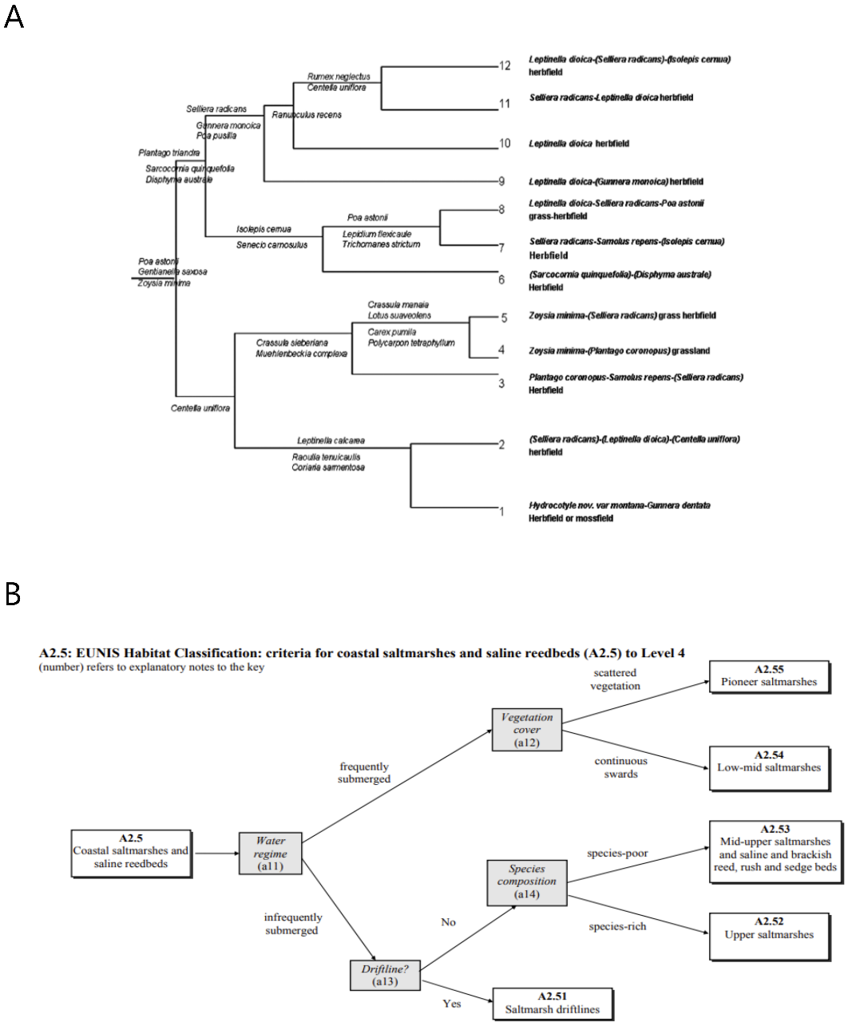

Figure 1. Examples of an ecosystem typology.

Notes: A: reproduced from the European Nature Information System habitat classification for the European Union (Davies et al. 2004). B: reproduced from a typology for coastal turfs in New Zealand (Rogers & Wiser 2010).

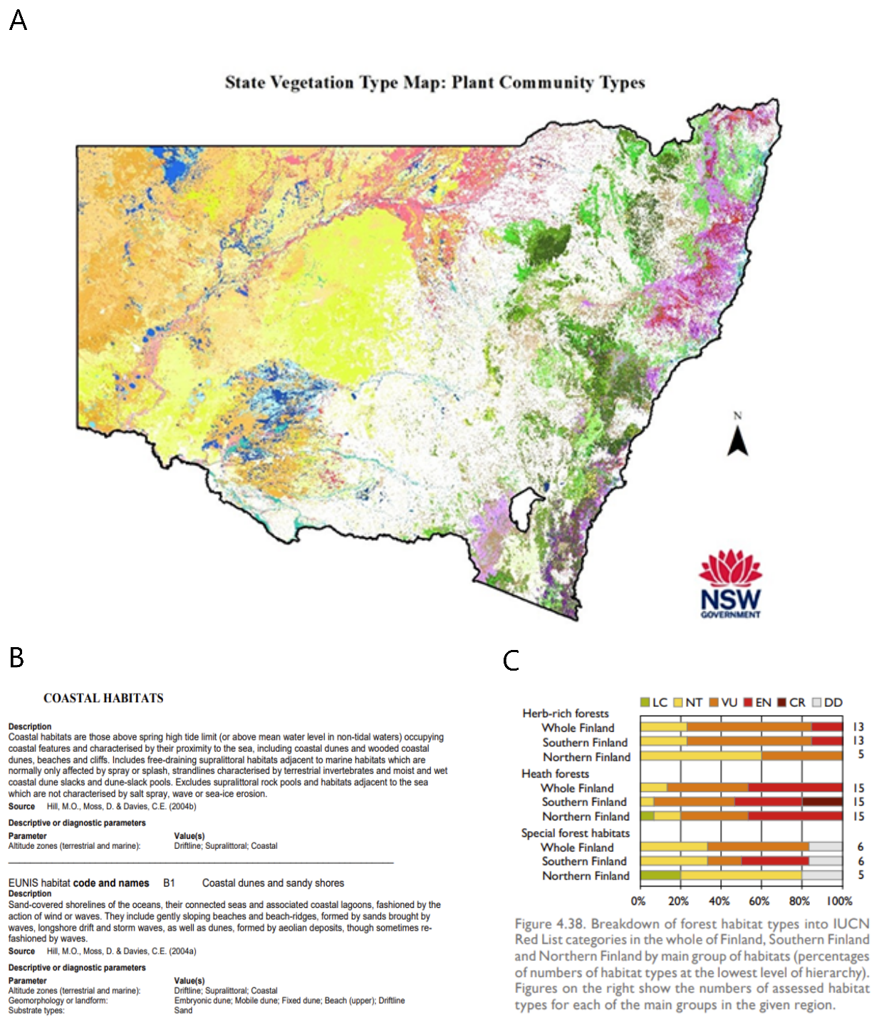

Figure 2 Examples of products derived from an ecosystem typology

Notes: A: reproduced from New South Wales’s State Vegetation Type Map (New South Wales Government 2024). B: reproduced from Finland’s assessment of their threatened ecosystems following the IUCN Red List of Ecosystems protocol and using their habitat typology (Finnish Environment Institute & Ministry of the Environment 2019). C: reproduced from factsheets for the EUNIS habitat classification system (Davies et al. 2004).

Internationally there are good examples of countries/political entities such as the European Union that have a robust and mature cross-domain ecosystem typology that is used for myriad purposes in environmental planning, management, and research. These typologies all took concerted effort and cross-organisational support and collaboration to devise. While there are several examples of these cross-domain typologies, we have chosen to focus on the following ones from South Africa and the European Union.

South Africa has the National Ecosystem Classification System, which spans domains and is used for managing ecological infrastructure and ecosystem services, and for understanding biodiversity patterns and protection. Individual typologies of individual domains have been in development for many decades, but the work in South Africa on integrating across domain-specific typologies began in 2011, and their National Ecosystem Classification System is the result of many years of resourcing and cross-agency collaboration (Dayaram et al. 2021).

Similarly, the European Union has its habitat classification system, EUNIS (European Nature Information System), which covers habitats across Europe and across domains. The development of EUNIS began in the mid-1990s, and in 2004 detailed descriptions of the habitat units in the classification system were published (Davies et al. 2004). The typology has been reviewed since, and revisions are ongoing (e.g. Evans et al. (2017)).

While several domains in New Zealand have an existing, domain-specific ecosystem typology, we do not have a unifying typology that brings together typologies from different domains into a single conceptual framework. The goal for this project is to start New Zealand on the journey to achieve the long-term vision of a unifying typology of ecosystem types, underpinned by robust, well-developed typologies in the marine, subterranean, terrestrial, wetland, and freshwater (rivers and lakes) domains.

In this report we consider options for a unifying typology and will recommend a preferred typology that could act as a framework to connect domain-specific typologies. Based on Keith et al. (2022a), we define a ‘unifying typology’ to mean that the overarching typology is conceptually consistent across the biosphere, thus accommodating all NZ ecosystem domains (i.e. wetlands, rivers, lakes, groundwater, marine and estuarine, and terrestrial) and provides a scalable structure of organisation; i.e. ecosystems should be arranged in a hierarchical or nested structure to reflect the nature and magnitude of their similarities.

Why New Zealand needs a unifying ecosystem typology

New Zealand does not have a current overarching and unifying ecosystem typology that is consistent and hierarchical across domains. Existing domain-specific typologies currently in use vary in their approach to ecosystem classification, and in their level of detail. Some typologies use abiotic characteristics to classify ecosystem types (such as for rivers), others use biotic factors such as vegetation communities (e.g. terrestrial typologies), and others use both abiotic and biotic factors as well as biogeographical information (e.g. marine typologies). Some domains have more than one typology in use. Also, many domain-specific typologies either do not include or poorly describe anthropogenically derived ecosystem types. Finally, typologies that span domains are in various stages of development and fitness for purpose.

A unifying typology is foundational to many conservation, land-use, and research purposes in New Zealand. It should underpin the prioritisation of ecosystem protection, monitoring, and analysis of ecosystem extent and condition, assessment of ecosystem risks, national and international reporting on the state of our ecosystems, policy development, setting of limits for natural resource use, and research on ecological drivers and change.

An example of a current need is to assess the ecological representation of legal protection in New Zealand for international commitments (Kunming-Montreal Global Biodiversity Framework, Target 3). Work is underway to improve the Protected Areas Network of New Zealand (PAN-NZ), which maps areas that have legal protection (Planzer et al. 2023; Planzer et al. 2024), but understanding the ecological representation of this legal protection requires that PAN-NZ be overlaid with a consistent, cross-domain ecosystem map.

Another example is the research in progress on a pilot of the IUCN Red List of Ecosystems. This research requires a unifying typology to be able to define the ecological units for assessment in a consistent and comprehensive way (analogous to species in threat assessments), so that the threat status of ecosystem types can be determined and repeated over time.

A final example is the current mapping of ecosystem extents, including of rivers, lakes, and wetlands (Booker 2023; Booker et al. 2024). A unifying typology would help to ensure consistent mapping of ecosystem types between domains.

The current approach of having siloed domain-specific typologies is not sufficient for New Zealand to meet its international obligations, such as reporting on the post-2020 Kunming-Montreal Global Biodiversity Framework; nor is it sufficient for application at a national level. Changes to New Zealand’s ecosystems are occurring, yet our ability to monitor or manage these changes consistently across domains is made more difficult without a unifying typology. Furthermore, without integration across domains, ecological gradients between domains could be missed and therefore left unmanaged.

Project context

This project builds on previous work that explored how well current typologies met the needs of the relevant agencies, including the Department of Conservation (DOC) and regional councils. As part of that work, several stakeholder workshops were held during 2023 to identify and articulate the principles to which an overarching ecosystem typology would need to adhere (Collins 2024). This resulted in the identification of nine national principles and five additional requirements.

Project scope

This project covers six domains: terrestrial, marine and estuarine, rivers, lakes, groundwater, and wetlands. The scope included an investigation of international unifying typologies, an in-depth analysis of the International Union for Conservation of Nature Global Ecosystem Typology (IUCN GET) and its potential fit for New Zealand, and implementation of the IUCN GET by other countries.

The following activities were considered out of scope for the current contract:

a full literature review of all multi-national typologies currently in use

extensive stakeholder engagement – several workshops were held as part of previous work done on typologies in New Zealand in 2023, so, to avoid duplication, stakeholder engagement was focused on feedback on the preferred unifying typology and assessment of existing typologies for the domain

an evaluation of how well each of the domain typologies accommodates te ao Māori (which was beyond the expertise of the project team)

mapping of ecosystem types

collation of relevant data to inform updates to domain typologies.

Also, while domain leads from the project team will devise roadmaps that describe the key actions required for the current domain-specific typology to meet the principles for a standardised typology, they will not update current typologies.

Aims and objectives

The aim of this work is to investigate a unified and overarching ecosystem typology for New Zealand. This includes the following objectives:

1. Explore the international context of unifying typologies, including the IUCN GET and its implementation globally (including examples of challenges and experiences from other jurisdictions).
2. Assess these unifying typologies against the principles for a standardised typology (see below).
3. Summarise how well the current domain-specific typologies in New Zealand map to the IUCN GET.
4. Describe the challenges anticipated in developing and implementing a unifying framework in New Zealand, including options for how to mitigate and manage these challenges.
5. Recommend the preferred unifying typology for New Zealand.
6. Complete full crosswalks, or translations, of naturally uncommon ecosystems to the overarching preferred unifying typology.

Principles for a standardised typology

In a series of workshops in 2023, representatives from DOC, regional councils, the Ministry for Primary Industries (MPI) and the Ministry for the Environment (MfE) identified nine national principles and five additional requirements for a standardised typology. These principles and requirements are discussed in Collins (2024). The explanations for these principles and requirements were brief, and they were not defined, and several principles and requirements conceptually overlapped. The principles and requirements needed full definitions and clear interpretations to be used to evaluate existing ecosystem typologies.

Table 1 below provides clarifying text developed by the project team in consultation with the project steering group. The original nine national principles and five requirements were grouped into seven overarching principles, along with sub-principles, which we will hereafter refer to collectively as the ‘Principles’. The definitions now specify whether the Principles refer to the development of the typology or the products derived from the typology (e.g. maps).

These definitions were modified and took inspiration from Dayaram et al. (2021), De Cáceres et al. (2015), and Keith et al. (2022a, 2022b). While many of the Principles are similar to the design principles of typologies from other countries, we also wanted to ensure that New Zealand’s needs and unique ecological processes are reflected in the Principles.

Table 1. Principles and definitions of a standardised typology

| Principle | Sub-principles | Definition |
| --- | --- | --- |
| Hierarchical  structure | | Standardised typologies have a structure with levels, with lower levels nested within higher ones. Higher levels of the hierarchy usually encompass more variation than do lower levels, and usually (but not always) correspond to a greater spatial extent. Thus, higher levels are more generic (e.g. forest [terrestrial]; warm-wet climate [rivers]), and lower levels are more specific (e.g. red-silver beech forest [terrestrial]; warm-wet lowland [rivers]). |
| Spatially explicit | | Distributions of typological units should be mappable through any practical combination of ground observation, remote sensing, and spatial modelling. |
| Accommodates increased knowledge and change over time | Updateable | This Principle relates to the products derived from typologies (e.g. maps). Typology-derived products should be able to be changed or updated. This could include the following types of changes: changes to the spatial boundaries of ecosystem types based on both improvements in underlying data and real change over time (these two types of change should be able to be distinguished); and temporal changes to attributes (e.g. condition) of the defined ecosystem types. |
| Flexibility/ adaptability | This Principle pertains to the typology itself. The typology should be able to be modified and have a clear and transparent version history. Changes to a typology could include: new ecosystem types can be added to the typology as more data become available; ecosystem types can be split or combined when justified by new data – these may be ecosystem types that were present but not defined in the typology, or ecosystems that did not exist previously; methodological changes to the typology to define the ecosystem types more clearly – this particularly applies to domains where ecosystem types are defined by environment. |
| Temporally explicit | This Principle pertains to both the typology itself and the derived products. Both the typology and the derived products should be explicit about when the typology was created, when the underlying data were collected, and the time period to which derived products apply and when they have been updated. |
| Compatibility across domains and typologies | Compatible | Ecosystem types in a typology are required to have clear relationships with the ecosystem types of other typologies for the same domains that are in use or were widely used in the recent past. This facilitates the transfer of information from one typology to another and enables comparisons across typologies. |
| Consistent use of species concepts | The typology can accommodate the fact that species names or the taxonomic concepts they represent can change through time. |
| Nesting under IUCN GET | The typology should be able to crosswalk to the IUCN GET, particularly to level 3, ecosystem functional groups. |
| Robust | Parsimony and utility | The typology should be no more complex than required to achieve its specified purposes, and should use simple, accessible and clearly defined terminology (Keith et al. 2022a). |
| Transparent and reproducible | How the typology itself was created should be transparent and either sufficiently well described so that it could be repeated by a different person and achieve the same result, or defensible. It should be clear whether the typology is derived from data by quantitative analysis, informed by data, or expert-derived. |
| Comprehensive | Coverage for ecotones | The typology should allow areas of transition between ecosystems to be depicted, both by their relationship to the classification units and in mapping. |
| Accommodates transformed ecosystems | The typology should include ecosystem types that encompass, as much as possible, the full range of ecosystem variation within their spatial, temporal, and ecological extents.  Transformed ecosystems include the following: human engineered ecosystems; those created by passing an ecological tipping point; successional ecosystems; and novel or no-analogue ecosystems.[1] |
| Captures biotic assemblages that are uncommon | The typology should be thorough enough to capture rare or uncommon species assemblages or their habitats. |
| New Zealand-specific principles | Reflects NZ’s ecological diversity and processes | NZ’s biodiversity and ecosystems should be represented and well described in the typology. |
| Understood by New Zealanders | The terminology and concepts used in the typology are familiar to NZ ecologists and conservation practitioners. |
| Takes account of te ao Māori | The typology can accommodate te ao Māori at a local and regional level. |

International unifying typologies

International unifying typologies

Global need for a unifying typology

The need for a global ecosystem framework arose out of the efforts to monitor the global condition of ecosystems under the IUCN Red List of Ecosystems framework.[2] A consistent and standardised typology of global ecosystems was required to underpin monitoring and reporting, and this was emphasised with the development of the UN Global Biodiversity Framework, agreed at the 15th Conference of the Parties (COP15) to the United Nations Convention on Biological Diversity (UN CBD). A global ecosystem typology was needed to inform international conservation decisions and reporting on progress towards Global Biodiversity Framework targets (Keith et al. 2022a). The global ecosystem typology would also support the two headline indicators for ecosystems: the Red List of Ecosystems and the extent of natural ecosystems (Bersovine 2020; United Nations Statistics Division 2024).

Concurrently, several other international efforts pointed to the need for an agreed-upon global ecosystem typology. The UN’s System of Environmental Economic Accounting needed a reference ecosystem classification system for its ecosystem accounting protocols (United Nations 2021). The UN also declared 2021–2030 as the decade of ecosystem restoration (UN Environment Programme & Food and Agriculture Organization of the United Nations). More generally, there have been increasing global concerns about the decline in biodiversity and ecosystem condition, in addition to schemes to value ecosystem services and nature-based solutions. Figure 3 summarises the uses of a global ecosystem typology.

Ecologists representing countries around the world (i.e. Keith et al. (2022b)) have assessed existing global-scale ecosystem classifications to determine whether they would be fit for purpose to be used across ecosystem types and spatial scales, and simple enough to be implemented by many users. The principles under which ecosystem classification systems were evaluated were:

representation of ecological processes and ecosystem functions

representation of biota

conceptual consistency throughout the biosphere

scalable structure

spatially explicit units

parsimony and utility.

The review by Keith et al. (2022b) grouped existing typologies into categories and used examples in these categories to assess how well they met their six design principles. The review found that the existing typologies did not meet all of the design principles (see Table S1.2 in Appendix S1 of Keith et al. (2022b)). In response, ecologists proposed a new global ecosystem typology, the International Union for Conservation of Nature Global Ecosystem Typology (IUCN GET) to meet the design principles, and the needs of the international community for global synthesis and reporting on ecosystem change.

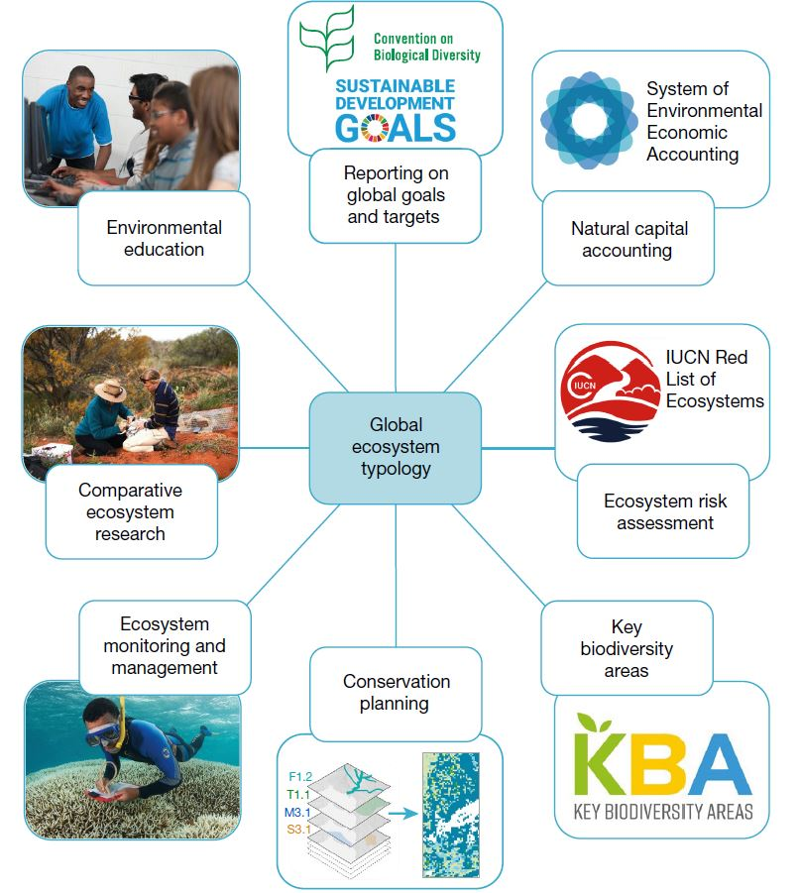

Figure 3. Potential and current uses for a global ecosystem typology.

Notes: Figure reproduced from Keith et al. (2022a) under [Creative Commons license 4.0.](https://creativecommons.org/licenses/by/4.0/) No changes were made to the figure. Photo credits: Keith Ellenbogen (Ecosystem monitoring and management); Getty Images (Environmental education); KBA World Database of Key Biodiversity Areas at www.keybiodiversityareas.org; United Nations Sustainable Development Goals at: www.un.org/sustainabledevelopment.

The IUCN GET is a globally comprehensive, common framework across realms/domains. It has extensive metadata for each of the units defined within its hierarchical levels 1–3, as well as indicative global distribution maps of ecosystem functional groups (level 3). It also provides a framework to which country-level or subnational ecosystem typologies can contribute.

The IUCN GET has been adopted by the IUCN, the United Nations System of Environmental Economic Accounting – Ecosystem Accounting (UN SEEA-EA) (United Nations 2021), and the UN Convention on Biological Diversity (UN CBD), giving it credibility and the international community confidence that it will be used. The IUCN adopted the GET for its protocols for the Red List of Ecosystems, which enable consistent ecosystem condition and risk assessments (Bersovine 2020). Similarly, the UN CBD adopted the IUCN GET for its global biodiversity framework to use for reporting against its ecosystem indicators (United Nations Statistics Division 2024).

IUCN GET

Levels of the IUCN GET

The IUCN GET has six hierarchical levels (Figure 4). The upper levels represent functional similarities among ecosystems, and the lower levels represent different compositional expressions of ecosystems. The explanatory text below is largely adapted from Keith et al. (2022c).

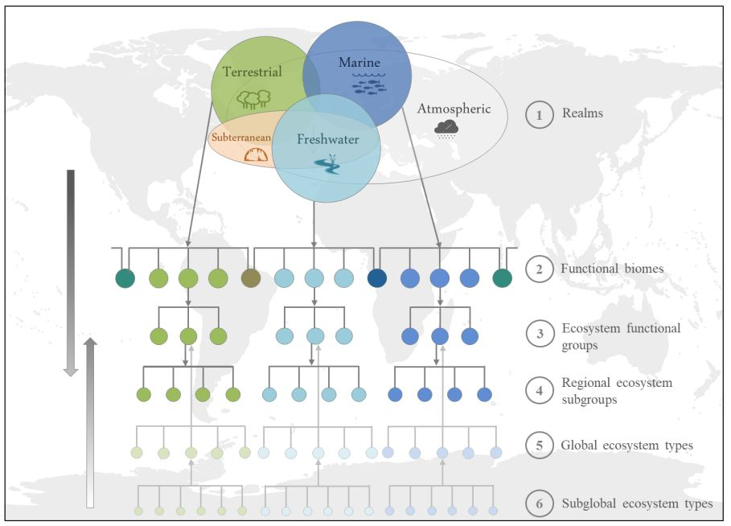

Figure 4. Hierarchical structure of the IUCN GET, with a simplified expanded structure of levels 1–6; arrows represent that there has been top-down delineation of levels 1–4 and bottom-up delineation of levels 5–6.

Notes: Levels 4 and 5 both nest into level 3; level 5 is not nested within level 4. Figure reproduced from Keith et al. (2022c) under [Creative Commons license 4.0.](https://creativecommons.org/licenses/by/4.0/) No changes were made to the figure.

Realms (level 1) are components of the biosphere that differ fundamentally in ecosystem organisation and function. They are largely comparable to the ‘domains’ used in New Zealand. The IUCN GET has five core realms: terrestrial, freshwater, marine, subterranean, and atmospheric. It also has six transitional realms, representing the interfaces and continuous variation between the core realms. These six transitional realms are: marine-terrestrial, subterranean-freshwater, freshwater-marine, marine-freshwater-terrestrial, subterranean-marine, and terrestrial-freshwater. The atmospheric realm does not have any typological units described in it yet (Keith et al. 2022d).

Functional biomes (level 2) are components of a realm united by one or a few common major ecological drivers that regulate major ecosystem functions and ecological processes. There are 25 functional biomes. Examples in New Zealand include temperate-boreal forests and woodlands (T2), marine shelf (M1), and rivers and streams (F1).

Ecosystem functional groups (EFGs, level 3) are groups of related ecosystems within a biome that share common ecological drivers, which shape similar ecosystem properties. There are 110 EFGs, which include 15 anthropogenic functional groups. Examples of EFGs in New Zealand include *Oceanic cool temperate rainforests* (T2.3), *Marine kelp forests* (M1.2), and *Permanent upland streams* (F1.1).

Levels 4–6 accommodate differences in biotic composition among functionally convergent ecosystems. These levels have not yet been developed, so they do not have the metadata and descriptions available as for levels 1–3. It is also important to note that level 6 nests within level 5, but levels 4 and 5 both nest within level 3 EFGs; levels 4 and 5 do not nest within each other. This is illustrated in Figure 4.

Regional ecosystem subgroups, also called biogeographical ecotypes, (level 4) are proxies for compositionally distinct geographical variants that occupy different areas within the distribution of a functional group. They are derived top-down from level 3, and their primary purpose is to support global reporting for the IUCN Red List of Ecosystems. For New Zealand, we anticipate that level 4 ecotypes will not be suitable for country-level purposes (i.e. national-scale conservation management and planning), because these ecotypes are too coarse.

Global ecosystem types (level 5) nest into level 3 EFGs and comprise biota and their physical environment. Global ecosystem types within a level 3 EFG share similar ecological processes but differ substantially in biotic composition. Global ecosystem types are derived from the bottom up, either based on ground observations or by grouping subglobal ecosystem types (level 6).

Subglobal, or local, ecosystem types (level 6) are a subunit of a global ecosystem types. Local ecosystem types within the same global ecosystem type are more compositionally similar to each other than to other local ecosystem types nested under a different global ecosystem type. They represent units from country-level classifications and are derived directly from ground observations. For New Zealand, we anticipate that levels 5 and 6 will be useful for country-level purposes and uses.

Although the hierarchical structure of the IUCN GET is fixed, its creators expect there to be progressive improvements made to the typology as it becomes adopted and implemented by countries around the world (Keith et al. 2020; Keith et al. 2022d). Implementation by countries and common challenges with alignment will influence the changes made to future versions. Furthermore, while some countries have assessed their alignment with the IUCN GET, they are not letting the IUCN GET unduly influence their local typologies (A. Dayaram and A.L. Skowno, South African National Biodiversity Institute, pers. comm., 23 April 2024). Therefore, when New Zealand is aligning with the IUCN GET, an inability to fully align is not a reason to reject its use entirely.

Assessment of the IUCN GET against the Principles

To assess the IUCN GET consistently and thoroughly against the Principles, guiding questions were created for each Principle. These questions aimed to determine whether the IUCN GET met the Principles, and if not, how it violated them. The guidelines we created to complete our assessment are given in Appendix 1. We used the work of Keith et al. (2022c, 2022d) to complete our assessment. Table 2 contains both the assessment questions and the assessment of the IUCN GET itself.

Table 2. Assessment of how well the IUCN GET aligns with the Principles

|  | Principle/requirement | IUCN GET assessment |
| --- | --- | --- |
| Hierarchical structure | Level type | Environmental/biotic. |
| Nesting type | Imperfectly nested (levels 4 and 5 both nest into level 3 ecosystem functional groups [EFGs]). |
| Spatially explicit | Is the typology mapped? | Level 2 (biomes) and level 3 (EFGs) are mapped – these are indicative distribution maps. |
| Indicate extent, resolution, and accuracy. | The maps were produced for a global extent, with a spatial resolution of 1 km2 or better for 60–80 of the EFGs. The maps show indicative major and minor occurrences of each EFG. A minor occurrence means that the EFG is either scattered within the matrix of another EFG or it is in only a part of a larger area of another EFG (Keith et al. 2022c). These occurrences do not have certainty estimates. |
| Indicate how the ecosystem occurrence is represented. | Raster |
| If not mapped, are there data that could be used to produce maps? | N/A |
| What is the temporal extent (current, historical, potential)? | Current (source maps dated from 1992 to 2021). |
| Are the methods used to map the typology sufficiently well described that they could be reproduced by a third party? | For the majority of the EFGs, existing published spatial data were used and therefore it would be possible to reproduce these maps. For 34 EFGs, however, maps were created from combinations of remote sensing and environmental proxies. These methods were described in cited publications, so we assume it would also be possible to reproduce these mapping methods. |
| Other comments | The disclaimer from the IUCN GET website says: ‘The maps were designed to be indicative of global distribution patterns and are not intended to represent fine-scale patterns ... Given bounds of resolution and accuracy of source data, the maps should be used to query which EFG are likely to occur within areas, rather than which occur at particular point locations.’ <https://global-ecosystems.org/page/methods> |
| Accommodates increased knowledge and change over time: updateable | Can spatial boundaries on maps change over time? | Yes, improvements of distribution maps of the EFGs are expected and will be updated periodically at <https://global-ecosystems.org/>. |
| Can temporal changes be made to mapped unit attributes? | No, the mapped units have no other attributes (e.g. condition). |
| Accommodates increased knowledge and change over time: flexible/ adaptable | Can new ecosystem types be added? | The IUCN GET has already been updated as new information has become available (Keith et al. 2022d). Updates are published as versions (e.g. Keith et al. (2020)). However, it is unclear whether marked changes in the scope of units and structure will be possible. Whether new ecosystems can be added needs to be verified. |
| Can ecosystems be split or combined? | This is not the final version of the GET. It is stated that future updates will be available, but whether EFGs could be split or combined needs to be verified. |
| Can methods be changed to better define ecosystem types? | It is stated that future updates will be available, but whether the methods can be changed needs to be verified. |
| Accommodates increased knowledge and change over time: temporally explicit | Is the time span of underlying data and when typology was created documented? Have any changes been date-stamped? | There is documentation for when the GET was created and the descriptions, and the typology versions are specified (i.e. 1.0 and 2.0). Descriptions of EFGs are referenced and documented based on literature review and expert knowledge. No data underpin the typology itself. |
| If maps have been created, is the time period of application documented? Have any changes been date-stamped? | Yes, the maps of EFGs are based on published data, and the references from which the global distribution maps are derived are cited. Map versions are clearly specified, as well as the date of the most recent update. |
| Compatibility across domains and typologies: compatible | Is the rationale behind typology structure clear? | Yes |
| Does it build on/acknowledge other typologies? Are relationships to units in other typologies explained? | It does acknowledge other global typologies, and Keith et al. (2022b) assessed the IUCN GET and other global typologies against six design principles. The descriptions of the EFGs reference other works, but no explicit relationships are described. |
| Could the typology be crosswalked to other typologies in the domain? | Yes it could, but this hasn't been done yet. |
| Compatibility across domains and typologies: consistent use of species concepts | Describe whether and how taxonomic changes can be accommodated. | The levels currently enumerated (levels 1–3) focus on functional properties, not taxa. Specific species or genera are not mentioned in the level 3 EFG descriptions. |
| Do biotic names follow a reference taxonomy (e.g. NZOR)? Please provide name of reference taxonomy. | See response in above row. Biotic composition is in levels 5–6 of the IUCN GET, and the details for these levels have not been completed yet. |
| Compatibility across domains and typologies: nesting under IUCN GET | Does the typology nest under the IUCN GET (Yes, No, Partially)? | N/A |
| Robust: parsimony & utility | Do detailed descriptions of units exist? | Yes, detailed descriptions of units exist down to level 3 EFGs. Levels 4–6 have not been populated with details yet. A glossary is provided, which has definitions of terms used: <https://global-ecosystems.org/page/glossary> |
| Are there clearly applicable diagnostic criteria to allow identification of units? | Descriptions of EFGs include: ecosystem properties, ecological drivers, and global distribution. Some key ecological criteria are not well defined (e.g. 'wet'). |
| Do ecosystem names facilitate identification in the field? | Yes, the EFG names are generally recognisable (e.g. Large permanent freshwater lakes, Intertidal forests and shrublands, and Oceanic cool temperate rainforests). |
| Is the number of units manageable? Please specify the number of units at each level. | Yes: there are 5 core realms, 6 transitional realms, 25 functional biomes, and 110 EFGs. |
| Robust: transparent and reproducible | Is the method to produce typology documented and independently reproducible? | Yes, the method to produce typology is documented, but no, it is not independently reproducible. |
| If the above is 'No', is the method defensible? | Yes. |
| Was typology data-derived, data-informed, or expert-derived/ qualitative? | Expert derived |
| Comprehensive | Does it accommodate transformed ecosystems, including engineered, passed-tipping-point, successional, and novel ecosystems? | It does accommodate engineered ecosystems (e.g. intensive land-use biome and artificial wetlands biome). It appears that successional, passed-tipping-point, and novel ecosystems could be accommodated, but they are not explicitly catered for. |
| Does it accommodate ecotones? | It accommodates some ecotones at levels 1 and 2 in the transitional realms and biomes. EFGs (level 3) accommodate ecotones between levels 5 and 6 (ecosystem types) nested within that EFG. However, ecotones between ecosystem types in levels 5 and 6 in different EFGs could be accommodated in the crosswalk process. |
| Does it distinguish biotic (e.g. species) assemblages that are uncommon? | The levels currently enumerated (levels 1–3) focus on functional properties, not taxa. |
| Is there any other form of ecosystem variation that is missing from the typology? | Not yet identified. |
| NZ Specific | Does the typology reflect NZ ecological diversity and processes? | May accommodate, but it was not designed to reflect NZ ecological diversity. Some naturally uncommon ecosystem types did not have an analogue in the IUCN GET. |
| Does the typology use terminology and concepts familiar to NZ ecologists and conservationists? | Many of the concepts and much of the terminology will be familiar to NZ ecologists, but some of the terms used by the IUCN GET could be unfamiliar or less commonly used. For example, the IUCN GET uses 'realms' instead of 'domains'. |
| Does the typology take account of te ao Māori? | No, the IUCN GET has an international scope, but it would be good for us to raise with David Keith and co-authors that indigenous perspectives and ways of knowing need to be considered and accommodated. |

Overall, the IUCN GET meets most of the Principles (Table 2). The IUCN GET is hierarchical, with the levels and units defined by environmental and biotic components. The typology is spatially explicit and mapped down to level 3 EFGs. It is expected that the maps produced from the typology can be updated (i.e. the boundaries of EFGs can be changed), but the mapped units do not have other attributes and are not represented at a resolution that is usable for country-level applications (Keith et al. 2022d).

It is also expected that the typology itself will be updated as new knowledge or information emerges. Specifically, the authors of the IUCN GET have stated that there will be future updates to the typology, but it is not clear what types of changes could be made (i.e. whether changes could include new units in the levels, splitting of units, or other changes) (Keith et al. 2022d). Also, both the typology and the derived products (e.g. maps) are temporally explicit.

The typology is compatible across domains and across other typologies. It acknowledges other typologies, and the rationale behind the structure of the typology is well described and clear. It has not, however, described explicit relationships with other typologies, although other typologies can crosswalk to it.

Use of species concepts does not apply at the higher levels (levels 1–3). Species composition is relevant for levels 5–6 of the GET, which will adopt existing national/continental classifications. Aggregating level 6 (subglobal types) into level 5 (global ecosystem types) will require the adoption of agreed-upon reference taxonomies, which is currently a work in progress.

The IUCN GET meets the Principle of being robust as there are a manageable number of units at each level. Although the IUCN GET is expert-derived, the method to produce the typology is documented and each of the units in levels 1–3 are well described and include literature citations.

By and large the IUCN GET is comprehensive, although some ecosystem types (successional and novel) are not catered for and some naturally uncommon ecosystem types in New Zealand do not fit it well. The transitional realms of the IUCN GET accommodate ecotones at a broad conceptual level (see Figure 5 below), but they are not necessarily accommodated at lower levels. Note that transitional realms are distinct from successional or novel ecosystems: transitional realms are the interface between two or more realms, whereas novel or successional ecosystems are relevant in the lower levels of the hierarchy and result from multiple ecological drivers.

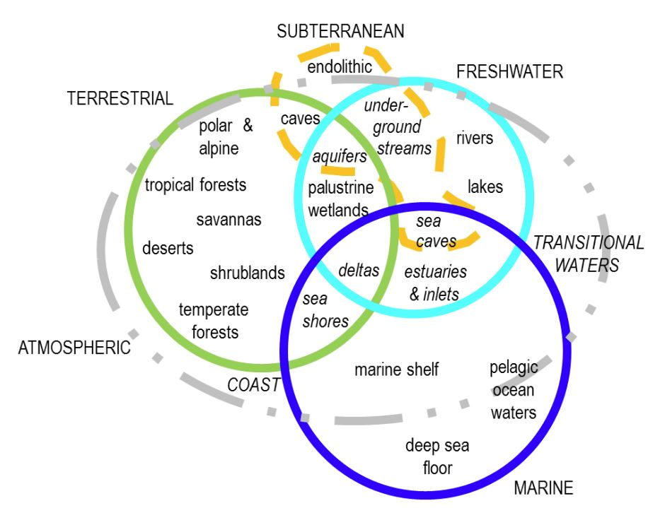

Figure 5. Schematic of the core and transition realms (level 1) of the IUCN GET with example functional biomes (level 2).

Notes: Transitional realms (level 1) and transitional biomes (level 2) are written in italics. Figure reproduced from Keith et al. (2022c) under [Creative Commons license 4.0.](https://creativecommons.org/licenses/by/4.0/)  No changes were made to the figure.

The only Principle the IUCN GET does not meet well is the Principle of New Zealand-specific concepts. The GET may accommodate New Zealand ecological diversity and processes, but it was not designed to accommodate New Zealand’s ecological diversity.

The IUCN GET also does not take account of te ao Māori and therefore does not meet this sub-principle. It has an international scope, and therefore incorporating te ao Māori into the global levels of the GET would not be relevant for other nations. However, there is no recognition or acknowledgement of indigenous perspectives in the IUCN GET framework. It is important for the IUCN GET to consider how indigenous perspectives could be incorporated at a national or sub-national scale (i.e. levels 5 or 6) (International Union for Conservation of Nature Indigenous Peoples Organisations 2022). Other international bodies, such as the Intergovernmental Platform for Biodiversity and Ecosystem Services (IPBES), acknowledge that this lack of indigenous perspectives requires further effort to resolve (IPBES Secretariat 2023).

Implementation and alignment with the IUCN GET

Alignment between typologies or classification systems is typically done using a ‘crosswalk’. A crosswalk is a systematic framework for defining the relationships between the units of different typologies (Peet & Roberts 2013). For each unit in a typology, the match to units in another typology can be described based on either its membership of objects (e.g. samples of the ecosystem, such as vegetation plots in the terrestrial domain) or the description of its properties. The outcome can be one-to-one, one-to-many, or many-to-many matches, or it can be that no analogue is found in the corresponding typology, or only a partial analogue.

Sometimes the terms ‘mapping’ or ‘translation’ are used instead of ‘crosswalk’. Figure 6 illustrates the concept of mapping or crosswalking the units of one typology to another. The illustrations include an example of a one-to-one fit, one-to-many fit, a partial analogue, and no analogue.

Figure 6. Illustrations showing how the units in one typology crosswalk to another.

Notes: The illustrations on the left show how units in the typologies map to each other, and those on the right show how units could fit within each other. Note that these illustrations do not cover all possible relationships.

The uncertainty inherent in one-to-many or many-to-many matches does not imply an unworkable translation between typologies. Where a unit maps to more than one unit in another typology, the uncertainties in the match to the target typology can be estimated as proportions. For example, in Figure 6, unit B in typology orange could be estimated to match into units 2 and 3 in typology pink at a proportion of 0.7 and 0.3, respectively. These proportions promote transparency in subsequent inferences, such as the generation of coarse summary statistics of ecosystem extent within regional or national boundaries.

Other countries’ crosswalks to the IUCN GET

To identify countries that have crosswalked their national typology with IUCN GET, we:

contacted the primary author of the IUCN GET (David Keith) and followed up based on the contacts provided

used Google Scholar to search for citations of the Global Ecosystem Typology V2.1 (Keith et al. 2022a), V2.0 (International Union for Conservation of Nature 2020), and V1.01 (Keith et al. 2020), and examined potential references (we could not reference versions 1.0 or 2.01 of the IUCN GET using Google Scholar or Google)

searched Google using variants of the following search terms: cross-walk/ crosswalk/ translation/ cross reference IUCN GET/ IUCN Global Ecosystem Typology/ Global Ecosystem Typology/ Level 3 Ecosystem Function Groups/ L3 EFG; these searches were not successful in finding other countries’ crosswalks or implementations of the IUCN GET.

For crosswalks to the IUCN GET, countries have mapped their national-level typologies to the GET level 3 EFGs, as this is the level used by the UN SEEA-EA for its reference classification for ecosystem accounting (United Nations 2021). This is also what is recommended by the IUCN GET team (David Keith, pers. comm., 13 May 2024).

Summary of findings

The IUCN GET is relatively new, with the major publication and resource development occurring in the past few years. It is therefore only just beginning to be tested via crosswalks from existing national and continental typologies. We found eight crosswalks of other typologies to the IUCN GET. Some of these spanned multiple domains, and others were primarily for terrestrial systems.

We found mixed results in terms of how well other countries’ ecosystem types mapped to the IUCN GET (see Table 3 for a summary of these results). For some countries (South Africa, Chile, and Myanmar), their terrestrial ecosystems generally crosswalked well to the IUCN GET, although some terrestrial ecosystem types in South Africa mapped to multiple IUCN GET level 3 EFGs. The European Union’s habitat classification system (EUNIS) also crosswalked well for terrestrial systems; it is notable that most EU habitat types were narrower in ecological breadth than the IUCN GET level 3 EFGs.

Crosswalking freshwater and freshwater wetland ecosystem types to the IUCN GET posed challenges for several countries. Several wetland types in South Africa did not fit well, and Italy found that several of their freshwater ecosystem types did not have a match at all in the IUCN GET. Finland found that neither their wooded swamp types nor edges of rivers and shorelines (i.e. small-scale terrestrial-freshwater ecotones) had a clear analogue in the IUCN GET.

Only three crosswalks (South Africa, Finland, and EUNIS habitat types) included marine ecosystems. Finland’s typology and the EUNIS classification generally crosswalked well to the IUCN GET marine and coastal EFGs. However, South Africa has a fundamentally different approach to classifying their marine environments (they group the benthic and pelagic zones), and therefore their marine classification did not crosswalk well to the IUCN GET.

In these countries’ crosswalks there was a common theme of ecosystems that are transitional between domains being missing from or not well circumscribed in the IUCN GET. Some successional ecosystem types did not fit well into the IUCN GET either, such as semi-natural forest successions in Italy and Finland’s early successional boreal forest.

The full assessment of these international crosswalks is provided in the table in Appendix 2.

Table 3. Summary of international crosswalks to the IUCN GET, by domain. Blank cells indicate that either the country’s typology does not yet include this domain or no crosswalks have been completed yet for these domains.

| Country | Terrestrial | Wetlands | Marine / coastal/ estuarine | Subterranean | Lakes | Rivers | Anthropogenic | Comments |
| --- | --- | --- | --- | --- | --- | --- | --- | --- |
| South Africa (Typology: Dayaram et al. (2021)) | Good | Moderate | Poor |  |  | Good |  |  |
| Chile (Typology: Luebert and Pliscoff (2017); Luebert and Pliscoff (2022)) | Perfect |  |  |  |  |  |  |  |
| Myanmar (Typology: Murray et al. (2020)) | Perfect | Perfect | Perfect | Perfect |  |  |  | The developers of Myanmar’s typology used the framework of the IUCN GET to create this typology, so it is no surprise that their ecosystem types fit perfectly. Not all freshwater (wetlands, subterranean, coastal/ estuarine) ecosystem types have been described in this typology yet, but our assessment of fit was based on those that have been completed. |
| Italy (Typology: Capotorti et al. (2023)) | Moderate | Poor |  |  |  |  |  | The fit of transitional terrestrial-freshwater ecosystems in Italy’s typology has also been assessed, and the fit was poor. |
| Netherlands (Typology: Statistics Netherlands & Wageningen University and Research (2022)) | Good fit overall | | |  |  | Good fit overall | | Only a summary of the assessment was available. The fit of dynamic semi-natural ecosystems in the Dutch typology was also assessed and was found to be poor. |
| Estonia (Typology: Oras et al. (2021)) | Good fit overall | | |  | Good fit overall |  |  | Only a summary of the assessment was available. |
| Finland (Typology: Finnish Environment Institute & Ministry of the Environment (2019); Kotilainen et al. (2020)) | Good | Moderate | Good |  |  |  |  | The fit of transitional terrestrial- freshwater ecosystems in Finland’s typology has also been assessed, and the fit was poor. |
| European Union (Typology: Davies et al. (2004); European Environment Agency (2021)) | Good | Good | Good |  |  |  | Good | Marine and many freshwater ecosystem types have not yet been crosswalked to the IUCN GET. |

Summary of New Zealand domains’ alignment with the IUCN GET

The project team used example crosswalks from domain-specific typologies to assess, based on their expert opinion, the alignment with the IUCN GET levels 1–3. Table 4 summarises the domain typologies’ alignment to the GET, and more details are provided in the domain-specific reports referenced below. Note that the difference between ‘poor’, ‘moderate’, and ‘good’ is based on the expert opinions of the project team and the fit was not quantified.

Table 4. Summary of New Zealand domains’ alignment with the IUCN GET

|  |  |  |
| --- | --- | --- |
| Domain | Typology source | Alignment with the IUCN GET |
| Wetlands | Johnson and Gerbeaux (2004) | Moderate |
| Terrestrial | Singers and Rogers (2014) | Good |
| Wiser et al. (2011); Wiser and De Cáceres (2013); Wiser et al. (2016); Smale MC (2018); Wiser and De Cáceres (2018); McCarthy JK (2022); Wiser et al. (2022) | Good |
| Lakes | Leathwick et al. (2010) | Poor |
| Rivers | Snelder and Biggs (2002) | Moderate |
| Groundwater | No developed typology for NZ | Moderate |
| Marine and Estuarine | Ministry of Fisheries & Department of Conservation (2008); Hume et al. (2016) | Moderate |
| Coastal Marine Ecosystem Classification Standard (CMECS) | Moderate |
| Naturally uncommon ecosystems | Williams et al. (2007) | Moderate |

Wetlands

The project team undertook a crosswalk from the Johnson and Gerbeaux (2004) typology at the level of ‘wetland type’. However, Johnson and Gerbeaux's is a system for naming and describing wetlands at finer levels below ‘wetland type’; it does not provide a classification and enumeration of component New Zealand wetland ecosystems reflecting biotic differences. (See Burge (in prep) for further details.)

The overall fit of the Johnson and Gerbeaux typology is moderate. Most of the New Zealand wetland types examined (three of the four examined) mapped to multiple EFGs (i.e. a many-to-many match). For example, a swamp in the Johnson and Gerbeaux typology maps to both the IUCN GET level 3 EFGs *TF1.2 Subtropical/ temperate forested wetlands* and *TF1.3 Permanent marshes*, depending on whether it is forested or not.

The IUCN GET has a philosophically unclear approach to forested wetlands in that all forested bogs, swamps, and marshes are grouped together into one EFG, whereas non-forest wetland types are divided into separate EFGs. This means the forested wetland EFGs in the IUCN GET are substantially broader in ecological breadth than the non-forested wetland EFGs. It also limits the applicability of IUCN GET level 3 for conservation purposes, given the unevenness of breadth.

More details are given in Burge (in prep).

Terrestrial

The overall fit of the Singers and Rogers (2014) typology is good. Most of the New Zealand ecosystem types examined (six out of seven) either mapped one-to-one to an IUCN GET level 3 EFG or one-to-many to IUCN GET level 3 EFGs. The fit was not perfect, however, as one of the New Zealand ecosystem types examined had only a partial analogue in an IUCN GET level 3 EFG (*MF5: Black beech forest*, in the Singers & Rogers 2014 typology). This indicates that there is probably a new IUCN GET level 3 EFG required.

The overall fit of the Wiser et al. (2011); Wiser and De Cáceres (2013); Wiser et al. (2016); Wiser et al. (2022) typology is good. Most of the New Zealand ecosystem types examined (five out of seven) mapped to the IUCN GET either one-to-one, one-to-many, or many-to-one. Two of the seven New Zealand ecosystem types examined had only a partial analogue in an IUCN GET level 3 EFG (*A: PF1 Mountain neinei – Inanga low forest and subalpine shrubland*, and *A: BF1 Black/ mountain beech forest (subalpine)*. This indicates that there is probably a new IUCN GET level 3 EFG required.

More details are given in McCarthy and Wiser (in prep).

Lakes

The overall fit of the *Freshwater Ecosystems of New Zealand* (FENZ) typology (Leathwick et al. 2010) is poor. Although all seven New Zealand lake ecosystem types examined mapped to one IUCN GET level 3 EFG (six types mapped to *F2.2 Small permanent freshwater lakes* and one mapped to *F2.1 Large permanent freshwater lakes*), the current New Zealand lakes typology is missing key information needed to accurately crosswalk to the IUCN GET. For example, the New Zealand lakes typology does not include lake size, whether the lakes freeze/thaw, and whether they are salt lakes. These are key delineating factors in the IUCN GET level 3 EFGs for lakes. Furthermore, the New Zealand lakes typology does not differentiate between natural and artificial lakes, which means accurate crosswalks to level 2 biomes of the IUCN GET cannot be completed.

More details are given in Wood and Schallenberg (in prep).

Rivers

The overall fit of the river environment classification (Snelder & Biggs 2002) is moderate due to the conceptual approach in the IUCN GET level 3 EFG descriptions of splitting EFGs by stream order. Permanent upland streams are described in Keith et al. (2022d) as being 1st to 3rd order, fast and turbulent, with coarse substrates. Permanent lowland rivers are described as being 4th to 9th order, slow and low turbulence, with depositional (fine) substrates.

The rivers experts in the project team suggest that stream size (represented here by stream order) and stream hydraulics/substrate should not be viewed as mutually exclusive, because larger rivers can be relatively fast with coarse substrates in steeper upland locations, whereas smaller rivers can be relatively slow and silty in low-slope lowland locations. This is true in New Zealand, where larger braided rivers that are relatively fast with coarse substrates are present in mountainous locations, and small channelised rivers that are relatively slow and silty are common in lowland locations.

To resolve the issue of non-mutual exclusivity, the rivers experts in the project team chose to down-weight the importance of stream order within the definitions of EFGs F1.1 and F1.2 when seeking to crosswalk with the New Zealand river typologies. Therefore the most emphasis was placed on the upland–lowland, fast–slow, and coarse–fine parts of the descriptions of F1.1 and F1.2. There is currently an inability to crosswalk to EFG F3.5 (canals, ditches and drains).

More details are given in Franklin and Booker (in prep).

Groundwater

The overall fit for groundwater is currently moderate, as the IUCN GET includes two level 3 EFGs within the subterranean-freshwater realm (*SF1.1 Underground streams and pools*, and *SF1.2 Groundwater ecosystems*). Currently most groundwater typologies would nest under this SF1.2. However, there could be more nuanced functional groups based on differences in biotic or abiotic conditions. For SF1.1 there are limited data to suggest this functional group exists but is poorly described.

There are two additional functional groups within the Anthropogenic subterranean freshwater biome: *SF2.1 Water pipes and subterranean canals*, and *SF 2.2 Flooded mines and other voids*. These two functional groups are absent from or poorly described in our New Zealand domain-specific typologies.

More details are given in Houghton et al. (in prep).

Marine and estuarine

The overall fit of the marine and estuarine ecosystem typologies (Ministry of Fisheries & Department of Conservation 2008; Hume et al. 2016) and of the Coastal Marine Ecosystem Classification Standard (CMECS) were moderate. Within the marine and marine transitional realms, all but four EFGs are mapped within the IUCN GET to New Zealand (*M1.3 Photic coral reefs*, *M2.5 Sea ice*, *M3.9 Chemosynthetic-based ecosystems*, and *MFT1.1 Coastal river deltas*). Of the 34 marine-associated EFGs in the New Zealand Exclusive Economic Zone, 20 are exclusively marine and 14 are cross-realm / transitional functional groups; these transitional ecosystem types are often absent or poorly described in New Zealand domain-specific typologies.

The IUCN GET level 2 biomes are generally good fits, based on depth or pelagic/benthic differentiation. However, the IUCN GET level 3 EFGs do not conform to any consistent hierarchy, with a mix of drivers including substrate, topography, hydrography, and biotic elements. In contrast, most other accepted marine and estuarine typologies have a consistent hierarchy, with abiotic and bioregional elements at the highest levels, and biotic elements at lower hierarchical levels.

Although this does not prevent crosswalking or reporting to the IUCN GET, it could result in confusion due to overlap of EFGs; for example, coastal kelp forests could be classified as M1.2 (*Kelp forests*), *Subtidal rocky reefs* (M1.6), or *Upwelling zones* (M1.9), depending on whether a biotic, substrate, or hydrographic driver is dominant. Similarly, while the New Zealand hydrosystem classification (i.e. estuaries) generally crosswalks to the IUCN GET, there is also potential confusion between freshwater-marine (primarily based on hydrography), marine-terrestrial (primarily based on substrate), and marine-freshwater-terrestrial (primarily based on biotic); for example, *Permanently open riverine estuarine and bays* (FM1.2) would probably include *Intertidal forest and shrublands* (MFT1.2) and *Coastal saltmarshes and reed beds* (MFT1.3), as well as *Rocky shorelines* (MT1.1).

More details are given in Lundquist et al. (in prep).

Naturally uncommon ecosystems

The overall fit of the naturally uncommon ecosystem typology (Williams et al. 2007) was moderate, which is better than might have been anticipated given that these ecosystems often reflect extreme or unusual environments that may be overlooked in typologies that focus on ecosystems that are more apparent and better understood. Across the 72 naturally uncommon ecosystems defined by Williams et al. (2007),[3] 58 were completely included within one IUCN GET level 3 EFG, three mapped to two different EFGs, and 11 had no analogue in the IUCN GET.

It is notable that seven of these eleven ecosystems did not fit well into any of the IUCN GET biomes as currently circumscribed, and two (sinkholes and cave entrances, see below) did not fit well within an IUCN GET realm. Also note that the naturally uncommon ecosystems typology largely relates to terrestrial ecosystems, including wetland types dominated by terrestrial plants or emergent hydrophytes, yet they span three New Zealand domains (terrestrial, wetlands, subterranean), three IUCN GET realms (terrestrial, subterranean, freshwater), and four IUCN GET transitional realms (marine-terrestrial, terrestrial-freshwater, subterranean-freshwater, and marine-freshwater-terrestrial), which exemplifies their diversity.

Crosswalks of naturally uncommon ecosystems

Twelve of the thirteen naturally uncommon coastal ecosystems were included within the EFG unit *MT2.1 Coastal shrublands and grasslands*. Two-thirds of the inland and alpine ecosystems were included within *T3.4 Young rocky pavements, lava flows and screes*, and six fitted within one of *T3.3 Cool temperate heathlands*, *T6.4 Temperate alpine grasslands and shrublands*, *T3.2 Seasonally dry temperate heath and shrublands*, and *T1.3 Tropical/Subtropical montane rainforests*. The geothermal system ‘hydrothermally altered ground (now cool)’ was largely consistent with *T3.3 Cool temperate heathlands* if the restriction to maritime environments is disregarded. Fumeroles fitted well within *F2.9 Geothermal pools and wetlands*. All ecosystems within the group ‘Induced by native vertebrates’ fitted within *MT2.2 Large seabird and pinniped colonies*. Eleven wetlands fitted in a many-to-one match across five EFGs. Wetlands included the only three ecosystems that mapped to two EFGs, reflecting the conceptual differences in how wetland types are distinguished in New Zealand compared to the IUCN GET.

It is also notable that although these ecosystems clearly align with an EFG, not all of these EFGs are mapped or described as occurring in New Zealand by either Keith et al. (2022d) or the IUCN GET website. These include:

*T3.3 Cool temperate heathlands* (include Old tephra plains (frost flats), Frost hollows, Hydrothermally altered ground (now cool))

*T3.2 Seasonally dry temperate heath and shrublands* (includesStrongly leached terraces and plains ‘Wilderness’)

*T1.3 Tropical/Subtropical montane rainforests* (includes Cloud forests, but note this system is still poorly defined in New Zealand)

*TF1.3 Permanent marshes* (includes Lake margins).

Although we felt these ecosystems aligned with the IUCN GET, there are instances where the description in the IUCN may need to be broadened to properly encompass them. Following are two examples.

Stony beach ridges aligned to *MT2.1 Coastal shrublands and grasslands*: the description of the substrate as 'consolidated substrates (headlands, cliffs) and unconsolidated dunes' would need to be broadened to include the substrate of wave-deposited water-smoothed gravel and cobbles.

Volcanic dunes and Inland sand dunes aligned with *T3.4 Young rocky pavements, lava flows and screes*: The substrate description for T3.4 would need to be broadened to include sands. Otherwise, the drivers are the same.

We summarise 10 other examples where the IUCN GET EFG ecosystem description needs to be broadened to accommodate New Zealand naturally uncommon ecosystems in Appendix 3.

Proportionally, subterranean/semi-subterranean and geothermal ecosystems had the highest numbers of ecosystems with no analogue in the IUCN GET (Figure 7). Sinkholes and cave entrances are at the transition between the subterranean and terrestrial realms of the IUCN GET, but a suitable transitional realm has not yet been defined. The three geothermal ecosystems that have no analogue are Heated ground (dry), Acid rain systems, and Geothermal streamsides. In the IUCN GET, geothermal ecosystems are positioned in *F2.9 Geothermal pools and wetlands*, which does not accommodate terrestrial geothermal ecosystems such as these.

Other ecosystems that are not represented in the EFGs of the IUCN GET include the following.

Ultrabasic hills – no temperate heathlands or shrublands of the IUCN include those on ultrabasic substrates.

Inland outwash gravels – soils in these ecosystems are too developed to fit into *T3.4 Young rocky pavements, lava flows and screes*, and too infertile to fit into *T4.5 Temperate subhumid grasslands*.

Braided riverbeds, as defined by Williams et al. (2007), encompasses the terrestrial component of these systems, in contrast to the aquatic component of braided rivers that may be captured within *F1.2 Permanent lowland rivers*. Braided riverbeds share the episodic nature of *TF1.5 Episodic arid floodplains*, but they are not arid. Braided riverbeds would fit most logically within the transitional terrestrial-freshwater realm, but all component biomes are wetlands.

Inland saline (salt pans) are too infertile to fit within *T4.5 Temperate subhumid grasslands* and do not fit elsewhere.

Ephemeral wetlands would best be classified with other wetlands within the terrestrial-freshwater realm. *F2.3 Seasonal freshwater lakes* is in the freshwater realm, and the description only encompasses the aquatic aspect of these systems. It is noteworthy that the photograph accompanying the description of this EFG shows California vernal pool, which is a transitional system known for endemic plant species.

Shell barrier beaches are not accommodated.

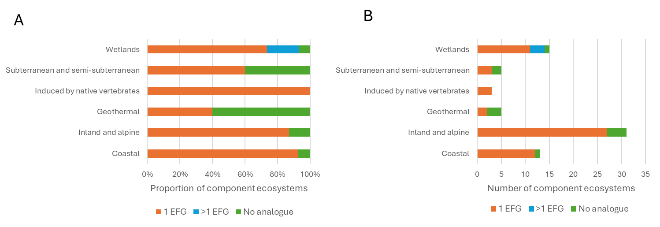

Figure 7. Summary of the fit of naturally uncommon ecosystems into the IUCN GET EFGs.

Notes: Naturally uncommon ecosystems are grouped as in Williams et al. 2007. A: presented as proportions of the total number of ecosystems in that group; B: presented as numbers of ecosystems

Challenges to developing and implementing a unifying typology in New Zealand

In discussions with the domain experts in our project team, stakeholders, and the project steering group, we identified several challenges to achieving a unifying typology in New Zealand. We have organised our assessment into fundamental challenges to aligning with the IUCN GET, challenges to developing a unifying typology, and challenges to implementing one. Here we have defined a fundamental challenge as an inconsistency of approaches, methods, or rationale between New Zealand’s current domain typologies and either the IUCN GET or the Principles.

Challenges to aligning with the IUCN GET

These include:

1. Some common ecosystem types (e.g. dry beech forests) in New Zealand do not have an analogue in an IUCN GET level 3 EFG.
2. Some ecosystems that are rare and of high conservation significance to New Zealand (e.g. ephemeral wetlands and the terrestrial component of braided riverbeds) do not have an analogue in an IUCN GET level 3 EFG, so they would be excluded from international reporting.
3. New Zealand knowledge and data describing biota and physical parameters (e.g. ice cover and depth for lakes) that are indicative of some ecosystem types are lacking. This is also a challenge to developing a unifying typology.

Challenges to developing a unifying typology

These include:

1. limited resources (financial and time) to develop domain-specific typologies
2. lack of coordination in New Zealand between typology development in different domains, and between people and organisations undertaking these developments
3. a lack of clarity as to which organisation should lead the coordination of typologies’ developments.

Challenges to implementing a unifying typology

These include:

1. limited resources (financial and time) of the agencies required to implement and maintain domain-specific typologies
2. lack of clarity with regard to which organisation will manage and maintain the typologies
3. lack of clear guidelines to produce a spatially continuous and integrated map of ecosystem types across domains.

The recommendations and requirements for a unifying typology in the section below include mitigations for all these challenges. The full table of challenges identified and their mitigations is provided in Appendix 4.

Recommendations for a unifying typology

As a result of our review and after conversations with stakeholders, we feel the question ‘What is the preferred unifying typology for New Zealand?’ is not sufficiently nuanced to encompass the various purposes of a unifying typology. We found there are two main requirements for a unifying typology in New Zealand.

1. New Zealand needs a framework to meet our international obligations to report on ecosystem indicators and enable the global syntheses needed to progress towards the UN Global Biodiversity Framework targets.
2. New Zealand needs a unifying typology to provide a framework for a broad range of applications, including to manage land use and development, guide biodiversity protection, monitor environments, and support ecological research and understanding across domains. This typology would need to facilitate integration across domains, consistent use across agencies and land managers, and spatially continuous mapping.

We recommend that New Zealand adopt and adapt the IUCN GET as its unifying typology, since the IUCN GET is the best typology for both goals. We discuss why this recommendation meets each of these needs below.

A typology to meet our international obligations

The IUCN GET is the best candidate typology for New Zealand to report against for our international obligations. Keith et al. (2022b) assessed other global ecosystem classification systems and found that they were inadequate for international monitoring and synthesis purposes. The IUCN GET has been adopted internationally by both the UN SEEA-EA and the UN CBD (United Nations 2021; United Nations Statistics Division 2024) and will be used for monitoring and reporting against the post-2020 Global Biodiversity Framework.

We also asked David Keith, lead author of the IUCN GET, whether he was aware of other unifying typologies, and his response was the following:

there are really no other workable unifying classifications. Appendix S1 in our paper is still current. Ecoregions and a couple of book series (Goodall’s original ecosystems of the world, and the more recent Encyclopedia of world biomes by DellaSalla & colleagues) are the only ones that span terrestrial, freshwater and marine. The book series are not really classifications, so much as ad hoc compendiums. Ecoregions are not ecosystems (our paper elaborates on why) and the marine component only covers the shelf (not the pelagic layers or the deep sea floor). So GET is the only show in town. (David Keith, 19 Feb 2024)

Therefore, we recommend that once our domain typologies in New Zealand are revised, or created, full crosswalks to the IUCN GET level 3 EFGs should be completed for all domains. Based on our initial examination of the current domain typologies’ crosswalks to the IUCN GET, we expect that not all of New Zealand’s ecosystem types will be represented in the GET, nor will all of New Zealand’s ecological drivers. However, we recommend compiling these issues and raising them with the IUCN GET team to be included in future revisions.

A typology for New Zealand applications

In separate domain-specific reports we have recommended actions to update or create domain typologies that will be fit for purpose and meet the Principles. However, simply updating each domain typology will not ensure they are integrated and cohesive. A unifying typology would ensure conceptual alignment across domains, as well as spatial continuity and edge matching when mapping.

In sections 2 and 3 of this report we examined the IUCN GET and its suitability as a preferred unifying typology for New Zealand. The IUCN GET is conceptually robust and meets many of the Principles. It also facilitates international reporting to the Global Biodiversity Framework, including the IUCN Red List of Ecosystems. However, while the IUCN GET is an international umbrella framework to which New Zealand’s domain-specific typologies can crosswalk, it does not include unique New Zealand ecosystem types, such as some naturally uncommon ecosystems, or some common ecosystem types such as dry beech forests. Furthermore, for some domains, the drivers in the EFGs do not make sense for New Zealand and do not represent how we classify ecosystems (e.g. rivers and marine). The IUCN GET will evolve (Keith et al. 2022d), and as it develops and our own domain typologies develop, ecosystem units can be harmonised.

Despite the instances of misalignment between some New Zealand domain typologies and some ecosystem units with the IUCN GET, we believe that New Zealand should use the IUCN GET as a conceptual framework for our national-scale unifying typology (see Figure 8 below for a conceptual representation). We would adopt the level 1 realms (including the very useful approach of defining transitional realms) and the level 2 functional biomes of the IUCN GET. We can crosswalk our domain-specific typologies to the IUCN GET level 3 EFGs to enable international reporting and adopt those IUCN GET EFGs within which our New Zealand ecosystem types fit.

Where New Zealand’s ecosystem types do not fit into an existing IUCN GET EFG (e.g. because the ecological drivers do not reflect New Zealand’s ecological diversity, the ecosystem itself is not represented in the IUCN GET level 3, the IUCN GET level 3 EFG is poorly described, or the way the IUCN GET subdivided biomes into EFGs is inconsistent with the established New Zealand approach for a domain), we could create our own equivalents of level 3 EFGs in a manner consistent with IUCN GET definitions and granularity (Keith et al. 2022c).

This would require the preparation of descriptive profiles following the format presented in Keith et al. (2022d). This is represented in Figure 8 by the unfilled circle EFGs with hashed lines, which would be our New Zealand additions to the IUCN GET level 3 EFGs. For the purposes of international reporting, we suggest that until these new New Zealand-specific level 3 EFGs are added to the IUCN GET, we should note that there is no analogue EFG and specify the ecosystem types that are not included in New Zealand’s reporting. Our domain-specific typologies would then nest below this overarching framework and adaptation of the IUCN GET.

The IUCN GET level 3 EFGs are recognised as being too coarse to be used at a country level to inform planning and policy (United Nations 2021; Nicholson et al. 2024). We found the same issue when we examined example crosswalks for the domain typologies in New Zealand. Where our domain ecosystem types mapped to the IUCN GET level 3 EFGs, the EFGs were not sufficient to discriminate ecosystem types for ecological function and management purposes in New Zealand.

Therefore, we recommend continuing to develop our domain-specific typologies, which would populate levels 5 and 6 of the IUCN GET and possibly form finer-resolution levels (e.g. levels 7 onwards), depending on the hierarchical structure of the domain typologies. These levels 5 and 6 would be used for national-scale planning, management, and policy, whereas theoretical levels 7 and 8 may be more useful at local scales. We do not recommend using level 4 of the IUCN GET for New Zealand because it is based on biogeographical variation and so would not be suitable for country-level uses.

Figure 8. Conceptual diagram of how New Zealand should use the structure of the IUCN GET as a unifying typology.

Notes: New Zealand should adapt the IUCN GET levels 1–3. New Zealand’s domain typologies would nest underneath levels 1–3, consistent with GET levels 5 and 6. Level 4 of the IUCN GET is not included in this figure because it is based on biogeographical variation and therefore would not be suitable for country-level uses. The unfilled level 3 EFGs with diagonal lines represent New Zealand-specific EFGs that we would add to our framework to adapt the IUCN GET.

Recommendations to develop and implement a unifying typology

Please note that a summary of these recommendations and actions is given in Appendix 5.

Recommendation 1: Adopt and adapt the IUCN GET as New Zealand’s unifying typology

The IUCN GET is the only suitable candidate typology for New Zealand to report against for our international obligations and to provide a framework for a broad range of applications.

Action 1: Adopt levels 1 and 2 and adapt level 3 of the IUCN GET.

Where New Zealand’s ecosystem types do not fit into an existing IUCN GET level 3 EFG, we could create our own equivalents of level 3 EFGs in a manner consistent with IUCN GET definitions and granularity. Our domain-specific typologies would then nest below this overarching framework and adaptation of the IUCN GET.

Action 2: Complete full crosswalks of revised domain typologies to the IUCN GET

Once the domain typologies have been revised and integrated, domain experts should complete full crosswalks to the IUCN GET level 3 EFGs. The domain experts should follow the crosswalking guidance, which the IUCN GET team is currently writing, and estimate the proportional fit of New Zealand’s ecosystem types to the level 3 EFGs.

Recommendation 2: Set up a clear governance structure and protocols to develop and implement a national unifying typology

The unifying typology for New Zealand should have a governance structure and protocols to develop and maintain the typology across domains. We suggest first that the current project steering group contacts other countries about their typologies and governance structures. Following guidance from other countries, we recommend establishing a national governance group and individual governance groups for each domain. The development and implementation of a unifying typology and the revision of the current domain typologies will need to be supported by a research programme, so we have specified below which actions should be taken by the governance group and which by the research programme.

The national governance group would ensure consistency across domains, resolve map boundary issues between domains, and oversee the process for updating the unifying typology. Governance protocols would include rules or guidance on what will or can change within the structure of the typology, and how often. The national governance group would also discuss the following topics (although note that this is not an exhaustive list):

liaising with and promoting New Zealand’s perspective to the IUCN GET team (see Recommendation 1).

funding mechanisms

engagement and consultation with stakeholders (see Recommendation 3)

Action 1: Follow guidance from other countries

To start the planning for the development of a unifying typology in New Zealand, we recommend that the current project steering group contacts other countries about their unifying typologies and governance structures. For example, South Africa has a mature typology across domains, and their handbook has useful guidance on the structure of their typology, maintenance, and mapping (Dayaram et al. 2021). They have also set up a governance model for their unifying typology, and for their domain-specific typologies. The guidance from other countries would inform the governance structure (next action) of the governance group, research programme, and domain governance groups.

Action 2: Set up governance group and domain governance groups

We recommend that the natural resources cluster of central government (MfE, MPI, and DOC) should lead the creation of this governance group, building on the current steering group in place for this project. Ultimately, the national governance group should include a representative of each domain and each stakeholder group, but it may need to be smaller to start with.

The research programme would report to the national governance group and would focus on the more technical aspects of the development and implementation of a unifying typology. This would include the following conceptual integration across domains (see Recommendation 5), the provision of derived products, and how to estimate and depict uncertainty in domain typologies.

The domain governance groups would resolve issues specific to their domains, such as defining and ranking the priorities to advance progress, and addressing the standards for data collection, analysis, classification, review, and archiving needed to meet the needs of that domain typology and related products (e.g. maps, websites). This action will mitigate challenges 5-6 in the list of challenges in section 3.4.

Action 3: Clarify the roles and responsibilities of the organisations involved

The national governance group will need to determine the lead organisation for developing the unifying typology as well as the lead organisation(s) for holding, maintaining, and distributing the typology infrastructure (i.e. the typology versions, methods, underpinning data). The lead organisation will be responsible for regular communication with the national governance group, wide consultation and engagement when needed, and record keeping of the national governance group meetings and decisions.

The national governance group will also need to decide the appropriate people and organisations to undertake the various tasks in the domain roadmaps. This could potentially span Crown Research Institutes (CRIs), universities, DOC, consulting firms and independent contractors, and postgraduate students. These decisions should be based on qualifications and expertise, not cost, because cost is better resolved by identifying the appropriate funding mechanisms. We recommend that the current steering group in place for this project develop terms of reference that include the roles and responsibilities as a first task. This action will mitigate challenges 5-6 in the list of challenges in section 3.4.

Action 4: Clarify the purposes and uses of a unifying typology

The unifying typology will need to fulfil several purposes, including the facilitation of international reporting, the protection of uncommon and threatened ecosystems, and the prioritisation and management of ecosystems. The national governance group will need to determine these purposes and their relative importance to ensure the unifying typology is fit for purpose. This requirement is also true for the domain-specific typologies, in that the purposes of these typologies need to be well defined in advance. In some cases, a domain typology might not meet all of the Principles but will still be fit for purpose.

Action 5: Explore funding mechanisms

Given that a unifying typology for New Zealand ecosystems forms a critical piece of biodiversity infrastructure, the development and maintenance of this typology (and the domain-specific typologies) need to be viewed as an all-of-government (and beyond) effort. It will need to be funded jointly by central government departments (MfE, DOC, MPI), local and regional authorities, and research institutes (CRIs, universities) and associated funding agencies. The national governance group will need to advocate for this work being a national priority and identify appropriate funding mechanisms for initial development, operationalisation, and maintenance. This action will mitigate challenges 4 and 7 in the list of challenges in section 3.4.

An initial step may be to hold a workshop to explore and discuss funding opportunities. Participants would include members of the current project steering group, those involved in this report (or suitable representatives from the associated research organisations), and individual suitably interested academics from the university system. In this workshop it would be beneficial to examine the funding mechanisms for other countries’ development of national scale typologies, as well as for other biodiversity infrastructure in New Zealand.

Action 6: Contact the IUCN GET team to recommend revisions to the GET

The national governance group will need to compile instances where New Zealand’s ecosystems do not match the IUCN GET and link these to examples where other countries have a similar issue with their crosswalks and/or ecosystem types. The national governance group can then raise these instances with the IUCN GET team through David Keith, the lead author of the IUCN GET. The national governance group should continue to communicate issues faced in aligning with the IUCN GET as it is revised and updated. This action will mitigate challenges 1 and 2 in the list of challenges in section 3.4.

Recommendation 3: Involve stakeholders, partners, and technical experts

Consultation will be essential for socialisation of the domains’ roadmaps, the creation of robust, fit-for-purpose domain typologies, and uptake of the revised typologies. We have identified several stakeholder groups that were not included in the initial scoping of typologies in New Zealand (as described in Collins (2024)). These stakeholders include the biodiversity research community (i.e. those in CRIs and universities), as researchers globally use ecosystem typologies as frameworks in both fundamental and applied research; ecological consultants; and mana whenua.[4] We recommend promoting and publicising the work on updating, implementing, and maintaining domain typologies and associated products via diverse avenues (workshops, websites, oral/poster presentations at national and regional conferences and society meetings, articles in suitable popular publications and New Zealand scientific journals).

The roadmaps developed by the domain experts should be seen as proposals. They were developed based on the Collins (2024) report and consultation with a limited number of stakeholders. We recommend that MfE share these domain roadmaps widely, particularly with technical experts, and compile the feedback. Based on the feedback received, some domains may need a workshop with stakeholders to discuss and revise the roadmaps, while others may gain approval from stakeholders and will not require a workshop.

Recommendation 4: Accommodate te ao Māori

The concept of a national-scale typology and boundaries between ecosystems and domains is based on a global scientific perspective. Te ao Māori emphasises the interconnectedness of the natural world, and therefore considers biodiversity as part of a holistic system of living and non-living things (Harmsworth & Awatere 2013). Te ao Māori is often place-based, so engagement with a typology would probably be on a local or regional level.

We recommend working with MfE’s Chief Science Advisor (Māori) and with those involved with similar initiatives, such as the pilot project on the IUCN Red List of Ecosystems in New Zealand, for advice on the appropriate form of engagement with mana whenua on how to accommodate te ao Māori. Greater coordination is needed across environmental reporting activities, so engagement with mana whenua could also include soils, biodiversity, and threatened species as components of ecosystems, rather than engaging on them separately. A pilot programme could be done at a local level across domains to explore this further. The national governance group will also need to ensure that mana whenua are well represented (and resourced) to collaborate in high-level discussions about a unifying typology.

The unifying national ecosystem typology needs to be available and meaningful for Māori rights, interests, and aspirations. The national governance group will need to ensure that there is support for iwi to access the typology and relate it to their rohe.

From an international perspective, the national governance group should recommend to the IUCN GET team that they need to engage collaboratively with indigenous peoples on the Global Ecosystem Typology. The IUCN GET team could also learn from other initiatives, such as the International Indigenous Forum on Biodiversity and Ecosystem Services, who are working with the IPBES (IPBES Secretariat 2023). The UN’s System of Environmental-Economic Accounting Ecosystem Accounting (SEEA-EA) has also been encouraged to recognise indigenous perspectives, so there are likely to be learnings that can be shared from that work too (Normyle et al. 2022).

Recommendation 5: Integrate across domains

Although domain typologies can be updated so that they accommodate ecotones, challenges may remain in terms of accommodating ecotones between domains. New Zealand domain experts will need to work together to agree on the integration of ecotones that span domains and how they will be classified in the respective domain typologies. For example, the two currently used terrestrial typologies both contain some wetland ecosystem types, although they do not comprehensively cover wetlands.

In the short term we recommend allowing duplication of ecosystem types across multiple domain typologies and crosswalking between them. Over time the research programme will need to resolve the dual presence of ecosystem types in different domain typologies and ensure these ecosystems are not double-counted when mapping and reporting.

Integrating across domains will help to identify whether there are ecosystem types that are missing from the domain-specific typologies (e.g. sea caves, anthropogenic systems). In particular, New Zealand does not have a domain-specific typology for subterranean systems beyond the groundwater domain. It is possible that these ecosystems could be under-represented or poorly described. Integration across domains will help to identify the gaps in comprehensiveness.

Action 1: Agree on the conceptually consistent resolution of ecosystem units in the domain-specific typologies

To be able to use the national-scale typology across domains, it is critical that New Zealand domain experts collaborate and agree on the conceptually consistent resolution of ecosystem units in the domain-specific typologies. All current domain-specific typologies are hierarchical, but key drivers of typologies differ among domains. For example, the terrestrial domain’s hierarchical structure is primarily based on biotic features (e.g. vegetation type), whereas the marine domain is primarily based on abiotic features (e.g. depth, topography, substrate type) to define biomes and functional groups.

To compare across domains, typology users will need to ensure they are comparing equivalent units of ecological variation. Once the domain typologies are revised to meet the Principles, the typologies should be compatible and robust. However, the research programme will need to agree on the practical resolution at which to compare and map ecosystem types nationally. Once domain experts have agreed on the consistent resolution of ecosystem types, we recommend testing integration across domains and ecotones at a case study site.

Action 2: Align with work on data systems’ accessibility and compatibility

Open, accessible information is required for integration, especially if reporting and mapping are anticipated. Observations and data are currently available unevenly among systems and taxa, and several domain roadmaps, such as Groundwater, recommend collecting data to underpin their typology. Across the domains, we suggest that research programme ensure that data collection efforts align with advice and initiatives for better data accessibility and compatibility (e.g. Secretary for the Environment's Science Advisory Panel Science Advisory Panel (2023)). This action will mitigate challenges 3 and 5 in the list of challenges in section 3.4.

Action 3: Produce integrated maps of ecosystem types

There are two general approaches to producing integrated maps of ecosystem types.

1. Produce maps for each domain independently, and then integrate them to create a unified map of ecosystem types. This approach has the advantage that it allows each domain to conduct mapping as it sees fit. This approach has the disadvantage that it would not encourage integrated mapping suitable for environmental management purposes because links between domains would not be explicitly recognised. For example, mapped terrestrial units may not correctly coincide with riverbanks, and mapped rivers would not necessarily flow correctly to independently mapped lakes, wetlands or estuaries. This is important because it is often useful to know land-cover types alongside a river channel, land-cover types upstream of a river site, or river types that are flowing into a lake. Furthermore, each domain may create maps with different extents, leading to unmapped areas when independent maps from domains are joined.
2. Produce a mapping framework onto which ecosystem types from each domain can be mapped. Each domain may conduct mapping as it sees fit within the framework. This approach has the advantage that it would encourage integrated mapping suitable for management purposes because links between domains would be explicitly recognised. For example, users would be more certain about characterising the terrestrial types that are intersecting with rivers, because river locations would be explicitly represented in the mapping framework. The cross-domain framework would ensure that mapped rivers would correctly flow into mapped lakes, wetlands, estuaries, and/or river mouths. Furthermore, each domain would be encouraged to map to a consistent extent. An improved national digital network, as described in Booker (2023) and proposed in Booker et al. (2024), represents a framework onto which ecosystem types from each domain can be mapped.

We recommend the second approach: the production of a mapping framework onto which ecosystem types from each domain can be consistently mapped. The research programme, and ultimately the national governance group, will need to agree on the spatial resolution of the maps as well as the temporal extent (i.e. whether the maps represent current, historical, or potential ecosystems). The maps produced should ideally be spatially continuous, with an agreed approach to how to map overlapping ecosystems between domains and mosaics of ecosystem types. This will require transparent steps for how spatial layers will be merged or coordinated, including how to address boundaries between ecosystems and mosaics of ecosystem types.

This mapping exercise could be replicated (e.g. every 5–10 years) to show trends in ecosystems’ spatial extent and to measure changes in condition. The use of remotely sensed data for efficient and effective mapping needs to be explored. This action will mitigate challenge 9 in the list of challenges in section 3.4.

Recommendation 6: Determine approach to assessing and classifying anthropogenic influence and transformed ecosystems

Action 1: Agree on relevant ecological reference states

The national governance group, with advice from the research programme, will need to agree on a relevant ecological reference state to determine the extent of anthropogenic influence, threats to ecosystems, and trends in ecosystem condition and extent. We recommend following the IUCN Red List of Ecosystems guidance and risk assessment criteria (Keith et al. 2013; International Union for Conservation of Nature 2016).

In these criteria the risks of ecosystem decline and collapse are assessed over three time scales: current, future, and historical. This means there is not just one reference state; instead there are estimations of decline and change over different time scales. The current time scale assesses change over the past 50 years to capture current trends and understand the direction of change. The future time scale assesses change over the next 50 years, or a 50-year period that includes the present and future. Predictions of future change could assume a constant proportional rate of change, but, regardless, assumptions on the rate of change in the future must be defensible.

The historical time scale uses the reference baseline date of 1750, which approximately equates to the start of ecosystem exploitation globally (Keith et al. 2013), although a later date may be more suitable for New Zealand. To determine the historical state of ecosystems in 1750, distribution models that include environmental drivers could be used. However, this approach may not work well in New Zealand given the high level of tectonic activity and glaciation that New Zealand’s systems are subjected to. These large-scale disturbances over-ride environmental determinism across much of New Zealand’s landscapes. The research programme will therefore need to determine the optimal method of determining the historical state of ecosystems in the reference baseline year. The national governance group and the research programme should align with the current pilot project on the Red List of Ecosystems, which is considering this now.

Action 2: Clarify how to classify and map transformed and anthropogenic ecosystems

The current domain typologies either do not include anthropogenic ecosystems, only include a few anthropogenic ecosystem types, or poorly describe anthropogenic ecosystems. Also, none of the current domain typologies include a process for identifying and distinguishing ecosystems that have been modified or transformed from their indigenous state as a result of anthropogenic disturbance. The research programme will need to devise clear definitions of transformed ecosystems, which will include human-engineered ecosystems (e.g. drainage pipes), human-modified and -managed ecosystems (e.g. intensively managed grasslands for livestock), and novel ecosystems where there is little current human intervention (e.g. ecosystems that are heavily invaded by exotic plants).

The research programme will also need to determine how to classify and distinguish between degraded and novel ecosystems. Ultimately, the level of effort spent identifying and defining different types of modified ecosystems will depend on the value of that information, particularly in relation to how it is used (e.g. to provide a report on the extent of different ecosystems, or to target efforts to protect or rehabilitate certain ecosystems and the perceived value of the ecosystems in question). Appendix 6 has a discussion on the potential definitions and scenarios of modified ecosystems.

Action 3: If needed, integrate with the national land-use classification scheme

The new draft national land-use classification scheme, New Zealand Land Use Map (NZLUM), is intended to be a general-purpose classification system. The intent is to classify land according to its primary use, based on the primary land management objective of the landowner or manager, and additional ancillary land uses can be captured separately (Law et al. 2024).

However, the purposes of the domain-specific typologies and the unifying typology may be different from the purposes of NZLUM. The research programme will need to consider NZLUM and whether integration between the unifying typology and NZLUM is required. At a minimum, spatial information and maps of ecosystem types should be available for cross referencing between the systems. If integration is needed, the IUCN GET framework could be used, because the land-use categories in NZLUM crosswalk to the IUCN GET level 3 EFGs.

Conclusions

New Zealand needs a comprehensive, national, unifying typology. Ecosystem typologies form the fundamental infrastructure for biodiversity protection, monitoring, management, and research, and they can be used for many purposes. We identified two main goals of a unifying typology in New Zealand: to meet our international obligations for reporting; and to provide a framework for a broad range of applications at a regional and national scale.

We believe that the IUCN GET is the best candidate for a unifying typology to achieve both goals. The IUCN GET has been adopted by the UN and will be used for monitoring and reporting against the post-2020 Global Biodiversity Framework, which means it will meet New Zealand’s needs for a typology to enable our international reporting. Despite misalignment between some New Zealand domain typologies and some ecosystem units with the IUCN GET, we recommend that New Zealand use the IUCN GET as a conceptual framework for our national-scale unifying typology too. We suggest adapting the IUCN GET level 3 EFGs where our New Zealand ecosystem types do not fit, and nesting our domain typologies within this framework to ensure a comprehensive, compatible, and robust unifying framework. Developing and implementing a unifying typology in New Zealand is a critical piece of work and will ensure a strong foundation for New Zealand’s conservation, land-use planning, and research.

Acknowledgements

We would like to thank the domain leads on our project team for their feedback and comments on this report and their recommendations: James McCarthy from MWLR (terrestrial domain expert), Olivia Burge from MWLR (wetlands domain expert), Carolyn Lundquist from NIWA (marine and estuarine domain expert), Paul Franklin and Doug Booker from NIWA (rivers domain experts), Susie Wood from Cawthron Institute (lakes domain expert), Karen Houghton from GNS (groundwater domain expert), and Netty Bolton and Louise Weaver from ESR (groundwater domain experts).

We appreciate the feedback from our wider project team, which includes scientists in MWLR, NIWA, Cawthron Institute, GNS, and ESR; Appendix 7 contains the full list of our project team members. We would also like to thank Jo Cavanagh at MWLR for discussions and information about land-use classification systems and NZLUM’s alignment with the IUCN GET.

We would like to thank the project steering group for their direction and guidance, which comprised the following people: Fiona Hodge, Anne-Gaelle Ausseil, and Carolyn Mander from MfE; Elaine Wright from DOC; Roger Uys from Greater Wellington Regional Council; Scott Jarvie from Otago Regional Council; and Michael Berardozzi from MPI. We thank the stakeholders who the domain experts met with, and those stakeholders involved in the Collins (2024) project preceding this one for their suggestions on the principles and for revising the domain typologies, as well as feedback on the proposed overarching typology.

Finally, thank you to Duane Peltzer for reviewing this manuscript, Ray Prebble for editing it, and Kate Boardman for formatting it.

Glossary

|  |  |
| --- | --- |
| Term | Definition |
| Ecological unit | An abstract entity that describes and represents a subset of ecological variation (definition modified from De Cáceres et al. 2015). |
| Ecosystems | Ecological units that comprise a biotic complex, an abiotic complex, and the interactions between and within them, and that occupy a finite physical space (definition from Keith et al. 2020). |
| Ecosystem type | Here we use ‘ecosystem type’ to refer to a class or category of an ecosystem. |
| Ecosystem typology or classification | A classification system that establishes, defines, and ranks ecosystems within hierarchical series groups (definition modified from Lincoln et al. 1986). |
| Unifying typology | We interpret ‘unifying’ to mean that the overarching typology is conceptually consistent across the biosphere, thus accommodating all New Zealand ecosystem domains (i.e. wetlands, rivers, lakes, groundwater, marine and estuarine, and terrestrial), and provides a scalable structure of organisation; i.e. ecosystems should be arranged in a hierarchical or nested structure to reflect the nature and magnitude of their similarities (definition modified from Keith et al. (2022a). |
| Domain/realm | The largest of the biosphere units, encompassing major climatic or physiographic zones (definition modified from Lincoln et al. 1986). The IUCN GET uses the term ‘realm’, but for the purposes of this report we assume the definition of a domain is comparable to that of a realm.  Here, we have six domains: terrestrial, marine and estuarine, wetlands, rivers, lakes, and groundwater. |
| Ecotone | The boundary or transitional zone between adjacent ecosystems along an ecological gradient (definition modified from Lincoln et al. 1986). |

References

Bersovine D 2020. Introducing the new IUCN Global Ecosystem Typology, updated 3 March 2020: https://iucnrle.org/news/introducing-the-new-iucn-global-ecosystem-typology

Booker DJ 2023. National river digital networks and the River Environment Classification: future pathways for stewardship, maintenance, and upgrading of products and services for national benefit. NIWA client report 2023272CH. 39 p.

Booker DJ, Wilkinson C, Wilkins M 2024. Digital Networks: challenges, solutions, and case studies to inform nationwide integrated freshwater-land mapping. NIWA client report 2024138CH. 90 p.

Burge OR Roadmap to update the existing ecosystem typology for wetlands.

Capotorti G, Del Vico E, Copiz R, Facioni L, Zavattero L, Bonacquisti S, Paolanti M, Blasi C 2023. Ecosystems of Italy. Updated mapping and typology for the implementation of national and international biodiversity-related policies. Plant Biosystems - An International Journal Dealing with all Aspects of Plant Biology 157(6): 1248–1258.

Collins K 2024. Standardised Ecosystem Typologies: Recommendations for New Zealand.

Craw D, Rufaut C 2021. Geoecological Zonation of Revegetation Enhances Biodiversity at Historic Mine Sites, Southern New Zealand - University of Otago. Minerals (Basel) 11(2): 1-18.

Craw D, Druzbicka J, Rufaut C, Waters J 2013. Geological controls on palaeo-environmental change in a tectonic rain shadow, southern New Zealand. Palaeogeography, Palaeoclimatology, Palaeoecology 370: 103-116.

Davies CE, Moss D, Hill MO 2004. EUNIS Habitat Classification Revised 2004.

Dayaram A, Skowno AL, Driver A, Sink K, Van Deventer H, Smith-Adao L, Van Niekerk L, Harris LR, Job N, Nel JL 2021. The South African National Ecosystem Classification System Handbook: First Edition. Pretoria, South Africa, South African National Biodiversity Institute.

Druzbicka J, Rufaut C, Craw D 2015. Evaporative Mine Water Controls on Natural Revegetation of Placer Gold Mines, Southern New Zealand. Mine Water and the Environment 34(4): 375-387.

European Environment Agency 2021. EUNIS terrestrial habitat classification 2021_1 with crosswalks to Annex I in separate rows, updated 2021: <https://www.eea.europa.eu/data-and-maps/data/eunis-habitat-classification-1/eunis-terrestrial-habitat-classification-review-2021/eunis-terrestrial-habitat-classification-2021-1>

Finnish Environment Institute & Ministry of the Environment 2019. Threatened Habitat Types in Finland 2018. Red List of Habitats – Results and Basis for Assessment The Finnish Environment 2/2019. 254 p.

Franklin P, Booker D Roadmap to update the existing ecosystem typology for rivers.

Harmsworth GR, Awatere S 2013. Indigenous Māori knowledge and perspectives of ecosystems. In: Dymond J ed. Ecosystem services in New Zealand - conditions and trends. Lincoln, New Zealand, Manaaki Whenua Press. Pp. 274-286.

Hobbs RJ, Higgs ES, Hall CM 2013. Defining Novel Ecosystems. Novel Ecosystems: Intervening in the New Ecological World Order, John Wiley & Sons, Ltd. Pp. 58-60.

Houghton KM, Bolton A, Weaver L Roadmap to update the existing ecosystem typology for groundwater GNS Science Report 2024/35.

Hume T, Gerbeaux P, Hart D, Kettles H, Neale D 2016. A classification of New Zealand's coastal hydrosystems NIWA Client report No. HAM2016-062. 120 p.

International Union for Conservation of Nature 2016. Guidelines for the application of IUCN Red List of Ecosystems Categories and Criteria, Version 1.0. 94 p.

International Union for Conservation of Nature 2020. IUCN Global Ecosystem Typology 2.0: descriptive profiles for biomes and ecosystem functional groups. Gland, Switzerland, IUCN, International Union for Conservation of Nature.

International Union for Conservation of Nature Indigenous Peoples Organisations 2022. Global Indigenous Agenda for the Governance of Indigenous Lands, Territories, Waters, Coastal Seas and Natural Resources. World Summit of Indigenous Peoples and Nature, 2022 June.

IPBES Secretariat 2023. International Indigenous Forum on Biodiversity and Ecosystem Services (IIFBES), updated Fri, 16/06/2023:

Johnson P, Gerbeaux P 2004. Wetland Types in New Zealand. Wellington, New Zealand, Department of Conservation. 182 p.

Keith D, Ferrer J, Nicholson E, Bishop M, Polidoro B, Ramirez-Llodra E, Tozer M, Nel J, Nally R, Gregr E and others 2020. The IUCN Global Ecosystem Typology v1.01: Descriptive profiles for Biomes and Ecosystem Functional Groups.

Keith DA, Rodríguez JP, Rodríguez-Clark KM, Nicholson E, Aapala K, Alonso A, Asmussen M, Bachman S, Basset A, Barrow EG and others 2013. Scientific Foundations for an IUCN Red List of Ecosystems. PLOS ONE 8(5): e62111.

Keith DA, Ferrer-Paris JR, Nicholson E, Bishop MJ, Polidoro BA, Ramirez-Llodra E, Tozer MG, Nel JL, Mac Nally R, Gregr EJ and others 2022a. A function-based typology for Earth’s ecosystems. Nature 610(7932): 513-518.

Keith DA, Ferrer-Paris JR, Nicholson E, Bishop MJ, Polidoro BA, Ramirez-Llodra E, Tozer MG, Nel JL, Mac Nally R, Gregr EJ and others 2022b. Appendix S1. Review of existing ecological typologies. Appendix of 'A function-based typology for Earth's ecosystems'. Nature 610(7932): 513-518.

Keith DA, Ferrer-Paris JR, Nicholson E, Bishop MJ, Polidoro BA, Ramirez-Llodra E, Tozer MG, Nel JL, Mac Nally R, Gregr EJ and others 2022c. Appendix S3. Structure of the IUCN Global Ecosystem Typology. Appendix of 'A function-based typology for Earth’s ecosystems'. Nature 610(7932).

Keith DA, Ferrer-Paris JR, Nicholson E, Bishop MJ, Polidoro BA, Ramirez-Llodra E, Tozer MG, Nel JL, Mac Nally R, Gregr EJ and others 2022d. Appendix S4. the IUCN Global Ecosystem Typology v2.1: Descriptive profiles for Functional Biomes and Ecosystem Functional Groups. Appendix of 'A function-based typology for Earth’s ecosystems'. Nature 610(7932): 513-518.

Kotilainen A, Kiviluoto S, Kurvinen L, Sahla M, Ehrnsten E, Laine A, Lax H-G, Kontula T, Blankett P, Ekebom J and others 2020. Threatened habitat types in Finland 2018: the Baltic Sea. Red List of habitats. Part 2: Descriptions of habitat types The Finnish Environment 23/2020. 98 p.

Law R, Whitehead B, Cavanagh J, Ardo J, Harmsworth GR, Harris L 2024. Land Use Information System – Land Use Classification Framework Manaaki Whenua – Landcare Research contract report LC4488.

Law S, Rufaut C, Lilly K, Craw D 2016. Geology, evaporative salt accumulation and geoecology at Springvale historic gold mine, Central Otago, New Zealand. New Zealand Journal of Geology and Geophysics 59(3): 382-395.

Leathwick JR, West D, Chadderton L, Gerbeaux P, Kelly D, Robertson H, Brown D 2010. Freshwater Ecosystems of New Zealand (FENZ) Geodatabase. Version One, User Guide.

Luebert F, Pliscoff P 2017. Sinopsis bioclimática y vegetacional de Chile. 2nd ed. Santiago, Chile, Editorial Universitaria. 384 p.

Luebert F, Pliscoff P 2022. The vegetation of Chile and the EcoVeg approach in the context of the International Vegetation Classification project. Vegetation Classification and Survey 3: 15-28.

Lundquist C, Brough T, Hume T, Rowden A, Nelson W Roadmap to update the existing ecosystem typology for the marine and estuarine domain.

McCarthy JK, Wiser SK Roadmap to update the existing typology for terrestrial ecosystems.

McCarthy JK BP, Wiser SK, Buxton RP, Fergus A, Jolly BH, et al. 2022. Baseline information about vegetation and birds to guide kaitiakitanga in Russell ngahere.

Ministry of Fisheries & Department of Conservation 2008. Marine Protected Areas : Classification, Protection Standard and Implementation Guidelines. 54 p.

Murray NJ, Keith DA, Tizard R, Duncan A, Htut WT, Oo AH, Ya KZ, Grantham M 2020. Threatened ecosystems of Myanmar: An IUCN Red List of Ecosystems Assessment. Version 1. 394 p.

Nicholson E, Andrade A, Brooks TM, Driver A, Ferrer-Paris JR, Grantham H, Gudka M, Keith DA, Kontula T, Lindgaard A and others 2024. Roles of the Red List of Ecosystems in the Kunming-Montreal Global Biodiversity Framework. Nature Ecology & Evolution 8(4): 614-621.

Normyle A, Vardon M, Doran B 2022. Ecosystem accounting and the need to recognise Indigenous perspectives. Humanities and Social Sciences Communications 9(1): 1-7.

Oras K, Ronk A, Aun K, Luukas G, Ehrlich Ü, Kosk A, Adermann V, Indres E 2021. Development of the ecosystem accounts Grant Agreement 881542— 2019-EE-ECOSYSTEMS.

Peet RK, Roberts DW 2013. Classification of Natural and Semi-natural Vegetation. In: van der Maarel E, Franklin J ed. Vegetation Ecology. 2nd ed, John Wiley & Sons, Ltd. Pp. 28-70.

Rufaut C, Pillai D, Craw D 2023. Enhancement of alkaline saline soil-free bare substrates and specialist ecosystems, southern New Zealand. Environmental Earth Sciences 82(19): 440.

Secretary for the Environment's Science Advisory Panel Science Advisory Panel 2023. Kia whakatere ai te raraunga taiao. Navigating the data landscape: Role of data in support of environmental decision-making and stewardship. Bridging Paper 3.

Singers NJD, Rogers GM 2014. A classification of New Zealand's terrestrial ecosystems Science for Conservation 325.

Smale MC WS, Bergin MJ, Fitzgerald NB 2018. A classification of the geothermal vegetation of the Taupō Volcanic Zone, New Zealand. Journal of the Royal Society of New Zealand 48: 21-38.

Snelder TH, Biggs BJF 2002. Multiscale River Environment Classification for Water Resources Management. JAWRA Journal of the American Water Resources Association 38(5): 1225-1239.

Statistics Netherlands & Wageningen University and Research 2022. Natural Capital Accounting in the Netherlands - Technical report 2022.

United Nations 2021. System of Environmental-Economic Accounting - Ecosystem Accounting, White cover (pre-edited) version. 371 p.

United Nations Statistics Division 2024. Factsheet - Indicators for the Post 2020 Global Biodiversity Framework, updated 2024:

Williams PA, Wiser S, Clarkson B, Stanley MC 2007. New Zealand’s historically rare terrestrial ecosystems set in a physical and physiognomic framework. New Zealand Journal of Ecology 31(2).

Wiser SK, De Cáceres M 2013. Updating vegetation classifications: an example with New Zealand's woody vegetation. Journal of Vegetation Science 24(1): 80-93.

Wiser SK, De Cáceres M 2018. New Zealand's plot-based classification of vegetation. Phytocoenologia 48(2): 153-161.

Wiser SK, Thomson F, De Cáceres M 2016. Expanding an existing classification of New Zealand vegetation to include non-forested vegetation. New Zealand Journal of Ecology 40(1): 160-178.

Wiser SK, Hurst JM, Wright EF, Allen RB 2011. New Zealand's forest and shrubland communities: a quantitative classification based on a nationally representative plot network. Applied Vegetation Science 14(4): 506-523.

Wiser SK, McCarthy JK, Bellingham PJ, Jolly B, Meiforth JJ, Kaitiaki WK 2022. Integrating plot-based and remotely sensed data to map vegetation types in a New Zealand warm-temperate rainforest. Applied Vegetation Science 25(4): e12695.

Wood S, Schallenberg L Roadmap to update the existing ecosystem typology for lakes.

Appendix 1 – Guidelines to assess the Principles

To assist with consistent evaluation of the domain typologies and the IUCN GET against the Principles, the project team created the below guidelines for assessment. These may be useful to better understand our interpretations of the Principles and how we assessed against them.

1. **Hierarchical structure**

We interpret this to mean that standardised typologies have a structure with levels, with lower levels nested within higher ones. Higher levels of the hierarchy usually encompass more variation than do lower levels, and usually (but not always) correspond to a greater spatial extent. Thus, higher levels are more generic (e.g. forest (terrestrial); warm-wet climate (rivers)), and lower levels are more specific (e.g. red-silver beech forest (terrestrial); warm-wet lowland (rivers)).

* 1. Please record the types of levels in ecological (or environmental) classifications, using the headings below.
     1. *biotic:* all levels are biotically or compositionally defined
     2. *environmental:* all levels are environmentally defined
     3. *environmental/biotic:*  upper levels are environmentally defined; lower levels are biotically defined or *vice versa*
     4. *biogeographical:* the levels reflect implied ecological and evolutionary processes; the distribution of species groups is generalised into bioregions, floristic provinces or zoogeographical regions.
  2. Please record which type of nesting:
     1. *perfectly nested:*  all ecosystem types nest perfectly into one and only one type at the next higher level of the hierarchy; all sample units (e.g. vegetation plots) align with the types of the hierarchy following this nested pattern
     2. *imperfectly nested*: the above does not hold (e.g. IUCN GET with level 4 vs levels 5 and 6)
     3. *not nested*:  there is only one level in the typology.

1. **Spatially explicit**
   1. Is the typology mapped? If so:
      1. briefly describe how this was done
      2. indicate extent, resolution, and accuracy if possible
      3. indicate how ecosystem occurrence or environmental groups are represented (e.g. points, lines, polygons *or* pixels)
      4. if not mapped, are there data that could be used to produce maps?
   2. Do maps represent:
      1. historical extent of ecosystem types and if so, what was the baseline date
      2. current extent of ecosystem types – specify the time period of underlying data and when mapping was done
      3. potential distribution (i.e. where the ecosystem could occur under current environmental conditions [this is modelled])?
   3. Are the methods used to map the typology sufficiently well described that they could be reproduced by a third party?
   4. Add any other useful comments (e.g. Do maps use mosaics? Are overlapping ecosystems represented?).
2. **Accommodates increased knowledge and change over time**
   1. Updateable
      1. Can changes be made to the spatial boundaries of mapped ecosystem types based on both improvements in underlying data and real change over time?
      2. Can temporal changes be made to attributes (e.g. condition) of the mapped ecosystem units?
   2. Flexibility/ adaptability
      1. Can new ecosystem types be added to the typology as more data become available? These may be ecosystem types that were present, but not defined in the typology or ecosystems that did not exist previously.
      2. Can ecosystem types be split or combined when justified by new data?
      3. Can methodological changes be made to the typology to define the ecosystem types more clearly? This especially applies to domains where ecosystem types are defined by environment.
   3. Temporal explicitness
      1. Is there documentation regarding the temporal explicitness of the underlying data and when the typology itself was created? Have any changes been date-stamped?
      2. Is there documentation of the time period to which any maps of the typology apply? Have any changes been date-stamped?
3. **Compatibility across domains and typologies**
   1. Compatible
      1. Is the rationale behind the structure of the typology clear?
      2. Does it build on or acknowledge other typologies? If so, does it describe the relationship between the groups/ types in the other typologies and its groups/types?
      3. Are the levels and groups/types that are defined by the typology sufficiently well described to enable crosswalks to other typologies in the domain?
      4. Any other comments.
   2. Consistent use of species concepts
      1. Please describe whether and how taxonomic changes can be accommodated.
      2. Biotic names follow a reference taxonomy (e.g. New Zealand Organism Register). Please provide the name of the reference taxonomy
   3. Nesting under the IUCN GET– do the ecosystem types in the typology nest under and align with the IUCN GET?
4. **Robust**
   1. Parsimony and utility
      1. Are there detailed descriptions of the levels and ecosystem groups/types in the typology?
      2. Are there clearly applicable diagnostic criteria to allow identification of ecosystem groups/ types?
      3. Do ecosystem names facilitate identification in the field?
      4. Are the number of levels and ecosystem types manageable? Please specify the number of units at each level.
   2. Transparent and reproducible
      1. Was the method used to develop the typology sufficiently well described to be repeated by a different person and achieve the same result?
      2. If not (e.g. due to analytical stochasticity or data uncertainty), is the method defensible?
      3. Record whether the typology was: derived from data by quantitative analysis; informed by data; or expert-derived/qualitative.
5. **Comprehensive**
   1. Does it accommodate transformed ecosystems? These include:
      1. engineered ecosystems or those created by humans (see intensive land use biome in the IUCN GET; reservoirs or underground pipes)
      2. those created by passing an ecological tipping point (e.g. a river downstream from a dam)
      3. successional ecosystems
      4. novel ecosystems formed by natural processes – novel ecosystems differ in composition and/or function from present and past systems, and although heavily influenced by humans are not under human management.
   2. Does it accommodate ecotones (i.e. transitions between ecosystems along an ecological gradient)?
   3. Does it distinguish biotic (e.g. species) assemblages that are uncommon?
   4. Is there any other form of ecosystem variation that is missing from the typology?
6. **New Zealand-specific Principles**
   1. Does the typology reflect New Zealand ecological diversity and processes?
   2. Does the typology use terminology and concepts familiar to New Zealand ecologists and conservation practitioners?
   3. Does the typology take account of te ao Māori? (*Note: The project team agreed with the project steering group that we will not evaluate this sub-principle).*

Appendix 2 – Other countries’ crosswalks to the IUCN GET

The full table is attached as an Excel spreadsheet found [here](https://environment.govt.nz/assets/publications/4eca3f5f8e/Appendix-2-Other-countries-crosswalks-to-the-IUCN-GET.xlsx).

Appendix 3 – Crosswalks of naturally uncommon ecosystems to the IUCN GET

The table of crosswalks is attached as an Excel spreadsheet found [here](https://environment.govt.nz/assets/publications/7a47a54e72/Appendix-3-Crosswalks-of-naturally-uncommon-ecosystems.xlsx).

Appendix 4 – Challenges to the development and implementation of a unifying typology in New Zealand

The full table of the challenges identified, and their mitigations, is attached as an Excel spreadsheet found [here](https://environment.govt.nz/assets/publications/c7717886c8/Appendix-4-Challenges-with-the-development-and-implementation-of-a-unifying-typology.xlsx).

Appendix 5 – List of recommendations and actions

Recommendation 1: Adopt and adapt the IUCN GET as New Zealand’s unifying typology

The IUCN GET is the best candidate typology for New Zealand to report against for our international obligations and to provide a framework for a broad range of applications.

Action 1: Adopt levels 1 and 2 and adapt level 3 of the IUCN GET.

We recommend adopting levels 1 and 2 of the IUCN GET. Where New Zealand’s ecosystem types do not fit into an existing IUCN GET level 3 EFG, we could create our own equivalents of level 3 EFGs in a manner consistent with IUCN GET definitions and granularity. Our domain-specific typologies would then nest below this overarching framework and adaptation of the IUCN GET.

Action 2: Complete full crosswalks of revised domain typologies to the IUCN GET

Once the domain typologies have been revised and integrated, domain experts should complete full crosswalks to the IUCN GET level 3 EFGs.

Recommendation 2. Set up a clear governance structure and protocols to develop and implement a national unifying typology

Action 1: Follow guidance from other countries

We recommend that the current project steering group contact and learn from other countries about their unifying typologies.

Action 2: Set up governance group and domain governance groups

We suggest establishing both a national governance group and individual governance groups for each domain. The national governance group would ensure consistency across domains, resolve map boundary issues between domains, and oversee the process for updating the unifying typology. The development and implementation of a unifying typology and the revisions of the current domain typologies will also need to be supported by a research programme.

Action 3: Clarify the roles and responsibilities of the organisations involved

The national governance group will need to determine the lead organisation for developing the unifying typology as well as the lead organisation(s) for holding, maintaining, and distributing the typology infrastructure.

Action 4: Clarify the purposes and uses of a unifying typology

The national governance group will need to determine the purposes and their relative importance to ensure the unifying typology is fit for purpose.

Action 5: Explore funding mechanisms

Given that a unifying typology for New Zealand ecosystems forms a critical piece of biodiversity infrastructure, the development and maintenance of this unifying typology needs to be viewed as an all-of-government (and beyond) effort. It will need to be funded jointly. The national governance group will need to advocate for this work being a national priority and identify appropriate funding mechanisms for initial development, operationalisation, and maintenance.

Action 6: Contact the IUCN GET team to recommend revisions to the GET

The national governance group will need to compile the instances of where New Zealand’s ecosystems do not match the IUCN GET and link these to examples where other countries have a similar issue with their crosswalks / ecosystem types.

Recommendation 3: Involve stakeholders, partners, and technical experts

Wide consultation will be essential for socialisation of the domains’ roadmaps, creation of robust, fit-for-purpose domain typologies, and uptake of the revised typologies.

Recommendation 4: Accommodate te ao Māori

We recommend working with the Ministry for the Environment’s Chief Science Advisor (Māori) and those involved with other similar initiatives, such as the pilot project on the IUCN Red List of Ecosystems in New Zealand, for advice on the appropriate form of engagement with mana whenua on how to accommodate te ao Māori.

Recommendation 5: Integrate across domains

It is critical that New Zealand domain experts collaborate to ensure integration across domains. New Zealand domain experts will need to work together to agree on the integration of ecotones that span domains and how they will be classified in the respective domain typologies.

Action 1: Agree on the conceptually consistent resolution of ecosystem units in the domain-specific typologies

The research programme will need to agree on the practical resolution at which to compare and map ecosystem types nationally. Once domain experts have agreed on the consistent resolution of ecosystem types, we recommend testing integration across domains and ecotones at a case study site.

Action 2: Align with work on data systems’ accessibility and compatibility

We suggest that the national governance group and the research programme ensure that data collection efforts align with advice and initiatives for better data accessibility and compatibility.

Action 3: Produce integrated maps of ecosystem types

We recommend producing a mapping framework onto which ecosystem types from each domain can be consistently mapped. The research programme, and ultimately the national governance group, will need to agree on the spatial resolution of the maps as well as their temporal extent.

Recommendation 6: Determine approach to assessing and classifying anthropogenic influence and transformed ecosystems

Action 1: Determine an agreed ecological reference state

The national governance group, with advice from the research programme, will need to agree on an ecological reference state to determine the extent of anthropogenic influence, threats to ecosystems, and trends in ecosystem condition and extent. We recommend following the IUCN Red List of Ecosystems guidance and risk assessment criteria.

Action 2: Clarify how to classify and map transformed and anthropogenic ecosystems

The national governance group, with advice from the research programme, will need to devise clear definitions of transformed ecosystems, and determine how to classify and distinguish between degraded and novel ecosystems.

Action 3: If needed, integrate with the national land-use classification scheme

The national governance group will need to consider whether integration between the unifying typology and the New Zealand Land Use Map (NZLUM) is required. If integration is needed, the IUCN GET framework could be used because the land-use categories in NZLUM crosswalk to the IUCN GET level 3 EFGs.

Appendix 6 – Scenarios to assist with defining modified ecosystems

We identified three scenarios that will assist with defining and distinguishing types of modified ecosystems. The first of these scenarios is systems where there is minimal human intervention to change the state of an ecosystem and exotic weed species dominate the ecosystem (e.g. gorse, broom, wilding conifers). These systems could be considered to be degraded states of an indigenous-species-based ecosystem, or they could be considered to be different ecosystems (based on the relevant attributes).

The second scenario is where land is being actively rehabilitated (through planting, potentially pest and weed control) to return land to a natural state, or planted for environmental and infrastructure protection (e.g. erosion control). Rehabilitation or plantings for environmental and infrastructure protection may include indigenous or exotic plant species, which in turn influence the final ecosystem. Where there is a return to an indigenous-species-dominated ecosystem, this could be identified either as a rehabilitated state of an original ecosystem or a different ecosystem.

The final scenario is when modified and new ecosystems have been created as a result of human intervention, particularly when special protection has subsequently been put in place to conserve the ecosystem. For example, in the Central Otago region an arid climate has combined with the legacy effects of hydraulic sluicing from placer gold mining to support a distinctive and rare inland salt-tolerant plant ecosystem (Craw et al. 2013; Druzbicka et al. 2015; Law et al. 2016). Salination of the sites from mine water runoff for over 100 years limited the colonisation of tall native and exotic plants, with natural rehabilitation resulting in the formation of a distinctive and rare inland salt-tolerant or halophyte plant ecosystem with low-growing plants (Druzbicka et al. 2015; Law et al. 2016). These areas have recently been made into scientific reserves (Craw & Rufaut 2021), and research is ongoing to investigate ways in which these soil-free ecosystems can be rehabilitated through enhancement of natural processes (Rufaut et al. 2023).

Appendix 7 – Project team members

|  |  |  |
| --- | --- | --- |
| Role | Name | Organisation |
| Project co-lead | Rowan Sprague | MWLR |
| Project co-lead; Domain co-lead – Terrestrial | Susan Wiser | MWLR |
| Domain co-lead – Terrestrial | James McCarthy | MWLR |
| Domain lead – Wetlands | Olivia Burge | MWLR |
| Domain contributor – Terrestrial transformed ecosystems | Jo Cavanagh | MWLR |
| Domain co-lead – Groundwater | Karen Houghton | GNS |
| Domain co-lead – Groundwater | Louise Weaver | ESR |
| Domain co-lead – Groundwater | Annette Bolton | ESR |
| Domain co-lead – Rivers | Paul Franklin | NIWA |
| Domain co-lead – Rivers | Doug Booker | NIWA |
| Domain lead – Marine/Estuary | Carolyn Lundquist | NIWA |
| Domain contributor – Marine/Estuary | Tom Brough | NIWA |
| Domain contributor – Marine/Estuary | Ashley Rowden | NIWA |
| Domain contributor – Marine/Estuary | Terry Hume | NIWA |
| Domain contributor – Marine/Estuary | Wendy Nelson | NIWA; Auckland Museum |
| Domain lead – Lakes | Susie Wood | Cawthron |
| Domain contributor – Lakes | Lena Schallenberg | Cawthron |

1. We use the following definition for novel ecosystems: ‘A novel ecosystem is a system of abiotic, biotic and social components that, by virtue of human influence, differ from those that prevailed historically, having a tendency to self-organise and manifest novel qualities without intensive human management.’ Hobbs RJ, Higgs ES, Hall CM 2013. Defining Novel Ecosystems. Novel Ecosystems: Intervening in the New Ecological World Order, John Wiley & Sons, Ltd. Pp. 58-60.
2. International Union for Conservation of Nature 2016. Guidelines for the application of IUCN Red List of Ecosystems Categories and Criteria, Version 1.0. 94 p.
3. Note that ‘boulderfields of quartzose rock’ was inadvertently omitted from Table 2 of Williams et al. 2007 but is included in our analysis.
4. Territorial rights, power from the land, authority/jurisdiction over land or territory, power associated with possession and occupation of tribal land. ‘Mana whenua’ is also sometimes used to describe those associated with such rights/authority, or (more loosely) with tribal links to a specific area.